Terraform-02-Task

Task Title
Terraform-02
Objective
The objective of this task is to watch the Terraform-02 video posted on slack with and worked on executing templates shown in video.
Prerequisites
List all requirements before starting:
- AWS
- Visual studio code
- HashiCorp installed on both ec2 server and Windows
- Jenkins plugin- Terraform
TASK 1- Watch the Terraform-02 video.
Execute all the templates shown in the video.
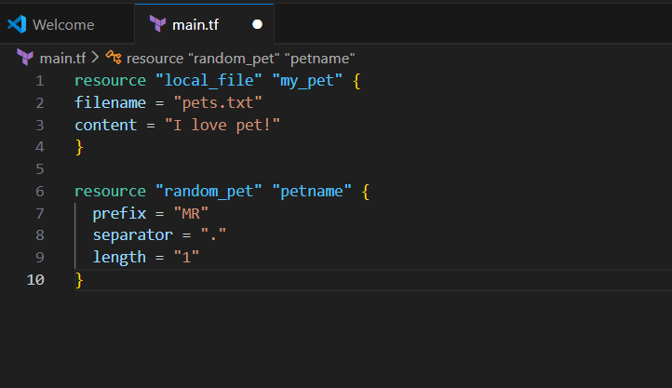
Now we need to type
Terraform init : nitializes a working directory containing Terraform configuration files
Terraform will always use the latest version when “terraform init” is executed
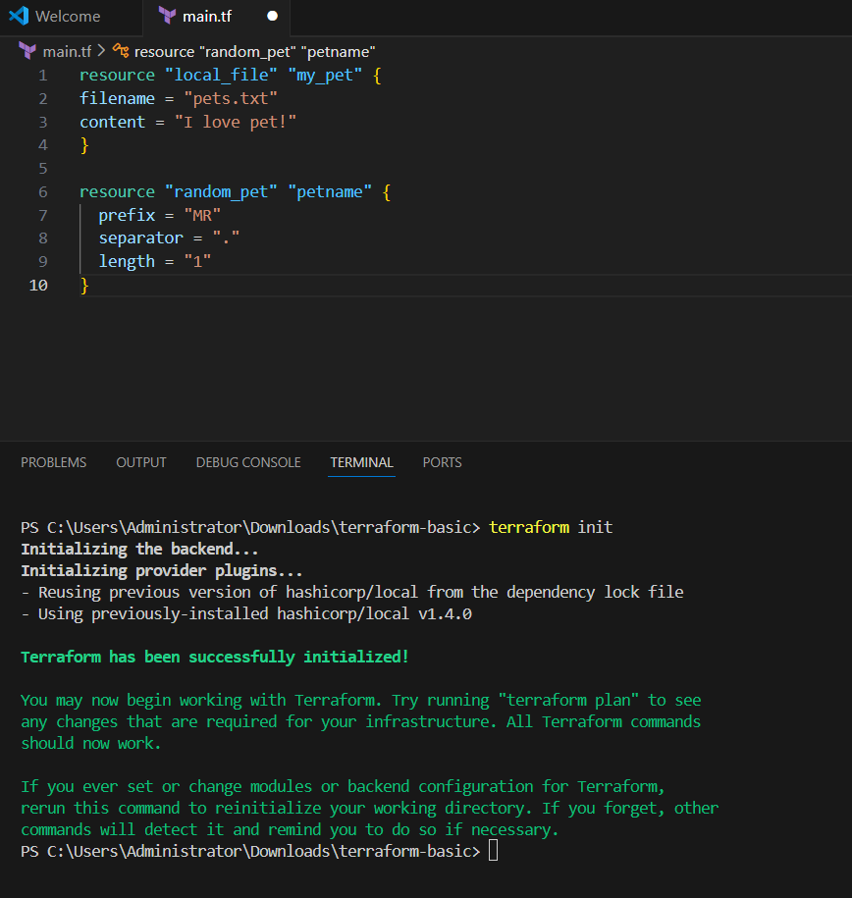
Terraform plan – Its now, ready for execution.
To compare your configuration to your resource's state, review changes before you apply them, or to refresh your workspace's state
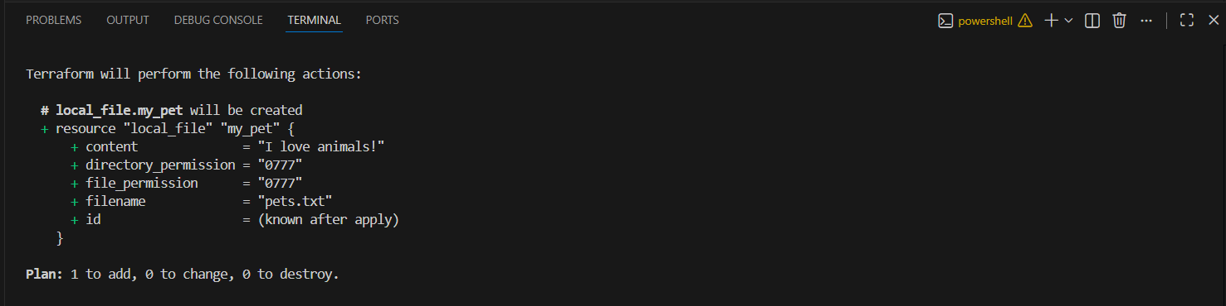
Terraform apply – Let’s execute the configuration provided for random provider
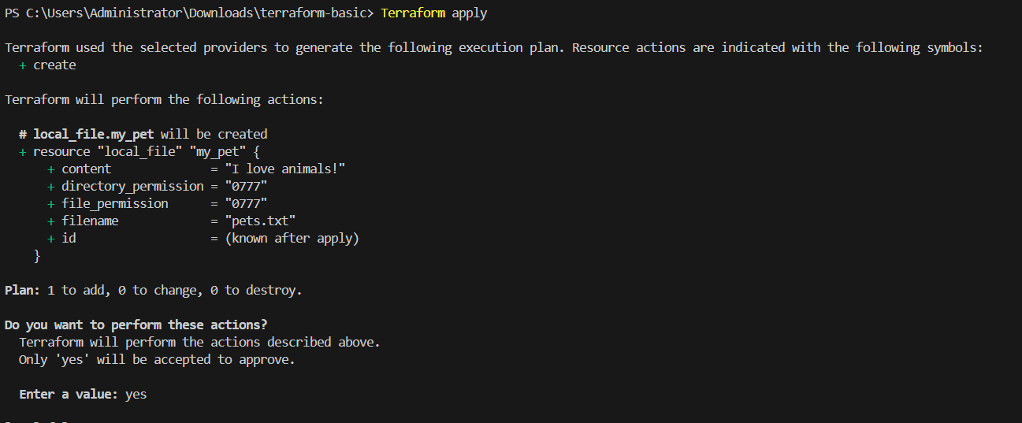
Now providers have been added to the main.tf
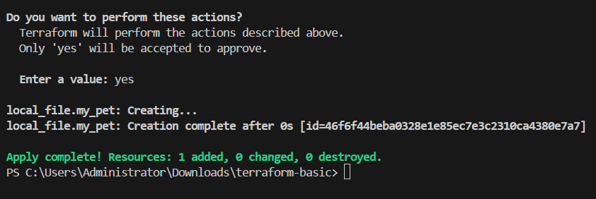
Now we need to verify the random names automatically provided by terraform we can find in the .tfstate file.
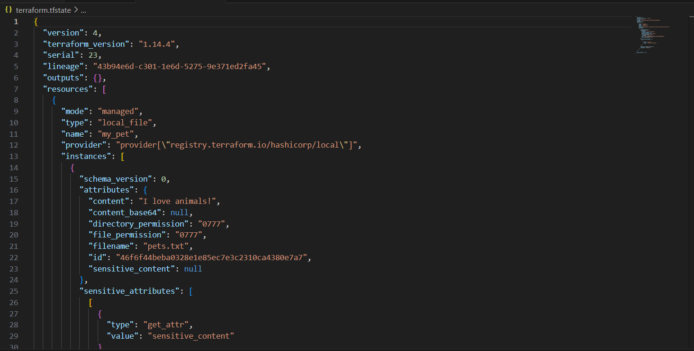
Second most important to execute and verify is backup file.
Even .tfstate file will have backup created, when there is a change to the existing state file.
Let’s make a change to the existing state file.
We changed content from pet dog in 1st provider
We changed resource from petname dog in 2nd provider.
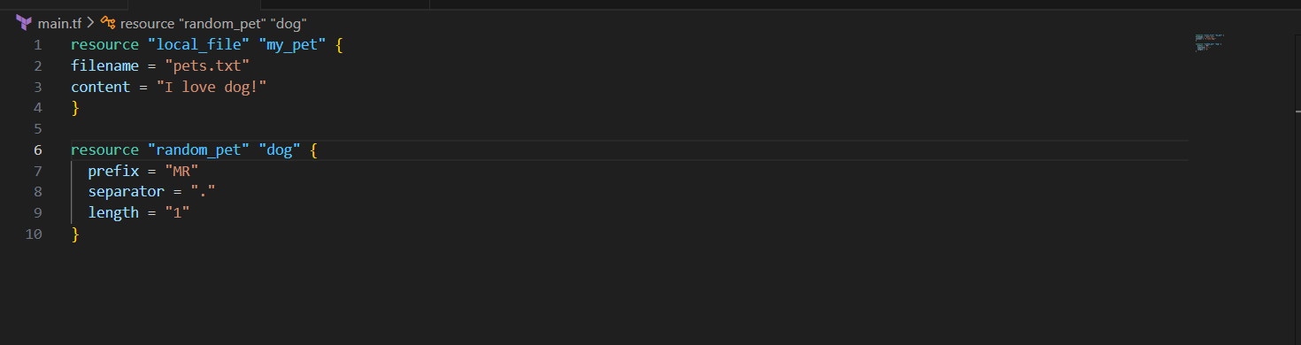
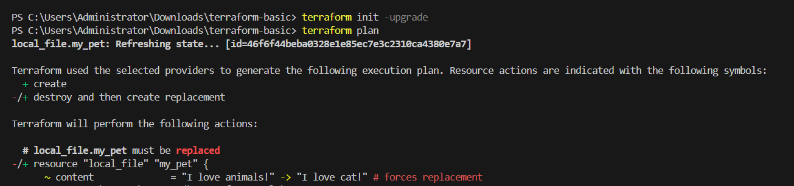
We can verify in the below that the changes made to the configuration is destroyed and created with updates made.

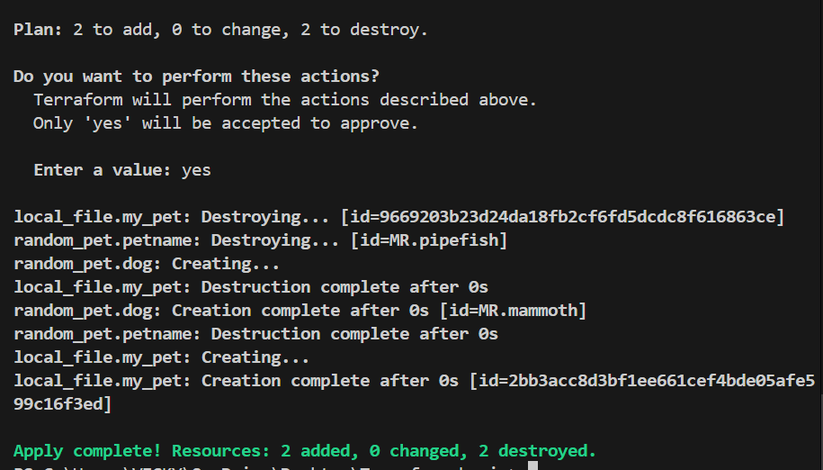
Let’s verify if the .tfstate backup created?
Terraform.tfstate. backup created automatically when a change made to the existing. tfstate file.
It’s always best to make changes in the provider, not in the .tfstate file.
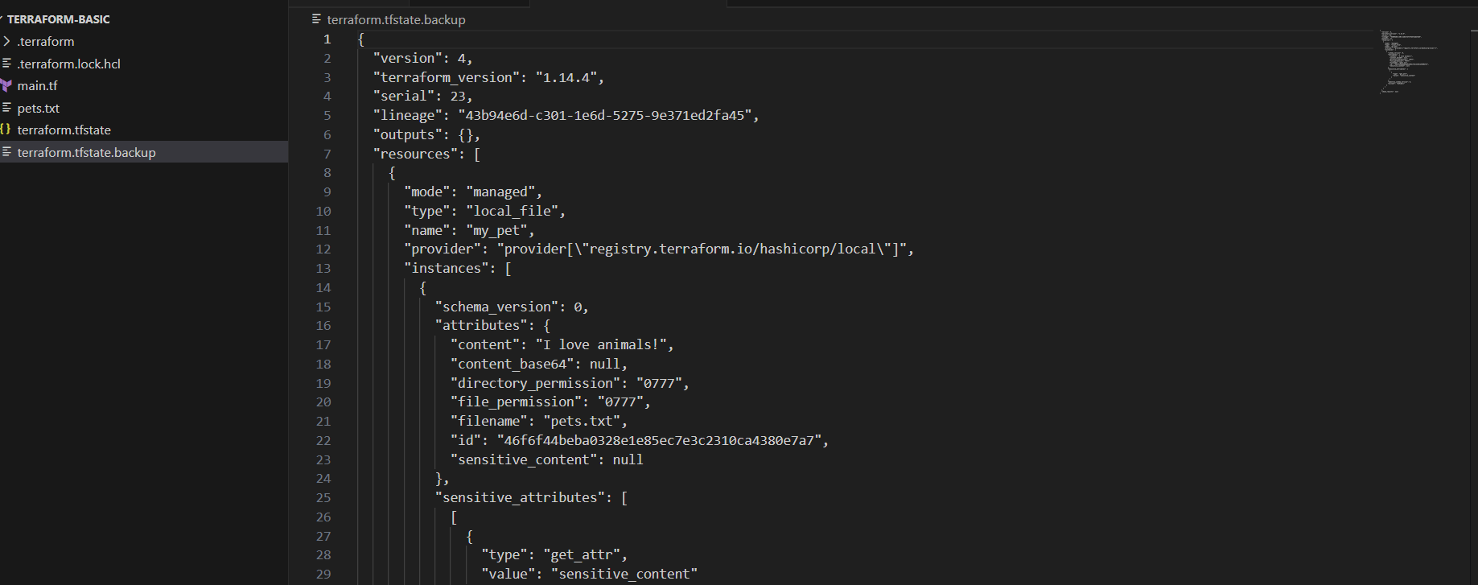

Configuration Directory
Main.tf = main configuration file containing resource
Variables.tf = contains variable declaration
Output.tf = contains outputs from resources
Provier.tf = contains the provider definition
Terraform Immutable vs Mutable infrastructure
Mutable = Mutable (The "Repair" Model)
How it works: Updates are applied to existing servers in-place.
IMMUTABLE = Immutable (The "Replace" Model)
How it works: Servers are never modified. To make a change, you build a new server and delete the old one.
Terraform uses Immutable infrastructure by destroying the previous version and creating a new one.
Example, if there is a new version if nginx is available, then the previous version of server will be destroyed and new server will be launched.
This is how Immutable infrastructure works.
Lifecycle Rules- Terraform
There are 3 lifecycle rules in Terraform
- Create_before_destroy
- Prevent_destroy
- Ignore_changes
Let’s perform an example of create_before_destroy
Below, in the existing provider – we added lifecycle and create_before_destroy = true
Changed content from dog tiger
Now, we shall verify if the execution happens creating first and destroying next.

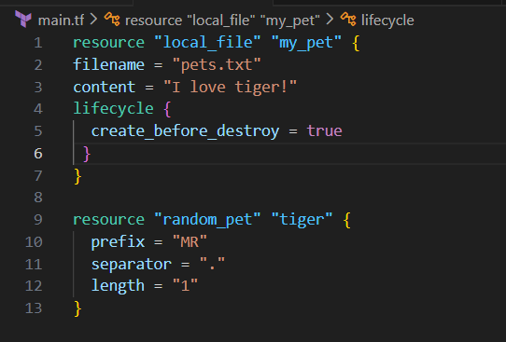
- That’s it now we executed the changes made- terraform apply
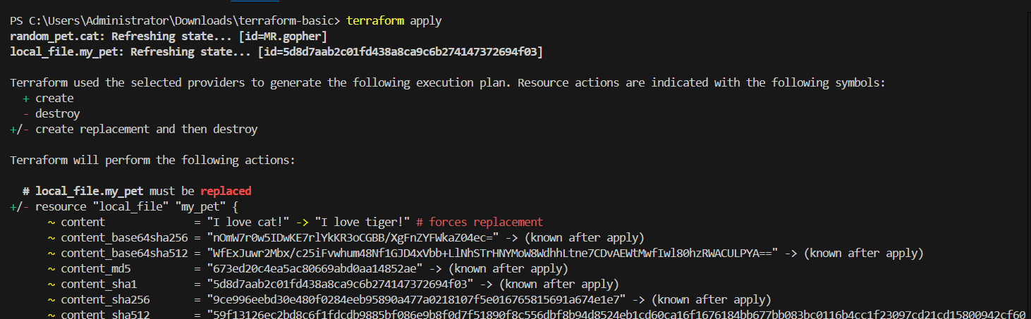
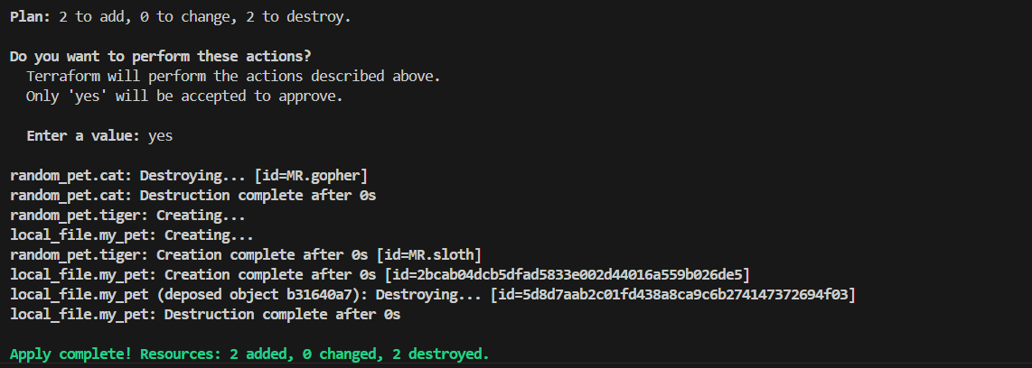
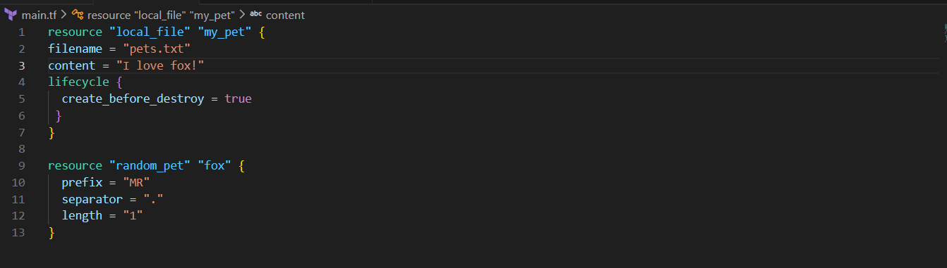
- Let’s create an example for “prevent_destroy”

- Below, in the existing provider – we added lifecycle and prevent_destroy = true
- Changed content from tiger fox
- Now, we shall verify if the execution happens
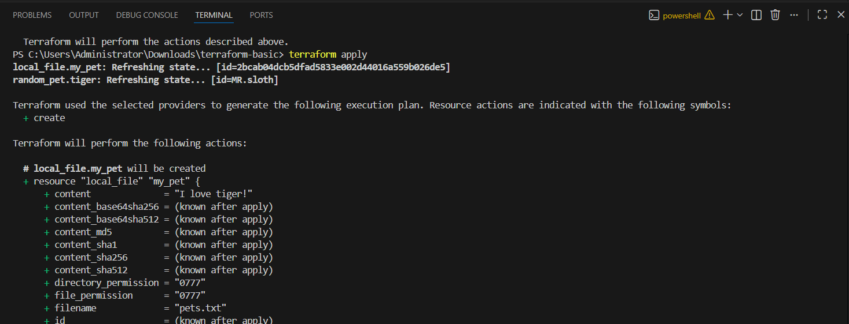
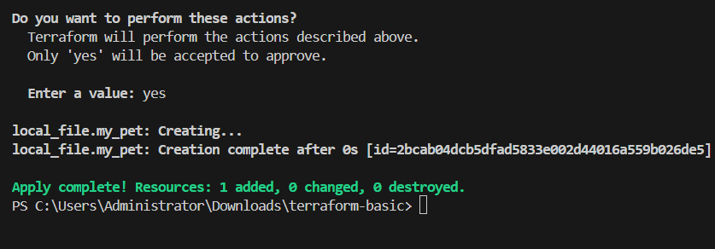
- Now, we made a change to content from fox parrot and executed “terraform apply”.
- We can see an error popped up, that to disable prevent_destroy.
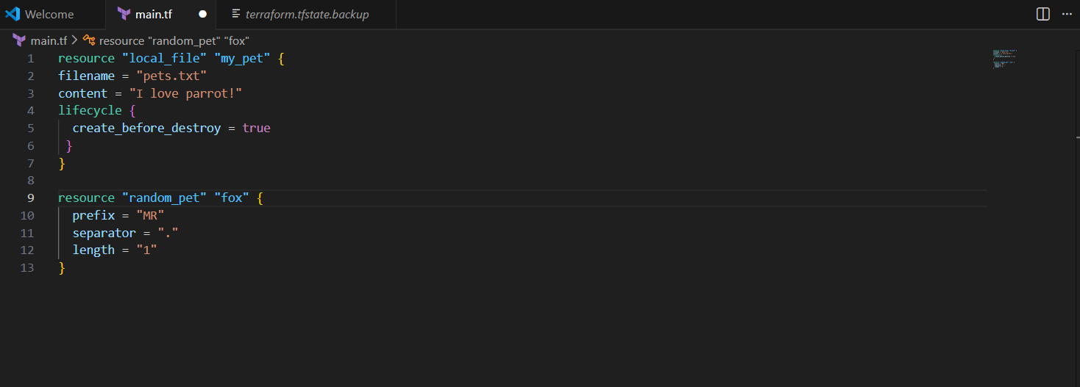
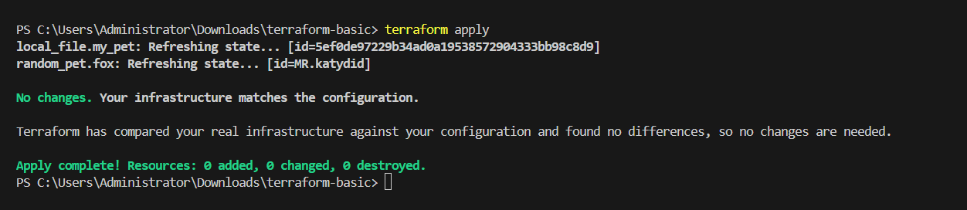
Hard coded vs Soft coded
Hard coded:
What is hard coded?
Ans. It’s always not a best practice to make all the changes in main.tf file
Instead, we need to create a file – variables.tf and soft code and make all the changes in the variables.tf file, not on main.tf file.
That is the difference between Hard coded and Soft coded.
Let’s perform an example in VS Code.
variable "filename" {
default = "pets.txt"
type = string
}
variable "content" {
default = "I love FOX"
}

- Made changes to main.tf

resource "local_file" "my_pet" {
filename = var.filename
content = var.content
}
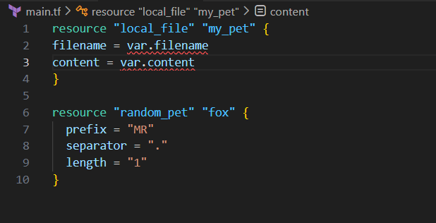
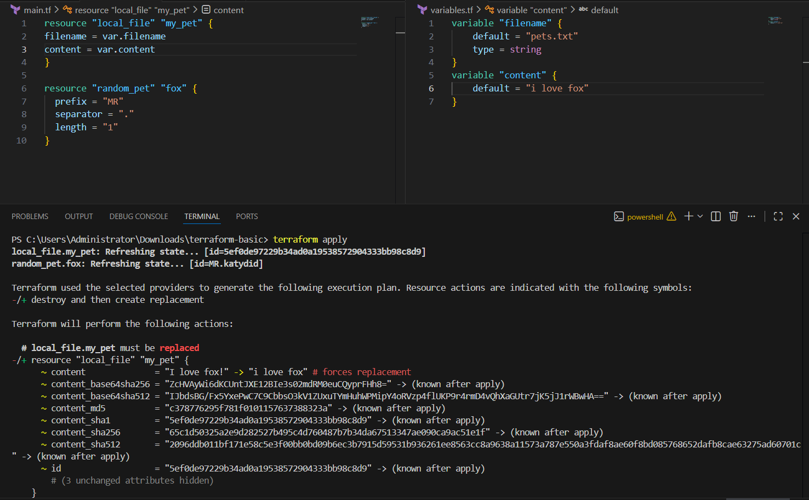
Updated the variables.tf and main.tf
Updated for second provider- random conf.
Added variable “prefix” and “length”
Updated main.tf for “prefix” and “length
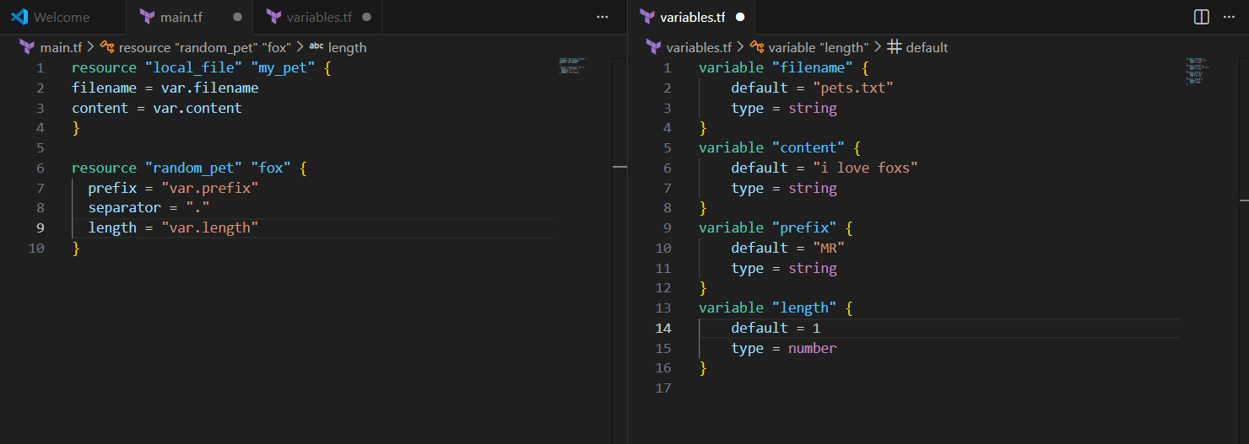
Integrate Terraform in Jenkins using the Terraform plugin.

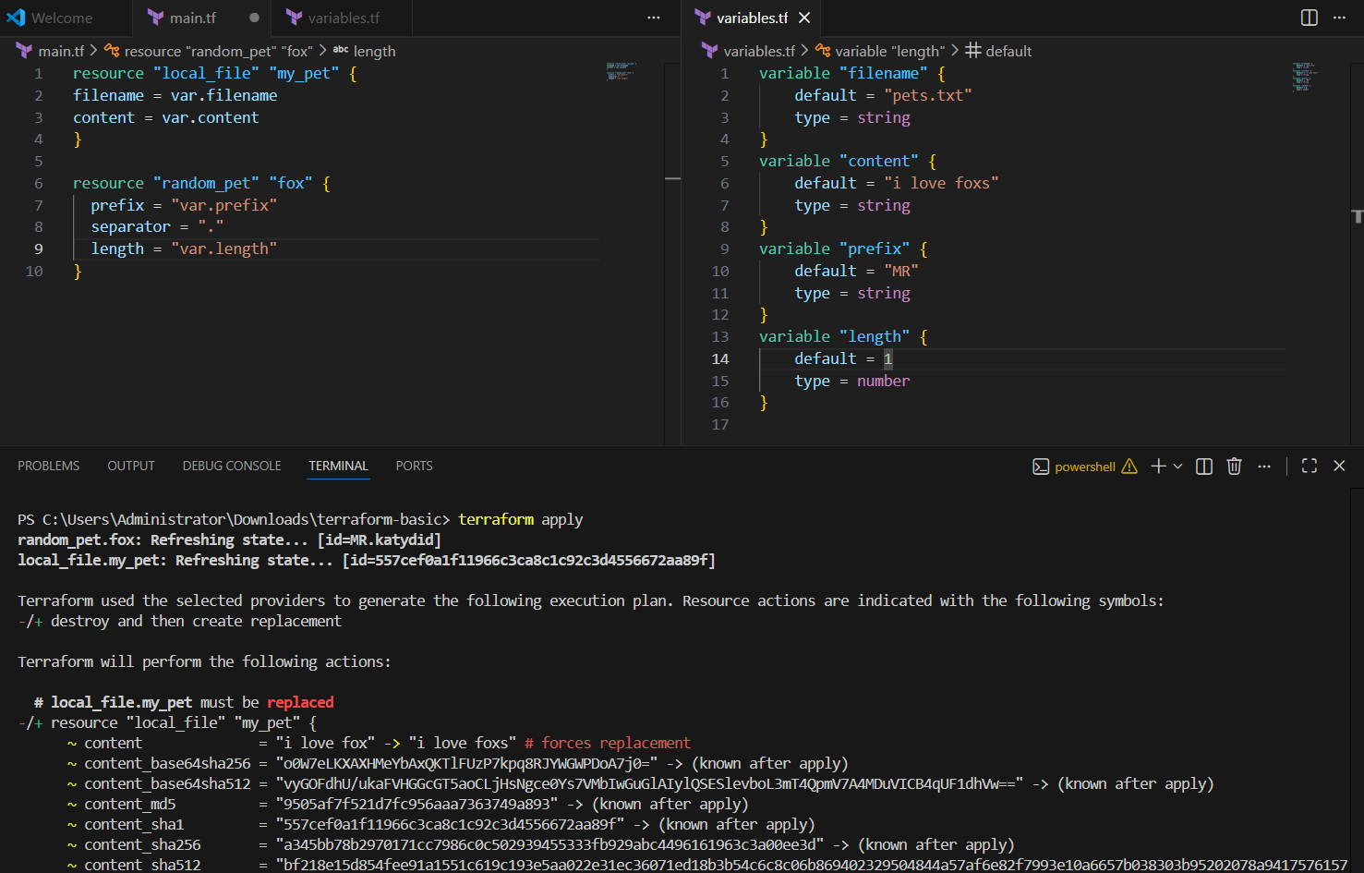
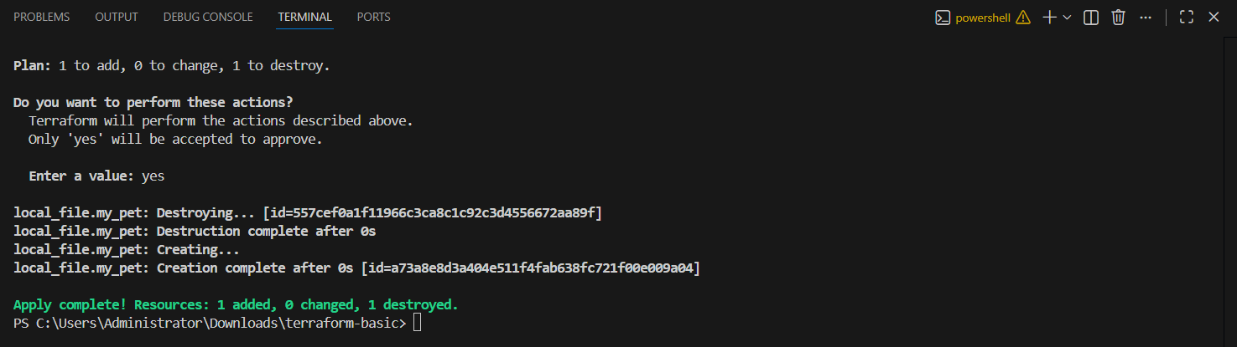
Now we saw how variables work when soft coded.
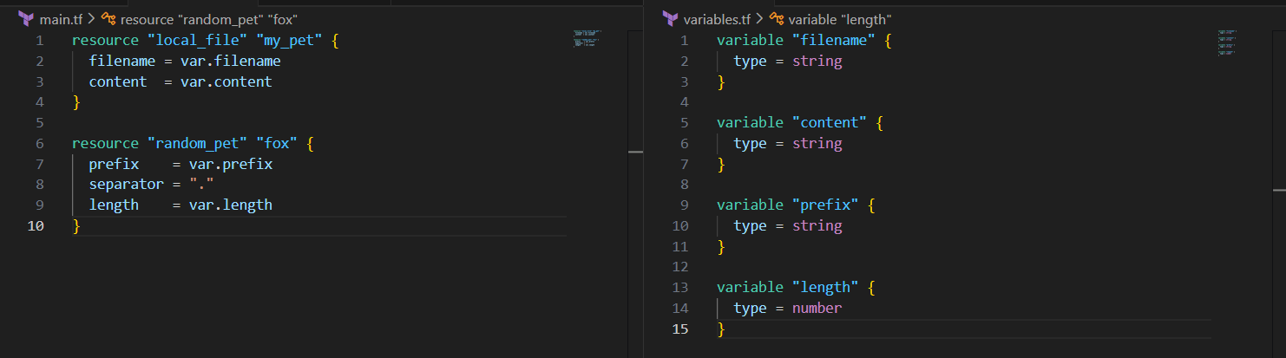
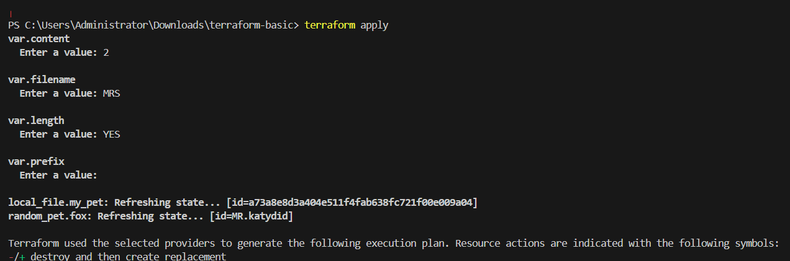
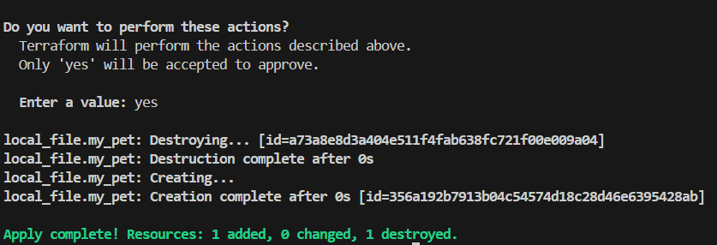
Integrate Terraform in Jenkins using the Terraform plugin.
First login to your aws a/c then start jenkin server

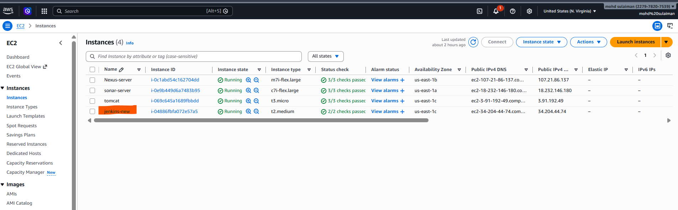
Now go to terraform website copy all command sudo yum install -y yum-utils shadow-utils
All
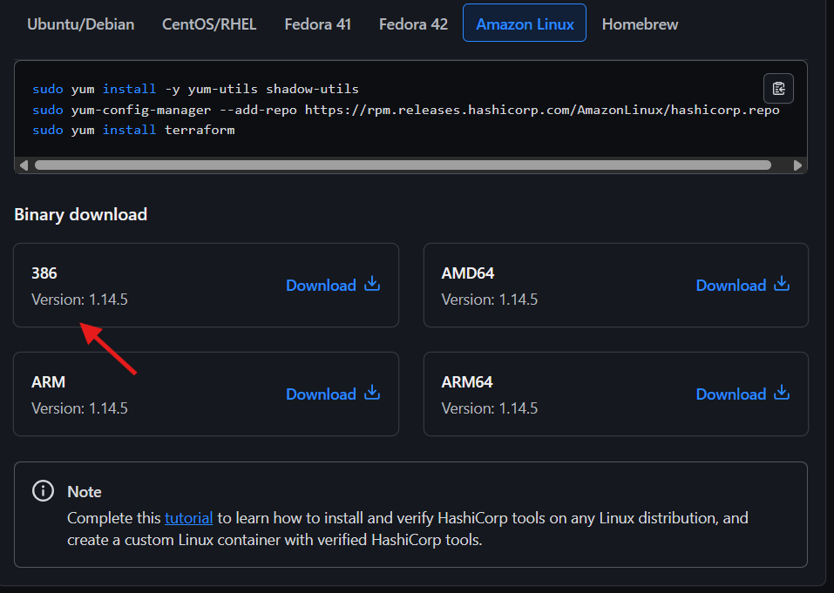
Now paste next
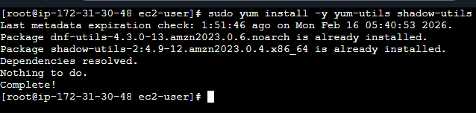
Now paste sudo yum install terraform on our server make sure its your Jenkins server
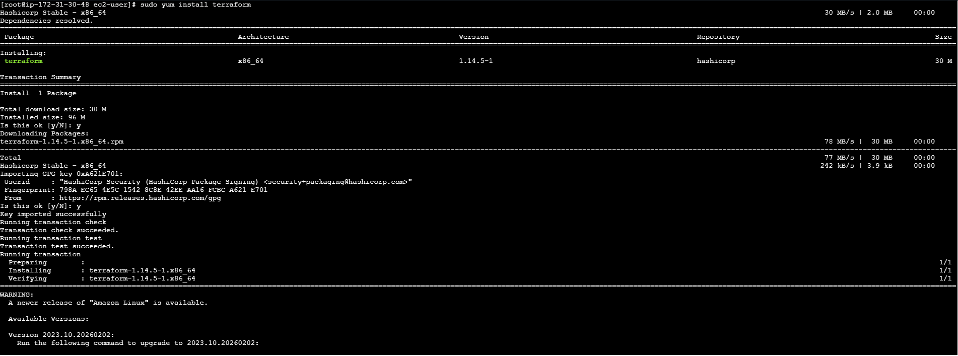
Now we need plugin click correct click on install button
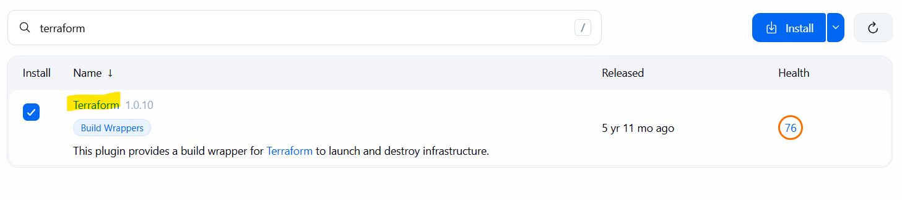
Now it take 1 2 min then install it
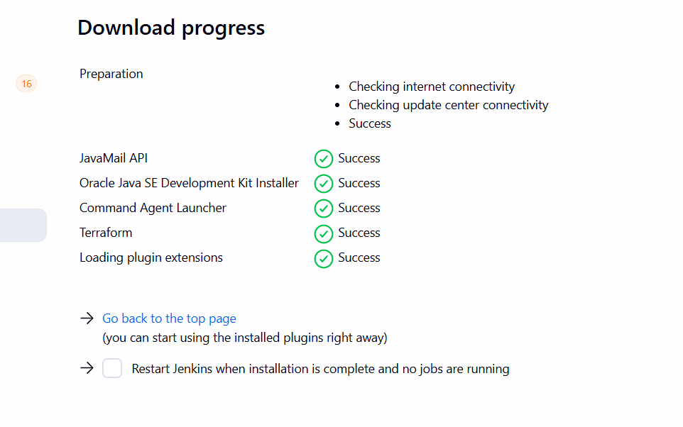
Now configuration of your terraform on Jenkins server
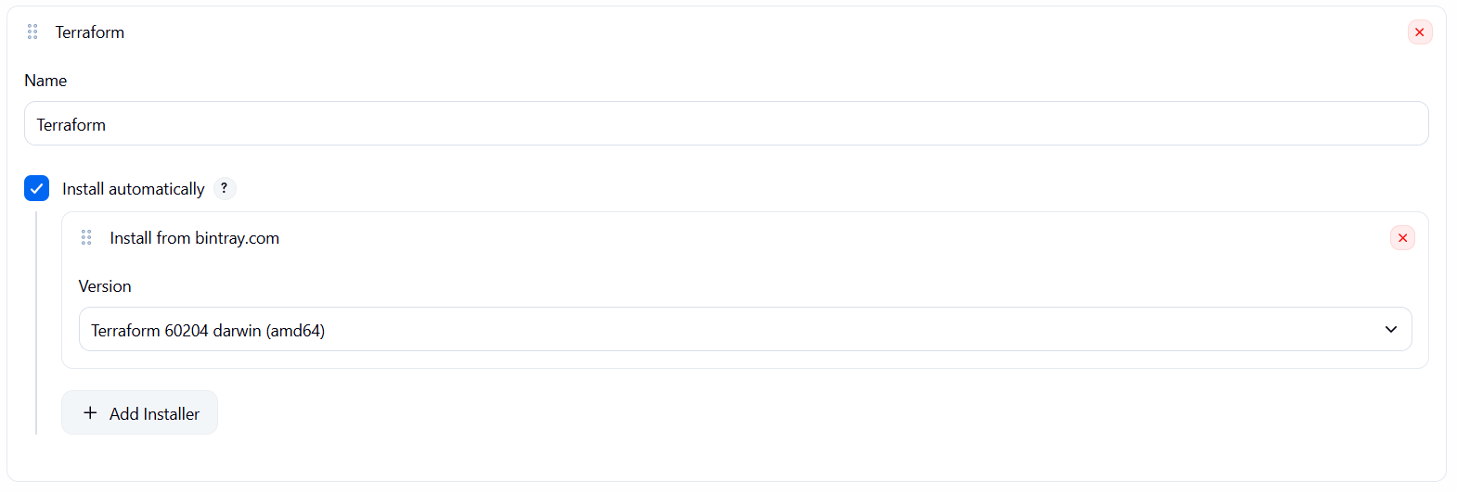
Now we need git repo for this lets create it give any name also on read me then click on create repo
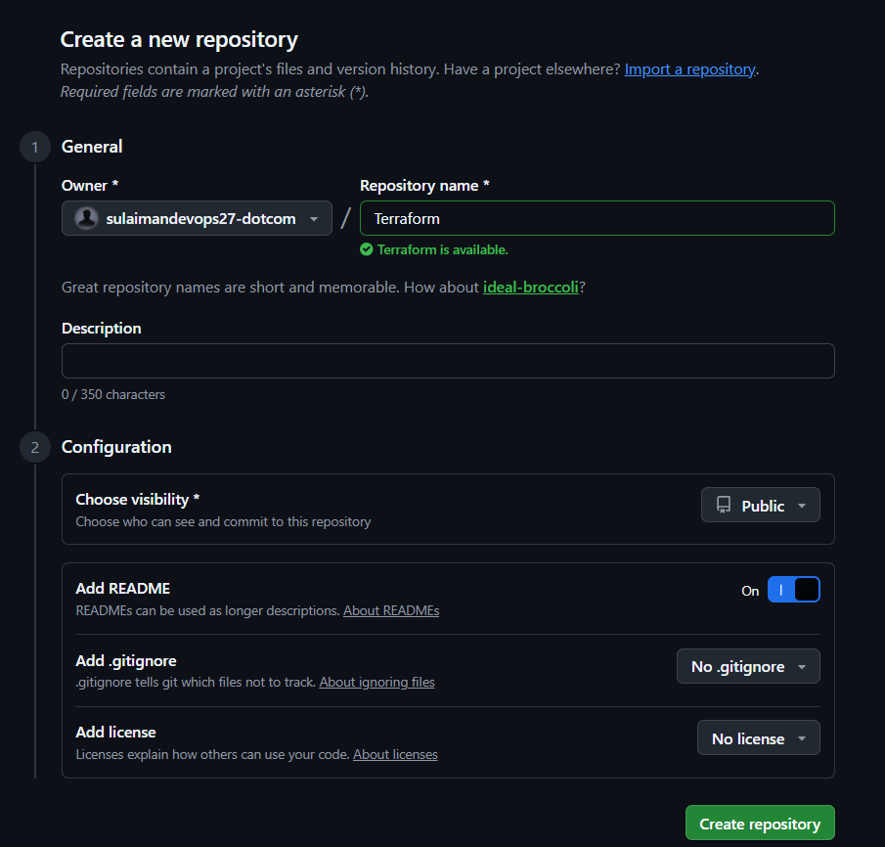
Now we need one file give file name main.tf that’s now click on commit change
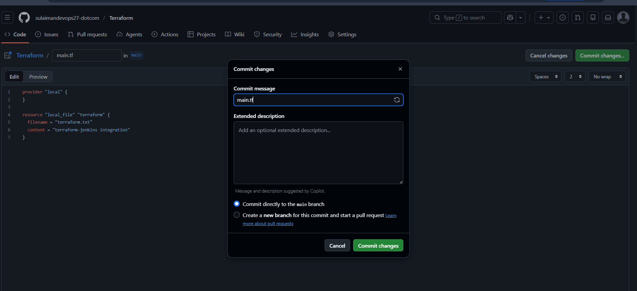
Now it add on our dash board
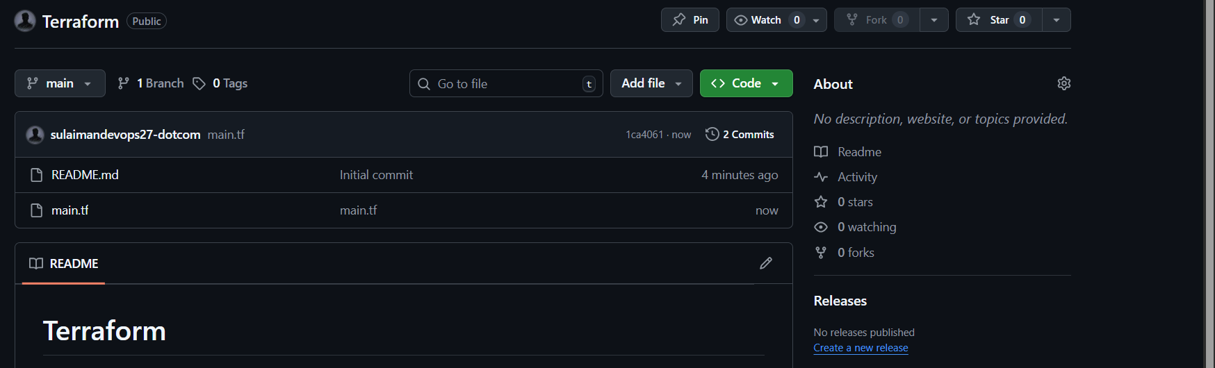
Ok now simple terraform script
Go to Jenkins server click on new item write any name in my case I have written terraform select pipeline then click on ok
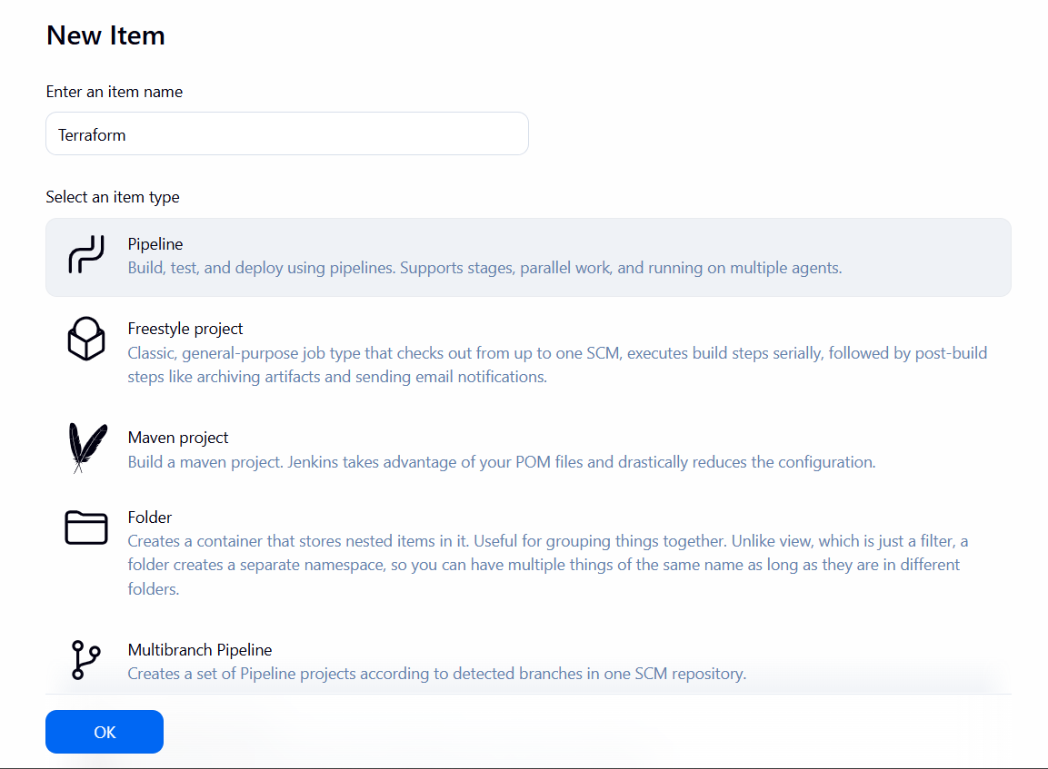
Now going use one script
pipeline {
agent any
tools {
terraform 'Terraform'
}
stages {
stage('Git Clone') {
steps {
git branch: 'main',
url: 'https://github.com/sulaimandevops27-dotcom/Terraform.git'
}
}
stage('Terraform Init') {
steps {
sh 'terraform init'
}
}
stage('Terraform Plan') {
steps {
sh 'terraform plan'
}
}
stage('Terraform Apply') {
steps {
sh 'terraform apply -auto-approve'
}
}
}
}

