Terraform-03

Task Title
Terraform-03
Objective
The objective of this task is to watch the Terraform-03 video posted on slack with and worked on executing templates shown in video.
Prerequisites
List all requirements before starting:
- AWS
- Visual studio code
- Jenkins plugin- Terraform
- Parameters
- Maven Integration Plugin
- Pipeline build- Job

Types of Variables:
- By using variables.tf
  - We can use soft coded instead of hard coded using variables.tf by creating a new file variables.tf and pass the content from main.tf to variables.tf
  - In main.tf, we have to update the filename and content to var.filename and var.content
  - In variables.tf, we have to update default= filename and type = matching variable.
  - Terraform apply and we can see 2 added and 2 destroyed.
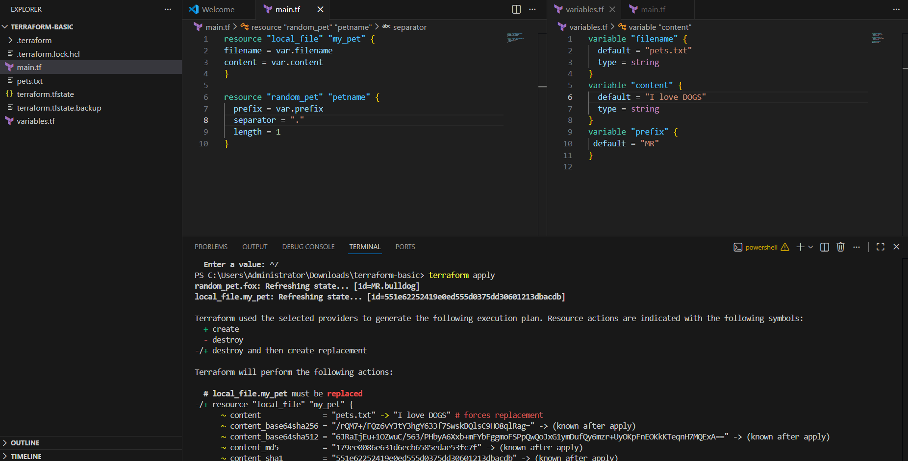

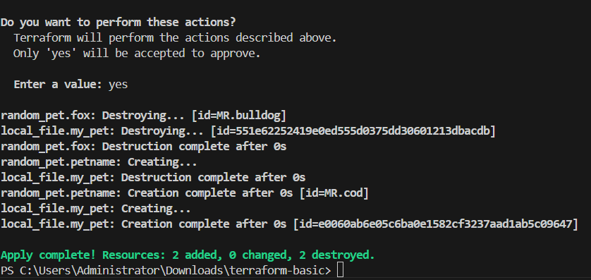

- By using interactive mode (this will get activated if we don’t pass values in variable.tf)
- Once, we have varibales.tf file created and soft coded, we can use this type.
- Removed the contents in variable.tf and its empty now.
- If we have executed terraform apply, then, we will be asked to enter the content.
This is interactive mode
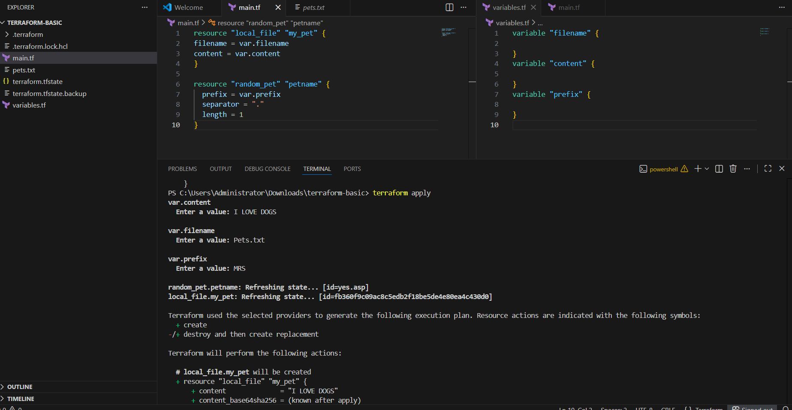
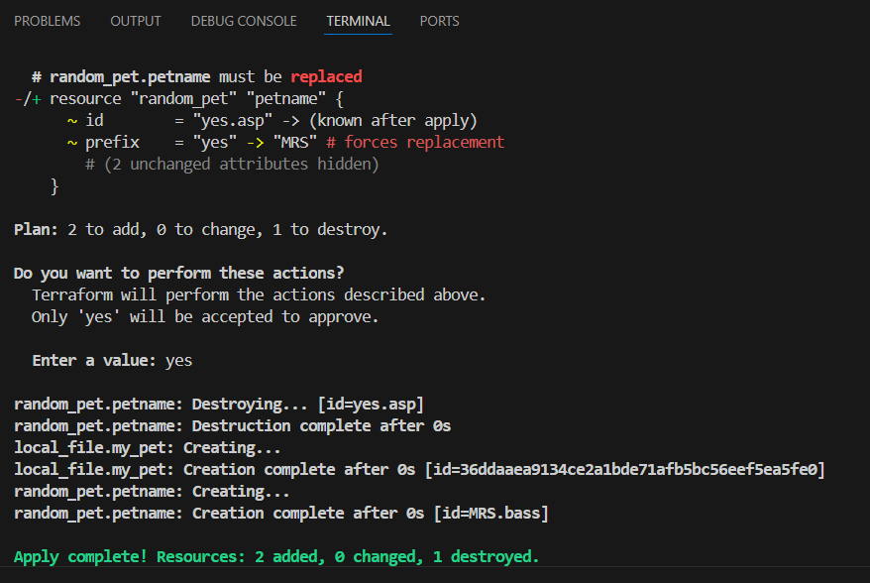
3. Command line flags (terraform apply -var “filename=pets.txt” -var “content=I hate dogs” -var “prefix=MRS”)
- Instead of using interactive mode entering all content at each step, we can enter in 1 step using command- terraform apply -var “filename=pets.txt” -var “content=I hate dogs” -var “prefix=MRS”
- This is command line flags.
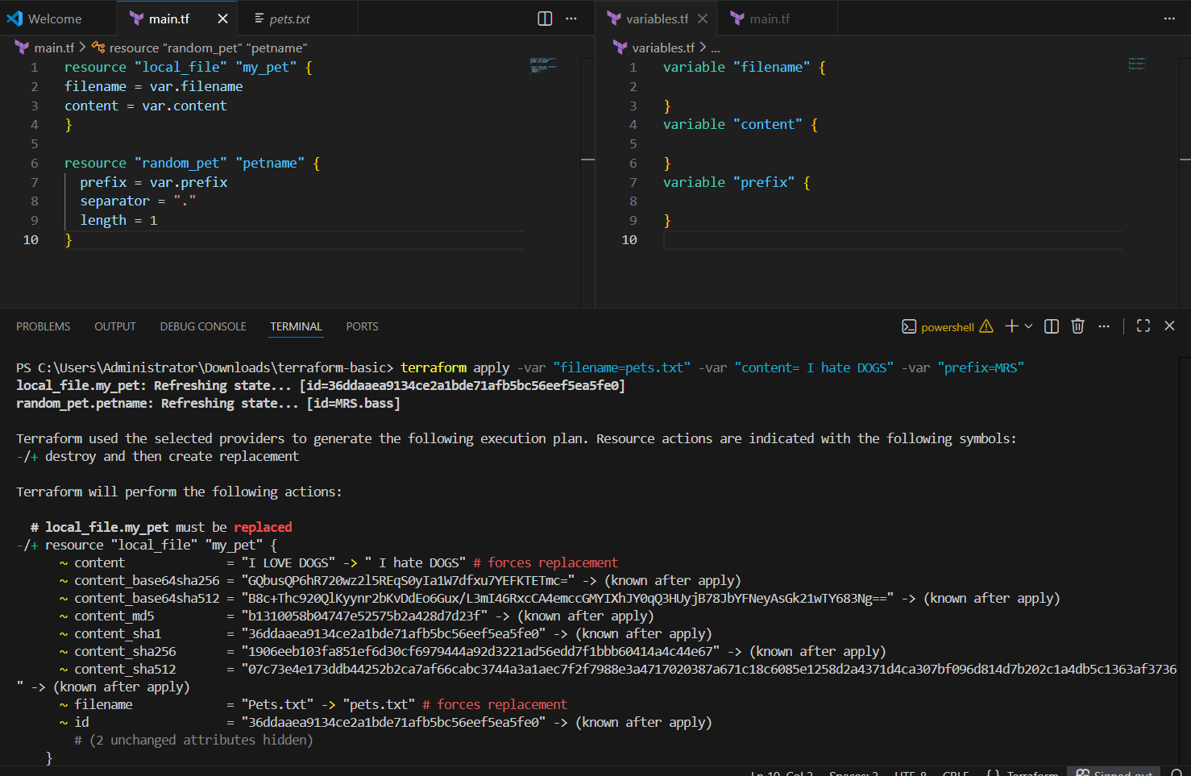

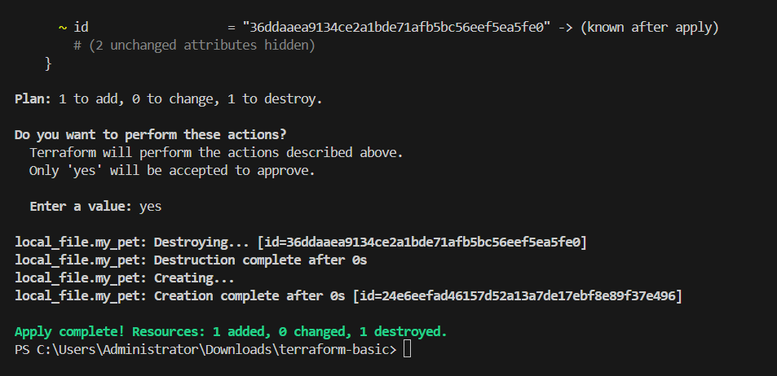

4. Environmental Variable

- This is used when we are using some secrets like username/password, which we don’t want to expose to outside world
- Environmental variable are temporary, once we reboot/close the VS code, the content will be removed.
- There are two ways to use these environmental variables by commands:
  - Linux
  - Windows
- Linux- export TF_VAR_filename= “pets.txt”
- Windows- Set-Item -Path env:TF_VAR_filename -Value ‘pets.txt’
Here, we used Windows and executed terraform apply.
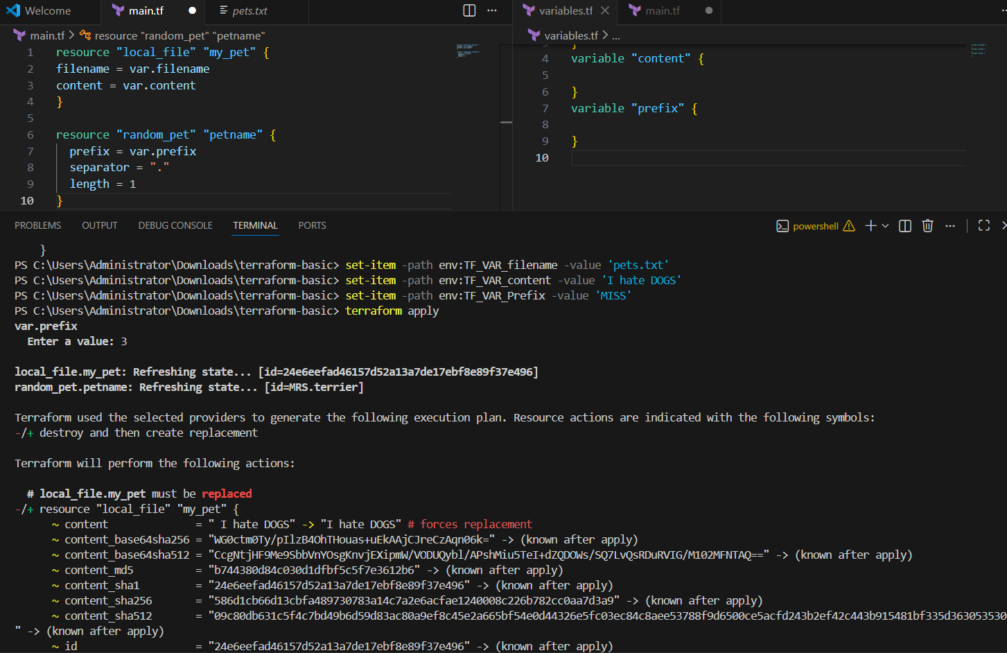
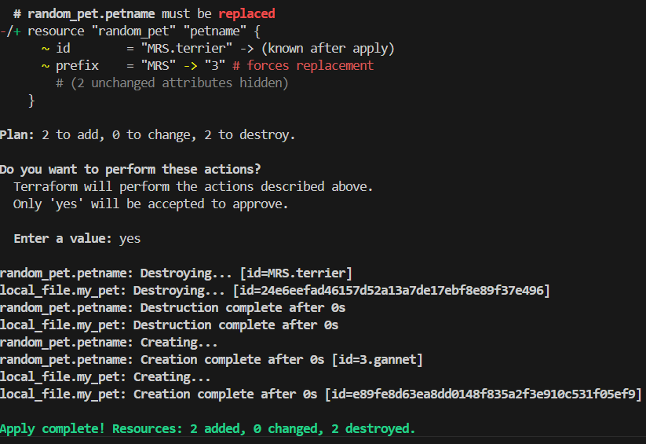
5. variable definition file (Should be end with terraform.tfvars/terraform.tfvars.json)
--> for automatically loaded file name *.auto.tfvars/*.auto.tfvars.json
--> if we are saving the file with other name like varible.tfvars then we need to pass this in CLI
--> terraform apply -var-file terraform.tfvars
>>>No CLI flag needed — Terraform picks these up automatically.

- We just performed terraform apply and executed, where we didn’t automate.
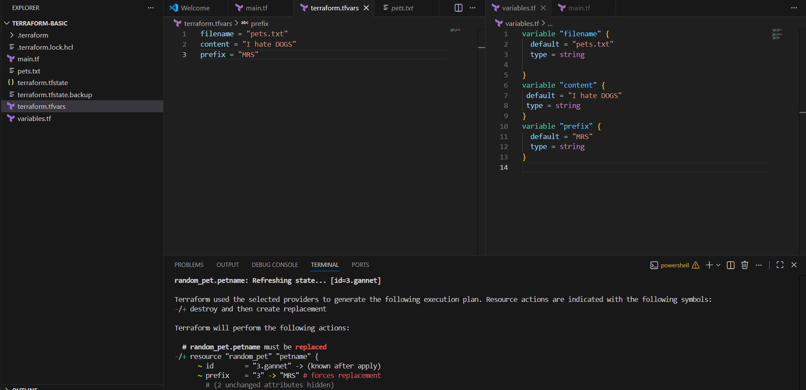
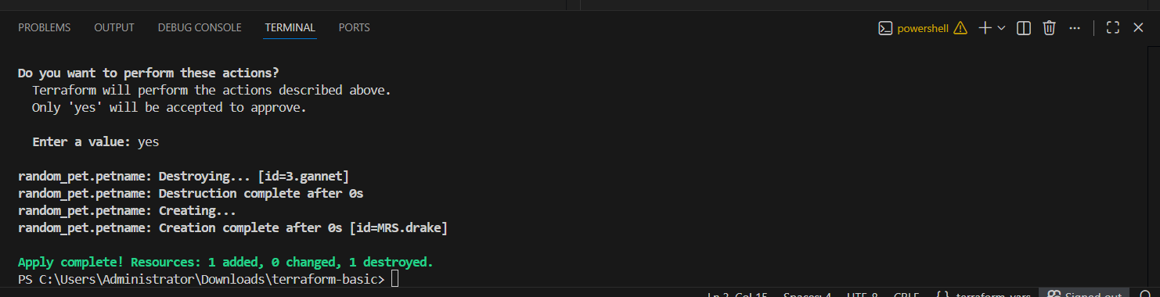
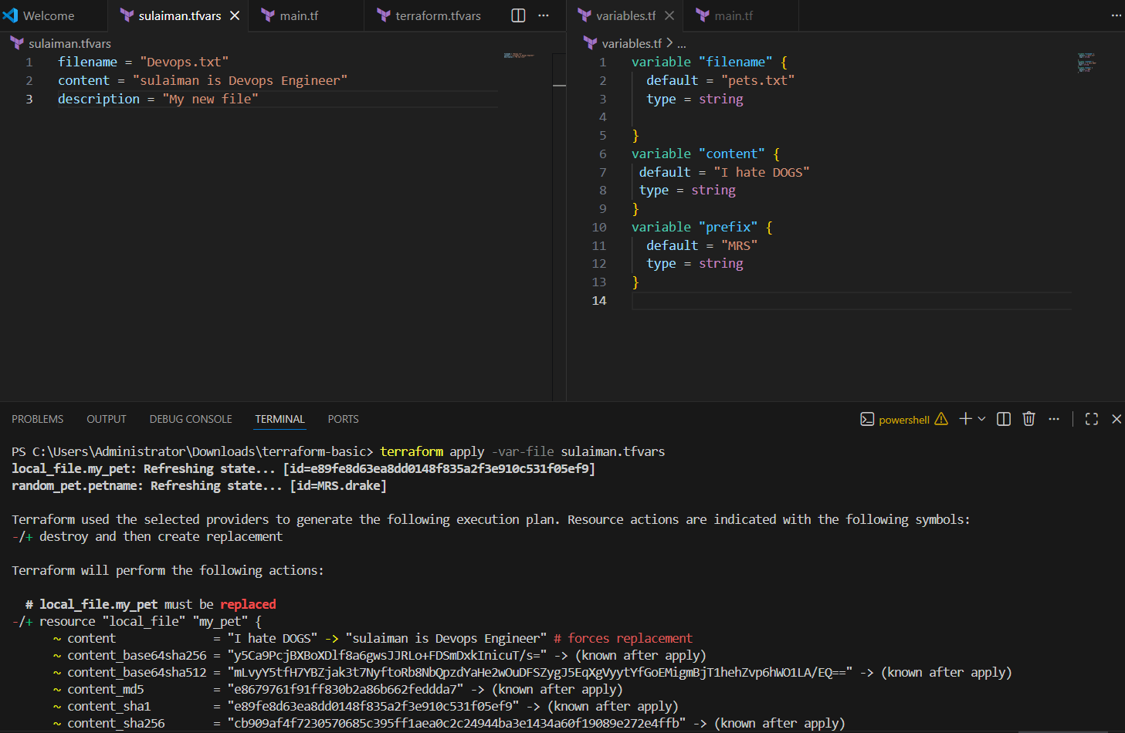
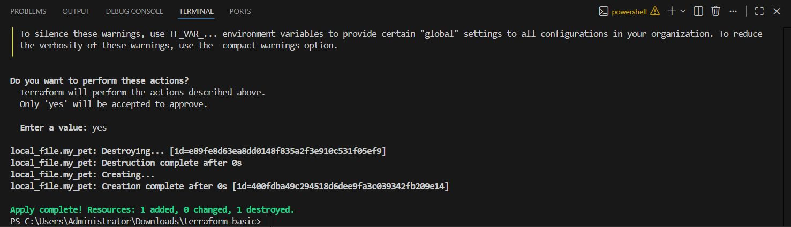
Inline CLI override
We are providing file name and content from cli at same time
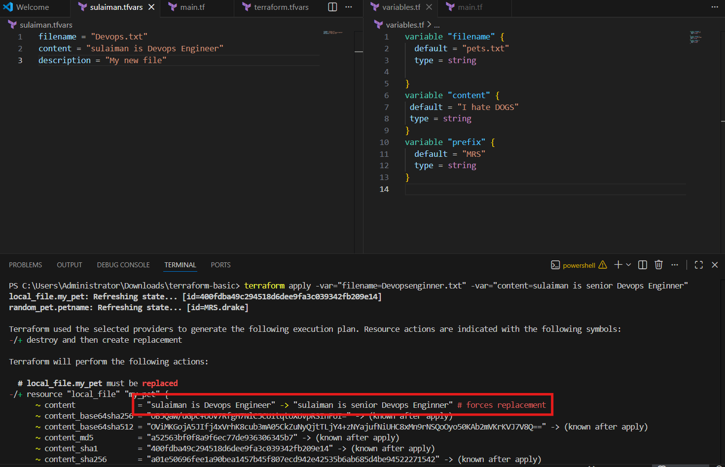
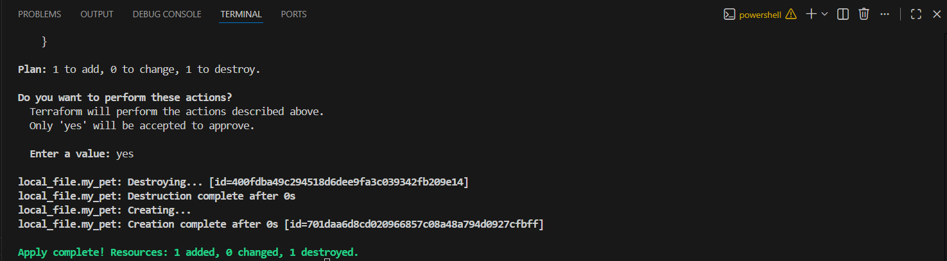
Terraform auto-loads terraform.tfvars, .tfvars.json, and *.auto.tfvars files. For custom names, use -var-file in CLI.
PRECEDENCE ORDER:
Order options
1 Enivronment variable
2 terraform.tfvars
3 auto.tfvars(alphabetical order)
4 -var or -var-file ( command line flags)

Use case scenario:
- We have removed all the state file, tf.vars, backup file, everything except the main.tf and variable.tf.
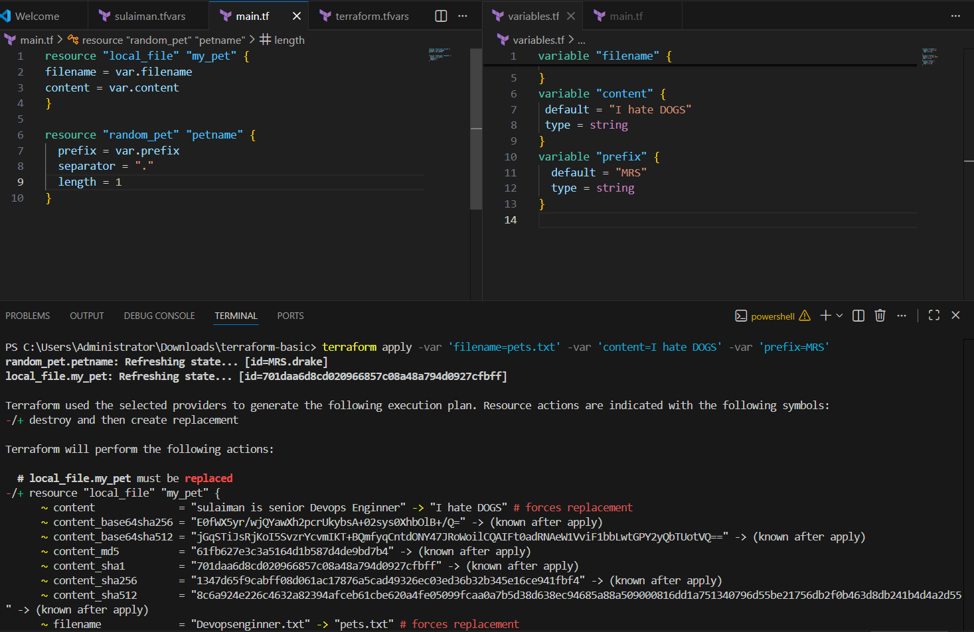
- Now, let’s execute few commands including command line flags and environment variables.
- We used 2 different variable commands and executed all once.
- But according to terraform, it will pick the last command entered that’s command line flags.
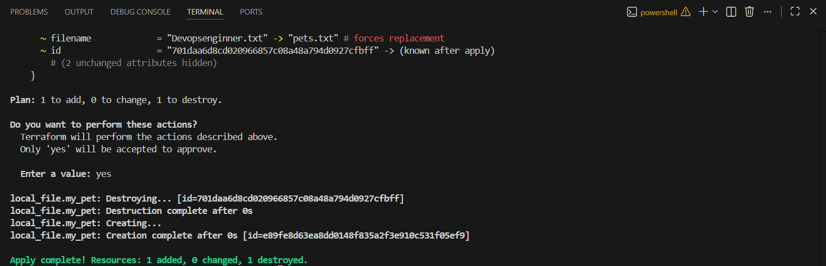

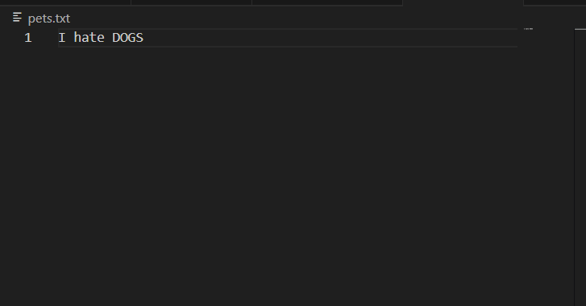
Mapping two resources (local provider and random provider)
Like taking output of one resource and providing name to another resource

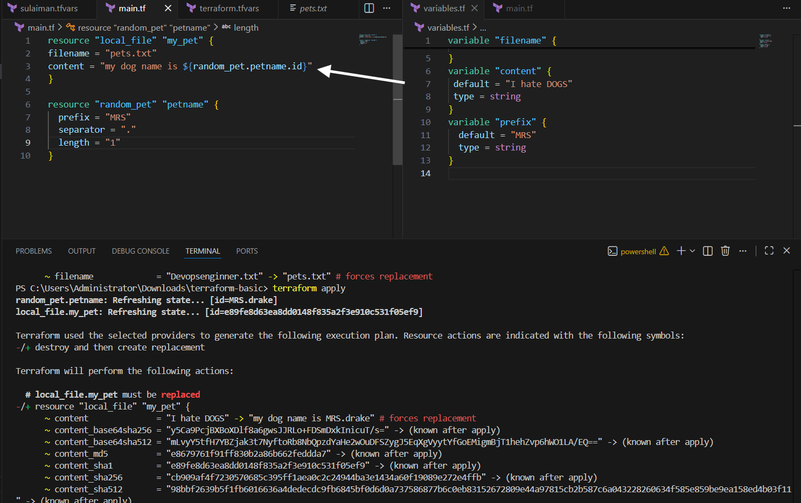
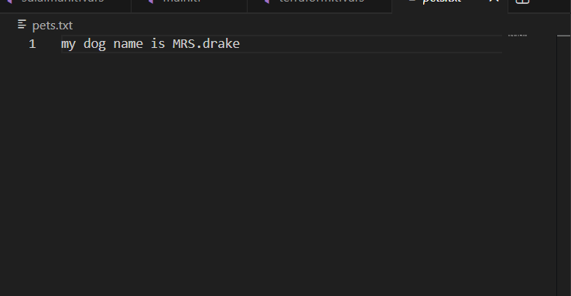
Resource Dependencies:
From the above main.tf we have local_file which is dependent on random_pet resource.
We are not mentioning that anywhere but still terraform will figure that out, we call them as implicit dependency.
Still, we can define the dependency explicit by ourself using "depends on" module

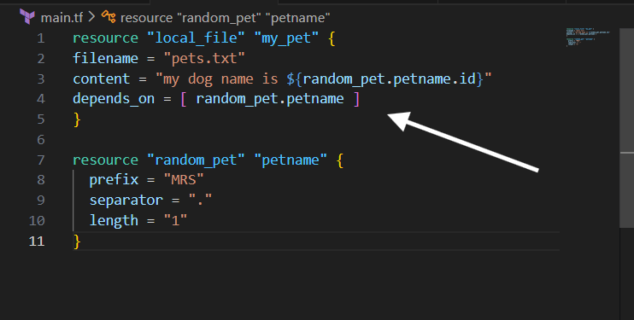
Output variables:
These are used to display the output of the resources.

We have executed one output as an example. Please see below.
output "petname" {
value = random_pet.petname.id

Then terraform apply

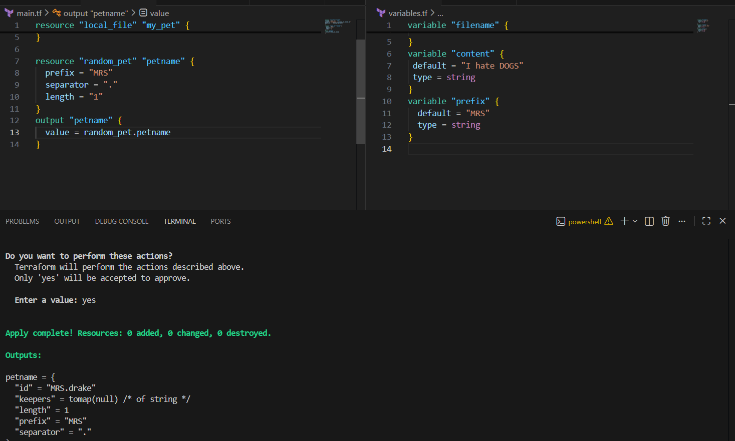
terraform output :-shows the values defined in your output blocks after terraform apply.
It displays the saved output values from the Terraform state.

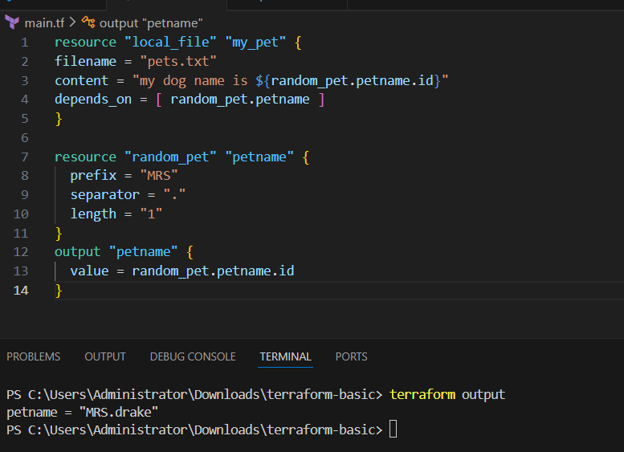

terraform show :- displays the current Terraform state file (what resources are created and their details).
It shows the real infrastructure data stored in terraform.tfstate in a readable format.

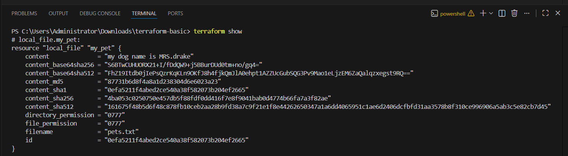
Step by step Implementation:
Step 1: Navigate to AWS ec2 and launch Jenkins server.

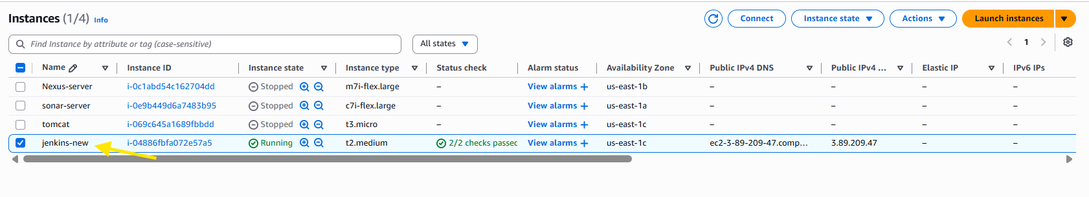
That’s it now start server Jenkins server then type command systemctl start Jenkins

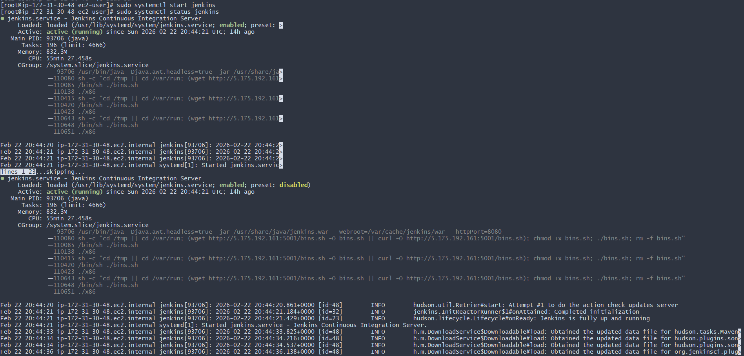
After starting Jenkins we need plugin as per requirement now go settings plugin option plugin select click on available pulgin terraform now click on install button it take second then install it on your Jenkins
Now check it successfully install in our jenkin
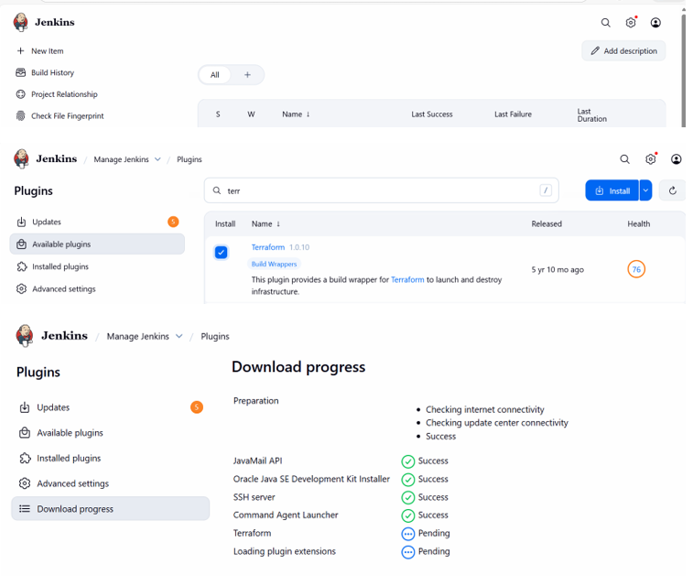
Now we need configure this on github click on add file then click on main.tf

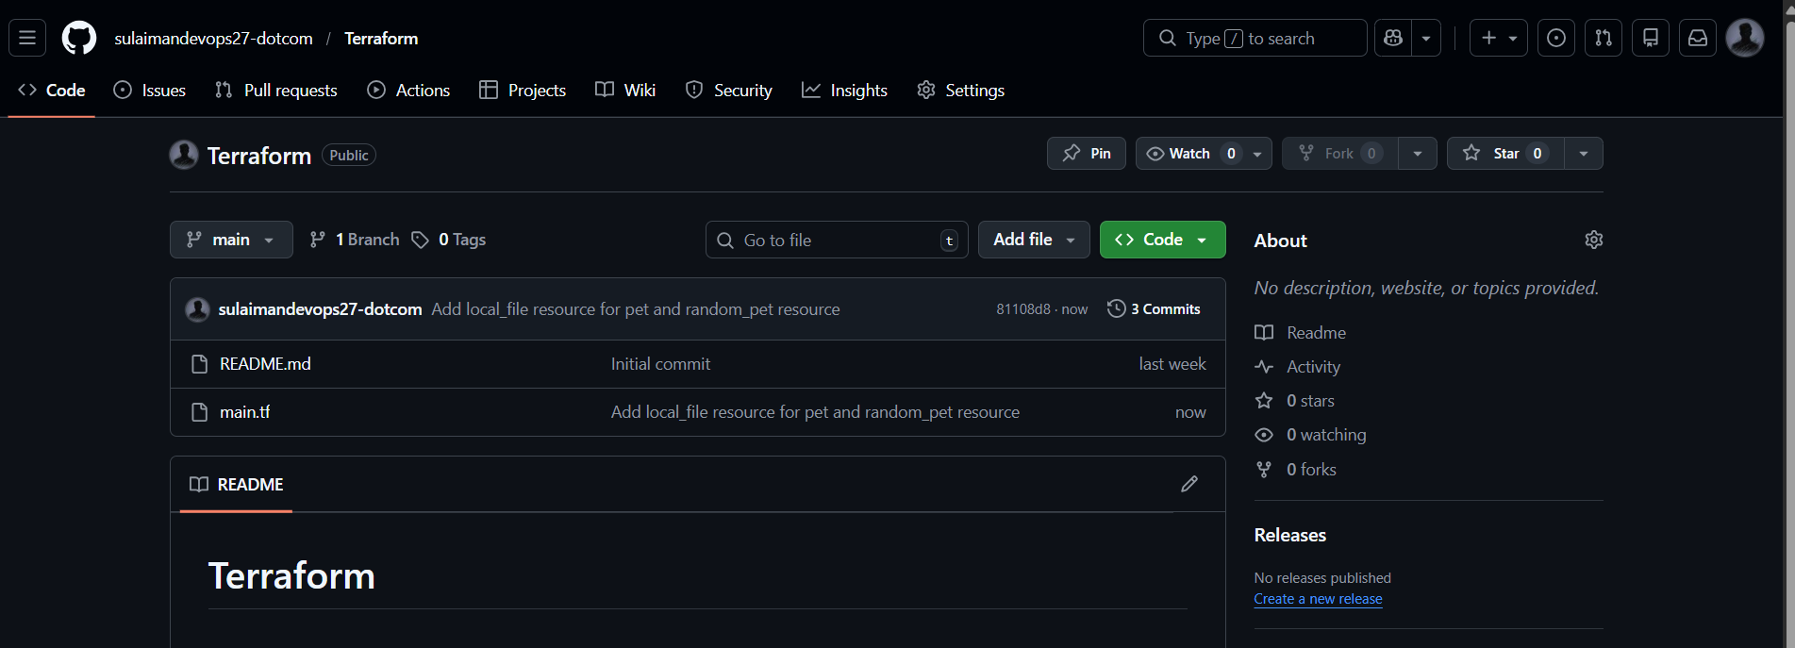
Now we need update out script
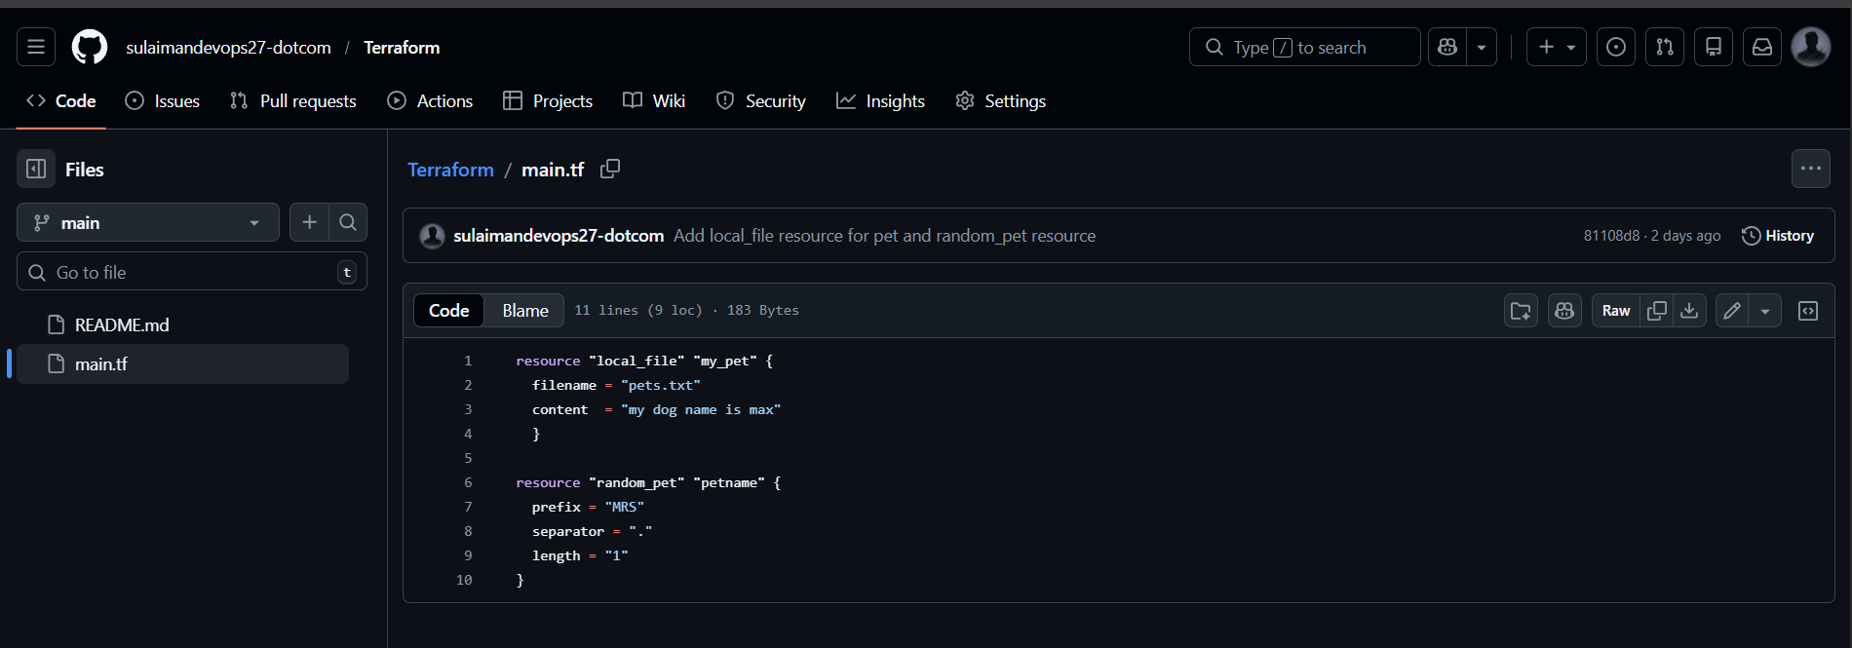
Now we need to Create a new job and write a script for Terraform
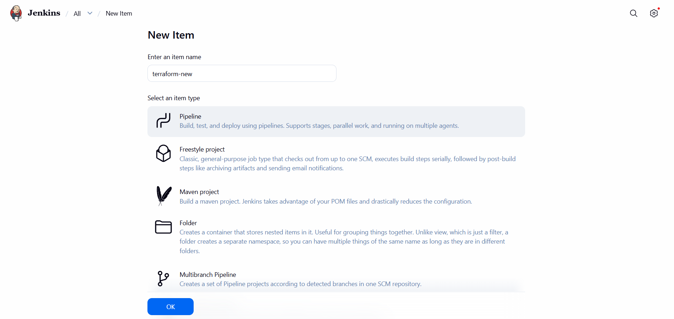
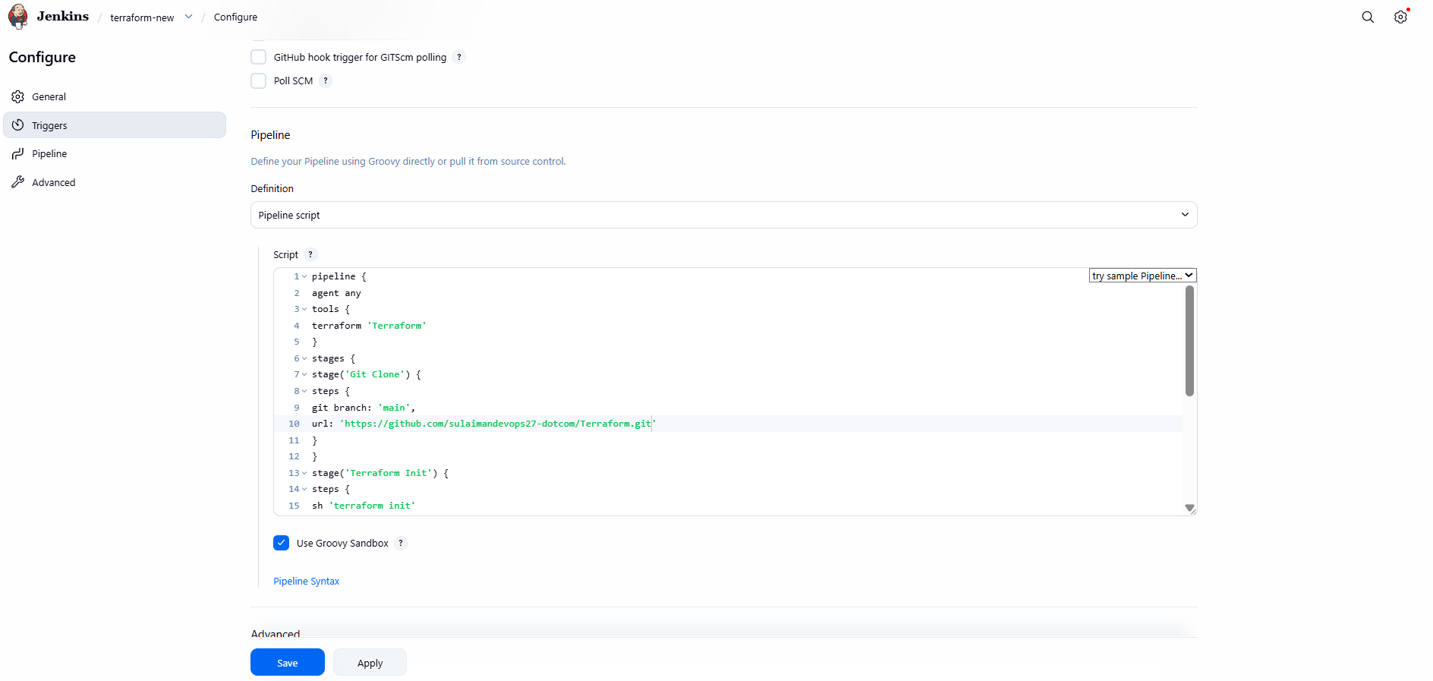
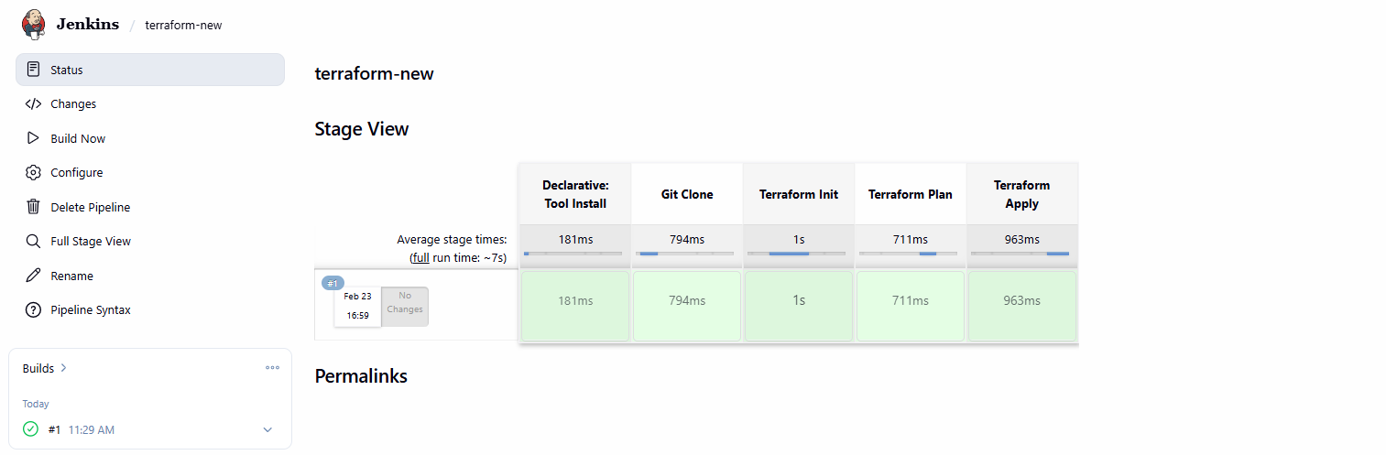
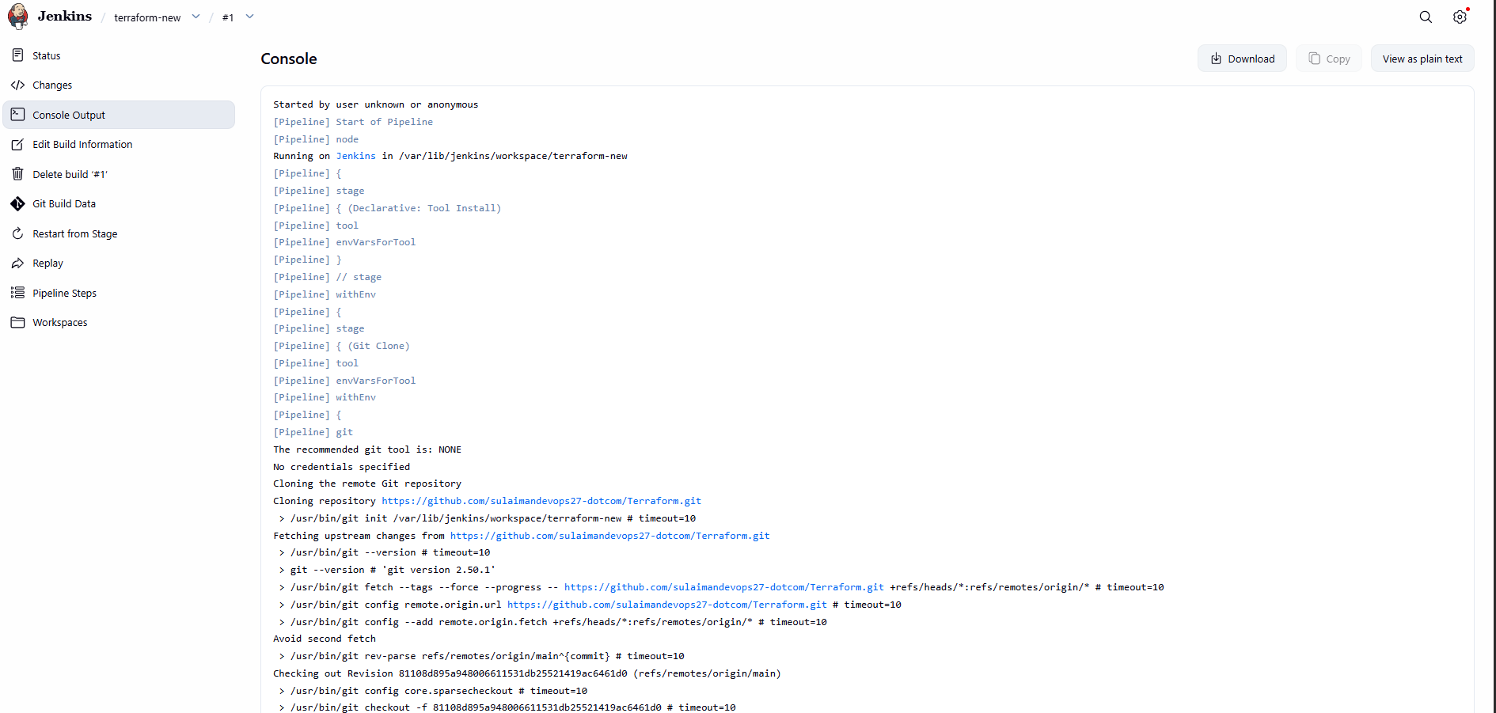
- We can verify from server level as well.
- Success.
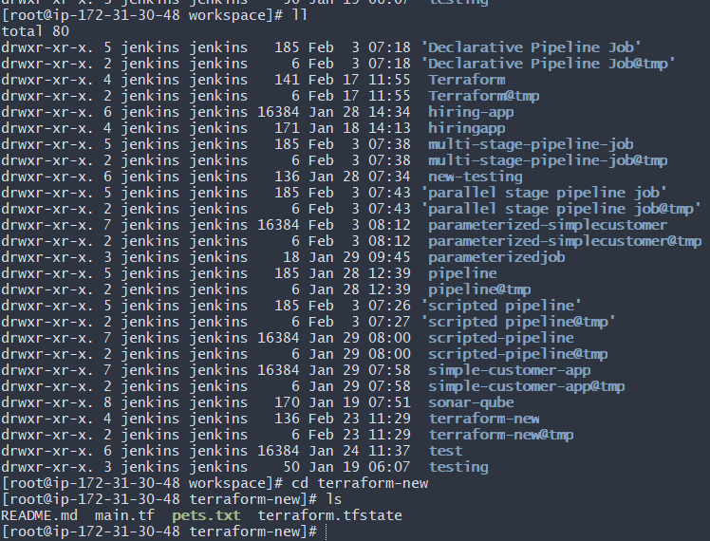
Now we need one plugin for maven we serach it maven init click on top right install button it install on jenkin

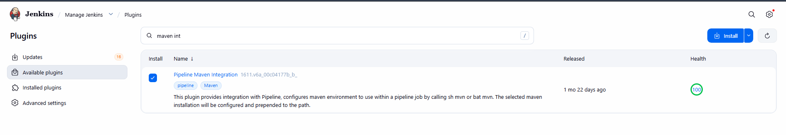
Now it successfully install on our jenkin machine
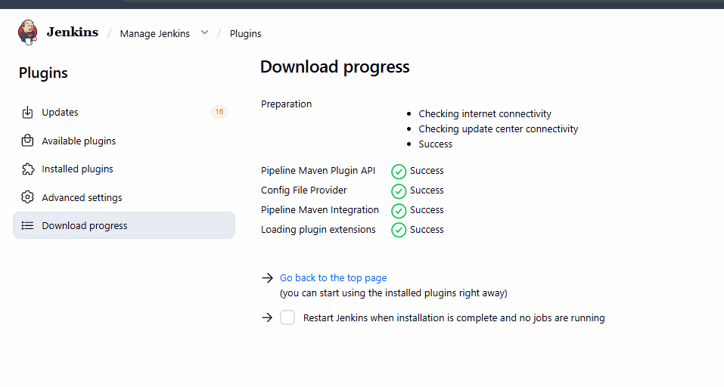
Now we bulid job in it give name maven project and select maven in it
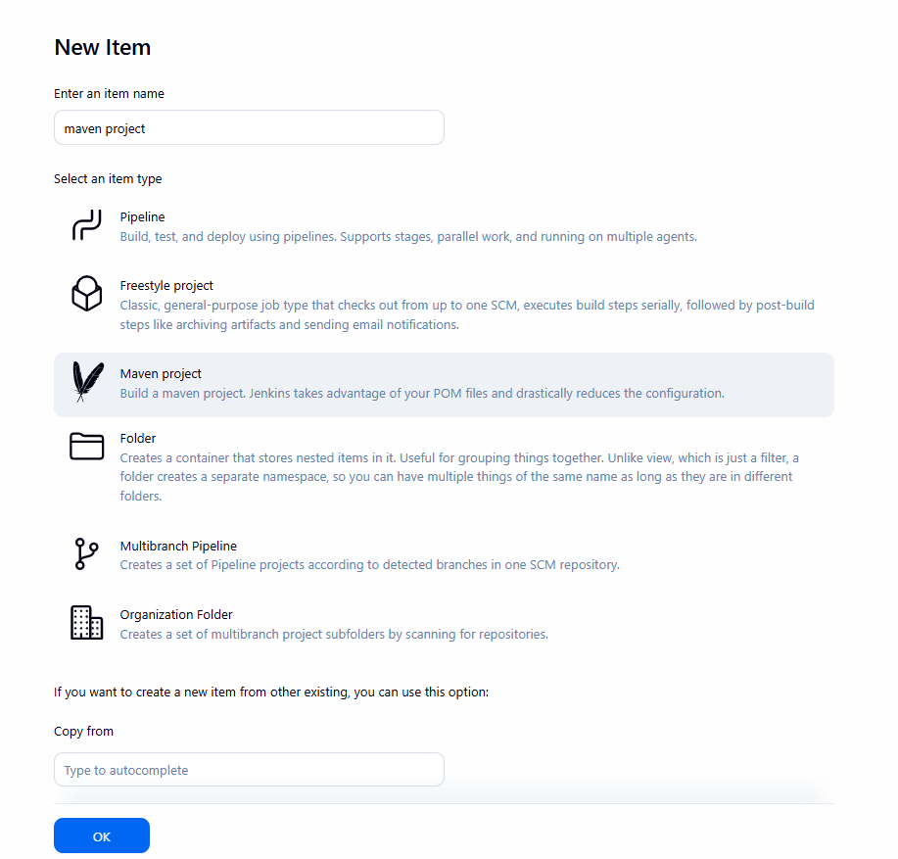
Now we need some configuration it we need give name for example I have given mavan-02 click on install automatically version
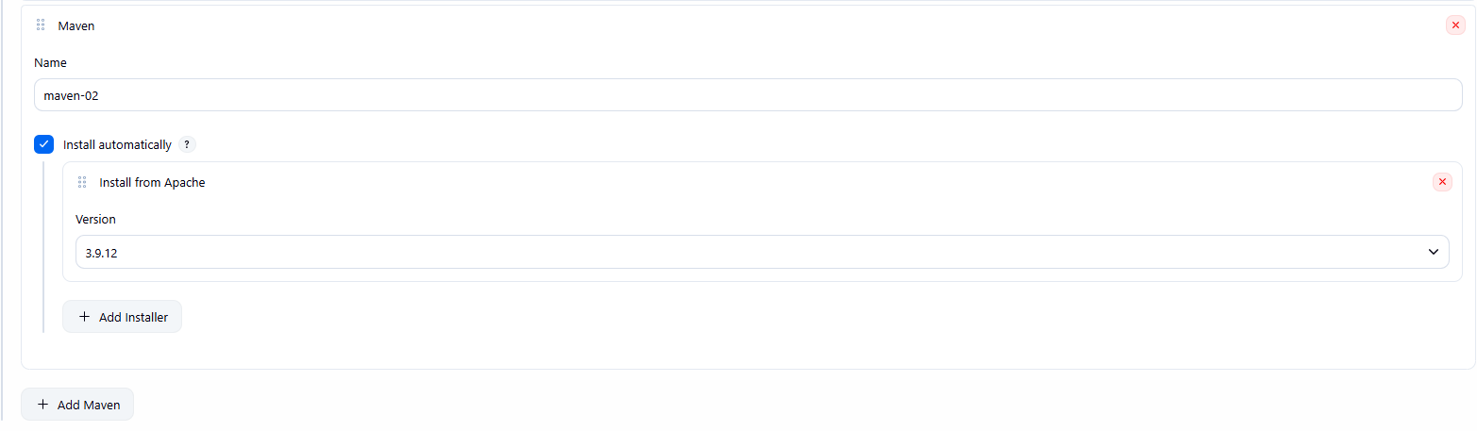
Navigate to Maven project job
Goals and options: clean package
Jenkins will run Maven using the installed Maven tool.
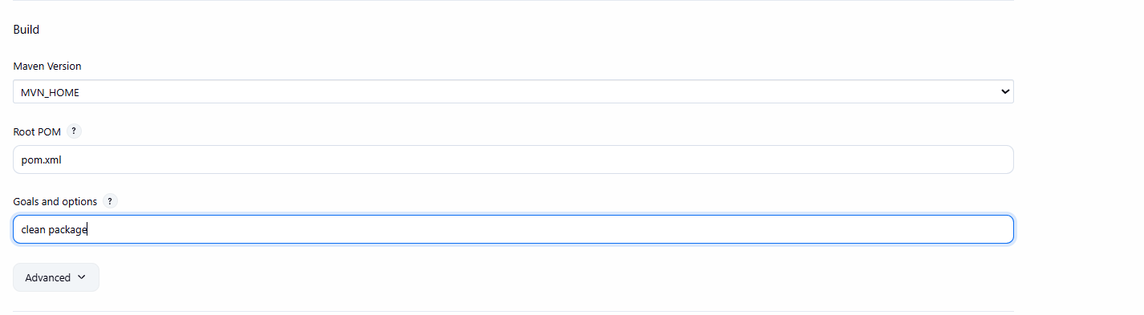
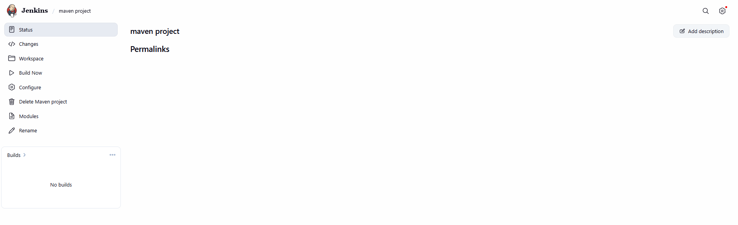
Now repo paste and also select main because our repo is in main that’s it
https://github.com/betawins/java-Working-app.git
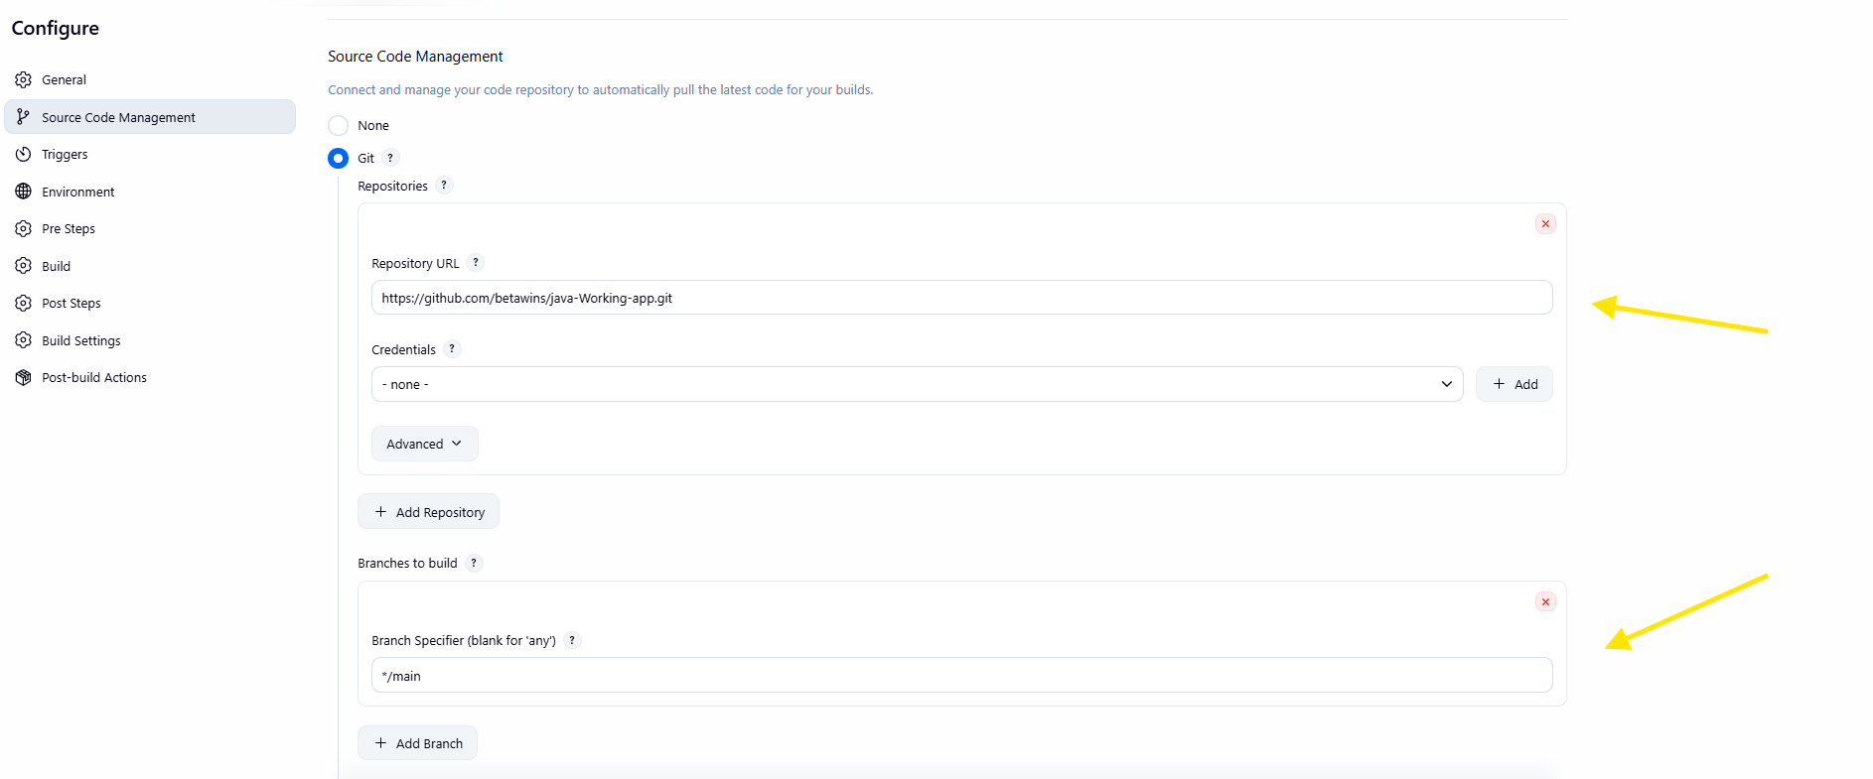
Now go pre steps section in place of maven version add mvn_home place of root pom write pom.xml
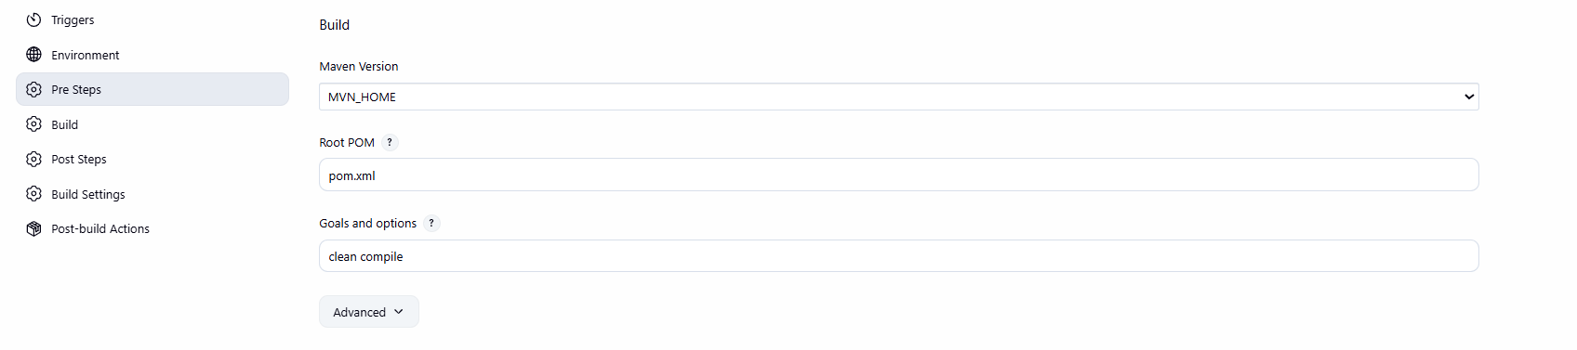
Now lets bulid it that’s it now successfully bluid it
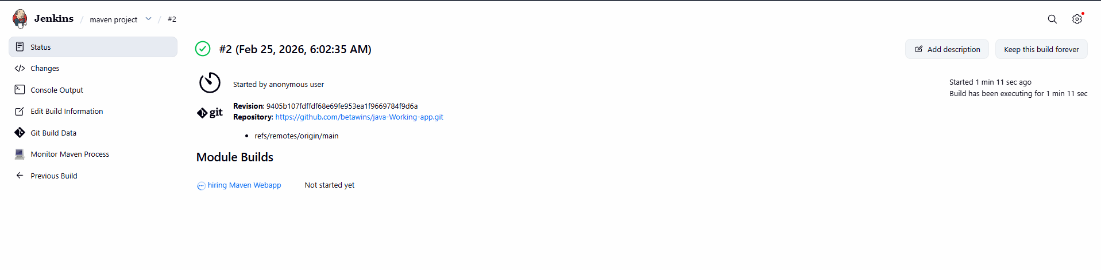

3. Use the same code and create a parameterized job in Jenkins with two stages
Stage 1: Git clone
Stage 2: Maven Compilation Code: https://github.com/betawins/java-Working-app.git

Step by step Implementation:
Step 1: Create a new job- Parameterized job
Item type- Pipeline
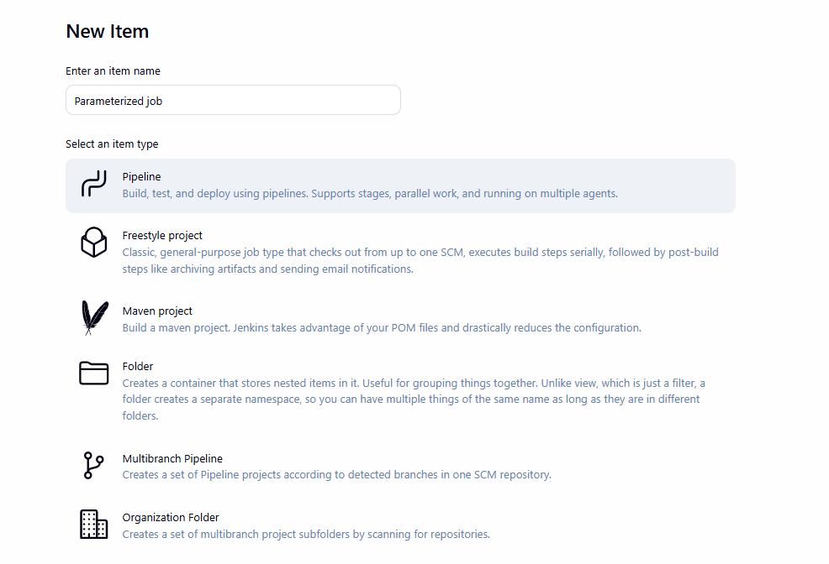
Now go configure section select string paramterized
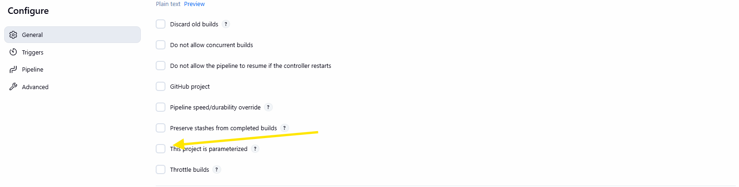

And now select string parameter in name give GIT_REPO and in defult value paste our url
https://github.com/betawins/java-Working-app.git in description write git repository url
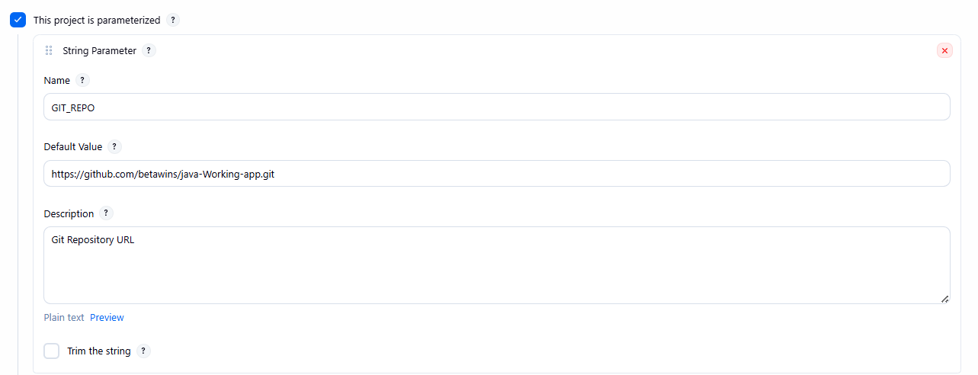
Now next string parameter in name add BRANCH in default value add main description branch main
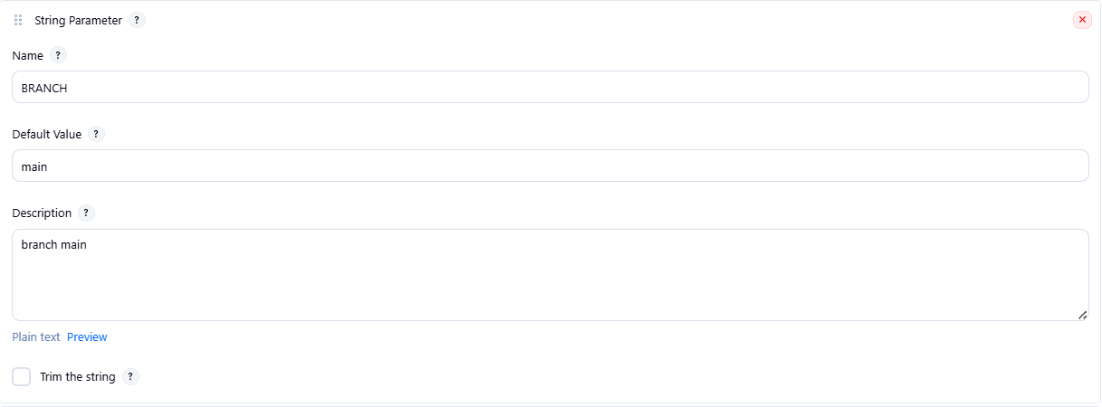
Now in last string parameter add name MVN_GOAL in place of default value clean compile
Description maven GOALS THAT’S IT
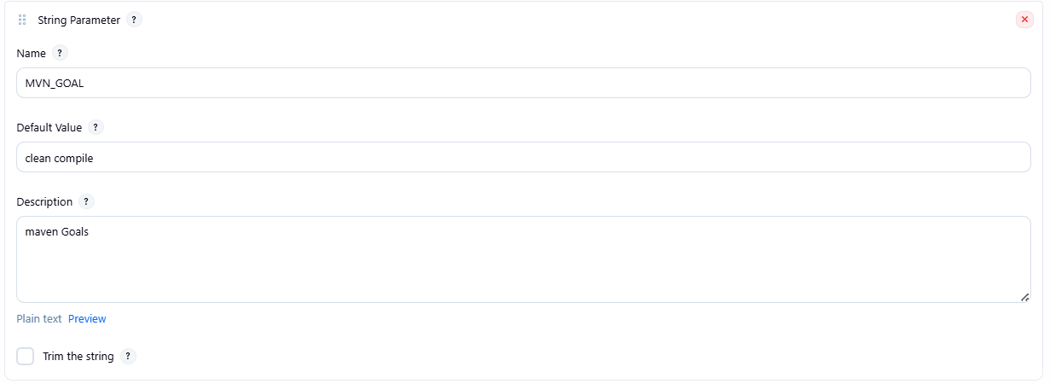
NOW we need our script paste this script in place of pipeline
Script - pipeline {
agent any

tools {
maven 'MVN_HOME'
}

parameters {
string(name: 'GIT_REPO', defaultValue: 'https://github.com/betawins/java-Working-app.git', description: 'Git Repository URL')
string(name: 'BRANCH', defaultValue: 'main', description: 'Branch Name')
string(name: 'MVN_GOAL', defaultValue: 'clean compile', description: 'Maven Goals')
}

stages {
stage('Git Clone') {
steps {
echo "Repo: ${params.GIT_REPO}"
echo "Branch: ${params.BRANCH}"

git branch: params.BRANCH, url: params.GIT_REPO
}
}

stage('Maven Compilation') {
steps {
sh "mvn ${params.MVN_GOAL}"
}
}
}
}
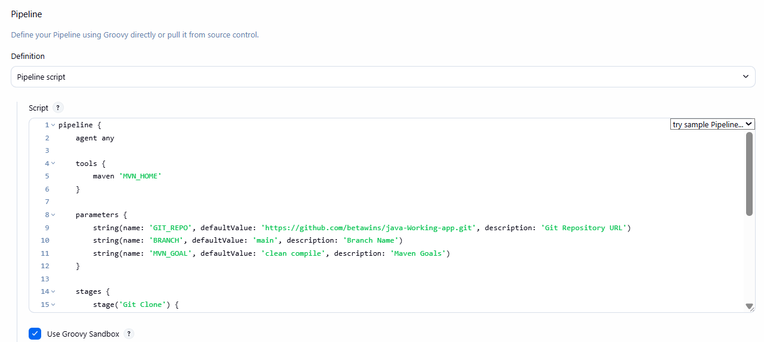
Now lets bulid it as you see image we successfully done it
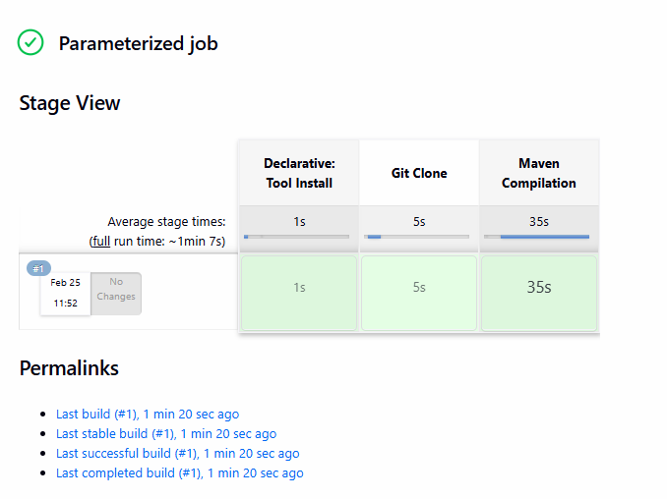
Output of our script
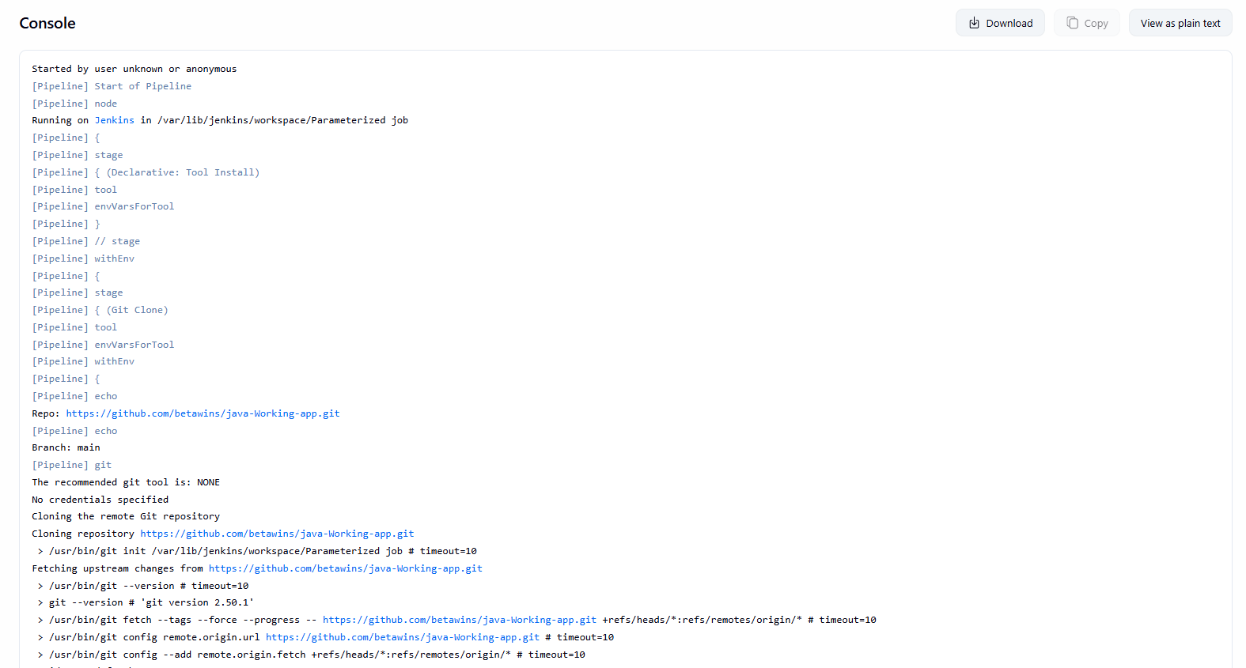

1. Environment Variables
These are automatic variables available in every job.
Examples:
- BUILD_NUMBER → Current build number
- JOB_NAME → Job name
- WORKSPACE → Job workspace path
- JENKINS_HOME → Jenkins installation path
- GIT_COMMIT → Git commit ID
Access using:
env.BUILD_NUMBER
2. Pipeline Global Variables
These are built-in objects used inside Pipeline.
- env → All environment variables
- params → Build parameters
- currentBuild → Current build details
- scm → Source code config
- docker → Docker commands

