Terraform-04-task
Why Terraform is important
1. Infrastructure as Code (IaC)
Write infrastructure in .tf files → version-controlled, repeatable, and auditable.
2. Automation & Speed
Create servers, networks, databases, and services in minutes with init → plan →
apply.
3. Consistency & No Human Error
Same code = same infrastructure across dev, test, and prod.
4. Multi-Cloud Support
Works with AWS, Azure, GCP, and on-prem from a single tool.
5. State Management
Tracks real infrastructure using a state file, enabling safe updates and drift detection.
6. Idempotency
Running Terraform multiple times won’t break infra — it only changes what’s
needed.
7. Easy CI/CD Integration
Integrates smoothly with Jenkins, GitHub Actions, GitLab CI, etc.
8. Scalable & Modular
Reuse infrastructure using modules as your environment grows.
9. Cost & Resource Control
Plan before apply → know exactly what will be created or destroyed.
10. Industry Standard
Widely used in DevOps and cloud roles; strong interview and production relevance.

- Watch Terraform-04 video.
- Execute the script shown in the video.
To change version we need first to terraform repository serach on your browser then it open page click on hashicorp local
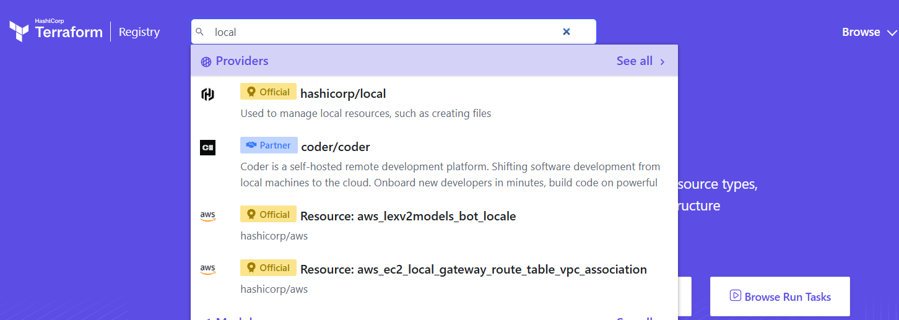
Now it redirect his version controlling page at option you notice there options proversion hashicorp local version click on version select which version you need as if now we need 2.6.0 click on it
Then click on use provider it give one script paste on your terraform
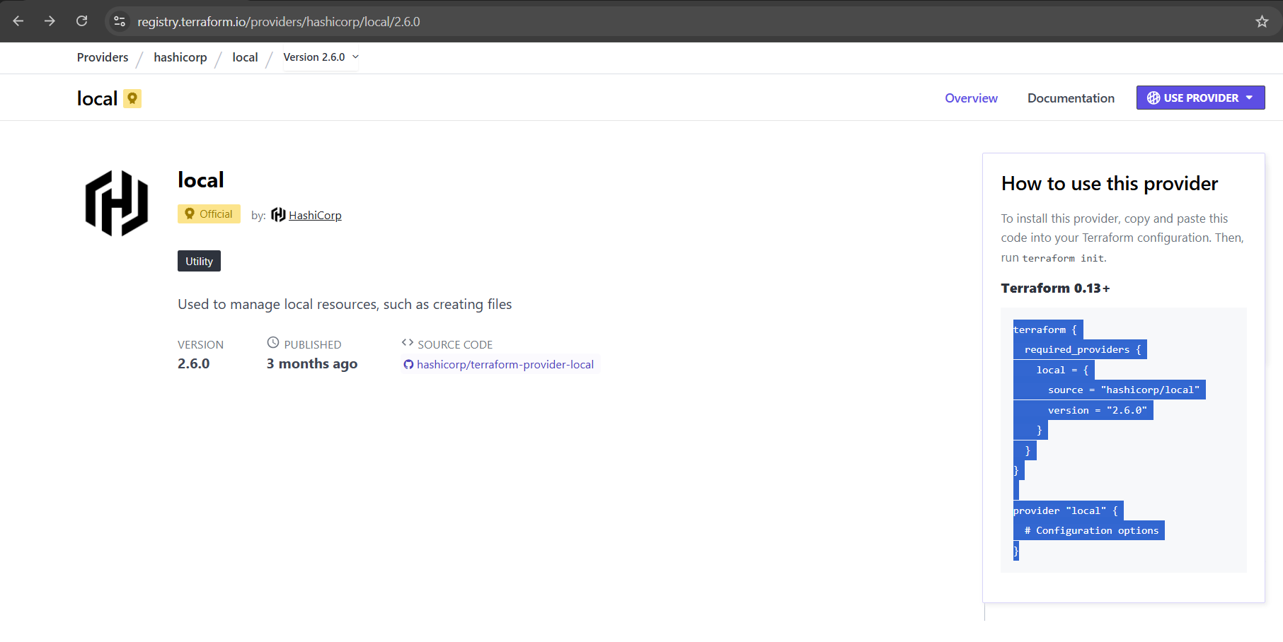
Now after pasting script make sure click on save after then type in terminal terraform init
terraform init is the first command you run in a Terraform project.
It initializes the working directory by downloading required providers, setting up the backend, and preparing Terraform to run plan and apply.

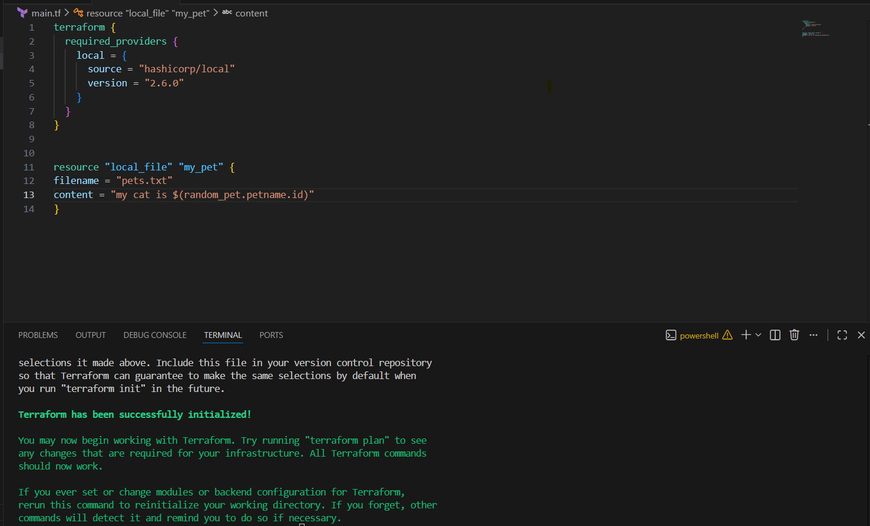
Version Constraints
Changing in terraform providers version may get us into incompatability issues.
By default terraform will always try to downlaod the latest version of provider available from
registry.
To make sure to use the specific version provider we can add the provider block in
configura@on.
Example:
=======
terraform {
required_providers {
local = {
source = "hashicorp/local"
version = "2.3.0"
}
}
- terraform init
- apply terraform apply
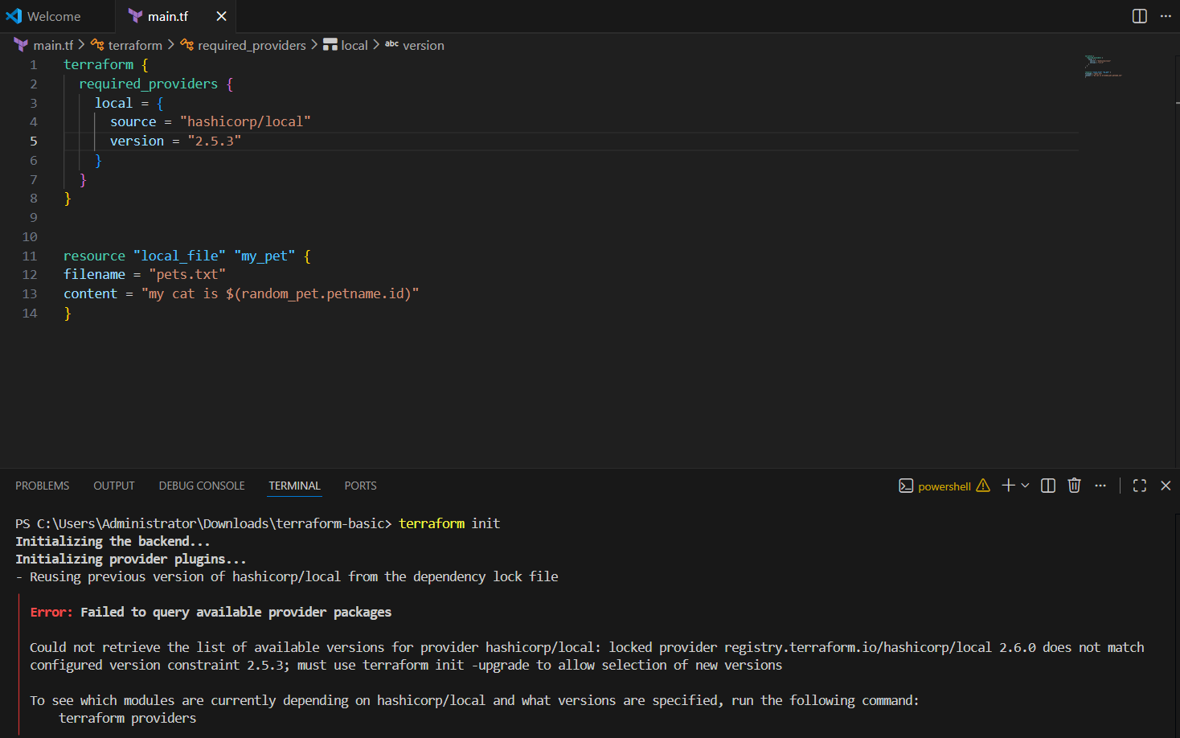
version = "2.3.0" --> download the exact version
version = "!=2.3.0" --> will not use the men@oned version
version = "< 2.3.0" --> lesses than the men@on version
version = "> 2.3.0" --> greater than the given version
version = "~> 2.3.0" --> specific version or higher version.
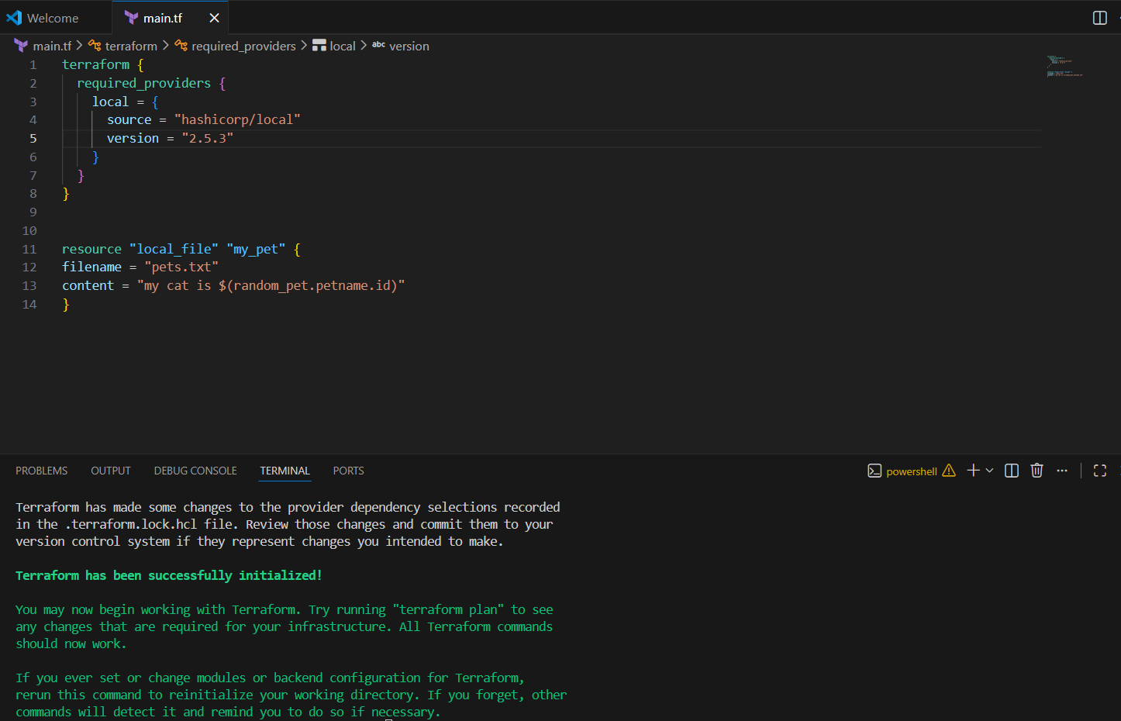
version = "!=2.3.0" --> will not use the men@oned version
if don’t went use this version at that case we use this
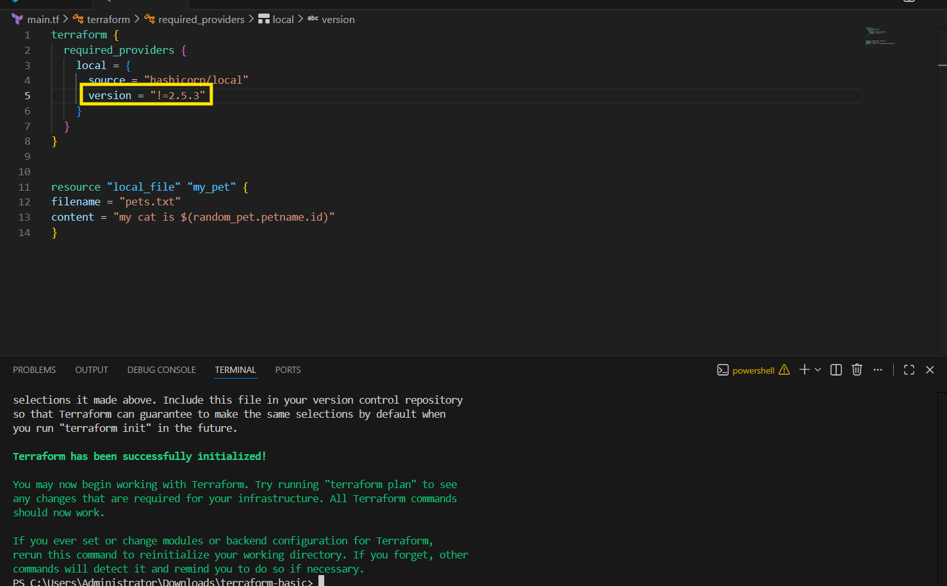
version = "> 2.3.0" --> greater than the given version
Terraform will install any provider version greater than 2.3.0. make sure delete terraform.lock.hcl
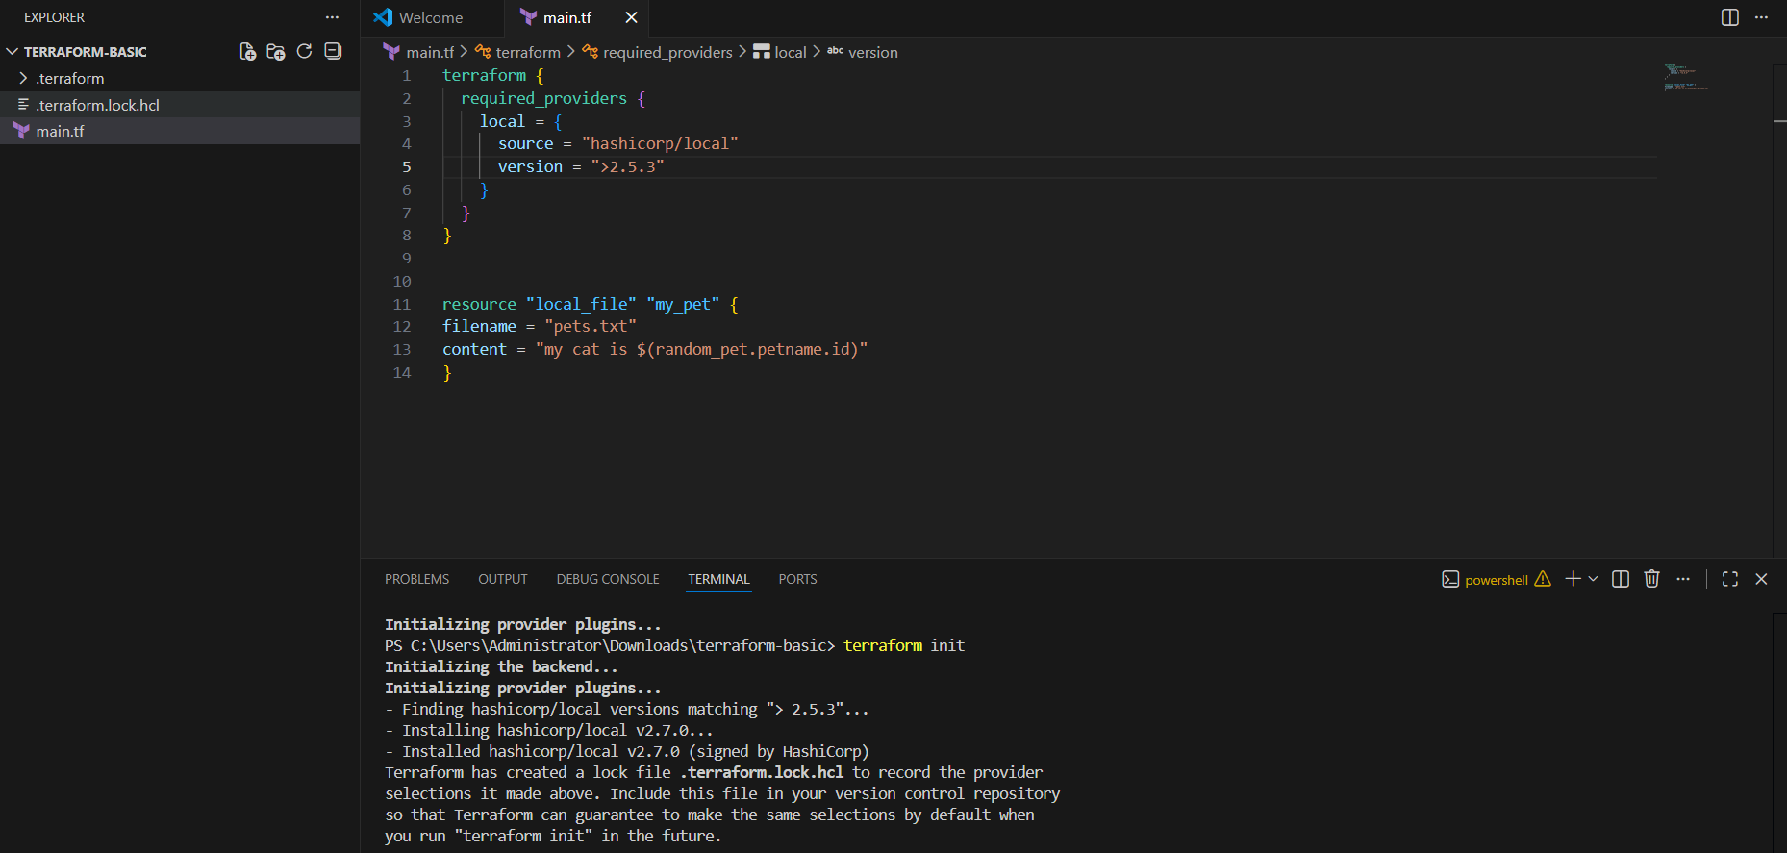
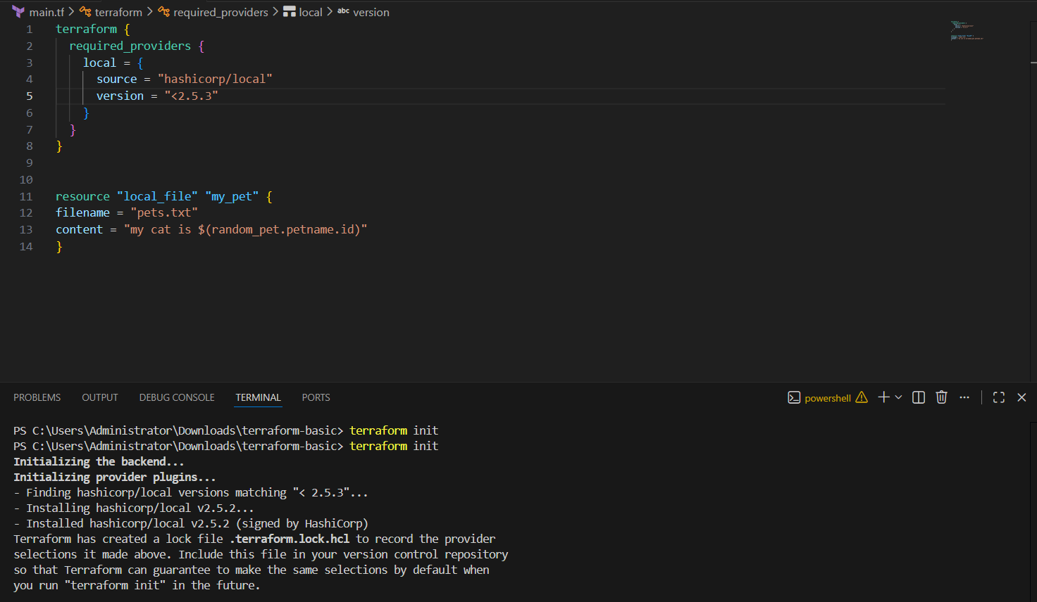
version = "~> 2.3.0" --> specific version or higher version.
version = "~> 2.5.3"
It will install only 2.3.x versions (like 2.3.1, 2.3.5).
It will NOT install 2.4.0 or higher.
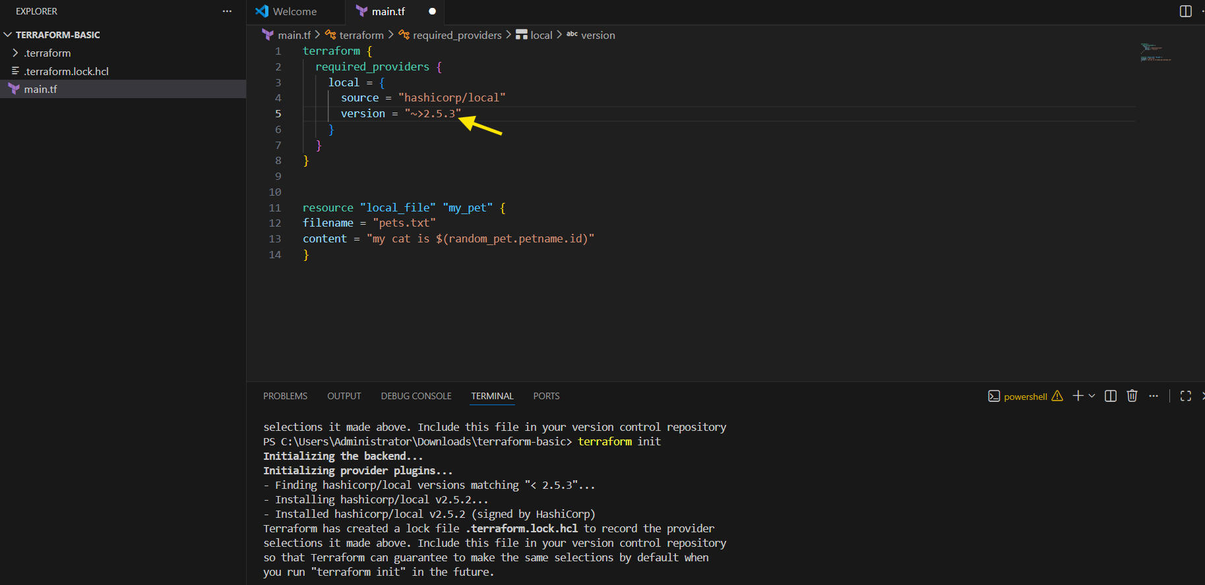

Data sources?
Data source is used to read existing resources.
It does NOT create anything new.
Example:
If VPC or file already exists, Terraform can read its details using data source.
=======================================================
Apart from terraform we have multiple other tools where the infra
can be created.
Ex: ansible,salt,puppet,bash script,manual process.
Data sources are used to read the content of the infrastructure
for example if we want terraform to read the content of the file
which has been created by any other tool.
create a file called in dogs.txt in the same terrafrom working
directory.
main.tf
======
resource "local_file" "my-pet" {
filename = "pets.txt"
content = data.local_file.dog.content
}
data "local_file" "dog" {
filename = "dogs.txt"

now we need dog.txt file create click on terraform basic select file then name dog.txt that’s it save and now type terraform apply
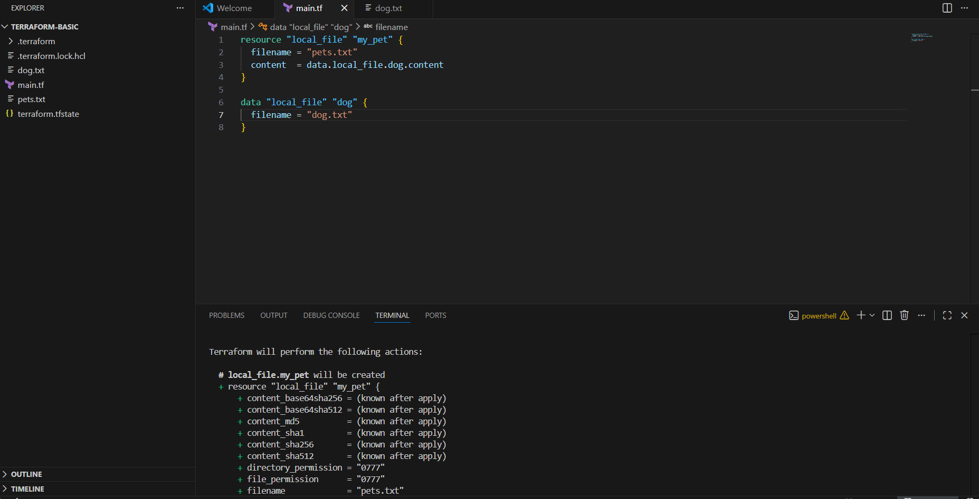
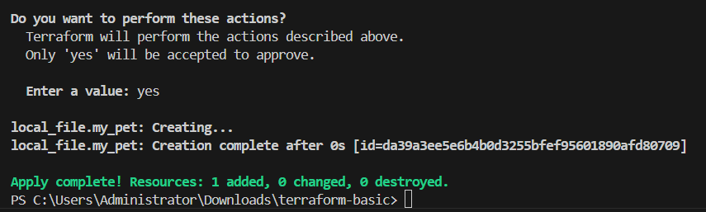
Provide variable values in variable.tf file also add count as 3
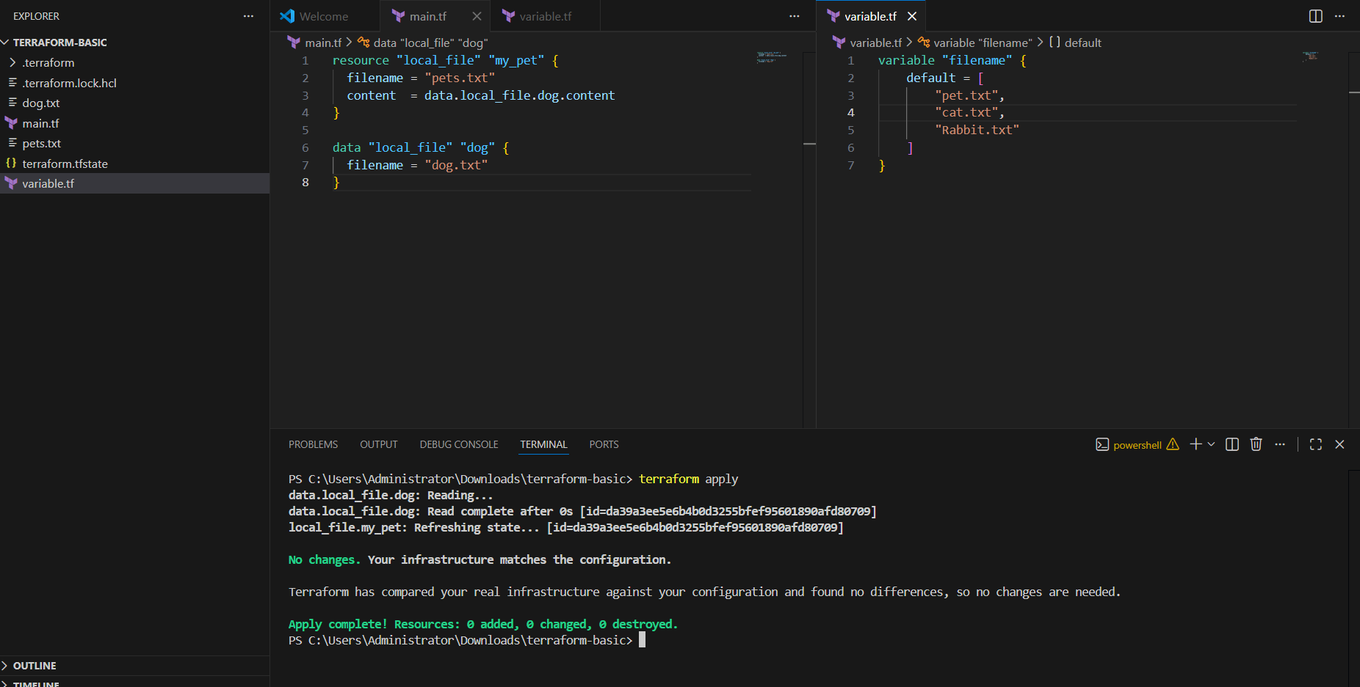
Meta-Arguments:-
Meta-Arguments are special arguments in Terraform that control how a resource behaves.
👉 They decide things like how many resources to create, dependency order, and lifecycle rules (example: count, for_each, depends_on).
Meta arguments are used if we want to create multiple resources.
Meta arguments can be used within any resource block to change the behaviour of
the resources.
Examples for meta arguments:
1) Depends_on
2) lifecycle rules
3) Count
4) For_each
Example of count:
Add count as length (var.filename)

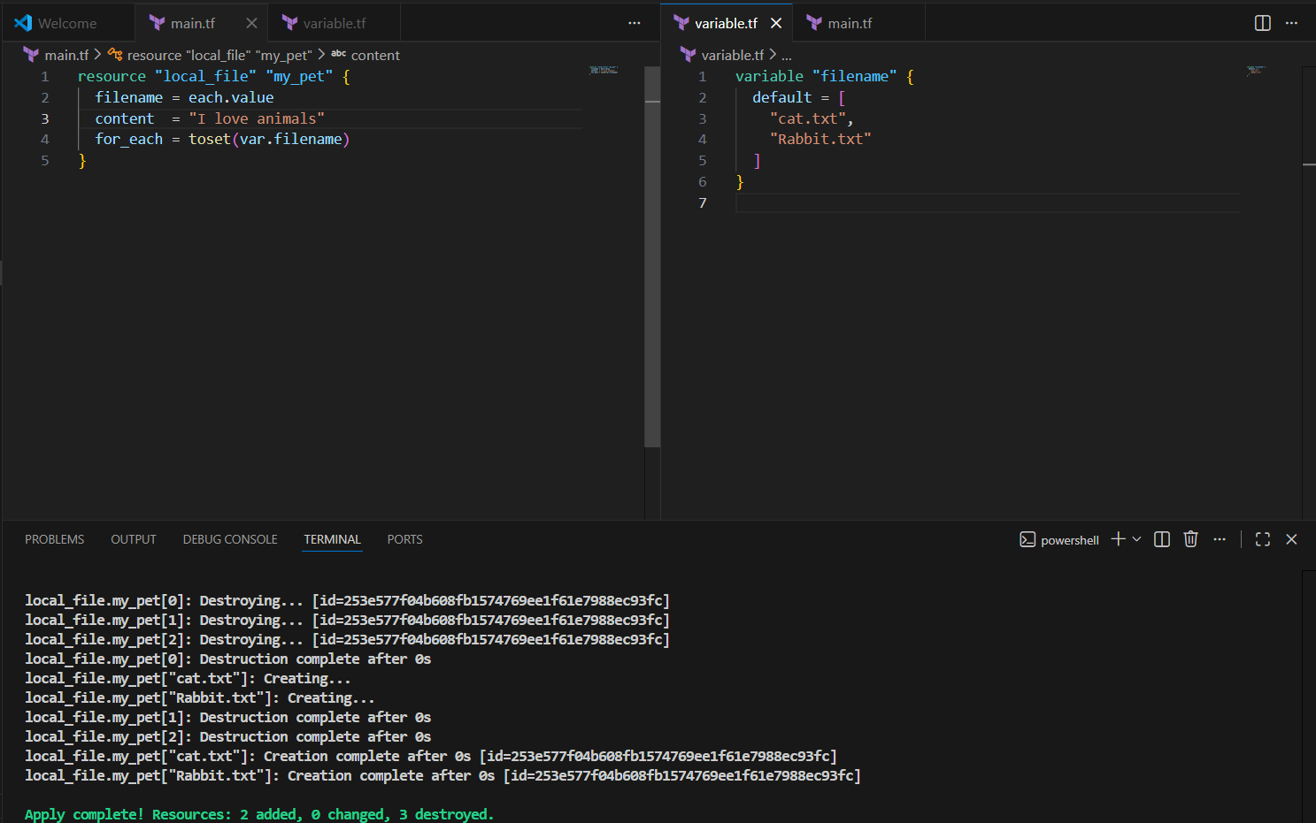
AWS IAM USER:
• Simple IAM user script as shown in the below main.tf file
If its not showing while type aws configuration then you need download aws cli from official page just type in browser aws cli and download it then install click next,next tick finished that’s it now open taskbar type in it powershell type aws –version if it show version it successfully install if not then try repair it that’s now restart your terraform then you can type aws configuration it access key full your info as it saying that it if you face this kind of error follow this step to fix it
Ok now type of on your aws configuration secrect access give info then type terraform apply it create iam user in aws
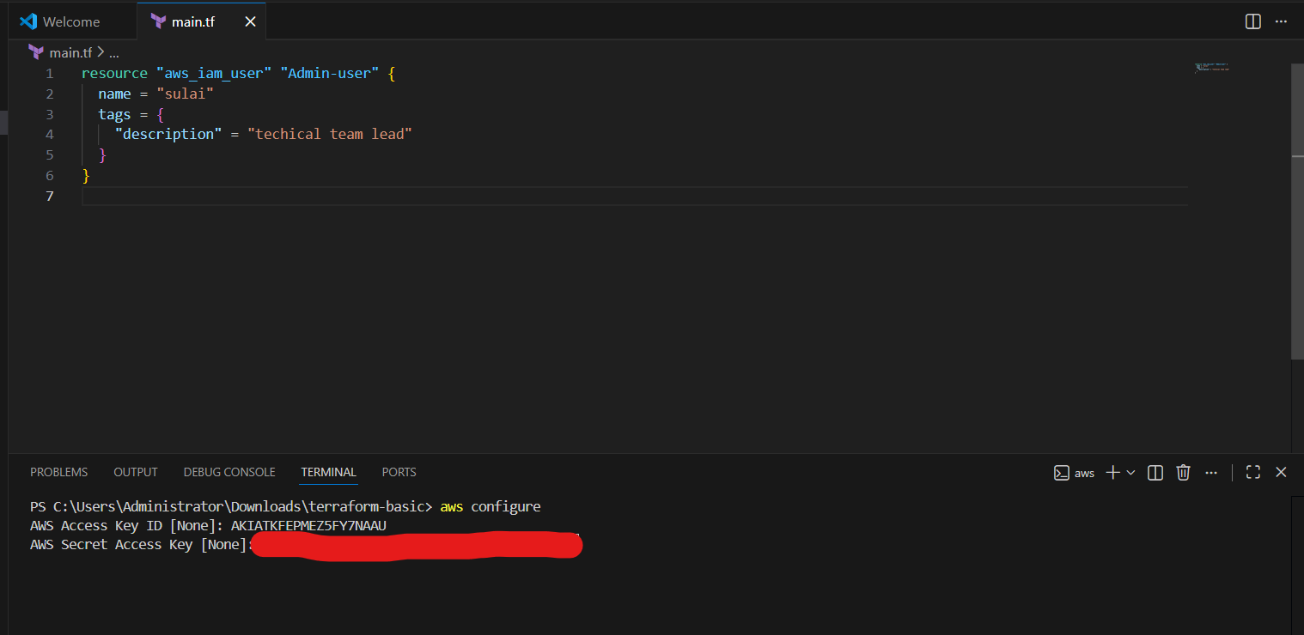
Now as you see we have successfully created sulai user in our aws machine
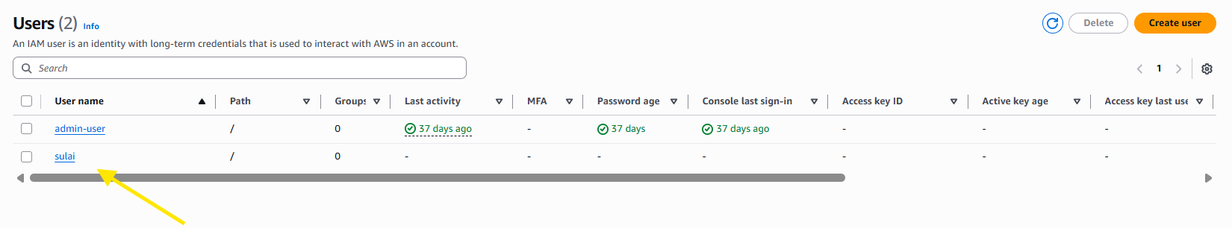
As if now we notice that user don’t any policie now we need give it polices to sulai user
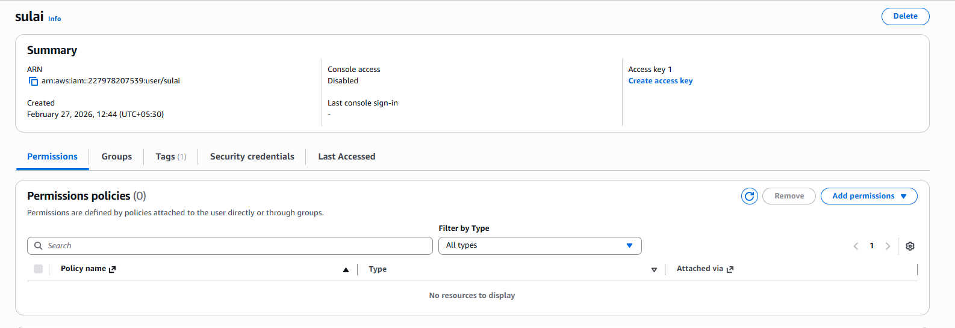
Now we successfully given it policies to the user
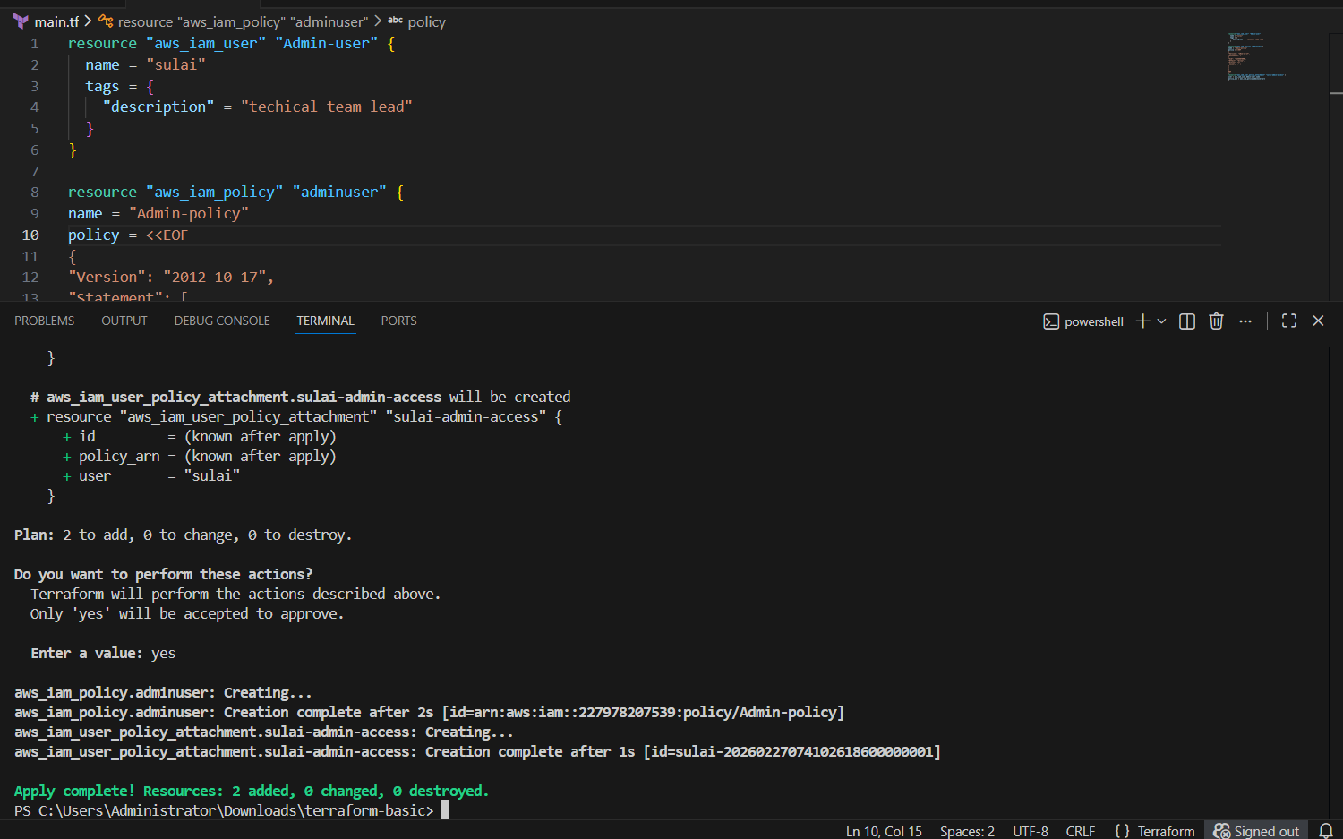
Now see we have successfully given it admin-policy
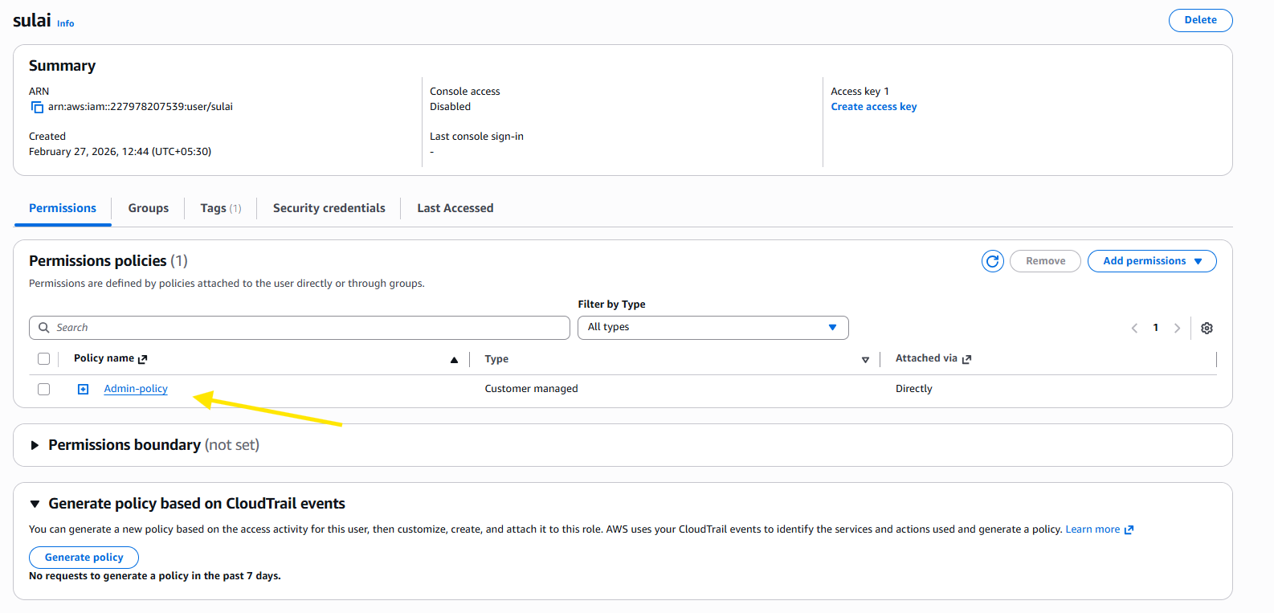
3. Integrate Terraform in Jenkins using the Terraform plugin
Go to Jenkins server --> plugin --> available plugin --> install plugin ‘Terraform’
In my case I already download this plugin so it showing me in your it might show you different just tick on terraform tick on and top of the right side click on install button it install on your jenkin server
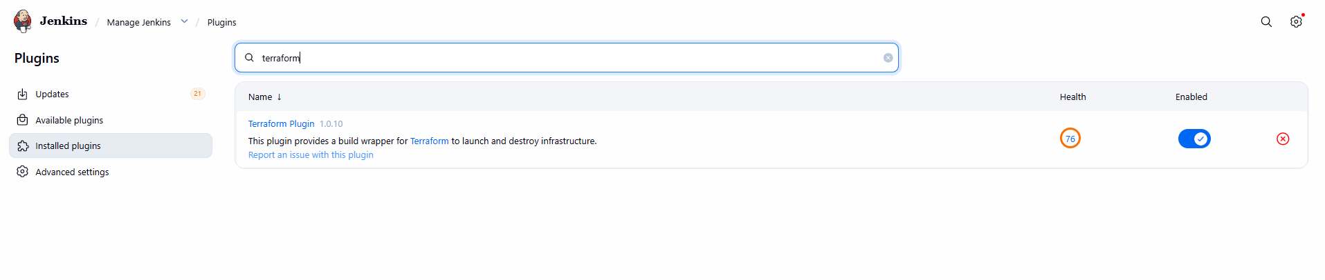
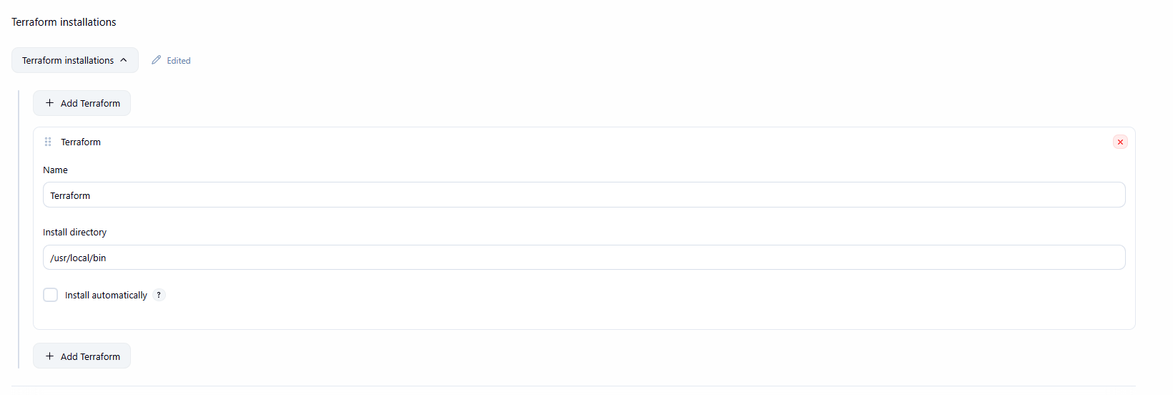
4. Create a CI/CD pipeline for a Nodejs Application: https://github.com/betawins/Trading-UI.git
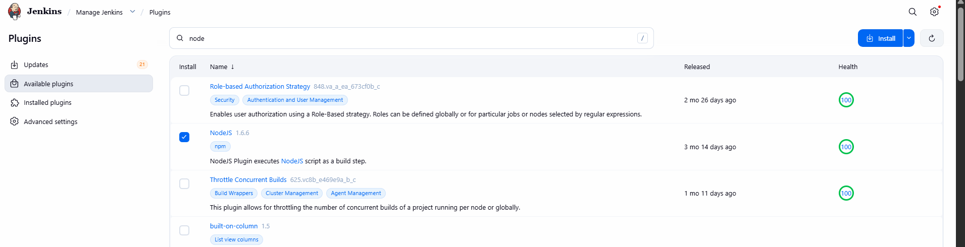
Add Nodejs plugin in Global tool and select version which should not be latest
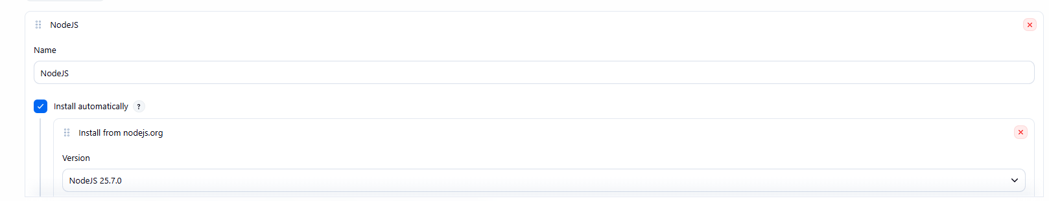
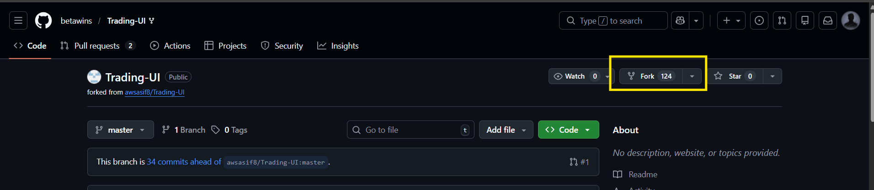
Under our forked repo --> in jenkinsfile --> add terraform script to exedcute
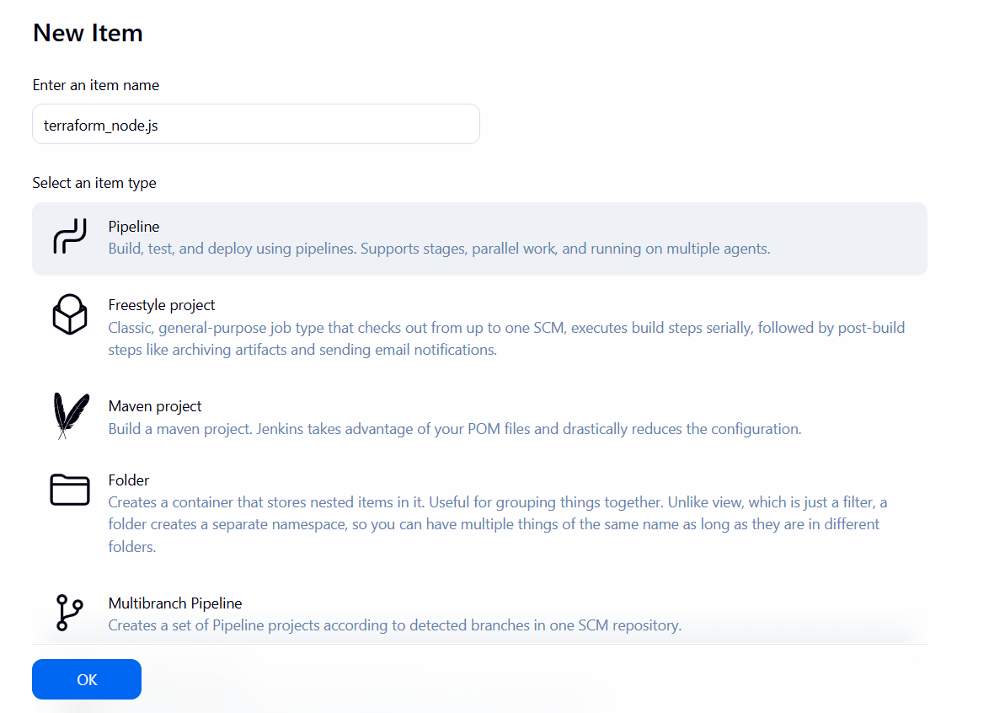
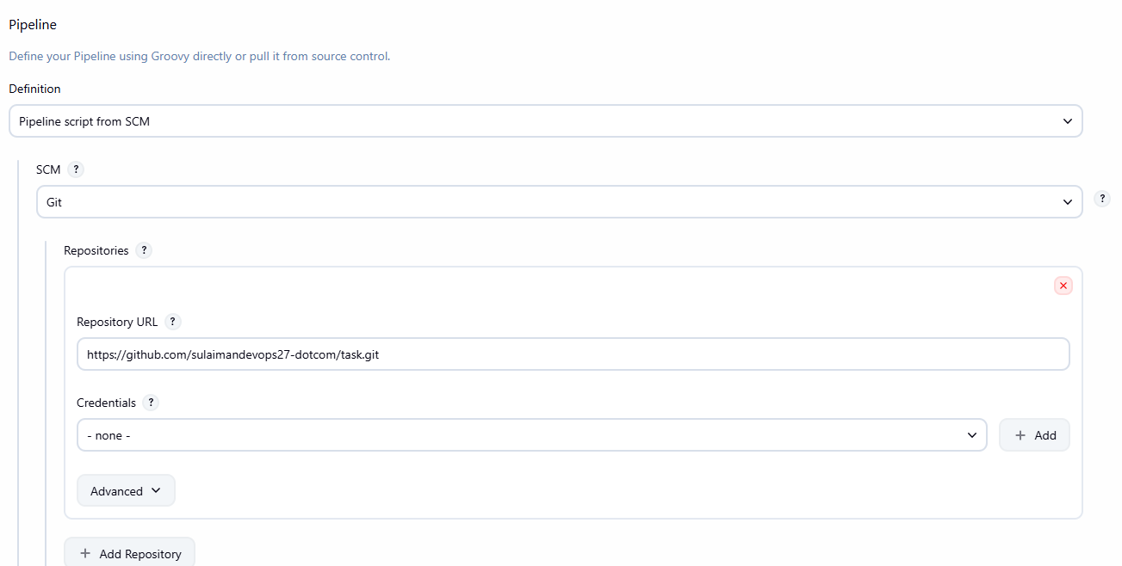
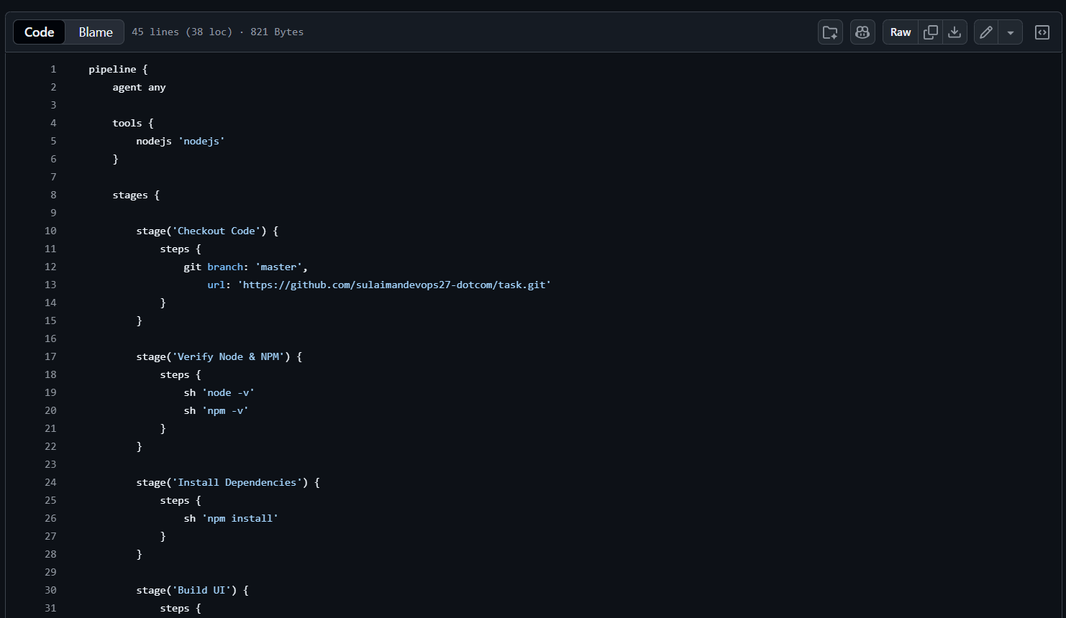
pipeline {
agent any

tools {
nodejs 'Node.js'
}

stages {

stage('Checkout Code') {
steps {
git branch: 'master',
url: 'https://github.com/sulaimandevops27-dotcom/task.git'
}
}

stage('Verify Node & NPM') {
steps {
sh 'node -v'
sh 'npm -v'
}
}

stage('Install Dependencies') {
steps {
sh 'npm install'
}
}

stage('Build UI') {
steps {
sh '''
export NODE_OPTIONS=--openssl-legacy-provider
CI=false npm run build
'''
}
}
}

post {
always {
deleteDir()
}
success {
echo 'Build completed successfully'
}
failure {
echo 'Build failed'
}
}
}
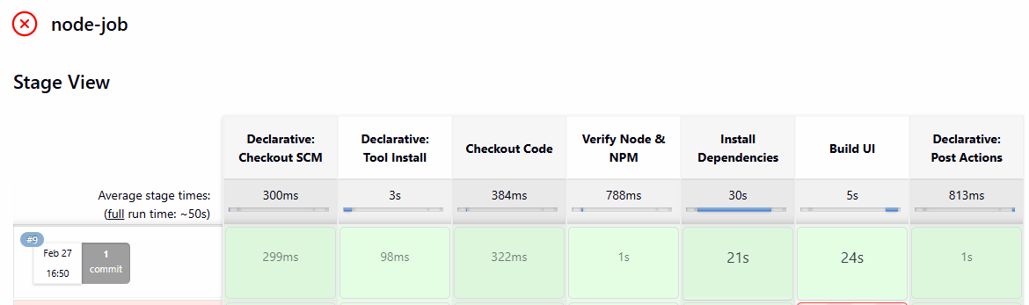
5. Explain 10 Maven commands.
1. mvn clean
- Purpose: Deletes the target directory (where compiled code and build artifacts are stored).
- Usage:
- Ensures a fresh build without leftover files.
2. mvn compile
- Purpose: Compiles the source code of the project.
- Usage:
- Generates .class files in target/classes.
3. mvn test
- Purpose: Runs unit tests using frameworks like JUnit/TestNG.
- Executes tests in src/test/java.
4. mvn package
- Purpose: Packages compiled code into a distributable format (JAR/WAR).
- Usage:
- Output stored in target/.
5. mvn install
- Purpose: Installs the package into the local Maven repository (~/.m2/repository).
- Usage:
- Makes the artifact available for other local projects.
6. mvn deploy
- Purpose: Deploys the artifact to a remote repository (e.g., Nexus/Artifactory).
- Usage:
- Used in CI/CD pipelines for sharing builds.
7. mvn site
- Purpose: Generates a project documentation site.
- Usage:
- Creates HTML reports in target/site.
8. mvn dependency:tree
- Purpose: Displays the dependency hierarchy of the project.
- Usage:
- Helps identify conflicts and transitive dependencies.
9. mvn verify
- Purpose: Runs integration tests and verifies the project meets quality standards.
- Usage:
- Ensures the build is valid before deployment.
10. mvn archetype:generate
- Purpose: Creates a new Maven project from a template (archetype).
- Usage:
- Interactive command to bootstrap new projects.

