Terraform-05
Task Title
Terraform-05
Objective
The objective of this task is to watch the Terraform-05 video posted on slack with and worked on executing templates shown in video.
Prerequisites
List all requirements before starting:
- AWS
- Visual studio code
- S3- backend
- Dynamo DB- state locking
- Ec2
Issues Faced: Briefly mention issues and how you fixed them. Posted below in the last.
Conclusion
Conclusion has been provided for every task at the end.
- Watch the Terraform-05 video.
Execute the script shown in the video.

- Executed a basic script – resource block provider- local_file

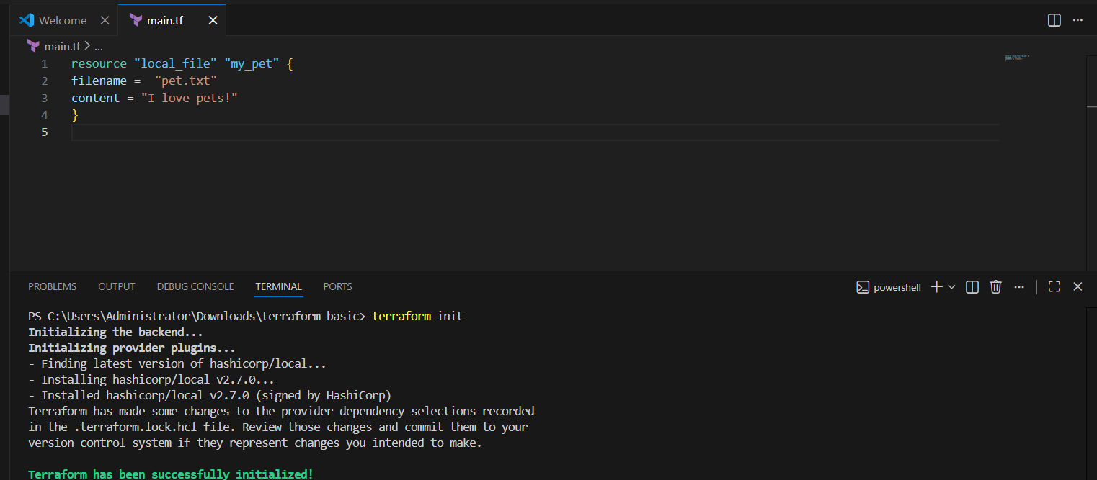
Terraform destroy –auto-approve I have used alredy terraform destroy command so that might defecult result done this
The terraform destroy --auto-approve command is used to delete your entire infrastructure instantly without asking for your final "yes" confirmation.
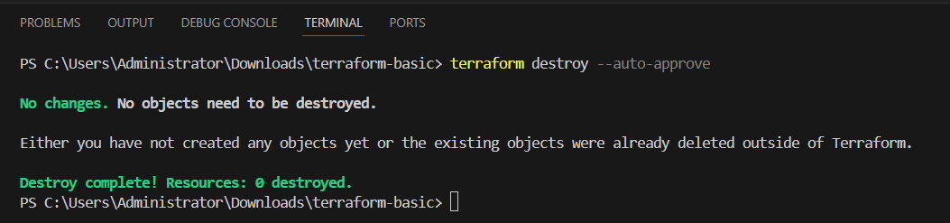
Terraform Remote State and State Locking:
Remote State: It moves your Terraform "records file" from your laptop to the Cloud (S3) so your whole team stays on the same page and data is never lost
: Storing your terraform.tfstate file in an AWS S3 bucket so your teammates can access the same infrastructure data from their own laptops.
State Locking: It acts like a "Security Guard" (via DynamoDB) that allows only one person to change the infrastructure at a time, preventing any data corruption.
: Using a DynamoDB table to "lock" the configuration while you are running an update, so your colleague cannot make changes at the exact same time.

Create S3 using terraform
provider "aws" {
region = "us-east-1"
}
resource "aws_s3_bucket" "s3_bucket" {
bucket = "sulaiman-terraform-backend-ap-south-1-001"
}
Now lets test our script in terraform this script use for create s3 bucket in your aws and bucket name is sulaiman
First we need type terraform init command
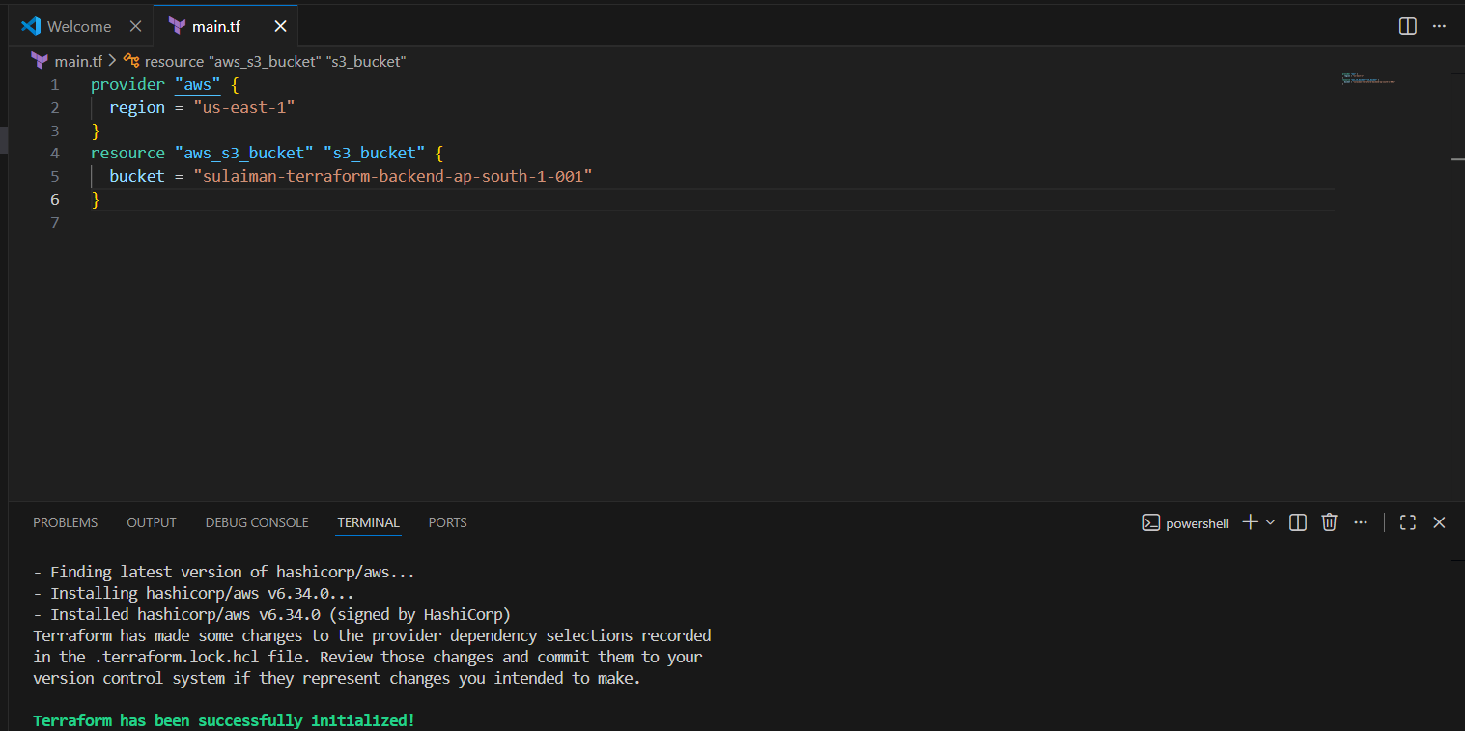
Now after init command now we need apply it or can we can check for type terraform plan but you even use terraform apply the diffrenet this both command is apply for apply changes they does plan like checking verfy you can check it
So now we type apply command
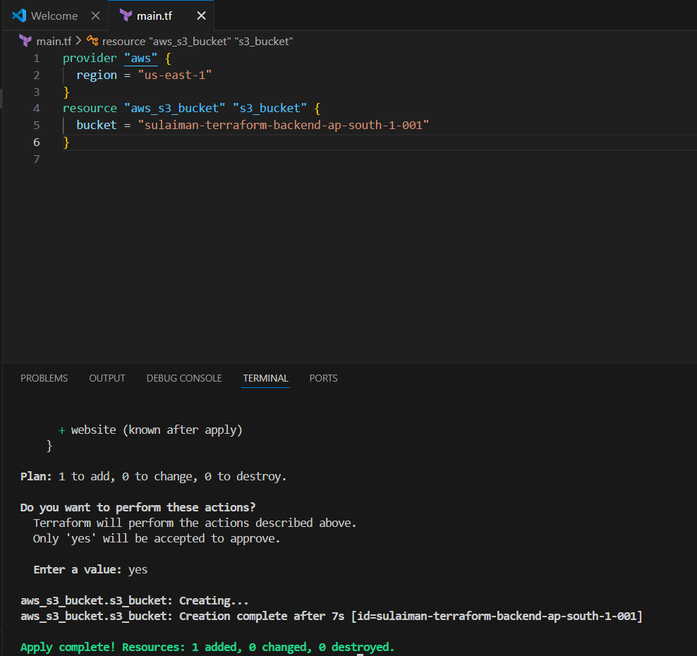
Now see on image we successfully create our bucket using terraform command also see it date,time info about our bucket they applied on our script
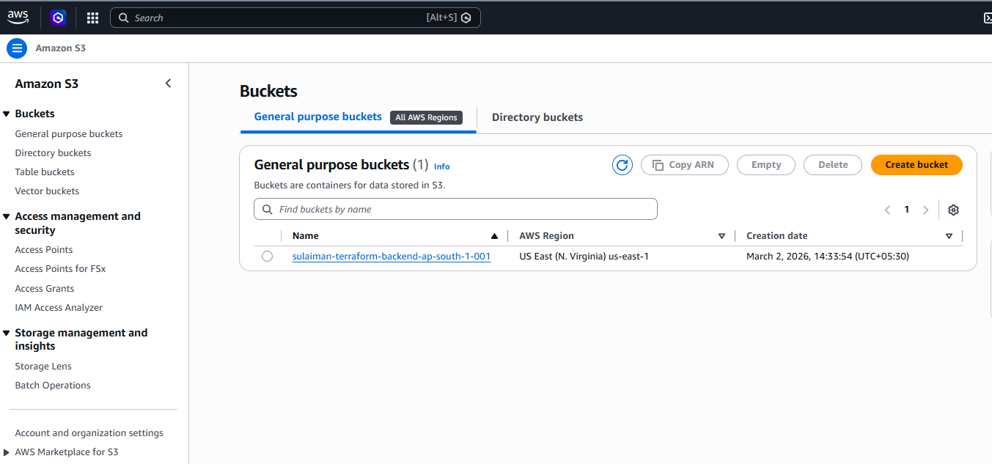

Now lets us movie to next topic which State Locking using Dynamo DB
A quick explain of it

State Locking with DynamoDB creates a temporary "lock" record in a database table to prevent multiple users from running Terraform commands simultaneously and corrupting the state file.
We used below code to create a Dynamo DB in aws

resource "aws_dynamodb_table" "dynamodb-terraform-state-lock" {
name = "terraform-state-lock-dynamo"
hash_key = "LockID"
read_capacity = 20
write_capacity = 20

attribute {
name = "LockID"
type = "S"
}
Now we need write our terraform init command
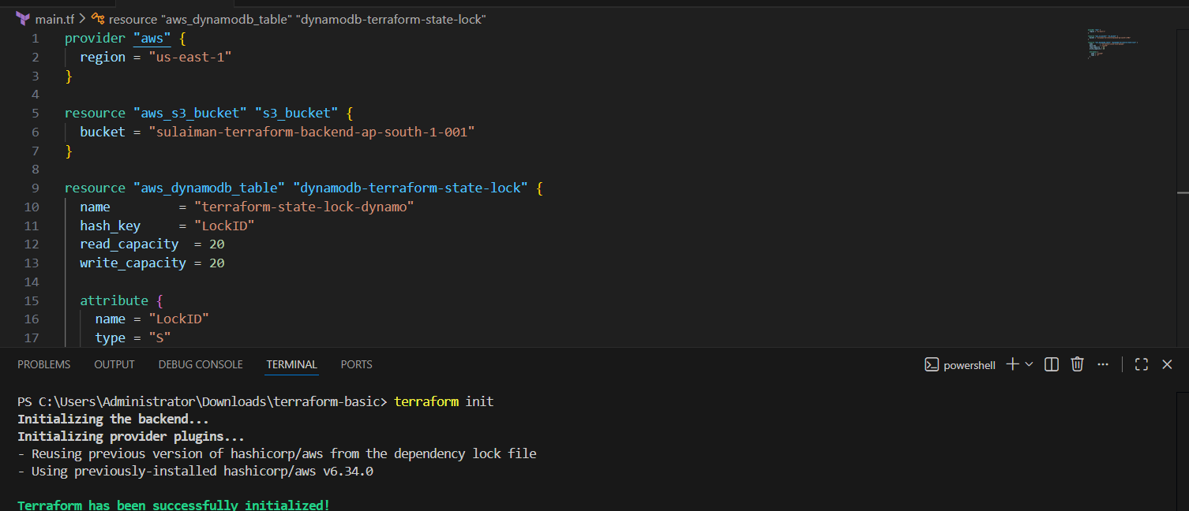
That’s it now terraform apply
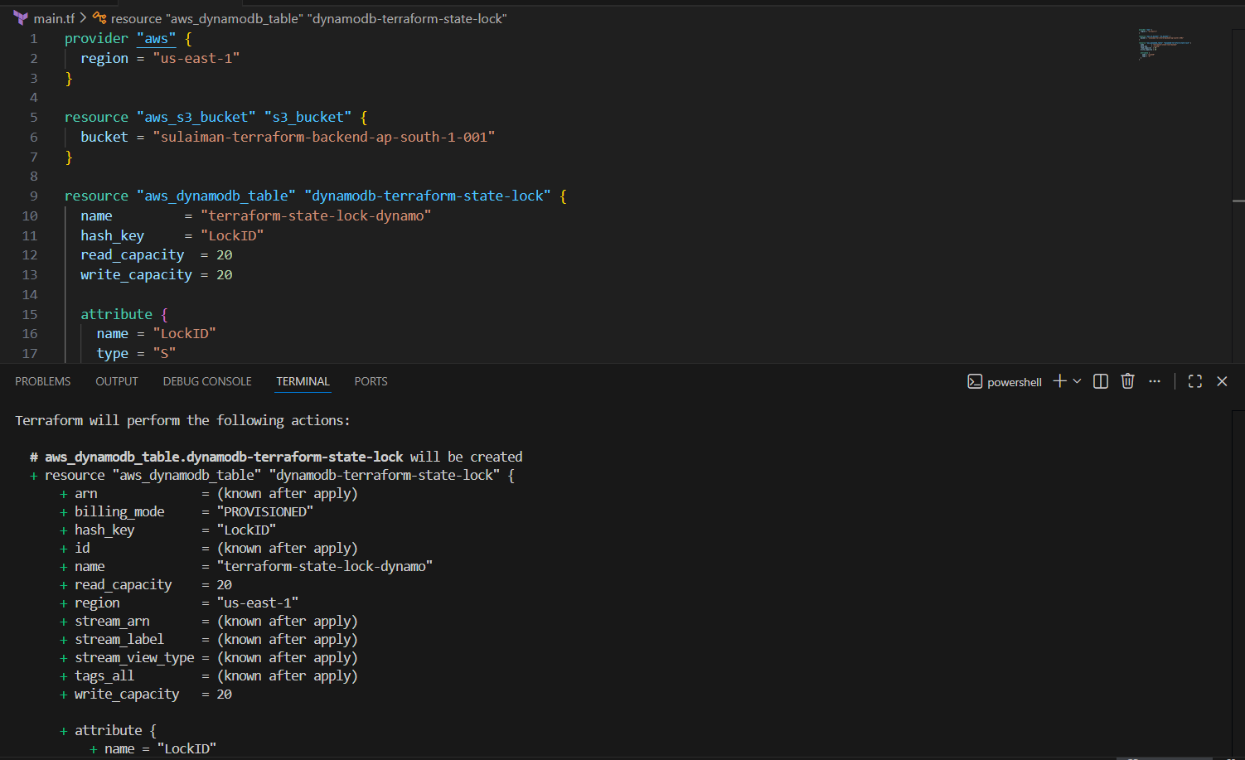
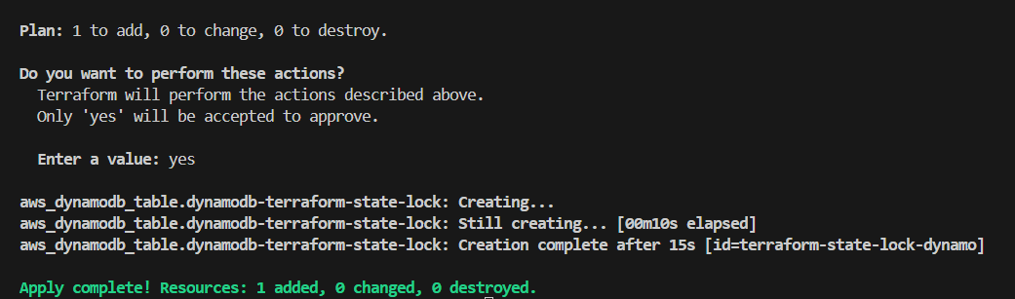
That’s it We can verify in the Dynamo DB that, 1 table has been created for us and it’s an empty table.
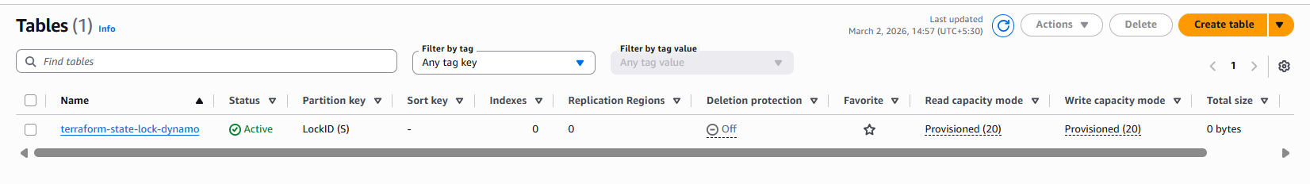
Now, we updated a code, where, s3 will communicate with DynamoDB and perform the state locking to prevent multiple users to execute the same point of time.
terraform {
backend "s3" {
bucket = "vicky-terraform-backend-us-east-1-001"
dynamodb_table = "terraform-state-lock-dynamo"
key = "terraform.tfstate"
region = "us-east-1"
}
}

Now lets type our command terraform init
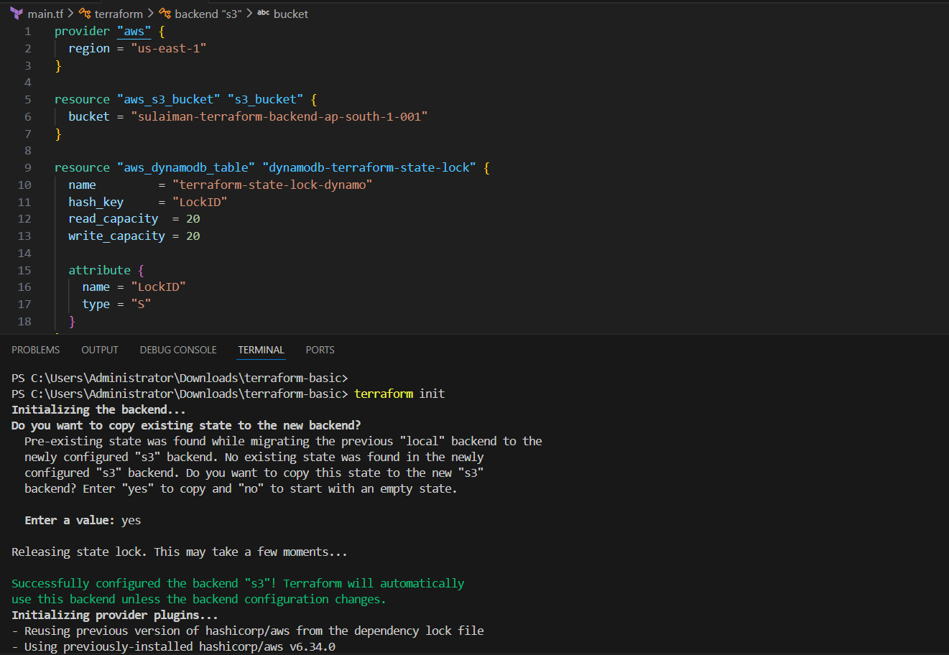
Now lets verfy it it successfully create it
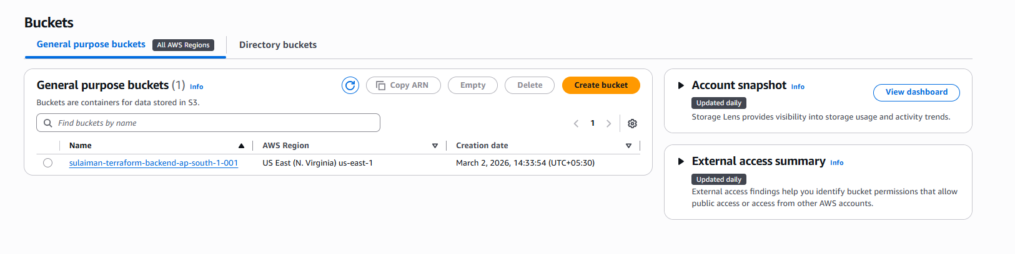
One lock ID has been created for us in Dynamo DB.
Success.
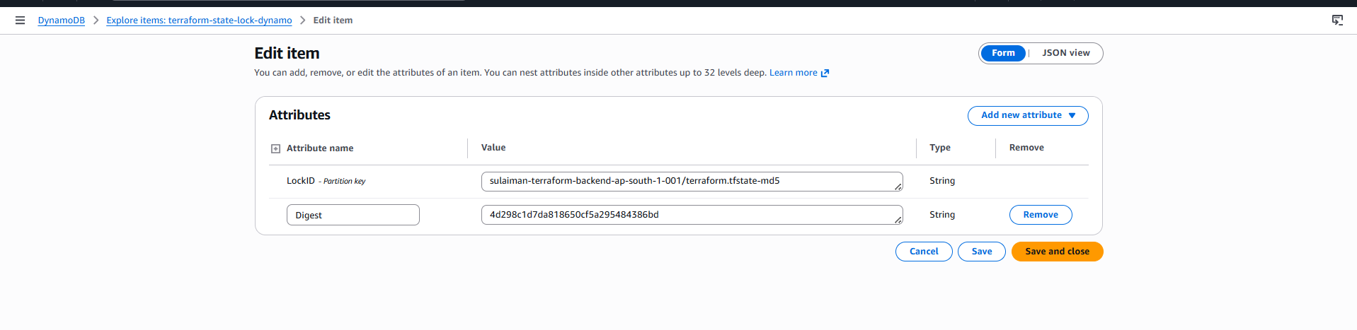
Yet, we haven’t applied- terraform apply in VS code.
Now, we shall update a code for local_file provider and see what’s happening in the backend.
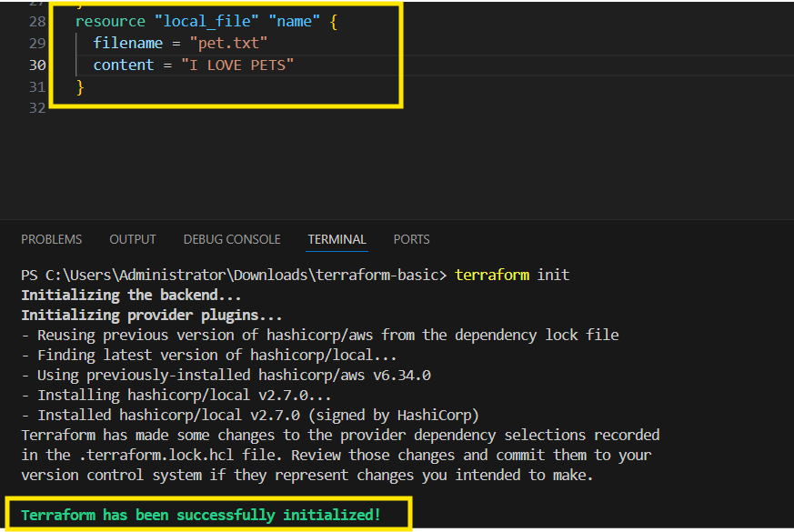
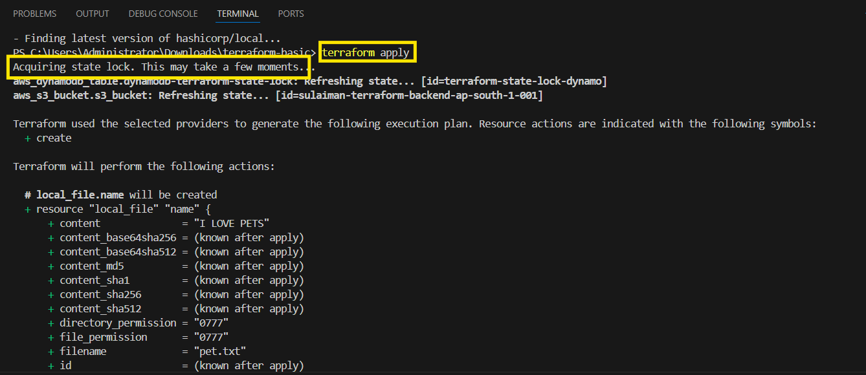

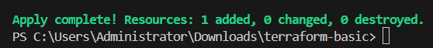
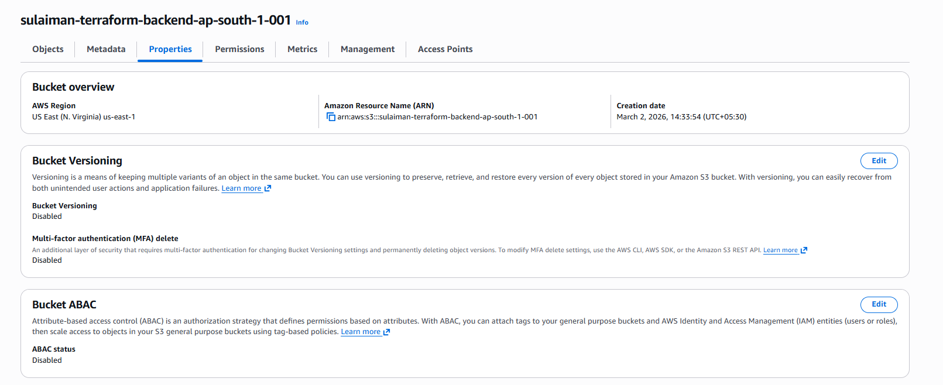

Interview Question?

If we have used Terraform and why?
- We used Terraform to provision aws services by creating
  - VPC
  - Ec2
  - Route 53
  - CloudWatch Monitoring
  - S3
  - RDS

We have used s3 as our backend and DynamoDB for state locking, so that we can push our tf.statefile to s3 without manual intervention
Used DynamoDB, so that, no multiple users can execute at the same point of time.

Create basic ec2 instance

resource "aws_instance" "terraform" {
ami = "ami-0532be01f26a3de55"
instance_type = "t3.micro"
key_name = "aws.key"
tags = {
Name = "terraform-instance"
}
}
After writing your script type terraform init
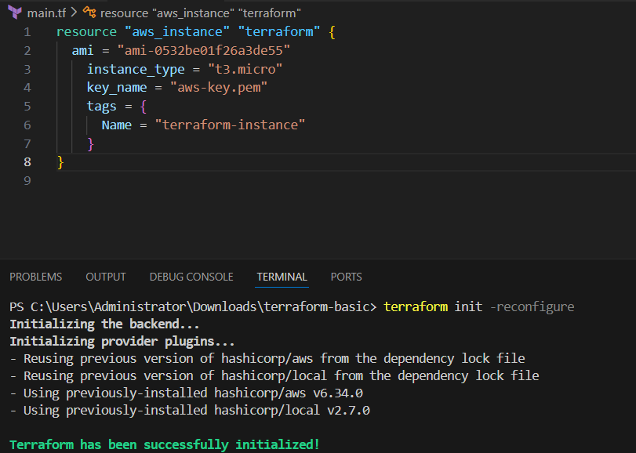
Now we need write terraform apply

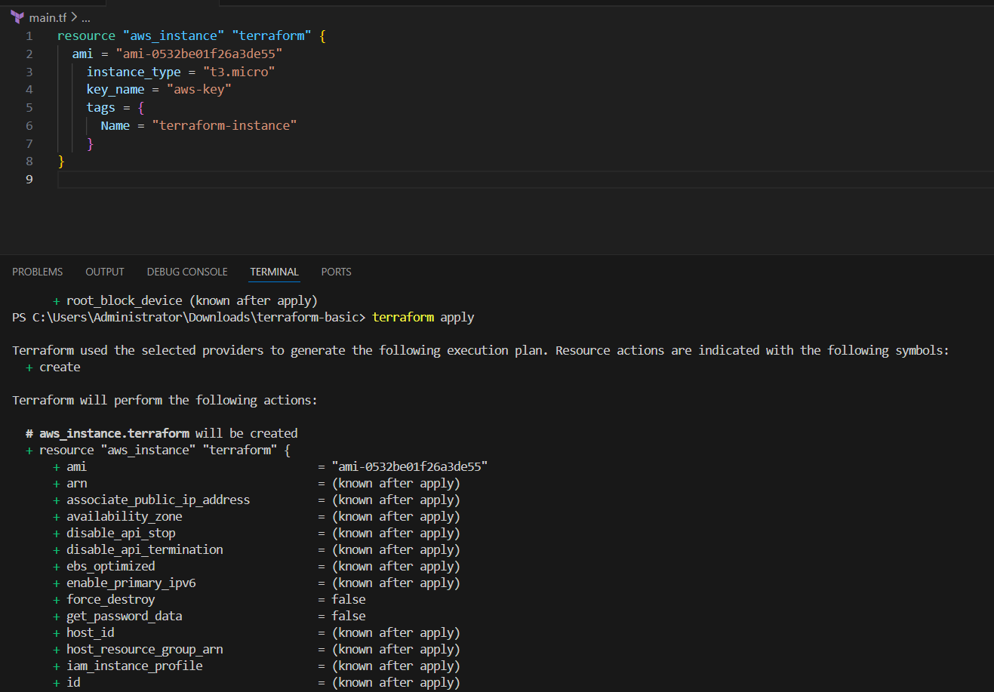
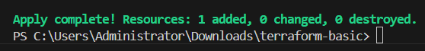
That’s it now we verfy it
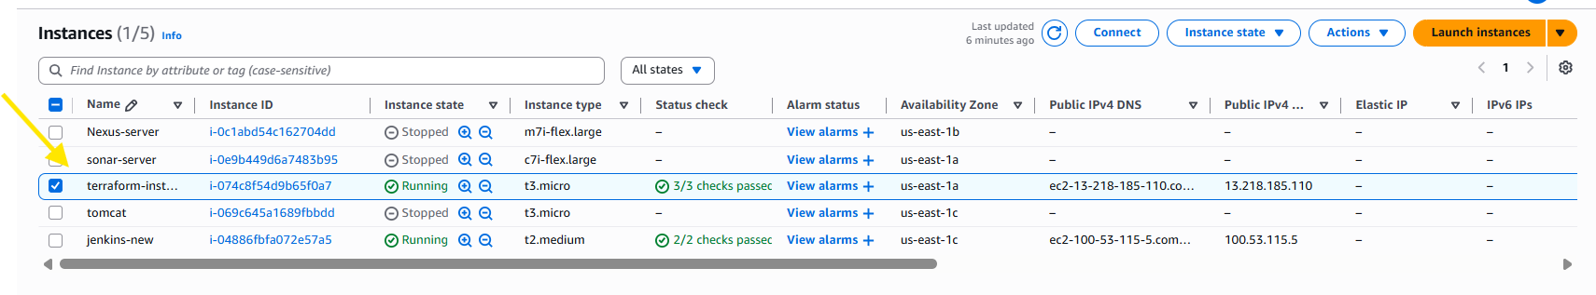

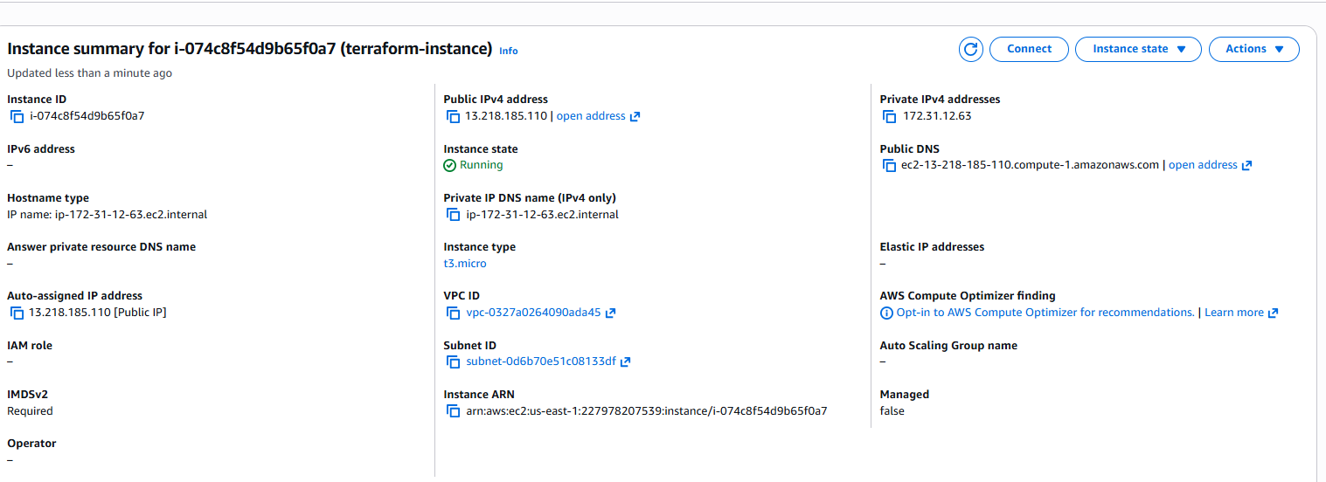
Terraform Provisioners

- We have two provisioners
  - Remote Provisioners
  - Local Provisioners

For testing purposes, we have removed the ec2 instance, which we created earlier.
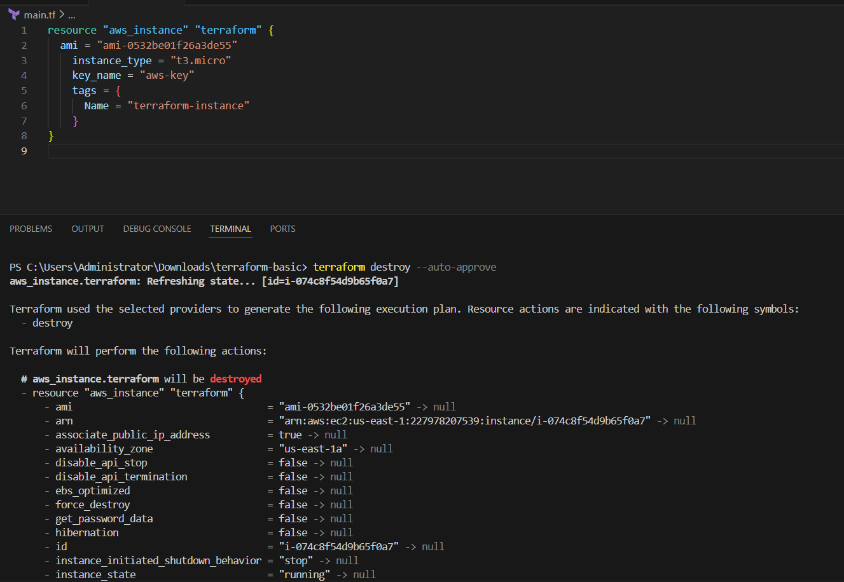
- Now, we shall add a local provisioner

provisioner "local-exec" {
command = "echo ${aws_instance.terraform.public_ip} > ip_address.txt"
}
}
Now we need type
Terraform init
Then terraform apply
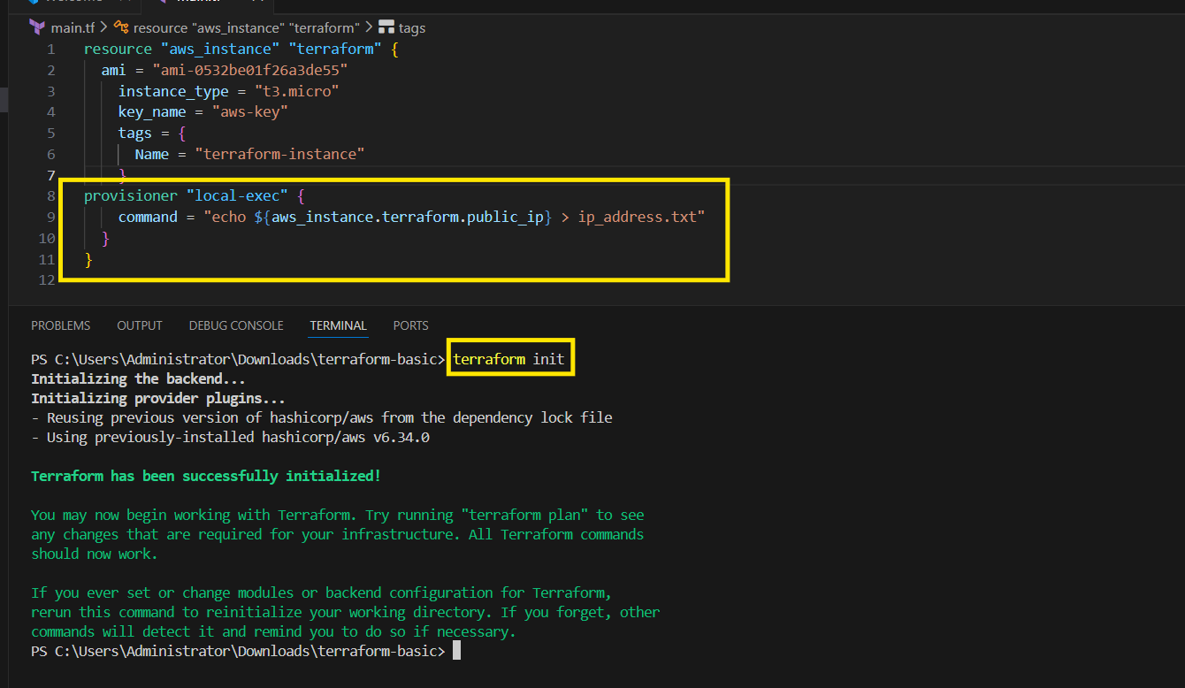
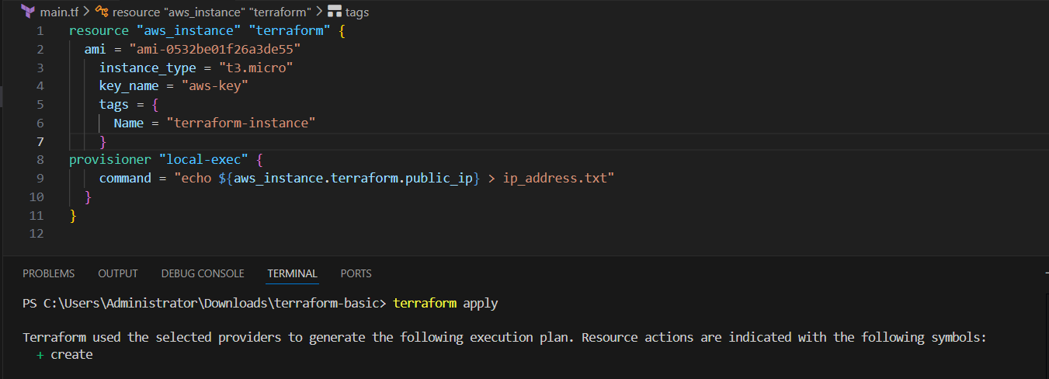
In left bar ip address .txt you notice you go ip address here click you see aws ec2 ip
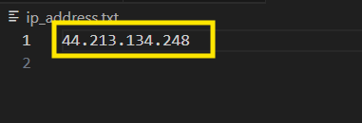
Even we can verfy it on ec2 directly
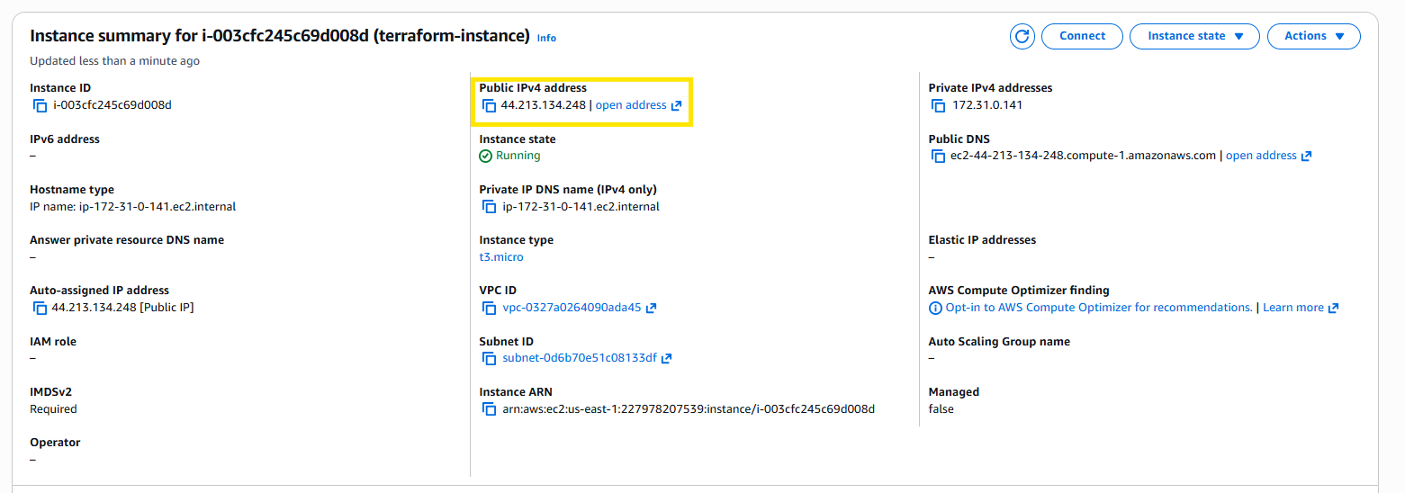
2. Create one EC2 instance with httpd installed using a Terraform script.
Step by step Implementation:
Syntax: resource "aws_instance" "httpd" {
ami = " ami-0532be01f26a3de55"
instance_type = "t3.micro"
key_name = "Jenkins-M"
user_data = <<-EOF
#!/bin/bash
sudo yum update -y
sudo yum install -y httpd
sudo systemctl start httpd
sudo systemctl enable httpd
echo "HTTPD working successfully from $(hostname -f)" > /var/www/html/index.html
EOF
tags = {
Name = "httpd-instance"
}
provisioner "local-exec" {
command = "echo ${aws_instance.httpd.public_ip} > ip_address.txt"
}
}
Terraform init
Terraform apply
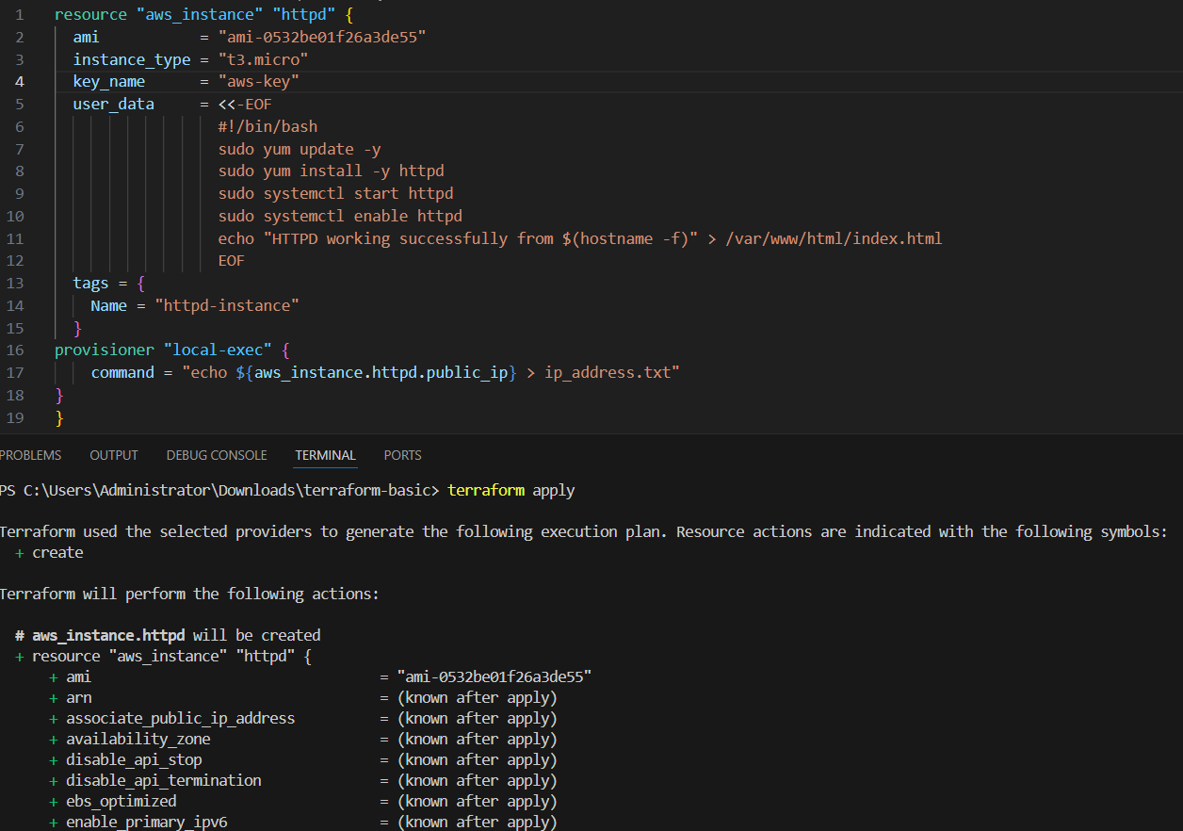
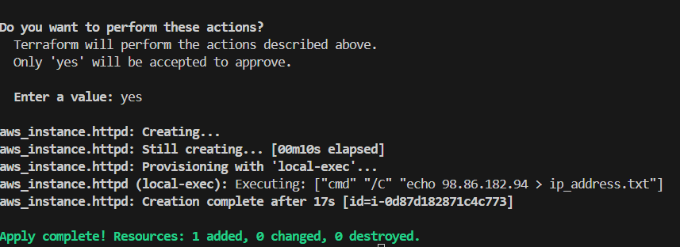
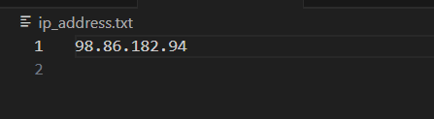
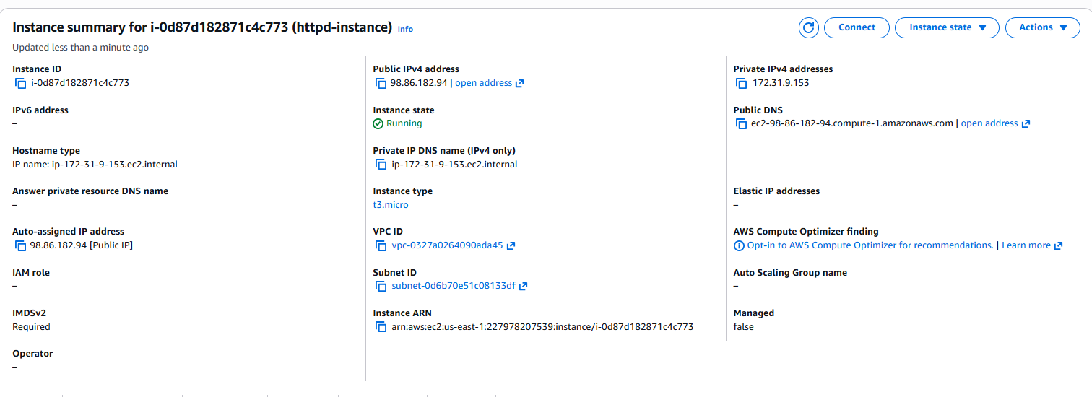
3. Set up S3 as backend for task 2
Syntax:
resource "aws_instance" "httpd" {
ami = "ami-0532be01f26a3de55"
instance_type = "t3.micro"
key_name = "Jenkins-M"
user_data = <<-EOF
#!/bin/bash
sudo yum update -y
sudo yum install -y httpd
sudo systemctl start httpd
sudo systemctl enable httpd
echo "HTTPD working successfully from $(hostname -f)" > /var/www/html/index.html
EOF
tags = {
Name = "httpd-instance"
}
provisioner "local-exec" {
command = "echo ${aws_instance.httpd.public_ip} > ip_address.txt"
}

}

resource "aws_s3_bucket" "s3_bucket" {
bucket = "vicky-s3-bucket-techie-horizon"
}

Terraform apply
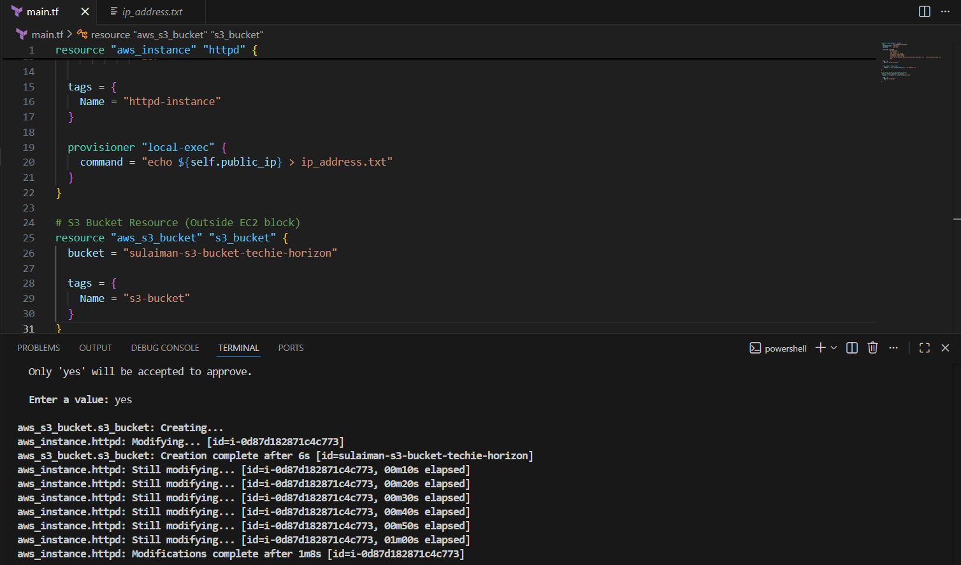
Now our bucket has been successfully created
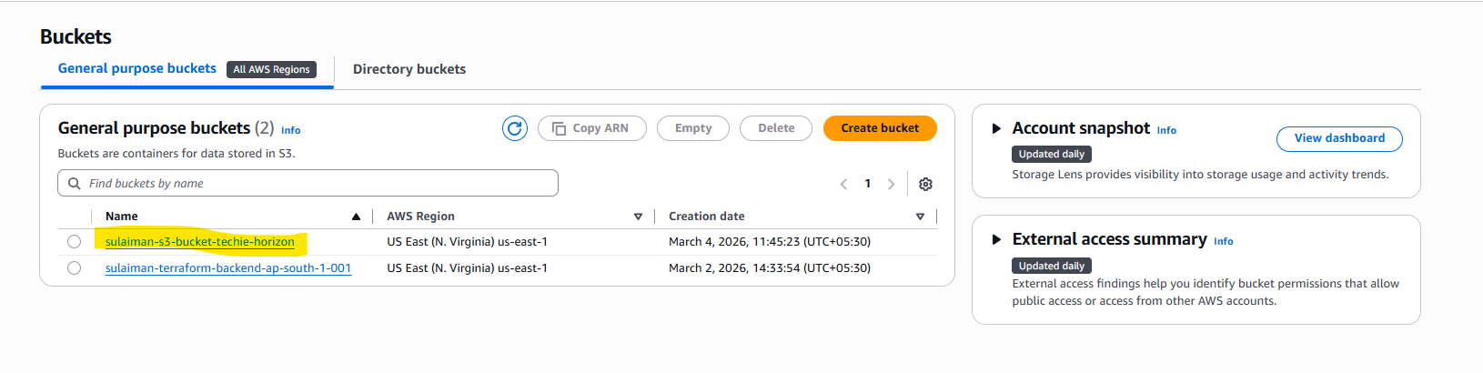
- Now, we shall do the s3 backend with below codes.

terraform {
backend "s3" {
bucket = "vicky-s3-bucket-techie-horizon"
key = "terraform.tfstate"
region = "us-east-1"
}
}

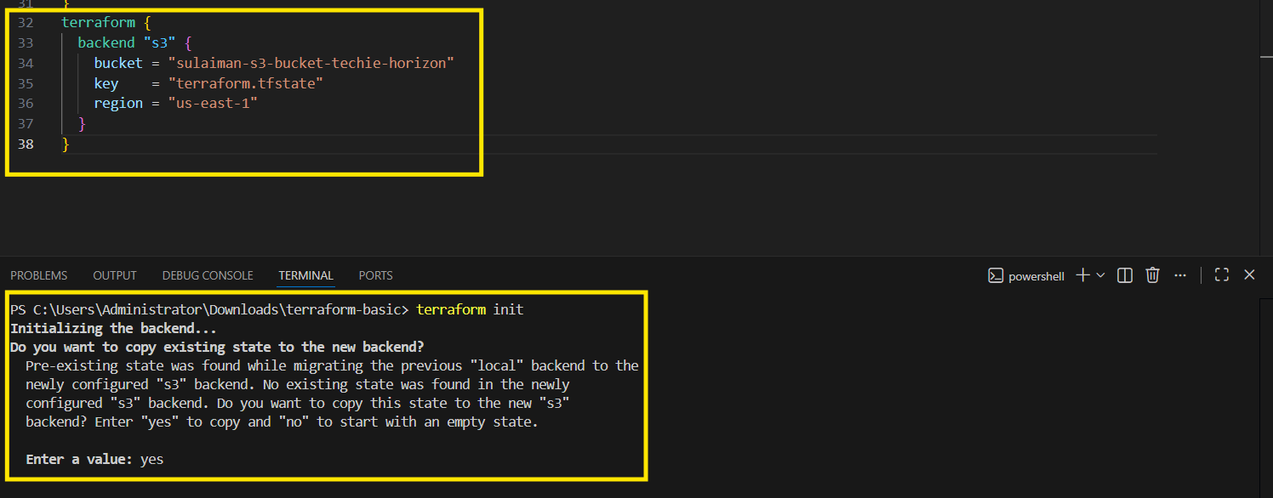
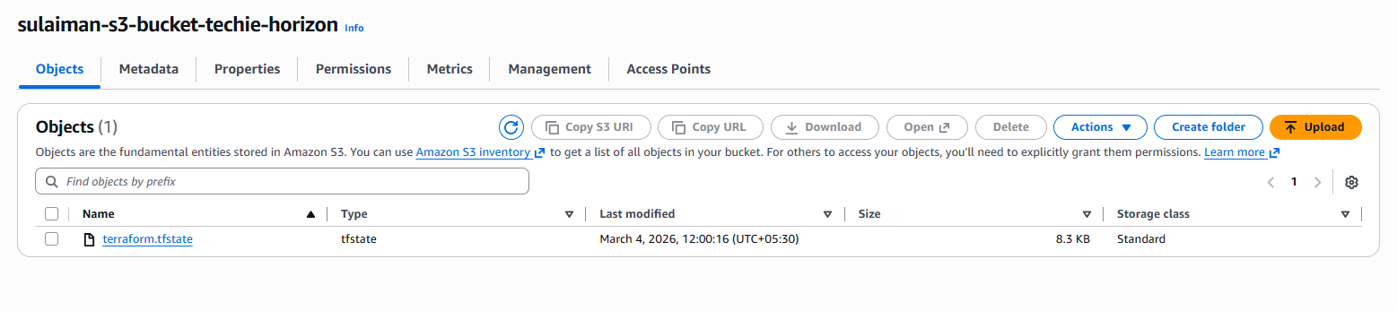

4. Set up DynamoDB locking for task 2.
Now we need to attach the below syntax to the earlier main.tf file.
Syntax: resource "aws_dynamodb_table" "sulaiman-terraform-backend" {
name = "sulaiman-terraform-backend"
hash_key = "LockID"
read_capacity = 20
write_capacity = 20
attribute {
name = "LockID"
type = "S"
}
}

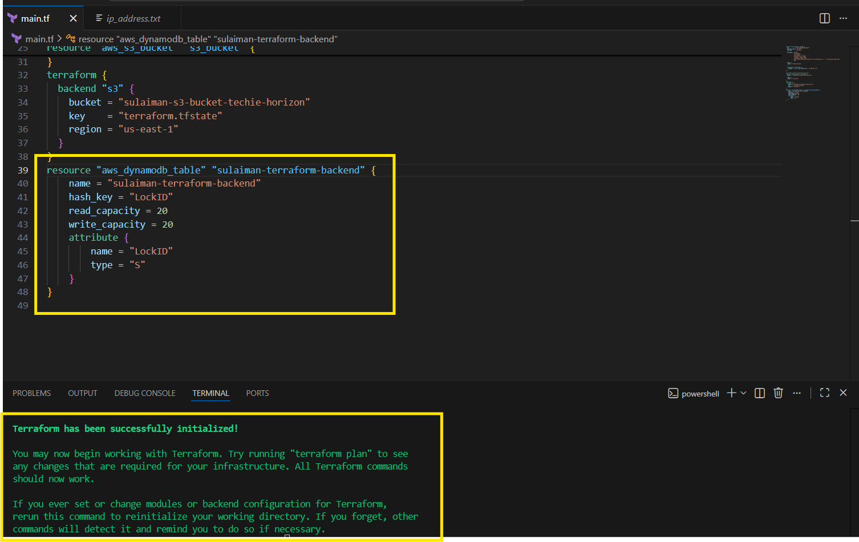
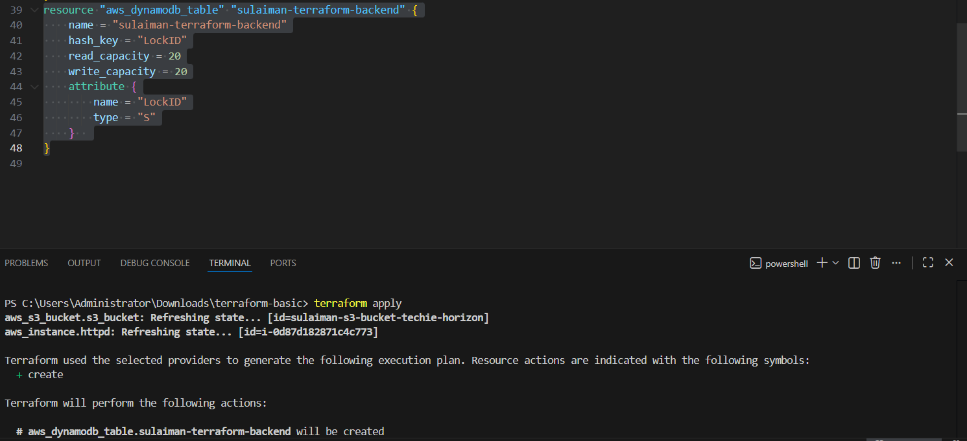
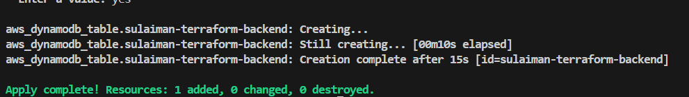
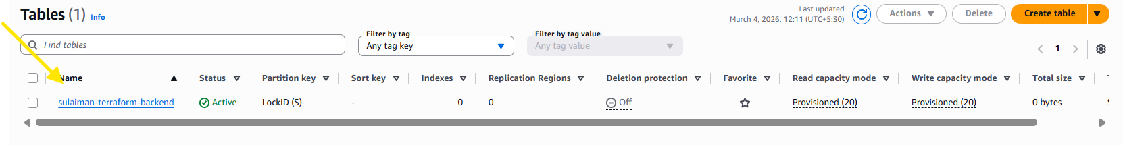
Now, we updated a code, where, s3 will communicate with DynamoDB and perform the state locking to prevent multiple users to execute the same point of time.
terraform {
backend "s3" {
bucket = "sulaiman-s3-bucket-techie-horizon"
dynamodb_table = "sulaiman-terraform-backend"
key = "terraform.tfstate"
region = "us-east-1"
}
}

Now, s3 will automatically use this backend and state locking is in place
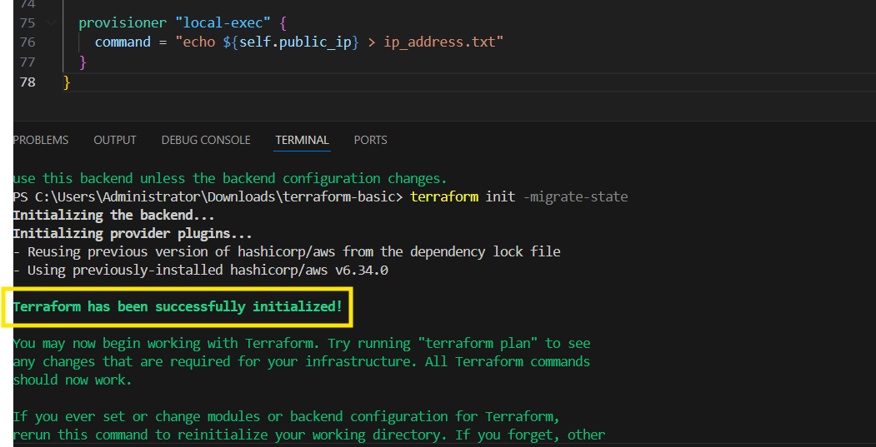
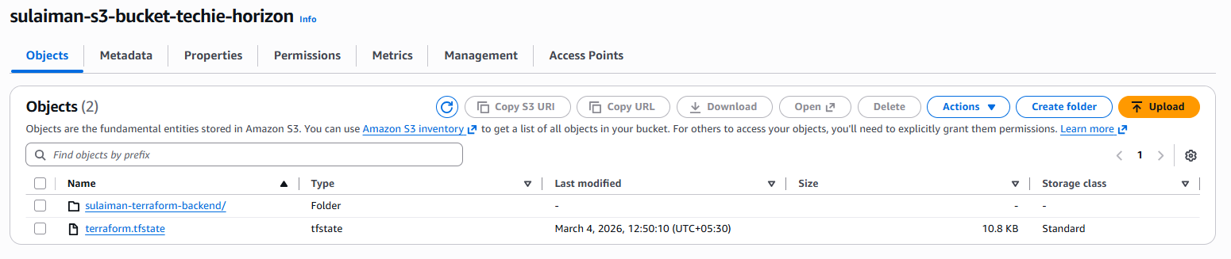
Final Syntax:

resource "aws_instance" "httpd" {
ami = "ami-0532be01f26a3de55"
instance_type = "t3.micro"
key_name = "Jenkins-M"
user_data = <<-EOF
#!/bin/bash
sudo yum update -y
sudo yum install -y httpd
sudo systemctl start httpd
sudo systemctl enable httpd
echo "HTTPD working successfully from $(hostname -f)" > /var/www/html/index.html
EOF
tags = {
Name = "httpd-instance"
}
provisioner "local-exec" {
command = "echo ${aws_instance.httpd.public_ip} > ip_address.txt"
}

}

resource "aws_s3_bucket" "s3_bucket" {
bucket = "vicky-s3-bucket-techie-horizon"
}

resource "aws_dynamodb_table" "sulaiman-terraform-backend" {
name = "sulaiman-terraform-backend"
hash_key = "LockID"
read_capacity = 20
write_capacity = 20
attribute {
name = "LockID"
type = "S"
}
}
terraform {
backend "s3" {
bucket = "sulaiman-s3-bucket-techie-horizon"
dynamodb_table = "sulaiman-terraform-backend"
key = "terraform.tfstate"
region = "us-east-1"
}
}

