Terrafrom Task_6
1. Terraform Modules
- A module is a collection of .tf files used together
- Every Terraform configuration is a module
- Root module → main working directory
- Child module → reusable module called using module {}
➢ Module Structure
- main.tf → resources
- variables.tf → input variables
- outputs.tf → outputs
- versions.tf → Terraform & provider versions
- Calling a Module
- Uses module block
- Requires source argument
➢ Module Inputs & Outputs
- Inputs passed using variables
- Outputs accessed as module.<name>.<output>
➢ Module Sources
- Local path
- Terraform Registry
- Git repository
- S3 / HTTP
➢ Module Best Practices
- Keep modules small and focused
- Do not hardcode values
- Avoid provider configuration in child modules
- Use version constraints
- Make modules environment-agnostic
2. Terraform Workspaces
- A workspace allows multiple state files for the same configuration
- Default workspace name: default
- Same code, different state
➢ Why Workspaces?
- Manage multiple environments
- Quick switching between environments
  - Reduce code duplication
➢ Workspace Commands
  - terraform workspace list
  - terraform workspace new <name>
  - terraform workspace select <name>
➢ Workspace Usage
  - Workspace name accessed using terraform.workspace
  - Commonly used for environment-specific values
➢ State Behavior
  - Each workspace has its own state file
  - Local backend → separate state files
  - Remote backend → separate state keys
➢ Limitations of Workspaces
  - Not recommended for production
  - Weak environment isolation
  - Risk of accidental changes
  - Same backend and credentials
➢ Modules vs Workspaces
  - Modules → code reusability
  - Workspaces → state separation
  - Modules organize infrastructure
  - Workspaces separate environments (limited use)
Watch Terraform-05 video. (TASK_1)
1. Execute the script shown in the video. (TASK_6)
  - Create Terraform directory and then create under that directory create 3
- more directory
  - Aws_instance, development, production
  - Under aws_instance we have
Terraform Modules:
→ Module is a collection of configuration files in a directory
→ We can create Ec2 for different environments so that we can create a directory for
→aws_instance configuration
→main.tf
resource "aws_instance" "webserver" {
ami = var.ami
instance_type = "t2.micro"
}
variable.tf
variable "ami" {
watch terraform-05 video. (task_1)
1. Exeute the script shown in the video.
• Create Terraform directory and then create under that directory create 3
more directory
• Aws_instance, development, production
• Under aws_instance we have
Terraform Modules:
→ Module is a collection of configuration files in a directory
→ We can create Ec2 for different environments so that we can create a directory for
→aws_instance configuration
→main.tf
resource "aws_instance" "webserver" {
ami = var.ami
instance_type = "t2.micro" }
variable.tf
variable “ami” {
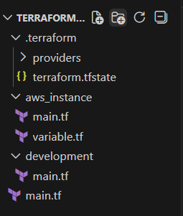
example:
module "dev-webserver" {
source = "../aws_instance"
ami = "ami-02f3f602d23f1659d"
}
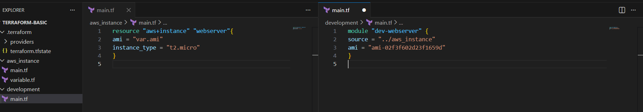
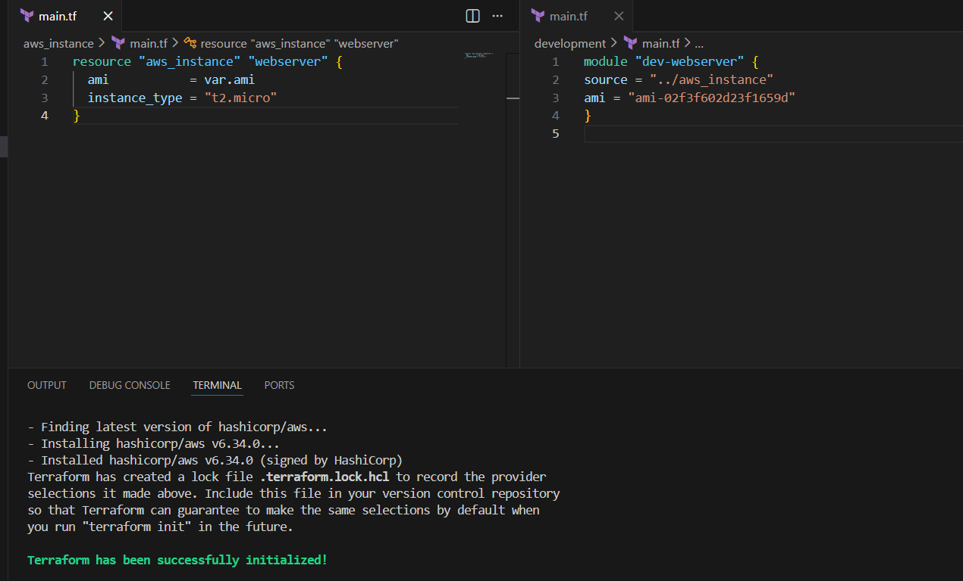
Now apply the code (terraform apply)
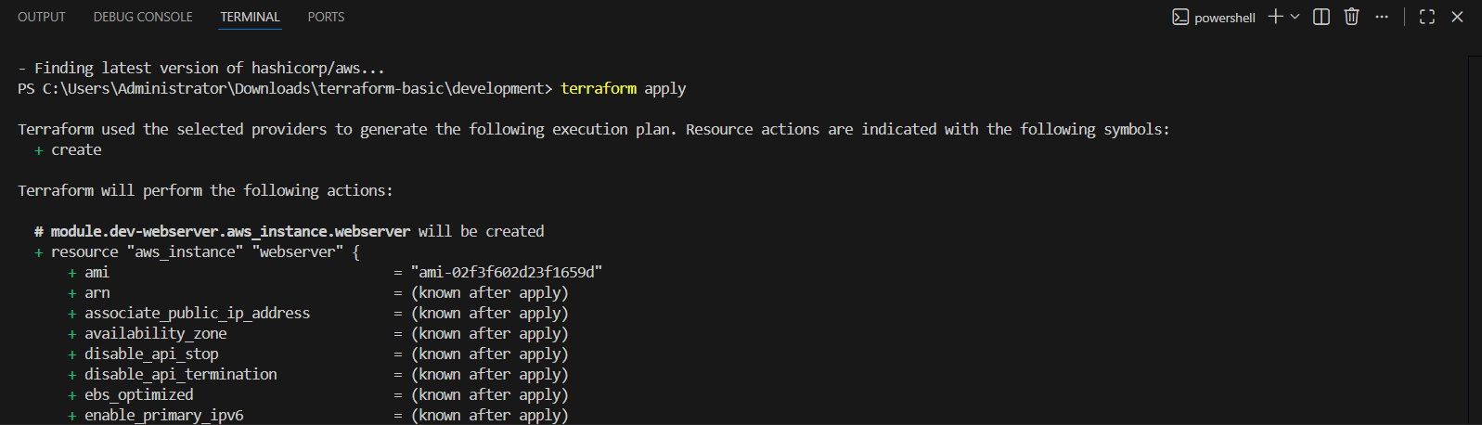
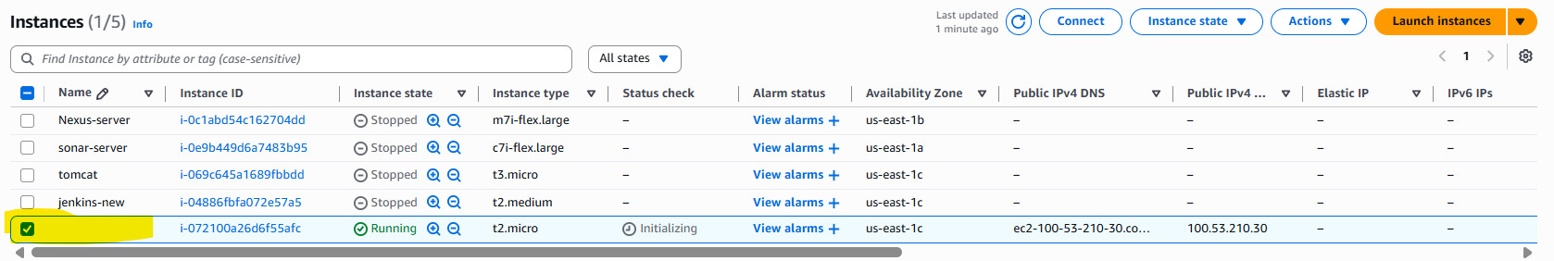
Terraform workspaces:
Workspace can be used if we have multiple project/
environments using the same configuration.
Workspace commands:
==================
terraform workspace new projectA --> to create a workspace names projectA
terraform workspace list --> to list the workspaces available
terraform workspace selecr projectA --> to swtich to specific workspace
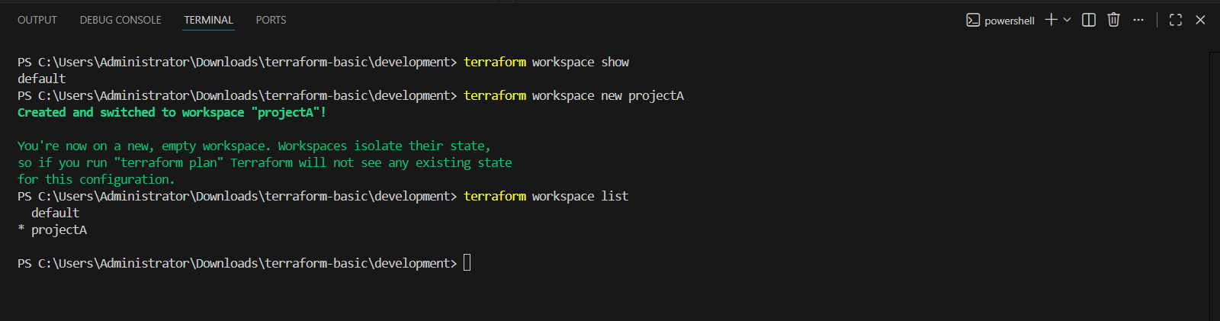
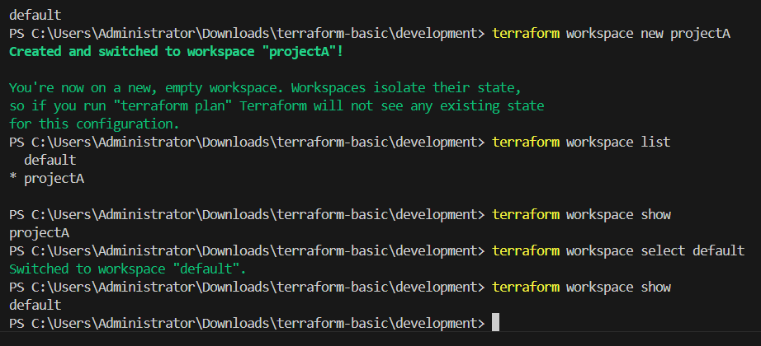
Need to add the code for main.tf
resource "aws_instance" "webserver"{
ami = var.ami["ProjectA"]
instance_type = "t3.micro"
}

Then for variables.tf
variable "ami" {
type = map[“string”]
default = {
"ProjectA" = "ami-02f3f602d23f1659d"
"ProjectB" = "ami-02f3f602d23f1659d"
}
}
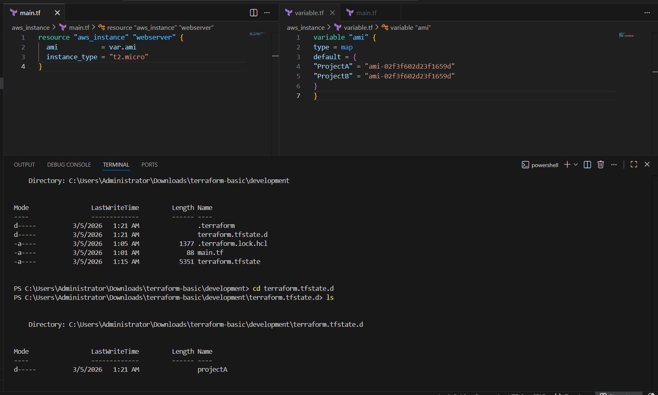
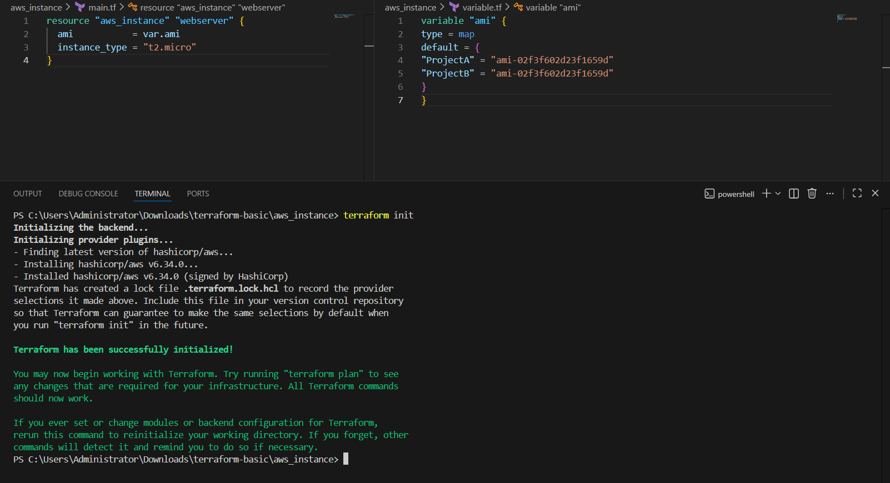
Then terraform apply
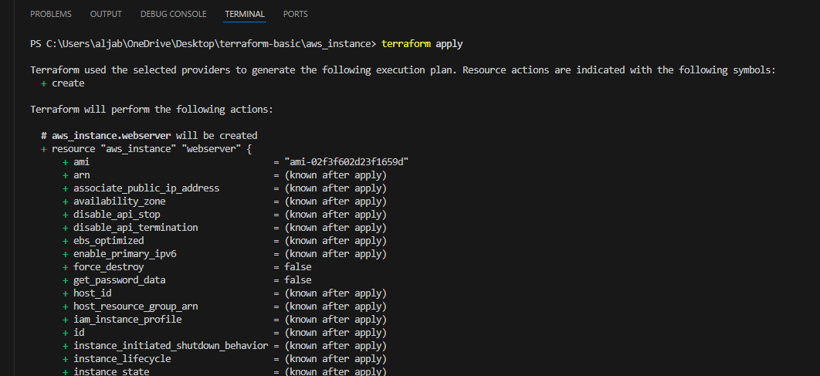
02. Provision EC2, S3, and VPC using Terraform modules.
Ans: first we have to create different folder for each services
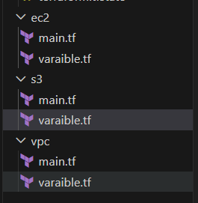
Now first we are creating vpc so under the vpc folder created main.tf and variables.tf now entering the code
For main.tf below is the code which is been used
=============================================
terraform {
required_providers {
aws = {
source = "hashicorp/aws"
version = "~> 5.0"
}
}
}

provider "aws" {
region = var.region
}

resource "aws_vpc" "main" {
cidr_block = var.vpc_cidr
enable_dns_support = true
enable_dns_hostnames = true

tags = {
Name = "terraform-vpc"
}
}

resource "aws_internet_gateway" "igw" {
vpc_id = aws_vpc.main.id

tags = {
Name = "terraform-igw"
}
}

resource "aws_subnet" "public" {
vpc_id = aws_vpc.main.id
cidr_block = var.public_subnet_cidr
availability_zone = var.az
map_public_ip_on_launch = true

tags = {
Name = "public-subnet"
}
}

resource "aws_subnet" "private" {
vpc_id = aws_vpc.main.id
cidr_block = var.private_subnet_cidr
availability_zone = var.az

tags = {
Name = "private-subnet"
}
}

resource "aws_route_table" "public" {
vpc_id = aws_vpc.main.id

route {
cidr_block = "0.0.0.0/0"
gateway_id = aws_internet_gateway.igw.id
}

tags = {
Name = "public-rt"
}
}

resource "aws_route_table_association" "public_assoc" {
subnet_id = aws_subnet.public.id
route_table_id = aws_route_table.public.id
}

output "vpc_id" {
value = aws_vpc.main.id
}

output "public_subnet_id" {
value = aws_subnet.public.id
}

output "private_subnet_id" {
value = aws_subnet.private.id
}

=============================================
And below is the variables.tf
=============================================
variable "region" {
description = "AWS region"
default = "us-east-1"
}

variable "vpc_cidr" {
description = "VPC CIDR block"
default = "10.0.0.0/16"
}

variable "public_subnet_cidr" {
description = "Public subnet CIDR"
default = "10.0.1.0/24"
}

variable "private_subnet_cidr" {
description = "Private subnet CIDR"
default = "10.0.2.0/24"
}

variable "az" {
description = "Availability zone"
default = "us-east-1a"
}

=============================================
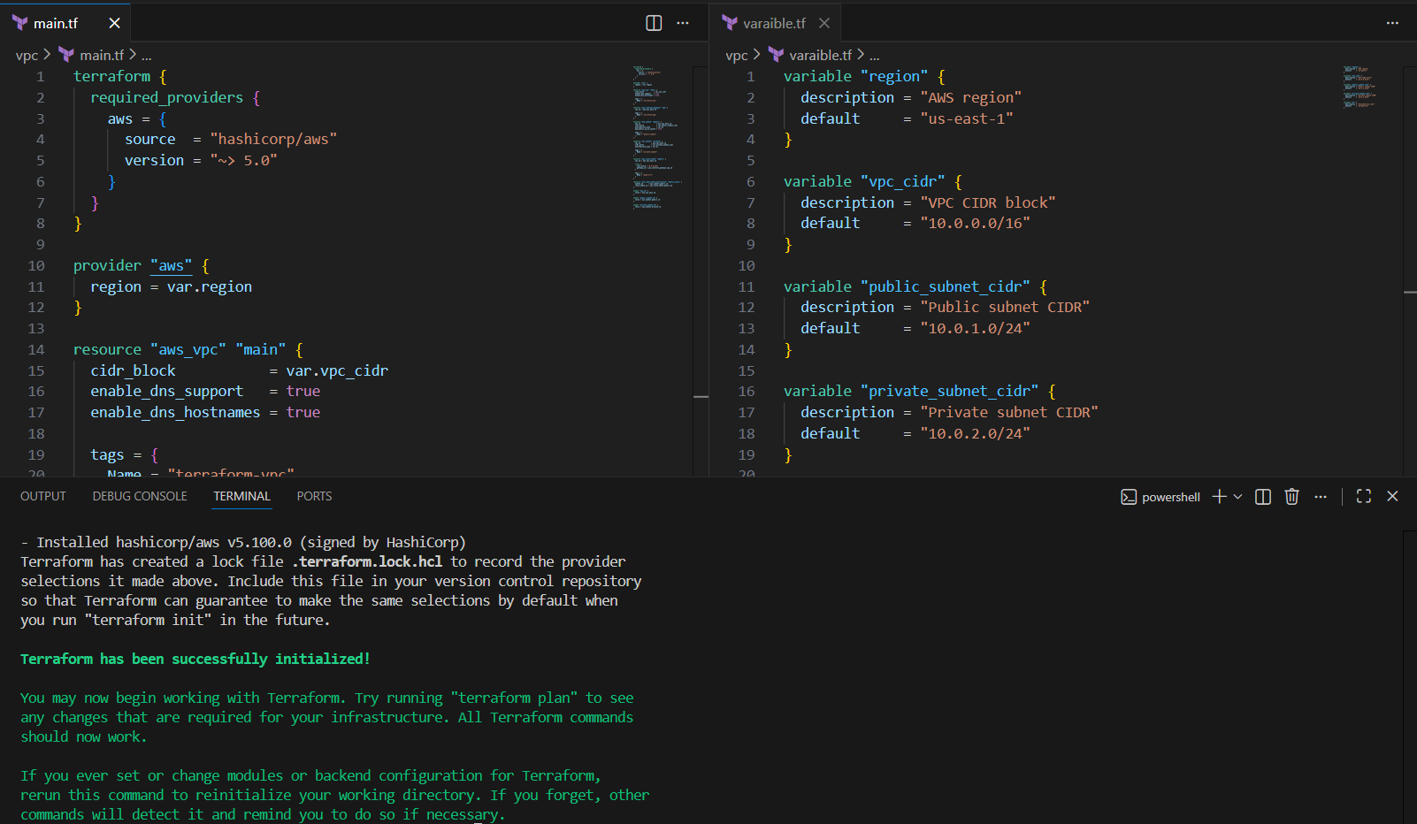
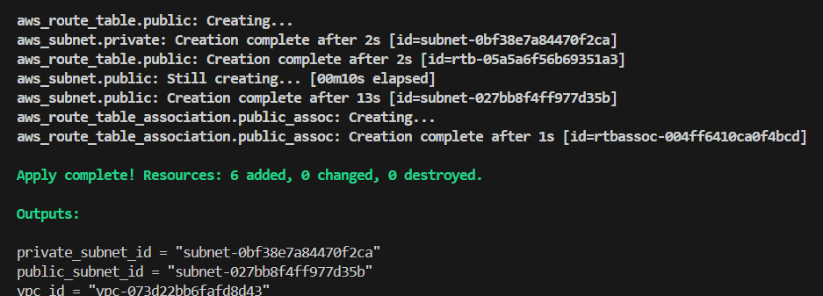
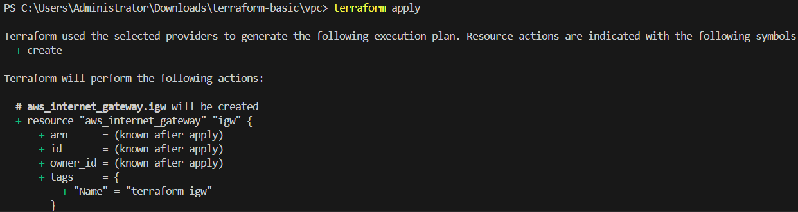
Now checking aws account
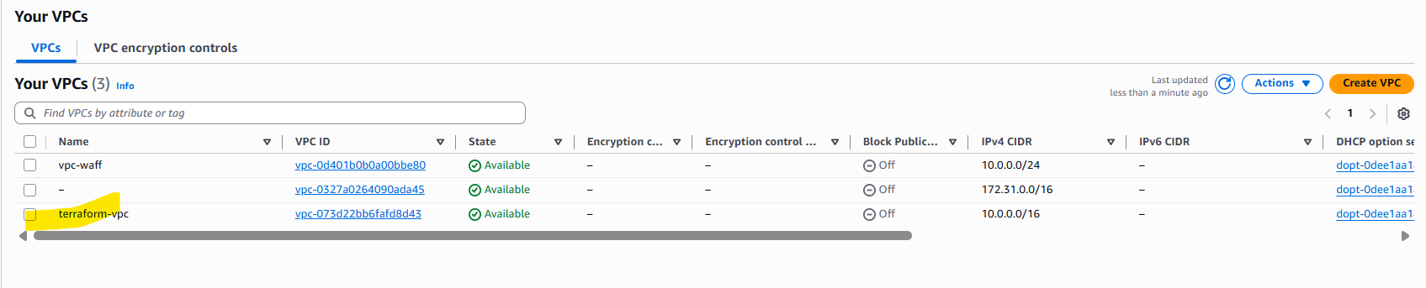
New vpc is been created
Creating ec2 instance with the same vpc under the main.tf and variables.tf entering the code to create the ec-2 instance below is the main.tf
=============================================
terraform {
required_providers {
aws = {
source = "hashicorp/aws"
version = "~> 5.0"
}
}
}

provider "aws" {
region = var.region
}

resource "aws_security_group" "ec2_sg" {
name = "ec2-sg"
description = "Allow SSH"
vpc_id = var.vpc_id

ingress {
description = "SSH"
from_port = 22
to_port = 22
protocol = "tcp"
cidr_blocks = ["0.0.0.0/0"]
}

egress {
from_port = 0
to_port = 0
protocol = "-1"
cidr_blocks = ["0.0.0.0/0"]
}

tags = {
Name = "ec2-security-group"
}
}

resource "aws_instance" "web" {
ami = var.ami_id
instance_type = var.instance_type
subnet_id var.public_subnet_id
vpc_security_group_ids = [aws_security_group.ec2_sg.id]
key_name = var.key_name
associate_public_ip_address = true

tags = {
Name = "terraform-ec2"
}
}

output "ec2_public_ip" {
value = aws_instance.web.public_ip
}

=============================================
Variables.tf
=============================================
variable "region" {
default = "us-east-1"
}

variable "vpc_id" {
description = "vpc-0fb352a3f17a41f1b"
}

variable "public_subnet_id" {
description = "10.0.1.0/24"
}

variable "key_name" {
description = "aws-key"
}

variable "instance_type" {
default = "t2.micro"
}

variable "ami_id" {
default = "ami-0c02fb55956c7d316"
}

=============================================
Now open the terminal and change the directory cd ec-2 and use the command terraform init
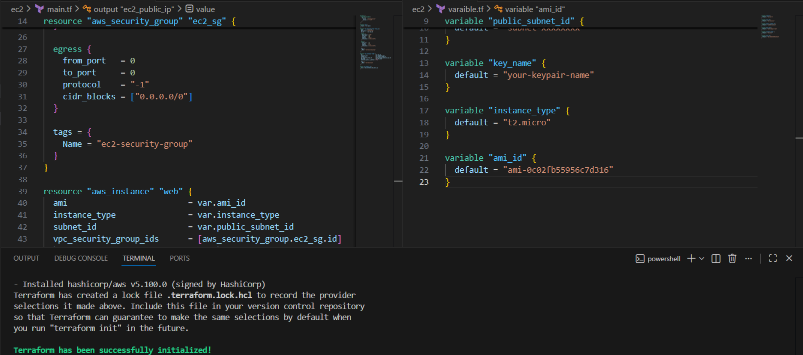
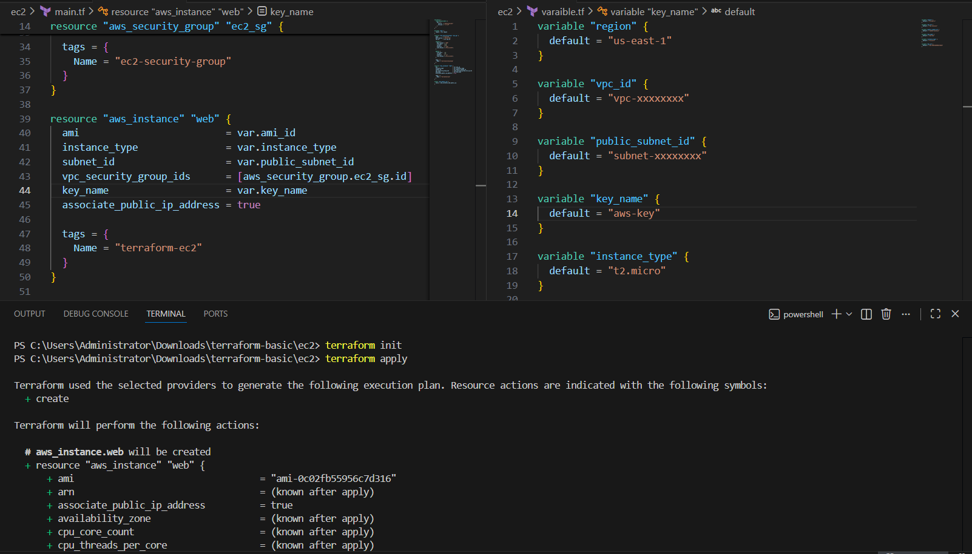
Now check in aws account
S3: now creating s3 bucket added the code to create the s3 bucket in main.tf
=============================================

resource "aws_s3_bucket" "my_bucket" {
bucket = var.bucket_name

tags = {
Name = "terraform-bucket"
Environment = "dev"
}
}

resource "aws_s3_bucket_public_access_block" "block" {
bucket = aws_s3_bucket.my_bucket.id
block_public_acls = true
block_public_policy = true
ignore_public_acls = true
restrict_public_buckets = true
}
resource "aws_s3_bucket_versioning" "versioning" {
bucket = aws_s3_bucket.my_bucket.id

versioning_configuration {
status = "Enabled"
}
}
output "bucket_name" {
value = aws_s3_bucket.my_bucket.bucket
}
=============================================
Variables.tf code
============================================
variable "bucket_name" {
description = "aljab-terraform-s3"
}
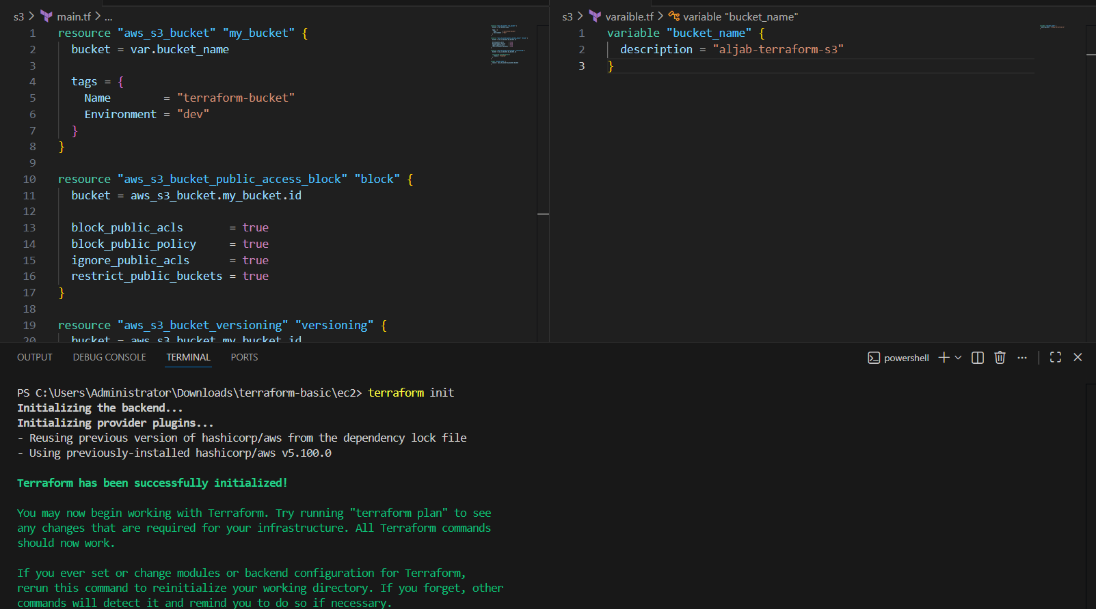
Now apply the code terraform apply ( make sure your bucket name must unique )
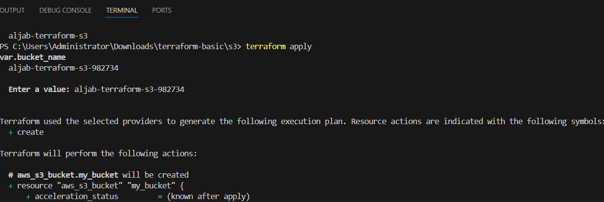
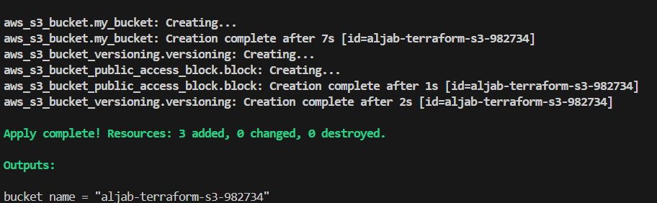
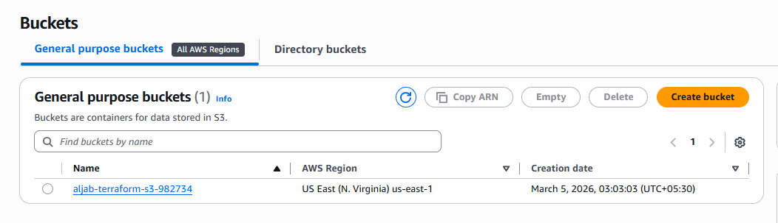
Now we have successfully Created vpc,s3,ec-2 instance successfully
03.Provision EC2 for 3 different environments (Dev, Staging, and Prod) using Terraform workspaces.
Ans: first need to create three workpsace (dev,staging,prod)
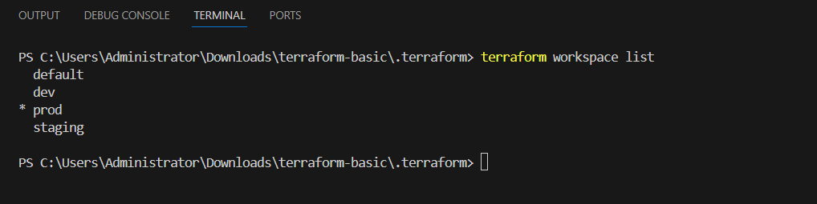
Now created 2 files main.tf and variables.tf added the code below is the main.tf code
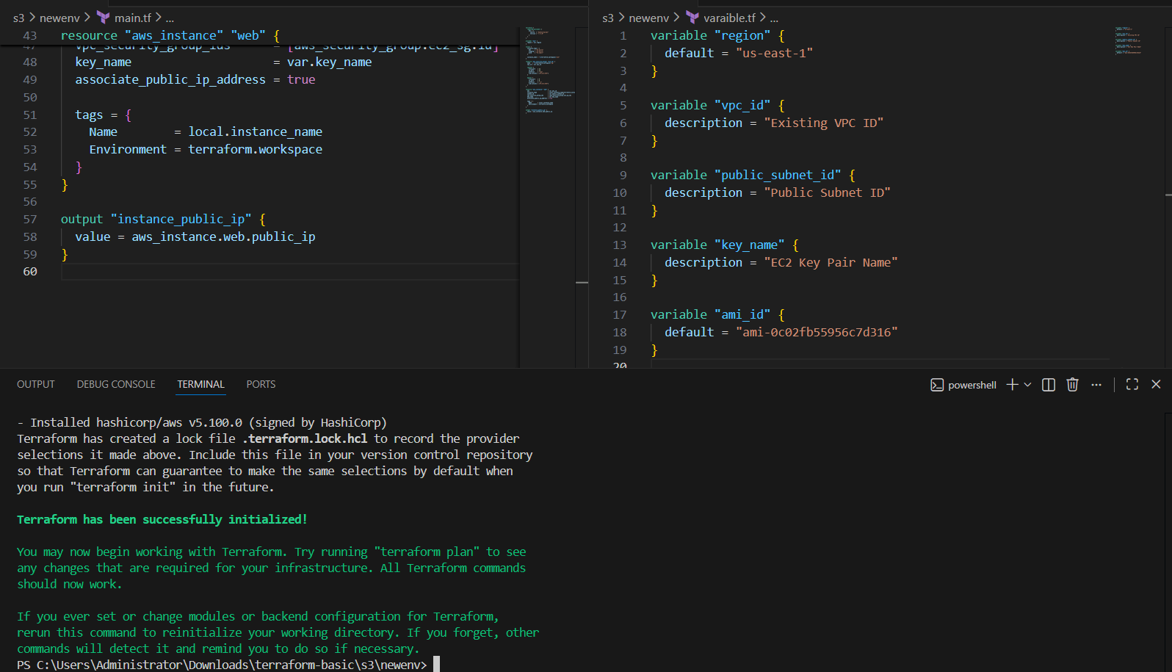
Now we have successfully created 3 vpc using terraform
