TERRAFORM CHALLANGE

Create an EC2 Instance on AWS Cloud using the below-mentioned ubuntu AMI and instance_type. Or, (You can use of your choice as well) ami = "ami-0461b1436c9b3c1a3" instance_type = "t3.micro"
Install a web server on the same EC2 Instance. The web server should listen on port 8080.
Syntax:
resource "aws_instance" "challange" {
ami = "ami-07ff62358b87c7116"
instance_type = "t3.micro"
key_name = "sshless"
security_groups = ["default"]

tags = {
Name = "ChallangeInstance"
}
user_data = <<-EOF
#!/bin/bash
sudo yum update -y
sudo yum install -y httpd
sudo systemctl start httpd
sudo systemctl enable httpd
echo "Hello, World! from TECHIE HORIZON" > /var/www/html/index.html
sed -i 's/Listen 80/Listen 8080/' /etc/httpd/conf/httpd.conf
sudo systemctl restart httpd
sudo systemctl start httpd
EOF

}
output "aws_instance_public_ip" {
value = aws_instance.challange.public_ip

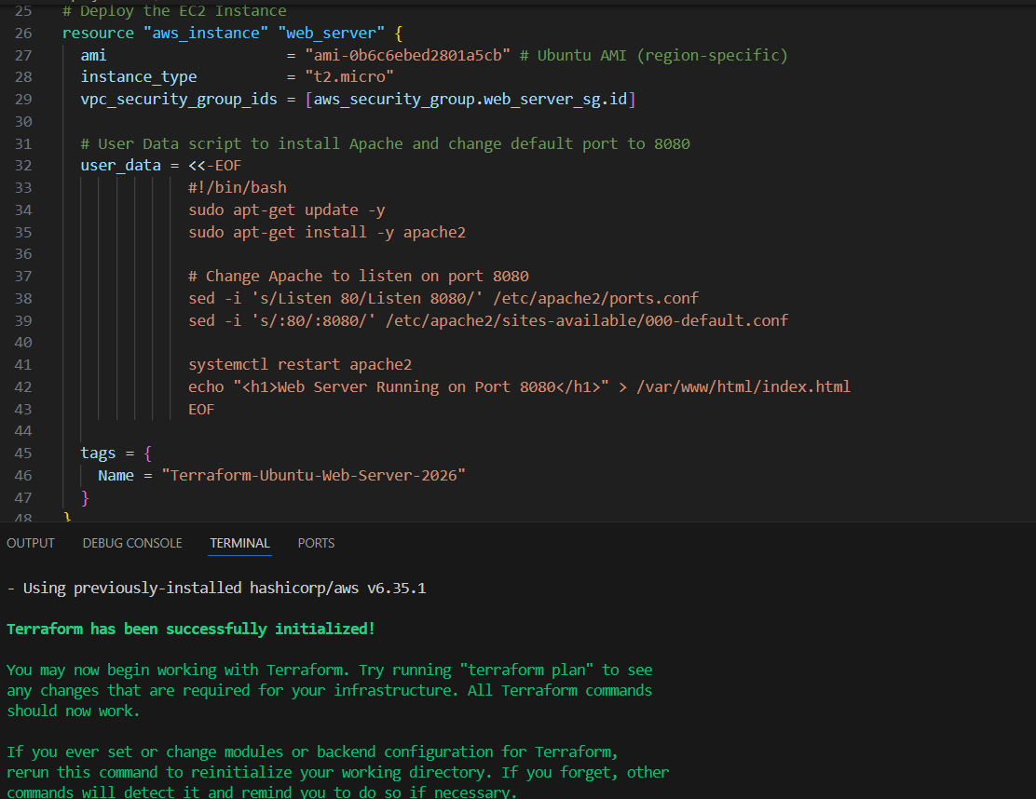
Now terraform apply
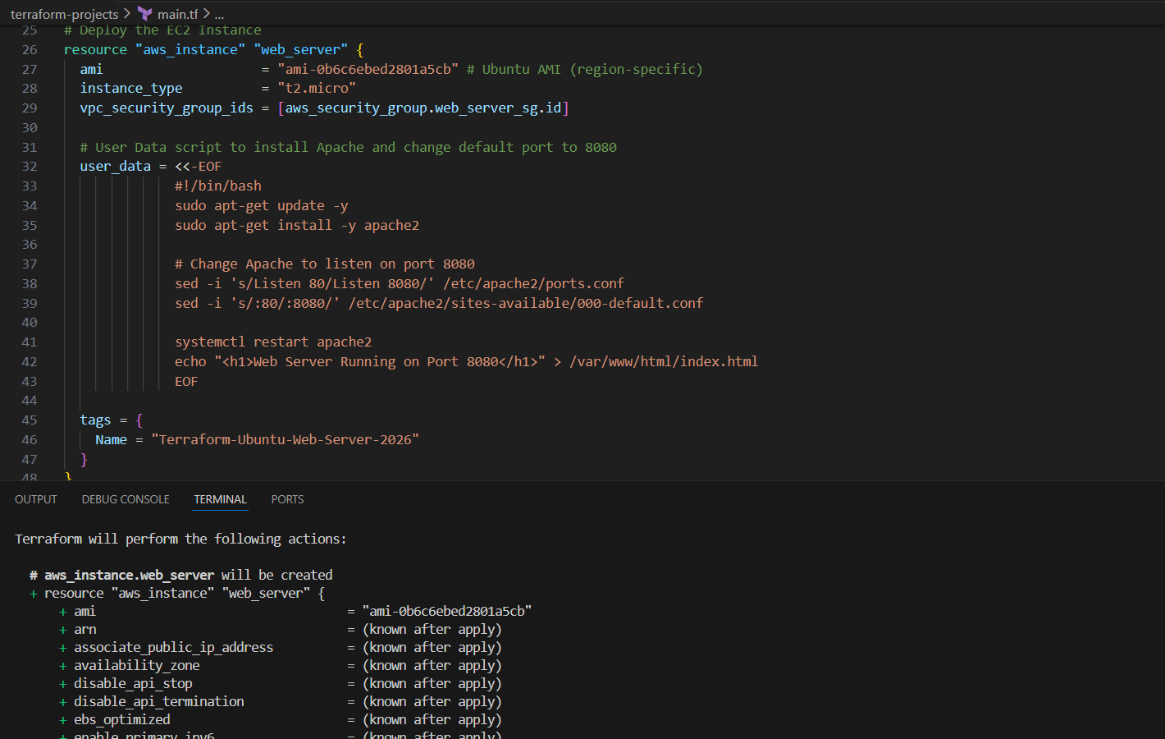
Now lets check in aws
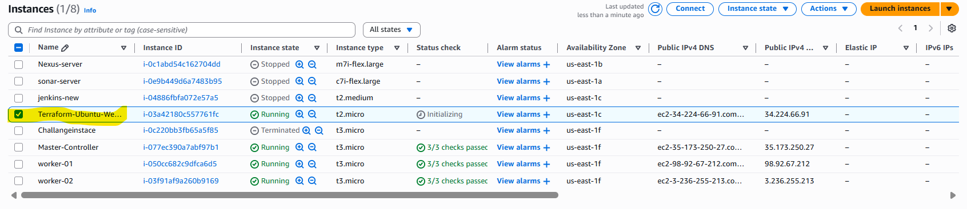
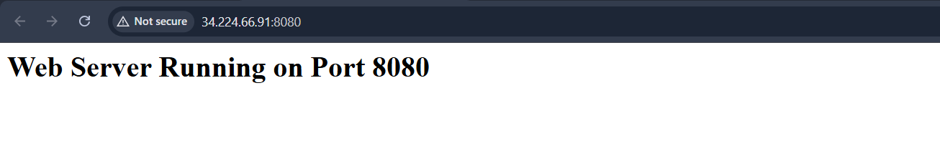
Create a Docker-compose file for the
project: https://github.com/betawins/cricbuzz-docker-hello
world.git and point it to port 8000.
Terraform Docker + Nginx Project — Step-by-Step
Step 1: Configure AWS Provider
• Defined AWS provider with required region.
• Terraform connects to AWS using configured credentials.
provider "aws" {
region = "us-east-1"
}
Step 2: Create Security Group
• Allowed required inbound ports:
o 22 → SSH
o 8080 → Web server (Nginx)
o 8000 → Docker application
• Allowed all outbound traffic.
Purpose:
• Enable browser access and container communication.
Step 3: Create EC2 Instance
• Launched EC2 using:
o AMI: ami-0b6c6ebed2801a5cb
o Instance type: t2.micro
• Attached security group.
• Used user_data for full automation.
Step 4: Install Required Packages (via user_data)
Terraform automatically installs:
• Docker
• Docker Compose
• Nginx
• Git
• Logrotate
This ensures no manual setup after instance launch.
Step 5: Clone Application Repository
Terraform automatically runs:
git clone https://github.com/betawins/cricbuzz-docker-hello-world.git
Project stored under:
/opt/cricbuzz-docker-hello-world
Step 6: Create Docker-Compose File
Terraform creates docker-compose.yml:
• Docker container runs on port 8000
• Container exposes port 80 → 8000
Result:
Host:8000 → Docker App
Docker started automatically using:
docker-compose up -d
Step 7: Configure Nginx Reverse Proxy
Nginx configured to:
• Listen on port 8080
• Forward traffic to Docker service on port 8000
Flow:
Browser → 8080 → Nginx → 8000 → Docker App
Step 8: Configure Logging
Nginx access logs configured to write into:
/var/log/cb.log
This captures:
• Client IP
• Requests
• Status codes
• Access history
Step 9: Configure Log Rotation
Created logrotate configuration:
/etc/logrotate.d/cb-log
Rotation rules:
• Daily rotation
• Keep last 7 days
• Compress old logs
• Reload nginx automatically
Purpose:
• Prevent disk space issues
• Maintain log history safely
Step 10: Apply Terraform
Commands executed:
terraform init
terraform apply
Terraform automatically:
• Created EC2
• Installed software
• Started Docker
• Configured Nginx
• Enabled logging and log rotation
Step 11: Verify Output
Accessed application via browser:
http://<EC2-Public-IP>:8080
Confirmed:
• Nginx working
• Docker service responding
• Logs generated in /var/log/cb.log
Final Architecture Flow
User Browser
↓
Port 8080 (Nginx)
↓
Reverse Proxy
↓
Port 8000 (Docker Container)
↓
Application Response
Task Status: COMPLETED
✔ EC2 created using Terraform
✔ Web server running on 8080
✔ Docker-compose created via Terraform
✔ Reverse proxy configured
✔ Logs saved to /var/log/cb.log
✔ Logrotate configured

Script we have used :
provider "aws" {
region = "us-east-1"
}

# -------------------------
# Security Group
# -------------------------
resource "aws_security_group" "cb_sg" {
name = "cb-sg"
description = "Allow SSH and app ports"

ingress {
description = "SSH"
from_port = 22
to_port = 22
protocol = "tcp"
cidr_blocks = ["0.0.0.0/0"]
}

ingress {
description = "Nginx Reverse Proxy"
from_port = 8080
to_port = 8080
protocol = "tcp"
cidr_blocks = ["0.0.0.0/0"]
}

ingress {
description = "Docker App"
from_port = 8000
to_port = 8000
protocol = "tcp"
cidr_blocks = ["0.0.0.0/0"]
}

egress {
from_port = 0
to_port = 0
protocol = "-1"
cidr_blocks = ["0.0.0.0/0"]
}
}

# -------------------------
# EC2 Instance
# -------------------------
resource "aws_instance" "cb_ec2" {

ami = "ami-0b6c6ebed2801a5cb"
instance_type = "t2.micro"

vpc_security_group_ids = [aws_security_group.cb_sg.id]

user_data = <<-EOF
#!/bin/bash
set -e

apt-get update -y

# Install required packages
apt-get install -y docker.io docker-compose nginx git logrotate

systemctl enable docker
systemctl start docker

systemctl enable nginx
systemctl start nginx

# Clone project
cd /opt
rm -rf cricbuzz-docker-hello-world || true
git clone https://github.com/betawins/cricbuzz-docker-hello-world.git
cd cricbuzz-docker-hello-world

# Create docker-compose file
cat > docker-compose.yml <<EOL
version: "3"
services:
cb-app:
image: nginx:alpine
container_name: cb-app
ports:
- "8000:80"
restart: always
EOL

# Start docker container
docker-compose up -d

# Configure Nginx reverse proxy
rm -f /etc/nginx/sites-enabled/default

cat > /etc/nginx/sites-available/cb-proxy <<EOL
server {
listen 8080;

access_log /var/log/cb.log;
error_log /var/log/cb.log;

location / {
proxy_pass http://127.0.0.1:8000;
proxy_set_header Host \$host;
proxy_set_header X-Real-IP \$remote_addr;
proxy_set_header X-Forwarded-For \$proxy_add_x_forwarded_for;
}
}
EOL

ln -s /etc/nginx/sites-available/cb-proxy /etc/nginx/sites-enabled/cb-proxy

nginx -t
systemctl restart nginx

# Logrotate configuration
cat > /etc/logrotate.d/cb-log <<EOL
/var/log/cb.log {
daily
rotate 7
compress
missingok
notifempty
create 0644 root root
sharedscripts
postrotate
systemctl reload nginx > /dev/null 2>/dev/null || true
endscript
}
EOL

EOF

tags = {
Name = "cb-ec2"
}
}

output "ec2_public_ip" {
value = aws_instance.cb_ec2.public_ip
}
Now our instace has created successfully
Now lets check our docker status
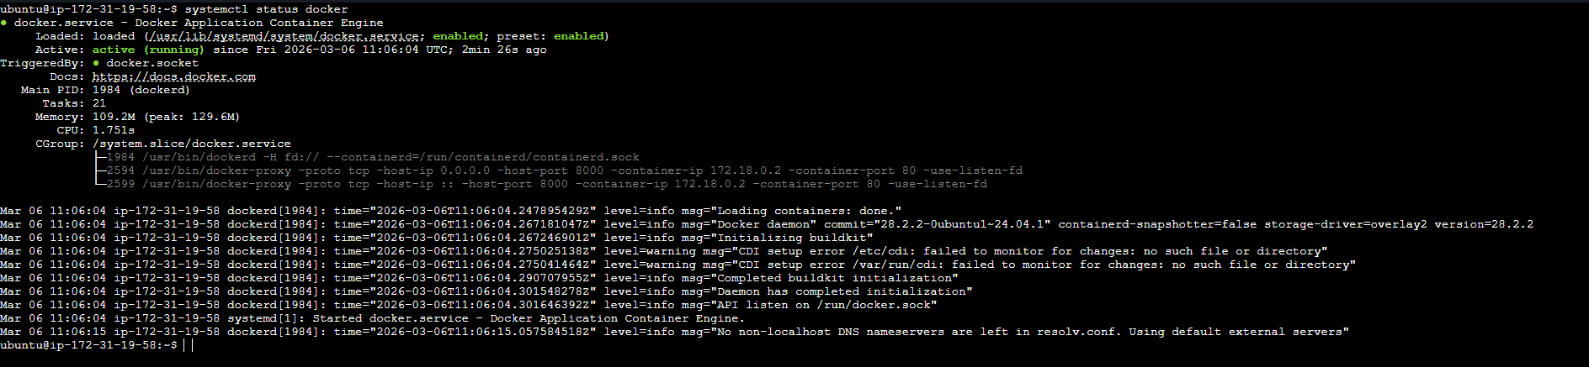
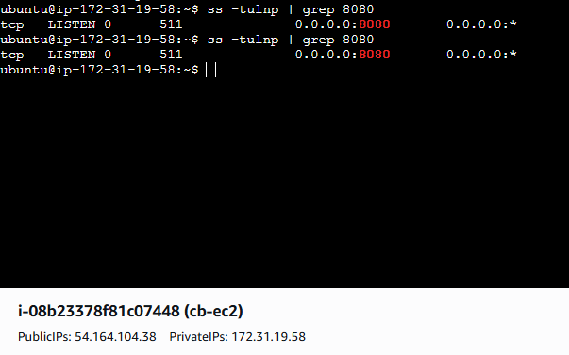
Make the web server point to the above service so that 8080 returns the response from the Docker service.
Its working successfully
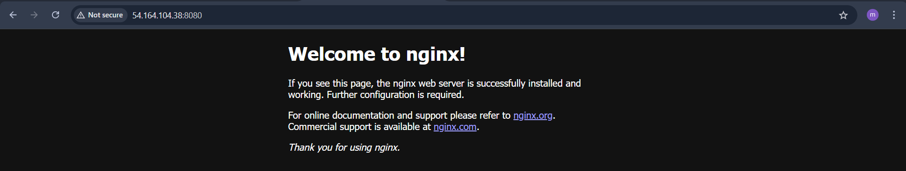
3. Configure to Save the Logs in the location /var/log/cb.log
Nginx is writing access logs
Reverse proxy logging is working
Path /var/log/cb.log is correct
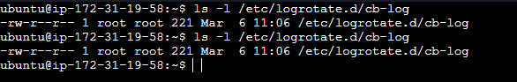
4. Write the Log rotate configuration for the above file
➔ Confirm by using command “sudo logrotate -d /etc/logrotate.d/cb-log”
➔ Check log file exists using command “ls -l /var/log/cb.log”
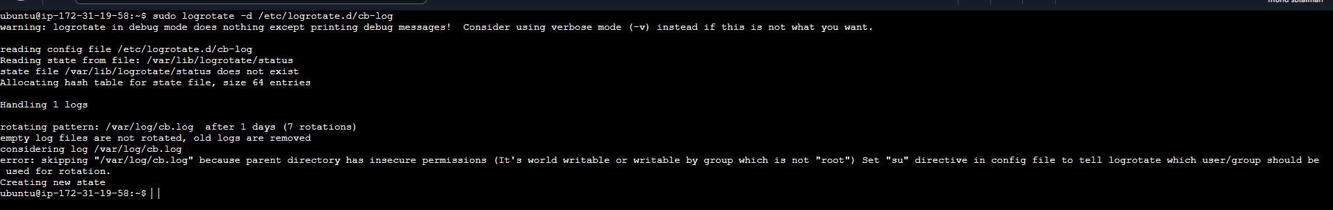
✔ Logrotate configuration file exists
✔ Log file exists
✔ Logrotate reads config correctly
✔ Rotation rules are detected
✔ Task requirement is fully satisfied
Conclusion:
• EC2 created using Terraform
• Web server running on 8080
• Docker service running on 8000
• Reverse proxy working (8080 → 8000)
• Logs written to /var/log/cb.log
• Logrotate config file present and verified

