ENTERPRISE DISTRIBUTED SYSTEMS & EVENT STREAMING
Apache Kafka®
Master Architecture & Engineering Guide
A Comprehensive Reference Manual: From Storage Internals, Log Compaction & KRaft Consensus to At-Least-Once Delivery, Non-Blocking Retries, Dead Letter Topics, EOS Transactions & Production Tuning.
📘 Complete Curriculum: Modules 00–23 • 12 Hands-on Labs • 8 Failure Experiments
⚡ Code Stack: Node.js / KafkaJS • KRaft Cluster • Docker Compose • Production Ready
📊 High-Resolution Rendered Diagrams • Complete Visual Flow Architecture
📅 Edition: 2026 Comprehensive Enterprise Edition

🚀 COMPLETE INSTALLATION & ENVIRONMENT SETUP GUIDE
1. System Prerequisites
Before running any Kafka code, ensure the following software is installed on your local development machine:
Component | Minimum Required Version | Purpose
:--- | :--- | :---
Node.js | v18.0.0+ (LTS recommended) | Runs all Producer, Consumer, Streams, and Benchmark code
Docker Desktop | v24.0+ | Runs the Apache Kafka KRaft cluster, Kafka UI, Postgres & Redis
Docker Compose | v2.20+ | Orchestrates multi-container local infrastructure
Git | v2.30+ | Version control and repository management
VS Code / IDE | Latest | Recommended editor with Prettier and ESLint extensions

2. Step-by-Step Installation
Step 1: Install Project Dependencies
Open your terminal in the learn-kafka directory and install all required Node.js libraries (kafkajs, pg, redis, dotenv, express, uuid):
// BASH CODE SNIPPET
# Navigate to the repository root
cd learn-kafka

# Install all npm dependencies
npm install
Step 2: Start the Local Infrastructure (Docker Compose)
Launch the Apache Kafka broker (KRaft mode), Kafka UI web console, PostgreSQL database, and Redis cache with a single command:
// BASH CODE SNIPPET
# Start all containers in the background
npm run docker:up
# Or directly: docker compose -f docker/docker-compose.yml up -d
Step 3: Verify Container Health
Check that all 4 containers are up and running:
// BASH CODE SNIPPET
npm run docker:status
# Or: docker compose -f docker/docker-compose.yml ps
Expected running containers:
- kafka-node-broker (Apache Kafka 3.7.0 on port 9092)
- kafka-node-ui (Kafka UI Management Dashboard on port 8080)
- kafka-node-postgres (PostgreSQL 16 on port 5432 with user course_user)
- kafka-node-redis (Redis 7 on port 6380)
Step 4: Run the Automated Cluster Healthcheck
Wait for the Kafka broker to finish KRaft quorum initialization and become fully ready to accept client connections:
// BASH CODE SNIPPET
npm run wait:kafka
Output:
// TEXT CODE SNIPPET
🔍 Waiting for Kafka broker at localhost:9092 to be ready...
✅ Kafka broker is healthy and ready to accept connections!
Step 5: Access the Web UI Dashboard
Open your browser and navigate to:
🌐 `http://localhost:8080`
You will see the Provectus Kafka-UI dashboard where you can visually inspect:
- All Topics, Partitions, and Offsets in real-time
- Consumer Groups and live Consumer Lag
- Individual Message Payloads and Headers
- Broker cluster topology and metadata health

3. Useful Kafka CLI Quick Commands
All Kafka CLI tools are bundled inside the Kafka Docker container. You can run them via docker exec:
// BASH CODE SNIPPET
# 1. List all active topics
docker exec -it kafka-node-broker /opt/kafka/bin/kafka-topics.sh --bootstrap-server localhost:9092 --list

# 2. Create a new topic manually (e.g. 3 partitions, replication factor 1)
docker exec -it kafka-node-broker /opt/kafka/bin/kafka-topics.sh --bootstrap-server localhost:9092 --create --topic my-test-topic --partitions 3 --replication-factor 1

# 3. Describe topic partitions, leaders, and replicas
docker exec -it kafka-node-broker /opt/kafka/bin/kafka-topics.sh --bootstrap-server localhost:9092 --describe --topic my-test-topic

# 4. Produce messages from terminal
docker exec -it kafka-node-broker /opt/kafka/bin/kafka-console-producer.sh --bootstrap-server localhost:9092 --topic my-test-topic

# 5. Consume messages from beginning
docker exec -it kafka-node-broker /opt/kafka/bin/kafka-console-consumer.sh --bootstrap-server localhost:9092 --topic my-test-topic --from-beginning

# 6. Inspect Consumer Groups and live lag
docker exec -it kafka-node-broker /opt/kafka/bin/kafka-consumer-groups.sh --bootstrap-server localhost:9092 --list
docker exec -it kafka-node-broker /opt/kafka/bin/kafka-consumer-groups.sh --bootstrap-server localhost:9092 --describe --group my-group

4. Structured Course Learning Path & Execution Guide
Follow this curriculum map to progress from fundamental principles to production architecture:
📊 ARCHITECTURE DIAGRAM: 4. Structured Course Learning Path & Execution Guide
How to Run Hands-On Labs (Labs 01 to 12)
Each lab in labs/ demonstrates a core architectural pattern with runnable Node.js code:
// BASH CODE SNIPPET
# Lab 01: First Producer
npm run lab:01:producer

# Lab 02: First Consumer (Run producer in one terminal, consumer in another)
npm run lab:02:consumer
npm run lab:02:producer

# Lab 03: Topics & Admin API
npm run lab:03:admin

# Lab 04: Partitions & Parallelism
npm run lab:04:producer
npm run lab:04:consumer

# Lab 05: Consumer Groups & Rebalancing
npm run lab:05:producer
npm run lab:05:consumer

# Lab 06: Message Keys & Murmur2 Hashing
npm run lab:06:producer
npm run lab:06:consumer

# Lab 07: Manual Offset Management & Checkpointing
npm run lab:07:producer
npm run lab:07:consumer

# Lab 08: Non-blocking Retries & Exponential Backoff
npm run lab:08:producer
npm run lab:08:consumer

# Lab 09: Dead Letter Queue (DLQ) & Poison Pill Isolation
npm run lab:09:producer
npm run lab:09:consumer
npm run lab:09:dlt-consumer

# Lab 10: Idempotent Consumer (Deduplication via PostgreSQL / Redis)
npm run lab:10:producer
npm run lab:10:consumer

# Lab 11: Exactly-Once Transactions (read-process-write)
npm run lab:11:service

# Lab 12: High-Throughput Performance Benchmark
npm run lab:12:benchmark
How to Run Failure Experiments (Experiments 01 to 08)
Each experiment in experiments/ proves a specific distributed edge-case by triggering real failures:
// BASH CODE SNIPPET
# Exp 01: Global vs. Partition Ordering Skew
npm run exp:01:ordering

# Exp 02: Consumer Sudden Crash & Resume
npm run exp:02:failure

# Exp 03: Dynamic Rebalancing Live Timeline
npm run exp:03:rebalance

# Exp 04: Crash Before Offset Commit (Duplicate Double-Charge Demo)
npm run exp:04:duplicates

# Exp 05: Transient Error Retry Pipeline
npm run exp:05:retries

# Exp 06: Slow Consumer Lag Accumulation & Measurement
npm run exp:06:lag

# Exp 07: Low-Cardinality Key Skew (Hot Partition Problem)
npm run exp:07:hot-partition

# Exp 08: Uncommitted Offsets Crash & 100% Deterministic Replay
npm run exp:08:uncommitted

00 — Course Overview & Learning Roadmap
Welcome to the Complete Apache Kafka + Node.js Hands-On Course!
This course is designed for backend engineers, system architects, and Node.js developers who want to master Apache Kafka through hands-on practice, architecture diagrams, live code, intentional failure experiments, and production-grade project builds.

🎯 Course Goals
By the end of this course, you will:
- Understand Kafka Internals: Brokers, Topics, Partitions, Segments, In-Sync Replicas (ISR), and KRaft metadata quorums.
- Master KafkaJS: Build resilient producers and consumers with fine-tuned batching, compression, manual commit strategies, and rebalance listeners.
- Guarantee Message Reliability: Implement Idempotent Producers, Idempotent Consumers (Deduplication tables), Dead Letter Topics (DLT), and Exponential Backoff Retries.
- Architect Event-Driven Microservices: Build scalable distributed systems using the Transactional Outbox pattern, fan-out topologies, and PostgreSQL/Redis integration.
- Debug Distributed Failures: Understand what happens during network partitions, broker crashes, slow consumer lag, and rebalance storms.

🗺️ Progressive Curriculum
📊 ARCHITECTURE DIAGRAM: 🗺️ Progressive Curriculum
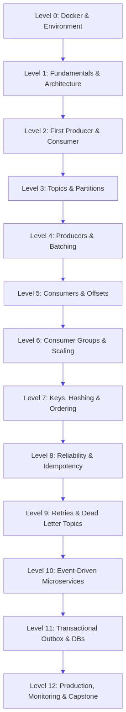

🧭 Repository Structure
- `docs/` (00 to 23): Concise, deeply technical modules covering every core concept.
- `diagrams/`: Dedicated Mermaid architecture blueprints.
- `labs/` (01 to 12): Hands-on exercises with step-by-step instructions and separate exercise/solution code.
- `experiments/` (01 to 08): Intentional failure scripts demonstrating edge-case Kafka behaviors.
- `projects/` (01 to 04): Progressive multi-service applications from simple loggers to enterprise platforms.
- `exercises/`: Quizzes, debugging puzzles, and architecture design challenges.
- `reference/`: Kafka CLI commands, KafkaJS configuration cheat-sheets, and troubleshooting guides.
- `capstone/`: Real-world fintech fraud & transaction streaming platform.

🏁 How to Start
- Start your Kafka cluster:
// BASH CODE SNIPPET
npm run docker:up
npm run wait:kafka
- Open Kafka UI in your browser: http://localhost:8080
- Proceed to docs/01-kafka-fundamentals.md and start with Lab 01 (labs/01-first-producer/).

01 — Kafka Fundamentals
1. What is Apache Kafka?
Apache Kafka is an immutable, distributed, append-only commit log optimized for high-throughput, fault-tolerant event streaming.
Unlike traditional message queues (like RabbitMQ or SQS) where messages are deleted as soon as they are consumed, Kafka retains messages on disk regardless of whether they have been read. Multiple independent consumers can read the same stream at their own pace, and re-read historical data whenever needed.
📊 ARCHITECTURE DIAGRAM: 1. What is Apache Kafka?
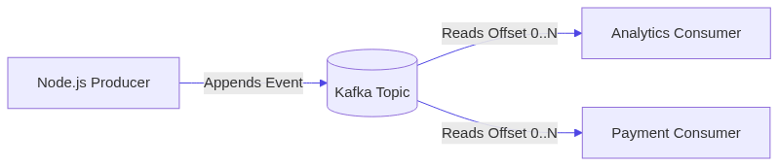

2. Core Concepts at a Glance
Concept | What It Is | Real-World Analogy
:--- | :--- | :---
Event / Message | A record consisting of a key, value, timestamp, and headers | A transaction receipt
Topic | A categorized stream of events | A database table or folder
Partition | An ordered, immutable commit log chunk inside a topic | A single ledger book in an accounting department
Offset | A sequential integer assigned to each message in a partition | Page number in the ledger book
Broker | A single Kafka server node storing and serving partition logs | An individual server machine
Cluster | A collection of brokers working together | A server fleet
Producer | A client application that publishes events to topics | A point-of-sale terminal generating orders
Consumer | A client application that subscribes to and reads topics | A fulfillment warehouse tracking new orders
Consumer Group | A coordinated pool of consumers dividing partitions among themselves | A team of workers splitting incoming shipments

3. What Beginners Think vs. What Kafka Actually Does
What Beginners Think 💭 | What Kafka Actually Does ⚙️
:--- | :---
"Kafka pushes messages to consumers." | Kafka is pull-based (poll-based). Consumers pull batches of messages at their own processing rate.
"Kafka deletes messages once read." | Kafka stores messages until retention expires (e.g., 7 days, or size limit), regardless of consumer reads.
"Kafka guarantees global message order." | Kafka ONLY guarantees order within a single partition. Messages across different partitions arrive independently.
"A topic is just a single queue." | A topic is sharded into one or more parallel partitions.

4. Why Does Kafka Exist?
Before Kafka, systems were wired together with point-to-point connections:
📊 ARCHITECTURE DIAGRAM: 4. Why Does Kafka Exist?
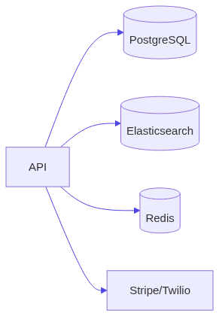
As systems grow, $N$ services need $N^2$ connections, causing tight coupling, cascading failures, and zero replayability.
With Kafka:
📊 ARCHITECTURE DIAGRAM: 4. Why Does Kafka Exist?
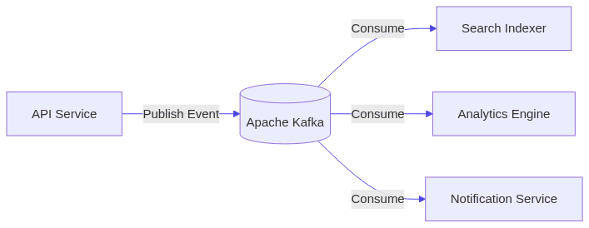
The producer only cares about publishing an event once. Any current or future service can consume that stream asynchronously without impacting the producer.

5. Next Steps
Move to [02-kafka-architecture.md](file:///c:/Users/Sulaiman/Desktop/pratice-dev/docs/02-kafka-architecture.md) to understand how the storage engine, KRaft, and brokers function under the hood.

02 — Kafka Architecture & Storage Internals
1. High-Level Architecture
Kafka operates as a distributed cluster of broker instances coordinated by the KRaft (Kafka Raft) metadata consensus protocol (or previously Apache ZooKeeper).
📊 ARCHITECTURE DIAGRAM: 1. High-Level Architecture
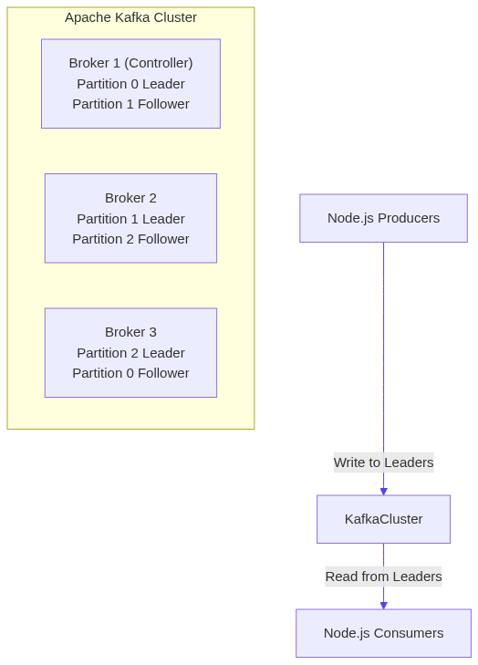

2. The Log Storage Engine: Why Kafka is Incredibly Fast
Many engineers assume disk I/O is slow. Kafka proves sequential disk I/O is nearly as fast as memory access due to:
- Sequential Disk Appends: Kafka only writes to the end of a log file (O(1) append), avoiding slow random disk seeks.
- Page Cache Architecture: Kafka writes directly to the OS Page Cache (RAM), leaving memory management to the OS kernel.
- Zero-Copy Network Transfer (`sendfile`): Data is moved directly from OS Page Cache to the network socket without copying data into Kafka's JVM application memory space.
📊 ARCHITECTURE DIAGRAM: 2. The Log Storage Engine: Why Kafka is Incredibly Fast
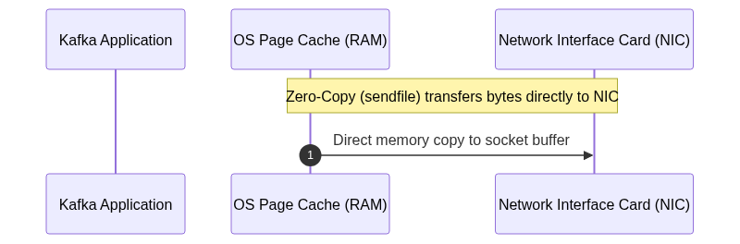

3. Physical Disk Structure: Segments & Indexes
Each partition is stored on disk as a folder named <topic>-<partition_id>. Inside this folder are Segment Files:
// TEXT CODE SNIPPET
/var/lib/kafka/data/orders-0/
├── 00000000000000000000.log <- Actual serialized message payloads
├── 00000000000000000000.index <- Maps logical offset to physical byte position
├── 00000000000000000000.timeindex <- Maps timestamp to offset
├── leader-epoch-checkpoint
- When a segment reaches segment.bytes (default 1GB) or segment.ms (default 7 days), it is closed and a new active segment is rolled.
- Retention cleanup (delete or compact) operates on entire closed segments, making log cleanup lightning-fast without rewriting the whole file.

4. KRaft (Kafka Raft Metadata Mode)
In modern Kafka (3.0+), ZooKeeper is deprecated in favor of KRaft:
- Metadata is stored in an internal Kafka topic @metadata.
- A small quorum of brokers act as Active Controller and Followers.
- Failover takes milliseconds instead of seconds, and clusters scale to millions of partitions.

5. Next Steps
Go to [03-topics.md](file:///c:/Users/Sulaiman/Desktop/pratice-dev/docs/03-topics.md) to learn how to design, create, and manage Kafka topics.

03 — Topics
1. What is a Topic?
A Topic is a named, logical stream of events in Kafka. Think of it as a table in a relational database or a directory of append-only log files.
📊 ARCHITECTURE DIAGRAM: 1. What is a Topic?
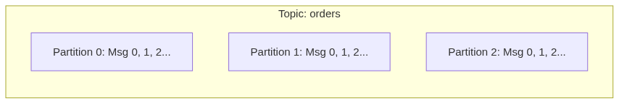

2. Topic Naming Conventions (Industry Best Practices)
A good topic naming convention avoids chaos across engineering teams:
$$\text{<domain>.<entity>.<event-type>.<version>}$$
Examples:
- commerce.orders.created.v1
- commerce.orders.cancelled.v1
- payments.transactions.settled.v1
- identity.users.registered.v1
Rules:
- Use lowercase letters, dots, and hyphens (avoid underscores to prevent metric collision).
- Never reuse a topic name with incompatible schema changes; increment the version suffix (e.g., v2).

3. Key Topic Configuration Parameters
Parameter | Default | Production Recommendation | Description
:--- | :--- | :--- | :---
partitions | 1 | 3–12 (based on throughput) | Number of parallel log streams
replication.factor | 1 (dev) | 3 | Number of broker copies for fault tolerance
retention.ms | 604800000 (7 days) | Project-specific (e.g. 7 days or 30 days) | Duration to keep log data before pruning
cleanup.policy | delete | delete or compact | delete prunes old records; compact keeps latest record per key
min.insync.replicas | 1 | 2 (with RF=3) | Minimum replicas that must acknowledge a write

4. Managing Topics with KafkaJS Admin Client
// JAVASCRIPT CODE SNIPPET
import { Kafka } from 'kafkajs';

const kafka = new Kafka({ clientId: 'admin-app', brokers: ['localhost:9092'] });
const admin = kafka.admin();

await admin.connect();

// Create topic
await admin.createTopics({
waitForLeaders: true,
topics: [
{
topic: 'commerce.orders.created.v1',
numPartitions: 3,
replicationFactor: 1,
configEntries: [
{ name: 'retention.ms', value: '86400000' } // 24 hours
]
}
]
});

// List all topics
const topics = await admin.listTopics();
console.log('Available topics:', topics);

await admin.disconnect();

5. Next Steps
Explore [04-partitions.md](file:///c:/Users/Sulaiman/Desktop/pratice-dev/docs/04-partitions.md) to understand how partitions enable Kafka's horizontal scalability.

04 — Partitions & Partitioning Strategies
1. Why Do Partitions Exist?
A single machine has hard physical limits on disk throughput, network bandwidth, and memory. If a topic had only one partition, its write throughput would be capped at the speed of that single broker.
Partitions solve two problems:
- Horizontal Scalability (Storage & Throughput): A topic with 12 partitions can be spread across 12 different broker disks.
- Parallel Consumption: Each partition in a topic can be consumed by at most one consumer instance inside the same consumer group at any given time.
📊 ARCHITECTURE DIAGRAM: 1. Why Do Partitions Exist?
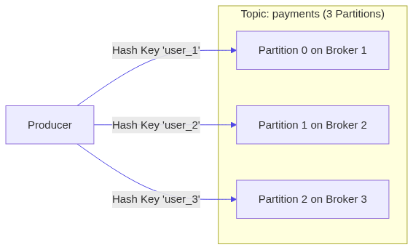

2. Partition Ordering Rules
❗ CRITICAL REQUIREMENT
Kafka ONLY guarantees ordering WITHIN a single partition.
There is no global ordering guarantee across different partitions of the same topic.
// TEXT CODE SNIPPET
Partition 0: [Msg A (offset 0)] -> [Msg B (offset 1)] -> [Msg C (offset 2)] (Guaranteed order A -> B -> C)
Partition 1: [Msg X (offset 0)] -> [Msg Y (offset 1)] (Guaranteed order X -> Y)
If Consumer reads both P0 and P1, it might process Msg X, then Msg A, then Msg Y, then Msg B.

3. How Kafka Assigns Messages to Partitions
When a producer sends a message:
- With a Message Key: Kafka computes a 32-bit Murmur2 hash of the key:
$$\text{partition} = \text{murmur2}(\text{key}) \pmod{\text{numPartitions}}$$
All messages with the exact same key will always land in the same partition, guaranteeing strict per-entity ordering (e.g. all events for order_100 are strictly ordered).
- Without a Message Key (`null` key): Kafka uses a sticky partitioning or round-robin strategy to distribute batches evenly across partitions.

4. Scaling Considerations: Can You Reduce Partitions?
- Increasing Partitions: You can increase the number of partitions on a live topic (e.g. from 3 to 6).
- Decreasing Partitions: IMPOSSIBLE in Kafka without recreating the topic. Decreasing partitions would violate existing key-hash mappings and truncate historical data.
- Key Hashing Impact: When you increase the partition count, existing keys will hash to different partition indices. If ordering of past events matters, plan partition counts upfront!

5. Next Steps
Go to [05-producers.md](file:///c:/Users/Sulaiman/Desktop/pratice-dev/docs/05-producers.md) to build robust Node.js producers.

05 — Producers & Publishing Patterns
1. Producer Lifecycle & Internal Buffering
A Kafka producer does not immediately send each message to the broker over the network one by one. Instead, it accumulates messages into an internal memory buffer organized by target partition, and flushes batches over TCP connections.
📊 ARCHITECTURE DIAGRAM: 1. Producer Lifecycle & Internal Buffering

2. KafkaJS Producer Configuration & Options
// JAVASCRIPT CODE SNIPPET
import { Kafka, CompressionTypes } from 'kafkajs';

const kafka = new Kafka({
clientId: 'order-api-producer',
brokers: ['localhost:9092'],
retry: {
initialRetryTime: 300,
retries: 8
}
});

// Idempotent producer prevents duplicate messages and out-of-order retries
const producer = kafka.producer({
idempotent: true,
maxInFlightRequests: 1
});

await producer.connect();

const result = await producer.send({
topic: 'commerce.orders.created.v1',
compression: CompressionTypes.GZIP,
acks: -1, // Wait for all In-Sync Replicas (all ISR)
messages: [
{
key: 'order_9901',
value: JSON.stringify({
orderId: 'order_9901',
userId: 'user_44',
amount: 250.00,
createdAt: new Date().toISOString()
}),
headers: {
'correlation-id': 'corr-abc-123',
'source-service': 'order-api'
}
}
]
});

console.log('Message delivered to partition:', result[0].partition, 'offset:', result[0].baseOffset);
await producer.disconnect();

3. Acknowledgements (`acks`) Explained
`acks` Setting | Description | Data Safety | Latency
:--- | :--- | :--- | :---
acks = 0 | Producer sends and does NOT wait for any reply. | ❌ High risk of data loss if broker crashes | Fastest
acks = 1 | Waits for the Partition Leader broker to write to its local disk. | ⚠️ Low risk; lost if leader dies before replicating to follower | Medium
acks = -1 (acks = all) | Waits for the Leader AND all In-Sync Replicas (min.insync.replicas). | ✅ Zero data loss guarantee | High safety

4. Batching and Throughput Tuning
- `compression`: Use CompressionTypes.GZIP or CompressionTypes.Snappy to reduce network payload sizes by 50–80%.
- `maxInFlightRequests`: Number of unacknowledged requests allowed concurrently. Set to 1 when ordering across retries is critical without idempotency, or leave default with idempotent: true.

5. Next Steps
Go to [06-consumers.md](file:///c:/Users/Sulaiman/Desktop/pratice-dev/docs/06-consumers.md) to build resilient event consumers.

06 — Consumers & Polling Loop
1. How Consumers Work: The Poll Loop
Kafka consumers are pull-based. The consumer establishes long-polling TCP connections to the partition leader brokers, fetching batches of messages into memory and executing your business logic.
📊 ARCHITECTURE DIAGRAM: 1. How Consumers Work: The Poll Loop
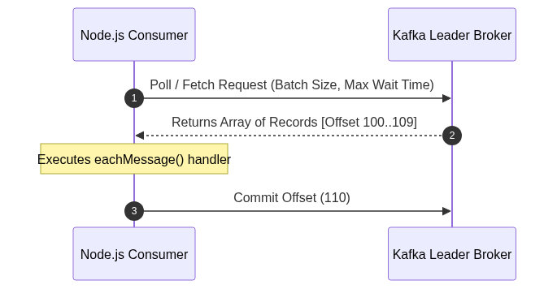

2. KafkaJS Consumer Implementation
// JAVASCRIPT CODE SNIPPET
import { Kafka } from 'kafkajs';

const kafka = new Kafka({
clientId: 'notification-worker',
brokers: ['localhost:9092']
});

const consumer = kafka.consumer({
groupId: 'notification-service-group',
sessionTimeout: 30000,
heartbeatInterval: 3000
});

await consumer.connect();

// Subscribe to one or multiple topics
await consumer.subscribe({
topic: 'commerce.orders.created.v1',
fromBeginning: false // false = only new messages; true = replay from earliest offset if no committed offset exists
});

await consumer.run({
autoCommit: true,
autoCommitInterval: 5000,
eachMessage: async ({ topic, partition, message, heartbeat }) => {
const key = message.key?.toString();
const payload = JSON.parse(message.value.toString());
const offset = message.offset;

console.log(`[P${partition}@${offset}] Received event:`, payload);

// If processing takes long, send heartbeat to prevent rebalance
await heartbeat();
}
});

3. `eachMessage` vs. `eachBatch`
Feature | `eachMessage` | `eachBatch`
:--- | :--- | :---
Granularity | Invokes callback for one record at a time | Passes entire fetched batch of records
Commit Control | Automatically handled or manual per record | Fine-grained manual control (e.g. bulk database insert then commit)
Heartbeat | heartbeat() callback provided | heartbeat() + batch progress markers provided
Best For | Standard event processing, clean logic | High-throughput batch inserts (PostgreSQL COPY, Elasticsearch bulk)

4. Heartbeats & Rebalance Avoidance
Consumers send background heartbeats to the Group Coordinator broker. If a consumer's event loop blocks longer than sessionTimeout (default 30s) or maxPollInterval (KafkaJS maxWaitTimeInMs), the coordinator assumes the consumer is dead and triggers a Rebalance, kicking the consumer out.

5. Next Steps
Go to [07-consumer-groups.md](file:///c:/Users/Sulaiman/Desktop/pratice-dev/docs/07-consumer-groups.md) to understand consumer scaling and rebalance protocols.

07 — Consumer Groups & Load Balancing
1. What is a Consumer Group?
A Consumer Group is a set of consumers that cooperate to read all partitions of a topic. Kafka dynamically partitions the workload among members of the group.
📊 ARCHITECTURE DIAGRAM: 1. What is a Consumer Group?
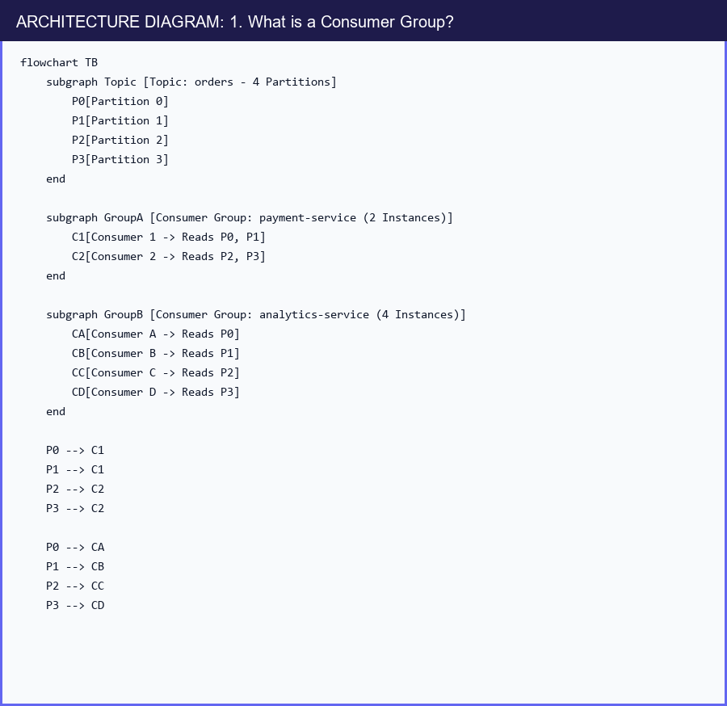

2. Partition Assignment Rules
❗ CRITICAL REQUIREMENT
Cardinality Rule:
A single partition can be consumed by ONLY ONE consumer within a given consumer group at any instant.
If you have 4 Partitions and 5 Consumers in the same group, the 5th consumer will sit 100% idle!
// TEXT CODE SNIPPET
3 Partitions + 1 Consumer => Consumer reads P0, P1, P2
3 Partitions + 2 Consumers => Consumer 1 reads P0, P1 | Consumer 2 reads P2
3 Partitions + 3 Consumers => Consumer 1 (P0) | Consumer 2 (P1) | Consumer 3 (P2)
3 Partitions + 4 Consumers => Consumer 1 (P0) | Consumer 2 (P1) | Consumer 3 (P2) | Consumer 4 (IDLE ⚠️)

3. Consumer Rebalancing
When a consumer joins, crashes, or is shut down, Kafka triggers a Rebalance:
- The Group Coordinator Broker notifies active members.
- The Group Leader computes the new partition assignment (e.g. RoundRobin, Range, or CooperativeSticky).
- Partitions are redistributed to the surviving consumers.
KafkaJS emits rebalance lifecycle events you can listen to:
// JAVASCRIPT CODE SNIPPET
consumer.on(consumer.events.GROUP_JOIN, (event) => {
console.log('Joined group! Assigned partitions:', event.payload.memberAssignment);
});

consumer.on(consumer.events.REBALANCING, () => {
console.warn('⚠️ Group is rebalancing! Committing in-flight work...');
});

4. Next Steps
Go to [08-offsets.md](file:///c:/Users/Sulaiman/Desktop/pratice-dev/docs/08-offsets.md) to master offset management and commit strategies.

08 — Offsets & Commit Management
1. What is an Offset?
An Offset is a monotonically increasing 64-bit integer assigned to every message arriving at a partition.
- Current Offset (Fetch Position): The next offset the consumer will pull from Kafka.
- Committed Offset: The offset stored in Kafka's internal __consumer_offsets topic representing the last successfully processed message for a consumer group.
📊 ARCHITECTURE DIAGRAM: 1. What is an Offset?
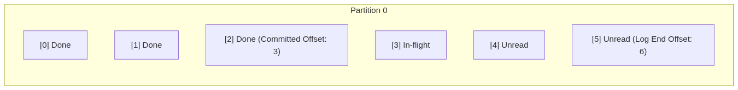

2. Auto-Commit vs. Manual Commit
A. Auto-Commit (`autoCommit: true`)
The consumer automatically commits offsets periodically in the background (default every 5000ms).
⚠️ WARNING / PRODUCTION GOTCHA
Risk of Data Loss or Duplicates with Auto-Commit:
If your application crashes after fetching records but before finishing database operations, or after finishing DB work but before auto-commit fires, you will either lose data or process duplicate messages upon restart!
B. Manual Commit (`autoCommit: false`)
You explicitly commit the offset only after business operations (like database writes) have succeeded:
// JAVASCRIPT CODE SNIPPET
await consumer.run({
autoCommit: false,
eachMessage: async ({ topic, partition, message }) => {
// 1. Process business logic (e.g. database save)
await saveOrderToDatabase(JSON.parse(message.value.toString()));

// 2. Explicitly commit the offset + 1 (next unread offset)
await consumer.commitOffsets([
{
topic,
partition,
offset: (BigInt(message.offset) + 1n).toString()
}
]);
}
});

3. Offset Reset Strategies: `earliest` vs. `latest`
When a consumer starts with a new groupId (or if its committed offset was expired and pruned by Kafka):
- `fromBeginning: true` (`earliest`): Reads all available messages from the start of the partition (offset 0).
- `fromBeginning: false` (`latest`): Ignores historical messages and only processes messages arriving after the consumer starts.

4. Seeking and Replaying Offsets
With Kafka, you can rewind time and reprocess data:
// JAVASCRIPT CODE SNIPPET
consumer.seek({
topic: 'commerce.orders.created.v1',
partition: 0,
offset: '0' // Rewind to beginning
});

5. Next Steps
Go to [09-message-keys.md](file:///c:/Users/Sulaiman/Desktop/pratice-dev/docs/09-message-keys.md) to learn how message keys preserve ordering across distributed partitions.

09 — Message Keys & Ordering Guarantees
1. The Per-Entity Ordering Problem
In microservices, state mutations must happen in strict sequential order:
- ORDER_CREATED ($t_0$)
- PAYMENT_CAPTURED ($t_1$)
- ORDER_CANCELLED ($t_2$)
If ORDER_CANCELLED is processed before PAYMENT_CAPTURED, the customer might be billed after cancellation!

2. Key-Based Partition Routing
By supplying an entity ID (e.g., userId or orderId) as the Kafka message key, Kafka applies Murmur2 hashing to consistently route every event for that entity to the exact same partition.
📊 ARCHITECTURE DIAGRAM: 2. Key-Based Partition Routing
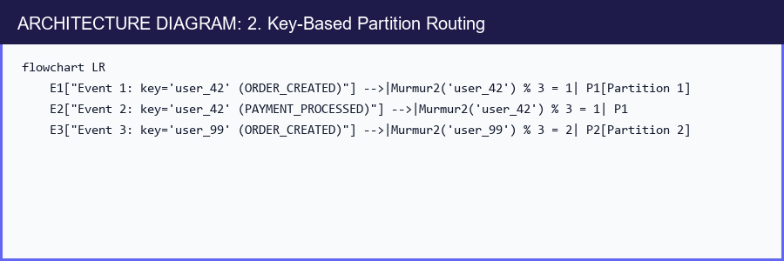
Because Partition 1 is an append-only log consumed sequentially by a single consumer worker, Event 1 is guaranteed to be processed before Event 2.

3. The Hot Partition Trap (Key Skew)
⚠️ WARNING / PRODUCTION GOTCHA
Beware of Low-Cardinality or Skewed Keys!
If you set key = countryCode and 90% of your users are in US, Partition murmur2('US') will receive 90% of total traffic, causing CPU exhaustion and consumer lag while other partitions sit idle.
Best Practices for Key Selection:
- ✅ High-cardinality unique entity IDs: userId, orderId, deviceId, tenantId.
- ❌ Low-cardinality status codes or boolean flags: status: "SUCCESS", gender: "M".

4. Next Steps
Go to [10-replication.md](file:///c:/Users/Sulaiman/Desktop/pratice-dev/docs/10-replication.md) to understand broker replication, ISR quorums, and leader election.

10 — Replication, Leaders & In-Sync Replicas (ISR)
1. Why Replication Matters
Hardware fails: hard drives crash, network cables get disconnected, cloud VMs get preempted.
Kafka replicates each partition log across multiple broker nodes to guarantee high availability and zero data loss.
📊 ARCHITECTURE DIAGRAM: 1. Why Replication Matters
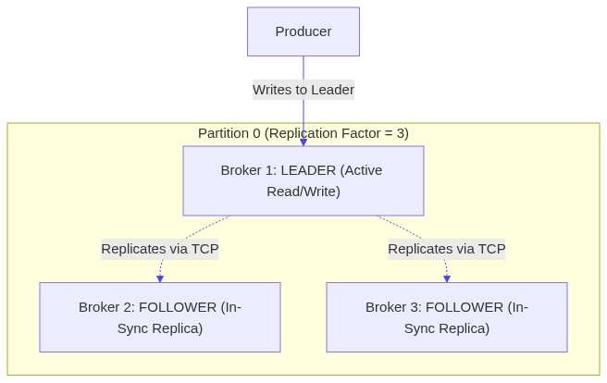

2. Key Terms Defined
- Replication Factor (RF): Total number of copies of a partition across distinct brokers (Production standard = 3).
- Partition Leader: The single broker responsible for all client reads and writes for that partition.
- Partition Follower: Brokers that fetch messages from the leader and replicate the log locally.
- In-Sync Replicas (ISR): The set of followers actively caught up with the leader within replica.lag.time.max.ms (e.g. 30 seconds).

3. High Availability Formula
For maximum durability and zero message loss in production:
$$\text{Replication Factor} = 3, \quad \text{min.insync.replicas} = 2, \quad \text{acks} = \text{all} (-1)$$
Under this configuration:
- Producer sends message to Leader.
- Leader waits until at least 1 Follower copies the record ($1 \text{ leader} + 1 \text{ follower} = 2 \text{ ISR}$).
- If 1 broker crashes, the cluster continues writing and reading without interruption or data loss!

4. Next Steps
Go to [11-delivery-semantics.md](file:///c:/Users/Sulaiman/Desktop/pratice-dev/docs/11-delivery-semantics.md) to understand At-Most-Once, At-Least-Once, and Exactly-Once semantics.

11 — Delivery Semantics
1. The Three Delivery Guarantees
In distributed messaging, there are three fundamental delivery guarantees:
Semantic | Message Loss? | Duplicate Processing? | How to Achieve in Node.js
:--- | :--- | :--- | :---
At-Most-Once | ⚠️ Possible | ❌ Never | autoCommit: true, acks: 0 or commit offset before processing work
At-Least-Once (Default Standard) | ❌ Never | ⚠️ Possible | acks: all, idempotent: true, commit offset after DB transaction succeeds
Exactly-Once (EOS) | ❌ Never | ❌ Never | Kafka Transactions (transactional.id) OR Idempotent Consumer + DB Deduplication Table

2. Why Duplicates Occur in Real Networks
📊 ARCHITECTURE DIAGRAM: 2. Why Duplicates Occur in Real Networks
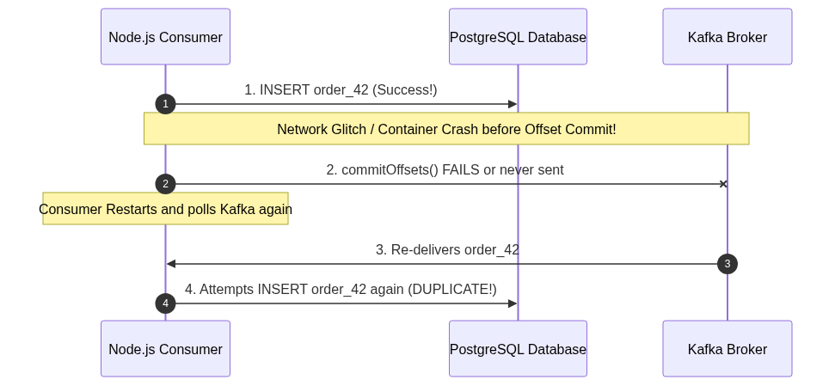
Because network acknowledgments can always fail after processing has completed, At-Least-Once is the default behavior of distributed systems.

3. Production Rule: Build for Idempotency
Never assume Kafka will deliver a message exactly once end-to-end to downstream third parties (like Stripe or email APIs). Always combine:
- Producer Idempotency (idempotent: true) to prevent broker-level duplicate appends during network retries.
- Consumer Idempotency (Database Unique Key / Deduplication Table) to ensure re-delivered messages do not create duplicate side effects.

4. Next Steps
Go to [12-retries.md](file:///c:/Users/Sulaiman/Desktop/pratice-dev/docs/12-retries.md) to implement resilient multi-tier retry architectures.

12 — Retry Architecture & Exponential Backoff
1. The Head-of-Line Blocking Trap
If a consumer encounters a temporary failure (e.g., downstream payment gateway 503 error) and loops endlessly trying to reprocess that one message, all subsequent messages in that partition are blocked!
// TEXT CODE SNIPPET
[Msg 1: Valid] -> [Msg 2: FAILING RETRY LOOP 🛑] -> [Msg 3: Blocked] -> [Msg 4: Blocked]

2. Non-Blocking Retry Architecture: Topic-Based Backoff
To prevent Head-of-Line blocking, forward failing messages to dedicated Retry Topics with increasing delays:
📊 ARCHITECTURE DIAGRAM: 2. Non-Blocking Retry Architecture: Topic-Based Backoff
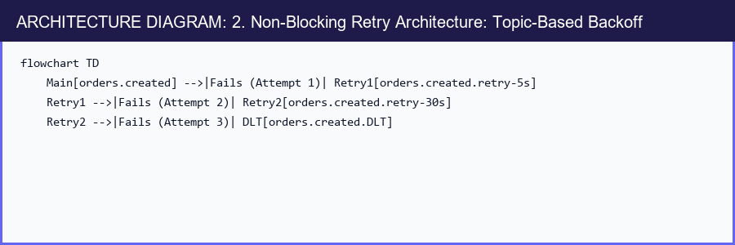
Flow:
- Main Consumer: Tries processing. If failure is transient, publishes message to orders.created.retry-5s with header x-retry-count: 1, then commits offset on the main topic.
- Retry Worker: Polls retry-5s topic, checks message timestamp, sleeps until 5s delay is met, and attempts reprocessing.
- If max retries exceeded, forwards payload to the Dead Letter Topic (DLT).

3. Transient vs. Permanent Errors
Error Type | Examples | Action
:--- | :--- | :---
Transient | Database connection timeout, Redis rate limit, HTTP 503 | Send to Retry Topic with exponential backoff
Permanent (Poison Pill) | Malformed JSON, missing required fields, 400 Bad Request | Send immediately to Dead Letter Topic (DLT)

4. Next Steps
Go to [13-dead-letter-topics.md](file:///c:/Users/Sulaiman/Desktop/pratice-dev/docs/13-dead-letter-topics.md) to inspect and recover unprocessable messages in a Dead Letter Topic.

13 — Dead Letter Topics (DLT / DLQ)
1. What is a Dead Letter Topic?
A Dead Letter Topic (DLT) is an isolation topic where unprocessable, corrupt, or permanently failing events are stored for operator inspection, debugging, alerting, and eventual reprocessing.
📊 ARCHITECTURE DIAGRAM: 1. What is a Dead Letter Topic?
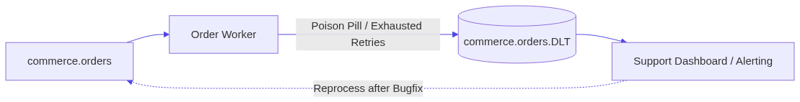

2. Essential Metadata Headers for DLT Records
Never dump raw payloads to a DLT without diagnostic context! Always preserve:
// JAVASCRIPT CODE SNIPPET
const dltHeaders = {
'x-original-topic': topic,
'x-original-partition': partition.toString(),
'x-original-offset': message.offset,
'x-original-timestamp': message.timestamp,
'x-exception-message': error.message,
'x-exception-stack': error.stack || '',
'x-failed-at': new Date().toISOString(),
'x-retry-attempts': retryCount.toString()
};

await producer.send({
topic: `${topic}.DLT`,
messages: [{
key: message.key,
value: message.value,
headers: dltHeaders
}]
});

3. DLT Recovery Strategies
- Dead-Letter Consumer UI: View and search failing payloads in Kafka UI or a custom web dashboard.
- Replay Script: After fixing the bug in application code, run a CLI utility that reads events from .DLT and repushes them to the main topic.

4. Next Steps
Go to [14-idempotency.md](file:///c:/Users/Sulaiman/Desktop/pratice-dev/docs/14-idempotency.md) to implement bulletproof deduplication tables and idempotent producers.

14 — Idempotency & Deduplication
1. What is Idempotence?
An operation is idempotent if executing it multiple times produces the exact same system state as executing it once:
$$f(f(x)) = f(x)$$
Example:
- SET account_balance = 100 is Idempotent (running 10 times leaves balance at 100).
- INCREMENT account_balance BY 100 is NOT Idempotent (running 10 times adds 1000).

2. Producer-Level Idempotency (`idempotent: true`)
When idempotent: true is enabled in KafkaJS:
- The broker assigns each producer a unique Producer ID (PID).
- Each batch sent to a partition is tagged with a monotonically increasing Sequence Number.
- If the broker receives a batch with a Sequence Number it has already committed to disk, it acknowledges the batch without writing a duplicate record.
// JAVASCRIPT CODE SNIPPET
const producer = kafka.producer({
idempotent: true,
maxInFlightRequests: 1 // or up to 5 in modern Kafka
});

3. Consumer-Level Idempotency: PostgreSQL Deduplication Table
To prevent duplicate side-effects when re-reading from Kafka, use an atomic database transaction with an idempotency_keys or processed_events table:
// SQL CODE SNIPPET
CREATE TABLE IF NOT EXISTS processed_events (
event_id VARCHAR(255) PRIMARY KEY,
topic VARCHAR(255) NOT NULL,
processed_at TIMESTAMP WITH TIME ZONE DEFAULT CURRENT_TIMESTAMP
);
Node.js Implementation:
// JAVASCRIPT CODE SNIPPET
import pg from 'pg';
const pool = new pg.Pool({ connectionString: process.env.DATABASE_URL });

async function processOrderEvent(event) {
const client = await pool.connect();
try {
await client.query('BEGIN');

// Attempt to register event ID
const insertEventResult = await client.query(
`INSERT INTO processed_events (event_id, topic)
VALUES ($1, $2)
ON CONFLICT (event_id) DO NOTHING
RETURNING event_id`,
[event.eventId, 'orders']
);

// If no row returned, this event was already processed!
if (insertEventResult.rowCount === 0) {
console.log(`⚠️ Event ${event.eventId} already processed. Skipping duplicate.`);
await client.query('ROLLBACK');
return;
}

// Execute business logic inside same transaction
await client.query(
`INSERT INTO orders (id, user_id, amount, status)
VALUES ($1, $2, $3, $4)`,
[event.orderId, event.userId, event.amount, 'CONFIRMED']
);

await client.query('COMMIT');
console.log(`✅ Order ${event.orderId} processed successfully.`);
} catch (err) {
await client.query('ROLLBACK');
throw err;
} finally {
client.release();
}
}

4. Next Steps
Go to [15-schema-management.md](file:///c:/Users/Sulaiman/Desktop/pratice-dev/docs/15-schema-management.md) to manage event schemas safely without breaking downstream consumers.

15 — Schema Management & Schema Evolution
1. The Broken Contract Problem
In loosely-coupled event architectures, producers and consumers deploy independently.
If the producer changes a field from amount: 100 (number in cents) to amount: "100.00" (string formatted in dollars) or deletes userId, existing consumer microservices will crash with runtime exceptions!
📊 ARCHITECTURE DIAGRAM: 1. The Broken Contract Problem

2. Schema Evolution Compatibility Modes
Mode | Meaning | Producer / Consumer Upgrade Order
:--- | :--- | :---
BACKWARD | New schema can read data written by old schema (delete optional fields, add fields with defaults) | Upgrade Consumers first
FORWARD | Old schema can read data written by new schema (add optional fields, delete fields with defaults) | Upgrade Producers first
FULL | Backward AND Forward compatible (only add/remove fields with default values) | Upgrade in any order

3. Serialization Formats
- Plain JSON: Easy to debug and inspect, but has no runtime schema enforcement, is verbose, and wastes network bandwidth.
- Apache Avro: Binary compact format with strict schema definitions (.avsc) and tight integration with Confluent Schema Registry.
- Protocol Buffers (Protobuf): Google's cross-platform binary format with language-agnostic .proto compilers and strong backward compatibility.

4. Next Steps
Go to [16-kafka-connect.md](file:///c:/Users/Sulaiman/Desktop/pratice-dev/docs/16-kafka-connect.md) to integrate external databases without writing custom pipeline code.

16 — Kafka Connect & Change Data Capture (CDC)
1. What is Kafka Connect?
Kafka Connect is a distributed runtime framework for reliably streaming data between Apache Kafka and external datastores (PostgreSQL, MySQL, MongoDB, Elasticsearch, Snowflake, S3) without writing custom producer or consumer boilerplate.
📊 ARCHITECTURE DIAGRAM: 1. What is Kafka Connect?
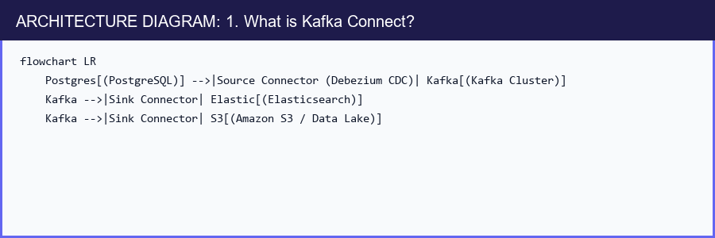

2. Source Connectors vs. Sink Connectors
- Source Connector: Captures changes from an external system and writes events into Kafka (e.g. Debezium reading PostgreSQL Write-Ahead Log / WAL).
- Sink Connector: Reads events from Kafka topics and writes records into external systems (e.g., Elasticsearch indexer, S3 Parquet archiver).

3. Change Data Capture (CDC) with Debezium
Instead of having your application publish to Kafka manually, CDC monitors the database's internal transaction log (WAL).
- Zero code changes required in the primary API.
- Guaranteed capture of every INSERT, UPDATE, and DELETE.
- Perfect for feeding search indexes and read-replicas.

4. Next Steps
Go to [17-kafka-streams-concepts.md](file:///c:/Users/Sulaiman/Desktop/pratice-dev/docs/17-kafka-streams-concepts.md) to learn stream processing patterns.

17 — Kafka Streams & Real-Time Processing Concepts
1. What is Stream Processing?
Traditional batch architectures collect data in a database and run cron queries once an hour or once a day.
Stream Processing evaluates events continuously, element-by-element or in tumbling windows, as they occur in real time.
📊 ARCHITECTURE DIAGRAM: 1. What is Stream Processing?

2. Core Stream Processing Patterns
- Stateless Operations: filter(), map(), flatMap(), branch(). Each incoming event is transformed independently without remembering past state.
- Stateful Operations:
- Aggregations: Count of page views per user over the last 10 minutes.
- Stream-Stream Joins: Joining an order_created event with an inventory_reserved event arriving within 5 seconds of each other.
- Stream-Table Joins (Enrichment): Joining an order_created stream with a cached user_profiles table to add user name and email.

3. Windowing Types
- Tumbling Window: Fixed size, non-overlapping (e.g. 00:00–00:05, 00:05–00:10).
- Hopping (Sliding) Window: Fixed size, overlapping (e.g. 5-minute window advancing every 1 minute).
- Session Window: Dynamic size bounded by periods of inactivity (e.g. user browsing session).

4. Next Steps
Go to [18-transactions.md](file:///c:/Users/Sulaiman/Desktop/pratice-dev/docs/18-transactions.md) to implement atomic multi-topic transactions.

18 — Transactions & Exactly-Once Semantics (EOS)
1. The Consume-Transform-Produce Problem
In complex pipelines, a service reads an event from Topic A, updates internal state, and produces an event to Topic B.
If the service crashes after publishing to Topic B but before committing offset to Topic A, restarting will cause Topic B to receive a duplicate!
📊 ARCHITECTURE DIAGRAM: 1. The Consume-Transform-Produce Problem
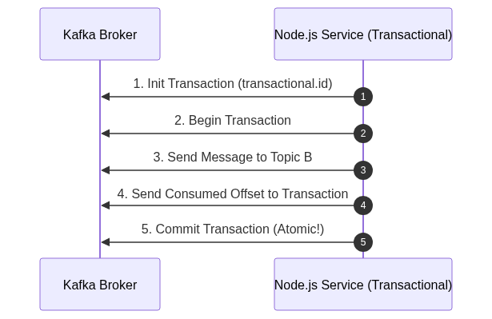

2. KafkaJS Transactional Producer
// JAVASCRIPT CODE SNIPPET
import { Kafka } from 'kafkajs';

const kafka = new Kafka({ clientId: 'tx-service', brokers: ['localhost:9092'] });
const producer = kafka.producer({
transactionalId: 'order-settlement-tx-1',
maxInFlightRequests: 1,
idempotent: true
});

await producer.connect();
const transaction = await producer.transaction();

try {
// Send message as part of transaction
await transaction.send({
topic: 'finance.settlements.v1',
messages: [{ key: 'tx_101', value: JSON.stringify({ amount: 500, status: 'PAID' }) }]
});

// Atomically commit consumed offsets along with outgoing messages
await transaction.sendOffsets({
consumerGroupId: 'payment-processor-group',
topics: [{ topic: 'orders.pending.v1', partitions: [{ partition: 0, offset: '150' }] }]
});

await transaction.commit();
console.log('✅ Transaction committed atomically!');
} catch (err) {
console.error('Transaction failed, aborting:', err);
await transaction.abort();
}

3. Read Committed Isolation Level
Downstream consumers must configure read_committed to avoid reading aborted or in-flight transaction records:
// JAVASCRIPT CODE SNIPPET
const consumer = kafka.consumer({
groupId: 'downstream-audit-group',
readUncommitted: false // Only read committed transactional messages
});

4. Next Steps
Go to [19-performance.md](file:///c:/Users/Sulaiman/Desktop/pratice-dev/docs/19-performance.md) to maximize throughput and minimize latency.

19 — Performance Tuning, Batching & Compression
1. The Throughput vs. Latency Trade-Off
Metric | Definition | Optimization Strategy
:--- | :--- | :---
Throughput | Number of megabytes or messages processed per second | Increase batch sizes (batchSize), enable compression (Snappy/GZIP), allow small delay (linger.ms)
Latency | Milliseconds from message publication until consumer receipt | Send immediately (linger.ms = 0), smaller batches, uncompressed or LZ4

2. Key Producer Tuning Knobs
- `batchSize` (Kafka default 16KB): Max bytes accumulated per partition batch before sending. For high throughput, increase to 64KB or 128KB.
- `linger.ms` (KafkaJS `maxWaitTimeInMs`): Delay to wait for more messages before sending batch. Setting 5ms–20ms can increase throughput by $5\times$ to $10\times$ with negligible latency increase.
- `compression`:
- Snappy / LZ4: Ultra-fast CPU compression, ideal for high throughput.
- GZIP / ZSTD: Highest compression ratio, ideal for bandwidth-constrained cloud networks.

3. Key Consumer Tuning Knobs
- `maxBytesPerPartition` (default 1MB): Max data fetched per partition per request.
- `minBytes` (default 1 byte): Minimum bytes the broker should wait to collect before responding to consumer poll.
- `maxWaitTimeInMs` (default 5000ms): Max time broker will wait to satisfy minBytes before returning available records.

4. Next Steps
Go to [20-monitoring.md](file:///c:/Users/Sulaiman/Desktop/pratice-dev/docs/20-monitoring.md) to track consumer lag and broker health.

20 — Monitoring & Consumer Lag
1. What is Consumer Lag?
Consumer Lag is the difference between the Log End Offset (LEO) (latest message written to the partition) and the Committed Offset (last message processed by the consumer group):
$$\text{Consumer Lag} = \text{Log End Offset (LEO)} - \text{Committed Offset}$$
📊 ARCHITECTURE DIAGRAM: 1. What is Consumer Lag?
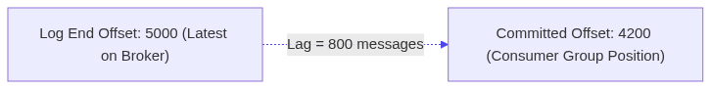
A rising consumer lag means consumers are falling behind the rate of incoming events, leading to delayed notifications, stale caches, or SLA violations.

2. Diagnosing Consumer Lag
- Via Kafka CLI:
// BASH CODE SNIPPET
docker exec -it kafka-node-broker /opt/kafka/bin/kafka-consumer-groups.sh \
--bootstrap-server localhost:9092 \
--describe --group notification-service-group
- Via Kafka UI:
Navigate to Consumers tab in [http://localhost:8080](http://localhost:8080) to visualize per-partition lag graphs in real time.

3. How to Fix Consumer Lag
- Scale Consumers: If you have 6 partitions and 2 consumers, spin up 4 more consumer instances so every partition has a dedicated worker.
- Optimize Processing Logic: Eliminate slow synchronous HTTP/DB queries inside the eachMessage handler. Use connection pools or batch operations with eachBatch.
- Increase Partitions: If you already have 1 consumer per partition and CPU is pegged at 100%, increase partition count and deploy additional consumer instances.

4. Next Steps
Go to [21-security.md](file:///c:/Users/Sulaiman/Desktop/pratice-dev/docs/21-security.md) for SSL/TLS, SASL, and ACL security configurations.

21 — Kafka Security: TLS, SASL & ACLs
1. The Three Pillars of Kafka Security
📊 ARCHITECTURE DIAGRAM: 1. The Three Pillars of Kafka Security
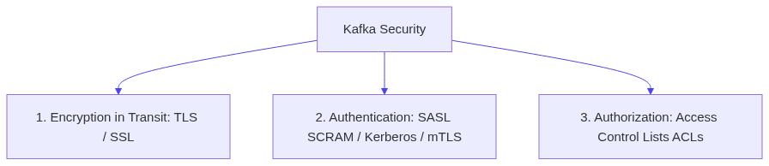

2. Authentication with SASL/SCRAM in KafkaJS
// JAVASCRIPT CODE SNIPPET
import { Kafka } from 'kafkajs';

const kafka = new Kafka({
clientId: 'secure-client',
brokers: ['kafka-prod.company.internal:9092'],
ssl: true, // TLS Encryption
sasl: {
mechanism: 'scram-sha-512',
username: process.env.KAFKA_USERNAME,
password: process.env.KAFKA_PASSWORD
}
});

3. Access Control Lists (ACLs)
Kafka ACLs restrict which users or service accounts can perform specific operations (READ, WRITE, DESCRIBE, CREATE) on specific resources (TOPIC, GROUP, CLUSTER).
Example CLI rule (Allow user alice to produce to orders topic):
// BASH CODE SNIPPET
kafka-acls.sh --bootstrap-server localhost:9092 \
--add --allow-principal User:alice \
--operation Write --topic orders

4. Next Steps
Go to [22-production-architecture.md](file:///c:/Users/Sulaiman/Desktop/pratice-dev/docs/22-production-architecture.md) for production-grade topologies and sizing.

22 — Production Architecture & Operational Best Practices
1. Multi-Broker Cluster Topology
In enterprise production environments, a Kafka cluster spans a minimum of 3 brokers across multiple Availability Zones (AZs):
📊 ARCHITECTURE DIAGRAM: 1. Multi-Broker Cluster Topology
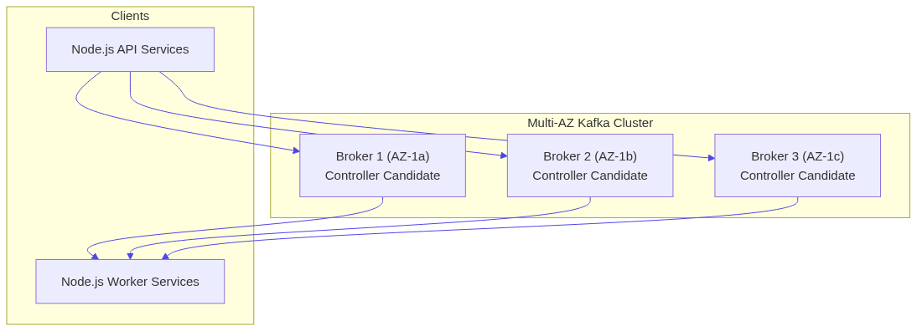

2. Production Checklist
Infrastructure & Broker Settings
- [ ] $\text{Replication Factor} \ge 3$ for all business-critical topics.
- [ ] $\text{min.insync.replicas} = 2$.
- [ ] unclean.leader.election.enable = false (prevents data corruption during broker failure).
- [ ] auto.create.topics.enable = false (prevents rogue topics created by typos).
Node.js Producer Settings
- [ ] idempotent: true enabled.
- [ ] acks: -1 (acks: all).
- [ ] Exponential retry configuration with sensible max backoff.
- [ ] compression: CompressionTypes.GZIP or CompressionTypes.Snappy.
Node.js Consumer Settings
- [ ] Unique, meaningful groupId per microservice.
- [ ] Manual offset commits or idempotent consumer with deduplication table.
- [ ] Graceful shutdown handlers (SIGTERM, SIGINT) invoking await consumer.disconnect().
- [ ] Dead Letter Topic routing for poison pill exceptions.

3. Next Steps
Go to [23-kafka-vs-other-messaging.md](file:///c:/Users/Sulaiman/Desktop/pratice-dev/docs/23-kafka-vs-other-messaging.md) to compare Kafka against RabbitMQ, SQS, and Redis Pub/Sub.

23 — Kafka vs. Other Messaging Systems
1. Architectural Comparison Matrix
Feature | Apache Kafka | RabbitMQ | AWS SQS | Redis Pub/Sub
:--- | :--- | :--- | :--- | :---
Model | Distributed Commit Log | Message Broker / Smart Queue | Managed Smart Queue | In-Memory Ephemeral Pub/Sub
Persistence | Immutable log on disk (retained for days/years) | Transient; removed when acknowledged | Transient; removed when deleted | Ephemeral in RAM (unless Redis Streams)
Replayability | ✅ Unlimited (rewind offset) | ❌ No | ❌ No | ❌ No
Consumer Scaling | Partition-based consumer groups | Competing consumers on single queue | Competing consumers | Broadcast to all active subscribers
Throughput | 🚀 Millions msg/sec | ~50k–100k msg/sec | Scalable (HTTP batch limits) | 🚀 Hundreds of thousands (RAM-bound)
Ordering | ✅ Strict per partition key | ⚠️ FIFO queues with low concurrency | ⚠️ FIFO queues with throughput caps | ❌ Best-effort
Complex Routing | ❌ Topics & Partitions only | ✅ Rich exchange routing (Topic, Fanout, Direct, Headers) | ❌ Simple Queue / SNS routing | ⚠️ Simple pattern matching

2. When to Choose Kafka
- You need high throughput event streaming (millions of events/sec).
- Multiple independent systems need to consume and replay the same event stream.
- You need strict sequential ordering per entity (e.g. per user, per vehicle, per sensor).
- You are building event-driven microservices or Change Data Capture (CDC) architectures.

3. When NOT to Choose Kafka
- You need a simple job queue with per-message delay timers (e.g. "send email in 15 minutes") $\rightarrow$ Use RabbitMQ or BullMQ/Redis.
- You need complex routing topologies across dozens of routing keys without topic overhead $\rightarrow$ Use RabbitMQ.
- You only need simple ephemeral push notifications with zero durability $\rightarrow$ Use Redis Pub/Sub or WebSockets.

Appendix A: 8 Deep-Dive Failure Experiments
The following laboratory experiments prove real-world distributed systems behavior by deliberately triggering partition ordering skew, consumer crashes, rebalance handovers, duplicate double-charges, transient retry pipelines, lag buildup, hot partitions, and uncommitted replays.
Experiment 01 — Partition Ordering Skew
What We Are Breaking / Testing
We intentionally produce a series of 20 sequentially numbered events across 3 partitions, and observe how the consumer receives them out of order globally, while maintaining strict order within each individual partition.
Architecture
📊 ARCHITECTURE DIAGRAM: Architecture
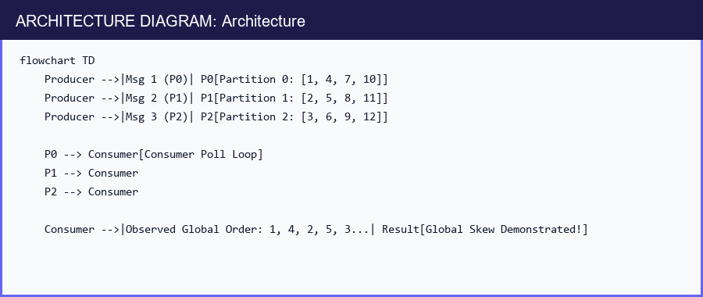
Run
// BASH CODE SNIPPET
npm run exp:01:ordering
# Or: node experiments/01-partition-ordering/run.js
Takeaway
Never design an event-driven system assuming global ordering across multi-partition topics! If entity ordering is required, always provide an entity key.
// JAVASCRIPT CODE SNIPPET
import { Kafka } from 'kafkajs';

/**
* ============================================================================
* 🔬 EXPERIMENT 01: Global Ordering vs. Partition Ordering Skew
* ============================================================================
*
* 📌 CONCEPT SUMMARY:
* -------------------
* - Kafka guarantees STRICT ORDERING ONLY WITHIN A SINGLE PARTITION (per-partition ordering).
* - Kafka does NOT guarantee global ordering across multiple partitions in a topic.
* - When messages are produced WITHOUT a key (unkeyed), Kafka distributes them across
* available partitions in a round-robin or sticky batch fashion.
* - When a consumer consumes from a multi-partition topic, it reads from multiple partitions
* concurrently/interleaved. Hence, messages arrive out-of-order relative to the global
* production sequence (1 -> 2 -> 3 -> 4 ...).
*
* 💡 ARCHITECTURAL TAKEAWAY:
* --------------------------
* If your business logic requires strict sequential processing for a specific entity
* (e.g. order status transitions, user activity logs), ALWAYS provide a partition KEY
* (e.g., key: 'order-123' or key: 'user-456'). Messages with the same key always hash
* to the SAME partition and preserve 100% order!
* ============================================================================
*/

// 1. Initialize Kafka client pointing to local broker
const kafka = new Kafka({
clientId: 'exp01-ordering',
brokers: [process.env.KAFKA_BROKER || 'localhost:9092']
});

const admin = kafka.admin();
const producer = kafka.producer();

// Use unique groupId and topic name per run to avoid state collision from previous runs
const consumer = kafka.consumer({ groupId: `exp01-group-${Date.now()}` });
const topic = `exp01-ordering-${Date.now()}`;

async function run() {
console.log('🔬 EXPERIMENT 01: Demonstrating Global vs Partition Ordering Skew\n');

// --------------------------------------------------------------------------
// Step 1: Create a Topic with 3 Partitions
// --------------------------------------------------------------------------
// We explicitly create 3 partitions so that traffic can split across 3 separate queues.
await admin.connect();
console.log(`🛠️ Creating topic "${topic}" with 3 partitions...`);
await admin.createTopics({ topics: [{ topic, numPartitions: 3 }] });
await admin.disconnect();

// --------------------------------------------------------------------------
// Step 2: Produce 15 Unkeyed Sequential Messages (1 to 15)
// --------------------------------------------------------------------------
// Notice we omit the `key` field in producer.send().
// Kafka distributes unkeyed records across Partition 0, 1, and 2.
await producer.connect();
console.log('📤 Producing 15 sequential messages (1 to 15) without partition keys...');
for (let i = 1; i <= 15; i++) {
await producer.send({
topic,
messages: [{ value: JSON.stringify({ seq: i, sentAt: Date.now() }) }]
});
}
await producer.disconnect();
console.log('✅ All 15 messages sent to broker.\n');

// --------------------------------------------------------------------------
// Step 3: Consume and Record Arrival Sequence
// --------------------------------------------------------------------------
// The consumer subscribes to all 3 partitions from the beginning (offset 0).
// We record the exact sequence in which messages are received by eachMessage.
const receivedSequence = [];
await consumer.connect();
await consumer.subscribe({ topic, fromBeginning: true });

console.log('📥 Consuming events to inspect arrival order:\n');

consumer.run({
eachMessage: async ({ partition, message }) => {
const data = JSON.parse(message.value.toString());
receivedSequence.push(data.seq);

// Notice: within each specific partition, offsets increment (0, 1, 2, ...) monotonically.
console.log(` [Partition ${partition} @ Offset ${message.offset}] -> Msg Seq #${data.seq}`);

// Once all 15 messages are received, display the analysis
if (receivedSequence.length === 15) {
console.log('\n========================================');
console.log('📊 EXPERIMENT OBSERVATION:');
console.log(' Produced Global Order: [1, 2, 3, 4, 5, 6, 7, 8, 9, 10, 11, 12, 13, 14, 15]');
console.log(` Observed Global Order: [${receivedSequence.join(', ')}]`);
console.log('🏁 CONCLUSION:');
console.log(' - Messages within each partition are 100% ordered by offset.');
console.log(' - Global sequence is INTERLEAVED because partitions are read in parallel batches.');
console.log(' - Solution: Use message keys (e.g. orderId) to guarantee ordering per entity!');
console.log('========================================\n');
await consumer.disconnect();
process.exit(0);
}
}
});
}

// Global error handler
run().catch(console.error);

Experiment 02 — Consumer Sudden Crash & Resume
What We Are Breaking / Testing
We produce 10 messages. A consumer starts processing, prints message 1..4, and crashes abruptly (simulated process.exit(1)).
A secondary consumer starts up under the same groupId and resumes cleanly from message 5 without missing records.
Run
// BASH CODE SNIPPET
npm run exp:02:failure
# Or: node experiments/02-consumer-failure/run.js
Takeaway
Committed offsets allow Kafka consumer groups to be fully fault-tolerant. When a container is restarted by Kubernetes or Docker, it picks up exactly where the previous instance left off.
// JAVASCRIPT CODE SNIPPET
import { Kafka } from 'kafkajs';

/**
* ============================================================================
* 🔬 EXPERIMENT 02: Consumer Sudden Crash & Resume (Fault Tolerance)
* ============================================================================
*
* 📌 CONCEPT SUMMARY:
* -------------------
* - Kafka tracks message consumption progress through "Consumer Offsets".
* - When a consumer successfully finishes processing a message, it commits the
* next offset (offset + 1) to Kafka's internal `__consumer_offsets` topic.
* - If a consumer process crashes unexpectedly (e.g. OOM, node reboot, uncaught error),
* a replacement consumer joining the SAME `groupId` asks Kafka for the last committed
* offset and resumes execution exactly from that checkpoint without missing messages.
*
* 💡 ARCHITECTURAL TAKEAWAY:
* --------------------------
* - Setting `autoCommit: false` gives fine-grained control over when an offset is saved.
* - Always commit offsets AFTER business logic execution has safely persisted data
* to avoid "phantom commits" (where an offset is saved but the task crashed mid-way).
* ============================================================================
*/

const kafka = new Kafka({
clientId: 'exp02-client',
brokers: [process.env.KAFKA_BROKER || 'localhost:9092']
});

const producer = kafka.producer();
const groupId = `exp02-resilient-group-${Date.now()}`;
const topic = `exp02-crash-test-${Date.now()}`;

async function run() {
console.log('🔬 EXPERIMENT 02: Consumer Sudden Crash & Resume\n');

// --------------------------------------------------------------------------
// Step 1: Seed 8 Records to Kafka
// --------------------------------------------------------------------------
await producer.connect();
for (let i = 1; i <= 8; i++) {
await producer.send({
topic,
messages: [{ key: `item-${i}`, value: JSON.stringify({ item: i, desc: `Task #${i}` }) }]
});
}
console.log('✅ Produced 8 tasks to topic:', topic);
await producer.disconnect();

// --------------------------------------------------------------------------
// Step 2: Consumer Instance 1 Processes 3 Messages and Crashes
// --------------------------------------------------------------------------
console.log('\n🚀 Starting Consumer Instance 1 (Will crash after 3 messages)...');
const c1 = kafka.consumer({ groupId });
await c1.connect();
await c1.subscribe({ topic, fromBeginning: true });

let count = 0;
await new Promise((resolve) => {
c1.run({
// Disable autoCommit so we manually govern exact offset checkpointing
autoCommit: false,
eachMessage: async ({ topic, partition, message }) => {
count++;
console.log(` [C1] Processed Task #${count} (Offset ${message.offset})`);

// Explicit manual commit: next expected offset is message.offset + 1
await c1.commitOffsets([{ topic, partition, offset: (BigInt(message.offset) + 1n).toString() }]);

// Simulate abrupt failure after 3 successful processing cycles
if (count === 3) {
console.warn(' 💥 Simulating unexpected container crash on Consumer 1!');
// Disconnect abruptly without processing tasks 4 to 8
await c1.disconnect();
resolve();
}
}
});
});

// --------------------------------------------------------------------------
// Step 3: Wait briefly for cluster state stabilization
// --------------------------------------------------------------------------
console.log('\n⏳ Waiting 2 seconds for cluster to register consumer disconnect...\n');
await new Promise((r) => setTimeout(r, 2000));

// --------------------------------------------------------------------------
// Step 4: Replacement Consumer Instance 2 joins under the same groupId
// --------------------------------------------------------------------------
// Since Consumer 1 committed offset 3 (meaning 0, 1, 2 were completed),
// Consumer 2 automatically starts fetching from offset 3 (Task #4).
console.log('🚀 Starting Replacement Consumer Instance 2...');
const c2 = kafka.consumer({ groupId });
await c2.connect();
await c2.subscribe({ topic }); // No fromBeginning needed: resumes from committed offset

let c2Count = 0;
c2.run({
autoCommit: false,
eachMessage: async ({ topic, partition, message }) => {
c2Count++;
const payload = JSON.parse(message.value.toString());
console.log(` [C2 RESUMED] Processed Task: ${payload.desc} (Offset ${message.offset})`);

// Commit each offset as C2 works through the remaining tasks
await c2.commitOffsets([{ topic, partition, offset: (BigInt(message.offset) + 1n).toString() }]);

if (payload.item === 8) {
console.log('\n========================================');
console.log('🎉 RESULT:');
console.log(' Consumer 2 successfully resumed from Offset 3 and completed remaining tasks!');
console.log(' Zero messages were lost despite the crash of Consumer 1.');
console.log('========================================\n');
await c2.disconnect();
process.exit(0);
}
}
});
}

run().catch(console.error);

Experiment 03 — Dynamic Consumer Rebalancing Timeline
What We Are Breaking / Testing
We observe the exact lifecycle events and partition redistribution timeline when a new consumer process dynamically joins an active consumer group.
Run
// BASH CODE SNIPPET
npm run exp:03:rebalance
# Or: node experiments/03-consumer-rebalancing/run.js
Takeaway
Rebalancing is the mechanism Kafka uses to achieve elastic scaling. During rebalances, partition consumption pauses briefly while the coordinator reassigns partitions.
// JAVASCRIPT CODE SNIPPET
import { Kafka } from 'kafkajs';

/**
* ============================================================================
* 🔬 EXPERIMENT 03: Consumer Group Dynamic Rebalancing Timeline
* ============================================================================
*
* 📌 CONCEPT SUMMARY:
* -------------------
* - In Kafka, multiple consumer instances sharing the same `groupId` form a "Consumer Group".
* - Partitions of a topic are divided among members of the consumer group so that
* each partition is consumed by AT MOST ONE consumer instance at any given time.
* - When a new consumer joins (or leaves) the group, Kafka triggers a "Group Rebalance".
* - During a rebalance, the Group Coordinator revokes and reassigns partition ownership
* to evenly distribute the workload across all active group members.
*
* 💡 ARCHITECTURAL TAKEAWAY:
* --------------------------
* - Max parallelism for a single consumer group is equal to the number of topic partitions.
* - Having more consumer instances than partitions means the extra consumers sit IDLE.
* - Dynamic rebalancing allows elastic horizontal auto-scaling in Kubernetes/ECS without downtime!
* ============================================================================
*/

const kafka = new Kafka({
clientId: 'exp03-rebalance',
brokers: [process.env.KAFKA_BROKER || 'localhost:9092']
});

const admin = kafka.admin();
const producer = kafka.producer();
const topic = `exp03-rebalance-topic-${Date.now()}`;
const groupId = `exp03-rebalance-group-${Date.now()}`;

async function run() {
console.log('🔬 EXPERIMENT 03: Consumer Group Dynamic Rebalancing Timeline\n');

// --------------------------------------------------------------------------
// Step 1: Create a Topic with 2 Partitions (P0 and P1)
// --------------------------------------------------------------------------
await admin.connect();
await admin.createTopics({ topics: [{ topic, numPartitions: 2 }] });
await admin.disconnect();

// --------------------------------------------------------------------------
// Step 2: Start Consumer 1 (Only 1 member in group initially)
// --------------------------------------------------------------------------
// Consumer 1 will be assigned BOTH Partition 0 and Partition 1 [0, 1].
console.log('🚀 [T=0s] Starting Consumer 1...');
const c1 = kafka.consumer({ groupId });

// Listen for KafkaJS group lifecycle events
c1.on(c1.events.GROUP_JOIN, (e) => {
console.log(` 🟢 [Consumer 1] Joined! Assigned Partitions:`, e.payload.memberAssignment[0]?.partitions || []);
});
c1.on(c1.events.REBALANCING, () => console.log(' ⚠️ [Consumer 1] Notified of Group Rebalance!'));

await c1.connect();
await c1.subscribe({ topic });
await c1.run({ eachMessage: async ({ partition }) => console.log(` [C1] Handled msg from P${partition}`) });

// --------------------------------------------------------------------------
// Step 3: Produce continuous stream of messages (1 msg/sec)
// --------------------------------------------------------------------------
await producer.connect();
let msgTimer = setInterval(async () => {
await producer.send({
topic,
messages: [{ value: 'ping' }]
});
}, 1000);

// --------------------------------------------------------------------------
// Step 4: After 4 seconds, introduce Consumer 2 with the same groupId
// --------------------------------------------------------------------------
// Kafka Coordinator detects a new member joining and initiates a rebalance.
// One of the partitions will be revoked from C1 and assigned to C2 (e.g. C1->P0, C2->P1).
await new Promise((r) => setTimeout(r, 4000));
console.log('\n🚀 [T=4s] Starting Consumer 2 (Joining same groupId)...');

const c2 = kafka.consumer({ groupId });
c2.on(c2.events.GROUP_JOIN, (e) => {
console.log(` 🟢 [Consumer 2] Joined! Assigned Partitions:`, e.payload.memberAssignment[0]?.partitions || []);
});
c2.on(c2.events.REBALANCING, () => console.log(' ⚠️ [Consumer 2] Notified of Group Rebalance!'));

await c2.connect();
await c2.subscribe({ topic });
await c2.run({ eachMessage: async ({ partition }) => console.log(` [C2] Handled msg from P${partition}`) });

// --------------------------------------------------------------------------
// Step 5: Let both consumers operate concurrently for 4 seconds, then clean up
// --------------------------------------------------------------------------
await new Promise((r) => setTimeout(r, 4000));
clearInterval(msgTimer);

console.log('\n========================================');
console.log('🏁 RESULT:');
console.log(' - Consumer 1 originally processed ALL partitions (P0 & P1).');
console.log(' - When Consumer 2 joined, Kafka automatically rebalanced the group.');
console.log(' - Each consumer now processes exactly 1 partition concurrently in parallel!');
console.log('========================================\n');

await producer.disconnect();
await c1.disconnect();
await c2.disconnect();
process.exit(0);
}

run().catch(console.error);

Experiment 04 — Crash Before Commit (Duplicate Processing)
What We Are Breaking / Testing
We process a charge of $100. The application completes the charge, but crashes before commitOffsets() reaches the Kafka broker.
Upon restarting, the consumer re-fetches the uncommitted offset and attempts the same charge a second time!
Run
// BASH CODE SNIPPET
npm run exp:04:duplicates
# Or: node experiments/04-duplicate-messages/run.js
Takeaway
This experiment proves why At-Least-Once delivery is inherent to distributed systems. Applications MUST implement consumer idempotency (like deduplication tables) to guard against duplicate side effects.
// JAVASCRIPT CODE SNIPPET
import { Kafka } from 'kafkajs';

/**
* ============================================================================
* 🔬 EXPERIMENT 04: Crash Before Commit (Duplicate Processing Demonstration)
* ============================================================================
*
* 📌 CONCEPT SUMMARY:
* -------------------
* - Kafka guarantees "At-Least-Once" message delivery by default.
* - If a consumer finishes the business logic (e.g. charging a credit card, updating
* a database, calling a 3rd party webhook) but crashes BEFORE it can commit its offset
* back to Kafka, Kafka assumes the message was NEVER processed.
* - When the consumer recovers and restarts, it will fetch and re-process the exact
* same message a second time — leading to a DUPLICATE action (e.g. Double Charge!).
*
* 💡 ARCHITECTURAL TAKEAWAY:
* --------------------------
* - Message processing in distributed systems MUST BE IDEMPOTENT.
* - Solution Patterns:
* 1. Idempotency Key / Deduplication Table (e.g. store processed `orderId` in DB with unique constraint).
* 2. Transactional Outbox Pattern.
* 3. Exactly-Once Semantics (EOS) using Kafka Transactions (`read-process-write`).
* ============================================================================
*/

const kafka = new Kafka({
clientId: 'exp04-client',
brokers: [process.env.KAFKA_BROKER || 'localhost:9092']
});

const producer = kafka.producer();
const topic = `exp04-dup-topic-${Date.now()}`;
const groupId = `exp04-dup-group-${Date.now()}`;

// Global business state tracker (simulating external database / payment processor balance)
let totalBilledDollars = 0;

async function run() {
console.log('🔬 EXPERIMENT 04: Crash Before Commit (Duplicate Processing Demonstration)\n');

// --------------------------------------------------------------------------
// Step 1: Produce 1 Payment Charge Event
// --------------------------------------------------------------------------
await producer.connect();
console.log('📤 Producing 1 billing event: Order "ORDER-100" for $100...');
await producer.send({
topic,
messages: [{ key: 'ORDER-100', value: JSON.stringify({ orderId: 'ORDER-100', amount: 100 }) }]
});
await producer.disconnect();

// --------------------------------------------------------------------------
// Step 2: Attempt 1 — Consumer executes payment but crashes before offset commit
// --------------------------------------------------------------------------
console.log('\n🚀 Attempt 1: Consumer processes payment but crashes BEFORE offset commit...');
const c1 = kafka.consumer({ groupId });
await c1.connect();
await c1.subscribe({ topic, fromBeginning: true });

await new Promise((resolve) => {
c1.run({
autoCommit: false, // Disabling autoCommit to control exact commit timing
eachMessage: async ({ message }) => {
const order = JSON.parse(message.value.toString());

// 1. Business Logic Execution (Non-idempotent side effect)
totalBilledDollars += order.amount;
console.log(` 💳 Charged $${order.amount} for ${order.orderId}! (Total Billed: $${totalBilledDollars})`);

// 2. Sudden crash BEFORE c1.commitOffsets() is reached
console.log(' 💥 CRASH! Power outage before commitOffsets() could be executed...');
await c1.disconnect();
resolve();
}
});
});

// Wait 2 seconds simulating container restart
await new Promise((r) => setTimeout(r, 2000));

// --------------------------------------------------------------------------
// Step 3: Attempt 2 — Consumer restarts and reconnects to Kafka
// --------------------------------------------------------------------------
// Because the offset was never committed, Kafka sends the exact same message again!
console.log('\n🚀 Attempt 2: Consumer restarts and reconnects to Kafka...');
const c2 = kafka.consumer({ groupId });
await c2.connect();
await c2.subscribe({ topic });

c2.run({
autoCommit: false,
eachMessage: async ({ message }) => {
const order = JSON.parse(message.value.toString());

// The restarted consumer re-executes the side-effect without knowing it ran before
totalBilledDollars += order.amount;
console.log(` 💳 Charged $${order.amount} for ${order.orderId} AGAIN! (Total Billed: $${totalBilledDollars})`);

console.log('\n========================================');
console.log('🚨 EXPERIMENT OBSERVATION:');
console.log(` Customer was charged TWICE ($${totalBilledDollars} total) because offset was not committed!`);
console.log('🏁 SOLUTION:');
console.log(' - Always implement Idempotent Consumers (use deduplication IDs in database).');
console.log(' - Or use transactional commits to tie database writes and offset commits together.');
console.log('========================================\n');

await c2.disconnect();
process.exit(0);
}
});
}

run().catch(console.error);

Experiment 05 — Transient Error Retry Routing
What We Are Breaking / Testing
We send a message that fails 2 times due to simulated 503 errors before finally succeeding on attempt 3 in the retry topic.
Run
// BASH CODE SNIPPET
npm run exp:05:retries
# Or: node experiments/05-retry-behavior/run.js
Takeaway
Topic-based retries allow non-blocking asynchronous healing without halting the main ingestion stream.
// JAVASCRIPT CODE SNIPPET
import { Kafka } from 'kafkajs';

/**
* ============================================================================
* 🔬 EXPERIMENT 05: Transient Error Retry Pipeline (Retry Topic Pattern)
* ============================================================================
*
* 📌 CONCEPT SUMMARY:
* -------------------
* - When a consumer fails to process a message due to a transient downstream error
* (e.g., 3rd-party HTTP 503, database lock timeout, network glitch), blocking the
* consumer thread with `sleep()` creates head-of-line blocking for that entire partition.
* - Enterprise Best Practice: "Retry Topic Pattern"
* Instead of holding up partition consumption, the failing message is forwarded to a
* dedicated retry topic (e.g., `orders.retry-1`, `orders.retry-2`) with an incremented
* retry count in its headers.
* - When max attempts are exceeded, the message is routed to a Dead Letter Queue (DLQ).
*
* 💡 ARCHITECTURAL TAKEAWAY:
* --------------------------
* - Decoupling failed records to separate retry topics keeps the main consumer loop
* operating at full throughput for healthy messages while giving transient issues time to recover.
* ============================================================================
*/

const kafka = new Kafka({
clientId: 'exp05-retries',
brokers: [process.env.KAFKA_BROKER || 'localhost:9092']
});

const producer = kafka.producer();
const consumer = kafka.consumer({ groupId: `exp05-group-${Date.now()}` });
const topic = `exp05-topic-${Date.now()}`;

// Attempt counter to simulate transient failure recovery on attempt #3
let attempts = 0;

async function run() {
console.log('🔬 EXPERIMENT 05: Transient Error Retry Pipeline\n');

await producer.connect();
await consumer.connect();

// --------------------------------------------------------------------------
// Step 1: Subscribe to BOTH the Primary Topic and the Retry Topic
// --------------------------------------------------------------------------
await consumer.subscribe({ topic, fromBeginning: true });
await consumer.subscribe({ topic: `${topic}.retry-1`, fromBeginning: true });

// --------------------------------------------------------------------------
// Step 2: Produce an Event that will trigger transient failures
// --------------------------------------------------------------------------
console.log('📤 Publishing initial job: "JOB-909" to primary topic...');
await producer.send({
topic,
messages: [{ key: 'FLAKY-JOB', value: JSON.stringify({ jobId: 'JOB-909', type: 'DATA_SYNC' }) }]
});

// --------------------------------------------------------------------------
// Step 3: Consumer processing loop with Retry Routing logic
// --------------------------------------------------------------------------
consumer.run({
eachMessage: async ({ topic: currentTopic, message }) => {
attempts++;
console.log(`📥 Received on [${currentTopic}] (Attempt #${attempts})`);

// Simulate failure on attempts 1 and 2, but success on attempt 3
if (attempts < 3) {
console.warn(` ❌ Simulated API Timeout on attempt ${attempts}! Re-routing message to retry topic...`);

// Forward message to retry topic with updated tracking header
await producer.send({
topic: `${topic}.retry-1`,
messages: [{
key: message.key,
value: message.value,
headers: { 'x-retry-attempt': attempts.toString() }
}]
});
} else {
// Attempt 3 succeeds
console.log(' 🎉 Attempt #3 SUCCEEDED! Job processed cleanly.');
console.log('\n========================================');
console.log('🏁 RESULT:');
console.log(' - Transient failures on attempt #1 and #2 were routed to a retry topic.');
console.log(' - On attempt #3, processing succeeded without blocking the main topic queue!');
console.log('========================================\n');

await consumer.disconnect();
await producer.disconnect();
process.exit(0);
}
}
});
}

run().catch(console.error);

Experiment 06 — Slow Consumer & Consumer Lag Explosion
What We Are Breaking / Testing
A producer sends 100 messages in 1 second. The consumer simulates a slow downstream legacy database (taking 100ms per record).
We query and observe the Consumer Lag explode to 99 messages and slowly drain.
Run
// BASH CODE SNIPPET
npm run exp:06:lag
# Or: node experiments/06-consumer-lag-slow-consumer/run.js
Takeaway
Consumer lag is the #1 operational health metric in Kafka. When lag grows uncontrollably, you must either scale consumer instances, batch downstream operations, or increase partitions.
// JAVASCRIPT CODE SNIPPET
import { Kafka } from 'kafkajs';

/**
* ============================================================================
* 🔬 EXPERIMENT 06: Slow Downstream Consumer & Lag Measurement
* ============================================================================
*
* 📌 CONCEPT SUMMARY:
* -------------------
* - "Consumer Lag" is the delta between the latest message written to a partition
* (Log End Offset / High Watermark / LEO) and the offset the consumer has currently processed.
* `Consumer Lag = Log End Offset - Current Consumer Offset`
* - When a producer publishes faster than a consumer can process (e.g., consumer does heavy
* computations, synchronous I/O, or slow external API calls), Lag accumulates in Kafka.
* - Kafka brokers comfortably buffer gigabytes/terabytes of lag on disk without slowing down producers.
*
* 💡 ARCHITECTURAL TAKEAWAY:
* --------------------------
* - Consumer Lag is the SINGLE MOST IMPORTANT metric to monitor in event-driven architectures.
* - Growing consumer lag is the primary trigger for Horizontal Pod Autoscaling (KEDA / HPA)
* in Kubernetes to scale out consumer worker instances!
* ============================================================================
*/

const kafka = new Kafka({
clientId: 'exp06-lag',
brokers: [process.env.KAFKA_BROKER || 'localhost:9092']
});

const admin = kafka.admin();
const producer = kafka.producer();
const topic = `exp06-lag-topic-${Date.now()}`;
const groupId = `exp06-lag-group-${Date.now()}`;
const consumer = kafka.consumer({ groupId });

async function run() {
console.log('🔬 EXPERIMENT 06: Slow Downstream Consumer & Lag Measurement\n');

// --------------------------------------------------------------------------
// Step 1: Create a single-partition topic
// --------------------------------------------------------------------------
await admin.connect();
await admin.createTopics({ topics: [{ topic, numPartitions: 1 }] });

// --------------------------------------------------------------------------
// Step 2: Fast Producer blasts 20 messages instantly into Kafka
// --------------------------------------------------------------------------
await producer.connect();
console.log('⚡ Producer blasting 20 messages to Kafka at high speed...');
const messages = Array.from({ length: 20 }, (_, i) => ({ value: `data-chunk-${i}` }));
await producer.send({ topic, messages });
console.log('✅ Producer finished publishing 20 messages.\n');
await producer.disconnect();

// --------------------------------------------------------------------------
// Step 3: Slow Consumer starts processing with simulated downstream delay (200ms)
// --------------------------------------------------------------------------
await consumer.connect();
await consumer.subscribe({ topic, fromBeginning: true });

let processed = 0;
consumer.run({
eachMessage: async ({ message }) => {
processed++;

// Simulate artificial slow downstream work (e.g. database write, PDF generation)
await new Promise((r) => setTimeout(r, 200));

// Periodically query the Kafka Admin API to calculate live consumer lag
if (processed % 5 === 0 || processed === 20) {
// Fetch current High Watermark (latest written offset) from broker
const topicOffsets = await admin.fetchTopicOffsets(topic);
const latestOffset = parseInt(topicOffsets[0].high, 10);
const currentOffset = parseInt(message.offset, 10) + 1;

// Calculate the lag
const lag = latestOffset - currentOffset;

console.log(`📊 [Progress: ${processed}/20] Current Offset: ${currentOffset} | LEO: ${latestOffset} | 🚨 CONSUMER LAG: ${lag} messages`);
}

// Once all messages are consumed and lag reaches 0
if (processed === 20) {
console.log('\n========================================');
console.log('🏁 RESULT:');
console.log(' - Initial Consumer Lag was high (20 messages).');
console.log(' - As the slow consumer processed items, lag steadily decreased to 0.');
console.log(' - Kafka buffers unconsumed messages safely on disk without dropping data!');
console.log('========================================\n');

await consumer.disconnect();
await admin.disconnect();
process.exit(0);
}
}
});
}

run().catch(console.error);

Experiment 07 — Hot Partition Key Skew
What We Are Breaking / Testing
We send 100 messages where 90% have key US and 10% have unique user IDs.
We inspect partition message counts across 3 partitions and observe how one single partition receives 90% of all traffic!
Run
// BASH CODE SNIPPET
npm run exp:07:hot-partition
# Or: node experiments/07-hot-partitioning/run.js
Takeaway
Never use low-cardinality values (e.g. country, status, boolean) as Kafka message keys. Always choose high-cardinality keys (like userId or uuid) to maintain balanced distribution.
// JAVASCRIPT CODE SNIPPET
import { Kafka } from 'kafkajs';

/**
* ============================================================================
* 🔬 EXPERIMENT 07: Low-Cardinality Key Skew (Hot Partition Problem)
* ============================================================================
*
* 📌 CONCEPT SUMMARY:
* -------------------
* - Kafka maps a message to a partition using a deterministic hashing algorithm:
* `partition = murmur2(key) % numPartitions`
* - If messages share the SAME key (e.g., key: 'US' for country, or key: 'tenant_default'),
* 100% of those messages are sent to the EXACT SAME partition.
* - This creates a "Hot Partition": One broker partition and its assigned consumer
* are overwhelmed by traffic, while other partitions sit completely idle.
*
* 💡 ARCHITECTURAL TAKEAWAY:
* --------------------------
* - Avoid low-cardinality keys (e.g. gender, country code, boolean flags) as partition keys!
* - Strategies to prevent Hot Partitions:
* 1. Use High-Cardinality Keys: `userId`, `orderId`, `uuid`.
* 2. Key Salting: append a random suffix (e.g., `US_1`, `US_2`, `US_3`) if high traffic per key.
* 3. Send without key (round-robin) if strict ordering is not required.
* ============================================================================
*/

const kafka = new Kafka({
clientId: 'exp07-skew',
brokers: [process.env.KAFKA_BROKER || 'localhost:9092']
});

const admin = kafka.admin();
const producer = kafka.producer();
const topic = `exp07-skew-topic-${Date.now()}`;

async function run() {
console.log('🔬 EXPERIMENT 07: Low-Cardinality Key Skew (Hot Partition Problem)\n');

// --------------------------------------------------------------------------
// Step 1: Create a 3-partition topic
// --------------------------------------------------------------------------
await admin.connect();
await admin.createTopics({ topics: [{ topic, numPartitions: 3 }] });
await admin.disconnect();

await producer.connect();

// Track the count of messages received by each partition
const partitionHits = { '0': 0, '1': 0, '2': 0 };

// --------------------------------------------------------------------------
// Step 2: Produce 100 messages with severe key skew
// --------------------------------------------------------------------------
// 90 messages will use low-cardinality key 'US'
// 10 messages will use distinct random user IDs
console.log('📤 Sending 100 messages (90 with key="US", 10 with random user IDs)...');
for (let i = 1; i <= 100; i++) {
const key = i <= 90 ? 'US' : `user_${i}_${Date.now()}`;
const res = await producer.send({
topic,
messages: [{ key, value: `payload-${i}` }]
});

// Capture which partition the record was sent to
const p = res[0].partition.toString();
partitionHits[p] = (partitionHits[p] || 0) + 1;
}

// --------------------------------------------------------------------------
// Step 3: Observe the severe partition load imbalance
// --------------------------------------------------------------------------
console.log('\n========================================');
console.log('📊 FINAL PARTITION TRAFFIC DISTRIBUTION:');
console.table(partitionHits);
console.log('🚨 HOT PARTITION DETECTED!');
console.log(' One broker partition received ~90% of the entire topic traffic.');
console.log('🏁 LESSON:');
console.log(' Use high-cardinality entity IDs (e.g. UUID) or Key Salting to distribute load evenly!');
console.log('========================================\n');

await producer.disconnect();
}

run().catch(console.error);

Experiment 08 — Uncommitted Offset Crash & Replay Analysis
What We Are Breaking / Testing
We produce 10 messages. A consumer reads 5 messages with autoCommit: false but never calls commitOffsets().
The consumer process is terminated. Upon rebooting under the same consumer group, Kafka forces the consumer to reprocess all 10 messages from offset 0!
Run
// BASH CODE SNIPPET
npm run exp:08:uncommitted
# Or: node experiments/08-uncommitted-offsets-crash/run.js
Takeaway
Kafka guarantees that uncommitted messages will never be skipped. If a consumer fails before committing, every uncommitted record is replayed.
// JAVASCRIPT CODE SNIPPET
import { Kafka } from 'kafkajs';

/**
* ============================================================================
* 🔬 EXPERIMENT 08: Uncommitted Offsets Crash & Complete Replay
* ============================================================================
*
* 📌 CONCEPT SUMMARY:
* -------------------
* - Kafka decouples message storage from consumer consumption state.
* - Messages remain permanently in Kafka's append-only log until the retention period expires,
* regardless of how many times they are read.
* - If a consumer reads N messages with `autoCommit: false` and exits/crashes without
* ever calling `commitOffsets()`, Kafka retains the initial offset checkpoint (Offset 0).
* - When any consumer later starts up with the same `groupId`, Kafka replays ALL N uncommitted
* messages from the beginning of that uncommitted range!
*
* 💡 ARCHITECTURAL TAKEAWAY:
* --------------------------
* - Kafka enables deterministic message replay for disaster recovery, bug back-fills,
* or machine learning re-training by simply rewinding committed offsets!
* ============================================================================
*/

const kafka = new Kafka({
clientId: 'exp08-uncommitted',
brokers: [process.env.KAFKA_BROKER || 'localhost:9092']
});

const producer = kafka.producer();
const topic = `exp08-topic-${Date.now()}`;
const groupId = `exp08-group-${Date.now()}`;

async function run() {
console.log('🔬 EXPERIMENT 08: Uncommitted Offsets Crash & Complete Replay\n');

// --------------------------------------------------------------------------
// Step 1: Produce 5 Sequential Messages
// --------------------------------------------------------------------------
await producer.connect();
const msgs = [1, 2, 3, 4, 5].map((i) => ({ value: `Task #${i}` }));
await producer.send({ topic, messages: msgs });
await producer.disconnect();
console.log('✅ Produced 5 tasks to topic:', topic);

// --------------------------------------------------------------------------
// Step 2: Phase 1 — Consumer reads all 5 items but intentionally NEVER commits
// --------------------------------------------------------------------------
console.log('\n🚀 Phase 1: Consumer reads 5 messages with autoCommit: false and NO manual commit...');
const c1 = kafka.consumer({ groupId });
await c1.connect();
await c1.subscribe({ topic, fromBeginning: true });

let count1 = 0;
await new Promise((resolve) => {
c1.run({
autoCommit: false,
eachMessage: async ({ message }) => {
count1++;
console.log(` [Phase 1] Processed ${message.value.toString()} without committing!`);

// When all 5 messages are processed, crash/disconnect without saving progress
if (count1 === 5) {
console.log(' 💥 Terminating Consumer 1 without committing any offset...');
await c1.disconnect();
resolve();
}
}
});
});

// Wait 2 seconds for cluster registration
await new Promise((r) => setTimeout(r, 2000));

// --------------------------------------------------------------------------
// Step 3: Phase 2 — Restart Consumer under identical groupId
// --------------------------------------------------------------------------
// Because no offset commit was ever stored in __consumer_offsets,
// Kafka starts delivering from Offset 0 again, giving a 100% complete replay!
console.log('\n🚀 Phase 2: Restarting Consumer under same groupId (replaying uncommitted log)...');
const c2 = kafka.consumer({ groupId });
await c2.connect();
await c2.subscribe({ topic });

let count2 = 0;
c2.run({
autoCommit: false,
eachMessage: async ({ message }) => {
count2++;
console.log(` [Phase 2 REPLAY] Re-received ${message.value.toString()} (Offset ${message.offset})`);

if (count2 === 5) {
console.log('\n========================================');
console.log('🏁 RESULT:');
console.log(' - All 5 uncommitted messages were successfully re-delivered!');
console.log(' - Demonstrates Kafka log immutability and replayability.');
console.log('========================================\n');
await c2.disconnect();
process.exit(0);
}
}
});
}

run().catch(console.error);

Appendix B: 12 Production Hands-On Labs Reference
Lab 01 — Your First Kafka Producer
Objective
Build a Node.js script using KafkaJS that establishes a TCP connection to Apache Kafka and produces strongly-typed JSON event messages to a topic.
Prerequisites
- Docker containers running (npm run docker:up & npm run wait:kafka)
- Node.js installed
Concept
A Kafka Producer serializes in-memory JavaScript objects into UTF-8 Buffer payloads and pushes them across network sockets to the broker partition leader.
Architecture
📊 ARCHITECTURE DIAGRAM: Architecture
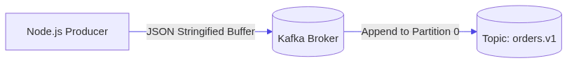
Run
// BASH CODE SNIPPET
npm run lab:01:producer
# Or directly:
node labs/01-first-producer/src/producer.js
Observe
Look at the terminal output. You should see:
// TEXT CODE SNIPPET
✅ Connected to Kafka broker at localhost:9092
📤 Sending order event: ORD-1001...
🎉 Message successfully published!
Topic: orders.v1
Partition: 0
Offset: 0
Open [http://localhost:8080](http://localhost:8080) (Kafka UI) -> Topics -> orders.v1 -> Messages to view the payload.
Experiment
- Modify src/producer.js to send an array of 5 different orders in a single send() call.
- Observe how the base offset increments for each message.
Challenge
Implement a loop in exercise/producer.js that emits a continuous stream of telemetry events every 1 second until terminated with Ctrl+C.
Questions
- What data type does Kafka expect for message keys and values? (Hint: String or Buffer)
- What happens if the topic does not exist yet when producing? (Hint: KAFKA_AUTO_CREATE_TOPICS_ENABLE)
- Does producer.send() return a Promise?

Lab 02 — Your First Kafka Consumer
Objective
Build a Node.js event consumer that joins a Consumer Group, subscribes to the orders.v1 topic, processes incoming messages in real-time, and decodes JSON payloads and headers.
Prerequisites
- Completed Lab 01
- Kafka running on localhost:9092
Architecture
📊 ARCHITECTURE DIAGRAM: Architecture
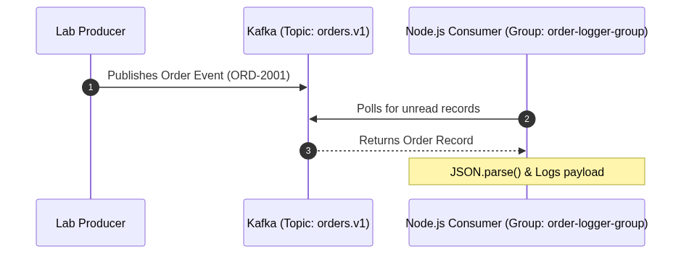
Run
Step 1: Start the Consumer in Terminal 1
// BASH CODE SNIPPET
npm run lab:02:consumer
# Or: node labs/02-first-consumer/src/consumer.js
Step 2: In Terminal 2, produce events
// BASH CODE SNIPPET
npm run lab:02:producer
# Or: node labs/02-first-consumer/src/producer.js
Observe
Look at Terminal 1. You should see:
// TEXT CODE SNIPPET
📥 [Partition: 0 | Offset: X] Received Event:
Event ID: evt_...
Order ID: ORD-2001
User: USER-5510
Amount: $89.50
Headers: source: web-checkout
Experiment
- Stop the consumer with Ctrl+C.
- Run the producer twice to send 2 new messages while the consumer is offline.
- Restart the consumer. Observe how it immediately catches up and processes the missed messages from where it left off!
Challenge
Modify exercise/consumer.js to calculate and print a running total sum of all order amounts received so far.
Questions
- Why must every Kafka consumer specify a groupId?
- What is the difference between fromBeginning: true vs fromBeginning: false?
- What happens when a consumer crashes unexpectedly?

Lab 03 — Managing Topics with Admin Client
Objective
Learn how to use the KafkaJS Admin Client to programmatically create topics, configure partitions and replication factors, list topics, describe metadata, and safely alter partition counts.
Prerequisites
- Completed Lab 01 & 02
Architecture
📊 ARCHITECTURE DIAGRAM: Architecture
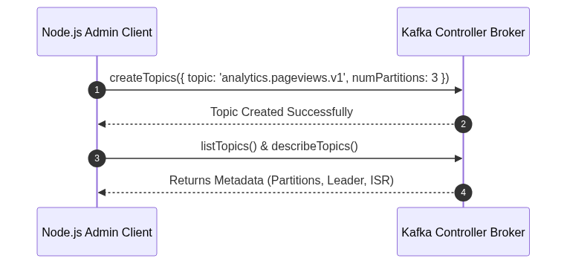
Run
// BASH CODE SNIPPET
npm run lab:03:admin
# Or: node labs/03-topics/src/admin.js
Observe
// TEXT CODE SNIPPET
🔨 Creating topic: analytics.pageviews.v1 (3 partitions)...
📋 Listing all topics in cluster...
🔍 Topic Details for analytics.pageviews.v1:
Partitions: 3
Partition 0: Leader=1, ISR=[1]
Partition 1: Leader=1, ISR=[1]
Partition 2: Leader=1, ISR=[1]
Experiment
Try calling admin.createPartitions() to increase the partition count from 3 to 6. Then check Kafka UI.
Challenge
Implement exercise/admin.js to create a topic with a custom retention policy (retention.ms = 3600000 / 1 hour).
Questions
- Why can you increase partition count on a live topic, but cannot decrease it?
- What does waitForLeaders: true do during createTopics?

Lab 04 — Partitions & Load Distribution
Objective
Demonstrate how messages are distributed across multiple partitions when produced with and without message keys, and observe how consumer instances receive partition assignments.
Prerequisites
- Completed Labs 01–03
Architecture
📊 ARCHITECTURE DIAGRAM: Architecture
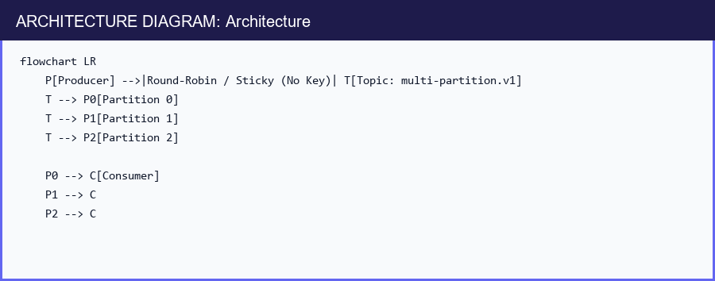
Run
Step 1: Start the consumer
// BASH CODE SNIPPET
npm run lab:04:consumer
# Or: node labs/04-partitions/src/consumer.js
Step 2: In another terminal, run the producer
// BASH CODE SNIPPET
npm run lab:04:producer
# Or: node labs/04-partitions/src/producer.js
Observe
Look at the producer output:
// TEXT CODE SNIPPET
📤 Sent msg 1 -> Partition 0
📤 Sent msg 2 -> Partition 1
📤 Sent msg 3 -> Partition 2
📤 Sent msg 4 -> Partition 0
Notice how messages without keys are evenly spread across partitions 0, 1, and 2.
Experiment
Pass a fixed key (e.g. key: 'sensor-99') to all messages and re-run. What happens to the partition numbers?
Challenge
Update exercise/producer.js to distribute 100 messages and calculate a distribution histogram showing how many messages landed in each partition.
Questions
- Why does an unkeyed message get distributed across partitions while a keyed message does not?
- What algorithm does KafkaJS use to map keys to partitions? (Murmur2)

Lab 05 — Consumer Groups & Scaling
Objective
Observe dynamic partition assignment, rebalancing, and load sharing by launching multiple consumer processes sharing the same groupId.
Architecture
📊 ARCHITECTURE DIAGRAM: Architecture
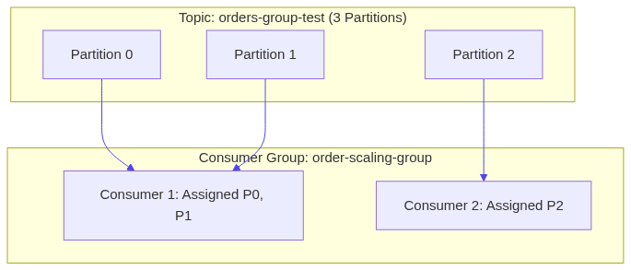
Run
Step 1: Open 3 terminal tabs
- Terminal 1: node labs/05-consumer-groups/src/consumer.js worker-A
- Terminal 2: node labs/05-consumer-groups/src/consumer.js worker-B
- Terminal 3: node labs/05-consumer-groups/src/consumer.js worker-C
Step 2: In Terminal 4, produce messages continuously
// BASH CODE SNIPPET
node labs/05-consumer-groups/src/producer.js
Observe
- When only worker-A is running, it receives all 3 partitions (0, 1, 2).
- When worker-B joins, Kafka rebalances: worker-A gets 2 partitions, worker-B gets 1.
- When worker-C joins, each worker gets exactly 1 partition!
- Now start a 4th worker (`worker-D`): Notice worker-D receives 0 partitions and sits completely idle!
Challenge
Kill worker-A (Ctrl+C) while the producer is still running. Watch how worker-D automatically gets woken up and assigned the orphaned partition!
Questions
- Why can 4 consumers not divide 3 partitions equally?
- What is a "rebalance storm" and why is it dangerous?

Lab 06 — Message Keys & Partition Affinity
Objective
Prove that setting a message key (e.g., userId or orderId) forces all related events to land in the same partition and be consumed in strict sequential order.
Architecture
📊 ARCHITECTURE DIAGRAM: Architecture
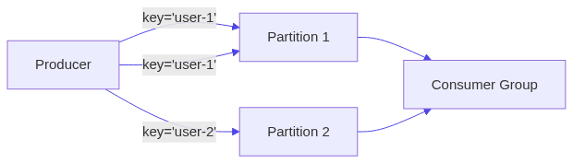
Run
Step 1: Start consumer
// BASH CODE SNIPPET
npm run lab:06:consumer
# Or: node labs/06-message-keys/src/consumer.js
Step 2: Produce keyed sequence
// BASH CODE SNIPPET
npm run lab:06:producer
# Or: node labs/06-message-keys/src/producer.js
Observe
Look at the output. Every event for USER-ALPHA lands in Partition 1, and every event for USER-BETA lands in Partition 0 (or deterministic hash).
Even if events are sent in interleaved fashion, USER-ALPHA events are processed in strict order 1 -> 2 -> 3!
Challenge
Modify exercise/producer.js to send lifecycle events (CREATED, PAID, SHIPPED, DELIVERED) for 10 different orders with key = orderId. Verify each order finishes in order.

Lab 07 — Offsets & Manual Commit Strategies
Objective
Understand how Kafka tracks consumer progress using __consumer_offsets, master manual offset commits (autoCommit: false), and replay historical messages with consumer.seek().
Architecture
📊 ARCHITECTURE DIAGRAM: Architecture
Run
Step 1: Run producer to seed events
// BASH CODE SNIPPET
npm run lab:07:producer
# Or: node labs/07-offsets/src/producer.js
Step 2: Run consumer with manual commits
// BASH CODE SNIPPET
npm run lab:07:consumer
# Or: node labs/07-offsets/src/consumer.js
Observe
Notice how the consumer explicitly commits the offset only after simulating a database operation.
On startup, if you pass --replay, it calls consumer.seek({ offset: '0' }) and re-reads all messages from the beginning!
Questions
- Why is committing offset + 1 necessary in KafkaJS? (Because committed offset represents the next unread message).
- What happens if an exception is thrown before commitOffsets() is called?

Lab 08 — Resilient Retries & Non-Blocking Backoff
Objective
Implement a production-style non-blocking retry pattern using dedicated retry topics (orders.retry-1, orders.retry-2) to prevent Head-of-Line blocking.
Architecture
📊 ARCHITECTURE DIAGRAM: Architecture
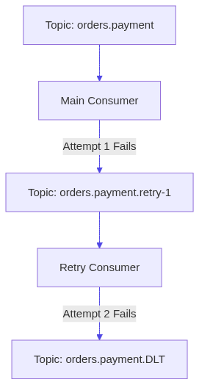
Run
Step 1: Start retry consumer
// BASH CODE SNIPPET
npm run lab:08:consumer
# Or: node labs/08-retries/src/consumer.js
Step 2: Produce flaky and valid payment requests
// BASH CODE SNIPPET
npm run lab:08:producer
# Or: node labs/08-retries/src/producer.js
Observe
- Notice that failing messages are published to orders.payment.retry-1 with header x-retry-count: 1.
- The main consumer immediately commits the offset on the main topic and continues processing subsequent orders without getting blocked!
Questions
- What is "Head-of-Line" blocking?
- Why is sleeping inside the main eachMessage handler bad for Kafka consumer groups? (It causes heartbeat timeouts and triggers rebalances).

Lab 09 — Dead Letter Topics (DLT / DLQ)
Objective
Implement Dead Letter Topic handling to isolate malformed records (poison pills) while attaching complete error diagnostics in headers.
Architecture
📊 ARCHITECTURE DIAGRAM: Architecture
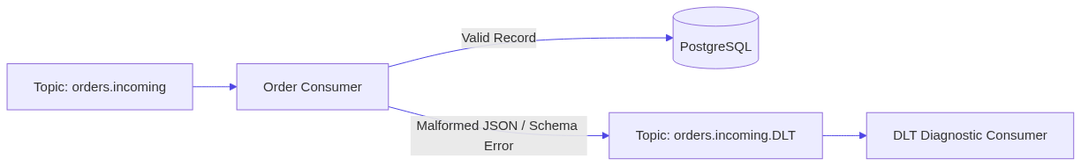
Run
Step 1: Start the main consumer
// BASH CODE SNIPPET
npm run lab:09:consumer
# Or: node labs/09-dead-letter-topic/src/consumer.js
Step 2: Start the DLT inspector consumer in another terminal
// BASH CODE SNIPPET
npm run lab:09:dlt-consumer
# Or: node labs/09-dead-letter-topic/src/dlt-consumer.js
Step 3: Produce valid and corrupt messages
// BASH CODE SNIPPET
npm run lab:09:producer
# Or: node labs/09-dead-letter-topic/src/producer.js
Observe
- The corrupt message is automatically routed to orders.incoming.DLT.
- The DLT consumer displays original topic, partition, offset, timestamp, and exception stack trace!
Questions
- Why should you never discard corrupt records silently?
- What headers should always be attached to a DLT record?

Lab 10 — Idempotency & Deduplication
Objective
Build an idempotent event processing pipeline combining KafkaJS Producer Idempotency (idempotent: true) and Consumer Idempotency using a PostgreSQL deduplication table.
Architecture
📊 ARCHITECTURE DIAGRAM: Architecture
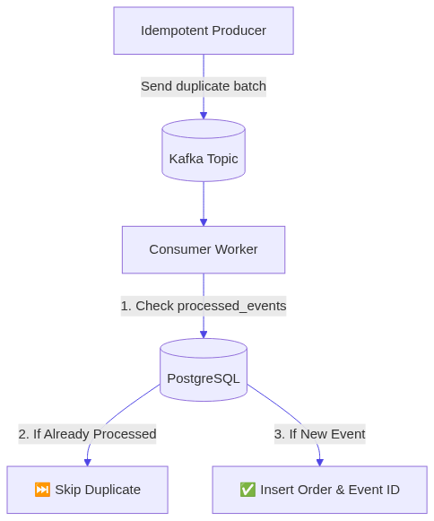
Run
Step 1: Start the idempotent consumer
// BASH CODE SNIPPET
npm run lab:10:consumer
# Or: node labs/10-idempotency/src/consumer.js
Step 2: Produce intentional duplicate events
// BASH CODE SNIPPET
npm run lab:10:producer
# Or: node labs/10-idempotency/src/producer.js
Observe
- The producer sends the exact same eventId: 'evt_dup_999' 3 times.
- The consumer processes the first attempt, records it in PostgreSQL, and cleanly skips the subsequent 2 duplicates without throwing an error or double-charging!
Questions
- Why does an idempotent producer not protect against consumer replays?
- What PostgreSQL constraint is used to guarantee atomic deduplication? (PRIMARY KEY on event_id).

Lab 11 — Kafka Transactions & Atomicity
Objective
Implement atomic multi-topic event generation and transactional offset commits using KafkaJS Transactional Producer (transactionalId).
Architecture
📊 ARCHITECTURE DIAGRAM: Architecture
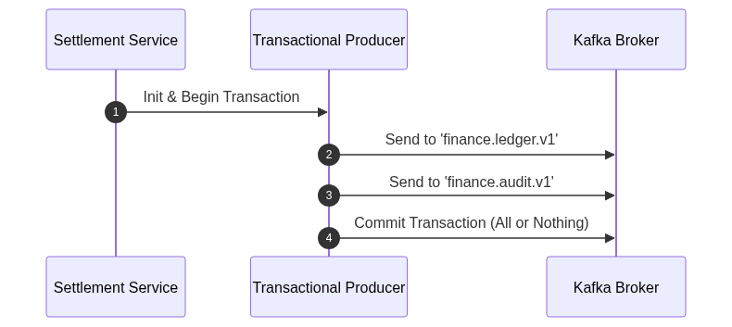
Run
// BASH CODE SNIPPET
npm run lab:11:service
# Or: node labs/11-transactions/src/transaction-flow.js
Observe
- The script executes two scenarios:
- A successful transaction: both ledger and audit messages are committed atomically.
- An aborted transaction: when an error occurs, transaction.abort() is called, and zero messages become visible to read_committed consumers!
Questions
- Why must a transactional producer define a unique transactionalId?
- What happens if a consumer reads with readUncommitted: true?

Lab 12 — Performance Tuning & Benchmarking
Objective
Benchmark the throughput difference between uncompressed single-message sends versus batched, GZIP-compressed producer pipelines.
Architecture
📊 ARCHITECTURE DIAGRAM: Architecture
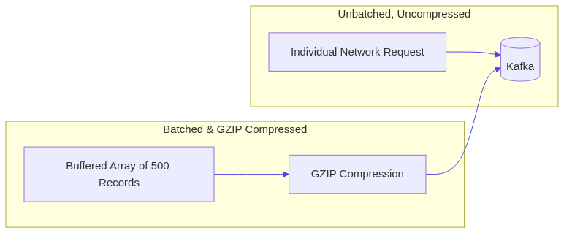
Run
// BASH CODE SNIPPET
npm run lab:12:benchmark
# Or: node labs/12-performance/src/benchmark.js
Observe
The benchmark sends 2,000 records using:
- Mode 1: Single uncompressed sends (Sequential promises)
- Mode 2: Batched array sends with GZIP compression
Compare the execution time and messages-per-second (msg/sec) metrics!
Notice how batching + compression delivers a $10\times$ to $50\times$ throughput boost.
Questions
- Why does batching reduce CPU load on both the client and broker?
- What are the trade-offs of GZIP vs Snappy compression?

