1. **public** **class** HomeController : Controller
2. {
3. [HttpGet]
4. **public** IActionResult Index()
5. {
6. **return** View();
7. }
9. [HttpPost]
10. **public** IActionResult Index( Operation model )
11. {
12. **if** ( model.OperationType == OperationType.Addition )
13. model.Result = model.NumberA + model.NumberB;
14. **return** View( model );
15. }
16. }

This is the View,

1. @model Operation
2. <form asp-controller="Home" asp-action="Index" method="post" >
3. <div **class**="form-group">
4. <div **class**="row">
5. <label asp-**for**="NumberA" **class**="col-lg-2"></label>
6. <input type="number" asp-**for**="NumberA" **class**="col-lg-2" />
7. </div>
8. <div **class**="row">
9. <label asp-**for**="NumberB" **class**="col-lg-2"></label>
10. <input type="number" asp-**for**="NumberB" **class**="col-lg-2" />
11. </div>
12. <div **class**="row">
13. <label asp-**for**="OperationType" **class**="col-lg-2"></label>
14. <select asp-**for**="OperationType" **class**="col-lg-2" asp-items="Html.GetEnumSelectList<OperationType>()">
15. <option selected="selected" value="">Select</option>
16. </select>
17. </div>
18. <div **class**="row">
19. <label asp-**for**="Result" **class**="col-lg-2"></label>
20. <input type="number" disabled="disabled" **class**="col-lg-2" asp-**for**="Result" />
21. </div>
22. <div **class**="row">
23. <input type="submit" value="Submit" asp-action="Index" />
24. </div>
25. </div>
26. </form>

View Result in the browser.

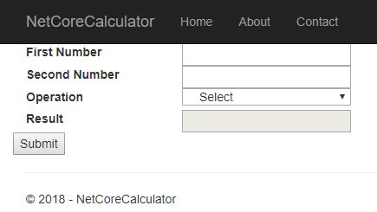

This is the model used in here.

1. **public** **class** Operation
2. {
3. [Display( Name = "First Number" )]
4. **public** **double** NumberA { **get**; **set**; }
6. [Display( Name = "Second Number" )]
7. **public** **double** NumberB { **get**; **set**; }
9. [Display( Name = "Result" )]
10. **public** **double** Result { **get**; **set**; }
12. [Display( Name = "Operation" )]
13. **public** OperationType OperationType { **get**; **set**; }
14. }
15. **public** **enum** OperationType
16. {
17. Addition,
18. Multiplication,
19. Division,
20. Subtraction
21. }