**Create Resource and Web App**

1. Open Web App create window. Click Create a resource(1) — Web(2) — Web App (3)

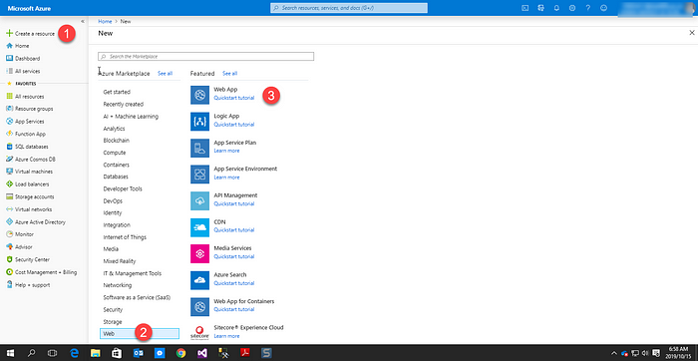

2. Create new resource. On Resource Group label Click Create new and name your group and click OK.

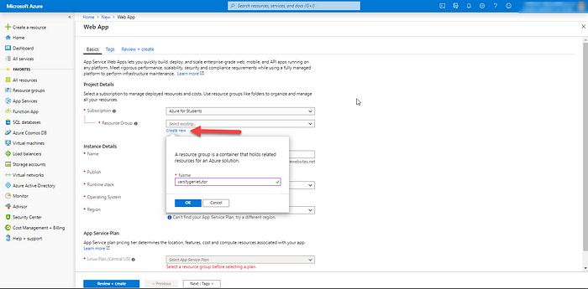

3. Create Web App. Name your app anything(1), Select Code(2), choose ASP.NET v4.7 (3), select Windows (4) and select Central US for region ( 5) and Click Review + Review

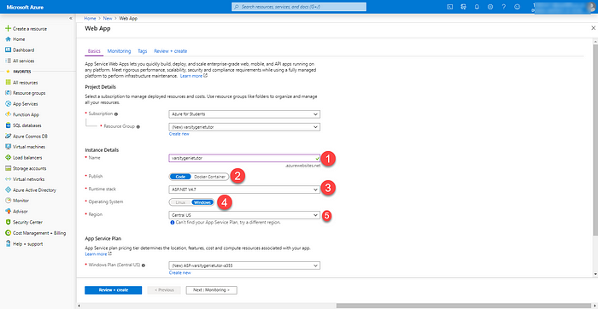

4. Review. Verify your information and click OK

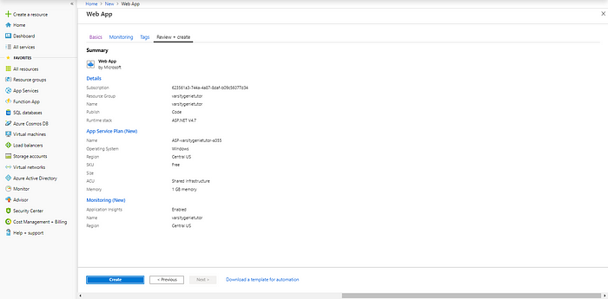

6. Deployment underway. Click notification icon on the Wait until deployment underway change to complete.

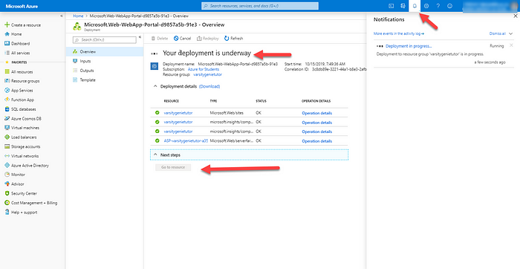

7. Deployment complete

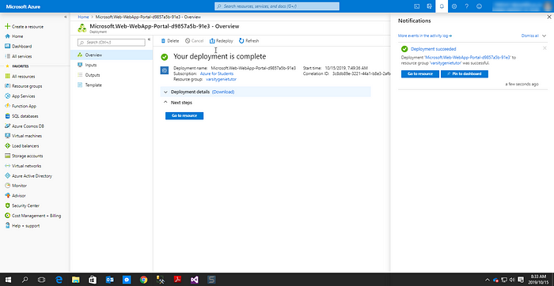

**Create Server and Database (SQL Database)**

1. Add new Database in the Resource group- Click Resource Group(1), Click name of resource group you adding databse into(2) and Add database (3)

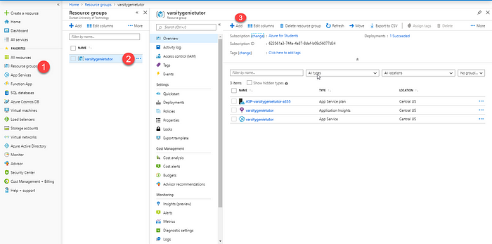

2. Add SQL Database Click Databases (1) and select SQL Database (2)

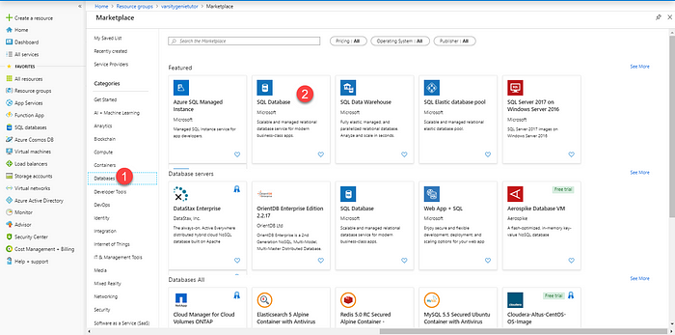

3. Create SQL Database

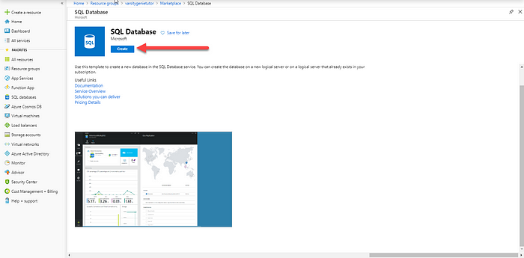

4. Create New Server. Click create new, name your server(1), create username for admin(2), create password and confirm password (3), select (US) East US(4) and click OK.

***NB: Write Your Username and password on paper you will need them when we work with connection string***

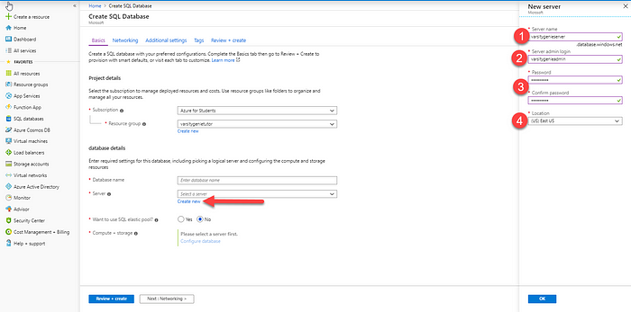

5. Name your Database and click Next: Networking button

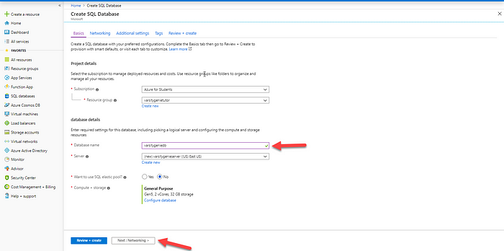

6. Configure network access and connectivity for your server. Select Public endpoint (1), select “YES” on allow azure services & resource to access the server (2), select “YES” on Add current client IP address (3) and click Review + Create

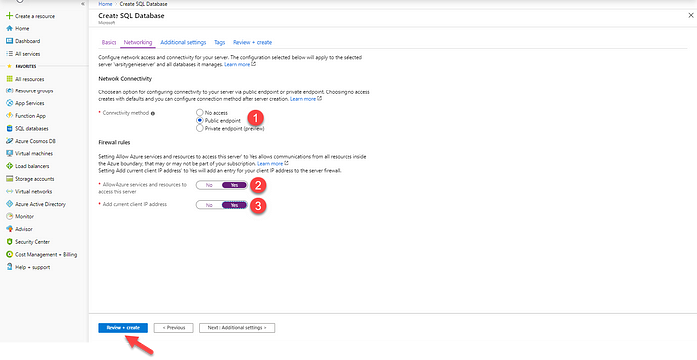

7. Review Database, server and Network and create

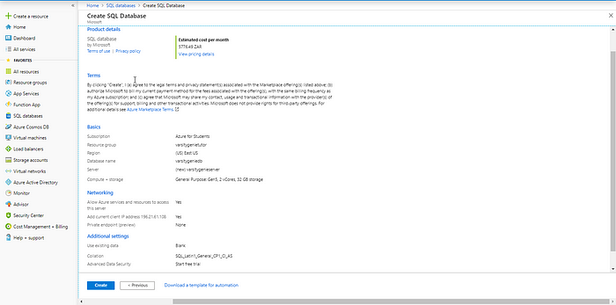

8. Server and Database Deployment underway

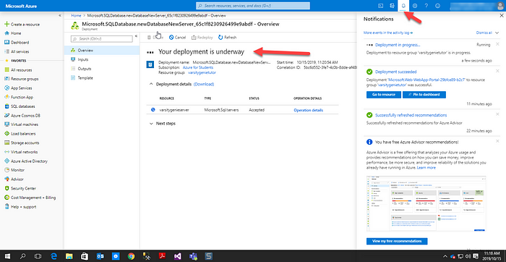

9. Server and Database Deployment complete. Click Go to resource

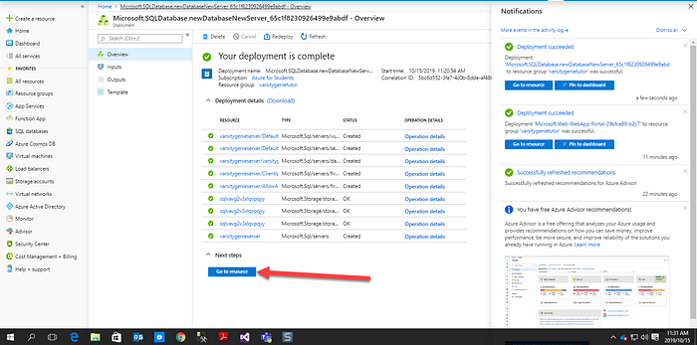

9. After clicking Go to resource database overview window will open.

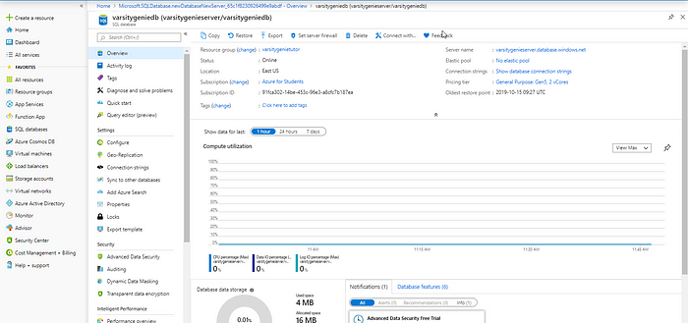

10. Click Connection strings(1) and copy ADO.NET (2)

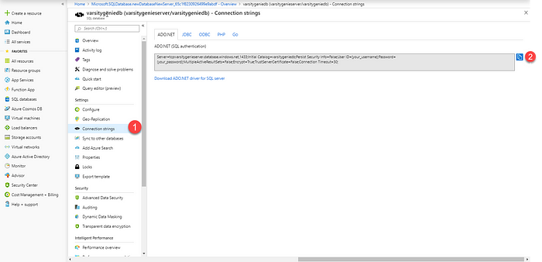

11. Open web app to download publish profile- Click Resource groups( 1), open your resource group(2) and click App Service(3)

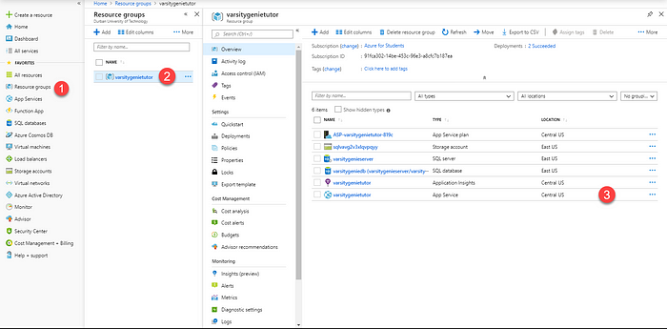

12. Download Get publish profile

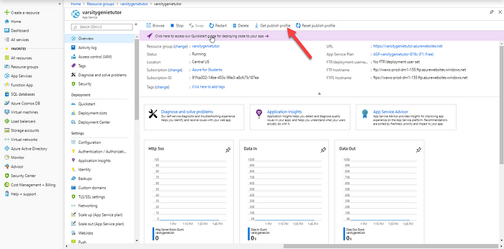

**Publish Web App on Visual Studio**

1. Go to Web.config and paste connection string from Azure to connection on your application. On user ID put username and password you created when you we creating your server.

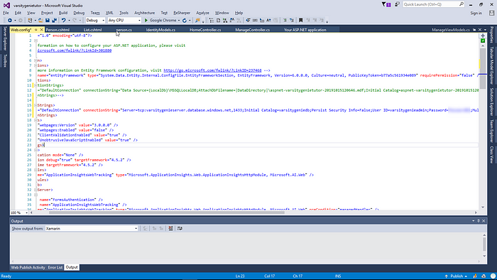

2. Upload Publishing profile- right on your app (1) and click publish(2)

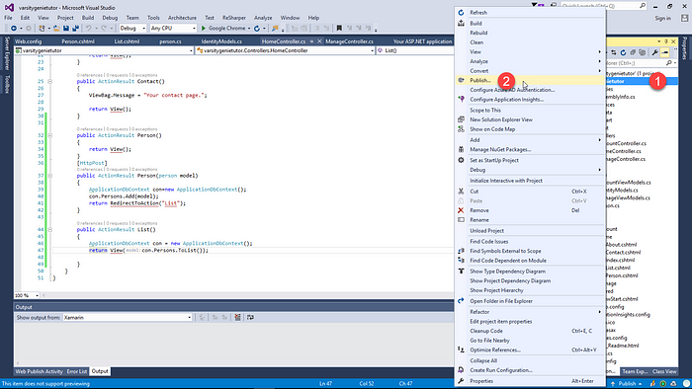

3. Click import (1), Browser(2) and select the publish profile downloaded from Azure (3)

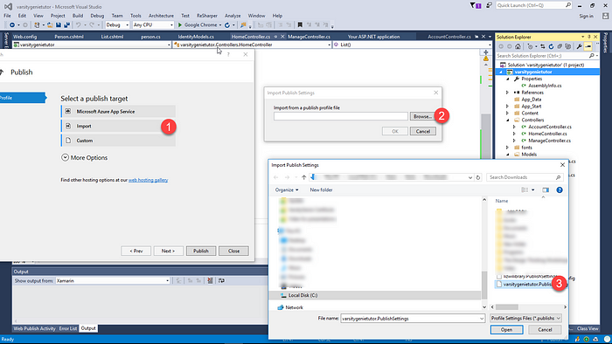

4. After uploading publish profile , click publish

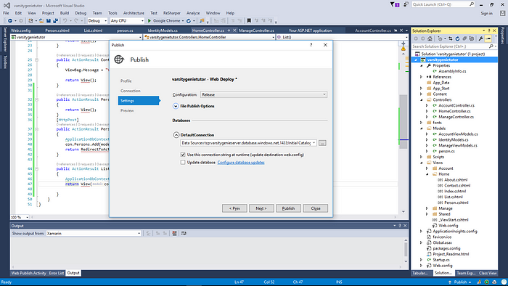

5. Successful published

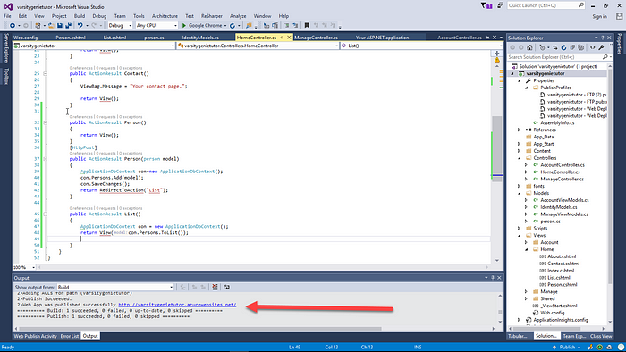

6. Enter information to Database on Azure

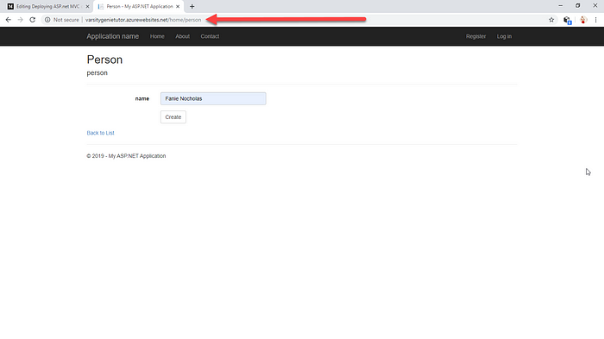

7. Display information from database

