Resource Group Creation is one of the mandatory prerequisite to have before you attempt to use any Azure services. You will always be asked to provide Resource Group details. It is because all the azure resources must reside in a Resource Group. Hence it is very important to understand and know all about Resource Group and its Creation.

Resource Group Creation is one of the mandatory prerequisite to have before you attempt to use any Azure services. You will always be asked to provide Resource Group details. It is because all the azure resources must reside in a Resource Group. Hence it is very important to understand and know all about Resource Group and its Creation.

## **Create a Resource Group in Microsoft Azure Cloud**

### **Step 1: Prerequisites**

a) You should have a valid Microsoft Azure Account.

b) You should have access to create Resource Group.

c) You should have valid subscription to create Resource Group.

### **Step 2: Open Resource Groups**

There are two ways to open resource groups. You can either Go to Portal Menu->Resource Groups or you can search it in Search Box as shown below.

### **Step 3: Click on Create**

Once it is Opened, you can Click on + Create as shown below.

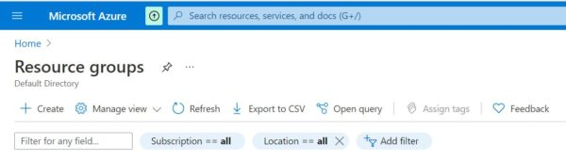

### **Step 4: Create a Resource Group**

**a) Basic Details**

In the basic details section, you need to provide your Subscription, Resource Group Name and Region. Here I am using below details.

**Subscription:** Free Trial

**Resource Group:** TestResourceGroup

**Region:** (US) East US

Since I have created a Free Trial Account in Microsoft Azure so I am using this subscription here. You can choose whichever subscription you are using. By default, region will be selected as (US) East US. You can also change the region based on your preference. You might have also noticed little red start mark(*) in below details section. This means that the start marked fields needs to be mandatorily filled and hence cannot be moved on from this section without providing those details.

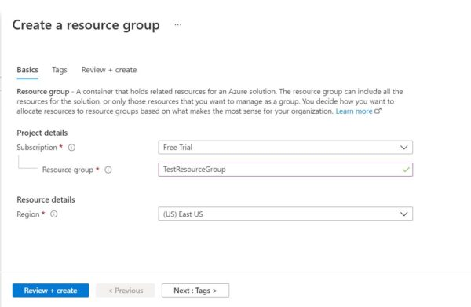

**b) Apply Tags**

Then the next section is about applying tags to your Resource Group. As you notice this is not a mandatory section so you can either leave this section and directly create your Resource Group or you can tag it using key-value pairs as per your need. Then Click on Next: Review + Create >

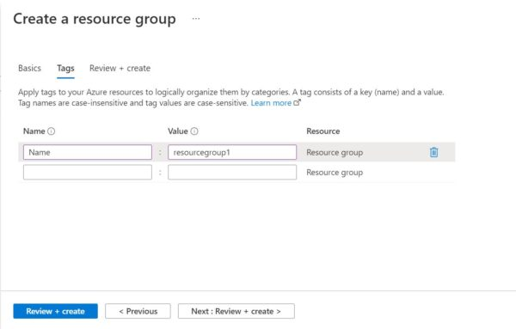

**c) Review + Create**

After passing all the validation checks you can now Click on Create. If everything goes well, resource group will be created within few minutes.

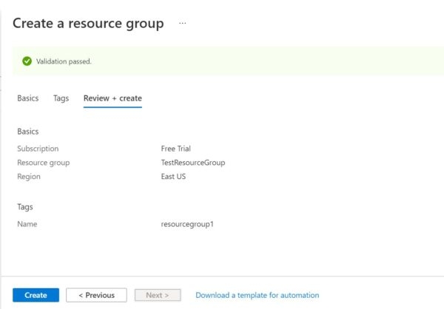

### **Step 5: List Resource Groups**

Once Resource Group is created, you will be able to see it as shown below. You can also click on it to get more details.

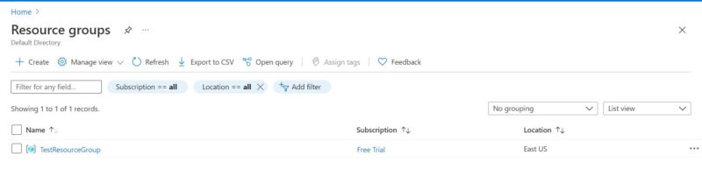

**How to Create App Services in Azure Portal{Step by Step Guide}**

Web Apps created in the App Services allows you to quickly build, deploy, and scale enterprise-grade web, mobile, and API apps running on any platform. Meet rigorous performance, scalability, security and compliance requirements while using a fully managed platform to perform infrastructure maintenance.

## **What is Azure App Service**

Azure App Service is a fully managed web hosting service for building web applications, services and RESTful APIs.

## **How to Create App Services in Azure Portal**

### **Step 1: Prerequisites**

a) You should have a valid Azure Account.

b) You should have a valid subscription.

c) You should have access to create an App Service.

### **Step 2: Login to Azure Portal**

First you need login to below [Azure Portal](https://portal.azure.com/) using your valid user account and password. Upon successful login, you will land into Portal Home Page from where you can create all the required resources.

### **Step 3: Create a Resource Group**

All the resources which you are going to create, it should be created in a Resource Group. So the next step is to create a Resource Group. You can check [How to Create a Resource Group in Microsoft Azure Cloud](https://www.cyberithub.com/how-to-create-a-resource-group-in-microsoft-azure-cloud/) to create a resource group.

### **Step 4: Open App Services**

In the next step you need to create an app service from Azure App Services. You can either search App Services from the Home Page search box or go directly to the Service from Portal Menu as you can see below.

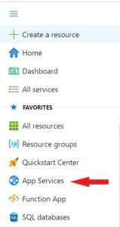

### **Step 5: Create App Service**

Once App Services opened, you can click on Create as shown below.

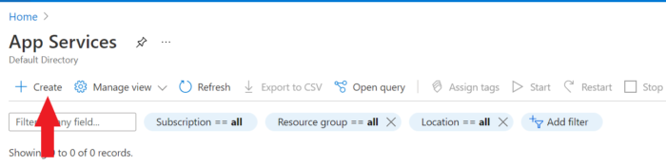

**a) Basics**

You will see below Create Web App window where you need to first fill the Basics section. You need to select your Subscription and Resource Group which you want to use.

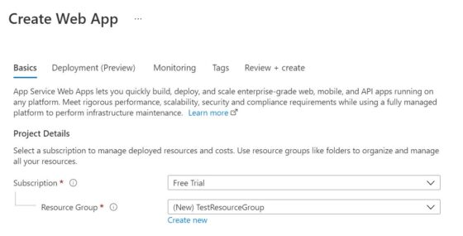

Then you need to provide the Instance details were you need to provide a unique instance name. I am using test301 so the complete name becomes test301.azurewebsites.net as you can see below. Then you have the option to publish it as Code or Docker Container. I will choose to publish as Code. Next you need to choose the Runtime Stack. I am using .NET 6(Early Access) as my runtime stack. You can choose as per your requirement.

Then you need to choose the Operating System you want to use. Currently Azure provides two options - Linux or Windows. I am going to choose Windows for my web app. Finally, you need to choose the Region. By default, Central US will be selected. I will use this default option however you can change it to a suitable location as per your need.

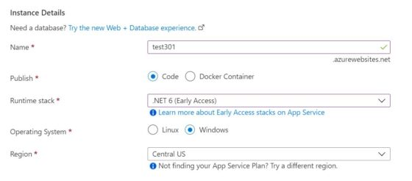

If you further scroll down, you will see App Service Plan details to fill. You can either use any existing App Service Plan or create a new one by Clicking on Create new. You can check [How to Create an App Service Plan in Azure{Step by Step Guide}](https://www.cyberithub.com/how-to-create-an-app-service-plan-in-azure-step-by-step-guide/) to create an App Service Plan.

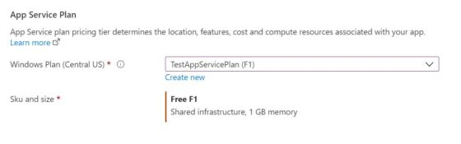

**b) Deployment(Preview)**

In the next section, you need to select your Deployment settings. This option is pretty handy if you are looking to perform Continuous deployment of your web app in App Service. You can set up GitHub repository to maintain your project source codes and can deploy your web app to App Service based on new commit done on repository.

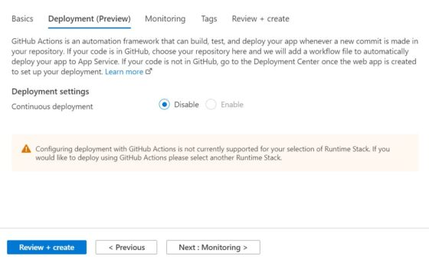

**c) Monitoring**

Next section is about enabling the monitoring for this app service using Application Insights. Azure has a very powerful Application Performance Management(APM) tool called Application Insights which can be used to monitor Azure resources for any performance anomalies. For the moment, I am keeping it disabled by clicking on No as you can see below. Then Click on Next: Tags to proceed.

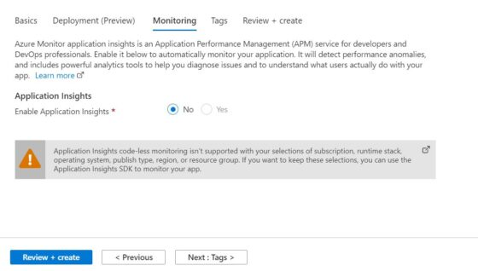

**d) Tags**

Here you can use the Tags to categorize your resources which further helps you in tracking the billing of those resources. Each of the tags that you create are just name/value pairs. Since here I am not using any tags so I will just click on Next: Review + create> to proceed to the next section.

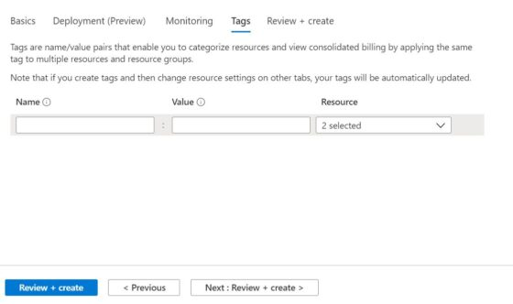

**e) Review+Create**

Finally, you can review all your configuration and then click on Create once you verified all the details given in each section.

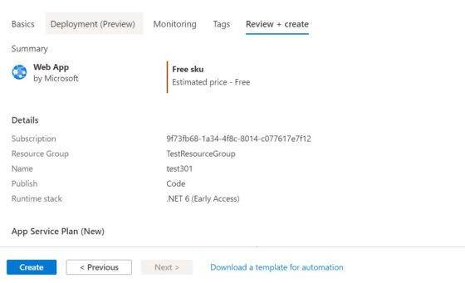

After a while you can see that your deployment is completed and it should look like below. You can get more details about this deployment by clicking on Go to resource . This completes the creation of web app Services.

