Go to [Microsoft Azure portal](https://portal.azure.com/), log-in with your Azure account credentials.  
  
Click ‘+’ sign => Web + Mobile => Mobile App.  
  
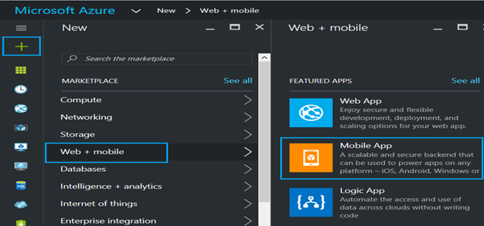  
  
**Blade with following details will appear.**

* *App Name* - Enter a Unique name for your Mobile App. This name is unique across Azure.
* *Subscription* - Your subscription for Azure services
* *Resource Group* - Group of related products / service created on Azure Portal. You can select existing resource group or create new.
* *App Service Plan* - You can select an existing App Service Plan or create new.  
    
  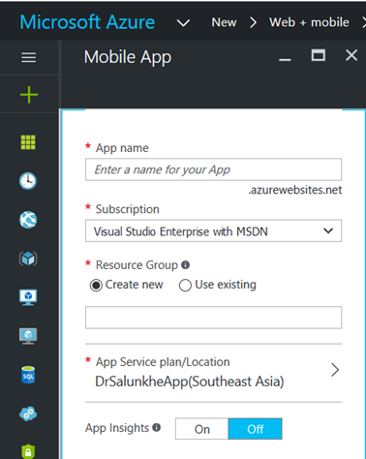

For this article, I have entered the below details.  
  
Once done with entering all required details, click "Create".  
  
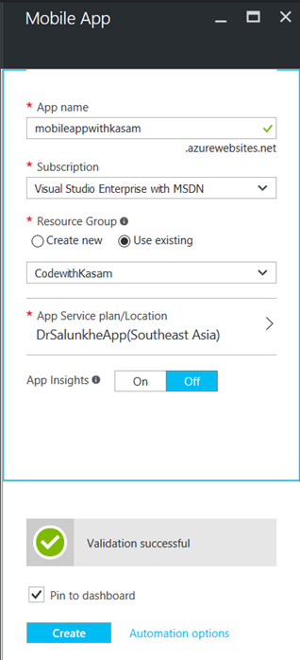  
  
As seen in the above image, we have pinned this to our Dashboard. You can very well track the deploying process over Dashboard.  
  
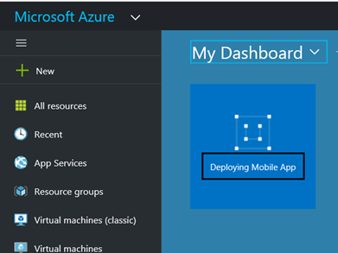  
  
Once done with deployment, notification too would be received.  
  
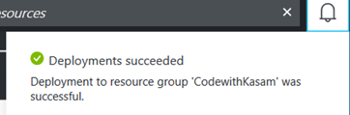  
  
So now, it’s shown as running. Click it for diving in for details.  
  
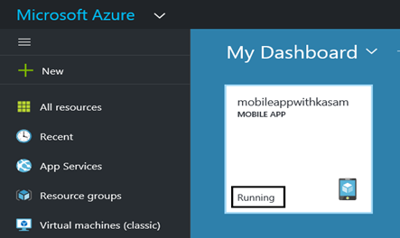  
  
An Overview of created Mobile app can be seen here with all essential details.  
  
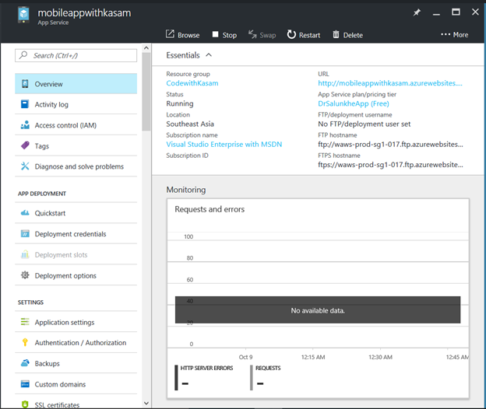  
  
Click on Quickstart option under AppDeployment. Options available are listed as seen.  
  
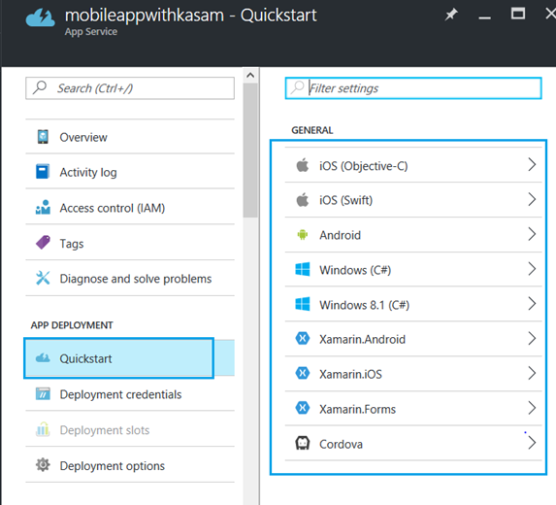  
  
To explore more, click any one of listed option.  
  
You can see that three steps are needed to be performed.

1. *Connect to Database* - Required to completed the process
2. *Create a table API -* It’s to store data in your backend. C# & Node.js can be used as backend language.
3. Configuring Client Application,
   * *Create a New App* - Application here is pre-configured to work with mobile backend. Instructions related to tools required are also provided. This configuration and tools details changes with change in platforms selected.
   * *Connect An Existing App* - Step to configure backend are provided here.  
       
     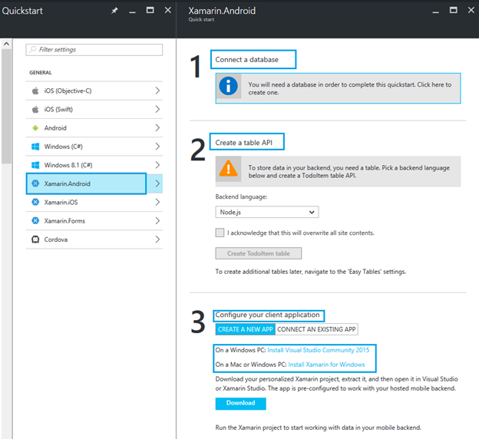

**Step 1 Connect to Database**  
This will give you option from SQL Database or Storage to add as data connection. You can select from your existing Database and storage account or can create new.  
  
To learn more about Azure SQL database creation, would recommend to read, Azure SQL - [Creation and Connection](http://www.c-sharpcorner.com/article/getting-started-with-azure-sql-creation-and-connection/)  
  
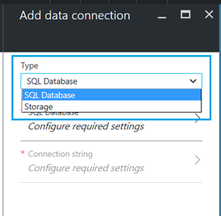  
  
Here, I have selected my existing storage account, and hence this step gets completed.  
 **Step 2 creating a table API**  
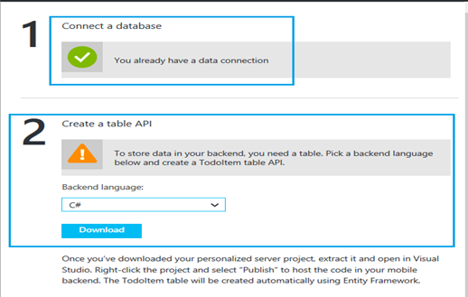  
  
Here, you have two options for languages to be selected as backend language, C# and Node.js  
  
For this article, let’s select Node.js as back-end Language. Check the acknowledge statement.  
  
And, click "CreateTodoItemtable".  
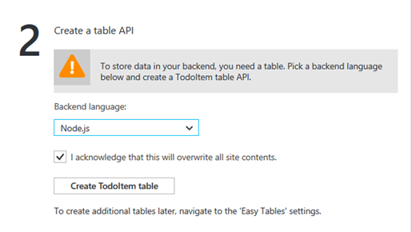  
  
**Step 3**  
Selecting ‘ConnectAn Existing App’ as an option, would instruct with all details needed to configure, as seen in below image. This instruction changes with the platform options being selected.  
  
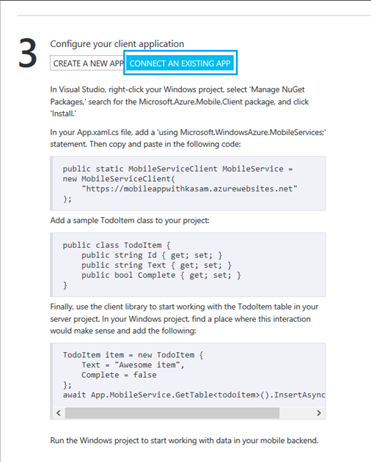  
  
Now, selecting "Create New App" as option will display details of development tool required for pre-configured app to work with mobile back-end.  
  
Again, this changes with platform selected, as shown below.  
  
For iOS (Objective-C) & iOS (Swift), on a Mac its needs to Xcode.  
  
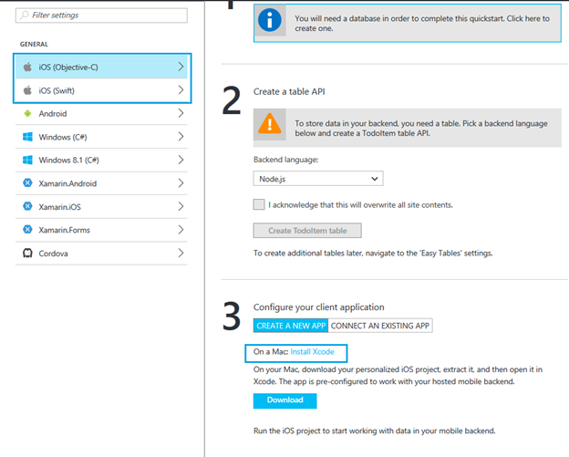  
**For Android**  
On a Mac or Windows PC, it needs Android Studio.  
  
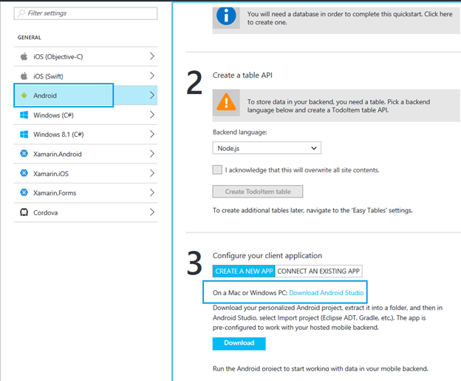  
  
**For Windows C# - Universal Windows Platform**  
On Windows PC, it needs Visual Studio 2015.  
 **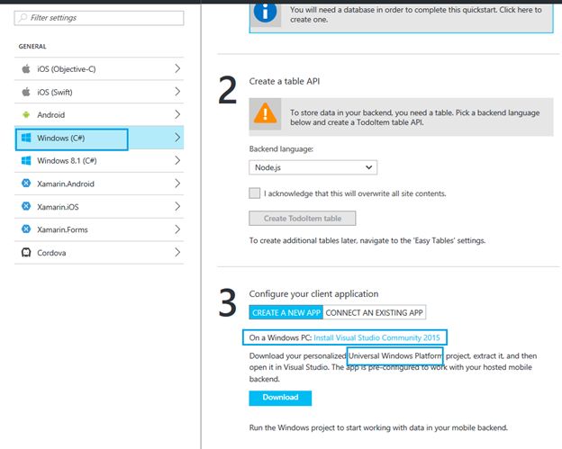  
  
For Windows 8.1 C#**  
On Windows PC, it needs Visual Studio 2015.  
  
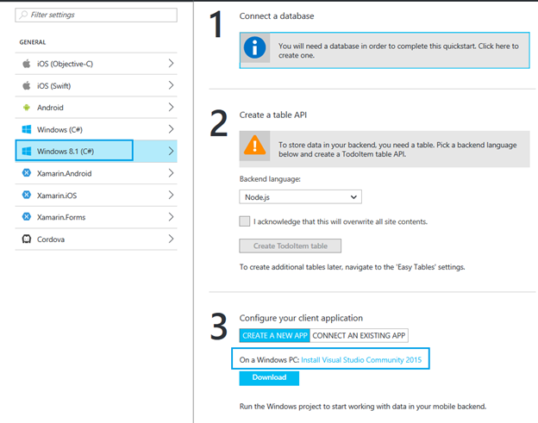  
  
**For Xamarin.Android, Xamarin.iOS and Xamarin.Forms**  
On Windows PC, it needs Visual Studio 2015 and on a Mac or Windows PC, it needs Xamarin for Windows.  
  
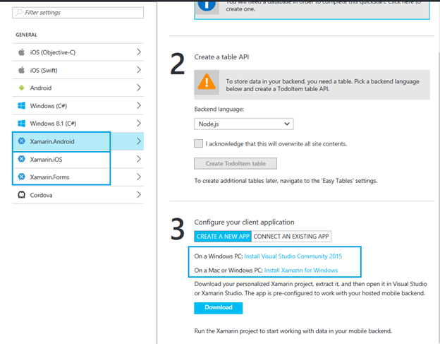  
  
**For Cordova**  
Click on Download and follow the instructions to get it installed and work.  
  
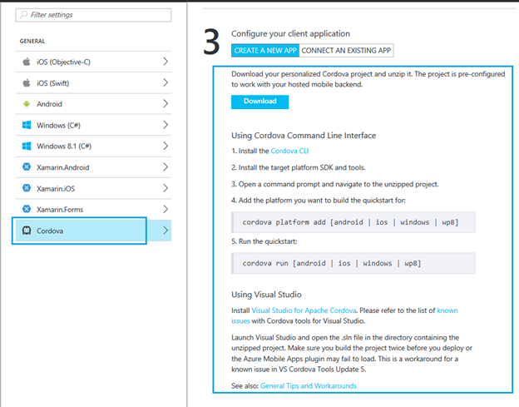  
  
Now, click on another option under App Deployment section, i.e. Deployment options.  
  
You can select any options listed in Source blade, as a source of files to be deployed for Mobile app.  
  
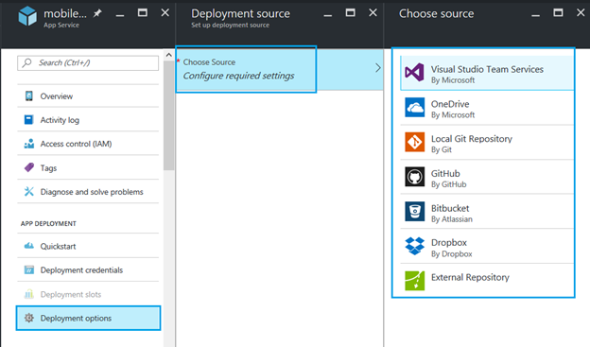  
  
For this article, will be selecting GitHub as a source.  
  
Would recommend to once go through, [how to deploy files to app using GitHub](http://www.c-sharpcorner.com/article/deploying-files-to-azure-web-app-through-github/). Click OK and you are done!  
  
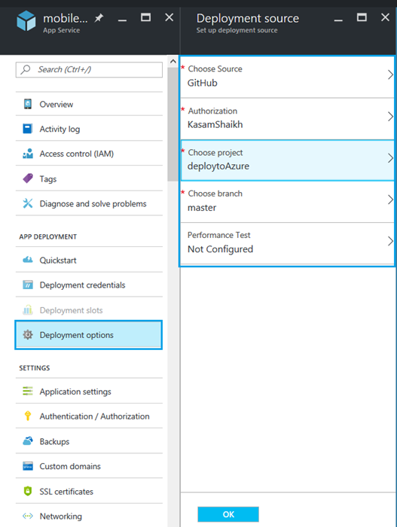  
  
For a quick glance about app status, URL, its mode, IP addresses, and FTP related details along with diagnostics logs, go to Properties, as seen below.  
  
