**Sign in to the Azure portal**

Sign in to the [Azure portal](https://portal.azure.com/).

**Create a blank database in Azure SQL Database**

A database in Azure SQL Database is created with a defined set of compute and storage resources. The database is created within an [Azure resource group](https://docs.microsoft.com/en-us/azure/active-directory-b2c/overview) and is managed using an [logical SQL server](https://docs.microsoft.com/en-us/azure/azure-sql/database/logical-servers).

Follow these steps to create a blank database.

1. On the Azure portal menu or from the **Home** page, select **Create a resource**.
2. On the **New** page, select **Databases** in the Azure Marketplace section, and then click **SQL Database** in the **Featured** section.

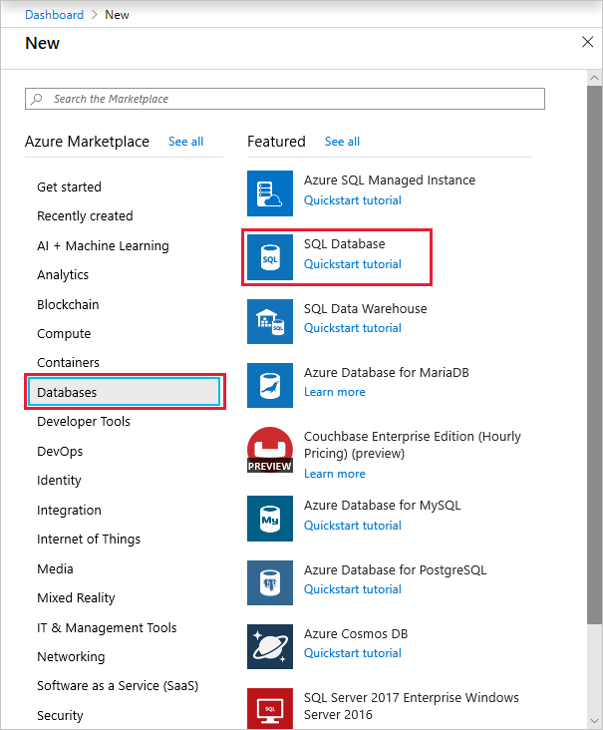

1. Fill out the **SQL Database** form with the following information, as shown on the preceding image:

| **TABLE 1** | | |
| --- | --- | --- |
| **Setting** | **Suggested value** | **Description** |
| **Database name** | *yourDatabase* | For valid database names, see [Database identifiers](https://docs.microsoft.com/en-us/sql/relational-databases/databases/database-identifiers). |
| **Subscription** | *yourSubscription* | For details about your subscriptions, see [Subscriptions](https://account.windowsazure.com/Subscriptions). |
| **Resource group** | *yourResourceGroup* | For valid resource group names, see [Naming rules and restrictions](https://docs.microsoft.com/en-us/azure/architecture/best-practices/resource-naming). |
| **Select source** | Blank database | Specifies that a blank database should be created. |

1. Click **Server** to use an existing server or create and configure a new server. Either select an existing server or click **Create a new server** and fill out the **New server** form with the following information:

| **TABLE 2** | | |
| --- | --- | --- |
| **Setting** | **Suggested value** | **Description** |
| **Server name** | Any globally unique name | For valid server names, see [Naming rules and restrictions](https://docs.microsoft.com/en-us/azure/architecture/best-practices/resource-naming). |
| **Server admin login** | Any valid name | For valid login names, see [Database identifiers](https://docs.microsoft.com/en-us/sql/relational-databases/databases/database-identifiers). |
| **Password** | Any valid password | Your password must have at least eight characters and must use characters from three of the following categories: upper case characters, lower case characters, numbers, and non-alphanumeric characters. |
| **Location** | Any valid location | For information about regions, see [Azure Regions](https://azure.microsoft.com/regions/). |

1. 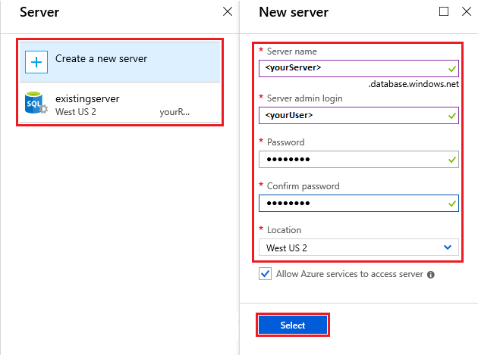
2. Click **Select**.
3. Click **Pricing tier** to specify the service tier, the number of DTUs or vCores, and the amount of storage. You may explore the options for the number of DTUs/vCores and storage that is available to you for each service tier.

After selecting the service tier, the number of DTUs or vCores, and the amount of storage, click **Apply**.

1. Enter a **Collation** for the blank database (for this tutorial, use the default value). For more information about collations, see [Collations](https://docs.microsoft.com/en-us/sql/t-sql/statements/collations)
2. Now that you've completed the **SQL Database** form, click **Create** to provision the database. This step may take a few minutes.
3. On the toolbar, click **Notifications** to monitor the deployment process.

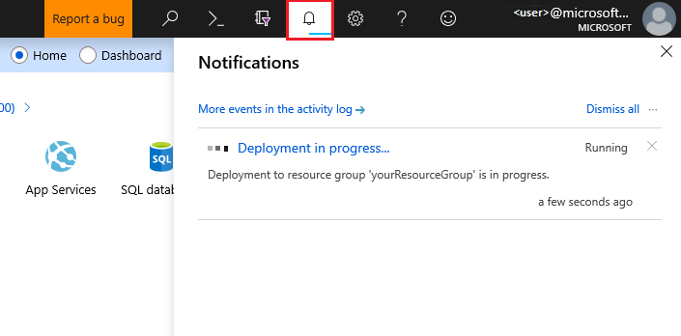

**Create a server-level IP firewall rule**

Azure SQL Database creates an IP firewall at the server-level. This firewall prevents external applications and tools from connecting to the server and any databases on the server unless a firewall rule allows their IP through the firewall. To enable external connectivity to your database, you must first add an IP firewall rule for your IP address (or IP address range). Follow these steps to create a [server-level IP firewall rule](https://docs.microsoft.com/en-us/azure/azure-sql/database/firewall-configure).

**Important**

Azure SQL Database communicates over port 1433. If you are trying to connect to this service from within a corporate network, outbound traffic over port 1433 may not be allowed by your network's firewall. If so, you cannot connect to your database unless your administrator opens port 1433.

1. After the deployment completes, select **SQL databases** from the Azure portal menu or search for and select *SQL databases* from any page.
2. Select *yourDatabase* on the **SQL databases** page. The overview page for your database opens, showing you the fully qualified **Server name** (such as contosodatabaseserver01.database.windows.net) and provides options for further configuration.

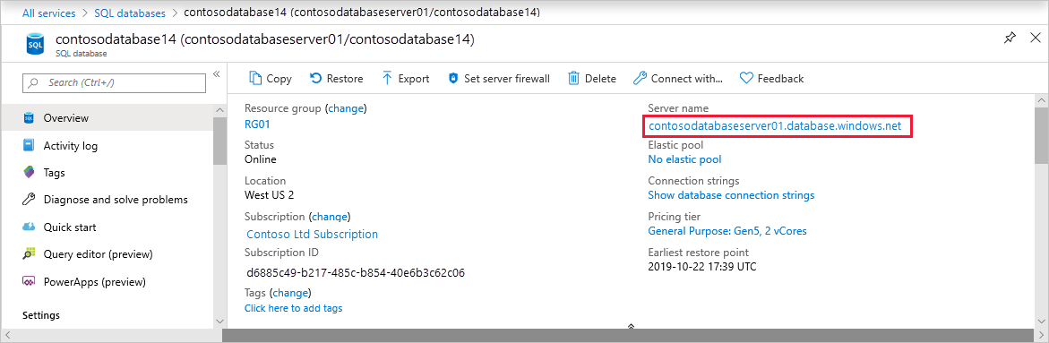

1. Copy this fully qualified server name for use to connect to your server and databases from SQL Server Management Studio.
2. Click **Set server firewall** on the toolbar. The **Firewall settings** page for the server opens.

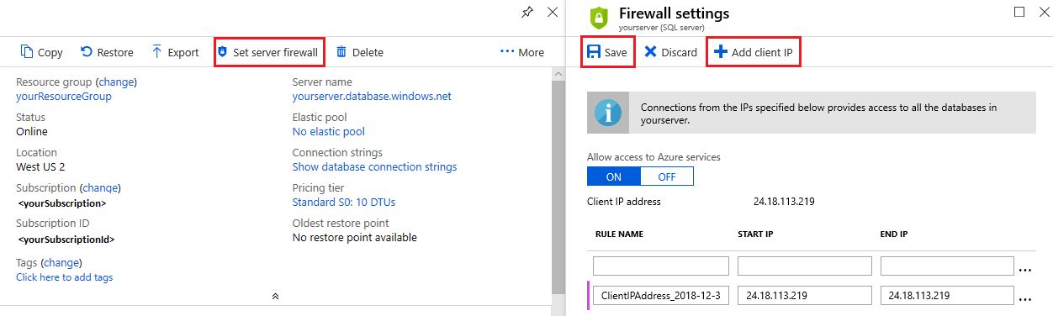

1. Click **Add client IP** on the toolbar to add your current IP address to a new IP firewall rule. An IP firewall rule can open port 1433 for a single IP address or a range of IP addresses.
2. Click **Save**. A server-level IP firewall rule is created for your current IP address opening port 1433 on the server.
3. Click **OK** and then close the **Firewall settings** page.

Your IP address can now pass through the IP firewall. You can now connect to your database using SQL Server Management Studio or another tool of your choice. Be sure to use the server admin account you created previously.

**Important**

By default, access through the SQL Database IP firewall is enabled for all Azure services. Click **OFF** on this page to disable for all Azure services.

**Connect to the database**

Use [SQL Server Management Studio](https://docs.microsoft.com/en-us/sql/ssms/sql-server-management-studio-ssms) to establish a connection to your database.

1. Open SQL Server Management Studio.
2. In the **Connect to Server** dialog box, enter the following information:

| **TABLE 3** | | |
| --- | --- | --- |
| **Setting** | **Suggested value** | **Description** |
| **Server type** | Database engine | This value is required. |
| **Server name** | The fully qualified server name | For example, *yourserver.database.windows.net*. |
| **Authentication** | SQL Server Authentication | SQL Authentication is the only authentication type that we've configured in this tutorial. |
| **Login** | The server admin account | The account that you specified when you created the server. |
| **Password** | The password for your server admin account | The password that you specified when you created the server. |

1. 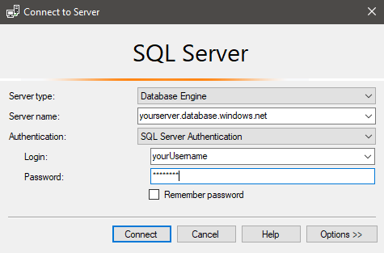
2. Click **Options** in the **Connect to server** dialog box. In the **Connect to database** section, enter *yourDatabase* to connect to this database.

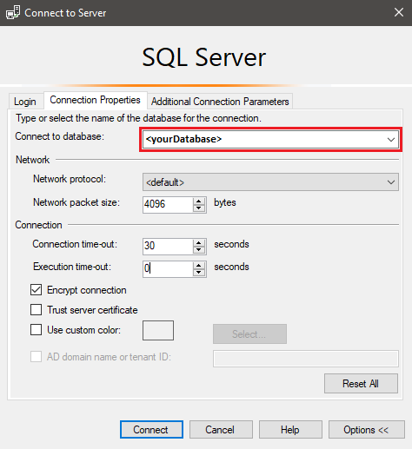

1. Click **Connect**. The **Object Explorer** window opens in SSMS.
2. In **Object Explorer**, expand **Databases** and then expand *yourDatabase* to view the objects in the sample database.