What is software project management?

Software in project management is dedicated to the planning, scheduling, resource allocation, execution, tracking, and delivery of software and web projects.

Project management in software engineering is distinct from traditional project management — software in project management has a unique life cycle process that requires multiple rounds of testing, updating, and customer feedback. Most IT-related projects are managed in the Agile style to keep up with the increasing pace of business and iterate based on customer and stakeholder feedback.

The role and responsibility of a software project manager

Software project managers may have to do any of the following tasks:

Planning: The software project manager puts together the blueprint for the entire project. The project plan will define the scope, necessary resources, timeline, procedure for execution, communication strategy, and steps required for testing and maintenance.

Leading: A software project manager assembles and leads the project team, which consists of developers, analysts, testers, graphic designers, and technical writers. Heading up a team requires excellent communication, people, and leadership skills.

Execution: The person who manages software projects will supervise the successful execution of each stage of the project. This includes monitoring progress,

Time management: Staying on schedule is crucial to the successful completion of any project. This can be particularly challenging with the management of software projects because changes to the original plan are almost guaranteed as the project evolves. Software project managers must be experts in risk management and contingency planning to ensure progress in the face of roadblocks or changes.

Budget: Like traditional project managers, professionals who manage software projects are tasked with creating a budget for a project and sticking to it as closely as possible, moderating spending and reallocating funds when necessary.

Maintenance: Project management in software encourages constant product testing to discover and fix bugs early, adjust the end product to the customer’s needs, and keep the project on target. The software project manager ensures the product is properly and consistently tested, evaluated, and adjusted accordingly.

How to manage a software project successfully

According to Forbes, there are eight ways to manage software projects effectively. These tips include:

1. Taking non-development work off your team’s plate to let them focus on the product
2. Motivating your team by sharing others’ success stories
3. Avoiding any changes to tasks once assigned
4. Trying to stick to the plan (until it needs to be changed)
5. Encouraging organization by being organized yourself
6. Streamlining productivity through effective delegation
7. Getting to know your team and building a rapport
8. Breaking down the plan and assigning specific daily tasks

Software Project Planning

A Software Project is the complete methodology of programming advancement from requirement gathering to testing and support, completed by the execution procedures, in a specified period to achieve intended software product.

Need of Software Project Management

Software development is a sort of all new streams in world business, and there's next to no involvement in structure programming items. Most programming items are customized to accommodate customer's necessities. The most significant is that the underlying technology changes and advances so generally and rapidly that experience of one element may not be connected to the other one. All such business and ecological imperatives bring risk in software development; hence, it is fundamental to manage software projects efficiently.

Software Project Manager

Software manager is responsible for planning and scheduling project development. They manage the work to ensure that it is completed to the required standard. They monitor the progress to check that the event is on time and within budget. The project planning must incorporate the major issues like size & cost estimation scheduling, project monitoring, personnel selection evaluation & risk management. To plan a successful software project, we must understand:

* Scope of work to be completed
* Risk analysis
* The resources mandatory
* The project to be accomplished-
* Record of being followed

Software Project planning starts before technical work start. The various steps of planning activities are:

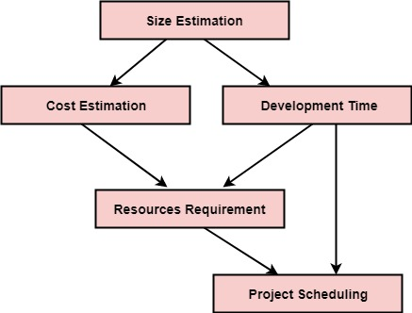

The size is the crucial parameter for the estimation of other activities. Resources requirement are required based on cost and development time. Project schedule may prove to be very useful for controlling and monitoring the progress of the project. This is dependent on resources & development time.

# What is Risk?

"Tomorrow problems are today's risk." Hence, a clear definition of a "risk" is a problem that could cause some loss or threaten the progress of the project, but which has not happened yet.

These potential issues might harm cost, schedule or technical success of the project and the quality of our software device, or project team morale.

Risk Management is the system of identifying addressing and eliminating these problems before they can damage the project.

We need to differentiate risks, as potential issues, from the current problems of the project.

Different methods are required to address these two kinds of issues.

For example, staff storage, because we have not been able to select people with the right technical skills is a current problem, but the threat of our technical persons being hired away by the competition is a risk.

Risk Management

A software project can be concerned with a large variety of risks. In order to be adept to systematically identify the significant risks which might affect a software project, it is essential to classify risks into different classes. The project manager can then check which risks from each class are relevant to the project.

There are three main classifications of risks which can affect a software project:

1. Project risks
2. Technical risks
3. Business risks

**1. Project risks:** Project risks concern differ forms of budgetary, schedule, personnel, resource, and customer-related problems. A vital project risk is schedule slippage. Since the software is intangible, it is very tough to monitor and control a software project. It is very tough to control something which cannot be identified. For any manufacturing program, such as the manufacturing of cars, the plan executive can recognize the product taking shape.

**2. Technical risks:** Technical risks concern potential method, implementation, interfacing, testing, and maintenance issue. It also consists of an ambiguous specification, incomplete specification, changing specification, technical uncertainty, and technical obsolescence. Most technical risks appear due to the development team's insufficient knowledge about the project.

**3. Business risks:** This type of risks contain risks of building an excellent product that no one need, losing budgetary or personnel commitments, etc.

**Other risk categories**

1. **1. Known risks:** Those risks that can be uncovered after careful assessment of the project program, the business and technical environment in which the plan is being developed, and more reliable data sources (e.g., unrealistic delivery date)
2. **2. Predictable risks:** Those risks that are hypothesized from previous project experience (e.g., past turnover)
3. **3. Unpredictable risks:** Those risks that can and do occur, but are extremely tough to identify in advance.

Principle of Risk Management

1. **Global Perspective:** In this, we review the bigger system description, design, and implementation. We look at the chance and the impact the risk is going to have.
2. **Take a forward-looking view:** Consider the threat which may appear in the future and create future plans for directing the next events.
3. **Open Communication:** This is to allow the free flow of communications between the client and the team members so that they have certainty about the risks.
4. **Integrated management:** In this method risk management is made an integral part of project management.
5. **Continuous process:** In this phase, the risks are tracked continuously throughout the risk management paradigm.
6. Risk Management Activities
7. **Risk management consists of three main activities, as shown in fig:**
8. 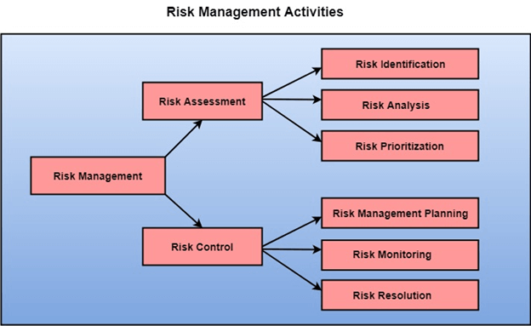-
9. Risk Assessment
10. The objective of risk assessment is to division the risks in the condition of their loss, causing potential. For risk assessment, first, every risk should be rated in two methods:
11. The possibility of a risk coming true (denoted as r).
12. The consequence of the issues relates to that risk (denoted as s).

Based on these two methods, the priority of each risk can be estimated:

                    p = r * s

Where p is the priority with which the risk must be controlled, r is the probability of the risk becoming true, and s is the severity of loss caused due to the risk becoming true. If all identified risks are set up, then the most likely and damaging risks can be controlled first, and more comprehensive risk abatement methods can be designed for these risks.

**1. Risk Identification:** The project organizer needs to anticipate the risk in the project as early as possible so that the impact of risk can be reduced by making effective risk management planning.

A project can be of use by a large variety of risk. To identify the significant risk, this might affect a project. It is necessary to categories into the different risk of classes.

There are different types of risks which can affect a software project:

1. **Technology risks:** Risks that assume from the software or hardware technologies that are used to develop the system.
2. **People risks:** Risks that are connected with the person in the development team.
3. **Organizational risks:** Risks that assume from the organizational environment where the software is being developed.
4. **Tools risks:** Risks that assume from the software tools and other support software used to create the system.
5. **Requirement risks:** Risks that assume from the changes to the customer requirement and the process of managing the requirements change.
6. **Estimation risks:** Risks that assume from the management estimates of the resources required to build the system

**2. Risk Analysis:** During the risk analysis process, you have to consider every identified risk and make a perception of the probability and seriousness of that risk.

There is no simple way to do this. You have to rely on your perception and experience of previous projects and the problems that arise in them.

It is not possible to make an exact, the numerical estimate of the probability and seriousness of each risk. Instead, you should authorize the risk to one of several bands:

1. The probability of the risk might be determined as very low (0-10%), low (10-25%), moderate (25-50%), high (50-75%) or very high (+75%).
2. The effect of the risk might be determined as catastrophic (threaten the survival of the plan), serious (would cause significant delays), tolerable (delays are within allowed contingency), or insignificant.

Risk Control

It is the process of managing risks to achieve desired outcomes. After all, the identified risks of a plan are determined; the project must be made to include the most harmful and the most likely risks. Different risks need different containment methods. In fact, most risks need ingenuity on the part of the project manager in tackling the risk.

**There are three main methods to plan for risk management:**

1. **Avoid the risk:** This may take several ways such as discussing with the client to change the requirements to decrease the scope of the work, giving incentives to the engineers to avoid the risk of human resources turnover, etc.
2. **Transfer the risk:** This method involves getting the risky element developed by a third party, buying insurance cover, etc.
3. **Risk reduction:** This means planning method to include the loss due to risk. For instance, if there is a risk that some key personnel might leave, new recruitment can be planned.

**Risk Leverage:** To choose between the various methods of handling risk, the project plan must consider the amount of controlling the risk and the corresponding reduction of risk. For this, the risk leverage of the various risks can be estimated.

Risk leverage is the variation in risk exposure divided by the amount of reducing the risk.

**Risk leverage = (risk exposure before reduction - risk exposure after reduction) / (cost of reduction)**

**1. Risk planning:** The risk planning method considers each of the key risks that have been identified and develop ways to maintain these risks.

For each of the risks, you have to think of the behavior that you may take to minimize the disruption to the plan if the issue identified in the risk occurs.

You also should think about data that you might need to collect while monitoring the plan so that issues can be anticipated.

Again, there is no easy process that can be followed for contingency planning. It rely on the judgment and experience of the project manager.

1. **Risk Monitoring:** Risk monitoring is the method that your assumption about the product, process, and business risks has not changed.