Event Management System Business Requirements Document

The Indian IT industry is faced with a severe shortage of trained employable resources with industry specific IT skill sets. This is despite of the fact that the number of students graduating every year in IT is increasing. The problem is more acute when it comes to the students graduating from the Tier II and Tier III cities which do not have easy access to quality IT training. The IT training ecosystem in the Tier II and Tier III cities is going to be our key focus area. There are several stakeholders involved in this IT training ecosystem and the task of bringing these together is a challenging aspect. The stakeholders include –

|  |  |  |
| --- | --- | --- |
| **Stakeholder** | **Needs** | **Concerns** |
| IT Companies | These are typically small and medium IT businesses, many times targeting some niche IT segments.  They want to train their employees in certain niche IT skills. | It is difficult to discover training institutes or free lancing trainers who have the required niche skills.  They look for partnering with institutes who impart training for recruitment purposes. |
| Product based IT companies | Product based IT companies are looking for training partners to impart skills in their products. Training is not their core competency and try to outsource it to reliable partners. | Locating reliable training partners.  They want as many trained professional in their products so as to increase their product usage and consequently sales. |
| Training Institutes | Small institutes | Limited facilities. They lack reach and scale. Have a small pool of trainers.  Find it difficult to locate quality trainers.  Sometimes they are not aware of the latest skills that the companies are looking for. |
| Students | Students graduating and looking for IT jobs or existing professionals looking to value-add to their skills. | Knowing what skills are most valued most in the IT marketplace. Trying to locate appropriate institutes, low on cost and high of quality, who offer training in these skills.  Easy and secure means to make payments for the courses and track their skill sets. |
| Trainers | Free lancing trainers who are experts in certain areas and want to share knowledge with others. | Do not have the means to attract students. Lack facilities to conduct trainings. Cannot spend on advertising.  Face problems regarding their credibility in absence of a body certifying their training skills. |
| Facilities Managers | IT institutes or other non-IT institutes who have space/facilities to conduct trainings. They also provide catering and any audio-visual services needed for trainings. | Lack information about classroom requirements of the training institutes and trainers.  Do not have visibility to the trainers. |

Electronica is an Event Management System that proposes to act as an intermediary bringing together these different stakeholders in the IT training domain. The key theme of EMS is “discovery”, discovery of committed stakeholders, price, valued IT skills, area experts (SMEs) and tries to reduce the costs and improve quality across the entire value chain of IT trainings thereby benefitting all the stakeholders. The EMS web site will provide the most important customer interface to the business. Using the web site, a customer will be able to browse courses, register for a course, and pay for the course using a credit card or possibly an electronic check. The system should have provision to manage the complete event, right from setting up the event, enrollment to the event and other logistical requirements like booking venue for the event, caterers, etc.

Given the resource and time constraints for developing such a system we are going to focus on a stripped down version of this scenario.

# Description of the proposed EMS Web Application:

**Lifecycle of key Business Entities:**

1. Event –

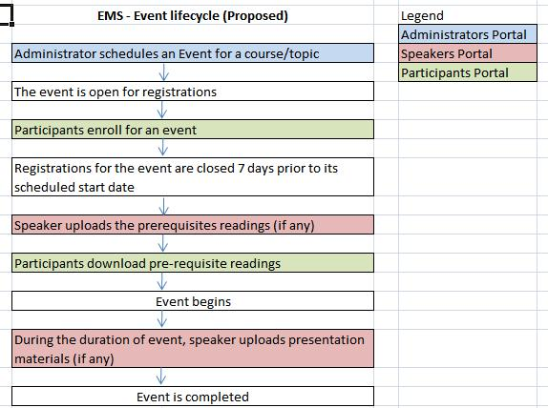

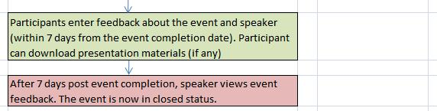

1. Course/Topic –

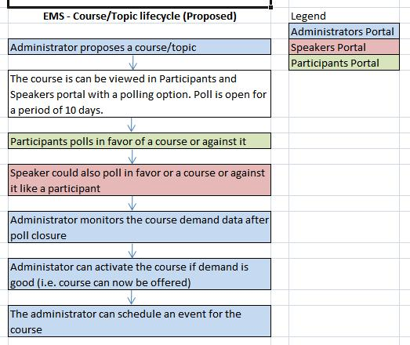

**The Modules:**

Following are the main modules of this application ‘Electronica’ -

* **Administrator Portal**: A user with an Administrator role can access the Administrator’s portal. The Administrator’s main page and the pages to which it links make it possible for us to –
* Create, modify, cancel events
* Create, modify courses/topics
* Create, modify promotion codes
* Create, modify, delete a speaker profile
* Add, modify a new location
* Add, modify a new venue/vendor
* propose a course to gather demand data
* **Speaker Portal**: A user with a Speaker role can access the Speaker’s portal. The Speaker’s page and the pages to which it links help the speaker do such things as –
* upload prerequisite readings or class materials/presentations for an event
* print a roster of participants in a class.
* View feedback for an event
* Express interest for a proposed course.

Simplifying assumption: Speaker cannot enroll for the event as a participant.

* **Participants**: A user with a Participant role can access the Participants portal*.* The Participant’s page and pages to which it links help the participant do activities like –
* View future scheduled events and events attended
* search for courses
* check the price and apply any promotion codes available and enroll for a course
* print enrolled event details
* cancel enrollment
* express interest for a proposed course
* download prerequisites and/or presentation materials related to an event
* enter feedback for an attended event

***Login Page*** – Based upon the roles there will be three options for login, those are –

1. Administrator login
2. Participants login
3. Speaker’s login

There is a button for a new user to register himself after which he becomes a participant.

***Home Page*** – The home page will be different for different roles (eg. Admin, participant, speaker).

***Home Page for Administrator –***

There will be a vertical menu in the left hand side of the screen. This will contain the following items and submenus –

1. Event
   * Create a new Event
   * Modify an existing Event
   * Cancel an event
   * Create/Propose a new course/topic
   * Modify an existing course/topic
   * Create a promotion code
   * View course demand data
   * Add a new location
   * Modify an existing location
2. Speaker

* Add a speaker
* Modify a speaker profile

1. Administrator

* Add an administrator

***Home Page for Participants –***

There will be a vertical menu in the left hand side of the screen. This will contain the following items and submenus –

This homepage for participants will also show the notifications from administrator.

1. Registration
2. Enrollment

* Search for an event
* Enroll for a particular event

1. Give feedback on a course

***Home Page for Speaker –***

There will be a vertical menu in the left hand side of the screen. This will contain the following items and submenus –

This homepage for participants will also show the notifications from administrator.

1. Enrollment

* Search & enroll for an event

1. View course feedback

Screens that are seen by customers (Participants & speaker) must look very attractive. On the other hand, screens that are only seen by administrators and speakers can be somewhat more “plain”.

This site really is all about managing a database of participants, speakers, locations, events, topic, courses and promotion codes.

# Proposed Features

***Login & Administration:***

**A. Login -**

1. The login screen should have three sections for administrator login, participant login & speaker login.
2. When a user logs in as a administrator then the user should be forwarded to the home page for administrator, similarly for participants & speaker user should be forwarded to the participant & speaker’s home page respectively after successful login.
3. If the user is not an authenticated user then one error message has to be shown.

**B. Administrator >>Topic>> Create a new topic**

1. Through this screen the administrator should be able to create a new topic.
2. Topic should contain fields like Category, Topic code, topic name, description etc.
3. After entering all the mandatory fields, user can click the ‘save’ button to create the topic.
4. User can click the ‘clear’ button to clear all the fields or can click the ‘cancel’ button to return to the last page.

**C. Administrator >> Topic >> Modify an existing topic**

1. This page should provide a search screen for searching all existing topics
2. On clicking the edit link near any of the topic found, a screen to modify the topic information will be displayed.
3. The screen should display all the topic details in this screen
4. User can modify the data in this screen and click the ‘Update’ button to have this information updated in database
5. The topic name cannot be modified once created

**D. Administrator >> Event >> Create new Event-**

1. Through this screen the administrator should be able to create a new event and also select a location, select a speaker and schedule the class.
2. There should be a drop down list to select a topic on which this event is conducted
3. There will be text boxes to capture the course title, location, class size, no of days etc.
4. There will be two date fields to capture the start date and end date of the event.
5. To select a speaker there should be a drop down list which will show all the available speakers along with their key skills. From this list administrator can select a speaker for a particular event.
6. After entering all the mandatory fields user can click the ‘save’ button to create the event.
7. User can click the ‘clear’ button to clear all the fields or can click the ‘cancel’ button to return to the last page.

**E. Administrator >> Event >> Modify an existing event –**

1. Through this screen the administrator should be able to change the schedule, location & speaker of a event.

2. User can search for a particular using search criteria like event title, date range, speaker etc. After giving the search criteria user click the search button which will retrieve all the classes matching those given criteria.

3. User can select the event from the search result shown in the grid and modify the details by clicking the ‘Modify’ button.

4. After clicking the ‘Modify’ button the class details page is opened. In this page user can change the schedule, location & speaker of the event and click the save button. The event details will be modified.

5. Event Name can not be modified.

**F. Administrator >> Event >> Cancel an existing event –**

1. Through this screen the administrator should be able to cancel an existing event.
2. The screen will prompt for a mandatory reason for cancelling the event, which will be maintained in the system.
3. Participant and Speaker would be informed about the cancellation through telephone calls which is not part of this system.
4. It should initial a refund operation to each of the participant.

G. **Administrator >> Speaker>>Create a speaker** -

1. Administrator can add a new speaker through this screen.

2. User can capture data like speaker’s name, address, phone number, key-skills etc.

3. After capturing all these details when user clicks the save button, this data is saved and a unique no is generated and associated with this speaker (Speaker code). This no is shown to the user by an alert message.

4. When administrator add a speaker and click the save button one notification mail is sent to the speaker to login and update his/her profile.

H. **Administrator >> Speaker>>Add an administrator** -

1. One administrator can add another person as administrator through this screen.

2. User can enter all the personal & professional details through this screen and click the save button to add the person as administrator.

3. Each administrator should have access to all the other modules of the system.

I. **Administrator >> Location >>Add a location** –

1. A location is a particular **site**, such as conference room OZ3-2-TR11 at the Ozone in Pune.
2. It needs to have different fields like state, city to identify the location.

J. **Administrator >> Location >>Edit a location** –

1. Information like City, state etc should be allowed to be modified only if it is not associated with any event (open or closed).
2. If one or more events are associated with location, only simple fields like description etc should be allowed to be modified.

**K. Administrator >> Add a Promotion Code –**

1. Administrator can add a promotion code that is valid for a particular duration.

***Participant:***

**A. Participant >>Registration**

1. One participant can register using this screen.

2. User can enter all the credentials and also the userid , password for logging into Electronica.

**B. Participant >>Enrollment>> Search for an event**

1. Participant can search for a course/class and enroll for the class.

2. Once a participant enrolls for a class one email notification is sent to the administrator.

**C. Participant >> Event demand >>Expresses interest for an event on some topic.**

1. Participant can poll in favor of or against any proposed topic.

**D. Participant >> Give feedback on a course.**

1. After completion of a class one link is sent through a mail to every participant for giving a feedback about the course.

2. When the participant clicks on the link, then one login screen is opened, after logging in user is taken directly to the feedback screen .

3. Different sets of questions and multiple choice answers are given .User can select the answer of his/her choice and click the submit button to send the feedback to the administrator.

***Speaker:***

*Assumption*: The Speaker profile would be created by the Administrator and he would send the userid and password

for login to the speakers. The speakers can change their password later.

**A. Speaker >>Enrollment>> Search & Enroll for an event**

1. Speaker can search for a course/class and enroll as a participant

2. Once a speaker has enrolled a notification mail is sent to the admin.

**B. Speaker >> View course feedback**

1. The speaker can view feedback on course conducted by him.