Friendify


Session 2024 - 2028

Presented By: (G19)
Sulaman Shahzad(2024-CS-79)

Supervised by:
Miss Rabeeya Saleem

Course:
Data Stucture and Alogorithem

Department of Computer Science
University of Engineering and Technology Lahore Pakistan

Social Media System

Objectives:
The goal of this project is to build a basic social media feed system that shows how different data structures work in real life.
You will use queues, stacks, linked lists, arrays, searching, and sorting to manage common social media features.
The system will let users:
- create accounts
- make and view posts
- manage a friend list
- keep track of their activity and navigation history
It also stores data in text files so the information is saved even after the program closes.
Overall, this project helps students understand how real social media apps organize posts, show recent updates, support undo actions, and store user data.

Data Structures Used:

Data Structure Where Used in the Project Purpose / Why Used
Struct / Class Objects User, Post, Friends To store the information of each user
and post in an organized format.
To dynamically store an unknown

Linked List (Node) Friends

number of users and posts; allows efficient insertion and traversal.
Provides dynamic resizing and fast

Queue (FIFO)

Feed system (showing posts in order)

Used to display posts in the exact order they were created—first post appears first.

Stack (LIFO) Browsing history, Undo operations
Temporary storage,
Allows “go back,” undo like, undo
delete, and undo view features easily.
Simple fixed-size operations inside

Arrays
username/password checking
loops and search operations.

File Handling (Text Files) user.json, post.json Acts as a database to permanently store
users, posts, likes, and comments.

Searching Algorithms (Linear Search)
Sorting Algorithms (Custom Sort / Bubble/Selection)
Search user, search post by keyword
Sorting posts (trending), sorting friends
Used to find items inside the linked list or vector.
Used to arrange posts and friend lists in order (likes, date, alphabetical).

System Flow Diagram:
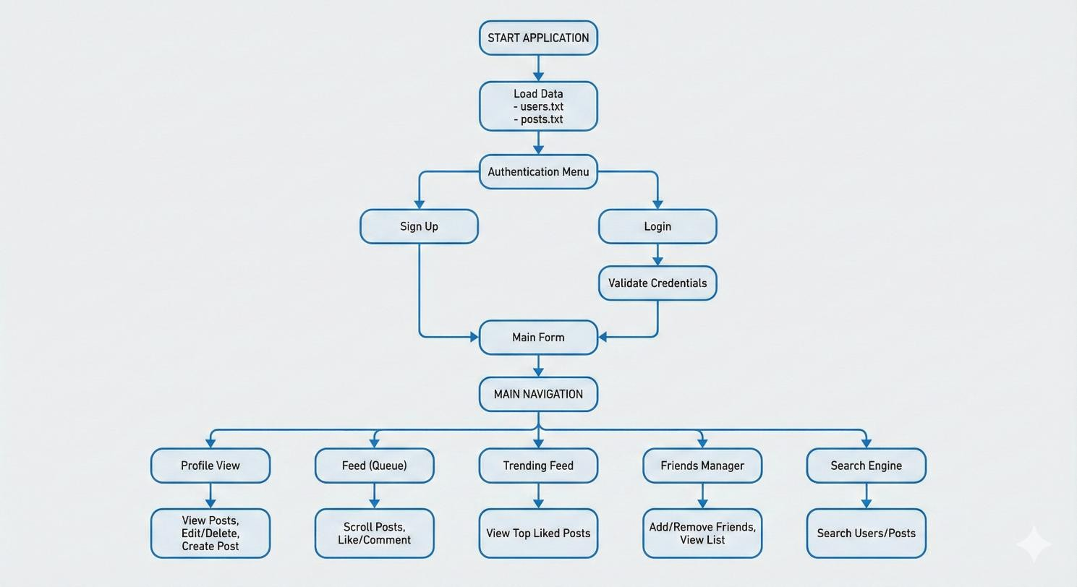
Implementation Details:

ARCHITECTURE OVERVIEW
The application follows a Layered Architecture with clear separation of concerns:

Frontend Layer (custom tinkter):
- Login - User authentication interface
- SignUp - New user registration
- Homepage - Primary application dashboard
- Various pages (Profile, FeedView,Friends etc.)

Business Logic Layer (SocialMediaSystem):
- User management and authentication
- Post operations and feed management
- Friend system and social interactions
- Search and navigation functionality
- Undo/Redo system

Data Access Layer:
- File-based persistence (users.txt, posts.txt)
- Custom data structures (LinkedList, Queue, Stack)
- Serialization/Deserialization of objects

Data Structures Layer:
- Generic LinkedList<T> for dynamic collections
- Queue<T> for chronological feed display
- Stack<T> for navigation and undo functionality

CORE COMPONENTS IMPLEMENTATION
  - Data Structures Implementation Linked List:

    - Purpose: Dynamic storage for user friends, posts, and comments
    - Key Methods: Add(), Remove(), Contains(), ToList()

Usage:
      - User.Friends: Stores friend usernames
      - User.Posts: Stores post IDs owned by user
      - Post.Comments: Stores comment strings with usernames

Queue:
    - Purpose: Maintain chronological order of posts in feed (FIFO)
    - Key Methods: Enqueue(), Dequeue(), Front()
    - Usage: FeedQueue stores all posts in creation order

Stack:
    - Purpose:
      - NavigationStack: Track user navigation history
      - UndoStack: Store reversible actions for undo functionality
    - Key Methods: Push(), Pop(), Top()
    - Usage: Multi-level undo system for all user actions

User Management System User Class Features:
    - Profile data: username, password, email
    - Social connections: Friends LinkedList
    - Content ownership: Posts LinkedList
    - File persistence: Serialize/deserialize to text format

Authentication Flow:
- Sign Up: Validate unique username → Create user → Hash password → Save to file
- Login: Verify credentials → Load user data → Initialize session → Redirect to main app

Profile Management:
  - Edit username, password, email with validation
  - Mutual friendship system (bidirectional relationships)
  - Post count and friend count tracking

Post Management System Post Creation:
    - Generate unique Post ID (P + random number)
    - Store content, timestamp, author information
    - Automatic addition to user's post list and global feed
    - Push CREATE action to undo stack

Post Operations:
    - Edit: Modify content with old version stored for undo
    - Delete: Remove from all collections with complete backup for undo
    - Like/Dislike: Increment/decrement like counter with undo tracking
    - Comment: Add comments with username attribution

Feed Systems:
    - Main Feed: Chronological display using Queue (FIFO)
    - Trending Feed: Posts sorted by like count (descending)
    - Profile Feed: User's own posts with edit/delete capabilities

Social Interaction System Friend Management:
    - Add Friend: Mutual friendship creation with validation
    - Remove Friend: Bidirectional removal with confirmation
    - Search Users: Find users by username with real-time results
    - Friend List: Display with status indicators and management options

Engagement Features:
    - Likes: Single-click post appreciation
    - Comments: Text responses with username attribution
    - Search: Find content across posts and users
    - Navigation: Stack-based browsing history

FILE PERSISTENCE SYSTEM
  - Data Storage Format users.json Format:
text username|password|email|friend1,friend2,friend3|postId1,postId2,postId3 posts.json Format:
text postId|username|content|timestamp|likes|user1:comment1;user2:comment2

Serialization Process Saving Data:
- Convert User/Post objects to string format
- Join collections with delimiters (commas for lists, semicolons for comments)
- Write to respective text files
- Handle file I/O exceptions

Loading Data:
- Read text files line by line
- Split strings using pipe delimiters
- Reconstruct objects and collections
- Rebuild data relationships (user posts, friendships)

Data Integrity
    - Automatic save on every modification
    - Transaction-like behavior with undo system
    - Error recovery through file backup mechanism
    - Data validation during deserialization

UNDO/REDO SYSTEM IMPLEMENTATION
  - Action Tracking Supported Actions:
    - CREATE_POST, EDIT_POST, DELETE_POST
    - LIKE_POST, DISLIKE_POST, ADD_COMMENT
    - EDIT_PROFILE, ADD_FRIEND, REMOVE_FRIEND

Action Storage Format:
text CREATE:postId
EDIT:postId:oldContent DELETE:fullPostData LIKE:postId
COMMENT:postId:username:commentText FRIEND_ADD:friendUsername

Undo Execution Process Flow:
- Pop action from UndoStack
- Parse action type and data
- Execute reverse operation
- Update UI accordingly
- Handle errors gracefully

Reverse Operations:
  - CREATE → DELETE (remove the created post)
  - DELETE → CREATE (restore deleted post)
  - EDIT → RESTORE (revert to previous content)
  - LIKE → DISLIKE (remove the like)
  - ADD_FRIEND → REMOVE_FRIEND (undo friendship)

USER INTERFACE IMPLEMENTATION
  - UI Architecture Login:
    - Professional split-panel design
    - Input validation and error handling
    - Secure credential management
    - Smooth transition to SignUpForm

Home:
    - Desktop-style layout with navigation panel
    - Dynamic content loading system
    - Responsive design with auto-refresh
    - Professional Instagram-like aesthetic

View :
    - BaseView abstract class for consistency
    - Event-driven updates between views
    - Modal dialogs for specific actions
    - Real-time data synchronization

Test Cases:
Test Case 1: User Registration and Authentication
Test Case ID: TC_AUTH_001
Test Title: New User Registration and Successful Login
Priority: High Module: Authentication Preconditions:
    - Application is freshly installed
    - No existing users in the system
    - users.txt file is empty or doesn't exist

Test Steps:
- Launch Application
  - Start the Social Media Application
  - Verify Login form displays with Sign Up and Login options

Navigate to Sign Up
  - Click "Create New Account" button
  - Verify SignUp form opens with username, email, and password fields

Complete Registration
  - Enter username: "testuser123"
  - Enter email: "testuser123@email.com"
  - Enter password: "SecurePass123!"
  - Check "I agree to terms" checkbox
  - Click "Create Account" button

Verify Successful Registration

  - Verify success message: "Account created successfully!"
  - Verify automatic redirect to Login form
  - Verify username field is pre-filled with "testuser123"

Login with New Credentials
  - Enter password: "SecurePass123!"
  - Click "Login" button

Verify Successful Login
  - Verify MainForm opens
  - Verify username "testuser123" displays in top navigation
  - Verify Profile view loads by default
  - Verify post count shows "0" and friends count shows "0"

Expected Results:
- User registration completes successfully
- User can login immediately after registration
- User data persists in users.txt file
- User session establishes correctly
- All UI elements update to reflect logged-in state

Post-Test Validation:
- Check users.txt file contains new user record
- Verify user can logout and login again successfully

Test Case 2: Post Creation and Management
Test Case ID: TC_POST_001
Test Title: Create, Edit, and Delete Post with Undo Functionality
Priority: High
Module: Post Management

Preconditions:
- User "testuser123" is logged in
- User has no existing posts
- Application is on MainForm

Test Steps:
- Navigate to Create Post
  - Click "Create Post" from left navigation
  - Verify Create Post view loads

Create First Post
  - Enter post content: "This is my first test post! #excited"
  - Click "Post" button
  - Verify success message: "Post created successfully!"

Verify Post Creation
  - Navigate to "Profile" view
  - Verify post count shows "1"
  - Verify post appears in profile with correct content
  - Verify timestamp is current

Edit the Post
  - Click "Edit" button on the post
  - Change content to: "This is my edited test post! #updated"
  - Click "Save" button
  - Verify success message: "Post edited successfully!"

Verify Post Edit
  - Verify post displays updated content

  - Verify original content is no longer visible

Test Undo Functionality
  - Click "Undo Last Action" button
  - Verify success message: "Last action undone successfully!"
  - Verify post content reverts to original: "This is my first test post! #excited"

Delete the Post
  - Click "Delete" button on the post
  - Confirm deletion in confirmation dialog
  - Verify success message: "Post deleted successfully!"

Verify Post Deletion
  - Verify post count shows "0"
  - Verify post no longer appears in profile
  - Verify "No posts yet" message displays

Test Undo Delete
  - Click "Undo Last Action" button
  - Verify post reappears in profile
  - Verify post count shows "1" again

Expected Results:
- Post creation, editing, and deletion work correctly
- Undo functionality properly reverses all post operations
- UI updates reflect all changes in real-time
- Post data persists correctly in posts.txt file

Performance Analysis:

Operation | Data | Time | Space | Description
USER
signUp() | Vector | O(n) | O(1) | Linear search for
login() | Array | O(n) | O(1) | Linear search for
editProfile() | Array | O(n) | O(1) | Linear search +
searchUsers() | Array | O(n) | O(k) | k = number of
makeFriend() | Array + | O(n) | O(1) | Linear search + LL
POST
createPost() | Array + | O(1) | O(1) | Array push_back +
editPost() | Array | O(n) | O(1) | Linear search for
deletePost() | Array | O(n) | O(1) | Linear search +

Operation | Data | Time | Space | Description
likePost() | Array | O(n) | O(1) | Linear search for
addComment() | Array + | O(n) | O(1) | Linear search + LL
searchPosts() | Array | O(n × m) | O(k) | n=posts, m=avg
LINKED LIST
add() | Linked List | O(n) | O(1) | Traverse to end
remove() | Linked List | O(n) | O(1) | Linear search +
contains() | Linked List | O(n) | O(1) | Linear search
toArray() | Linked List | O(n) | O(n) | Convert to array
QUEUE
enqueue() | Queue (via | O(n) | O(1) | LL add at end
dequeue() | Queue (via | O(1) | O(1) | Remove from head
front() | Queue (via | O(1) | O(1) | Access head
STACK
push() | Stack (via | O(n) | O(1) | Inefficient
pop() | Stack (via | O(1) | O(1) | Remove from head
top() | Stack (via | O(1) | O(1) | Access head
FILE
loadData() | File I/O | O(u + p) | O(u + p) | u=users, p=posts
saveData() | File I/O | O(u + p) | O(1) | Write all data

Screen Shots:

