Push sport_analytics_data_pipeline to GitHub — step by step
Context
The project is a git repo (branch master) with no commits, no remote, no git user.name/user.email set, and no gh CLI. Critical: .gitignore does not exclude .env or Azure_SQL_Logins.txt, which hold Azure credentials — they must be ignored before the first commit, or the secrets end up in GitHub history. src/ has no hardcoded secrets; .env.example is safe to commit.
Steps (run in the VS Code terminal, inside the project folder)
1. Protect secrets — add to .gitignore
# Secrets
.env
Azure_SQL_Logins.txt
(Optionally also add *.code-workspace if you don't want your editor workspace file public.)
2. Set your git identity (one-time, global)
git config --global user.name "Sulara Perera"
git config --global user.email "sulara.perera@gmail.com"
3. Rename branch to main (GitHub's default)
git branch -M main
4. Stage and verify nothing secret is included
git add .
git status
Confirm .env and Azure_SQL_Logins.txt are not listed.
5. First commit
git commit -m "Initial commit: sport analytics data pipeline"
6. Create an empty repo on GitHub
github.com → New repository → name e.g. sport-analytics-data-pipeline → Public/Private → do not add README/.gitignore/license (you already have them) → Create.
7. Connect and push
git remote add origin https://github.com/<your-username>/sport-analytics-data-pipeline.git
git push -u origin main
A browser window (Git Credential Manager) will open to sign in to GitHub the first time.
Verification
- Refresh the GitHub repo page: src/, README.md, images/, pyproject.toml, uv.lock, .env.example visible.
- Confirm .env and Azure_SQL_Logins.txt are absent.
- Future changes: git add . → git commit -m "..." → git push.
If secrets were ever pushed by mistake
Rotate the Azure SQL password and storage key in the Azure portal immediately — deleting the file from GitHub isn't enough.

Plan: Run the pipeline every day at 6pm (New Zealand time) with GitHub Actions
Context
The pipeline currently only runs by hand on your laptop (cd src/1_sport_analytics_data_pipeline_v1 && uv run python run_pipeline.py). It scrapes BBC and TheSportsDB, then writes to Azure Blob (testtech container) and Azure SQL (dbo.* tables). The goal is for GitHub to run it automatically every day at 18:00 NZ time, with no code changes to the pipeline itself.
Facts from the repo that shape the workflow:
- Python 3.11 + uv (uv.lock exists). pyproject.toml points a console script at a main() that doesn't exist, so install with uv sync --locked --no-install-project so uv doesn't try to build the project.
- Scripts use flat imports (from scrape import ...), so the job must run from inside src/1_sport_analytics_data_pipeline_v1/.
- Secrets are read from env vars via load_dotenv() (push_to_azure_blob.py:99, push_to_azure_sql.py:26-30). With no .env on the runner, load_dotenv() does nothing and the values come straight from the GitHub Secrets we inject. No code change needed.
- push_to_azure_sql.py:30 defaults to ODBC Driver 17, which isn't supported on Ubuntu 24.04 (the current ubuntu-latest). The workflow installs ODBC Driver 18 and sets AZURE_SQL_DRIVER="ODBC Driver 18 for SQL Server". The existing Encrypt=yes; TrustServerCertificate=no settings already suit Driver 18 + Azure SQL.
- Timezone: GitHub cron is UTC only. 6pm NZ is 05:00 UTC in summer (NZDT, UTC+13, late Sep to early Apr) and 06:00 UTC in winter (NZST, UTC+12). The workflow schedules both and a first step skips whichever one doesn't match NZ's current offset. Because it checks the offset (not the clock hour), it still works when GitHub starts the run late.
- Firewall: you chose "Allow Azure services and resources to access this server". GitHub-hosted runners run in Azure, so this lets them through.
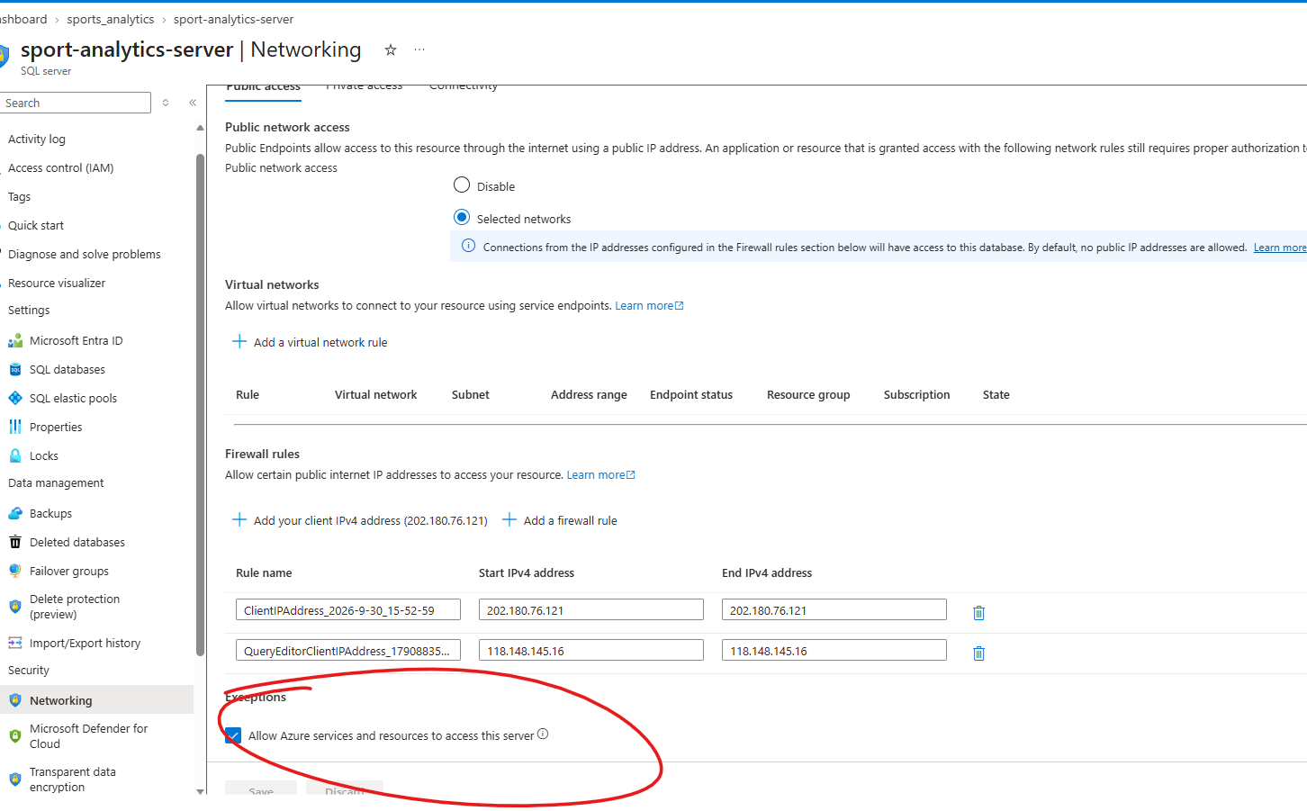
File to create in your project folder
.github/workflows/run_pipeline.yml
Note: yaml is a python like dictionary which holds the flow to execute your code in sequence. This file has key:value pairs

name: Sport analytics pipeline
on:
schedule:
- cron: "*/15 * * * *" # every 15 minutes (UTC)
workflow_dispatch: # "Run workflow" button for manual runs/testing

concurrency:
group: sport-pipeline
cancel-in-progress: false

jobs:
run-pipeline:
runs-on: ubuntu-latest
timeout-minutes: 30

steps:
- name: Check out code
uses: actions/checkout@v4

- name: Install ODBC Driver 18 for SQL Server
run: |
if odbcinst -q -d | grep -q "ODBC Driver 18 for SQL Server"; then
echo "Driver already installed"
else
curl -sSL -O https://packages.microsoft.com/config/ubuntu/$(lsb_release -rs)/packages-microsoft-prod.deb
sudo dpkg -i packages-microsoft-prod.deb
sudo apt-get update
sudo ACCEPT_EULA=Y apt-get install -y msodbcsql18 unixodbc-dev
fi

- name: Install uv
uses: astral-sh/setup-uv@v6
with:
enable-cache: true

- name: Install Python dependencies
run: uv sync --locked --no-install-project

- name: Run pipeline
working-directory: src/1_sport_analytics_data_pipeline_v1
env:
AZURE_STORAGE_CONNECTION_STRING: ${{ secrets.AZURE_STORAGE_CONNECTION_STRING }}
AZURE_SQL_SERVER: ${{ secrets.AZURE_SQL_SERVER }}
AZURE_SQL_DATABASE: ${{ secrets.AZURE_SQL_DATABASE }}
AZURE_SQL_USERNAME: ${{ secrets.AZURE_SQL_USERNAME }}
AZURE_SQL_PASSWORD: ${{ secrets.AZURE_SQL_PASSWORD }}
AZURE_SQL_DRIVER: ODBC Driver 18 for SQL Server
run: uv run --no-project python run_pipeline.py
(uv run --no-project uses the .venv that uv sync made at the repo root without trying to build the package. If it doesn't find the venv from the subfolder, the fallback is ../../.venv/bin/python run_pipeline.py.)
Step-by-step setup (what you'll do)
- Azure portal → SQL server → Networking: tick Allow Azure services and resources to access this server → Save.
- GitHub → repo sularaperera/sport-analytics-data-pipeline → Settings → Secrets and variables → Actions → New repository secret. Add these 5, copying the values from your local .env, without quotes:
AZURE_STORAGE_CONNECTION_STRING,
AZURE_SQL_SERVER,
AZURE_SQL_DATABASE,
AZURE_SQL_USERNAME
AZURE_SQL_PASSWORD.
- Create the workflow file above at .github/workflows/run_pipeline.yml (I'll write it).
- Commit and push to main. Scheduled workflows only run from the default branch.
- Test now: GitHub → Actions tab → Sport analytics pipeline → Run workflow. Watch the logs. "Run pipeline" should print the step banners and "successfully loaded" lines.
- Check the results: parquet files in Blob testtech show a new modified time, and the dbo.league_table and other tables in Azure SQL are refreshed.
- Wait for the automatic run at 6pm NZ. On each scheduled day, one run does the work and the other shows the run steps skipped. That's expected.
Things to know
- GitHub schedules can start 5–30+ minutes late at busy times. That's normal.
- On a public repo, GitHub turns schedules off after 60 days without commits. You'll get an email; re-enable with one click in the Actions tab.
- If the BBC changes its page's CSS class names (scrape.py:38), the run will fail. GitHub emails you when a workflow fails.
- The README (lines 23-24) says "every Saturday and Sunday". To switch to weekends only later, change * * * to * * 0,6 in both crons. Note this is UTC days, and 05:00/06:00 UTC is still the same NZ day.
Verification
- A manual workflow_dispatch run finishes green, with the gate step printing run=true.
- The Azure Blob and SQL data timestamps update after the run.
- The next day, the Actions tab shows two scheduled runs: one that ran the pipeline and one that skipped.

