Proposal on Role of IT in improving online Education in Nepal



Submitted To: Submitted By:
Name: Nikita Agarwal Name: Rupesh Ghale
Subject: Research Methodology Student Id: 7214

Date of Submission: 12/31/2025

Table of contents
1. Introduction 3
1.1 Background of the Study 3
2.Problem Statement 4
2.1 Key Research Questions 5
3. Objectives of the Study 6
3.1 General Objective 6
3.2 Specific Objective 7
4. Literature Review 8
4.1 Global Perspective on IT in Education 8
4.2 IT in Nepalese Education 8
4.3 Challenges Identified 9
4.4 Opportunities for Improvement 9
4.5 Research Gap 9
5. Theoretical Framework 10
5.1 Dependent Variable 10
5.2 Independent Variables 10
5.3 Moderating Variable 10
5.4 Operational Definition of Variables 12
5.5 Hypothesis Development 12
6. Research Methodology 13
6.1 Research Design 13
6.2 Nature of Data 13
6.3 Sampling Error 14
6.4 Methods of Data Collection 14
6.5 Data Analysis Tools 14
6.6 Ethical Considerations 14
7.Limitations of the Study 15
8.Study Timeline (Gantt chart) 16
9.References 17
10. Appendix 18
10.1 Structured Questions 18
10.2 Semi-Structured Questions 19
10.3 Unstructured Questions 20

1. Introduction

1.1 Background of the Study
Education is a cornerstone of national development, and in Nepal, access to quality education has long been challenged by geographical barriers, limited resources, and socio-economic disparities. The COVID-19 pandemic further exposed these weaknesses, forcing schools and universities to adopt online learning methods without adequate preparation. While this shift highlighted the potential of Information Technology (IT) in bridging educational gaps, it also revealed significant challenges such as poor internet connectivity, lack of digital devices, and limited digital literacy among teachers and students.
Nepal’s digital divide is particularly pronounced between urban and rural areas. In cities like Kathmandu and Pokhara, students often have access to computers, smartphones, and stable internet, whereas in remote districts, learners struggle with unreliable electricity and minimal connectivity. This inequality risks widening the educational gap unless IT is strategically leveraged to ensure inclusivity.
Globally, IT has transformed education through Learning Management Systems (LMS), e-libraries, interactive platforms, and mobile-based applications. These tools not only make learning more accessible but also enhance engagement, collaboration, and personalized learning experiences. For Nepal, adopting such innovations could democratize education by reaching marginalized communities, improving teaching quality, and fostering lifelong learning opportunities.
Therefore, studying the role of IT in improving online education in Nepal is crucial. It provides insights into how digital tools can overcome structural barriers, promote inclusivity, and enhance the overall quality of education. This background sets the foundation for exploring strategies that can transform Nepal’s education system into one that is resilient, equitable, and future-ready.

2.Problem Statement
Despite the growing importance of Information Technology in education worldwide, Nepal continues to face significant challenges in adopting and sustaining effective online learning systems. The COVID-19 pandemic accelerated the shift toward digital education, but the transition exposed deep structural weaknesses: poor internet connectivity in rural areas, limited access to digital devices, inadequate IT infrastructure in schools, and low levels of digital literacy among teachers and students.
This digital divide has created unequal learning opportunities, where urban students benefit from online platforms while rural learners are left behind. Furthermore, many institutions lack standardized Learning Management Systems (LMS) and rely on fragmented tools that do not ensure quality, consistency, or inclusiveness. Teachers often struggle to adapt traditional teaching methods to online environments due to insufficient training, while students face difficulties engaging with digital content in the absence of interactive and user-friendly platforms.
As a result, online education in Nepal risks becoming ineffective, inaccessible, and inequitable. Without strategic integration of IT, the country’s education system may fail to prepare learners for a technology-driven global workforce. Therefore, it is essential to investigate how IT can be leveraged to overcome these barriers, strengthen online learning, and ensure inclusive, high-quality education for all students in Nepal.

2.1 Key Research Questions
Although Information Technology (IT) has become a transformative force in global education; there is limited scholarly attention on how IT can be strategically applied to improve online education in Nepal. Existing studies mainly highlight the challenges of infrastructure and access, but the influence of IT on teaching quality, student engagement, inclusivity, and long-term educational outcomes remains insufficiently examined. This study aims to explore the following research questions:
- How does the integration of IT affect the accessibility and quality of online education in Nepal?
- In what ways can IT tools (such as Learning Management Systems, e-libraries, and mobile applications) be utilized to enhance teaching and learning experience?
- What challenges do students and teachers face when adopting IT for online education in Nepal?
- What conditions maximize the effective use of IT in creating inclusive and sustainable online education systems?
Dependence on IT has a significant impact on the future of online education in Nepal. While IT provides essential tools for expanding access, improving interactivity, and modernizing teaching methods, its effective use is often limited by poor infrastructure, lack of digital literacy, and unequal access to devices and connectivity. Addressing these challenges and creating supportive conditions—such as teacher training programs, affordable internet services, and user-friendly platforms—can help maximize the positive effects of IT, fostering inclusive, high-quality, and future-ready online education across Nepal.

3. Objectives of the Study
The main objective of this study is to examine how Information Technology (IT) can be effectively utilized to improve the accessibility, quality, and inclusivity of online education in Nepal.

3.1 General Objective

The general objective of this study is to examine how Information Technology (IT) can be effectively integrated to enhance the accessibility, quality, and inclusivity of online education in Nepal, thereby contributing to the modernization of the education system and preparing learners for a technology-driven global environment.

3.2 Specific Objective
The specific objectives of this study are to:
- Evaluate the current state of online education in Nepal, focusing on infrastructure, accessibility, and digital readiness.
- Examine how IT tools such as Learning Management Systems (LMS), e-libraries, mobile applications, and interactive platforms can enhance teaching and learning outcomes.
- Identify challenges faced by teachers and students in adopting IT for online education, including connectivity issues, lack of devices, and limited digital literacy.
- Assess the role of IT in promoting inclusivity, ensuring that students from rural and marginalized communities can access quality online education.
- Recommend strategies and policy measures to maximize the effective use of IT in strengthening Nepal’s online education system and aligning with the Digital Nepal Framework.

4. Literature Review

4.1 Global Perspective on IT in Education

Information Technology (IT) has transformed education worldwide by enabling Learning Management Systems (LMS), digital libraries, mobile learning apps, and interactive platforms. Studies emphasize that IT enhances accessibility, promotes personalized learning, and fosters collaboration among students and teachers. In countries with strong digital infrastructure, online education has become a mainstream mode of learning, offering flexibility and inclusiveness.

4.2 IT in Nepalese Education

In Nepal, the adoption of IT in education has accelerated, particularly after the COVID-19 pandemic. Research highlights several key points:
- Application of Digital Technology in Nepalese Education: IT tools such as e-learning platforms, mobile technology, and digital libraries are increasingly used, but challenges remain due to limited infrastructure, lack of digital literacy, and the rural-urban digital divide.
- Online Classes as a Paradigm Shift: The shift to online classes during the pandemic marked a cultural transformation in teaching and learning. While ICT improved access to education, issues such as poor connectivity, lack of devices, and insufficient teacher training hindered effectiveness.
- Impact of ICT in Higher Education: ICT adoption in Nepalese universities has shown potential to improve teaching quality and student engagement. However, the absence of standardized systems and weak institutional support limit long-term sustainability

4.3 Challenges Identified

- Digital Divide: Urban students benefit from IT tools, while rural learners face connectivity and resource shortages.
- Teacher Preparedness: Many educators lack training in digital pedagogy, reducing the effectiveness of online platforms.
- Infrastructure Limitations: Unreliable electricity, poor internet coverage, and limited access to devices remain major barriers.

4.4 Opportunities for Improvement

- Mobile-Based Learning: With high mobile penetration, smartphones can be leveraged for rural education.
- E-Libraries and Open Educational Resources (OER): These can democratize access to quality materials.
- Gamification and Interactive Tools: IT can make learning more engaging and improve retention.
- Capacity Building: Training teachers in digital tools is essential for sustainable online education.

4.5 Research Gap

While existing studies highlight the importance of IT in Nepalese education, few focus on how IT can systematically improve inclusivity, teaching quality, and long-term sustainability of online education. This study addresses that gap by exploring strategies to maximize Its role in strengthening Nepal’s digital education ecosystem.

5. Theoretical Framework
A theoretical framework provides the foundation for analyzing how Information Technology (IT) can improve online education in Nepal. This study draws upon several educational and technological theories to explain the relationship between IT adoption and effective learning outcomes.

5.1 Dependent Variable
Online Education Improvement This refers to the enhancement of accessibility, quality, and inclusivity in Nepal’s education system through IT integration, including better student engagement, improved teaching methods, and equitable learning opportunities.

5.2 Independent Variables
- Digital Infrastructure: Availability of internet connectivity, electricity, and access to digital devices.
- Teacher Digital Literacy: Knowledge and skills of educators to effectively use IT tools in teaching.
- Learning Management Systems (LMS) Adoption: Use of platforms such as Moodle, Google Classroom, or custom systems for managing online learning.
- Student Access to IT Tools: Availability and use of devices, applications, and e-learning resources by students.

5.3 Moderating Variable

Government and Institutional Support: Policies, training programs, subsidies, and initiatives from the government, NGOs, or educational institutions that influence the effective use of IT in online education

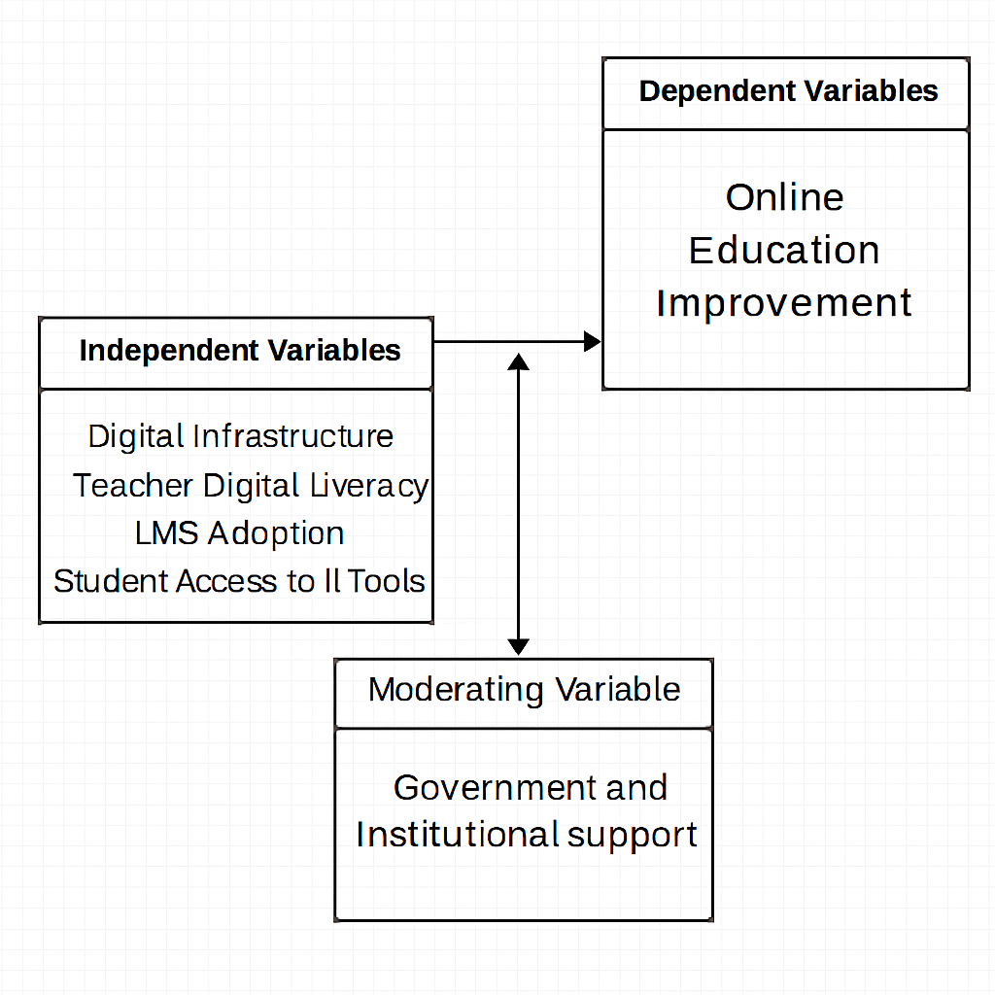

Diagram of Theoretical Framework

5.4 Operational Definition of Variables
- Online Education Improvement: Measured by student performance, engagement levels, and inclusivity in online learning.
- Digital Infrastructure: Availability and reliability of internet, electricity, and devices for online education.
- Teacher Digital Literacy: Ability of teachers to design, deliver, and evaluate online lessons using IT tools.
- LMS Adoption: Extent to which schools and universities implement and use structured online learning platforms.
- Government and Institutional Support: Presence of policies, training, and resources that promote IT integration in education.

5.5 Hypothesis Development
- H0 (Null Hypothesis): There is no significant relationship between digital infrastructure, teacher digital literacy, adoption of Learning Management Systems (LMS), government/institutional support, and the improvement of online education in Nepal.

- H1: Stronger digital infrastructure positively influences the improvement of online education in Nepal.
- H2: Higher teacher digital literacy positively affects the quality and effectiveness of online education.
- H3: Greater adoption of Learning Management Systems (LMS) contributes to improved student engagement and learning outcomes.
- H4: Government and institutional support strengthen the relationship between IT adoption and the improvement of online education.

6. Research Methodology
This proposal explains the methods and procedures used to collect, analyze, and interpret data for studying the role of Information Technology (IT) in improving online education in Nepal.

6.1 Research Design
The study follows descriptive and analytical research design:
Descriptive approach: To describe the status of online education in Nepal, focusing on IT infrastructure, accessibility, teacher preparedness, and student engagement.
Analytical approach: To examine relationships between variables such as digital infrastructure, teacher digital literacy, LMS adoption, student access to IT tools, and government/institutional support in enhancing online education.

6.2 Nature of Data

Primary Data
- Collected directly from teachers, students, and administrators through surveys, interviews, and focus group discussions.
- Designed to understand how IT tools are being used in online education, the challenges faced, and perceptions of effectiveness.
Secondary Data
- Secondary data is collected from:
- Government reports and policy documents (e.g., Digital Nepal Framework, Ministry of Education reports).
- Records from universities, schools, and IT institutions on online learning practices.
- Academic journals, newspapers, and previous studies on IT integration and online education in Nepal.

6.3 Sampling Error
Sampling errors may arise due to limited sample size, respondent bias, or time constraints. Efforts are made to minimize errors by combining multiple sampling techniques and ensuring diverse representation across institutions and regions.

6.4 Methods of Data Collection
Interviewing Structured and semi-structured interviews with a) Teachers using IT tools for online education b) Students engaged in online learning c) Administrators and policymakers involved in digital education initiatives
Questionnaire Structured questionnaire with closed-ended and some open-ended questions to collect quantitative data on IT usage, accessibility, challenges, and perceptions of online education effectiveness.
Observation Direct observation in schools, universities, and online platforms to study teaching practices, student engagement, and IT integration in learning activities.

6.5 Data Analysis Tools
- Quantitative data are analyzed using percentages, tables, and charts to identify trends and patterns.
- Qualitative data from interviews are analyzed using descriptive interpretation to capture experiences, challenges, and insights.

6.6 Ethical Considerations
- Participation is voluntary.
- Respondent confidentiality is maintained.
- Data is used only for academic purposes.
- Information consent is obtained before interviews and surveys.

7.Limitations of the Study
Every research study has certain boundaries and constraints. This study on the role of IT in improving online education in Nepal is subject to the following limitations:
- Geographical Coverage: The study may focus on selected districts, schools, and universities, which may not fully represent the diversity of Nepal’s educational landscape.
- Sample Size: Due to time and resource constraints, the number of respondents (teachers, students, and administrators) may be limited, affecting the generalizability of findings.
- Access to Reliable Data: Secondary data sources such as government reports and institutional records may be incomplete, outdated, or inconsistent.
- Rapid Technological Change: IT tools and platforms evolve quickly, so findings may become less relevant over time as new technologies emerge.
- Policy Constraints: The study may not fully capture the impact of ongoing or future government initiatives under the Digital Nepal Framework.
- Budget Constraints: Limited financial resources may restrict the scale of data collection, travel to remote areas, and access to advanced analytical tools.
- Time Constraints: The research must be completed within a fixed academic schedule, limiting the ability to conduct long-term observation or follow-up studies.

8.Study Timeline (Gantt chart)



9.References
- Rahman, A. (2024). Application of Digital Technology in Nepalese Educational System. Madhesh University, Nepal. Available here
- Discusses the benefits and limitations of digital tools in Nepalese education, especially post-COVID.
- Shahi, R., & Chaudhary, B. P. (2025). Digital Transformation: Adoption of Information Technology Systems in Higher Education Institutions of Nepal. Cogent Business & Management, 12(1), 2524601. DOI: 10.1080/23311975.2025.2524601
- Explores IT usage behavior, institutional readiness, and barriers to adoption in Nepalese universities.
- Gurung, N., & Shrestha, R. (2023). The Digitalization of Education in Nepal: A Critical Discussion of the Affordances of Digital Commons. Master’s Thesis, Arcada University of Applied Sciences.
- Analyzes how digital platforms and commons are reshaping education access and equity in Nepal.
- Investigates student and faculty experiences with online learning platforms, highlighting digital divide and pedagogical gaps.
- Thapa, D., & Adhikari, R. (2021). Digital Readiness of Nepalese Schools: A Policy Perspective. Nepal Education Review, 9(1), 15–30.
- Reviews government initiatives and school-level preparedness for digital education integration.
- Karki, B., & Tamang, S. (2023). Evaluating the Role of LMS in Enhancing Student Engagement in Nepalese Universities. International Journal of E-Learning & Distance Education, 38(1), 22–39.
- Provides empirical evidence on LMS effectiveness and student interaction patterns in virtual classrooms.
- UNESCO Nepal (2020). COVID-19 Education Response: Digital Learning in Nepal.

10. Appendix

10.1 Structured Questions
Structured questions provide fixed options for respondents to choose from, making the data easy to quantify and analyze.
- How frequently do you use IT tools (e.g., LMS, mobile apps, e-libraries) for teaching or learning?
a) Never
b) Occasionally (once or twice a month)
c) Regularly (weekly) d) Frequently (daily)

- What is the primary benefit you experience from using IT in online education?
a) Easier access to learning materials
b) Improved interaction with teachers/students
c) Flexibility in learning schedule d) Better academic performance

- What challenges do you face in using IT for online education?
a) Poor internet connectivity
b) Lack of digital devices
c) Limited digital literacy
d) Unfamiliarity with online platforms

- Has IT integration improved the overall quality of your online education experience? a) Yes, significantly
b) Yes, to some extent
c) Not sure
d) No

- Has IT integration improved the overall quality of your online education experience? a) Yes, significantly
b) Yes, to some extent
10.2 Semi-Structured Questions
Semi-structured questions provide guiding prompts but allow respondents to explain their answers in detail.
- How has the use of IT tools influenced your learning or teaching experience? (Probe: Have you used them for accessing materials, improving interaction, flexibility in learning, or performance outcomes?)

- Can you describe any specific ways IT has been integrated into your classroom or study routine? (Probe: Type of platform or tool used, challenges faced, and successes achieved)

- What are the main barriers preventing effective use of IT in online education? (Probe: Internet connectivity, device availability, digital literacy, institutional support, or policy gaps)

- In your opinion, what kind of support or guidance would help improve IT adoption in online education? (Probe: Training programs, subsidies for devices/internet, technical assistance, government initiatives, or community support)

10.3 Unstructured Questions
Unstructured questions are open-ended questions that allow respondents to answer freely in their own words, providing deeper insights and detailed information.
- How do you feel IT has affected your learning or teaching experience, both academically and socially?
- Can you share any experiences or stories about using IT tools (e.g., LMS, mobile apps, e-libraries) in your classroom or study routine?
- What challenges have you personally faced when trying to use IT for online education?
- What suggestions do you have for improving the use of IT to strengthen online education in Nepal?
- How do you envision the future of online education in Nepal if IT is fully integrated into the system?

