Supplier Evaluation & Operations Agent

A Multi-Agent AI System for Everest Manufacturing Pvt. Ltd.
Report

Name: Sulav Singh Thakuri
College: Fishtail Mountain College
Submission Date: 30th September, 2026
Tools Used: n8n (Docker), Openrouter (OpenAI nano model), Gmail

1. Business Problem Analysis
Everest Manufacturing Pvt. Ltd. is preparing to buy 25 laptops for newly hired employees on behalf of the Administration department, with a maximum budget of NPR 2,500,000. The Operations team has received quotations from three suppliers, each with different prices, specifications, delivery times, warranties, payment terms and past performance.

1.1 The Problem
Supplier evaluation is done manually. The Operations team reads each quotation, checks it against the purchase request and policy, reviews supplier history, spots risks and writes a recommendation for management. This causes four problems:
• Slow and repetitive: the same checks are repeated by hand for every supplier and every purchase.
• Inconsistent: different employees may weigh the same evidence differently or apply the policy differently.
• Risks can be missed: for example late deliveries, advance-payment terms, or missing tax or warranty information can go unnoticed under time pressure.
• Hard to review: management receives a supplier name without a clear, evidence-based explanation of why it was chosen.

1.2 The business objective
The Operations team wants supplier evaluation to be faster, more consistent, easier to review, evidence-based and safer for decision-making. The system must support the decision and not replace it. The Operations Manager will keep the final approval.

2. AS-IS Process
The current process is entirely manual and sequential:
Purchase request raised
Admin requests 25 laptops
↓
Quotations collected
3 supplier quotes received
↓
Manual spec & budget check
Checked against purchase request
↓
Manual history review
Past ratings and delays checked
↓
Manual risk spotting
Depends on reviewer judgement
↓
Recommendation drafted
Format varies by reviewer
↓
Manager decision
Approves or rejects purchase

The inconsistency risk sits mainly in steps 3–6: nothing forces two different reviewers to apply the same checks the same way, or to document their reasoning the same way. They're manual, judgement-dependent, and unstandardized.

2.1 Process Analysis
Processes | Repetitive | Time-consuming | Rule-based | Judgement-based | Human-approval-dependent
Spec & budget check (does each quote meet RAM/storage/CPU/OS, and is total ≤ NPR 2,500,000?) | Yes | Yes | Yes | No | No
History check (rating, late deliveries, complaints vs. thresholds) | Yes | Yes | Yes | No | No
Risk/exception spotting (deciding what a borderline case means for the business) | No | Yes | Partly | Yes | No
Trade-off comparison (e.g. cheaper vs. better warranty vs. faster delivery) | No | Yes | No | Yes | No
Recommendation write-up | No | Yes | No | Yes | No
Final purchasing decision | No | No | No | No | Yes

3. AI opportunity

3.1 Where AI should help
- Reading and structuring quotation data: language models handle text input well and can flag missing or unclear values instead of guessing.
- Explaining risks in plain language: turning check results into a risk register with evidence and clarification questions.
- Comparing suppliers with trade-offs: weighing price, delivery, warranty, payment terms and history together, and explaining why.
- Independent quality checking: a second agent audits the recommendation for invented facts or ignored rules.
- Writing the management report: producing a consistent, readable report every time.

3.2 Where fixed code is better than AI
The policy contains exact thresholds (budget of NPR 2,500,000, minimum 2-year warranty, rating below 3, more than 2 late deliveries). Applying these is deterministic, so the system uses code (the Rule Engine) rather than a language model. This gives identical results on every run and removes the risk of a model misreading a number.

3.2 What should not be fully automated
- The final purchasing decision. It stays with the Operations Manager, as required by policy.
- Interpretation of unclear policy points, for example whether "delivery within 14 days" is mandatory or preferred.
- Acceptance of a supplier with management-review flags (for example rating below 3, or more than 2 late deliveries).
- Any purchase order or payment. The system never approves or raises these automatically.

4. Proposed Multi-Agent Solution
The solution follows one principle: AI does the reading, comparing and explaining; fixed code does the rule-checking; a human makes the decision.
A manager types a request in a chat. The system loads the purchase request, policy, quotations and supplier history, applies any changes typed in the chat, checks every supplier against the rules, produces a risk register, compares suppliers, has the recommendation independently audited, writes an HTML report, and emails it to the Operations Manager with Approve and Decline buttons. The workflow waits for the manager's response and then finishes.

4.1 Why a multi-agent approach
- Separation of duties: analysing, deciding, checking and writing are different jobs. One large prompt tends to blur them.
- Easier testing and debugging: during testing, an inconsistent recommendation status was traced to one agent (Agent 3) and fixed by changing only that agent's instructions.
- Independent checking: a separate QA agent reviews the recommendation, which a single prompt cannot do for itself.
- Traceability: each agent leaves a visible output in n8n, so the evidence trail can be followed step by step.
- Cost and reliability: small focused tasks suit a low-cost nano model better than one long, complex task.

5. Agent Architecture
The system uses five AI agents and one deterministic Rule Engine.
Agent | Purpose | Receives | Produces | Output goes to
Agent 1 - Intake & Validation | Prepare clean, structured data and apply changes requested in chat. | Base business data and the manager's chat message. | Structured supplier data, changes applied, data issues. Unknown values are null. | Rule Engine
Rule Engine (code) | Check every supplier against requirements and policy. | Structured data from Agent 1. | Pass / fail / not met / cannot verify per rule, overall status per supplier. | Agent 2, 3, 4 and 5
Agent 2 - Compliance & Risk | Turn rule results into a risk register. | Rule Engine results. | Risks with severity and evidence, management-review items, clarification questions. | Agent 3
Agent 3 - Comparison & Recommendation | Compare suppliers with trade-offs and recommend. | Rule results and risk register. | Recommendation status, supplier, runner-up, comparison, reasoning, conditions, approvals needed. | Agent 4
Agent 4 - QA Critic | Independently audit the recommendation. | Rule results and recommendation. | PASS or FAIL, issues found, required corrections. | Agent 5
Agent 5 - Report Writer | Present verified analysis to management. | All previous outputs. | HTML management report with eight sections. | Gmail, then Operations Manager

5.1 Responsibility of each agent
Agent 1 - Intake & Validation: Handles the input. It never evaluates or ranks. Its key rule is to never invent a missing value: anything unknown becomes null and is listed as a data issue. It also applies changes stated in the chat message (for example a new warranty period or price), which makes it possible to test changed evidence without editing the workflow.
Rule Engine: Implemented as code because policy thresholds are exact. It separates mandatory requirements (budget, quantity, RAM, storage, operating system, processor, warranty), preferences (delivery time, payment terms), policy flags (rating below 3, more than 2 late deliveries, missing tax information) and information items. It also detects arithmetic inconsistencies, for example unit price multiplied by quantity not matching the stated total.
Agent 2 - Compliance & Risk: Explains the rule results. It is forbidden from changing any pass or fail status, so it can explain but not override the rules. Every risk must cite its source and actual value.
Agent 3 - Comparison & Recommendation: Applies a tiered evaluation logic (see Section 9.2) and never selects on price alone. It returns a status such as RECOMMENDED, RECOMMENDED_WITH_CONDITIONS, NO_CLEAR_RECOMMENDATION or ALL_NON_COMPLIANT and lists what the manager must approve.
Agent 4 - QA Critic: Acts as an independent auditor. It checks that no facts were invented, that no supplier with a mandatory failure was recommended, that missing information was flagged and not assumed, that price was not the only factor, and that the final decision was left to a human.
Agent 5 - Report Writer: Formats the verified analysis. It may not add facts or re-evaluate suppliers, and it must repeat Agent 3's status and supplier exactly.

6. TO-BE Workflow
Flow of the implemented system:
Chat Trigger → Load Business Data → Agent 1 Intake → Agent 2 Risk → Agent 3 Recommendation → Agent 4 QA Critic → Agent 5 Report Writer → Prepare Email → Gmail Send and Wait → Approved? → Record decision and finish
Stage | What happens
Input | The manager starts the run in chat. Purchase request, policy, three quotations and supplier history are loaded. Any changes typed in chat are passed along.
Processing | Agent 1 structures the data and marks unknown values as null. The Rule Engine checks every supplier against every requirement and policy rule.
Agent collaboration | Agent 2 builds the risk register. Agent 3 compares suppliers and recommends. Agent 4 audits the recommendation. Agent 5 writes the report. Each agent passes its output to the next and later agents can see the earlier evidence.
Output | A management-ready HTML report is emailed via Gmail. If QA did not pass, a visible warning banner was added at the top.
Human review | The Operations Manager approves or declines using the email buttons. The workflow waits (up to 48 hours). If there is no approval, no purchase proceeds. The decision and timestamp are recorded.

7. Working Multi-Agent System
The system is implemented as a single n8n workflow. The table lists every node and its role.
Node | Type | Role
Chat Trigger | Trigger | Starts the run from a chat message.
Load Business Data | Code | Holds the purchase request, policy, quotations and supplier history as evidence. Contains data only, never a recommendation.
Agent 1 - Intake | AI agent | Structures data, applies chat changes, records data issues.
Rule Engine | Code | Deterministic requirement and policy checks.
Agent 2 - Risk | AI agent | Risk register with evidence and clarifications.
Agent 3 - Recommendation | AI agent | Comparison, trade-offs and recommendation.
Agent 4 - QA Critic | AI agent | Independent audit of the recommendation.
Agent 5 - Report Writer | AI agent | HTML management report.
Prepare Email and Chat Summary | Code | Cleans HTML, adds a QA warning banner if needed, extracts summary fields.
Send Report & Wait for Approval | Gmail | Emails the report with Approve and Decline buttons and pauses the workflow.
Manager Approved? | IF | Routes on the manager's response.
Final: Approved / Declined or No Response | Set | Records the human decision and timestamp, then finishes.
Model nodes (x5) | OpenRouter | One language-model connection per agent.
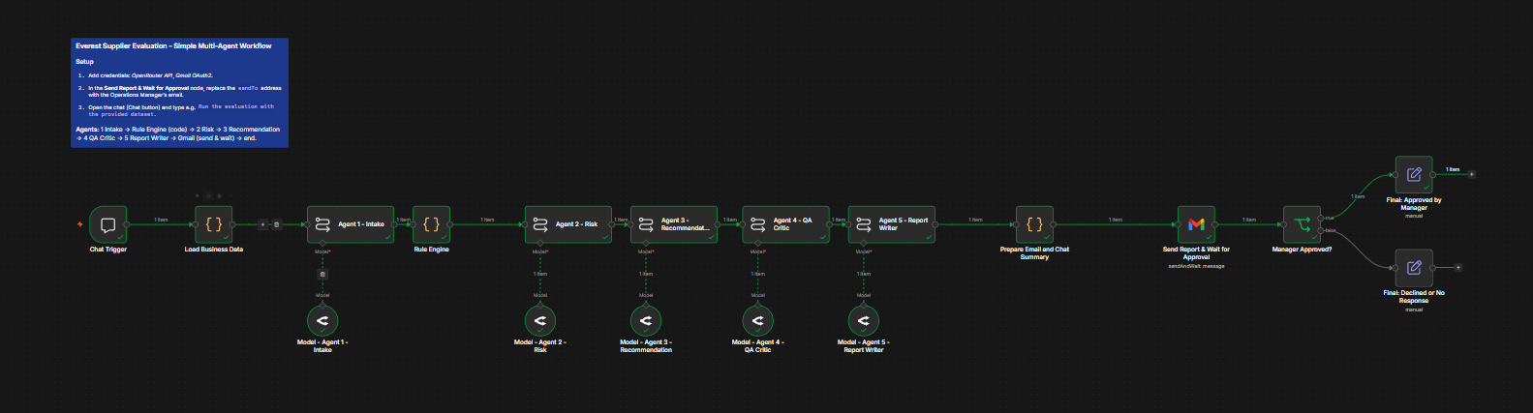

8. Agent Instructions and Configuration
Every agent has a system instruction that defines its role and limits, and a task prompt that supplies the evidence and the required output structure. Key instructions are summarised below. The full text is in the exported workflow file.
Agent | Key instructions (summary)
Agent 1 - Intake | Use only the supplied data and chat message. Never invent, guess or fill a missing value; use null. Apply a change only when explicitly stated. Recompute totals when a unit price changes and record it. Describe unclear or contradictory values in data issues. Output valid JSON only.
Agent 2 - Risk | Do not change any check status. Every risk must cite source and actual value. Never invent facts or policy rules. Separate mandatory failures, preference misses, policy flags and missing information. Output valid JSON only.
Agent 3 - Recommendation | Apply tiers in order: mandatory gate, missing or unclear information, policy flags, preferences, then combined comparison. Never choose on price alone. Quote actual values. If a supplier passes all mandatory requirements, name the best one; use NO_CLEAR_RECOMMENDATION only when no supplier is eligible or information is unresolved. The final decision belongs to the Operations Manager.
Agent 4 - QA Critic | Verify numbers against rule data; confirm no supplier with a mandatory failure is recommended; confirm missing information was flagged; confirm the recommendation is not price-only; confirm the final decision is left to a human. Return PASS or FAIL with issues.
Agent 5 - Report Writer | Do not re-evaluate or add facts. Use eight fixed sections in order. Repeat Agent 3's status and supplier exactly. Output an HTML fragment only.

Configuration: the language model for each agent is OpenAI nano via OpenRouter. The model can be changed per agent. The Gmail node sends to the Operations Manager’s address and waits for an Approve or Decline response with a 48-hour limit.

9. Business Logic and Decision Design

9.1 Requirements versus preferences
Category | Items | System behaviour
Mandatory requirements | Total price within NPR 2,500,000; 25 units; RAM at least 16 GB; SSD at least 512 GB; Windows 11 Pro; Intel Core i5 or equivalent or higher; warranty at least 2 years. | A failure marks the supplier NON_COMPLIANT and it cannot be recommended.
Preferences | Delivery within 14 days; payment 30 days after delivery. | A miss is listed as "not met", counted as a trade-off, and never disqualifies on its own.
Supplier risks and policy flags | Rating below 3/5; more than 2 late deliveries; missing warranty, tax, delivery or payment information; VAT not included; quotation validity. | Flagged in the report and marked for management review.
Needs management review | Any flag above, unclear policy interpretation, unclear processor equivalence. | Listed under "approval required" for the Operations Manager.

9.2 Supplier Evaluation Logic
Agent 3 compares suppliers using tiers, applied in order, so that a supplier that is better in one area but worse in another is judged fairly:
- Mandatory gate: any supplier failing a mandatory requirement cannot be recommended.
- Missing or unclear mandatory information: the supplier cannot be confidently recommended and the gap is listed for clarification.
- Policy flags: rating, late deliveries and missing information require management review and count against the supplier.
- Preferences: delivery and payment terms are weighed as trade-offs, not automatic disqualifiers.
- Combined comparison: total cost, delivery, warranty, payment terms, rating, late deliveries and quality complaints are compared together. Price alone is never the deciding factor.

9.3 Missing Information
If a value is missing (for example a warranty period), Agent 1 records it as null and lists it as a data issue. The Rule Engine marks the related check as "cannot verify" and lists the item under missing information. The supplier is given the status NEEDS_CLARIFICATION. The report asks for the missing item to be clarified. At no point does any agent supply a substitute value.

9.4 Conflicting or unclear information
- Required versus preferred delivery: the purchase request lists delivery within 14 days as "Required", but the policy says "Preferred". The system does not choose silently. It treats it as a preference, flags any miss, and records an interpretation note for the manager.
- Price arithmetic: if unit price multiplied by quantity does not match the stated total, the inconsistency is reported.
- Processor equivalence: if a processor is not an Intel Core i-series model, the check is marked "unclear" for human interpretation.
- Unparseable AI output: if Agent 1 returns invalid output, the Rule Engine falls back to the original dataset and records that chat changes were not applied.

9.5 Evidence
Every finding is tied to a source: purchase request, operations policy, supplier quotation or supplier history. Rule check results contain the actual value and the threshold. Agents are instructed to cite these values, and the QA Critic verifies them against the Rule Engine data. The data is stored as evidence only and does not contain a recommended supplier.

10. Testing Evidence
Four scenarios were designed, matching the brief. Test 1 was run end to end in n8n. The "Rule Engine check" column for Tests 2 to 4 shows the outcome of testing the Rule Engine logic with the changed inputs. The end-to-end results for those tests must be completed after running them in n8n.

Test | What was changed | Expected behaviour | Actual behaviour | Issue found | Improvement made
1 - Normal | Full provided dataset. Chat message: run the evaluation. | Workflow completes. TechNova fully compliant, Digital Hub compliant with flags (21-day delivery, advance payment, 3 late deliveries), Apex non-compliant (1-year warranty). Report emailed. | Workflow ran end to end. Report recommended TechNova Suppliers Pvt. Ltd. with status RECOMMENDED and QA PASS. | On the first run the chat summary showed NO_CLEAR_RECOMMENDATION while the report named TechNova. Agents disagreed and QA still passed. Also, a Respond to Chat node errored because of the trigger response mode. | Tightened Agent 3 status rule and required Agent 5 to repeat Agent 3's status exactly. Removed the Respond to Chat node.
2 - Incomplete information | Chat: Digital Hub's warranty is not stated. | Warranty is null, not invented. Digital Hub marked NEEDS_CLARIFICATION. The report asks for clarification. | Digital Hub's warranty was set to null and shown as "Not specified" and "cannot verify". Status was NEEDS_CLARIFICATION. The report requested clarification, flagged the 3 late deliveries, and did not recommend Digital Hub. TechNova was recommended with conditions, QA PASS. | Conditions in the recommendation referred to Digital Hub instead of the recommended supplier. Apex IT Traders was missing from the requirements check section. The comparison table lacked supplier names. QA did not catch these because it audits the recommendation only. | No improvement at all for now. Future improvement: Agent 5 instructed to cover every supplier in the requirements check and to include supplier names in the table. Agent 3 instructed to keep conditions about the recommended supplier separate from clarifications for other suppliers.
3 - Policy conflict | Chat: TechNova unit price is now NPR 105,000. | Total becomes NPR 2,625,000, above the NPR 2,500,000 budget. TechNova marked NON_COMPLIANT and not recommended. Reason explained. | Unit price change applied and total recalculated to NPR 2,625,000. Budget check failed, TechNova marked NON_COMPLIANT and not recommended. Overrun of NPR 125,000 stated correctly. Status NO_CLEAR_RECOMMENDATION. Report showed a QA warning banner. | Agent 3 returned no recommendation although Digital Hub passed all mandatory requirements, contradicting its instruction, and its reason confused mandatory requirements with preferences. QA returned FAIL by listing TechNova's budget failure, which is correct input data and not an error in the recommendation. | No improvement at all.  Future Improvements can be: Agent 3 instruction tightened to separate mandatory requirements from preferences and to recommend with conditions when a supplier passes all mandatory checks. QA instruction changed so that a supplier failing a check is expected, and FAIL applies only to errors in the recommendation itself.
4 - Changed evidence | Chat: Apex confirmed a 3-year warranty. | Apex becomes compliant. Recommendation and comparison change accordingly. Not the same output as Test 1. | Run completed. TechNova recommended (RECOMMENDED), QA PASS. Apex's confirmed warranty was not reflected in the report. | Report listed only TechNova and omitted Digital Hub and Apex. Report stated no adjustments were applied. Report contained conditions not present in the data. QA passed. | No improvement at all.  Future Improvements can be: Comparison table and requirements check generated by code from the Rule Engine so all suppliers always appear. Report Writer restricted to narrative sections and to quoting changes applied verbatim.

10.1 Test messages used
- Test 1: Run the evaluation with the provided dataset.
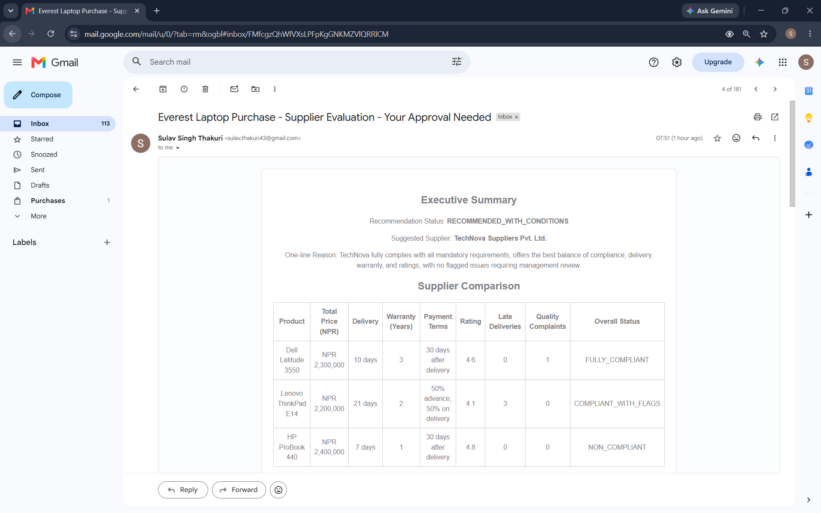

- Test 2: Run the evaluation. Digital Hub's warranty is not stated in their quotation.
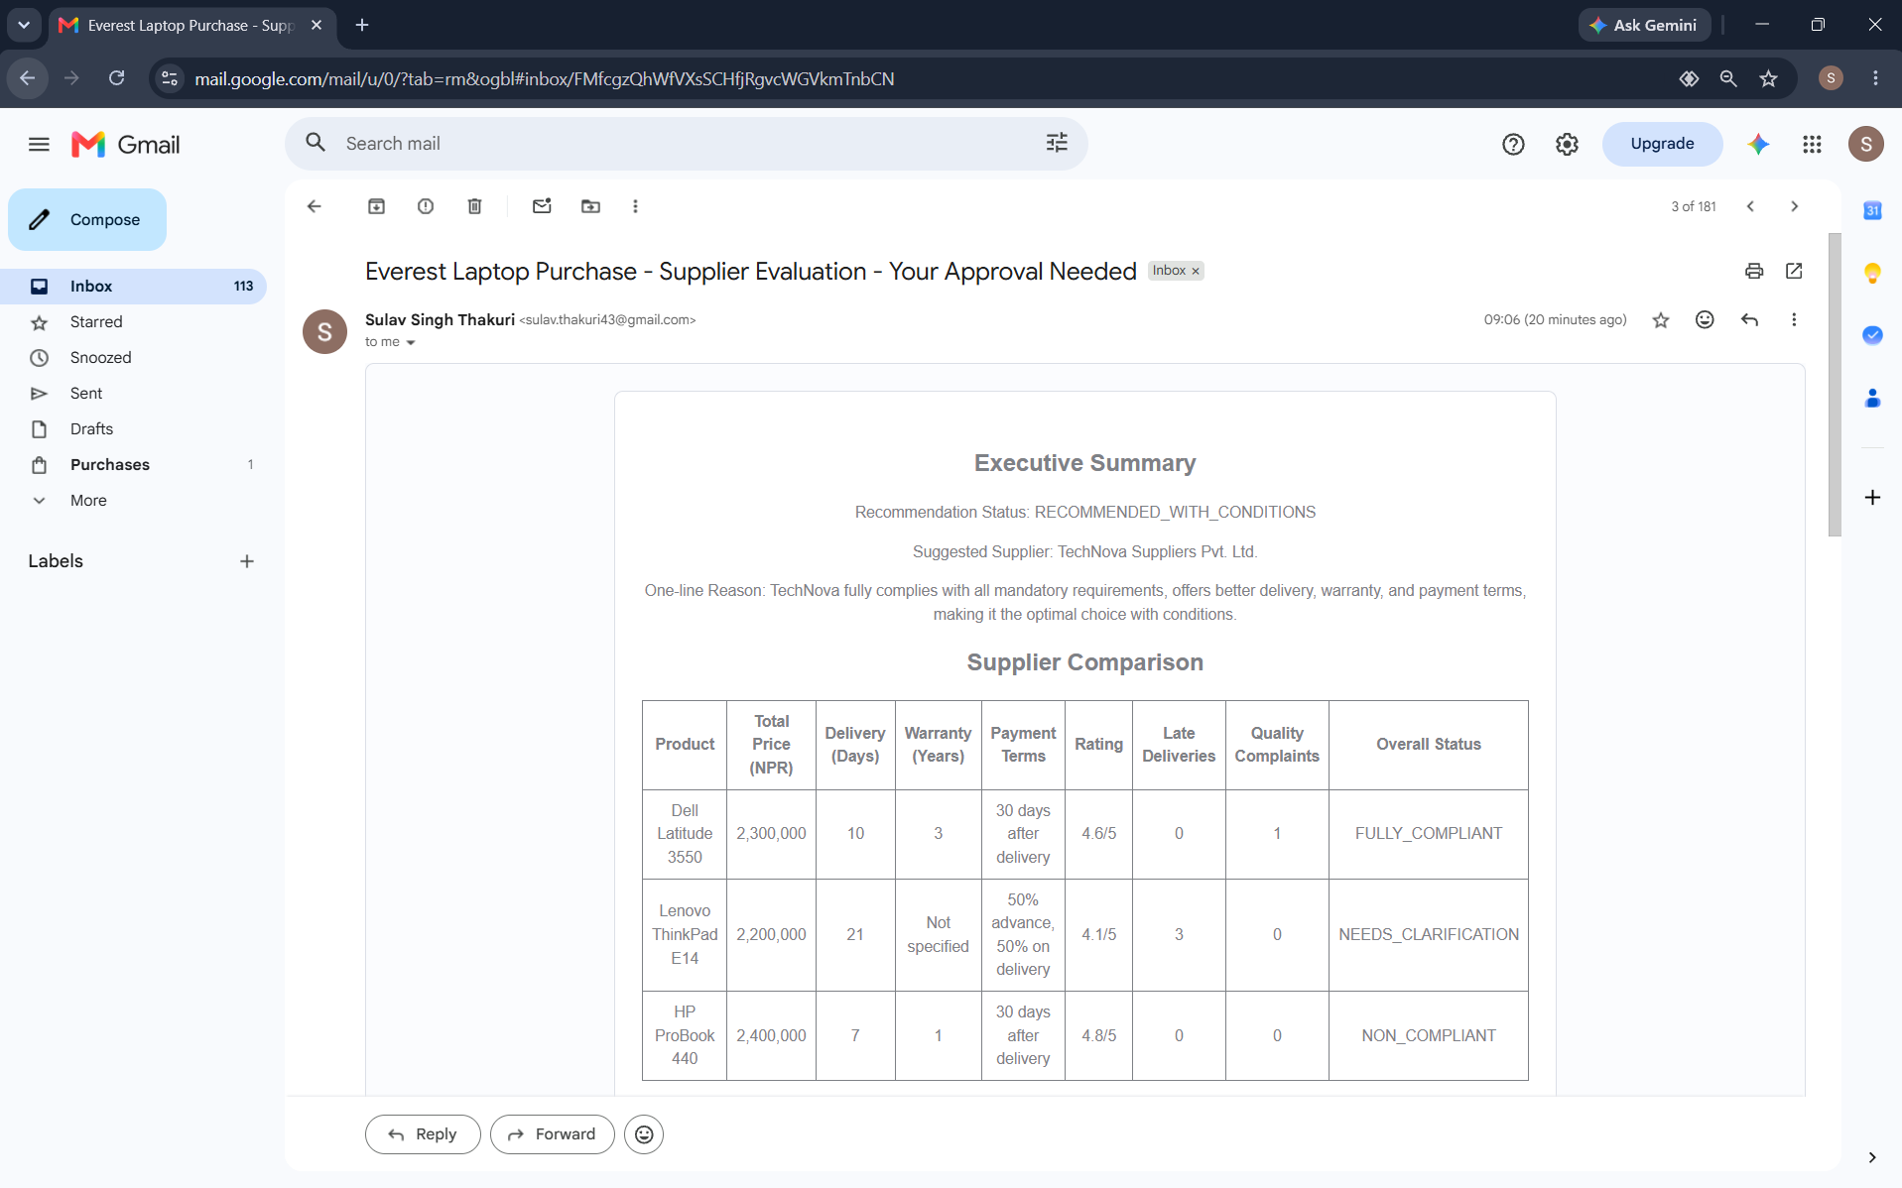

- Test 3: Run the evaluation. TechNova's unit price is now NPR 105,000.
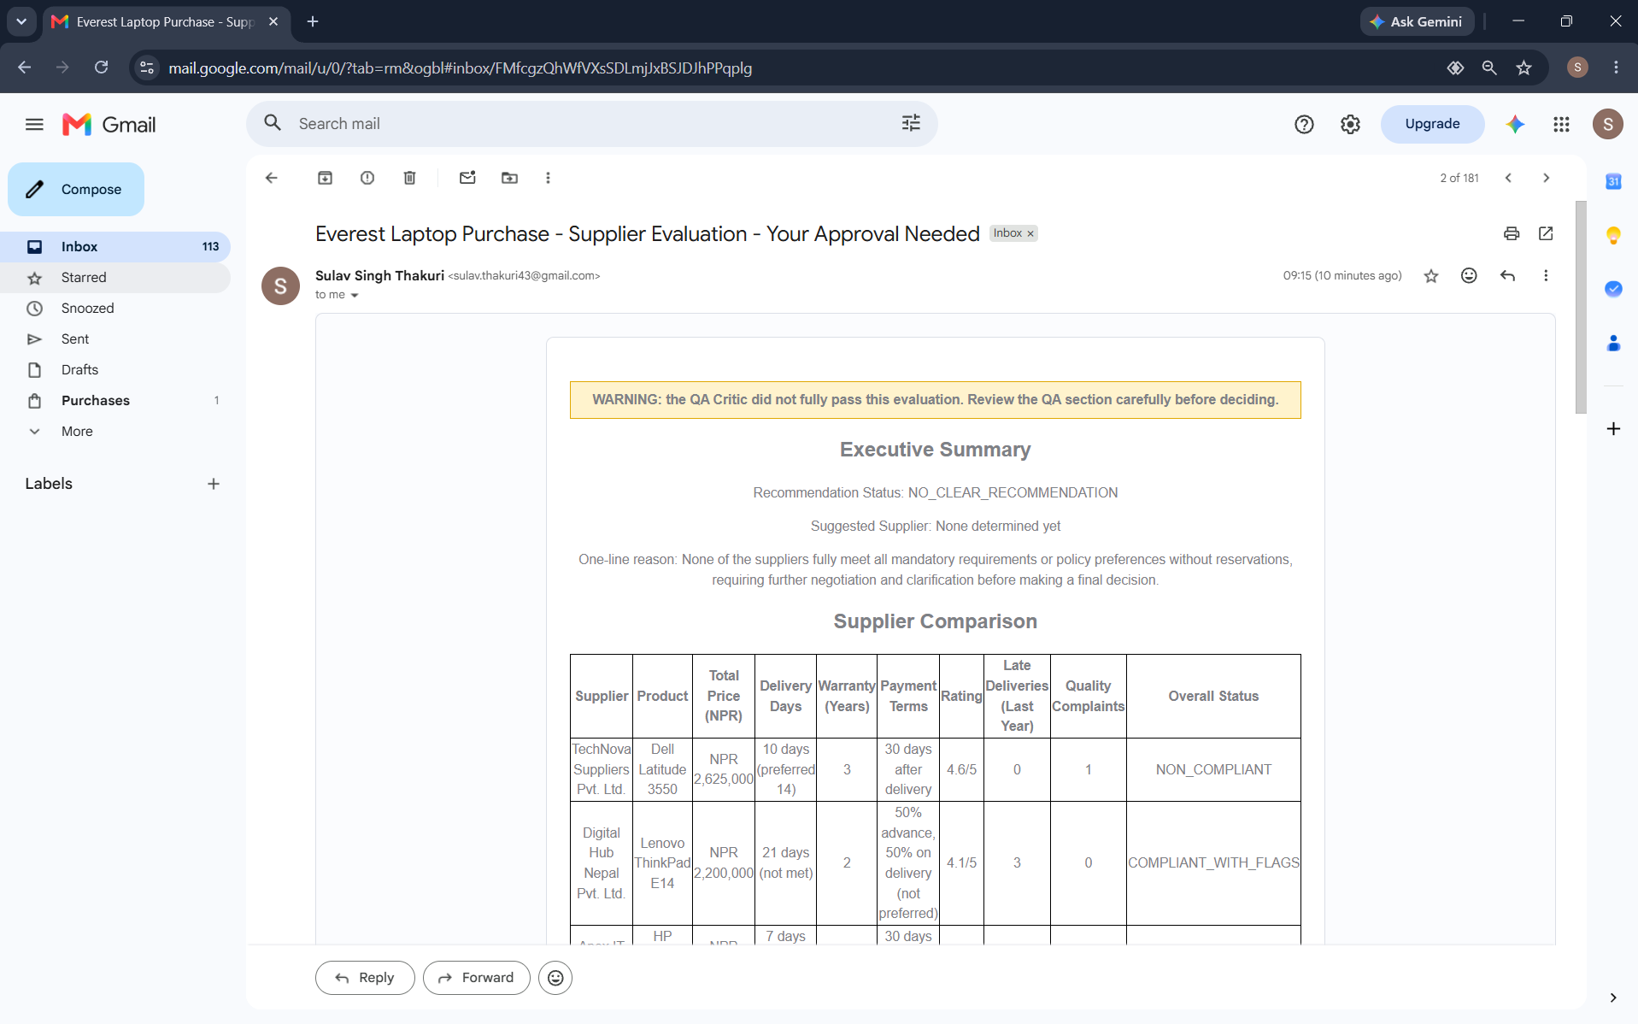

- Test 4: Run the evaluation. Apex confirmed a 3-year warranty.
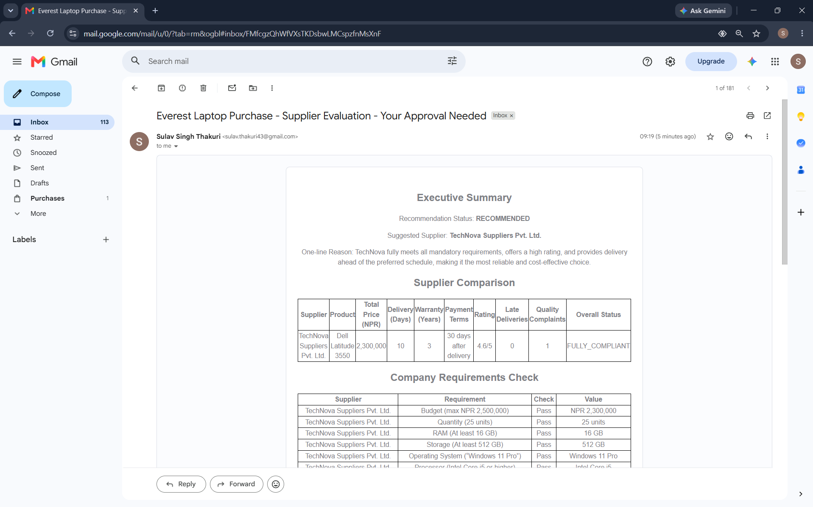

11. Final System Output
The system produces an HTML report, emailed to the Operations Manager, with eight sections:
- Executive summary: recommendation status, suggested supplier and the main reason.
- Supplier comparison table: product, total price, delivery, warranty, payment terms, rating, late deliveries, quality complaints and overall status.
- Company requirements check: each mandatory requirement and preference for each supplier, with the actual value.
- Risks and exceptions, including items needing management review.
- Information requiring clarification, including any changes applied from the chat message.
- Recommendation and reasoning, with trade-offs and conditions.
- QA check: verdict and any issues found.
- Approval required: a clear statement that this is a recommendation only, with Approve and Decline buttons.

11.1 Result of the normal run
With the complete provided dataset, the system recommended TechNova Suppliers Pvt. Ltd. The Rule Engine shows TechNova meets all mandatory requirements and preferences, with one quality complaint noted as information. Digital Hub Nepal meets the mandatory requirements but has flags: 21-day delivery, 50% advance payment, and 3 late deliveries in the previous year (above the threshold of 2). Apex IT Traders fails the mandatory warranty requirement (1 year against a minimum of 2 years), even though it has the best rating and the fastest delivery. This shows the system does not choose on price or on a single strength.

12. Business Impact
The benefits below are those that follow directly from how the system is built. No time-saving percentage is claimed, because it was not measured.
Area | Expected impact
Time | The reading, checking, comparing and writing steps run automatically from one chat message. Measuring the actual time saved would need a comparison against the manual process.
Consistency | Policy checks are performed by code, so the same evidence always produces the same rule results regardless of who runs it.
Quality of analysis | Every supplier is checked against every rule, and an independent QA step reviews the recommendation.
Visibility of risk | Late deliveries, advance payments, missing information and policy conflicts are listed explicitly instead of depending on individual attention.
Repeatability | Changing the input (for example a corrected quotation) and re-running produces a fresh evaluation without redesigning anything.
Decision support | Management receives reasons, trade-offs, risks and open questions, not just a supplier name, and keeps the final approval.

13. Limitations and Human Oversight

13.1 Limitations
- The system only knows what is in the supplied data. If a quotation or supplier history is wrong, the result will be wrong.
- A small language model can misjudge trade-offs or phrase things poorly. During testing an inconsistent recommendation status appeared and had to be fixed.
- The QA agent is also a language model. It reduces errors but does not guarantee correctness.
- The Rule Engine checks defined rules only. It cannot judge things outside the data, such as a supplier's real financial stability or how credible a quotation is.
- Supplier rating and history are treated as given. The system cannot verify them.
- The prototype has no live supplier database, permanent audit log or user access control.

13.2 Decisions that need human judgement
- Approving or declining the purchase.
- Deciding whether a flagged supplier is acceptable (for example more than 2 late deliveries).
- Interpreting unclear policy, such as whether the 14-day delivery is mandatory.
- Negotiating with suppliers or requesting missing information.

13.3 Human Oversight
The workflow ends at a Gmail approval step. The report states that it is a recommendation only. If the manager does not respond within 48 hours, the result is recorded as "declined or no response" and no purchase proceeds. The system never approves a purchase, raises a purchase order or makes a payment.

14. Future Improvements
Priorities before real deployment, in order:
- Connect real data sources (procurement system, supplier database) so data is not typed or pasted by hand, and validate incoming data.
- Store every run, its inputs, agent outputs and the manager's decision in an audit log.
- Add a formal clarification step so the system can request missing information from suppliers, with a manager reviewing before it is sent.
- Test with more real quotations and with edge cases, and compare results with manual evaluations by the Operations team.
- Confirm ambiguous policy points with management, for example the required versus preferred delivery wording, and update the rules.
- Add access control and data protection for supplier and pricing data.
- Use a stronger model for the recommendation and QA agents if testing shows the nano model is not reliable enough.

