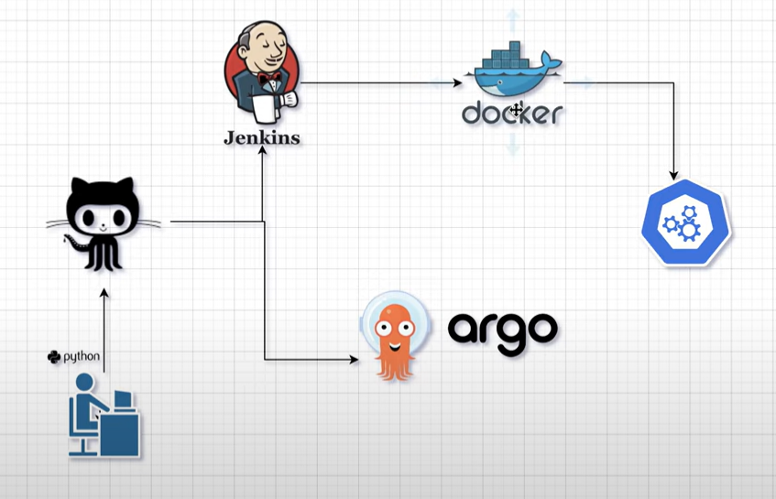

Jenkins Server

Add Credentials

* GitHub token
* DockerHub

Plugins

* Docker Pipeline
* Dashboard view

Install Docker