<https://github.com/sulbiraj06/jenkins-mvn-docker-hub.git>

Go to Jenkins URL

<http://52.7.48.19:8080/>

username: sulbiraj

password: jenkins

Create new pipeline job jenkins-mvn-docker-hub

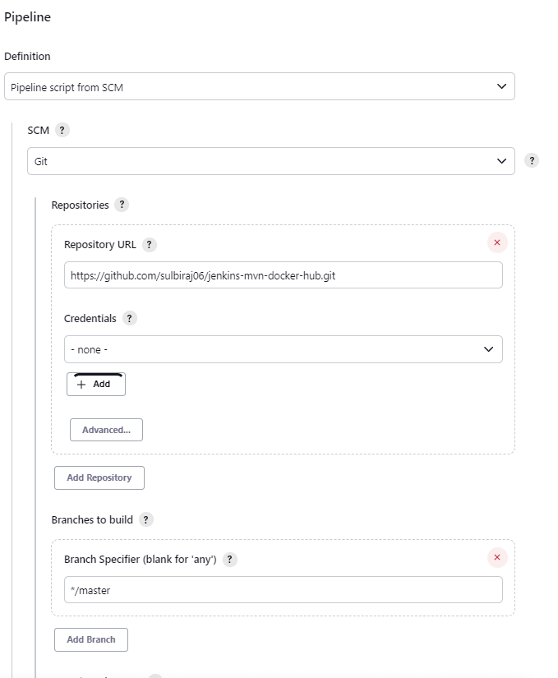

In Jenkins --> Manage Jenkins --> Global Tools configuration

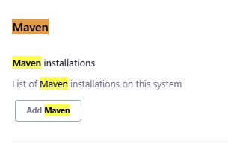

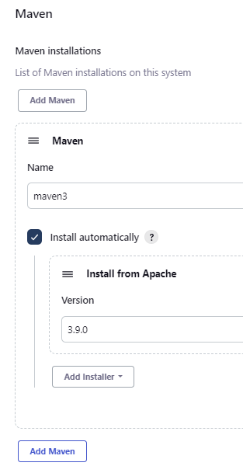

Save and Apply

Jenkins --> Manage Jenkins --> Global Tools configuration --> Manage credentials --> Add

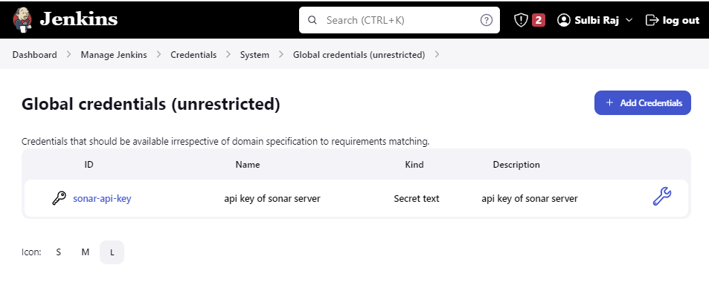

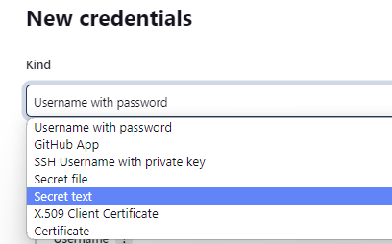

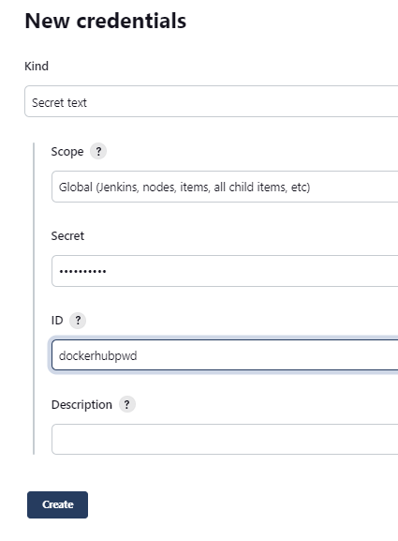

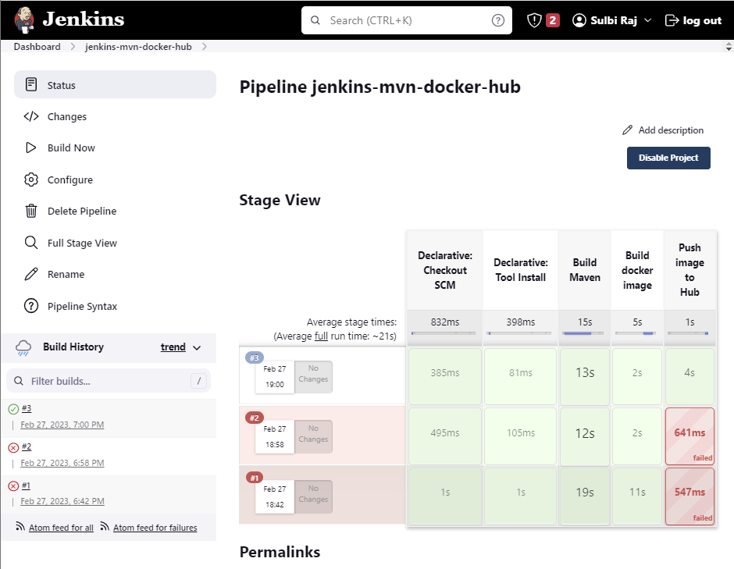

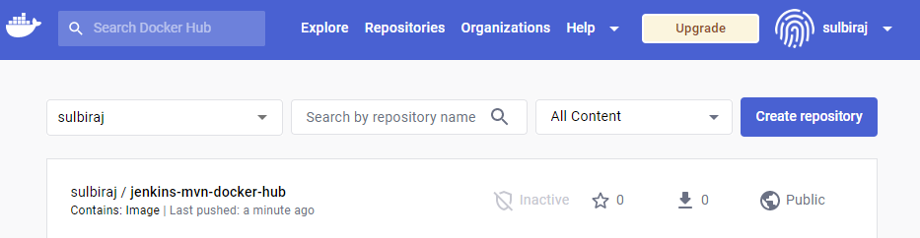

docker image has been uploaded to DockerHub