GAREUS run configuration — a worked walkthrough
From peptide sequence to free-energy surface, read off one YAML: RUNS/runs_rdy/KLVFF/KLVFF.yaml
GAREUS peptide sampler · schema_version 2.0 · double-adaptive 2D contacts × torsion-PCA · HMR-GaMD / REUS · MBAR/PMF
Scope: this document explains what a single staged run configuration does, end to end. KLVFF is chosen because it uses the current first-run CV pair (cv1: contacts, cv2: torsion-pca). The run is staged, not yet executed — only GENPEPT seeds and the config exist on disk — so the free-energy figures are SCHEMATIC (illustrative shapes, not KLVFF output).

1 What this run computes
GAREUS runs an explicit-solvent Amber14/OpenMM peptide simulation whose end product is a potential of mean force (PMF) — a free-energy surface over one or two collective variables (CVs). To reach every relevant conformation within a feasible amount of GPU time it stacks three enhanced-sampling ideas:
- Umbrella sampling / REUS — a ladder of harmonic-restrained "windows" pins the peptide at chosen CV values so the whole CV range is covered; replica exchange between windows keeps them ergodic.
- GaMD (Gaussian accelerated MD) — a smooth, shared boost potential ΔV lowers energy barriers so each window relaxes and crosses local barriers faster.
- Double-adaptive placement — short pilot runs decide where the windows go and how many, then epoch-based production adds / extends / retires windows until the surface converges.
The bias from every one of these layers must be removed at the end to recover the true, unbiased free energy. That final step (Section 6) is MBAR plus a separate GaMD-boost reweighting.

2 The pipeline at a glance
The diagram below is the whole run, top to bottom. Each box is one stage; the italic monospace label on the right names the YAML block (or code file) that controls it. Color bands group the stages into five phases.
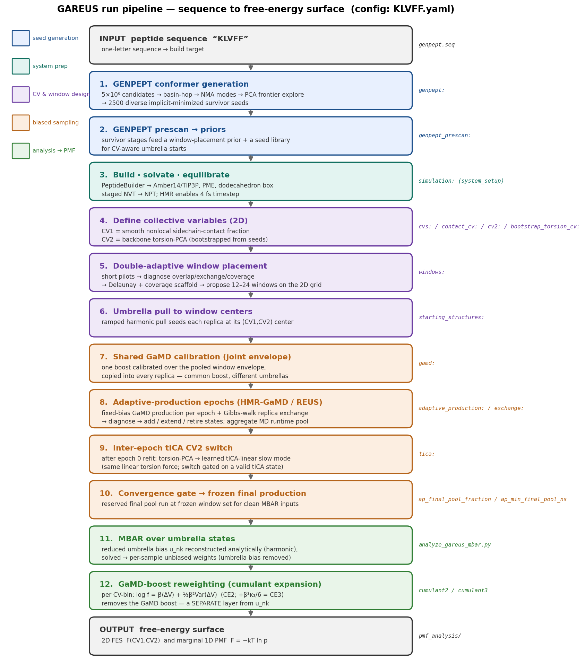
Figure 1. GAREUS pipeline for KLVFF.yaml: sequence → GENPEPT seeds → system prep → CV & window design → biased sampling → MBAR/boost reweighting → PMF.

3 The configuration file
The full run is described by one YAML file. Its top-level blocks map one-to-one onto the pipeline stages. The description string on line 2 is stale (it predates a bulk edit): the resolved knobs are md_budget_ns: 20000 (20 µs aggregate pool) and ap_epochs: 4, not the "4 µs, 3 epochs" the string claims — always trust the blocks below, not the description.
YAML block | Pipeline stage | What it sets
genpept: | 1 seed generation | GENPEPT conformer search: 5×10⁶ candidates, basin-hop, NMA modes, PCA frontier → 2500 survivor seeds
genpept_prescan: | 2 priors | Reuse survivor stages as a window-placement prior + CV-aware seed library
cvs: / contact_cv: / cv2: / bootstrap_torsion_cv: | 4 CV definition | CV1 = nonlocal sidechain-contact fraction; CV2 = backbone torsion-PCA bootstrapped from seeds
tica: | 9 CV2 switch | After epoch 0, refit tICA and switch CV2 from torsion-PCA to the learned slow mode
starting_structures: | 6 umbrella pull | Ramped harmonic pull to seed each replica at its window center
windows: | 5 window placement | Double-adaptive: pilots → Delaunay/coverage → 12–24 windows on the 2D grid
adaptive_production: | 8 / 10 epochs + final | 20 µs runtime pool, 4 epochs, reserved frozen-final fraction, run MBAR at the end
simulation: / gamd: / exchange: | 3 / 7 / 8 MD engine | HMR-GaMD at 4 fs, lower-dual-nonbonded-dihedral boost, Gibbs-walk exchange
output: / platform: | (all) | XTC solute-only trajectories, sample cadence, CUDA platform, CPU budget
Full file follows (RUNS/runs_rdy/KLVFF/KLVFF.yaml, 5.2 kB). Reproduced verbatim so the walkthrough below can quote real values.
schema_version: '2.0'
description: "KLVFF double-adaptive 2D contacts x rama-map HMR-GaMD/REUS. Runs3: sigma0=3 kcal/mol, max_windows=24, min_windows=12, 4 µs, 3 epochs."
genpept:
seq: "KLVFF"
out: "KLVFF_genpept_r3"
clean: false
two_stage: true
implicit_only: true
n: 5000000
n_candidate_seeds: 5000
n_final_seeds: 2500
jobs: 16
min_jobs: 1
generation_backend: fast
rama_sampling: stratified
initial_diversity_features: mixed
diversity_bank_preset: broad
preselection_bin_quota: 3
preselection_rg_bin_A: 1.0
preselection_e2e_bin_A: 1.0
preselection_contact_bin: 2
preselection_include_bank: true
adaptive_min: true
implicit_max_iterations: 300
adaptive_min_chunk_iterations: 25
adaptive_min_energy_tol: 0.05
adaptive_min_force_tol: 500.0
adaptive_min_stall_rounds: 2
basin_hop: true
bh_parent_seeds: 120
bh_steps: 3
bh_md_steps: 350
bh_temperature: 675.0
bh_friction: 5.0
bh_timestep: 0.0035
bh_hmr_mass: 3.014
bh_initial_min_iterations: 200
bh_min_iterations: 150
bh_restart_from_parent: true
nma_expand: true
nma_modes: 2
nma_amplitudes: "0.75,1.35"
nma_cutoff: 12.0
explore_loop: true
explore_rounds: 5
explore_proposals: 50000
explore_keep: 250
explore_bins: 45
explore_target_max_count: 0
explore_pca_padding: 0.15
explore_frontier_only: true
explore_allow_outside: true
explore_max_kept_per_bin: 4
explore_bh: false
genpept_prescan:
genpept_prescan: true
genpept_prescan_dir: "KLVFF_genpept_r3"
genpept_prescan_stages:
- candidate_seeds
- aa_implicit_minimized_pdbs
- basin_hop_minima
- nma_probe_seeds
- final_survivor_seeds
genpept_prescan_frontier_stages:
- aa_implicit_minimized_pdbs
- basin_hop_minima
- final_survivor_seeds
genpept_prescan_use_as_window_prior: true
genpept_prescan_use_as_seed_library: true
cvs:
cv1: contacts
cv2: torsion-pca
bootstrap_torsion_cv:
bootstrap_torsion_source: seeds
bootstrap_torsion_residualize_against_cv1: true
bootstrap_torsion_component: 1
bootstrap_torsion_min_seed_count: 20
contact_cv:
contact_scheme: residue-balanced
contact_atom_selection: sidechain-all
contact_min_sequence_separation: 3
contact_r0_a: 3.6
contact_beta_a_inv: 2.5
contact_normalize: true
cv1_range_min: 0.0
cv1_target_spacing: 0.167
cv1_k_min: 50.0
cv1_k_max: 250.0
cv1_boundary_pull_steps: 100000
cv1_boundary_pull_k: 200.0
cv1_frontier: true
cv1_frontier_probe_count: 2
cv2:
cv2_k_min: 5.0
cv2_k_max: 100.0
cv2_k_mode: adaptive
cv2_adaptive_overlap_sigma: 2.3
cv2_k_scale: 1.0
# cv2 centers are derived automatically from bootstrap_torsion_cv for torsion-pca.
tica:
tica_obs_interval: 50
tica_lag_frames: 50
tica_min_eigenvalue: 0.0
tica_update_after_epochs: [0]
tica_switch_cv2: true
tica_linear_k_min: 5.0
tica_linear_k_max: 50.0
starting_structures:
seed_conformers_dir: "KLVFF_genpept_r3"
us_pull_steps_per_window: 50000
us_pull_timestep_fs: 3.0
us_pull_k: 75.0
us_pull_ramp_stages: 5
us_2d_secondary_k_scale: 5.0
windows:
window_mode: double-adaptive
aggressiveness: aggressive
pilot_fraction: 0.004
pilot_steps: 40000
validation_steps: 50000
adaptive_rounds: 5
sparse_2d: true
max_2d_patches: 32
max_total_windows: 24
min_total_windows: 12
max_replicas: 24
explicit_2d_window_schema: generic
region_memory: true
region_memory_decay: 0.5
region_probe_unvalidated: true
region_prune_overscanned: true
region_extend_undersampled: true
adaptive_feedback_min_rounds: 3
target_overlap: 0.30
pilot_min_cv1_coverage: 0.80
pilot_min_cv2_coverage: 0.80
delaunay_iterate: true
delaunay_stability_tol: 0.001
delaunay_coverage_scaffold: true
delaunay_coverage_grid_n: 5
adaptive_production:
md_budget_ns: 20000.0
ap_epochs: 4
target_overlap: 0.30
ap_final_pool_fraction: 0.5
ap_min_final_pool_ns: 300.0
ap_min_samples: 10000
ap_min_samples_per_window: 200000
ap_resume: true
ap_write_reports: true
ap_write_mbar_inputs: true
ap_run_mbar: true
ap_fes_bins: "40,80"
ap_seed_bank: true
ap_seed_bank_max: 1
explicit_2d_windows:
explicit_2d_primary_cv_mode_column: primary_cv_mode
explicit_2d_primary_center_column: primary_cv_center
explicit_2d_primary_k_column: primary_cv_k_kcal
explicit_2d_secondary_cv_mode_column: secondary_cv_mode
explicit_2d_secondary_center_column: secondary_cv_center
explicit_2d_secondary_k_column: secondary_cv_k_kcal_mol
output:
seq: "KLVFF"
out: "KLVFF_2d_run3"
traj_interval: 150
report_interval: 150
distance_output_interval: 150
parquet_flush_rows: 200000
traj_format: xtc
traj_solute_only: true
sample_potential_energy: false
platform:
platform: CUDA
setup_cpu_threads: 8
cpu_budget: 32
max_cpu_per_replica: 6
simulation:
run_mode: hmr-gamd
timestep_fs: 4.0
nvt_warmup_timestep_fs: 0.5
npt_ramp_timestep_fs: 1.0
gamd:
production_steps: 10000000
boost_type: lower-dual-nonbonded-dihedral
sigma0p: 3.0
sigma0d: 3.0
equil_steps: 1500000
gamd_averaging_window: 5000
exchange:
exchange_mode: gibbs-walk
exchange_interval: 500
tui:
tui_mode: interactive

4 Stage-by-stage walkthrough

4.1 GENPEPT seed generation
Config: genpept:
Before any MD, GENPEPT builds a diverse library of starting conformers from the bare sequence KLVFF. It draws 5×10⁶ candidate backbones (stratified Ramachandran sampling), implicit-solvent minimizes them, then diversifies with three moves: basin-hopping (120 parent seeds, high-temperature 675 K MD kicks), normal-mode expansion (2 modes, amplitudes 0.75 / 1.35), and a 5-round PCA "explore" loop that pushes seeds toward the frontier of shape space. The 2500 survivors span folded, extended, and hairpin-like states so umbrella windows do not all start from the same basin.

4.2 GENPEPT prescan → priors
Config: genpept_prescan:
The prescan reuses those survivor stages twice: as a window-placement prior (where in CV space are conformers actually reachable?) and as a seed library so each umbrella window can be started from a real conformer near its target CV values rather than by pulling from a single structure. This is a sampling prior only — it never enters the PMF as evidence.

4.3 Build, solvate, equilibrate
Config: simulation: (system_setup)
The peptide is built with PeptideBuilder (φ=−60°, ψ=−45°, ω=180°), protonated at pH 7, and solvated in a rhombic-dodecahedron TIP3P box (1.0 nm padding, 0.15 M ions, neutralized). The physical model is Amber14 + PME (0.8 nm cutoff), HBonds constraints, rigid water. run_mode: hmr-gamd turns on hydrogen-mass repartitioning, which permits the 4 fs production timestep. Equilibration is staged: a short 0.5 fs NVT warm-up, a 1.0 fs NPT ramp, then the 4 fs production state — saved for reliable resume.

4.4 Collective variables (2D)
Config: cvs: / contact_cv: / cv2: / bootstrap_torsion_cv:
CV1 is a smooth nonlocal contact fraction over sidechain-all atoms (residue-balanced, minimum sequence separation 3, switching radius r₀=3.6 Å, β=2.5 Å⁻¹, normalized to [0,1]). It measures how compact / folded the peptide is without any single reference structure. CV2 is bootstrapped as the first backbone-torsion principal component, fit from the GENPEPT seeds and residualized against CV1 so the two axes are as orthogonal as possible. This CV2 is not static — see 4.9.
CV1 contact_ij = (1 − (r_ij/r0)^6) / (1 − (r_ij/r0)^12) [smooth, 0..1]

4.5 Double-adaptive window placement
Config: windows:
Windows are not placed on a fixed grid. Short pilots (0.4% of production, 40k steps) sample the seeded region; the diagnostics measure neighbor overlap, exchange acceptance and CV coverage. A Delaunay triangulation over the pilot samples plus a 5×5 coverage scaffold proposes window centers, iterating (up to 5 rounds) until the placement is stable. The target neighbor overlap is 0.30; the final set is capped at 12–24 windows (max 32 sparse 2D patches). Region memory lets later epochs remember which regions were over- or under-scanned.

4.6 Umbrella pull to window centers
Config: starting_structures:
Each replica is driven to its assigned (CV1, CV2) center by a ramped harmonic pull (50k steps, 5 ramp stages, k=75 kcal/mol, 3 fs), with the secondary CV2 restraint scaled ×5 during the pull. The endpoint becomes that replica’s production start.

4.7 Shared GaMD calibration (joint envelope)
Config: gamd:
GaMD adds a smooth boost potential ΔV(V) that raises energies below a threshold, flattening barriers. Rather than calibrating a separate boost per window, GAREUS calibrates ONE boost over the joint energy envelope pooled across all initial windows (lower-dual-nonbonded-dihedral boost, σ0p=σ0d=3 kcal/mol) and copies that same GaMD state into every replica. All replicas then share one boost thermodynamic setup and differ only in their umbrella restraint — which is exactly what makes the replica exchange valid.
V*(r) = V(r) + ΔV(V), ΔV = ½ k (E − V)² for V < E, else 0
k = k0 · 1/(Vmax − Vmin), k0 tuned so σ_ΔV ≤ σ0

4.8 Adaptive-production epochs (HMR-GaMD / REUS)
Config: adaptive_production: / exchange: / simulation:
Production is an epoch-based campaign, not one long run. Each epoch runs fixed-bias GaMD production for every active window and attempts Gibbs-walk replica exchange every 500 steps. Between epochs the diagnostics re-check overlap, exchange, coverage, GaMD boost health and per-window sample counts, then add, extend, or retire windows. A single aggregate runtime pool (md_budget_ns: 20000 = 20 µs summed over all windows × replicas) bounds the whole campaign — active replica count grows adaptively against that pool, up to ap_epochs: 4 epochs.
exchange accept: P = min(1, exp(−β[Uᵢ(x_b)+Uⱼ(x_a) − Uᵢ(x_a)−Uⱼ(x_b)]))
consumed_ns = n_states · steps_per_state · timestep_fs / 1e6
The GaMD boost is deliberately NOT part of the exchange criterion — only the umbrella restraint difference enters, because all replicas share the same boost.

4.9 Inter-epoch tICA — the CV2 switch
Config: tica:
CV2 has a lifecycle. It is bootstrapped as torsion-PCA at epoch 0 (Section 4.4). After the first tICA refit (tica_update_after_epochs: [0]), the package solves a time-lagged independent component analysis on accumulated backbone-dihedral observations and switches CV2 to the learned slowest mode (tica-linear). Both the bootstrap and the learned coordinate drive the SAME shared linear-torsion bias force — only the projection vector changes. The switch is gated (tica_switch_cv2: true): it happens only after a valid tICA state file is written, and fast-resume fails closed if that state is missing.
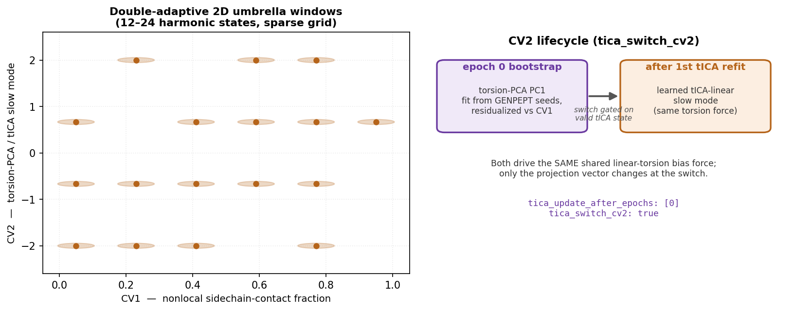
Figure 2. Left: the double-adaptive 2D umbrella windows over CV1 × CV2 (sparse, 12–24 harmonic states). Right: the CV2 lifecycle — torsion-PCA bootstrap at epoch 0, then a switch to the learned tICA-linear slow mode.

4.10 Convergence gate → frozen final production
Config: ap_final_pool_fraction / ap_min_final_pool_ns
Once the adaptive convergence gate passes, the window set is frozen and a reserved slice of the runtime pool (ap_final_pool_fraction: 0.5, at least ap_min_final_pool_ns: 300 ns) runs one clean, fixed-bias final production. Only these frozen-final samples are the intended PMF inputs — pilot and mid-epoch folders are diagnostics, not evidence.

5 From samples to the free-energy surface
This is the load-bearing step, and it has TWO independent bias-removal layers. Getting them separate is the whole game — conflating them gives a wrong PMF.

5.1 Layer 1 — MBAR removes the umbrella bias
Every sample carries a known harmonic umbrella bias. Rather than store the huge N×K bias matrix, GAREUS reconstructs it analytically at analysis time (lossless for harmonic umbrellas) and hands it to MBAR, which solves for the per-window free energies and returns per-sample unbiased weights that pool all windows into one unbiased ensemble.
U_k(cv) = ½ k_k (cv1 − c1_k)² + ½ k_k (cv2 − c2_k)² [kcal/mol]
reduced bias u_nk[n,k] = β · 4.184 · U_k(cv_n)
MBAR: solve f_k → per-sample weight w_n (umbrella bias removed)

5.2 Layer 2 — cumulant expansion removes the GaMD boost
The MBAR weights still contain the GaMD boost, because every frame was recorded under an added ΔV. The boost is removed by a SEPARATE per-CV-bin cumulant reweighting: within each CV bin, take the weighted mean and variance of the boost and multiply the binned probability by an exponential reweighting factor. Second order (CE2) keeps mean + variance; third order (CE3) adds the κ₃ term.
log-reweight f_bin = β⟨ΔV⟩ + ½ β² Var(ΔV) (CE2)
+ (β³/6) κ₃ (CE3, opt-in)
p(cv) = p₀(cv) · exp(f_bin), then F(cv) = −kT ln p(cv)
Implementation note: variance and κ₃ are accumulated mean-centered (two-pass), because raw moments catastrophically cancel when the boost mean (O(10–200 kJ/mol)) dwarfs its spread. This was a real bug that has been fixed.
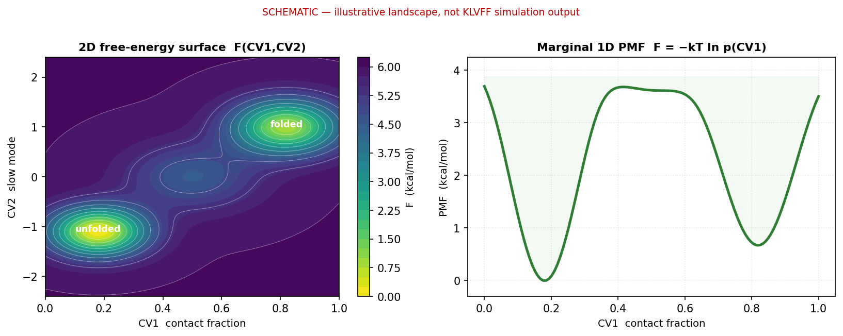
Figure 3. SCHEMATIC free-energy output (illustrative, not KLVFF data): the 2D FES F(CV1,CV2) and the marginal 1D PMF F = −kT ln p(CV1) obtained after both reweighting layers.

6 What lands on disk
Artifact | Contents
effective_config.yaml/json | Fully resolved config actually used (reproducible)
run_manifest.json | Environment, dependency, source and artifact hashes (provenance)
umbrella_explicit_windows.csv | Canonical window-major table of centers and force constants
samples/<seg>/chunk_*.parquet | Per-step cv1, cv2, potential, gamd_boost_* (~44 bytes/sample)
exchanges/<seg>/chunk_*.parquet | Replica-exchange events (step, replicas, ΔE, accepted)
adaptive_production/epoch_*/ | Per-epoch production, diagnostics, tICA observations
adaptive_production/final/ | Frozen-final production — the conservative PMF/MBAR stage
pmf_analysis/ | 2D FES, 1D PMF, MBAR metadata and overlap/ESS quality reports
final_run_report.md/json | Validation summary
The umbrella bias matrix is never stored; it is reconstructed on demand via gareus.query.export_analysis_arrays_npz for downstream MBAR tools.

7 Known caveats worth flagging
- GaMD-boost reweighting reliability (Layer 2): when Var(βΔV) is large, the exponential boost reweighting collapses (effective sample size → ~0) and even CE2 becomes unreliable. The analysis reports a gamd_reweight_ess diagnostic precisely to expose this — a small ESS means the PMF’s absolute free energies should be read with caution even when window overlap looks healthy.
- CV2 axis restraint: torsion / tICA windows can be over-restrained relative to CV1, giving low CV2-direction overlap; the cv2 k_mode: adaptive + overlap_sigma 2.3 settings here are the current mitigation.
- Staged vs executed: this KLVFF config has produced only GENPEPT seeds so far. Numbers like "12–24 windows" and "20 µs" are the configured targets, not measured outcomes; the free-energy figures are schematic.

8 How to run this configuration
# 1. generate GENPEPT seeds (already present as KLVFF_genpept_r3/)
python GENPEPT.py --config RUNS/runs_rdy/KLVFF/KLVFF.yaml
# 2. run the full double-adaptive GaMD/REUS campaign
gareus --config RUNS/runs_rdy/KLVFF/KLVFF.yaml
# resume from the furthest completed checkpoint / epoch boundary
gareus --config RUNS/runs_rdy/KLVFF/KLVFF.yaml --resume
# analyze → PMF (MBAR + GaMD-boost reweighting)
python analyze_gareus_mbar.py --run-dir KLVFF_2d_run3
ap_run_mbar: true means the campaign runs PyMBAR automatically after the frozen final; the standalone analyze_gareus_mbar.py is for re-analysis, extra reweighting orders (CE3 / exponential), and diagnostics.

