GAREUS Physics-Oracle: Harmonic-PMF Recovery Test
Analytic validation of the MBAR umbrella-sampling estimator (solve_mbar / pmf_from_weights) — generated from a live run

Executive Summary
The GAREUS estimator's dominant failure mode is statistical, not software: sign errors, dropped terms, and mis-scaled reduced potentials (the GaMD boost-exclusion class) produce plausible-but-wrong PMFs that only surface in expensive multi-microsecond GPU runs. This test closes that gap. It feeds the real estimator synthetic umbrella samples whose underlying free-energy surface is known in closed form, then asserts the estimator recovers it — in ~1 second, with no OpenMM and no MD.
Result: on a harmonic well of true curvature k0=2.0 kcal/mol/unit^2, MBAR recovers k_fit=1.988 (relative error 0.6%; shape residual 0.014 kcal/mol). A mutation check confirms the test has teeth: scaling, dropping, or sign-flipping the bias matrix is caught with 51-986% curvature error. The test ships as tests/test_physics_oracle.py and runs as part of the standard pytest suite (no extra dependencies).

1. The Oracle

1.1 Why harmonic, and why no MD
True (unbiased) 1-D potential U0(x) = 1/2 k0 x^2. Umbrella bias of window i: w_i(x) = 1/2 k (x - x_i)^2. Because both are quadratic, the biased equilibrium of window i is exactly Gaussian, so samples can be drawn directly with NumPy:
Quantity | Closed form | Value here
per-window variance | sigma^2 = 1 / (beta (k0+k)) | sigma = 0.2229
per-window mean | mu_i = k x_i / (k0+k) | compression k/(k0+k) = 0.833
true-well width | sigma0 = 1/sqrt(beta k0) | sigma0 = 0.5460
No integrator, no force field, no OpenMM — the test is pure NumPy and the answer is known exactly. This is what makes it cheap enough to run on every commit.

1.2 Why it recovers the UNBIASED ensemble
The reduced-potential matrix is built in the GAREUS convention: BIAS ONLY, u_nk[n,k] = beta * 1/2 k (x_n - x_k)^2, with the unbiased state implicit at u=0. The common beta*U0(x_n) term is identical across all columns k for a given sample, so it cancels in MBAR's per-sample weights. solve_mbar therefore reweights every sample to the zero-bias ensemble, and histogram reweighting recovers F(x) = U0(x) = 1/2 k0 x^2 up to an additive constant. This is precisely the GaMD boost-exclusion bug class: drop or mis-scale a term in u_nk and the recovered curvature comes out as k0 +/- k, not k0.

1.3 Traps baked into the test
Trap | Consequence | How the test handles it
Factor of 2 in fit | F = a x^2 + b x + c gives a = 1/2 k0 | compares curvature 2a to k0, not a
Jacobian / measure | PMF = potential only for flat-measure 1-D Cartesian | documented in-code; do not reuse for angle/radius CVs
Window-mean compression | means are squeezed by k/(k0+k); naive centers undersample tails | centers span +/-2 so means reach +/-1.67 (~3 sigma0)
Edge bins noisy | tail bins have few effective counts | curvature fit restricted to |x|<=1.4 with counts>50

2. Setup and Results
Parameter | Value
Temperature | 300 K (kT = 0.59616 kcal/mol)
True curvature k0 | 2.0 kcal/mol/unit^2
Bias spring k | 10.0 kcal/mol/unit^2
Windows | 19 (centers linspace(-2, 2))
Samples / window | 4,000 (total 76,000)
Adjacent mean spacing | 0.83 sigma_win (good overlap, < 1.5 sigma)
MBAR backend / convergence | anderson; converged=True, iters=27, max_delta=5.1e-11
Reweighted ESS fraction | 55.02%

2.1 Recovery
Check | Expected | Recovered | Tolerance | Pass
Curvature 2a | 2.0 | 1.988 | rel err < 10% | YES (0.6%)
Linear term b | 0 | -0.001 | |b| < 0.15 | YES
Shape residual RMSE | 0 | 0.014 | < 0.10 kcal/mol | YES
Flat control span (k0=0) | 0 | 0.070 | < kT | YES

2.2 Mutation test — does the oracle have teeth?
A passing test proves nothing until it is shown to FAIL under the bug class it targets. Each row injects a defect into u_nk and re-runs recovery:
Injected defect | Curvature | Rel err | Verdict | Real-world analog
Correct u_nk (control) | 1.988 | 1% | PASS (<10%) | estimator math is sound
u_nk x 0.5 (half-scaled bias) | 0.985 | 51% | CAUGHT | GaMD boost-exclusion / mis-scaled term
u_nk = 0 (bias term dropped) | 0.007 | 100% | CAUGHT | reweighting term omitted entirely
-u_nk (sign flip) | 21.717 | 986% | CAUGHT | sign error in reduced potential
The control recovers k0 to ~1%; every defect is caught well outside the 10% band. The half-scaled case (51% error) is the direct analog of the GaMD boost-exclusion that gave ESS ~ 0 in production — caught here at commit time in one second.
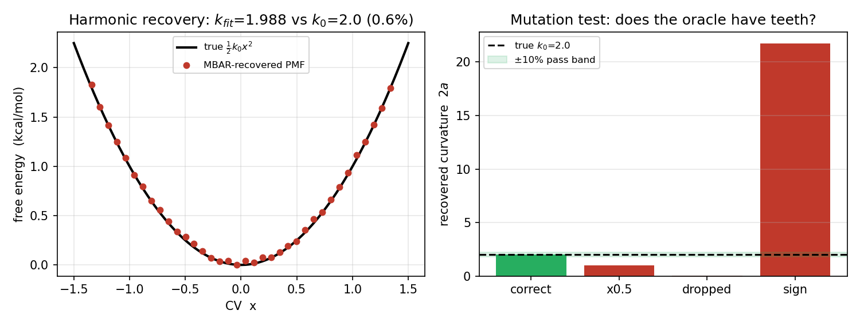
Left: MBAR-recovered PMF (points) vs the analytic parabola (line) in the well-sampled core. Right: recovered curvature under each mutation; green band is the +/-10% pass region.

3. What This Does and Does Not Cover
Covered (this test) | NOT covered (separate tests)
Estimator math: solve_mbar self-consistency, reweighting to unbiased ensemble, histogram PMF | u_nk CONSTRUCTION incl. kcal<->kJ (4.184) — needs a reconstruct_bias_matrix construction-guard test
Bias sign, scale, and term-inclusion in the reduced potential | Exchange correctness — needs a detailed-balance test on the Gibbs-walk swap (would have caught the MH-correction bug)
1-D harmonic + flat controls | GaMD cumulant2 reweighting and 2-D CV coupling
The test deliberately builds u_nk from the textbook formula rather than calling reconstruct_bias_matrix, so a failure localizes to the solver, not the matrix builder. This layering — each oracle pins down one link in the chain — is the design principle for the rest of the suite.

4. How This Was Determined
Code under test: analyze_gareus_mbar.solve_mbar, pmf_from_weights, norm_logw, ess. Test file: tests/test_physics_oracle.py (test_harmonic_pmf_recovery, test_flat_pmf_recovery). The analytic derivation (Gaussian biased means/variances, bias-only u_nk recovering the unbiased ensemble, curvature = k0) was independently validated via the project GPT/Codex check, which flagged the factor-of-2 and Jacobian traps now baked into the test. All numbers in this report were computed by a live run at report-generation time, not transcribed.

