The Pep-GaMD Integrator in ATLaS-MD
Method, implementation, cost anatomy and performance optimisations
ATLaS-MD / gareus v0.8.2 (main @ fa42346; Section 6.3: v0.8.3, aurum2 code dda8caa)
Date: 22 September 2026, updated 23 and 26 September 2026
Measurements: campaign chignolin_8, aurum2 node d094 (4 x NVIDIA L40S, 2 x AMD EPYC 9654); Section 6.3 on d098 and d093

0. Critical finding (22 Sep 2026, 23:30): chignolin_8 production runs unboosted
The Pep-GaMD boost is not being applied in chignolin_8 production. Checkpoint at step 245,200: all 248 replicas report stage = 2, ForceScalingFactor_Total and ForceScalingFactor_Dihedral exactly 1.0 (including all 62 lambda = 1 replicas, whose k0 values are correct: 0 / 0.236 / 0.647 / 1), and Vmax_Dihedral has drifted to 155 distinct values, Vmax_Total to 70, instead of the single frozen swarm envelope.
Mechanism: gamd-openmm's StageIntegrator chooses its stage from its own step counter. Stage 2 is conventional MD that accumulates statistics (and overwrites Vmax/Vmin); the boost is applied only in stage 5. The swarm-to-production hand-off (the epoch-0 sidecar, commit 03e0d43) delivers only the physics globals of the frozen envelope, not stepCount/stage, and calibration steps are 0, so every replica starts at step 0 and sits in stage 2 (bounds reconstructed from the stage counters: stage 1 up to ~5k steps, stage 2 until ~500k, boost after that). At the end of stage 2 each replica would also recompute its own threshold and k0, destroying the lambda ladder.
Consequences: the dynamics are plain umbrella sampling; MBAR and rung exchanges price a boost that was never applied, so the lambda > 0 labels are wrong and the exchange acceptance used energies that do not correspond to the sampled Hamiltonians. The epoch-0 production data of chignolin_8 should be treated as invalid for the ladder. Found by a parallel session; verified in this session against the live checkpoint. Fix direction: force stage 5 for frozen-envelope production (build the integrator with zero cMD/equilibration stages, or seed the step counter past stage 4) plus a regression test that asserts FSF < 1 on a lambda = 1 replica after one warm step.
Classification. chignolin_8 is recorded as a *sparse pseudo-2D layout validation run, umbrella sampling only (no GaMD boost)* (repository files CHIGNOLIN_RUNS.md and docs/atlas-md/developer/run-registry.md). It is kept running as a pure-US dataset and stops itself at step 485,200, the last checkpoint inside stage 2, before stage 3 would recalibrate each replica's boost.
Fix (implemented 22 Sep 2026, commit c73224f). seed_frozen_envelope_stage5() seats every replica in stage 5 (stepCount = stage_5_start - 1) when the frozen envelope carries no step counter, and is a no-op on the legacy path that does. verify_gamd_production_stage5() runs after any checkpoint restore and refuses production unless each replica's next step lands in stage 5 and the remaining steps fit before stage 5 ends. Tests drive the real integrator from a swarm-style envelope: unseeded it stays in stage 1/2 with FSF = 1.0 (the defect reproduced), seeded it runs in stage 5 with 0 < FSF < 1 on both channels. Deployed to aurum2 on 23 Sep 2026 after chignolin_8 stopped (DEPLOYED_COMMIT dc9cb29); confirmed live in job 2580889 (stage 5, FSF < 1 on both channels, Section 6.1).
Effect on this document: the physics in Section 2 describes the intended method. The performance numbers in Sections 4-6 remain valid as speed measurements: the branch-free arm B implements the full boosted force algebra (reads f0, f1, f2) and runs at the same speed as the stage-2 path (2,010 vs 1,978 steps/s single context; 10.61 vs 10.52 at 248 contexts with real CV forces).

1. Summary
ATLaS-MD samples peptide conformations with replica-exchange umbrella sampling (REUS) on a two-dimensional CV grid, combined with a lambda ladder of Gaussian-accelerated MD (GaMD) boost strengths. The boost is applied by PepGaMDLowerDualIntegrator (gareus/pep_gamd.py), a dual, dependent, lower-bound GaMD integrator that boosts only the peptide: water-water interactions and all umbrella/CV restraints are left unboosted.
This document describes the integrator's physics and its implementation, dissects what one MD step costs on the GPU, and records every performance optimisation tested on 22 September 2026 on the production campaign chignolin_8 (248 replicas on 4 GPUs). The net result for chignolin_8 is about +7 % (9.75 -> ~10.4 steps/s per replica). The large remaining gain requires CUDA MPS, which cannot serve 248 contexts on 4 GPUs; measured at 59 contexts/GPU with the boosted integrator it gives 2.75x the no-MPS node throughput (Section 6.1). It is scheduled for chignolin_9. On 23 Sep 2026 a second lever was measured and merged: evaluating the 1,256-pair contact sum once per step (one CustomCVForce for both umbrellas) adds +14.6 % at the chignolin_9 layout, for 2,624 ns/day/node at 236 contexts under MPS, 3.6x chignolin_8's 727 baseline (Section 6.2). On 26 Sep 2026 a third lever was measured in the harness: letting only 6-8 of each GPU's 59 resident replicas step at a time, with the MPS active-thread percentage at 25, raises node throughput at 236 contexts from 2,617 to 4,558-4,646 ns/day (+74% to +78%) and cuts host CPU from ~175 to ~30 cores (Section 6.3). It changes scheduling, not physics, and is not yet in production.

2. Physics

2.1 Energy partition: boosting only the peptide
The system's forces are assigned to fixed OpenMM force groups (assign_pep_gamd_force_groups):
Group | Contents | Energy
0 | Physical NonbondedForce (full PME), HarmonicBond, HarmonicAngle, CMMotionRemover | E0
1 | Auxiliary NonbondedForce PepGaMDWaterOnlyNonbonded: a copy of the physical force with peptide charges, LJ epsilon and peptide exceptions zeroed, i.e. water-water only; PME parameters pinned to the physical force | E1
2 | Dihedrals: PeriodicTorsionForce, CMAPTorsionForce | E2
29, 31 | Secondary-CV restraint (residual-torsion-pc) and primary contact umbrella (1,256 pairs); never boosted. Since fa42346 a residual CV2 over a contact CV1 carries both umbrellas in one force in group 29, and group 31 is empty (Section 6.2) | bias

The boosted peptide energy is V_pep = E0 - E1 + E2: everything minus water-water, i.e. peptide-peptide and peptide-water nonbonded interactions plus bonded terms and dihedrals. Stock GaMD boosts the total potential, whose fluctuations are dominated by ~21,000 water atoms; restricting the boost to V_pep aims it at the peptide's own barriers.
Invariant: the auxiliary force exists only in Systems driven by the Pep-GaMD integrator. It is added idempotently inside make_gamd_integrator; conventional-MD integrators built on a partitioned system exclude group 1 via setIntegrationForceGroups. PME parameters are pinned from OpenMM's own formula (pme_parameters_from_tolerance), not read back from a CPU context.

2.2 The lower-bound boost, two dependent channels
For a channel with energy E, threshold E_th = Vmax and frozen envelope (Vmin, Vmax):
k = lambda * k0max / (Vmax - Vmin)
dV(E) = 0.5 * k * (E_th - E)^2 if E < E_th, else 0
FSF(E) = 1 - k * (E_th - E) force-scaling factor, 1 at threshold

The two channels are dependent (gamd-openmm's DUAL_DEPENDENT scheme):
- Dihedral channel: E = E2, giving dV_D and FSF_D.
- Total channel: E = V_pep + dV_D (the dihedral boost is added before squaring), giving dV_T and FSF_T.
The force applied to every atom is
F = FSF_T*(f0 - f1) + FSF_T*FSF_D*f2 + f1 + f_bias
peptide nonbonded dihedrals water umbrella + CV2

so water-water forces and restraints act at full strength while the peptide surface is flattened.

2.3 Lambda ladder, frozen envelope, reweighting
- Each umbrella window is replicated at four boost strengths lambda in {0, 0.236, 0.647, 1}; 62 centres x 4 rungs = 248 states in chignolin_8. Only k0_Total and k0_Dihedral change with lambda; the threshold stays Vmax on both channels (set_replica_lambda_for_window).
- The envelope (Vmax, Vmin, sigma_V, k0max per channel) is calibrated once from the unbiased swarm stage and never recalibrated mid-campaign.
- MBAR reconstructs every state's bias from each frame's stored v_pep_kj_mol and v_dih_kj_mol with the same formula (pep_gamd_boost_kj); apply_ladder_boost_to_u is the single place the boost enters a bias matrix.
- Consequence used in Section 6: GaMD reweighting is exact for any boost that is a function of the coordinates, provided the applied force is its exact gradient and MBAR reweights the same recorded dV. V_pep need not be the exact PME peptide energy; it only has to target the right degrees of freedom efficiently.

3. Implementation

3.1 Class structure
PepGaMDLowerDualIntegrator subclasses gamd-openmm's dual LowerBoundIntegrator (itself a StageIntegrator, an OpenMM CustomIntegrator) and is built lazily so the module imports without gamd. It overrides three hooks: _setup_energy_values (the V_pep definition), _add_gamd_update_step (the partitioned force) and _add_conventional_md_update_step (cMD stages without the auxiliary force). It requires bias_force_groups explicitly: omitting them would silently drop the umbrella from the equations of motion, so construction fails loudly instead.

3.2 One production MD step
- Energy reads energy0, energy1, energy2 into globals PepE0/1/2. OpenMM allows one force group per computation step, so each is a separate read.
- Globals: dV_D, FSF_D, E_T = PepE0 - PepE1 + PepE2 + dV_D, FSF_T.
- Force reads f0, f1, f2 and one read per bias group into per-atom variables PepF0/1/2, PepFb0..n.
- Langevin velocity update: v = vscale*v + noisescale*gaussian/sqrt(m), then v += fscale*F/m with F from Section 2.2.
- Position update, constraints, velocity correction v = (x - newx)/dt.
- Inherited StageIntegrator bookkeeping: ~10 beginIfBlock conditions (stages 1-5, averaging window, step counters). Stages 1-2 are conventional MD (stage 2 accumulates statistics), 3-4 equilibrate the boost, 5 is boosted production. The stage is chosen from the integrator's own step counter, which is exactly what went wrong in chignolin_8 (Section 0).

3.3 Surrounding machinery
- NPT: a biased Metropolis-MC barostat (BiasedMCBarostatController, every 200 steps) accepts volume moves against the effective potential U* = physical + bias + boost, because a native barostat would sample the wrong ensemble under a boost. Each attempt evaluates U* from five group-energy reads, twice, plus a positions read.
- Exchange: gibbs-walk every 400 steps over the 2-D window x rung graph, using the same state-bias matrix that is written to disk.
- Known quirk: the first step() of a fresh gamd-openmm Context moves no atom; tests warm up one step before measuring.

4. What a step costs
Benchmark c8_integ_bench.py / c8_integ_bench2.py on the real chignolin_8 system (21k atoms), one context per GPU, no contention (jobs 2577764, 2579032):
Integrator / system | steps/s | relative to Langevin
Langevin, one force evaluation | 4,170 | 1.00
Langevin + auxiliary PME (still one evaluation) | 3,030 | 0.73
Pep-GaMD, per-group evaluations | 1,978 | 0.47
Pep-GaMD without the if blocks | 2,010 | 0.48
Pep-GaMD + real CV forces (production) | 1,461 | 0.35

- Second PME: -27 %. The water-only auxiliary force is inherent to the exact V_pep definition.
- Per-group passes: another -35 %. The same two PMEs evaluated as separate group passes instead of one; each pass pays kernel-launch, force-clearing and reduction overhead.
- CV forces: another -26 %. The contact umbrella (1,256 pairs) and the residual-torsion-pc CV2, which is residualised against CV1 and therefore re-evaluates the same 1,256-pair contact sum. Removed by the shared contact-sum force (Section 6.2).
- Conditionals: ~0 %. Refuted as a cost.

5. Performance optimisations tested (22-23 September 2026)
Baseline: chignolin_8, 248 replicas on 4 x L40S without MPS, 9.75 steps/s per replica = 2.9 ns/day per replica = 727 ns/day per node (dt 3.5 fs). Live A/B tests were run on the same node with a single launcher flag changed.
# | Change | Test | Result | Kept
1 | ulimit -n 65536 | context tests | Removes the hang at replica 225 (SLURM soft nofile 1024, CUDA raises to 4096, ~18 fds per context); enabling, not speed | yes
2 | MPS off | context tests | MPS refuses more than ~60 clients per L40S (241st context fails); required to run 248 states | for now
3 | Launcher re-wait loop + checkpoint every 20k steps | live | Chain no longer restarts epoch 0 at step 0 every job; all progress now retained | yes
4 | UseBlockingSync=true | live A/B | -2 to -4 % (9.25-9.44 vs 9.64-9.75); frees ~15 cores | yes (neutral)
5 | Branch-free integrator (no if blocks) | benchmark | 0 % (2,010 vs 1,978 steps/s single context; 10.61 vs 10.52 at 248) | no
6 | Merge bias forces into one group (29+31 -> 29) | benchmark, real CVs | +1.7 % (10.52 vs 10.34 at 248) | no
7 | Separate PME stream (--cuda-disable-pme-stream false) | live A/B | +8-11 % (10.29-10.48 vs 9.25-9.44 steps/s/rep) | yes
8 | Multi-GPU US pull (--us-pull-device-index 0,1,2,3) | implemented (ac549a5) | Expected 2 h 11 -> ~35 min per phase start; 0 on steps/s | yes
9 | Barostat / exchange barrier / GPU assignment | profiling | 1.7 % of wall / <=2 % GPU idle / balanced | not bottlenecks
10 | Keep 248 states, run without MPS | benchmark | Ceiling ~2,400 ns/day/node vs ~3,300 under MPS | no -> chignolin_9
11 | MPS at 59 contexts/GPU (236 states) | benchmark, stage 5 (2580889) | 2.75x node ns/day vs no MPS (2,307 vs 840); PME stream disabled beats enabled under MPS (-4 % enabled) | yes, chignolin_9
12 | Contact sum evaluated once per step (shared CV force) | benchmark, stage 5 (2608721) | +14.6 % at 236 contexts under MPS (2,290 -> 2,624 ns/day/node); +8.1 % at 1 context/GPU; bias identical to the split pair | yes, merged fa42346
13 | Cap active replicas per GPU (8 of 59 step at once; all stay resident) | benchmark, stage 5 (2664328, 2665264) | +57% at 236 contexts under MPS (2,617 -> 4,102 ns/day/node); host CPU ~175 -> ~31 cores | yes, to implement
14 | MPS active-thread percentage 25 % (with the cap) | benchmark, stage 5 (2664328, 2665264) | a further +11% (4,102 -> 4,558); 15 % and 10 % are slower; 50-step turns 4,646 | yes, to implement

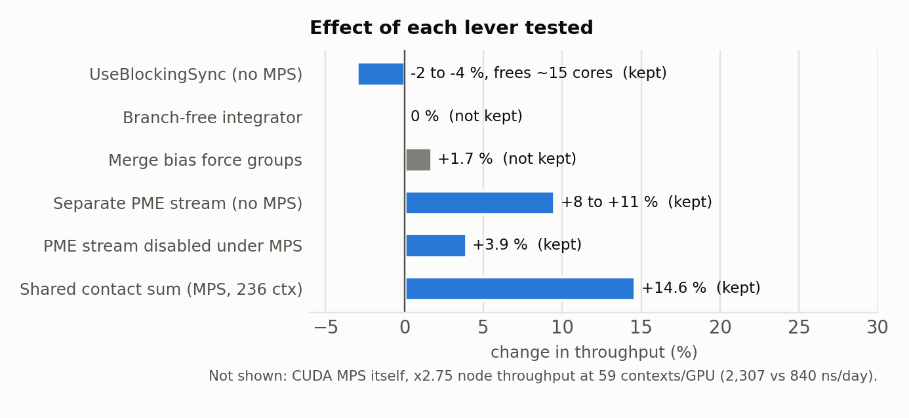
Figure 1. Effect of each lever tested, as percent change in throughput; blue = kept, gray = not kept. CUDA MPS itself (x2.75) is off this scale.
Items 11-14 apply to chignolin_9 (Sections 6.1-6.3). Net for chignolin_8: about +7 %, 9.75 -> ~10.4 steps/s per replica (~3.1-3.2 ns/day per replica). The gareus loop (exchange, sampling, barostat, reporters) accounts for only ~6 % of production step time (10.34 steps/s in the benchmark with real CV forces vs 9.75 in production).

6. Why MPS matters, and why it cannot be bypassed
Run | Contexts/GPU | ns/day/replica | Node ns/day
chignolin_7, MPS, 32 replicas | 8 | 105 | 3,373
chignolin_7, MPS, 64 replicas | 16 | 50 | 3,194
chignolin_8, no MPS, 248 replicas | 62 | 2.9 -> 3.1 | 727 -> ~780

- A 21k-atom context does not fill an L40S. Under MPS, kernels from several contexts run concurrently and fill the idle SMs; without MPS the GPU time-slices, one context at a time.
- Time-slicing can never beat one context per GPU, so the no-MPS ceiling for this integrator is ~2,400 ns/day/node (single-context rate x 4), and 248 contexts reach about half of that because the per-group passes are penalised by time-slicing (52 % retained vs 75 % for Langevin).
- MPS accepts at most ~60 client contexts per L40S; 248 states cannot run under it on 4 GPUs.

6.1 Measured: MPS at 59 contexts per GPU (23 Sep 2026, job 2580889)
Real Pep-GaMD integrator with the real CV forces, seeded into stage 5 with the frozen swarm envelope at lambda = 1. The boost was live in every arm (stage 5, FSF_Total 0.94-0.98, FSF_Dihedral 0.70-0.85), which also confirms the stage-5 fix on the cluster.
MPS | Contexts (per GPU) | PME stream | steps/s/rep | ns/day/rep | node ns/day | CPU/rep
on | 236 (59) | disabled | 32.3 | 9.8 | 2,307 | 0.75
on | 236 (59) | enabled | 31.1 | 9.4 | 2,220 | 0.75
on | 192 (48) | enabled | 37.6 | 11.4 | 2,182 | 0.94
on | 64 (16) | enabled | 163.0 | 49.3 | 3,154 | 0.99
off | 236 (59) | enabled | 11.8 | 3.6 | 840 | 0.77

- MPS at 236 contexts: 2.75x the no-MPS rate (2,307 vs 840 ns/day/node); per replica 9.8 vs 3.1-3.6 ns/day, about 3.1x over chignolin_8 production.
- Less than the 3-4.5x extrapolated from chignolin_7. Node throughput falls from 3,154 ns/day at 16 contexts/GPU to ~2,200-2,300 at 48-59; at 236 contexts ~177 of 192 host cores are busy (one thread per context), so the host CPU is a likely co-limit.
- PME stream under MPS: keep it disabled (-4 % when enabled), the opposite of the no-MPS result (+8-11 %, Section 5); chignolin_9's launcher sets --cuda-disable-pme-stream true.
- The 64-context point reproduces chignolin_7's production throughput (3,154 vs 3,194-3,373 ns/day), which validates the benchmark.

6.2 Measured: contact sum evaluated once per step (23 Sep 2026, job 2608721)
With CV2 = residual-torsion-pc, the CV2 CustomCVForce already holds a private copy of CV1's 1,256-pair contact sum (sub-CV res_contacts), so production evaluated that sum twice every step. The shared layout appends the CV1 umbrella 0.5*k*((res_contacts/contact_norm) - r0)^2 to the CV2 force and builds no separate CV1 force. Benchmark c8_integ_bench4.py (arm BIAS=shared), real Pep-GaMD integrator in stage 5 with the boost live, real CV forces from chignolin_8's frozen pair model, node d098:
Configuration | split (29 + 31) | shared (29) | gain
no MPS, 1 context/GPU, steps/s/rep (2 repeats) | 1,666 / 1,635 | 1,783 / 1,784 | +8.1 %
MPS, 236 contexts (59/GPU), PME stream disabled, node ns/day | 2,286 / 2,294 | 2,630 / 2,618 | +14.6 %
same, ns/day per replica | 9.7 | 11.1 | +14.6 %

- Correctness: same bias energy and forces as the split pair: CUDA mixed dE = 0, max|dF| 4.8e-7 kJ/mol/nm; double 2.3e-10; Reference on chignolin_8's real system through the production builder 1.4e-14 of 87 kJ/mol/nm, with identical CV1 and CV2 readings. The CV1 term is 9.33 of the 10.89 kJ/mol compared, so the check covers it.
- Repeats agree within 0.5 %; host CPU load unchanged (~179 of 192 cores). The gain is larger under MPS than at one context per GPU.
- Implemented in gareus/production.py (PR #93, merge fa42346, deployed to aurum2): add_umbrella_cv_forces builds the shared layout for every new residual-over-contacts campaign, so chignolin_9 gets it with no configuration change. The fast CV path reads CV1 from the shared force's contact_sum sub-CV. The recorded coordinates and energies do not change, so the kernel identity is unchanged.
- Resume: binary Context checkpoints, and the Pep-GaMD integrator's per-bias-group force variables, depend on the layout. A resumed campaign rebuilds the layout recorded in its CV metadata (no record = the old split layout), and a reused shared-GaMD context checkpoint is loaded only if its recorded bias force groups match.
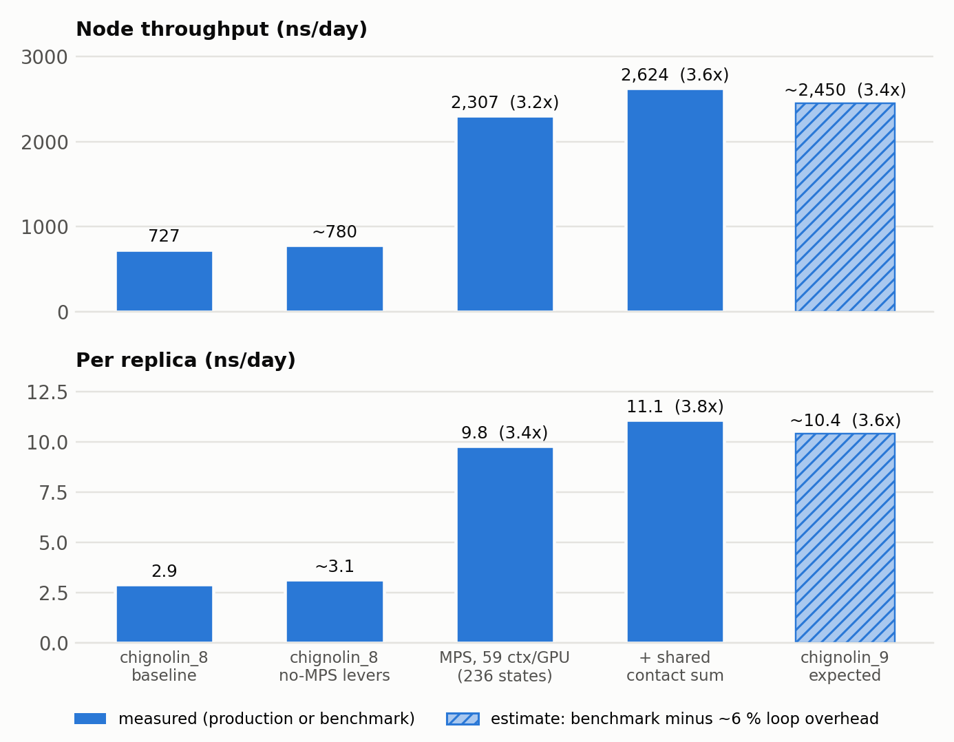
Figure 2. Throughput from chignolin_8 production to the chignolin_9 layout. Multipliers are relative to the chignolin_8 baseline. MPS and shared-contact-sum bars are benchmark measurements (jobs 2580889, 2608721); the hatched bar subtracts the ~6 % gareus-loop overhead measured in Section 5.

6.3 Measured: capping active replicas per GPU, and the MPS thread share (26 Sep 2026, jobs 2664328, 2665264)
Section 6.1 left the host CPU as a likely co-limit: at 236 contexts every replica thread keeps a CPU core busy while its GPU work is queued. The benchmark p3_admission_bench.py keeps all 236 contexts resident (59 per GPU, the chignolin_9 layout) but lets at most A replicas per GPU step at the same time. A replica that finishes its turn goes to the back of its GPU's queue, and every replica still completes the same 250 steps before the round ends, so node ns/day compares directly across A. System, integrator and CV forces as in Section 6.2 (production add_umbrella_cv_forces, shared contact layout, Pep-GaMD in stage 5 with the boost live), MPS on, PME stream disabled. The MPS active-thread percentage (CUDA_MPS_ACTIVE_THREAD_PERCENTAGE) is a per-process setting, so each percentage ran in a fresh process with A swept inside it. Two to four 60-s runs per cell on nodes d098 (job 2664328) and d093 (job 2665264):
MPS thread % | Active per GPU | Turn (steps) | ns/day/rep | node ns/day | vs today | CPU cores
default | all 59 | 250 | 11.1 | 2,617 | - | 174
default | 32 | 250 | 13.7 | 3,230 | +23% | 113
default | 16 | 250 | 16.6 | 3,907 | +49% | 60
default | 8 | 250 | 17.4 | 4,102 | +57% | 31
50 | all 59 | 250 | 11.7 | 2,754 | +5% | 179
50 | 16 | 250 | 17.9 | 4,214 | +61% | 60
50 | 8 | 250 | 18.8 | 4,426 | +69% | 31
25 | all 59 | 250 | 12.0 | 2,840 | +9% | 178
25 | 16 | 250 | 18.7 | 4,422 | +69% | 60
25 | 8 | 250 | 19.3 | 4,558 | +74% | 30
25 | 6 | 250 | 19.3 | 4,566 | +74% | 23
25 | 4 | 250 | 16.7 | 3,952 | +51% | 16
25 | 2 | 250 | 10.0 | 2,354 | −10% | 8
25 | 8 | 50 | 19.7 | 4,646 | +78% | 31
25 | 4 | 50 | 16.9 | 4,000 | +53% | 16
15 | 8 | 250 | 18.7 | 4,416 | +69% | 30
15 | 6 | 250 | 17.3 | 4,088 | +56% | 23
15 | 4 | 250 | 13.3 | 3,131 | +20% | 16
15 | 2 | 250 | 7.3 | 1,715 | −34% | 8
10 | 8 | 250 | 16.5 | 3,898 | +49% | 30
10 | 6 | 250 | 14.5 | 3,423 | +31% | 23
10 | 4 | 250 | 10.5 | 2,474 | −5% | 16
10 | 2 | 250 | 5.6 | 1,318 | −50% | 8
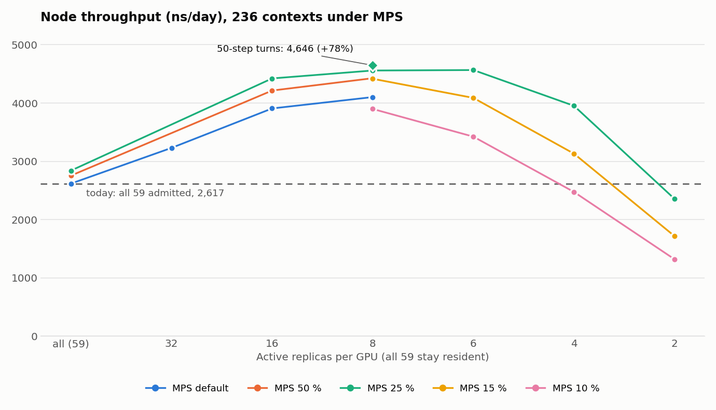
Figure 3. Node throughput at 236 resident contexts under MPS against the number of replicas per GPU allowed to step at once, one line per MPS active-thread percentage; each point is the mean of two to four 60-s runs. Dashed: today's scheduler (all 59 admitted, MPS default). Diamond: 25 % and 8 per GPU with 50-step turns.
- Result: 6-8 active replicas per GPU at MPS 25 % give 4,558-4,646 ns/day/node, 1.74-1.78x today's 2,617 and 6.3x chignolin_8's production 727; per replica 19.3-19.7 ns/day. The optimum is flat between 6 and 8 (4,566 vs 4,558); below 6 the GPUs run short of work (A = 4: 3,952; A = 2: 2,354).
- Why it works: each replica thread keeps a CPU core busy while it has GPU work queued. With all 59 admitted, 236 threads compete for 192 cores and MPS interleaves 59 clients per GPU; admitting 8 per GPU needs ~30 cores and still keeps each GPU full. Host CPU falls from ~175 to ~30 cores, which also frees room for the output helper threads planned in the helper-cpus specification.
- MPS share: a smaller active-thread percentage helps only while the admitted replicas together still request about 1.5-2 GPUs' worth of multiprocessors (8 x 25 % = 200 %, 6 x 25 % = 150 %). At 15 % and 10 % the admitted set cannot fill the GPU and throughput falls (8 per GPU at 10 %: 3,898). The percentage was set in each fresh process's environment; MPS reported no effective value, so it is recorded as requested, but the ordering 25 % > 50 % > default holds at every A.
- Turn length: 50-step turns instead of 250 add ~2 % (4,646 vs 4,558 at A = 8) and ~1 % at A = 4.
- Reproducibility: today's configuration (all admitted, default share) reads 2,578-2,702 across both jobs, matching Section 6.2's 2,618-2,630; repeats of each cell agree within 4 %; every arm kept finite energies with the boost live (FSF_Total 0.90-0.99).
- Caveat: the harness runs MD only. Production adds sample writing every 250 steps, exchange every 400 and checkpoints, all at common boundaries, so the gain has to be re-measured once the cap is in the production loop. The change is scheduling only: same forces, random-number order, exchange order and recorded numbers, so a running campaign can adopt it at a clean restart.

7. chignolin_8 as umbrella sampling: interim connectivity check
Run on the incomplete data on 23 Sep 2026 (steps 5,250-265,000; 257,920 samples, ~1,040 per window; boost columns zero in every sample). Read-only script c8_us_connectivity.py.
Check | Result | Verdict
Rung consistency (4 identical Hamiltonians per centre) | 49/62 centres with a rung pair > 3 block-SE apart (27/62 > 5); median largest difference 0.55 window sigma (max 1.42); KS median 0.34. Null, two time-halves of one rung: 7/62, 0.16 sigma, KS 0.18 | Fails: rungs differ ~3x more than a rung differs from itself; consistent with the phantom-boost exchange. Do not collapse rungs yet
MBAR connectivity, rungs collapsed to 62 states | One component at overlap >= 0.01; at 0.03/0.09 only the zero-k unrestrained state separates (its overlap spread thinly: O_ii = 0.02, 0.98 shared); weakest restrained best link 0.094; spectral gap 0.038 | Connected (slow-mixing)
Self-bias per state | median 0.90 kT, max 2.60 kT, none > 10 kT | Good
Reweighting ESS | per-state Kish ESS >= 8,233; unbiased-ensemble ESS 91 % | Good
CV2 spacing | 1.50 window sigma between CV2 neighbours everywhere; MBAR overlaps 0.10-0.21 across them | No gaps

Verdict so far: the swarm-designed sparse pseudo-2D layout is connected and reweightable; the open problem is the rung (exchange) artefact, whose cause the stage-5 fix removes.
Final check at the 485,200 cutoff (23 Sep 2026, 481,616 samples): analysis view RUNS/chignolin_8_US. All 248 states connected in one component on both the CV1 marginal (overlap >= 0.30) and the joint (CV1, CV2) overlap (>= 0.09); base MBAR ESS 87.1 %; self-bias median 3.1 kT, p90 5.4 kT. Weakest joint pair 0.155 (states 123 and 4, CV1-adjacent but poorly separated on CV2), which fails the pipeline's own window-overlap threshold. The native hairpin was not sampled (dG_fold about +5 kcal/mol) and the rung distortion persists. Verdict: the sparse layout is fit to carry chignolin_9.

8. Planned for chignolin_9
Change | Expected gain | Notes
0. MBAR connectivity of chignolin_8's sparse layout (Section 7) | decides the layout | Done: connected and reweightable at the cutoff; layout cleared for chignolin_9
GaMD stage-5 fix (Section 0) | prerequisite | Implemented (c73224f), deployed 23 Sep 2026 (dc9cb29), confirmed live
MPS throughput at 59 contexts/GPU, real integrator in stage 5 | 2.75x | Done 23 Sep 2026 (job 2580889), Section 6.1
236 states (59 centres x 4 rungs) under MPS, 59 contexts/GPU | 2.75x node throughput (measured, Section 6.1) | User decision 2026-09-22. Launcher and config ready (smoke/config/chignolin_9.sh/.yaml, max_replicas 236, MPS on, PME stream disabled). Seeds: a new ab-initio GENPEPT library (broad preset, contact_bias_sigma 1.0), so epoch 0 designs the 59-centre layout from its own swarm. Open: pull contexts vs the ~60-client limit
Replace the auxiliary PME with a real-space V_pep approximation | up to ~2x per context | CustomNonbondedForce with interaction groups (peptide x environment), cutoff / reaction field. Valid by Section 2.3; check correlation with exact V_pep on chignolin_8 frames first; new swarm envelope calibration
Evaluate the 1,256-pair contact sum once per step | +14.6 % (measured, Section 6.2) | Done: merged fa42346 and deployed; automatic for chignolin_9
Cap active replicas per GPU (6-8 of 59) + MPS active-thread 25 % | +74% to +78% (measured in the harness, Section 6.3) | Scheduling only: admission dispatcher in front of _ReplicaAffinityExecutor (active_replicas_per_gpu, default all) and an MPS percentage in the launcher; chignolin_9 can adopt it at a clean restart. Re-measure in the production loop first

Combined, measured in the benchmark harness at the chignolin_9 layout: 2,624 ns/day/node, 11.1 ns/day per replica, against chignolin_8's production 727 and 2.9 (3.6x and 3.8x). The gareus loop costs ~6 % on top of the harness (Section 5), so expect roughly 2,450 ns/day/node in chignolin_9 production. The real-space V_pep changes the boost definition and therefore the kernel identity, so it needs a fresh campaign and a new envelope calibration; the shared contact sum does not change any recorded number and needed no such break. Section 6.3's admission cap with MPS at 25 % raises the harness figure to 4,558-4,646 ns/day/node; with the same ~6 % loop overhead that is roughly 4,300 in production, until it is measured in the real loop.

9. Sources
- Code: gareus/pep_gamd.py, gareus/npt.py, gareus/production.py, gareus/seeding.py (v0.8.2, main @ 8853cc0; shared contact-sum force: PR #93, main @ fa42346, tests tests/test_shared_contact_cv_force.py).
- Measurements and decisions: docs/atlas-md/developer/gpu-throughput-benchmark-todo.md (T1-T8), docs/atlas-md/developer/chignolin_8_chain_no_checkpoint.md, docs/superpowers/specs/performance-upgrades/spec.md (P3, P4).
- Benchmark jobs on aurum2: 2563549 (context limits), 2577764 (integrator arms), 2579032 (bias groups, real CV forces), 2580889 (MPS at 59/GPU), 2608721 (shared contact sum); live A/B jobs 2567463, 2575924, 2579059. Harnesses and logs: docs/superpowers/specs/2026-09-23-pep-gamd-realspace-vpep-surrogate/benchmarks/; 2664328, 2665264 (active replicas per GPU x MPS thread %; harness, logs and figure script in docs/superpowers/specs/performance-upgrades/benchmarks/).

