GAREUS Adaptive Sampling
Synthetic Harness and Strategy Studies — Final Report

Testing and tuning adaptive umbrella-window placement without molecular dynamics
gareus/synth/ · 50 unit tests · no OpenMM · 2026-06

1. What this is, in one page
GAREUS moves umbrella-sampling windows around a 2-D collective-variable space during a run. Two subsystems do this: adaptive-FEEDBACK creates / moves / removes / re-tunes windows to lay out a good ladder, and adaptive-PRODUCTION then runs epochs that top-up under-sampled windows, add windows at weak edges, and retire redundant ones. Tuning either previously meant running real OpenMM GaMD/REUS molecular dynamics — GPU-hours per trial, and noisy.
The synthetic harness (gareus/synth/) replaces MD with cheap synthetic samples drawn from an analytic free-energy surface, feeds them into the REAL, unmodified GAREUS decision code, and scores the resulting window evolution against an oracle computed from the same surface — i.e. against a known answer. A full strategy sweep runs in seconds to minutes instead of GPU-days.
With it we ran two studies: 10 feedback (layout) strategies and 7 doubly-adaptive (epoch) strategies. This report consolidates both. Companion documents: the harness explainer (GAREUS_synthetic_adaptive_harness.docx) and the two detailed study reports (GAREUS_strategy_comparison.docx, GAREUS_double_adaptive_strategies.docx).

Headline conclusions
- It works: the harness reproduces create/move/remove/k-tune (feedback) and top-up/retire/add (production) and ranks strategies against a known answer, in seconds, with zero MD.
- Feedback: for the window LAYOUT, an aggressive policy at the 0.30 overlap target is the lean default (fewest windows at ~86% of top quality); a conservative/tight policy maximises fidelity at ~30% more windows.
- Production: for the EPOCH loop, balancing add-at-weak-edge with top-up wins; pure top-up cannot fix coverage gaps; retirement almost never fires under add pressure.
- One cross-cutting signal: across every strategy the dispatcher converges to ~0.7 neighbour overlap against its 0.30 target (over-resolution) — a single, consistent tuning lead, flagged with a k-scale caveat.

2. How the harness works
The key enabling fact: the adaptive decisions are pure, data-level functions, not entangled with OpenMM. The harness drives them directly and reimplements only the thin round/epoch glue.
analytic F(cv1,cv2) -> biased sampler (exact | Langevin) -> synthetic samples + exchange
|
feedback: run_adaptive_feedback_dispatcher_2d (shipped)
production: build_adaptive_epoch_schedule + propose_actions_from_diagnostics
+ evaluate_adaptive_convergence_gate (shipped)
|
evolved windows -> metrics vs grid oracle
- Samplers: exact grid inverse-CDF (oracle/regression) and adversarial overdamped Langevin (finite-time under-sampling, slow-CV2 trapping). An ESS/burn-in cost model lets epoch strategies separate even from i.i.d. draws.
- Landscapes & oracle: 4 analytic surfaces (mixture-wells, gated-barrier, banana-valley, slow-cv2-double-branch); the oracle derives the ideal minimal ladder, low-F region, and true PMF from the exact grid.
- Validation: 52 import-light unit tests (no OpenMM / PeptideBuilder / gamd-openmm); committed as gareus/synth/ + tests/test_synth_*.py.
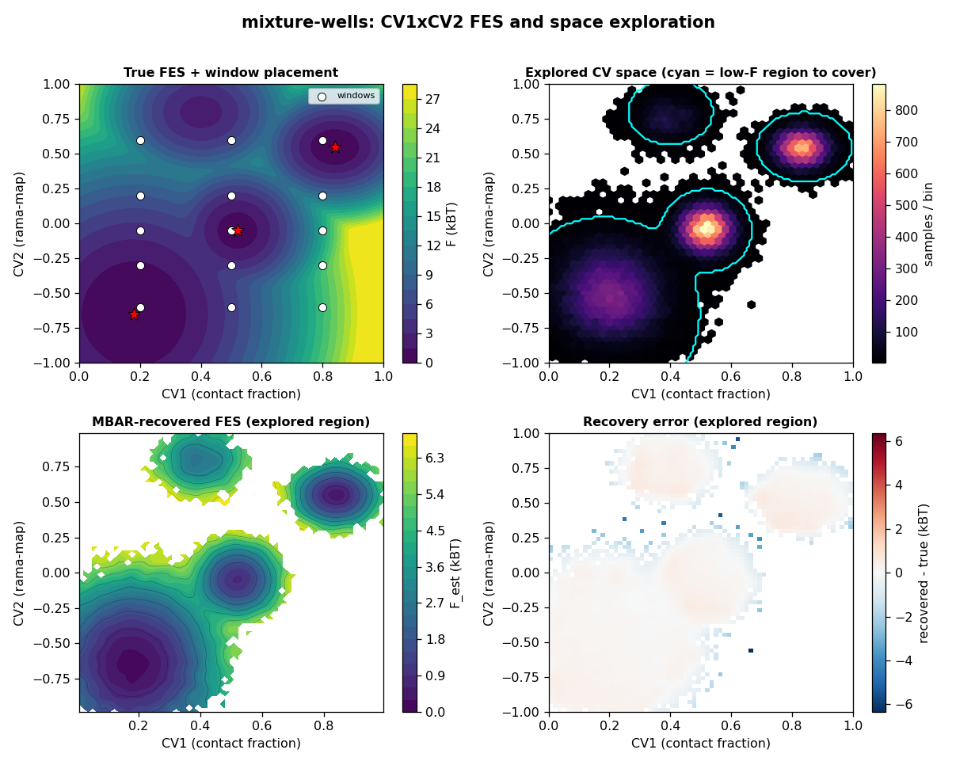
Figure 0. CV1×CV2 view (mixture-wells): true FES + window placement; explored sample density vs the low-F region to cover (cyan); MBAR-recovered FES; recovery error. Full set per landscape in GAREUS_cv_space_exploration.docx.

3. Study A — window-layout strategies (adaptive feedback)
Ten policies spanning aggressiveness (conservative→very-aggressive) × overlap target (0.20/0.30/0.45) × sampler (exact/Langevin), each from a common over-dense layout across all four landscapes. Top by composite: S08 (Conservative / 0.45 (safest)); the aggressive family (S04, S07, S03) is the lean sweet spot.
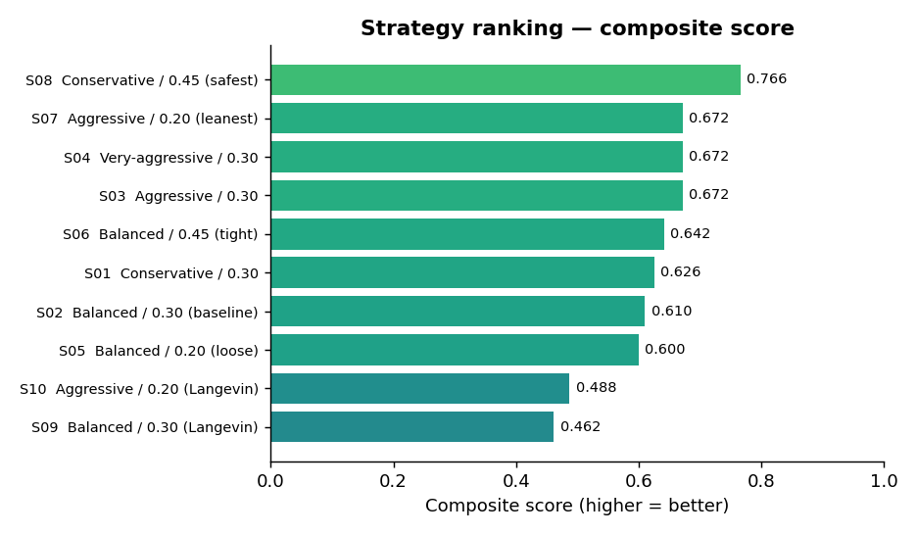
Figure A1. Feedback-strategy composite ranking.
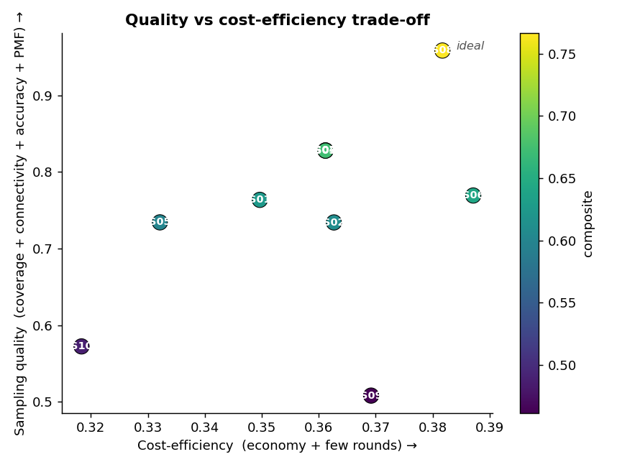
Figure A2. Quality vs cost-efficiency; upper-right is best.
ID | Composite | #win | overlap | econ | PMF(kBT)
S08 | 0.766 | 10.0 | 0.70 | 1.67 | 0.067
S04 | 0.672 | 7.6 | 0.71 | 1.75 | 0.089
S07 | 0.672 | 7.6 | 0.71 | 1.75 | 0.089
S03 | 0.672 | 7.6 | 0.71 | 1.75 | 0.089
S06 | 0.642 | 9.9 | 0.70 | 1.65 | 0.071
S01 | 0.626 | 9.0 | 0.70 | 1.80 | 0.087

Top 6 of 10 shown. Full detail in GAREUS_strategy_comparison.docx.
- Read: S08 conservative/0.45 maximises quality (best coverage, connectivity, PMF) at the most windows; the aggressive family gives ~86% of that quality with ~25% fewer windows; pure target-loosening (S05) is worst; Langevin (realistic under-sampling) collapses PMF recovery to ~1.4 kBT, proving layout quality is necessary but not sufficient.

4. Study B — epoch strategies (doubly-adaptive production)
Seven production policies on a frozen handoff layout, each spending the same 18,000-sample budget (ESS cost model), across four landscapes × 3 seeds. The top two — add_then_topup and weak_edge_triage — are tied within seed noise; both balance add-at-weak-edge with top-up.
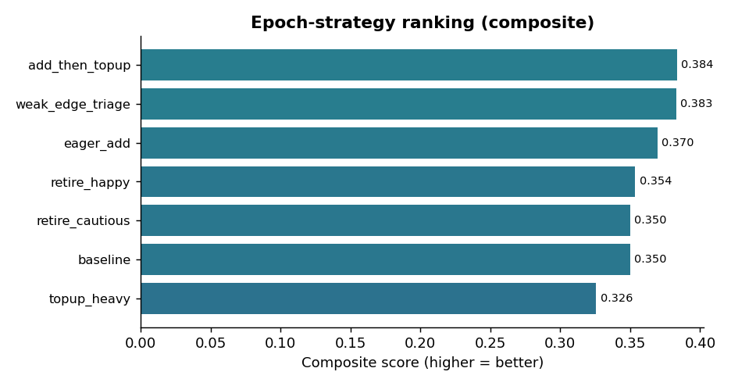
Figure B1. Epoch-strategy composite ranking.
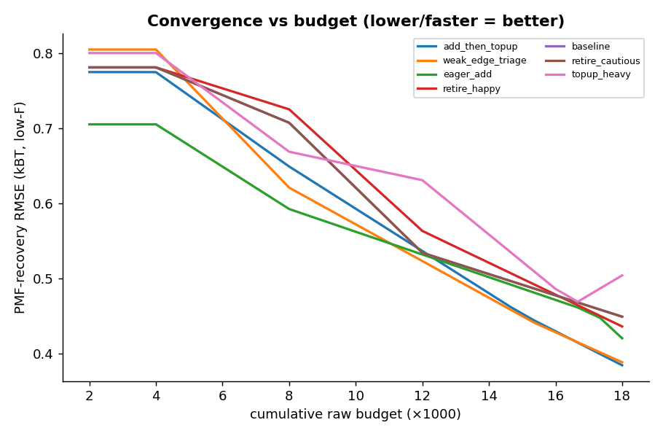
Figure B2. PMF recovery vs budget (lower/faster = more efficient).
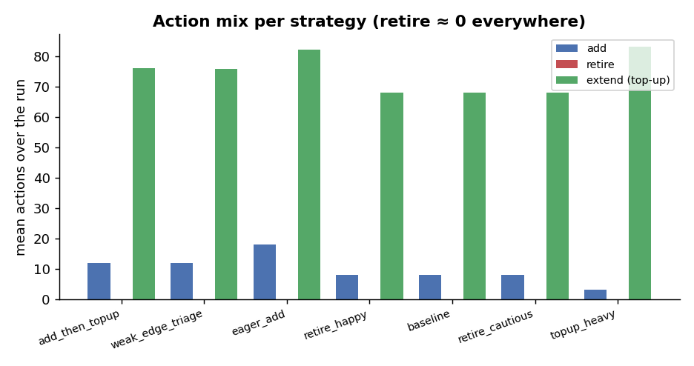
Figure B3. Action mix — retire is ≈ 0 for every strategy.
ID | Composite | PMF(kBT) | #win | adds | retires | topups
add_then_topup | 0.384 | 0.385 | 28 | 12 | 0 | 76
weak_edge_triage | 0.383 | 0.389 | 28 | 12 | 0 | 76
eager_add | 0.370 | 0.421 | 34 | 18 | 0 | 82
retire_happy | 0.354 | 0.437 | 24 | 8 | 0 | 68
baseline | 0.350 | 0.450 | 24 | 8 | 0 | 68
retire_cautious | 0.350 | 0.450 | 24 | 8 | 0 | 68
topup_heavy | 0.326 | 0.505 | 19 | 3 | 0 | 83

- Read: balanced add+top-up reaches the lowest PMF at fixed budget; pure top-up-heavy is worst (can't close coverage gaps); eager-add converges fastest but spreads thin. Retirement never fires: measured max effective count 99 < the 150 gate (budget/scale) and 19/20 windows touch a weak edge (genuine conservatism).
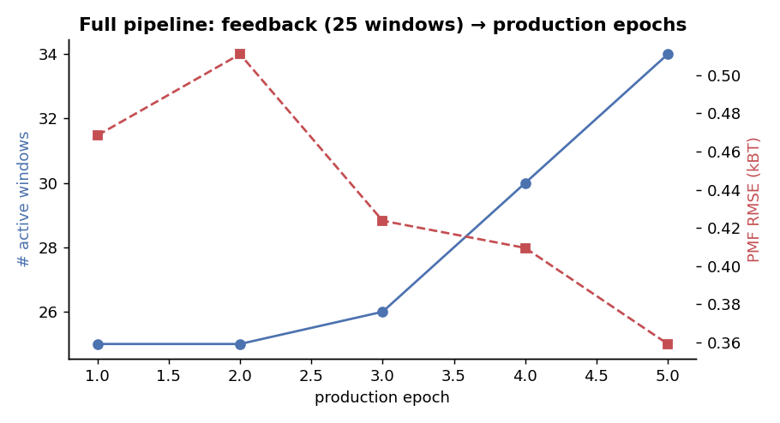
Figure B4. Full pipeline: feedback (25 windows) → production epochs; windows grow as it adds, PMF falls as it tops up.

5. Consolidated recommendations
Situation | Use | Why
Lean / GPU-constrained layout | Aggressive feedback @ 0.30 | fewest windows at ~86% of top quality
Fidelity-critical layout, ample budget | Conservative feedback @ 0.45 | best coverage/connectivity/PMF (~30% more windows)
Production epoch policy (default) | Add-then-top-up / weak-edge-triage | best PMF per sample; covers gaps and deepens sampling
Sparse handoff layout | Avoid pure top-up-heavy | more sampling cannot fix coverage gaps
Small / interruptible budget | Eager-add | fastest early PMF improvement
Window economy | Tune feedback / handoff density | production retirement rarely fires under add pressure

Independent of any strategy: ensure adequate sampling depth per window — the Langevin and ESS results both show reweighting fidelity is gated by sampling depth, not by the adaptive layout alone.

6. Methodology, validation, caveats
- Faithfulness: the adaptive decisions under test are shipped, unmodified GAREUS code; the harness owns only the thin round/epoch glue and the analytic models. Reported metrics are oracle-relative.
- Validation: self-consistent MBAR recovers the PMF to ~0.06–0.10 kBT on exact samples; the dispatcher-overlap metric uses the shipped histogram functional (directly comparable to 0.30); 50 unit tests pin sampler, oracle, driver, and metric behavior.
- Caveats: absolute overlap (~0.7 vs 0.30 target) carries a reduced-k vs contact-mode-k scale caveat — treat the over-resolution as a candidate lead, to confirm at a k-scale where 0.30 is achievable. The retire null result is part budget/ESS scale (max effective 99 < 150 gate) and part genuine conservatism (bad-touching); a denser, well-sampled layout makes retire fire. Epoch strategies are ranked at a fixed budget; Langevin runs use fewer seeds by design.
- Review status: an adversarial multi-agent review verified the feedback harness (14 findings fixed); the doubly-adaptive review’s verify phase was interrupted, so its findings beyond the manually-verified retire mechanism remain open.

Source: gareus/synth/ (committed) · companion docs: GAREUS_synthetic_adaptive_harness.docx, GAREUS_strategy_comparison.docx, GAREUS_double_adaptive_strategies.docx

