GAREUS CV-Space Exploration & FES Recovery
Visual diagnostics from the synthetic adaptive-window harness

How to read these panels
Each landscape gets one four-panel figure produced by gareus.synth.report.plot_cv_space, from a synthetic adaptive-feedback campaign (exact sampler, aggressive policy) on the analytic surface:
- Top-left — True FES + window placement: the analytic free energy F(cv1,cv2) in kBT (dark = low F = basins; red stars = declared basins); white dots are the windows the adaptive logic placed.
- Top-right — Explored CV space: a density (hexbin) of every sample actually drawn, with the cyan contour marking the low-F region (F ≤ min+5 kBT) that exploration should cover.
- Bottom-left — MBAR-recovered FES: the free energy reconstructed from the synthetic samples by self-consistent MBAR, over the explored region.
- Bottom-right — Recovery error: recovered minus true F (offset-aligned); near-white = accurate, red/blue = over/under-estimate.
Together they answer: did windows land on the basins, did sampling cover the relevant (low-F) region, and is the free energy recovered there?

mixture-wells
Several Gaussian basins of varied depth/width plus a weak high-F decoy — the generic multi-basin case.
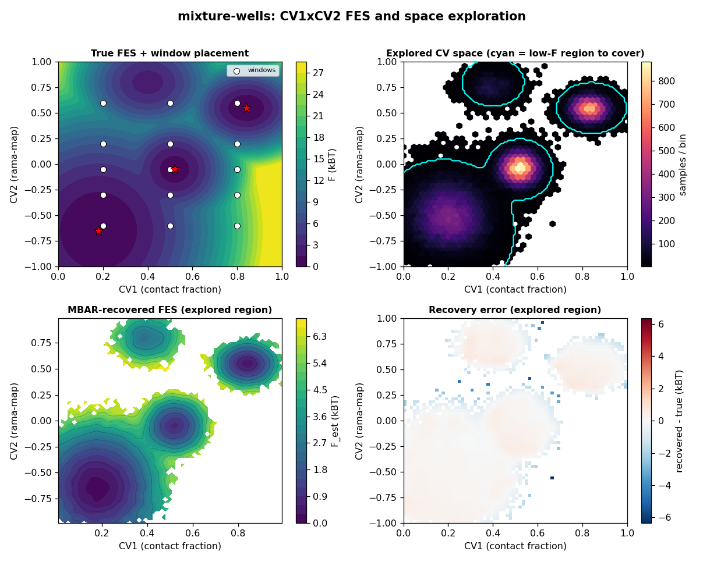
Figure. mixture-wells: low-F coverage 100%, ~15 windows, neighbour overlap 0.86, MBAR PMF-recovery error 0.04 kBT on the low-F region.

gated-barrier
Mixture wells with a CV1 ridge pierced by a single CV2 pass — tests whether exploration finds the one gate and bridges across it.
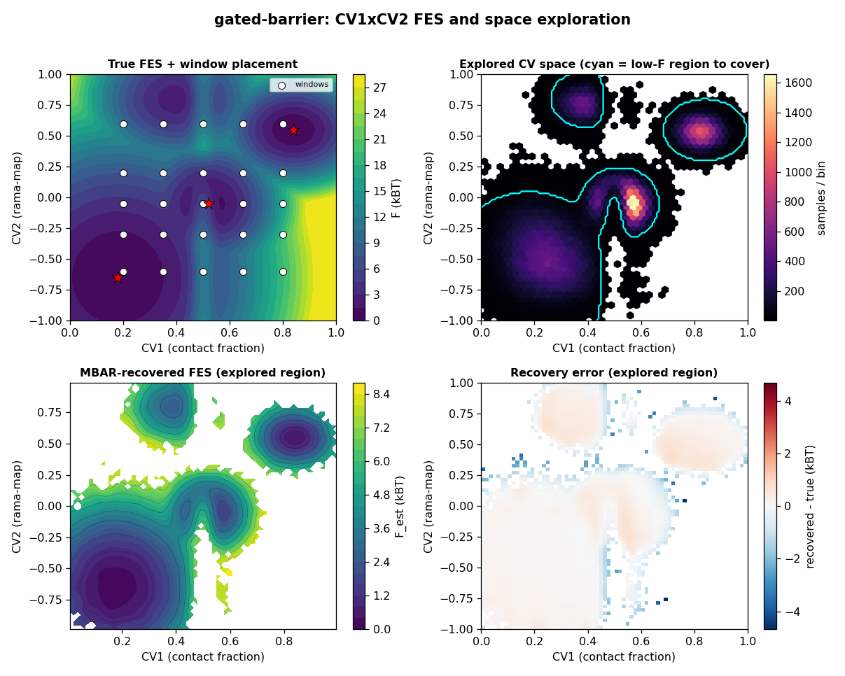
Figure. gated-barrier: low-F coverage 100%, ~25 windows, neighbour overlap 0.77, MBAR PMF-recovery error 0.05 kBT on the low-F region.

banana-valley
A curved low-F channel along cv2=0.7·sin(2π·cv1) — tests coverage of a non-rectangular, curved relevant region.
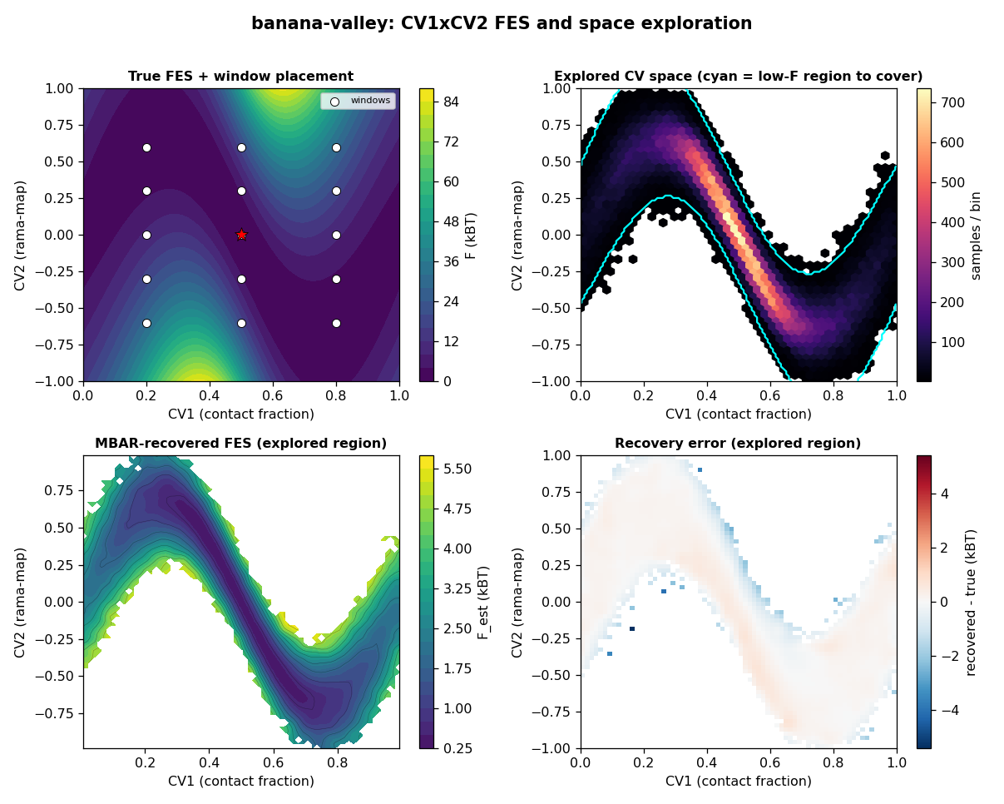
Figure. banana-valley: low-F coverage 100%, ~15 windows, neighbour overlap 0.89, MBAR PMF-recovery error 0.04 kBT on the low-F region.

slow-cv2-double-branch
Two CV2 wells split by a ~6 kBT saddle — tests whether both branches get covered (the hard, near-degenerate case).
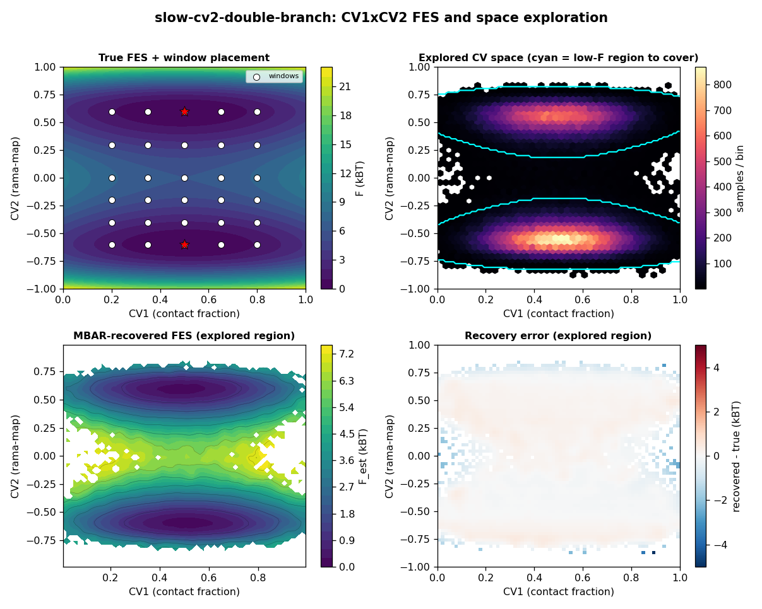
Figure. slow-cv2-double-branch: low-F coverage 100%, ~30 windows, neighbour overlap 0.71, MBAR PMF-recovery error 0.03 kBT on the low-F region.

Reading across the four cases
The mixture-wells and gated-barrier panels show windows tiling the basins and exploration filling the cyan low-F region, with small recovery error. The banana-valley case shows whether the curved channel is followed rather than boxed. The slow-cv2-double-branch case is the stress test: exact sampling covers both CV2 branches (top-right shows density in both), whereas a short Langevin run would populate only one — the harness’s built-in way to expose non-ergodicity. Where the explored density does not fill the cyan contour, or the error map reddens, the campaign left part of the relevant surface under-sampled — exactly the failure the harness is meant to surface cheaply.
These panels are produced for any run via: python -m gareus.synth --landscape <name> --plot <dir> (writes <name>_cv_space.png alongside the campaign plots).

