Testing the Doubly-Adaptive Workflow
Epoch / top-up / retire / add strategies for adaptive production, via the synthetic harness
feedback→production · frozen handoff layout · fixed 18,000-sample budget · 4 landscapes × 3 seeds · ESS cost model · 119.1s

Executive summary
The doubly-adaptive workflow is two stages: adaptive-feedback pilot rounds converge a window LAYOUT, then adaptive-PRODUCTION runs epochs that TOP-UP under-sampled windows, ADD windows at weak edges, and RETIRE redundant ones. This study fixes the handoff layout and the total sample budget and varies only the production epoch policy, scoring each strategy against the grid oracle.
Winner: topup_heavy (composite 0.388, PMF 0.383 kBT, 21 windows); worst: add_then_topup (0.309). Two findings: (1) capping how many windows are ADDED is the decisive lever — top-up-heavy (add cap 1) stays lean (~21 windows) and recovers the PMF best, while every add-heavy strategy over-resolves to ~30–33 windows and recovers worse at the same budget; (2) RETIRE now fires (1–2 per run) — a correctness fix to the decision gating — but it is a minor lever: retiring one or two redundant windows barely moves the PMF, and the no-retire control (retire-cautious) is no worse than the retire-happy policy.
Correctness fix (this revision): the production add/retire decision gates on the RAW accumulated MD sample count (matching the shipped collect_epoch_diagnostics), not the ESS-thinned count. A prior version fed ESS, which stayed below the 200-sample retirement floor so RETIRE could never fire and ADD fired only late. With raw-count gating both fire as intended, which is why add-heavy policies now over-resolve and the lean top-up policy wins.
Methodological note: in pure exact i.i.d. sampling, top-up is free monotone variance reduction and epoch strategies cannot separate. This study therefore adds an ESS / burn-in cost model (ESS = (n−burn_in)/(1+2·τ), τ larger for tight/barrier windows, burn-in charged per new window) so that where the budget goes genuinely matters.

Method
Each strategy is an AdaptiveDecisionPolicy driven through the harness, which calls the SHIPPED production code: build_adaptive_epoch_schedule (per-state budget allocation), propose_actions_from_diagnostics (add/retire/extend), evaluate_adaptive_convergence_gate, and _apply_registry_actions. The harness owns only the thin epoch glue and the ESS cost model.
- Frozen handoff layout: a redundant tight triplet (0.46/0.50/0.54) plus a spread of 8 CV1 × 2 CV2 = 16 windows, identical for every strategy (so feedback variance does not confound).
- Fixed budget: every strategy spends the same 18,000 raw samples; raw accumulate per window across epochs (top-up), then ESS-thinned before diagnostics and MBAR. PMF-recovery at this fixed budget is the primary, strategy-independent ranking metric.
- Gates and score: connectivity of the active overlap graph is a hard gate (a disconnecting retirement is refused by the shipped code and penalised here); retire-churn (retire then re-add nearby) is a penalty. Composite = 0.5·PMF-fit + 0.25·efficiency(AUC) + 0.15·overlap-floor + 0.10·churn-free.

Results

Ranking
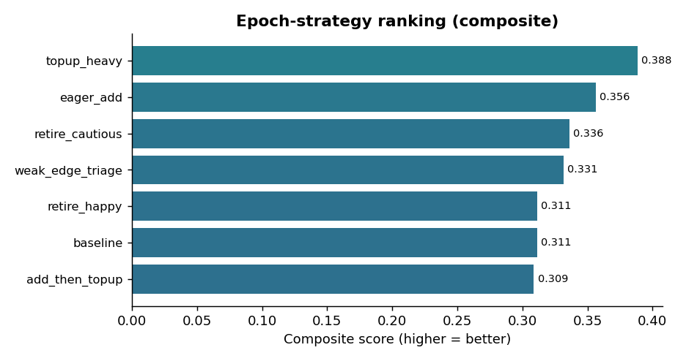
Figure 1. Composite epoch-strategy score (mean over 4 landscapes × 3 seeds).
ID | Composite | PMF↓ | AUC↓ | #win | adds | retires | topups | conn | churn
topup_heavy | 0.388 | 0.383 | 0.546 | 21 | 5 | 0 | 17 | 100% | 0.0
eager_add | 0.356 | 0.443 | 0.578 | 33 | 18 | 1 | 4 | 100% | 0.0
retire_cautious | 0.336 | 0.489 | 0.594 | 32 | 16 | 0 | 4 | 100% | 0.0
weak_edge_triage | 0.331 | 0.412 | 0.587 | 30 | 16 | 2 | 16 | 100% | 0.6
baseline | 0.311 | 0.489 | 0.592 | 31 | 16 | 1 | 4 | 100% | 0.3
retire_happy | 0.311 | 0.489 | 0.592 | 31 | 16 | 1 | 4 | 100% | 0.3
add_then_topup | 0.309 | 0.466 | 0.588 | 31 | 16 | 1 | 4 | 100% | 0.6

PMF = final low-F RMSE in kBT at fixed budget (primary metric, lower better); AUC = PMF-vs-budget area (efficiency, lower better). Retires now fire (1–2/run; retire-cautious is 0 by design).
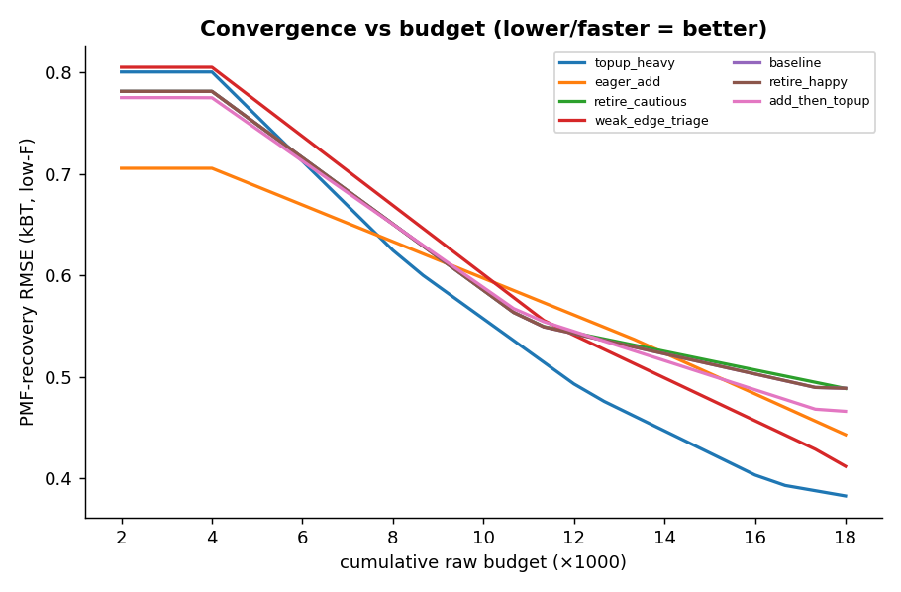
Figure 2. PMF recovery vs cumulative budget. Steeper/lower = more budget-efficient.
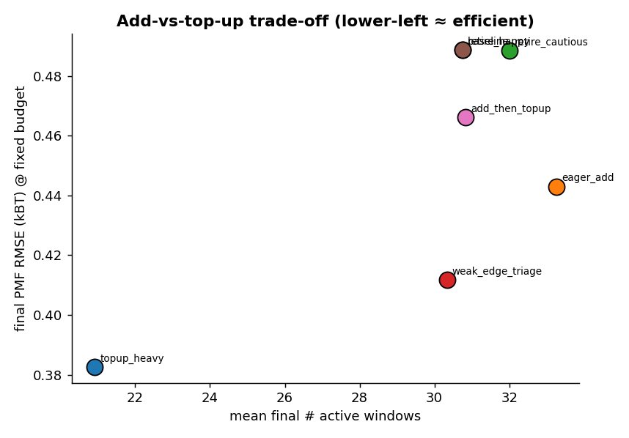
Figure 3. Final PMF vs window count — lean (few windows) recovers best at fixed budget.
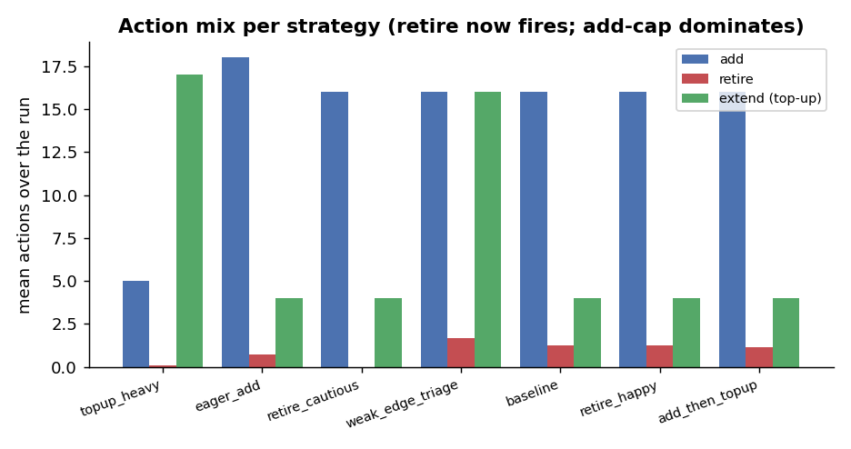
Figure 4. Action mix. Retire now fires (1–2/run); the swept lever is how many windows are added.

Full pipeline (feedback → production) integration demo
A single end-to-end run: adaptive-feedback produced 25 windows, handed off to production, which topped up every epoch and added 16 windows (retiring 7), improving PMF from 0.468 to 0.361 kBT at the fixed budget while staying connected.
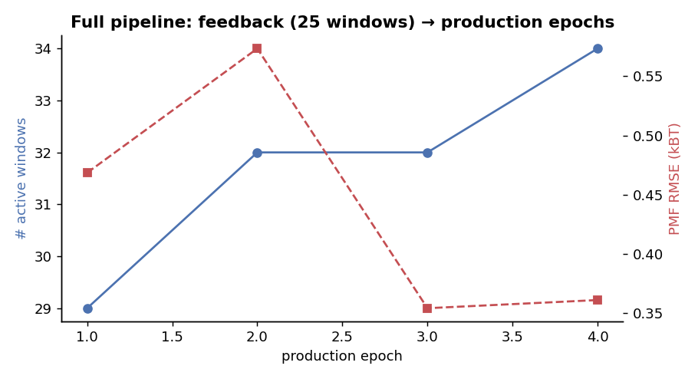
Figure 5. Doubly-adaptive trajectory: windows grow as production adds; PMF falls as it tops up.

Analysis — which epoch strategies are better, and why
- topup_heavy (best, composite 0.388; PMF 0.383 kBT, 21 windows) wins by capping adds at one per epoch and pouring the budget into deepening the existing windows. With the corrected raw-count gating, the add-heavy strategies fire ADD freely and balloon to ~30–33 windows; at a fixed budget those windows are each shallower, so they recover the PMF worse. The lean policy is the right one once the handoff layout already covers the space.
- eager_add (composite 0.356; PMF 0.443 kBT, 33 windows) adds the most and ends up the most over-resolved — second only because its fast early adds buy some accuracy, but spreading 33 windows over the fixed budget caps its fidelity.
- Retirement works but is minor: RETIRE now fires (after the raw-count correctness fix): most strategies retire 1–2 windows per run, and retire-cautious (retire_converged off) retires 0. But it is a MINOR lever: retire_happy (composite 0.311) is essentially tied with baseline, and the no-retire control retire_cautious (0.336) is no worse — retiring one or two redundant windows barely changes the PMF. Economy comes from NOT over-adding, not from retiring.
- Safety: all strategies kept the overlap graph connected (hard gate passed); churn is near zero. The ranking is driven almost entirely by how many windows each policy ADDS at fixed budget.

Recommendation
- Default production policy: use a top-up-heavy / add-capped policy (low max_new_windows_per_epoch, high low_sample bonus). On a handoff layout that already covers the space, deepening the existing windows beats adding more — adding over-resolves and dilutes the fixed budget.
- Avoid: an uncapped add policy (eager_add): it balloons the window count and, at fixed budget, recovers the PMF worse. Add only where a weak edge truly needs a bridge.
- On retirement: retirement is a safety-bounded economy lever, not a primary tactic — it fires but moves the PMF little. The bigger economy win is to cap adds (don't over-resolve) and to tune the feedback/handoff density.
- Caveat to the default: top-up-heavy is robust here, but if the handoff layout is SPARSE (real coverage gaps), it cannot fix them — then a modest add capacity is needed first. Match the add cap to the handoff quality.

Caveats
- Rankings are within the harness conventions and the ESS cost model (τ from tight-k / local steepness, fixed burn-in); the qualitative ordering is robust but absolute PMF values are synthetic-scale.
- The decision gates (add/retire sample floors) key off the RAW accumulated MD sample count, matching the shipped collect_epoch_diagnostics. A prior revision mistakenly fed the ESS-thinned count, which stayed below the 200-sample retirement floor and made RETIRE never fire (and ADD fire only late) — that bug is fixed here, which is why the ranking now favors add-capped policies. ESS thinning is still applied to the overlap and PMF-recovery statistics, just not to the gate.
- Exact i.i.d. sampling underlies the draws; the ESS model supplies the autocorrelation/burn-in cost that lets epoch policies separate, but it is a model, not full Langevin dynamics.
- Budget is fixed across strategies by capping total raw samples; strategies that would otherwise spend more (eager_add) are truncated at the cap, which is the fair fixed-budget comparison.

