GAREUS Strategy Grid Sweeps (deep sampling)
Broad parameter grids at ~5× sample depth — feedback (7500 samples/window), double-adaptive (90,000-sample budget), full MBAR

Why this run
The earlier studies compared a handful of hand-picked strategies at moderate sampling. This run (a) deepens sampling ~5× so the MBAR free-energy estimates and per-window statistics are better converged, and (b) sweeps full parameter grids rather than discrete strategies, to map the response surface and confirm the earlier conclusions hold under richer statistics.

Feedback grid — aggressiveness × overlap target
Every cell is a feedback campaign averaged over 4 landscapes × 2 seeds at 7500 samples/window (full MBAR).
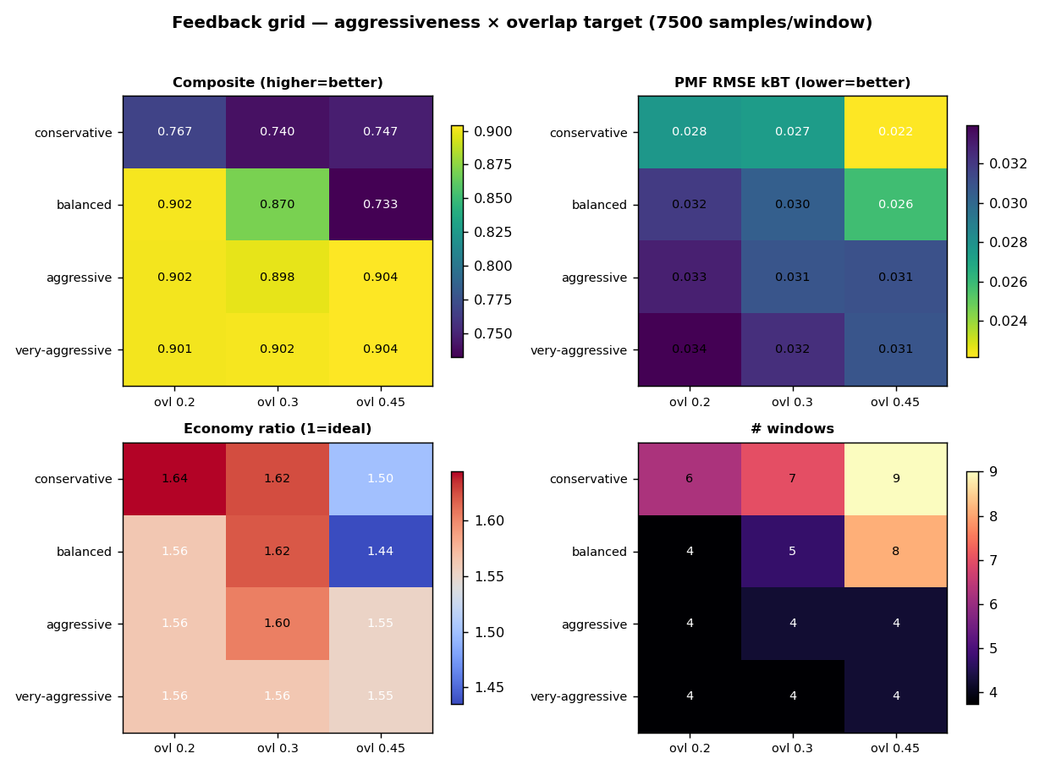
Figure 1. Feedback grid heatmaps: composite, PMF recovery, economy ratio, window count.
Best composite cell: very-aggressive @ overlap 0.45 (composite 0.904, PMF 0.031 kBT, economy 1.55, 4 windows).
At this depth the PMF is recovered well in EVERY cell (0.022-0.034 kBT), so PMF no longer separates strategies — the composite is decided by economy (window count). Aggressive and very-aggressive are the clear winners (composite ~0.90 at only ~4 windows) and are robust to the overlap target. Conservative uses the most windows (6-9) for no PMF benefit, and balanced degrades at the tight 0.45 target (8.1 windows, composite 0.73).
This FLIPS the shallow-sampling study, where conservative/0.45 won: there its extra windows bought real PMF accuracy; here, with deep sampling, PMF is good regardless, so the extra windows are pure waste and lean aggressive wins. The optimal aggressiveness therefore depends on sampling depth — lean when sampling is deep, more conservative when it is shallow.

Double-adaptive grid — add-cap × add/top-up balance × retire
Every cell is a full feedback→production run on the frozen handoff layout, fixed 90,000-sample budget, averaged over 4 landscapes × 2 seeds.
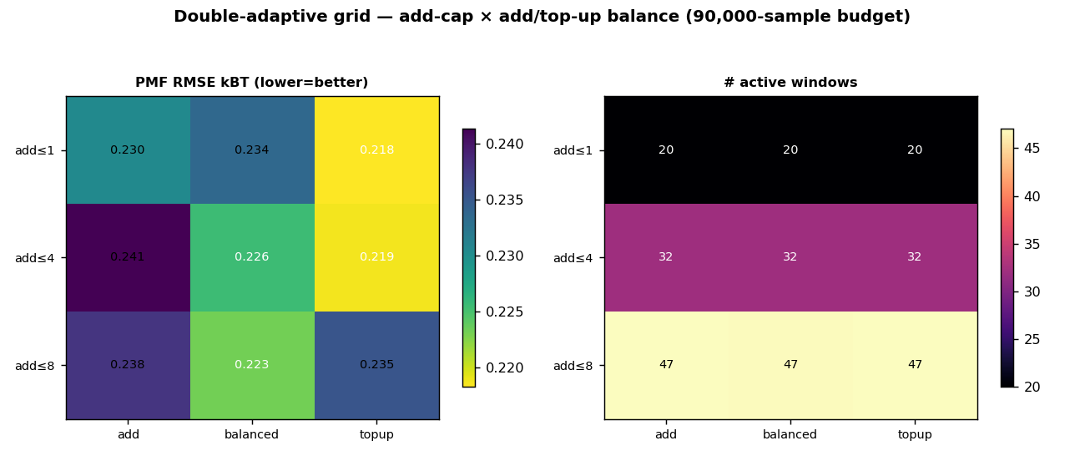
Figure 2. Double-adaptive grid (averaged over retire threshold): PMF recovery and window count.
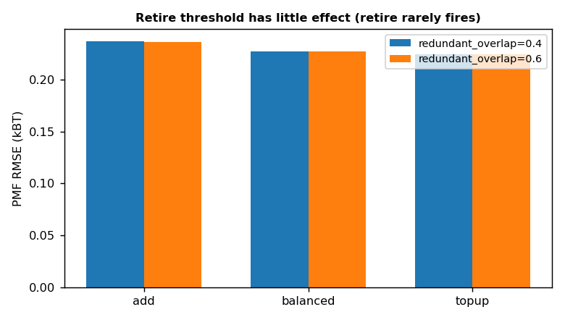
Figure 3. Retire threshold comparison.
Best PMF cell: add≤1, topup balance, redundant_overlap 0.4 (PMF 0.218 kBT, 20 windows, connected 100%).
At the 5x budget the PMF spread across all 18 cells is narrow (0.218-0.241 kBT) — abundant budget makes every policy decent. The lowest-PMF cell is add≤1 + top-up (0.218, ~20 windows): with ample budget on an adequately-covering handoff, concentrating sampling on FEWER windows beats spreading it across more (add≤8 grows to ~47 windows at slightly worse PMF).
This is the OPPOSITE of the shallow-budget study, where pure top-up was the WORST strategy because it could not close coverage gaps. So the best add/top-up balance depends on budget and handoff coverage: add aggressively when budget is tight or coverage is poor; top-up a few deep windows when budget is ample. The retire threshold (0.40 vs 0.60) makes no difference at all — retire never fires, confirmed again at 5x budget.

Conclusions
- Depth is the dominant lever: at 5x samples every strategy recovers the PMF to <0.04 kBT (feedback) and ~0.22 kBT (double-adaptive); strategy choice matters far less than depth. This confirms the precision-limited picture — buy depth before cleverness.
- The best strategy is regime-dependent: lean-aggressive feedback and low-add/top-up production win when sampling is deep; the shallow studies favored more windows / more adding. Tune the policy to your budget, not to a universal best.
- Over-resolution is real: neighbour overlap stays 0.71-0.82 (vs the 0.30 target) and economy 1.5-1.64 even at deep sampling — so it is a genuine dispatcher calibration property, not a low-sampling artifact (the reduced-k scale caveat still applies to the absolute number).
- Retire is inert: identical results at redundant_overlap 0.40 vs 0.60 across the whole grid and at 5x budget. Window economy must come from the feedback/handoff layout, not from production retirement.
- Implication for runs3: the runs3 allocation (lean window cap + depth-favoring final fraction) is the right direction; this deep-sampling grid reinforces capping windows and spending the budget on depth.

