Oracle CVT vs Linspace: 16-Replica chaos_2d Comparison, 5 Epochs
chaos_2d (24 sub-basins, 18 kBT CV1 + 10 kBT CV2 barriers, 10 noise traps) · R=16 · 5 epochs · 30M total samples (6M/epoch) · MBAR cap 15k/window · 1 seed · 1161s

chaos_2d Landscape
8 CV1 basins (varied depth/width) × 3 CV2 wells = 24 sub-basins. Main CV1 barrier: 18 kBT (vs ~14 kBT in rugged_2d). Secondary CV1 barrier: 10 kBT, CV2-dependent (tallest at CV2~0, half-height at CV2 extremes — requires diagonal bridging, not just axis-aligned ladders). CV2 barrier: 10 kBT at 0 + 5 kBT saddle at +0.33 (4 effective CV2 zones). 10 noise Gaussians (3–5 kBT) as reproducible metastable traps scattered across the surface.
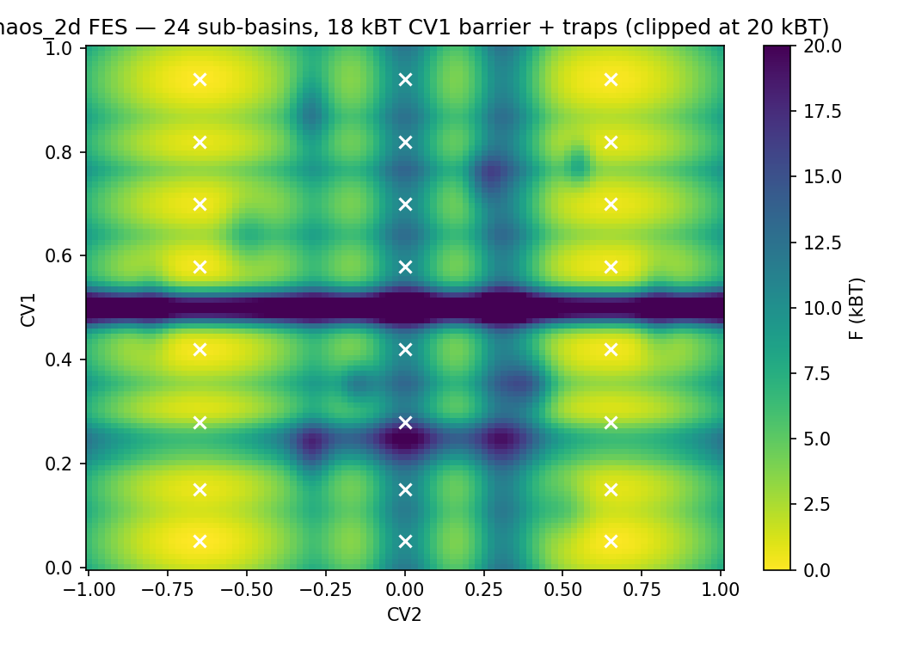

Initial Placement: R=16
Linspace (farthest-point greedy): k=22. Oracle CVT (Lloyd 30 iterations): k=22. Both k values calibrated to their own centers via calibrate_k_2d (target overlap 0.30).
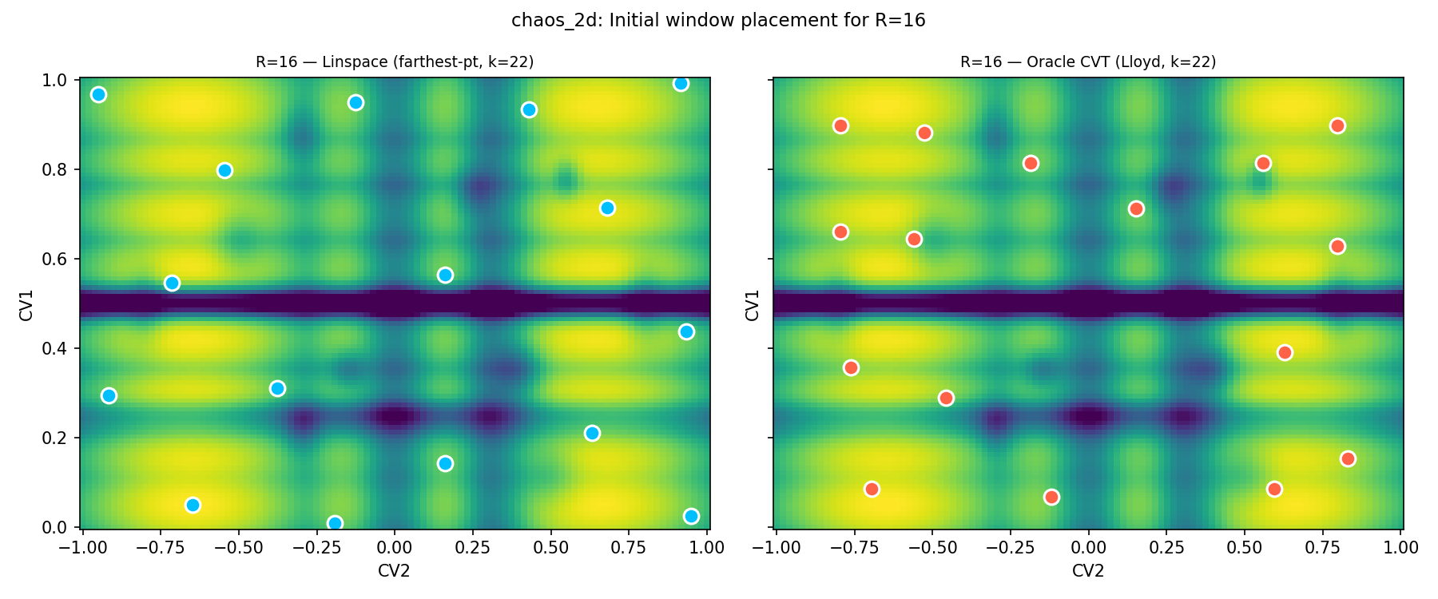

Epoch Convergence
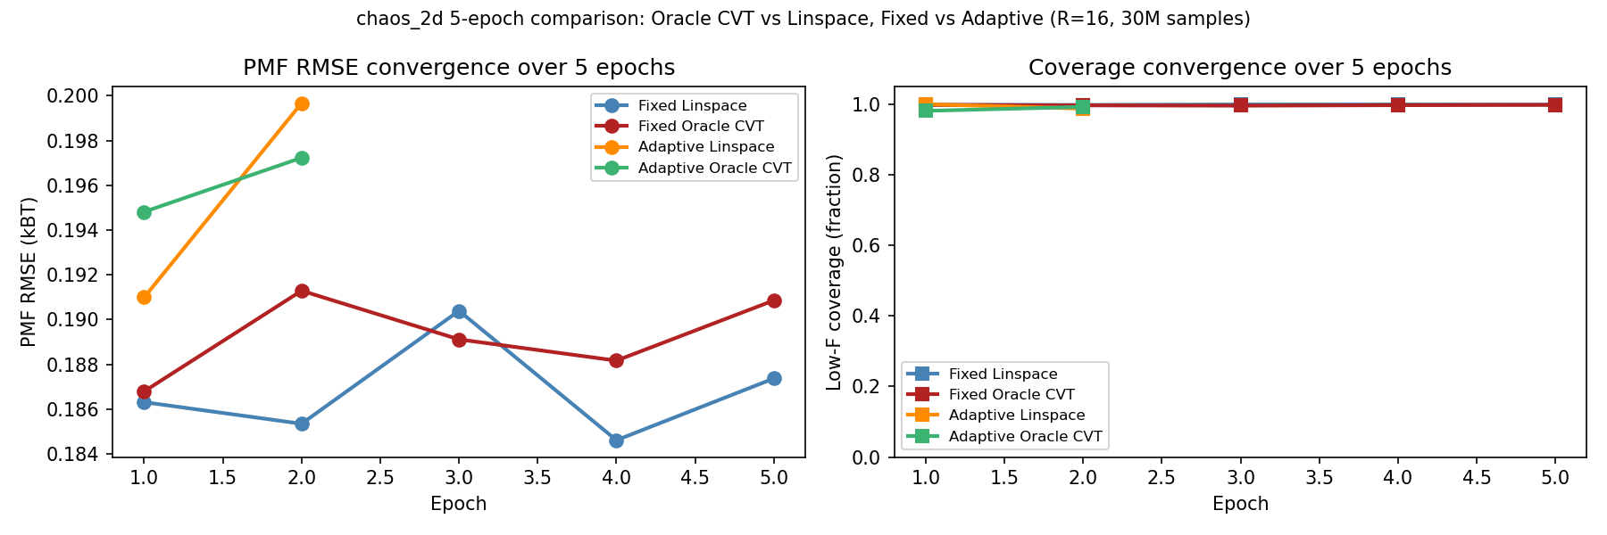
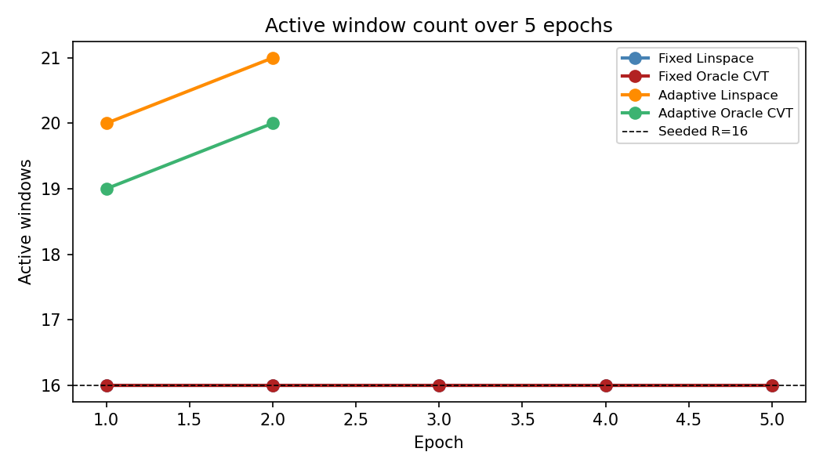

Final Results (after 5 epochs)
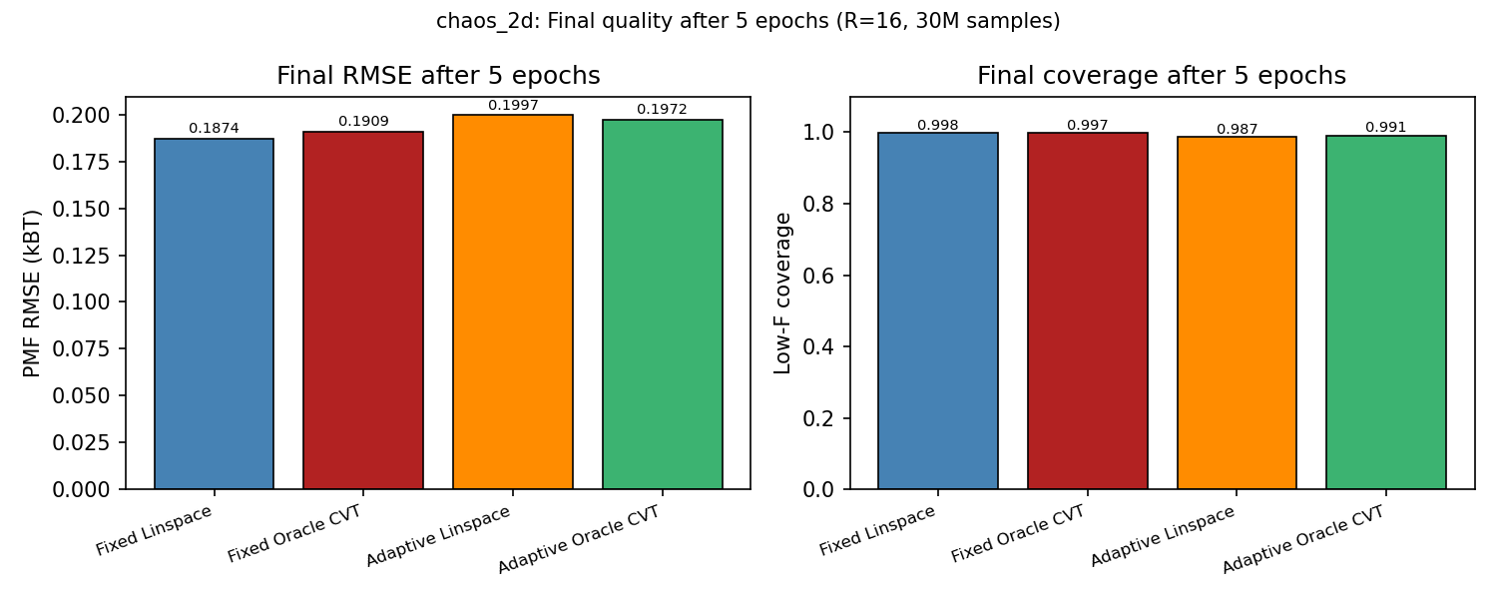
Strategy | Final RMSE (kBT) | Final coverage | Final windows | Budget spent
Fixed Linspace | 0.1874 | 0.998 | 16 | 30.0M
Fixed Oracle CVT | 0.1909 | 0.997 | 16 | 30.0M
Adaptive Linspace | 0.1997 | 0.987 | 21 | 30.0M
Adaptive Oracle CVT | 0.1972 | 0.991 | 20 | 30.0M

2D FES Recovery
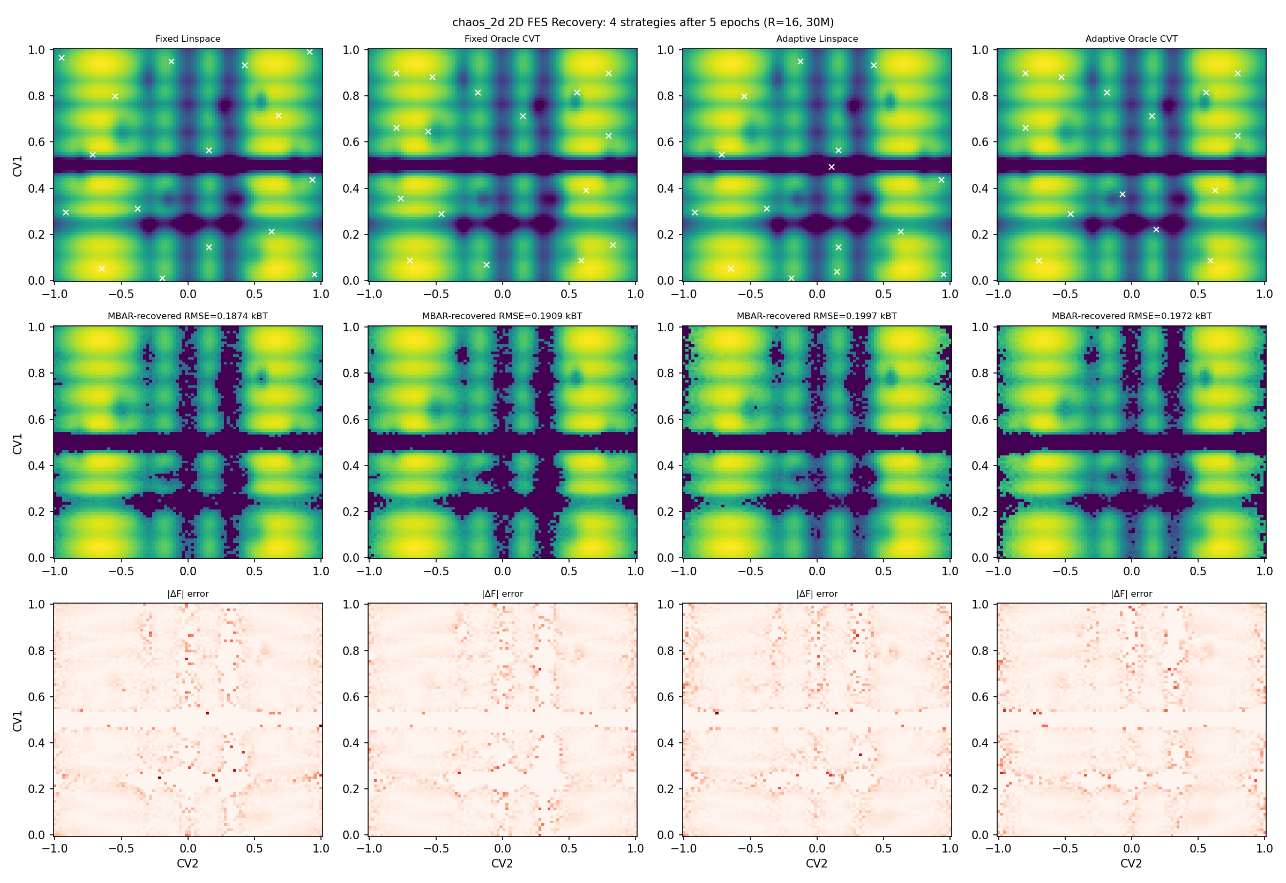

Answer
Best strategy: Fixed Linspace (RMSE = 0.1874 kBT).
Worst strategy: Adaptive Linspace (RMSE = 0.1997 kBT).
Oracle placement gain (fixed): -1.9% vs fixed linspace (0.1909 vs 0.1874 kBT).
Oracle placement gain (adaptive): +1.2% vs adaptive linspace (0.1972 vs 0.1997 kBT).
Adaptive gain for linspace initial: -6.6%.
Adaptive gain for oracle initial: -3.3%.
Key question — does oracle seeding help adaptive runs? Oracle CVT covers sub-basins more uniformly at epoch 1; the adaptive loop then corrects misplacements. If oracle seeding gives fewer corrections needed, the budget is better spent sampling than repositioning.

Caveats
1 seed (compute cost); exact sampler (no kinetic trapping). MBAR cap 15k/window; floor partly cap-limited. chaos_2d has 24 sub-basins — with R=16 windows many cells share coverage, so PMF RMSE reflects both coverage gaps AND over-smoothing at barriers. The secondary CV1 barrier is CV2-dependent; purely CV1-axis placement misses the diagonal bridging required to connect basins across both axes.

