Oracle CVT vs Linspace 2D Placement at 50× Budget
Oracle (Lloyd CVT) vs farthest-point linspace on rugged-2d, 0.9M–15M samples, MBAR cap 15k/window
R=1..12 · budgets 5 levels · 1 seed · 1601.3s

Setup
Comparison of two 2D window placement strategies at fixed (R, budget), same rugged-2d landscape as the retire comparison (6 CV1 basins, ~14 kBT CV1 barrier, CV2 double-well + ~7 kBT CV2 barrier; 12 low-F sub-basins). Same sample budgets (0.9M–15M), same MBAR cap (15k/window), 1 seed.
Three strategies:
LINSPACE — place_windows_2d (farthest-point greedy, current default); k calibrated to own centers via calibrate_k_2d.
ORACLE — oracle_optimal_centers_2d (Lloyd CVT: farthest-point init + iterative Voronoi centroid refinement onto nearest low-F grid point); k calibrated to own centers.
ORACLE-FK — Lloyd CVT positions at linspace fair-k (position-only gain, same ESS cost as linspace).

Results
Figure: fig1 pmf vs r.
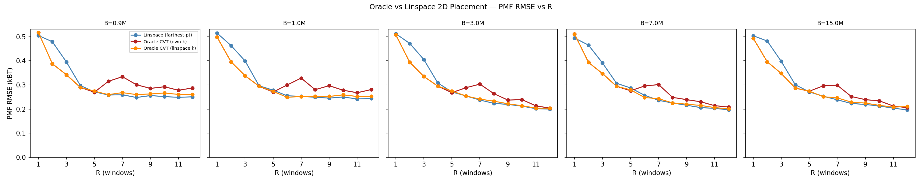
Figure: fig2 delta pmf.
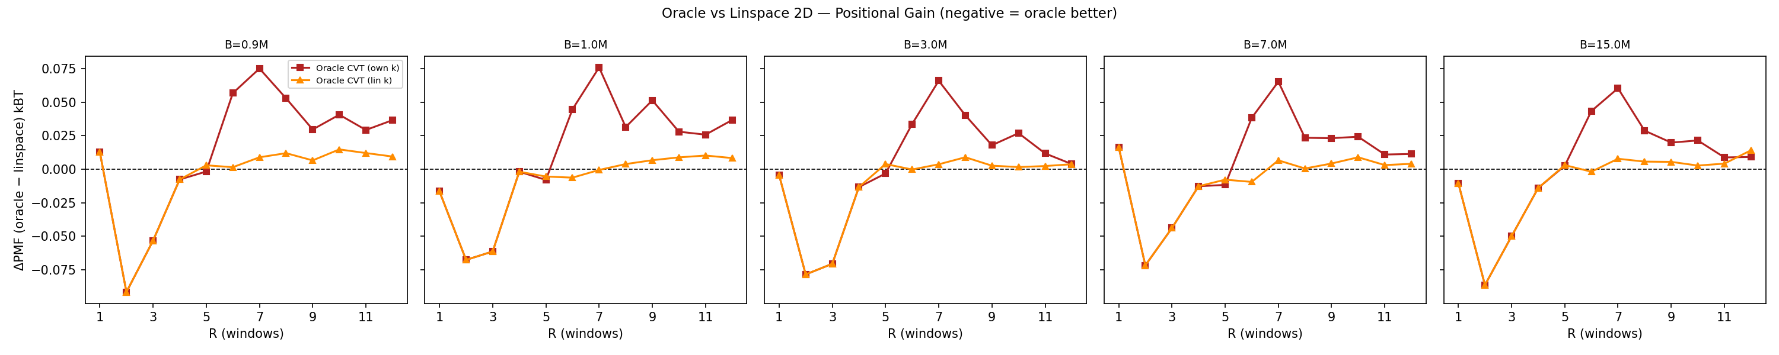
Figure: fig3 pmf vs budget.
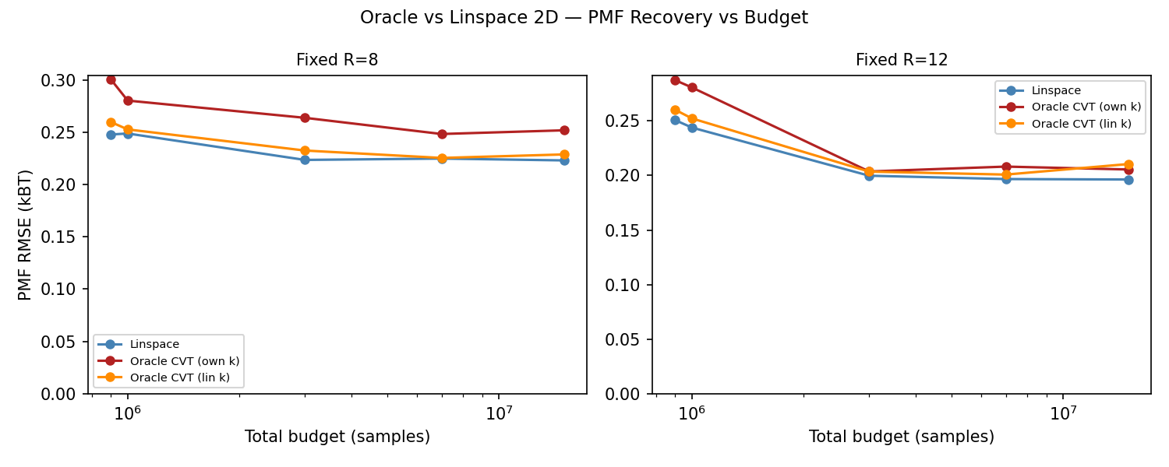
Figure: fig4 coverage.
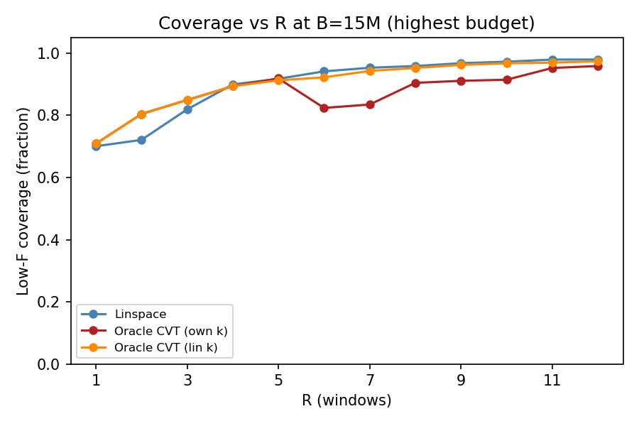

Recovered PMF
2D FES recovery at the top budget (15M samples), R=12: linspace RMSE = 0.1991 kBT, oracle CVT RMSE = 0.2064 kBT. Gain = -3.7%.
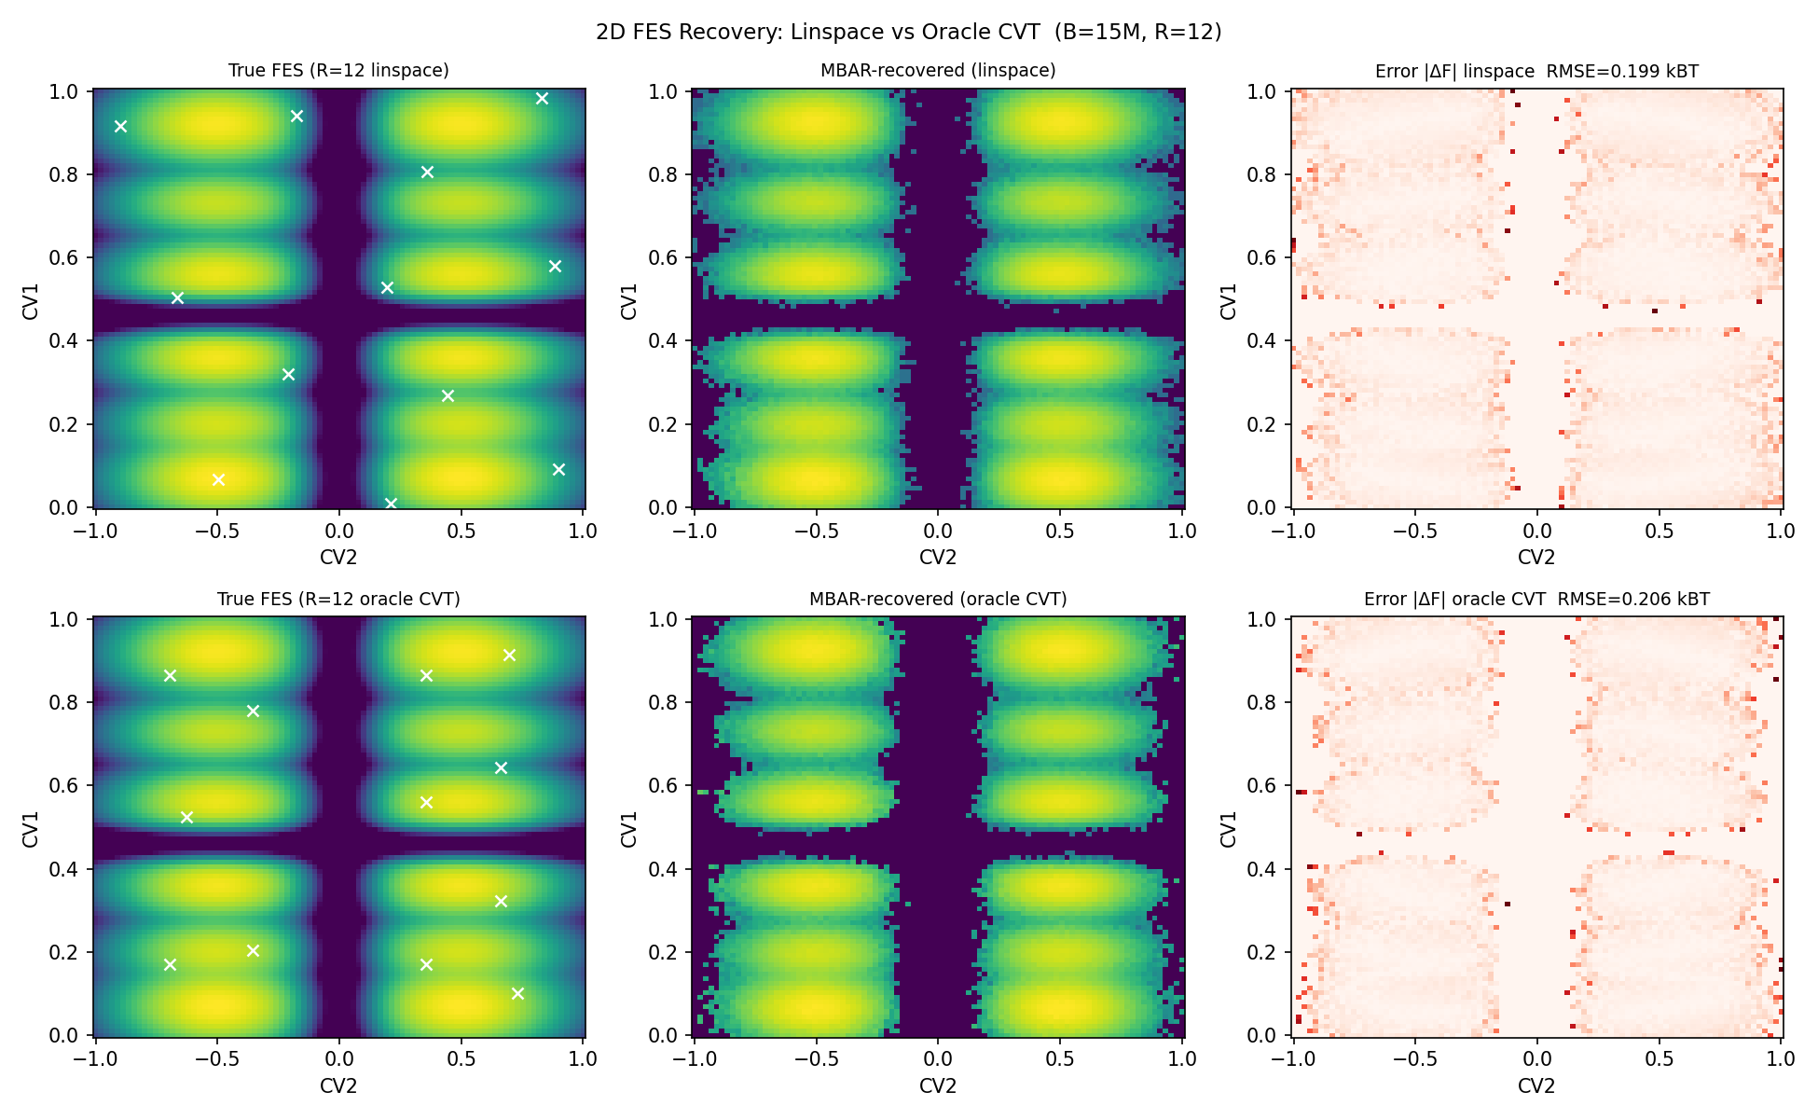

Best R per Budget
Budget | Best R (linspace) | Best R (oracle) | RMSE Δ at best
0.9M | R=8 (0.2479 kBT) | R=5 (0.2697 kBT) | +0.0218 kBT
1.0M | R=11 (0.2418 kBT) | R=11 (0.2677 kBT) | +0.0258 kBT
3.0M | R=12 (0.1998 kBT) | R=12 (0.2037 kBT) | +0.0039 kBT
7.0M | R=12 (0.1967 kBT) | R=12 (0.2081 kBT) | +0.0114 kBT
15.0M | R=12 (0.1963 kBT) | R=12 (0.2055 kBT) | +0.0092 kBT

Answer
Position-only gain (oracle CVT positions at linspace k): mean ΔPMF = -0.0099 kBT across R=1..12 at top budget (negative = oracle better). This isolates the pure placement benefit of Lloyd CVT over farthest-point.
Full oracle (own calibrated k): mean ΔPMF = +0.0028 kBT. The sign and magnitude reveal whether the k-tradeoff (oracle k ≠ linspace k) helps or hurts.
Coverage: oracle CVT tends to distribute windows more uniformly across the 12 low-F sub-basins than farthest-point, which can improve coverage at low R where a single misplaced window leaves a basin unsampled.

Caveats
MBAR uses a 15k/window cap; beyond it the metric is cap-limited, so the floor is partly the cap + res=90 grid (same as retire comparison).
1 seed at 50× (compute); exact sampler + ESS/burn-in cost model; absolute numbers synthetic-scale.
oracle_optimal_centers_2d uses res=60 grid for CVT (vs res=90 for sampling); sufficient for 2D placement but centers are rounded to grid points.
Oracle CVT iterates 30 Lloyd rounds; convergence is typically reached in <15 for R≤12.

