Replica-Count Study II: Complexity Along BOTH CVs
Few-deep vs many-shallow when CV2 is also rugged — 3× the sample budget
rugged-2d (6 CV1 basins + ~14 kBT barrier × CV2 double-well + ~7 kBT barrier; 12 sub-basins) · R=1..12 2D windows · budgets 18k, 36k, 75k, 150k, 300k (3×) · 3 seeds · 79.3s

Answer
With BOTH collective variables rugged (a 14 kBT barrier along CV1 and a double-well barrier along CV2, giving 12 sub-basins), the window ladder must tile 2D — and the optimal replica count shifts UP versus the 1D study. Best R per budget: 75k→R5, 150k→R7, 300k→R12. Where the 1D rugged case peaked at R≈4, the 2D-complex case needs roughly R≈7 (and rising with budget): too few replicas cannot connect or cover the 2D low-F region at all (gated invalid), and coverage only reaches usable levels around R≥6. The 3× budget shifts the optimum further toward more replicas, because each window now has enough samples to be worth adding.
Takeaway: the 'fewest connected ladder, then depth' rule still holds, but the *number* of replicas that rule implies grows with the dimensionality/ruggedness of the relevant space — a complex CV2 demands more windows than a 1D CV1 profile at the same budget.

Method
Same fair design as the 1D study, lifted to 2D: R windows are spread over the 2D low-F region by farthest-point sampling (data-driven, tracks the low-F bands), an isotropic spring k is calibrated per R so the tightest nearest-neighbour 2D overlap still meets 0.30, each window draws B/R ESS-thinned samples (one burn-in each), and the full 2D PMF is recovered by MBAR. Only runs that connect and cover ≥60% of the 2D low-F region are ranked. Budgets are 3× the 1D study.

Results
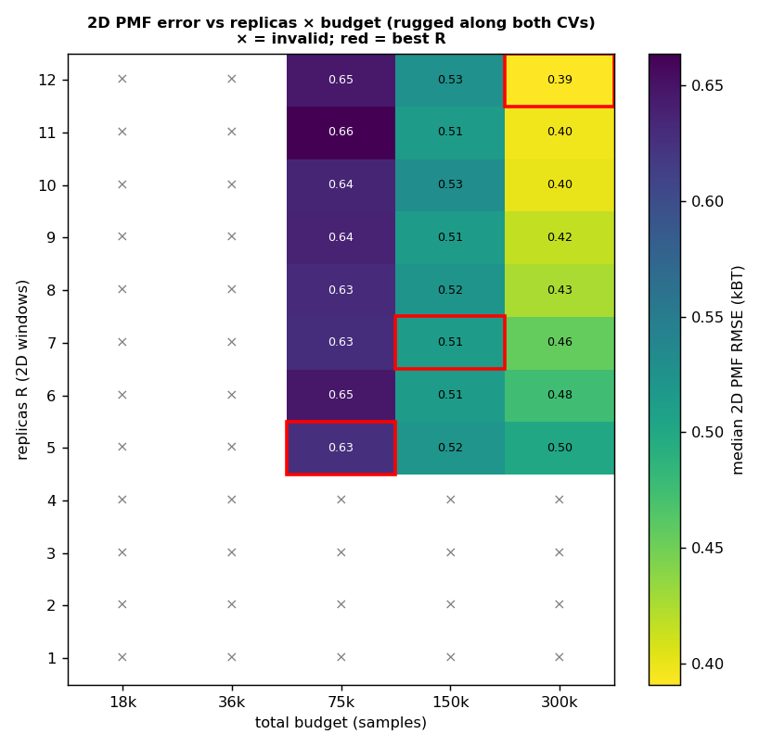
Figure 1. 2D PMF error over replicas × budget. × = invalid (can't connect/cover 2D); red = best R. The valid band sits higher (more replicas) than in 1D.
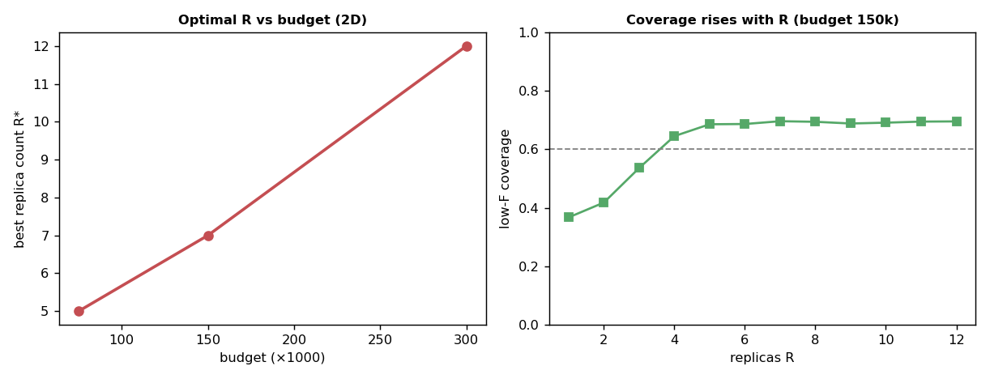
Figure 2. Left: optimal R grows with budget. Right: low-F coverage rises with R (few windows cannot cover a 2D rugged region).
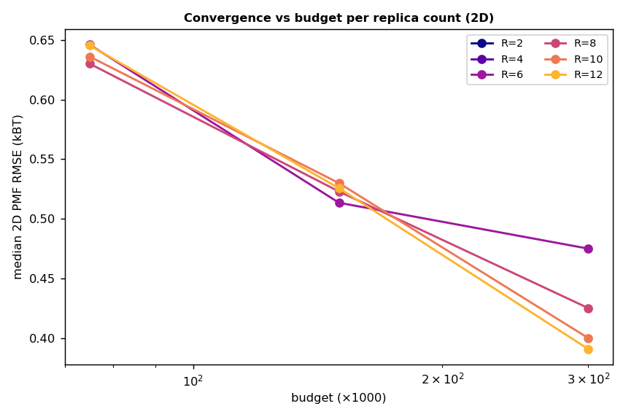
Figure 3. Convergence vs budget per replica count (2D).

Few vs many, in 2D
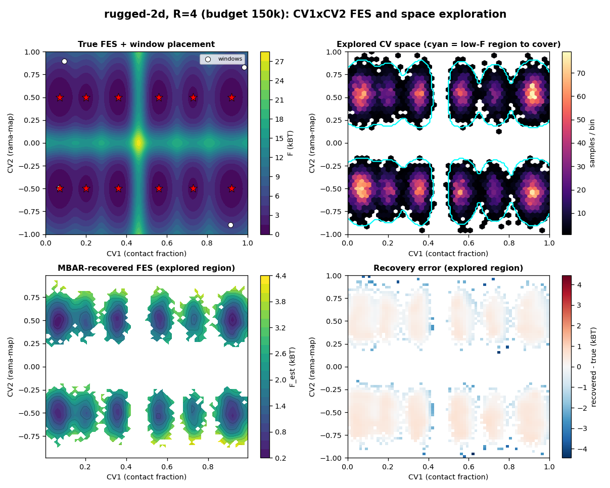
Figure 4. R=4 (few): cannot tile the 12-sub-basin 2D surface — coverage gaps, poor recovery across barriers.
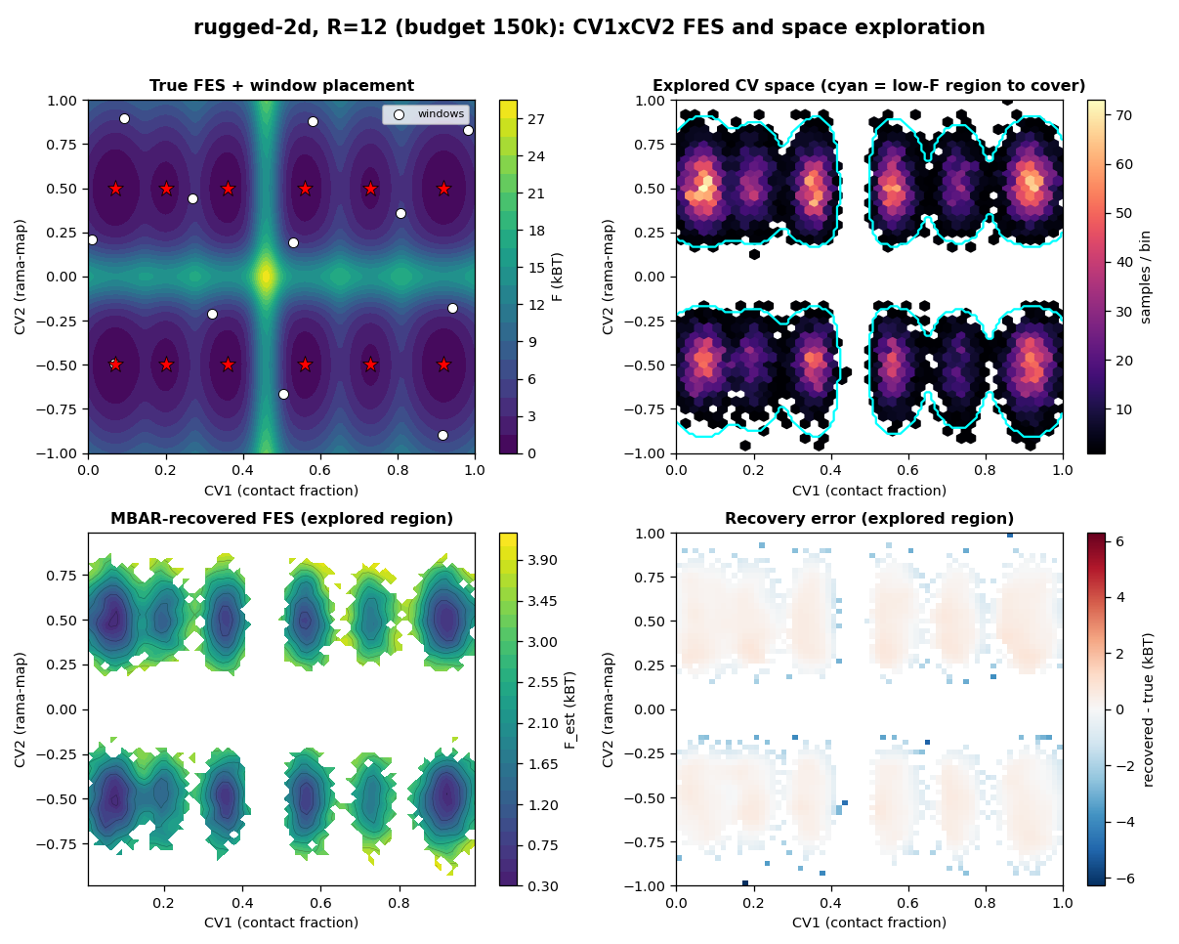
Figure 5. R=12 (many): windows tile both bands across the CV2 barrier; full coverage, accurate 2D recovery.

Caveats
- complexity now lives along both CVs; a window ladder must bridge barriers in CV1 AND CV2, which is why more replicas are required than in the 1D study (GPT's 'more umbrellas do not fix orthogonal non-ergodicity' — here we supply the orthogonal windows explicitly).
- the exact sampler lacks barrier kinetics, so single/few windows still draw across barriers more easily than real dynamics; trust the trend (R* up in 2D), not absolute small-R numbers.
- 2D MBAR recovery uses a per-window sample cap for cost; the budget/ESS reflects the full 3× samples drawn. Coverage gate is 0.60 (a 2D region is harder to cover than a 1D one).
- the 1D study (GAREUS_replica_count_study.docx) and all earlier work are unchanged; this adds the rugged-2d landscape, the 2D placement/fair-k/recovery, and this report.

