Replica-Count Study: Few Deep vs Many Shallow
At fixed total budget, how many umbrella replicas give the best PMF — and how does it converge?
rugged-1d landscape (6 basins, ~14 kBT barrier) · R=1..12 · budgets 6k, 12k, 25k, 50k, 100k · 3 seeds · 30.4s

Answer
On a deliberately hard landscape — six CV1 basins separated by a ~14 kBT barrier — the best replica count GROWS with the budget: 6k→R1, 12k→R1, 25k→R2, 50k→R4, 100k→R4. At small budgets, splitting across many windows starves each one, so few replicas win; as the budget grows, a moderate ladder (R≈4) becomes optimal. Over-resolution (R≥8) is consistently the worst at every budget — each window is too shallow and the per-window ESS collapses. So 'many samples from few replicas vs few from many' is regime-dependent: use the FEWEST replicas that still form a connected, barrier-bridging ladder, spend the rest on depth, and add replicas only as the budget grows.
Note: R=1 is an unbiased single-window baseline. It does deceptively well here because the exact grid sampler draws from the full Boltzmann distribution with no barrier-crossing kinetics — a real MD / Langevin run would trap a single window in one basin and fail to recover the relative basin depths. So the lean-ladder recommendation (R>=2, fewest-connected) is the robust one; the R=1 baseline is a property of the idealized sampler.

Method (the fair-k rule)
Each replica count R is made a FAIR ladder: R window centers are spread evenly over the low-F CV1 span, and the spring constant k is calibrated per R as the tightest value that still keeps every adjacent-window overlap ≥ 0.30 (so each R is an equally-connected ladder; a fixed k would let small R fail trivially). Each window draws B/R samples; the ESS/burn-in cost model (ESS=(n−burn)/(1+2τ), one burn-in per window) makes the trade-off physical. PMF is recovered by MBAR; only connected, low-F-covering runs are ranked. R=1 is the unbiased single-window baseline.

Results
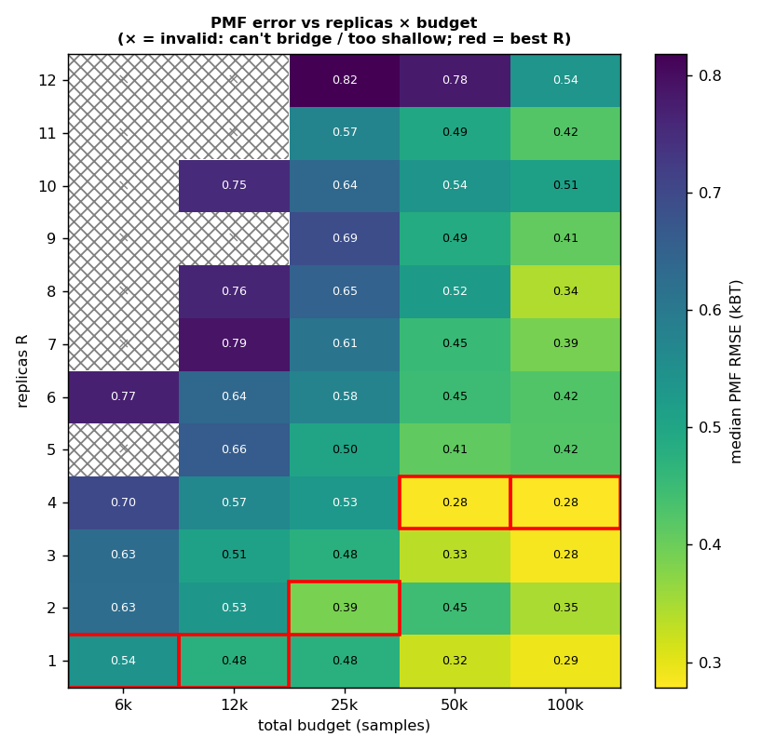
Figure 1. Median PMF error over replicas × budget. × = invalid (can't bridge / too shallow); red box = best R at each budget. The valid band shifts up-right.
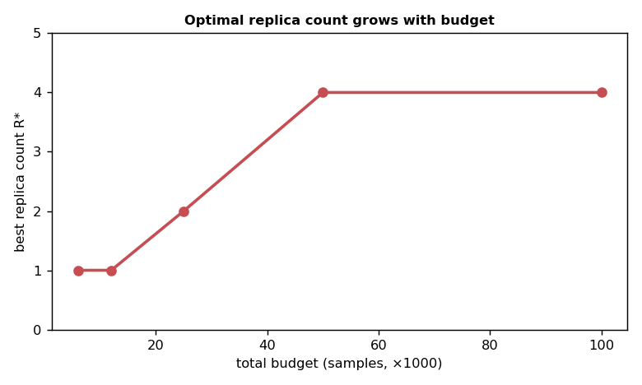
Figure 2. Optimal replica count R* increases with total budget.
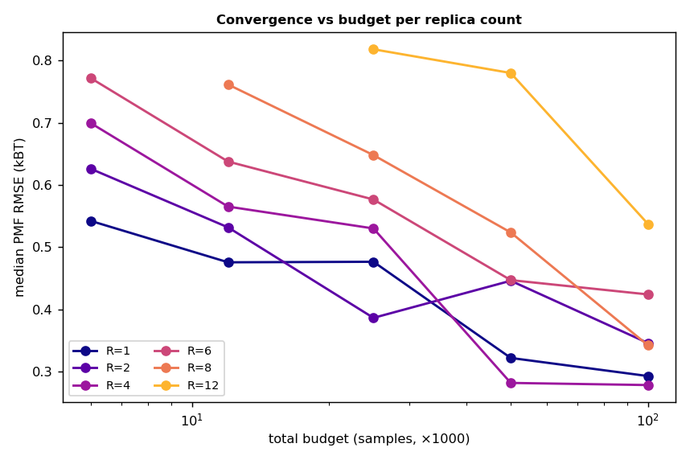
Figure 3. Convergence: PMF error vs budget, per replica count. Few replicas plateau (can't bridge); many replicas need a large budget before they pay off.
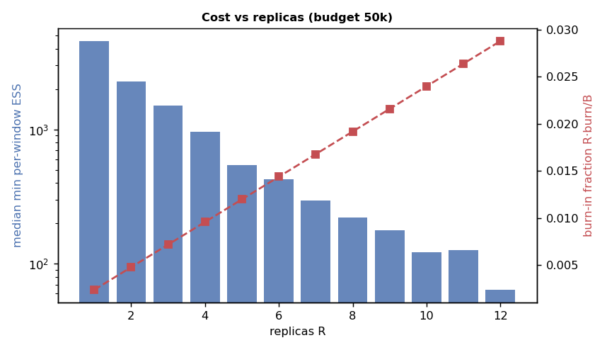
Figure 4. Cost vs replicas: min per-window ESS collapses and burn-in fraction rises as R grows — why too many replicas hurt at fixed budget.

Few-deep vs many-shallow, visually
The same 50k budget split two ways on the rugged-1d landscape:
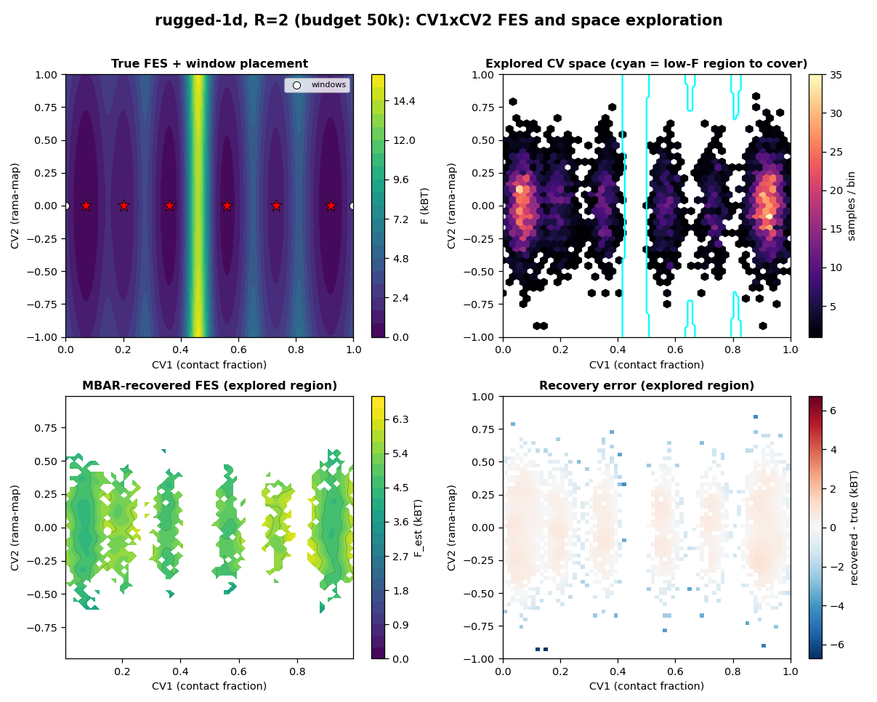
Figure 5. R=2 (few, deep): each window sampled deeply, but only two windows must span six basins and the barrier — coverage/recovery suffers across the gap.
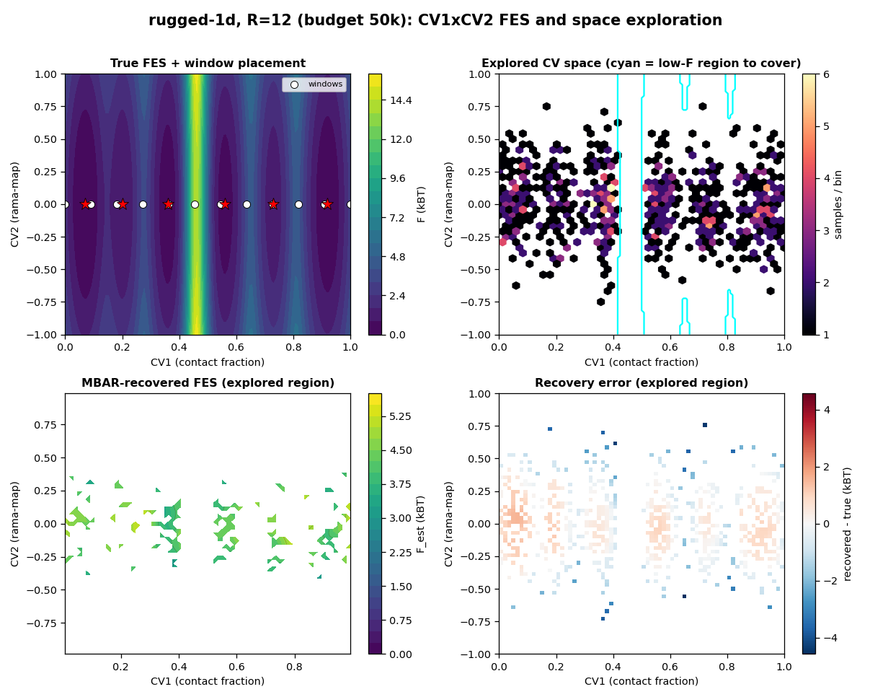
Figure 6. R=12 (many, shallow): full coverage and tight overlap, but each window is starved (low ESS), raising variance.

How it converges
Figure 3 shows the convergence behaviour per replica count. Too-few-replica ladders plateau at a high error floor — extra budget cannot fix a coverage/bridging deficit. Adequately-resolved ladders converge steadily as ~1/√ESS. Over-resolved ladders (large R) start poor (each window starved + burn-in overhead) and only catch up once the budget is large enough that B/R again buys sufficient per-window ESS — which is exactly why R* climbs with budget.

Caveats
- the PMF lives along CV1; CV2 is a mild fast nuisance well, so this isolates the replica-count trade-off (a slow/coupled CV2 would change the question — orthogonal non-ergodicity).
- results use the harness ESS/burn-in cost model (τ from k + local steepness, fixed burn-in); the qualitative shape is robust but absolute numbers are synthetic-scale.
- the fair-k rule makes every R a 0.30-overlap connected ladder; a real run with a fixed k or a different overlap target would shift the valid band.
- the exact sampler has no barrier kinetics, so the R=1 baseline samples across the 14 kBT barrier more easily than real dynamics would; the Langevin sampler (or real MD) would trap a single window. Trust the R>=2 ladder trend, not the R=1 absolute number.
- existing studies and docs are unchanged; this adds one landscape, one experiment module, and this report.

