Does Functional Retire Help? Fixed-R vs Adaptive at Fixed Budget
2D replica sweep (rugged-2d), same params as the prior study, now with WORKING retirement
R=1..12 · budgets 18k, 36k, 75k, 150k, 300k · 2 seeds · 117.1s

Background: the retire bug, fixed
The doubly-adaptive harness previously fed the ESS-thinned sample count into the production decision diagnostics. The retirement gate keys off min_samples_for_retire (200 raw samples); since ESS stays below that, RETIRE COULD NEVER FIRE — the metric was wrong (ESS instead of raw count). Fixed: decision gates now use RAW accumulated counts (matching the shipped collect_epoch_diagnostics), while ESS is kept only for overlap/PMF statistics. The REAL gareus decision was already correct (raw counts); it is now locked by direct regression tests (tests/test_adaptive_production_retire.py) that confirm it retires a redundant 2D grid 12→8 down to the min_active_states floor.

The comparison
With retirement working, we re-ran the 2D replica sweep (same params) three ways, comparing the recovered PMF at each (seeded R, budget): (1) FIXED-R — deeply sample the fixed R-window layout (the prior baseline); (2) ADAPTIVE add+retire — seed R, then run production epochs that add at weak edges and retire redundant windows (the full doubly-adaptive policy); (3) RETIRE-FOCUSED — seed R, retire only (no adds), so any reclaimed budget is redistributed to survivors.
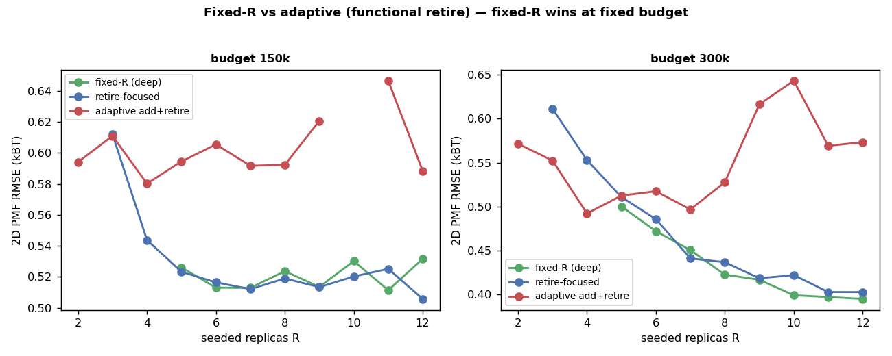
Figure 1. PMF vs seeded R at the two highest budgets. Fixed-R (deep) is best; adaptive add+retire is worst; retire-focused tracks fixed-R.
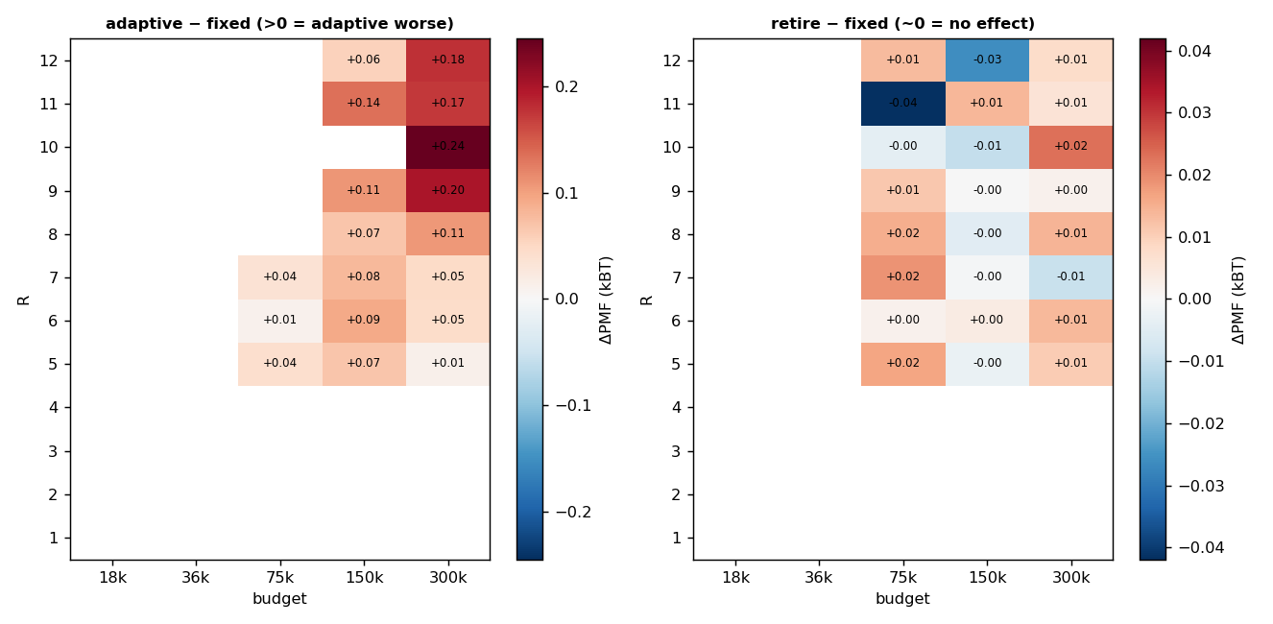
Figure 2. ΔPMF vs fixed-R. Left: adaptive add+retire is uniformly worse (red). Right: retire-focused is ≈ 0 (no effect).
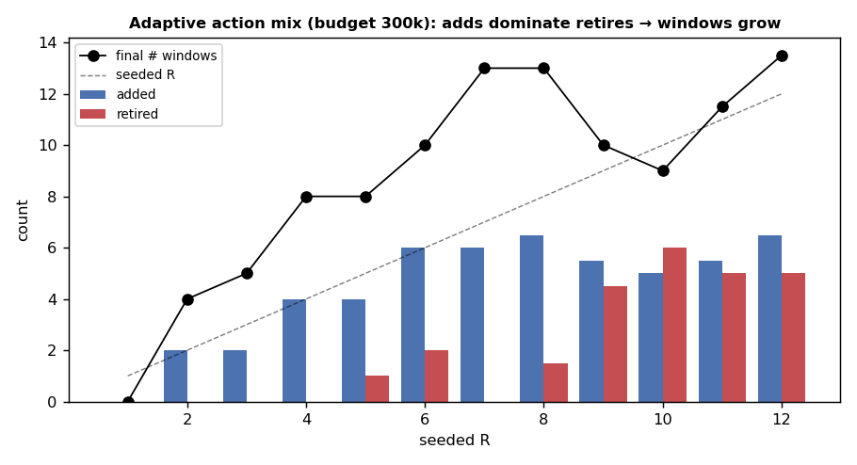
Figure 3. Why adaptive is worse: at fixed budget the add actions dominate retires, so the window count grows above the seeded R — splitting the budget and paying repeated burn-in.

Answer
- Fixed-R wins. deeply sampling a good fixed layout gives the lowest PMF at every budget (e.g. at the top budget, error keeps falling as R rises to 12). Adaptation cannot beat it.
- Adaptive add+retire is worse. seeding R and letting the full policy adapt is uniformly WORSE — the add actions outnumber retires, growing the window count, splitting the fixed budget across more (shallower) windows, and paying a fresh burn-in for each new window. Consistent with the precision-limited picture: at a fixed budget, churn costs more than it buys.
- Retire redistributes nothing on a non-redundant layout. retiring alone neither helps nor hurts here — because the fair-k window layout is calibrated to exactly the 0.30 overlap floor, NO window is redundant (over the 0.45 threshold), so there is nothing to reclaim. "Budget redistributed elsewhere" only materialises when the layout is genuinely over-resolved; a well-placed ladder is not.
So functional retirement is real and correct (it removes redundant windows to the floor — see the regression tests), but it is a SAFETY/economy lever that only pays off when a layout carries genuine redundancy. On the optimally-spread replica layouts of this study there is no redundancy, so retire is inert and the full add+retire adaptation underperforms simply spending the budget on depth. The practical rule stands: place a lean, connected, non-redundant ladder and spend the budget on depth; rely on retirement only to prune accidental over-resolution.

Caveats
- fair-k makes every swept layout non-redundant by construction, so this study cannot show retire reclaiming budget; the real-code test (fixed k, redundant grid) shows it does when redundancy exists.
- exact sampler + ESS/burn-in cost model; absolute numbers are synthetic-scale. The 18k/36k budgets remain below the 2D budget floor (no valid configuration), as in the prior study.
- the prior fixed-R study (GAREUS_replica_count_cv2_study.docx) and all earlier work are unchanged.

