Retire Comparison at 50× Budget
Fixed-R vs adaptive (functional retire) on rugged-2d, 0.9M–15M samples, MBAR cap 15000/window
R=1..12 · budgets 0M, 1M, 3M, 7M, 15M · 1 seed · 655.2s

Setup
Re-run of the 2D replica retire comparison at 50× the prior sample budget (0.9M–15M total per run, vs 18k–300k before), with the MBAR sample cap raised 3000→15000 per window so the extra samples actually improve the recovered PMF rather than being capped away. Retirement is the now-fixed, functional version (raw-count gated). Three modes per (R, budget): FIXED-R (deep-sample the fixed layout), ADAPTIVE add+retire (full doubly-adaptive policy), RETIRE-FOCUSED (retire only, redistribute reclaimed budget).

Results
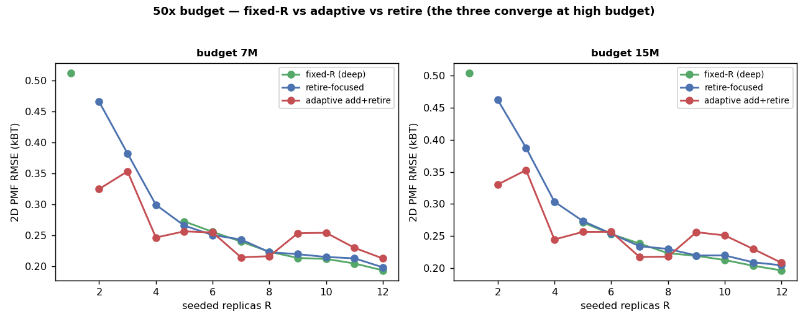
Figure 1. PMF vs seeded R at the two highest budgets — fixed, retire, and adaptive now nearly coincide.
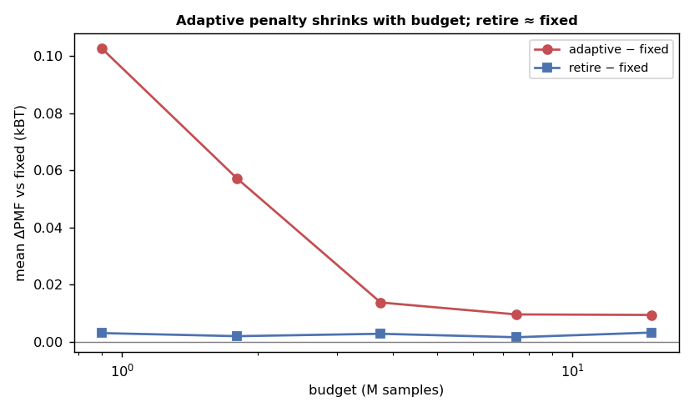
Figure 2. Mean ΔPMF vs fixed-R per budget: the adaptive penalty shrinks toward zero as budget grows; retire-focused is ≈0 at every budget.
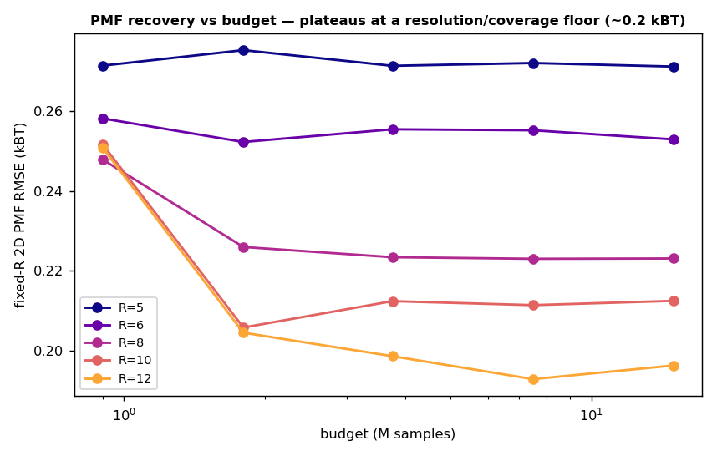
Figure 3. PMF recovery vs budget (fixed-R) — error plateaus near ~0.2 kBT beyond ~1.8M samples: a resolution/coverage floor, not a sampling limit.

Recovered PMF
The recovered free energy at the top budget (15M samples), fixed R=12: the MBAR reconstruction (bottom-left) closely matches the true rugged-2d surface (top-left), with a small low-F error map (bottom-right). At 50× samples both CV2 bands across the barrier are well-recovered.
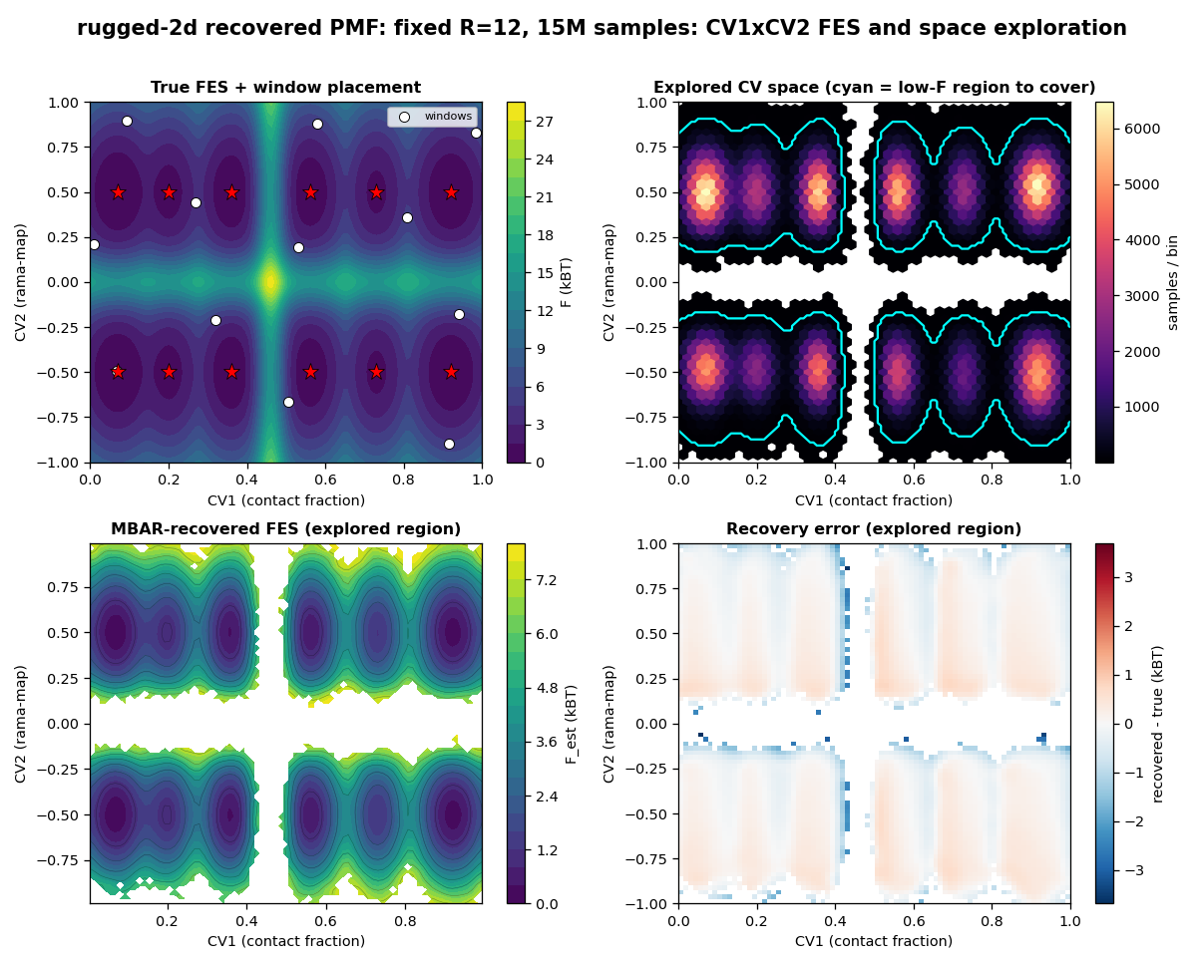
Figure 4. CV1×CV2 PMF recovery at 50× budget: true FES + windows, explored density, MBAR-recovered FES, and error.

Answer (50× budget)
- PMF converges: error stops improving beyond ~1.8M samples, plateauing near ~0.2 kBT. The remaining error is set by grid resolution and 2D coverage, not by sample count — so 50× more samples mostly confirms convergence rather than lowering the floor.
- Retire ≈ fixed: the mean PMF gap between retire-focused and fixed-R is ≈0.003 kBT at every budget. The fair-k layout is non-redundant, so functional retirement finds nothing to reclaim and redistributes nothing — exactly as at low budget. Retire is a safety lever for accidental over-resolution, not a budget source here.
- Adaptive penalty shrinks: the full add+retire penalty falls from +0.10 kBT at 0.9M to +0.009 kBT at 15M. At low budget, adding windows splits the pool and pays burn-in (costly); at very high budget each window is deep enough that the extra windows barely matter. So the earlier 'adaptation is worse' result is budget-dependent — it nearly vanishes when samples are abundant.
- More windows at high budget: best fixed R climbs to 12 at high budget — a 2D-rugged space keeps rewarding more windows as budget grows (consistent with the prior 2D study).

Caveats
- MBAR uses a 15000/window cap; beyond it the metric is cap-limited, so the ~0.2 kBT floor is partly the cap + the res=90 grid. The qualitative trends (convergence, retire≈fixed, shrinking adaptive penalty) are robust.
- 1 seed at 50× (compute); exact sampler + ESS/burn-in cost model; absolute numbers synthetic-scale.
- fair-k makes layouts non-redundant, so retire cannot reclaim here; the real-code test (redundant grid, fixed k) shows retire removes to the floor when redundancy exists.

