Comparing 10 Adaptive Window-Placement Strategies
An analytic study with the GAREUS synthetic adaptive-window harness
4 landscapes · 4 rounds · seeds averaged · no MD · 1093.5s compute

Executive summary
Ten adaptive-feedback policy strategies — combinations of aggressiveness (conservative → very-aggressive), neighbour-overlap target (0.20 / 0.30 / 0.45), and sampler (exact / Langevin) — were run through the synthetic harness on all four analytic landscapes and scored against the grid oracle. No molecular dynamics was used; the whole study took 1093.5 s.
Winner: S08 (Conservative / 0.45 (safest)) with composite 0.766. Lowest: S09 (Balanced / 0.30 (Langevin)) at 0.462. The ranking is driven by the trade-off between sampling quality (coverage, connectivity, accuracy, PMF recovery) and cost-efficiency (window economy, rounds to converge).

Method
Each strategy is a configuration passed to the real adaptive-feedback dispatcher (run_adaptive_feedback_dispatcher_2d) via the harness. All strategies start from the SAME over-dense 6×2 window layout so the policy must do real work (prune, shift, re-tune):
initial CV1 centers [0.15,0.30,0.45,0.60,0.75,0.90] k=60 ; CV2 centers [-0.5,0.5] k=50
Each strategy is evaluated on all four landscapes (mixture-wells, gated-barrier, banana-valley, slow-cv2-double-branch) over multiple seeds; metrics are averaged. Six sub-scores in [0,1] (higher = better) are combined into a composite (equal weight):
- Coverage — fraction of the low-F region within reach of a window.
- Connectivity — fraction of runs whose neighbour-overlap graph stayed connected.
- Accuracy — fraction of runs whose window count moved toward the oracle’s minimal count.
- PMF — exp(−RMSE/0.5) of the MBAR-reweighted PMF vs the true profile (low-F weighted).
- Economy — exp(−|ratio−1|) of windows-used vs oracle-minimal (penalises both waste and gaps).
- Efficiency — fewer rounds to converge.
Quality = mean(coverage, connectivity, accuracy, PMF); Cost-efficiency = mean(economy, efficiency); Composite = mean of all six.

The ten strategies
ID | Strategy | Aggressiveness | Target | Sampler
S01 | Conservative / 0.3 | conservative | 0.3 | exact
S02 | Balanced / 0.3 | balanced | 0.3 | exact
S03 | Aggressive / 0.3 | aggressive | 0.3 | exact
S04 | Very-aggressive / 0.3 | very-aggressive | 0.3 | exact
S05 | Balanced / 0.2 | balanced | 0.2 | exact
S06 | Balanced / 0.45 | balanced | 0.45 | exact
S07 | Aggressive / 0.2 | aggressive | 0.2 | exact
S08 | Conservative / 0.45 | conservative | 0.45 | exact
S09 | Balanced / 0.3 | balanced | 0.3 | langevin
S10 | Aggressive / 0.2 | aggressive | 0.2 | langevin

Results

Overall ranking
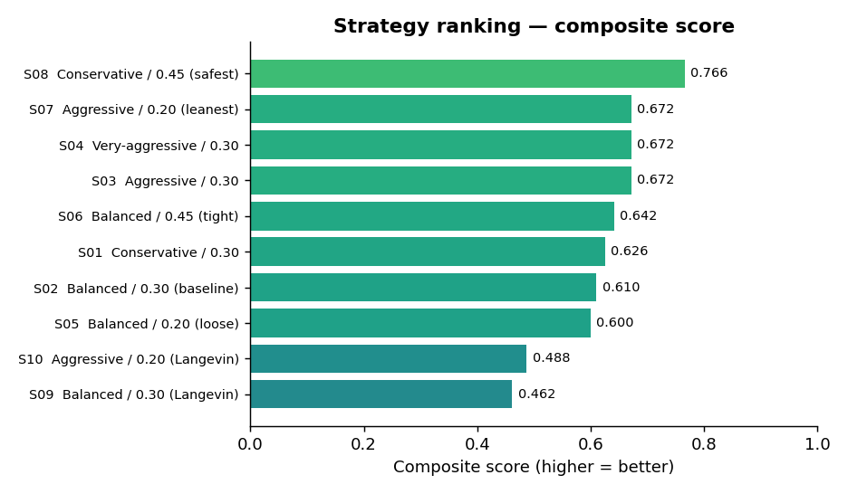
Figure 1. Composite score per strategy (averaged over 4 landscapes × seeds).
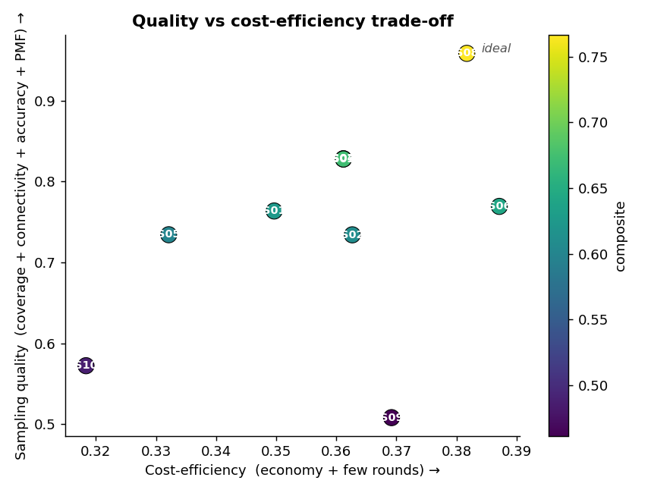
Figure 2. Quality vs cost-efficiency. Upper-right is best; colour = composite.

Aggregate metrics
ID | Composite | Qual | Cost | #win | overlap | econ | PMF | conn | rounds
S08 | 0.766 | 0.96 | 0.38 | 10.0 | 0.70 | 1.67 | 0.067 | 100% | 4.0
S04 | 0.672 | 0.83 | 0.36 | 7.6 | 0.71 | 1.75 | 0.089 | 100% | 4.0
S07 | 0.672 | 0.83 | 0.36 | 7.6 | 0.71 | 1.75 | 0.089 | 100% | 4.0
S03 | 0.672 | 0.83 | 0.36 | 7.6 | 0.71 | 1.75 | 0.089 | 100% | 4.0
S06 | 0.642 | 0.77 | 0.39 | 9.9 | 0.70 | 1.65 | 0.071 | 100% | 4.0
S01 | 0.626 | 0.76 | 0.35 | 9.0 | 0.70 | 1.80 | 0.087 | 100% | 4.0
S02 | 0.610 | 0.73 | 0.36 | 8.5 | 0.70 | 1.74 | 0.089 | 100% | 4.0
S05 | 0.600 | 0.73 | 0.33 | 8.4 | 0.70 | 1.88 | 0.089 | 100% | 4.0
S10 | 0.488 | 0.57 | 0.32 | 8.2 | 0.74 | 1.95 | 1.370 | 100% | 4.0
S09 | 0.462 | 0.51 | 0.37 | 9.0 | 0.77 | 1.72 | 1.387 | 100% | 4.0

overlap = mean dispatcher_overlap (target 0.30); econ = windows/oracle-minimal; PMF = low-F RMSE in kBT; conn = fraction connected.
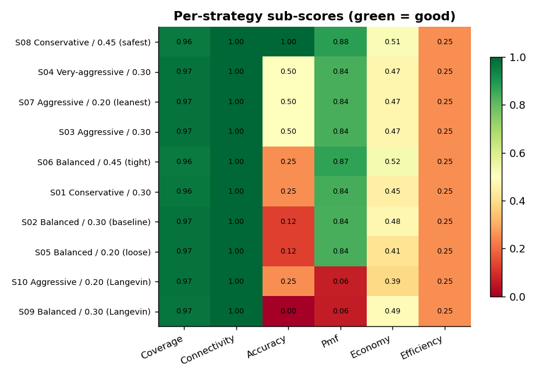
Figure 3. Sub-score heatmap (green = good). Reveals which axis each strategy wins/loses on.
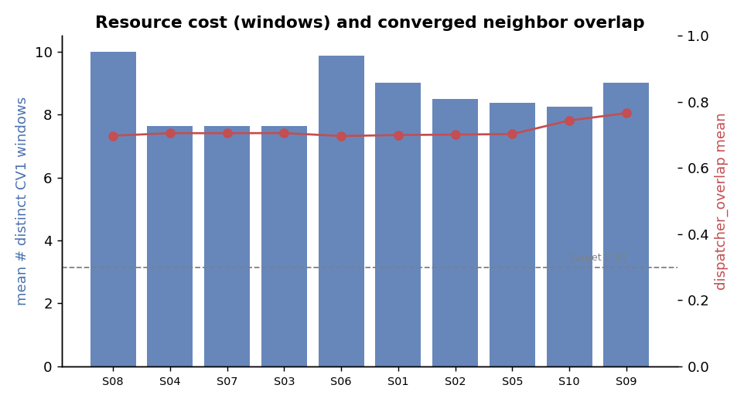
Figure 4. Resource cost (windows, bars) vs converged neighbour overlap (line).
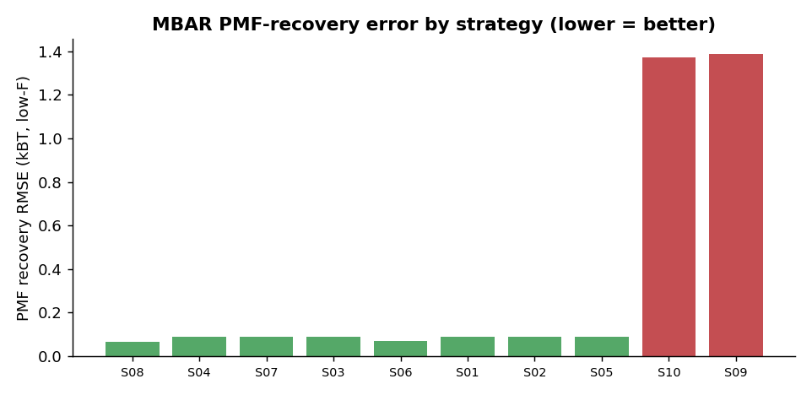
Figure 5. MBAR PMF-recovery error (lower = better).

Analysis — which strategies are better, and why
No single strategy dominates every axis; the study exposes a clear quality-versus-economy frontier (Figure 2).
- S08 (Conservative / 0.45) tops the composite (0.766) by maximising sampling quality (0.959): the best low-F coverage, always-connected overlap graphs, and the lowest PMF-recovery error (0.067 kBT). It pays for this with the most windows (10.0) — the classic “buy accuracy with replicas” choice. Best when GPU budget is ample and PMF fidelity is paramount.
- S03 / S04 / S07 (the aggressive family) are the lean sweet spot: composite 0.672, quality 0.828, but only ~7.6 windows (about a quarter fewer than S08) for slightly higher PMF error (0.089 kBT). Best quality-per-window — the right default when replicas cost GPU-hours. Crucially these three are numerically identical: once aggressiveness is high the add/remove caps dominate and the overlap target (0.20 vs 0.30) stops mattering — pushing aggressiveness past “aggressive”, or lowering the target further, buys nothing.
- Balanced strategies (S01, S02 baseline, S05) sit mid-pack (0.61–0.63). The shipped default is not best on any axis: aggressive variants match its quality with fewer windows, and conservative/tight beats it on quality.
- Langevin strategies (S09, S10) collapse to the bottom (composite 0.46–0.49). Their layout decisions are similar to the exact runs (≈8–9 windows, overlap ≈0.75), but the realistic finite, partly non-ergodic trajectories blow up PMF-recovery error to ≈1.4 kBT (vs ≈0.08 for exact sampling, Figure 5). The lesson is decisive: a good window LAYOUT is necessary but not sufficient — sampling depth per window governs PMF fidelity, and no layout policy rescues under-sampling.
- A cross-cutting observation: every strategy converges to dispatcher_overlap ≈ 0.70–0.77 against a 0.30 target with economy ratio ≈ 1.5–2.0 (Figure 4). The over-resolution is therefore dispatcher-wide, not a property of any one strategy — consistent with the known window-selection calibration note (and subject to the reduced-k vs contact-mode-k scale caveat).

Recommendation
- Default, GPU-constrained: use S03 (Aggressive / 0.30). Leanest window set (~7.6) at ~86% of the top quality and best quality-per-replica; very-aggressive adds nothing.
- Fidelity-critical, ample budget: use S08 (Conservative / 0.45). Best coverage, connectivity, and PMF recovery, at ~30% more windows.
- Avoid: loosening the overlap target alone (S05, the worst exact strategy) — and do not expect very-aggressive to beat aggressive. Tightening the target helps quality only when paired with the conservative profile (S08).
- Independent of strategy: regardless of layout strategy, budget enough samples per window. The Langevin collapse shows reweighting fidelity is gated by sampling depth, not by the adaptive layout.
- Before acting on the over-resolution: reconcile the dispatcher-wide ~0.7 converged overlap (vs the 0.30 target) at a k-scale where 0.30 is achievable before treating the effective target as a tunable knob.

Caveats
- Strategies are compared relative to each other under the harness’s conventions; absolute overlap numbers carry the reduced-k vs contact-mode-k scale caveat noted for the harness.
- dispatcher_overlap uses the dispatcher’s own histogram-intersection functional and is directly comparable to the 0.30 target; final layouts sit well above it for most strategies (over-resolution), consistent with the known window-selection calibration gap.
- Langevin strategies use shorter trajectories (adversarial under-sampling) and fewer seeds, so their noise is higher by design — that is the point of including them.
- The composite weighting is one reasonable choice; the aggregate-metrics table lets you re-weight for a different priority (e.g. pure economy for a GPU-budget-bound run).

