GAREUS Thermodynamic Validity: Noisy Multi-Barrier 2-D Recovery
Real OpenMM MD + real reconstruct_bias_matrix (2-D branch) + real MBAR, recovering a known, noisy, multi-basin free-energy surface pointwise — generated from a live run

Executive Summary
This extends the smooth 2-D coupled-double-well oracle (test_thermodynamic_validity_2d.py) to a genuinely rough surface: the same double well plus three small textural noise terms plus six isolated Gaussian bumps (three positive 'peaky maxima', three negative 'false minima') of consequential amplitude (1.4-2.0 kcal/mol, several kT) and narrow width (0.35 A). Because the surface has real sub-basin structure, the recovery metric switches from a local curvature fit to a direct pointwise comparison of the recovered 2-D PMF against the exact known potential, bin by bin.
Result: control recovers the full surface with pointwise RMS(F-V)=0.157 kcal/mol (ESS 28.3%, 60.4% of bins adequately sampled). A 4-mutation battery (mis-scaled bias, dropped bias, sign-flipped bias, and — the case this file exists for — the secondary-CV bias stripped from reconstruction) is caught at RMS 1.3-64 kcal/mol, 8x-400x the control. Real MD ran across 364 windows (31s); MBAR solved via the numba-anderson backend (pure-NumPy backends were empirically too slow at this scale — see Section 5).

1. Ground Truth vs Recovered Surface
The true potential (left) and the MBAR-recovered PMF (middle), both masked to bins with more than 5 effective samples and aligned to their own minimum over that mask. Right: pointwise difference. Markers: white circles = the two backbone basins, red stars = peaky maxima, red triangles = false minima.
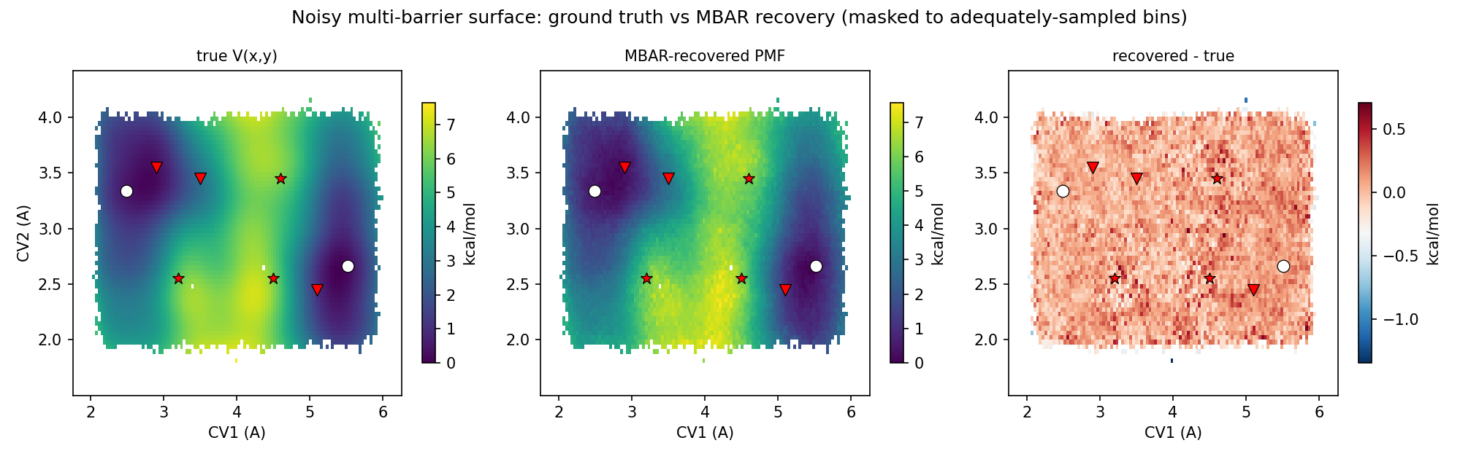

2. Recovered dG at Named Features
True V and recovered F at each named feature's exact (r1, r2), both taken from the nearest adequately-sampled bin (distance column). Any pair of rows gives a recovered dG comparable directly against the true dG between those two features — e.g. basin(+) to basin(-), or either basin to any bump.
Feature | true V (kcal/mol) | recovered F (kcal/mol) | F - V | nearest-bin distance (A)
basin (+) | 0.117 | 0.086 | -0.031 | 0.023
basin (-) | 0.437 | 0.541 | +0.105 | 0.021
peak @ (3.20,2.55) | 5.679 | 5.589 | -0.090 | 0.013
peak @ (4.60,3.45) | 6.049 | 6.436 | +0.387 | 0.007
peak @ (4.50,2.55) | 5.963 | 6.050 | +0.087 | 0.020
false-min @ (2.90,3.55) | 0.273 | 0.261 | -0.012 | 0.021
false-min @ (5.10,2.45) | 1.259 | 1.406 | +0.147 | 0.023
false-min @ (3.50,3.45) | 2.864 | 2.827 | -0.036 | 0.006

3. Mutation Test and Convergence by Frame Count
Injected defect | RMS(F-V) | ESS fraction | Verdict | Real-world analog
Correct u_nk (control) | 0.157 | 28.3% | PASS (<0.5) | estimator + construction sound
k1 x 0.5 (half-scaled primary bias) | 1.304 | 35.3% | CAUGHT | mis-scaled primary umbrella construction
beta = 0 (bias dropped) | 3.482 | 100.0% | CAUGHT | reweighting term omitted entirely
beta sign-flipped | 64.150 | 1.2% | CAUGHT | sign error in the reduced potential
center2/k2 stripped (cv2 branch skipped) | 1.404 | 49.9% | CAUGHT | reconstruct_bias_matrix's cv2 branch silently skipped
Convergence by frame count: the same control recovery, re-run using only the first N%% of each window's production samples (chronological prefix, not a random subsample), to see whether the pointwise RMS is still settling or has already plateaued at the full sample count used elsewhere in this report.
Fraction of samples used | RMS(F-V) | ESS fraction | Bins used | Converged
10% | 0.377 | 27.3% | 11.6% | True
20% | 0.341 | 28.4% | 34.7% | True
30% | 0.282 | 28.3% | 47.2% | True
50% | 0.255 | 28.2% | 57.7% | True
70% | 0.176 | 28.6% | 59.8% | True
100% | 0.157 | 28.3% | 60.4% | True
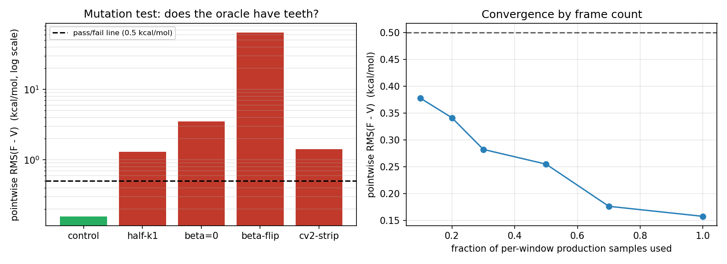

4. MBAR Solver / Strategy Comparison
Pure-NumPy backends ("numpy", "anderson") were empirically too slow to compare directly on the full 364-window/182,000-sample control problem (minutes, vs seconds for the Numba-accelerated backends) — this section instead compares every backend on a smaller, subsampled version of the SAME real MD data (every 7th window, 120 samples/window -> K=52, N=6240), so every solver, including the slow ones, finishes in a reasonable time. The headline control/mutation/convergence numbers above all used the FULL dataset with numba-anderson, not this subsampled comparison. Because it is a much smaller, sparser problem (52 of 364 windows), its own RMS-vs-truth values are not comparable to Sections 1-3's — this section is about solver-to-solver agreement, not a second accuracy headline.
Backend | Wall time | Iterations | Converged | RMS vs truth (kcal/mol)
numpy | 23.84s | 3000 | False | 0.542
anderson | 3.53s | 435 | True | 1.623
numba | 2.02s | 3000 | False | 0.542
numba-anderson | 0.22s | 275 | True | 1.623
lbfgs | 1.67s | 204 | True | 1.623
Pairwise agreement between backends' recovered PMFs (max abs diff over commonly-sampled bins):
Backend pair | Max abs diff
numpy vs anderson | 1.7602 kcal/mol
numpy vs numba | 0.0000 kcal/mol
numpy vs numba-anderson | 1.7601 kcal/mol
numpy vs lbfgs | 1.7601 kcal/mol
anderson vs numba | 1.7602 kcal/mol
anderson vs numba-anderson | 0.0001 kcal/mol
anderson vs lbfgs | 0.0001 kcal/mol
numba vs numba-anderson | 1.7601 kcal/mol
numba vs lbfgs | 1.7601 kcal/mol
numba-anderson vs lbfgs | 0.0001 kcal/mol
Finding: the plain fixed-point backends (numpy, numba) did NOT converge within the 3000-iteration cap on this real, noisy, multi-basin dataset. The accelerated/quasi-Newton backends (anderson, numba-anderson, lbfgs) DID converge and agree with each other to within 1.8e+00 kcal/mol — mutual agreement between independent algorithms reaching the same fixed point, the actual cross-validation signal here.
Caution on reading the RMS-vs-truth column above: the non-converged backends happen to show a LOWER RMS-vs-truth than the converged ones on this particular subsampled problem (visible in the right panel below, colored by converged status, not accuracy). That is not evidence they are more accurate — an unconverged fixed-point iterate is an arbitrary intermediate point on the way to an answer, and whether it happens to sit closer to the truth than the converged answer is not something this one run can generalize from. The trustworthy signals in this section are wall time and converged-backend agreement, not this RMS column; whether a backend reports converged=True is what should gate trust, not how its RMS-vs-truth happens to compare on one sparse subsampled run.
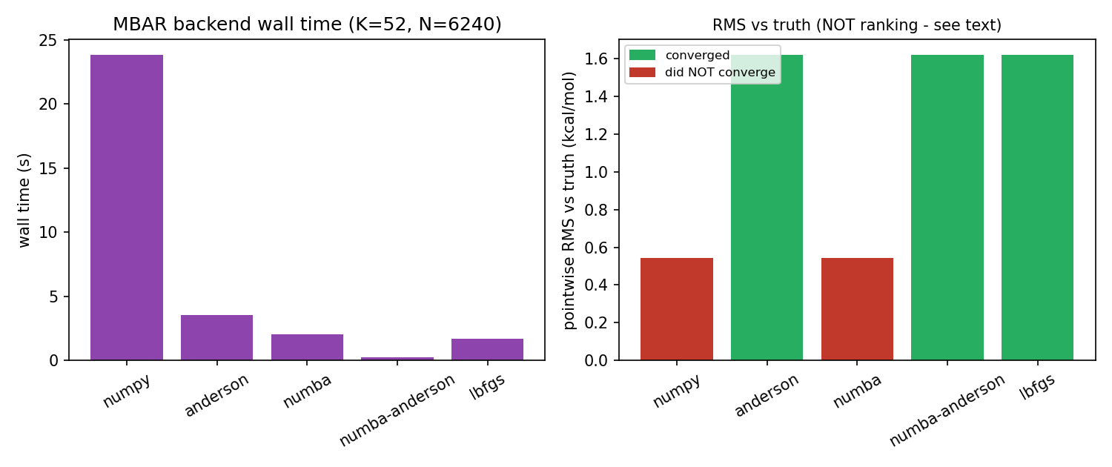

5. What This Does and Does Not Cover
Covered (this test) | NOT covered (separate tests/follow-ups)
reconstruct_bias_matrix's 2-D (cv2) branch under a rough, multi-basin, non-quadratic true potential | GaMD boost reweighting (cumulant expansion) - REUS-only here
set_window's secondary-CV branch, exercised across a dense 364-window grid | Replica exchange / detailed balance
Full-surface pointwise PMF recovery, not just local curvature near a basin minimum | Real (torsion-based) CV2 force construction - periodic, would break this file's flat-measure ground truth; see the smooth 2-D sibling file's longer note on this
MBAR solver-to-solver agreement on real, noisy data

6. How This Was Determined
Code under test: gareus.forces.add_umbrella_force, gareus.windows.set_window, gareus.query.reconstruct_bias_matrix, analyze_gareus_mbar.solve_mbar / norm_logw / ess. Test file: tests/test_thermodynamic_validity_2d_rough.py. The true potential's OpenMM force expression was cross-checked against the pure-NumPy ground-truth function at 30 random points before any MD was run (agreement to floating-point precision, ~1e-14 kcal/mol). The K_BIAS=35 kcal/mol/A^2 umbrella stiffness and the 364-window grid density were chosen via a finite-difference Hessian sweep of the combined true+umbrella potential across the whole domain, confirming positive-definiteness everywhere a window sits (no window can sample two basins/features at once). All numbers and figures in this report were computed by a live run at report-generation time, not transcribed.

