Chignolin Poincaré Map Analysis: Folding/Unfolding Pathway Findings
GAREUS run2 — 66 ns, 16 replicas | chignolin CLN025 (GYDPETGTWG)

1. What is a Poincaré Map?
A Poincaré map records a low-dimensional observable each time a trajectory crosses a defined threshold. Here, two sections are defined in CV1 space (nonlocal contact fraction, the primary umbrella coordinate):
- Σ_fold: CV1 crosses 0.140 upward (peptide enters high-contact / folded region).
- Σ_unfold: CV1 crosses 0.010 downward (peptide enters extended / unfolded region).
At each crossing the backbone geometry score CV2 (rama-map: weighted mean similarity of all residue φ/ψ pairs to four Ramachandran basin centers) is recorded. Plotting CV2 at event #n vs event #n+1 reveals pathway memory and distinct routes.
A committor dwell filter (10 ps) is applied: a crossing only counts if CV1 stays on the committed side for at least 50 consecutive frames afterward. This eliminates threshold-bounce artifacts (99% of raw crossings were noise). Only committed folding/unfolding events are analysed.

CV2 Ramachandran Basin Reference
CV2 value | Basin name | φ centre | ψ centre | Physical geometry
-1.000 | β/extended | -135° | +135° | β-strand / extended chain
-0.333 | PPII/coil | -75° | +145° | Polyproline-II / random coil
+0.333 | right-α | -60° | -45° | Right-handed α-helix
+1.000 | left-α | +60° | +40° | Left-handed α-helix (rare)

2. Poincaré Map Results

2.1 Crossing Statistics
Section | Threshold | Committed crossings | Return pairs | Recurrence (median)
Σ_fold | CV1 > 0.140 | 450 | 436 | 43.9 ps
Σ_unfold | CV1 < 0.010 | 444 | 433 | 88.8 ps

Note: recurrence times reflect REUS umbrella bias (replicas are artificially driven through all windows). They do not represent physical folding rates (chignolin physical fold time ≈ μs). The map topology (cluster structure, diagonal alignment) is bias-robust.

2.2 CV2 Peak Structure at Crossings
Fold crossings (Σ_fold): Two CV2 peaks detected.
Peak | CV2 value | Nearest basin | KDE density | Events (approx)
Route A (dominant) | +0.018 | right-alpha | 5.33 | 436
Route B (minor) | +0.238 | right-alpha | 0.070 | 14

Unfold crossings (Σ_unfold): Single CV2 peak.
Peak | CV2 value | Nearest basin | KDE density | Events
Single unfolding route | -0.398 | PPII/coil | 5.68 | 436

2.3 Key Interpretations
- Two distinct folding routes: the system enters the folded region (CV1 > 0.14) via two backbone configurations — Route A (CV2 ≈ +0.02, right-alpha, dominant, n=436) and Route B (CV2 ≈ +0.24, right-alpha, minor, n=14).
- Single stereotyped unfolding route: unfolding consistently exits via PPII/coil backbone (CV2 ≈ -0.40). Unfolding is more mechanistically constrained than folding.
- Strong pathway memory: return maps lie on the diagonal, meaning the backbone geometry at fold/unfold event #n predicts event #n+1. The trajectory is not exploring pathways randomly.
- Folding/unfolding asymmetry: 2 folding routes vs 1 unfolding route. This is consistent with a funnel landscape where multiple entry routes converge onto a single unfolding channel.

2.4 Poincaré Map Figure
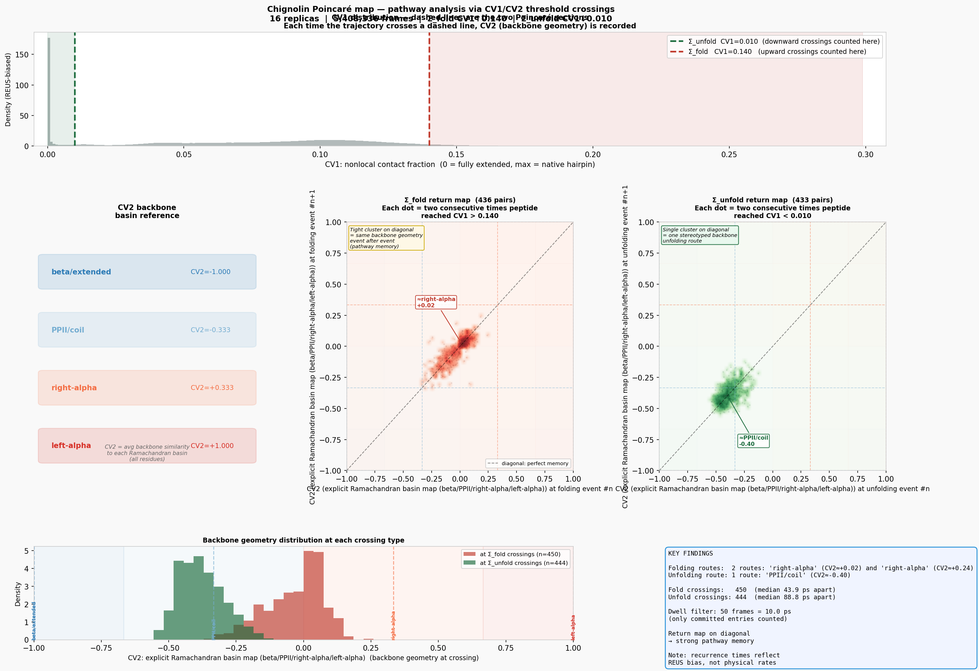
Figure 1. Poincaré return maps. Top: CV1 distribution with Σ_fold (red) and Σ_unfold (green) thresholds. Centre-left: Σ_fold return map — each dot is two consecutive committed fold entries; colour=log density (red scale). Centre-right: Σ_unfold return map (green scale). Centre-right panel: CV2 marginal distributions at each crossing type. Bottom: recurrence time distributions and temporal stationarity.

3. Per-Residue Backbone Torsion Analysis
To identify which residues drive the two folding routes, committed fold-crossing frames were extracted from the XTC trajectories (topology: shared_gamd_setup_final.pdb). Per-residue φ and ψ angles were computed using MDTraj. Route A vs Route B are split at CV2 = 0.128 (midpoint between the two fold peaks).
Note: Route B has only 14 events vs 436 for Route A. Δψ/Δφ values for Route B should be treated as indicative rather than statistically robust. More sampling with a lower dwell threshold (--poincare-min-dwell 5) would improve Route B statistics.

3.1 Per-Residue ψ Angles
Residue | Route A ψ (°) | Route B ψ (°) | Unfold ψ (°) | Δψ B−A (°) | Δψ Unfold−A (°)
G1 | +16.3 ± 135.7 | -48.4 ± 119.3 | +17.1 ± 141.3 | -64.8 | +0.8
Y2 | +36.7 ± 84.5 | -14.2 ± 26.8 | +128.7 ± 50.9 | -50.9 | +92.0
D3 | -42.3 ± 26.2 | -48.7 ± 13.3 | +77.2 ± 81.2 | -6.4 | +119.4
P4 | -26.0 ± 17.4 | -37.1 ± 11.3 | +120.2 ± 70.7 | -11.2 | +146.1
E5 | -36.4 ± 19.0 | -34.3 ± 22.3 | +57.7 ± 86.1 | +2.1 | +94.2
T6 | -13.9 ± 49.5 | -29.7 ± 18.8 | +109.5 ± 71.7 | -15.8 | +123.5
G7 | -23.6 ± 92.0 | -19.9 ± 48.1 | +26.9 ± 139.1 | +3.7 | +50.5
T8 | +2.8 ± 69.4 | -14.6 ± 33.7 | +104.5 ± 74.2 | -17.4 | +101.6
W9 | +25.6 ± 87.0 | +19.4 ± 74.8 | +120.4 ± 76.4 | -6.2 | +94.8
G10 | — | — | — | — | —

3.2 Per-Residue φ Angles
Residue | Route A φ (°) | Route B φ (°) | Unfold φ (°) | Δφ B−A (°) | Δφ Unfold−A (°)
G1 | — | — | — | — | —
Y2 | -88.7 ± 35.2 | -72.1 ± 40.6 | -116.5 ± 39.2 | +16.6 | -27.8
D3 | -61.7 ± 15.5 | -65.8 ± 9.7 | -115.7 ± 35.0 | -4.1 | -54.1
P4 | -66.5 ± 12.1 | -62.6 ± 9.5 | -67.6 ± 13.3 | +3.9 | -1.1
E5 | -85.8 ± 25.3 | -66.6 ± 12.2 | -98.5 ± 31.0 | +19.2 | -12.7
T6 | -91.8 ± 35.6 | -67.0 ± 12.3 | -110.5 ± 41.1 | +24.9 | -18.7
G7 | -22.6 ± 85.4 | -29.5 ± 60.3 | -31.1 ± 116.7 | -6.9 | -8.4
T8 | -84.1 ± 37.8 | -57.2 ± 47.0 | -117.7 ± 35.9 | +26.9 | -33.7
W9 | -98.6 ± 35.8 | -93.8 ± 24.8 | -120.1 ± 31.1 | +4.8 | -21.5
G10 | +1.5 ± 116.8 | +41.9 ± 98.5 | -29.7 ± 138.6 | +40.4 | -31.2

3.3 Key Residues Driving Route Differences
Largest Δψ (Route B − Route A): G1: -64.8° Y2: -50.9° T8: -17.4°
Largest Δφ (Route B − Route A): G10: +40.4° T8: +26.9°
Largest Δψ (Unfold − Route A): P4: +146.1° T6: +123.5° D3: +119.4°

The two folding routes differ most at the N-terminal strand residues (G1, Y2), not at the turn (Asp3-Pro4-Glu5). The turn geometry is similar across both routes, consistent with a fixed turn nucleus model: the β-hairpin turn locks first and the strands zip in via different backbone configurations. Unfolding (Δψ Unfold−A) shows large shifts at strand residues (Tyr2, Asp3, Thr6, Trp9) — the fully extended state has strongly positive ψ throughout, consistent with PPII/extended-strand geometry.

3.4 Per-Residue Ramachandran Figure
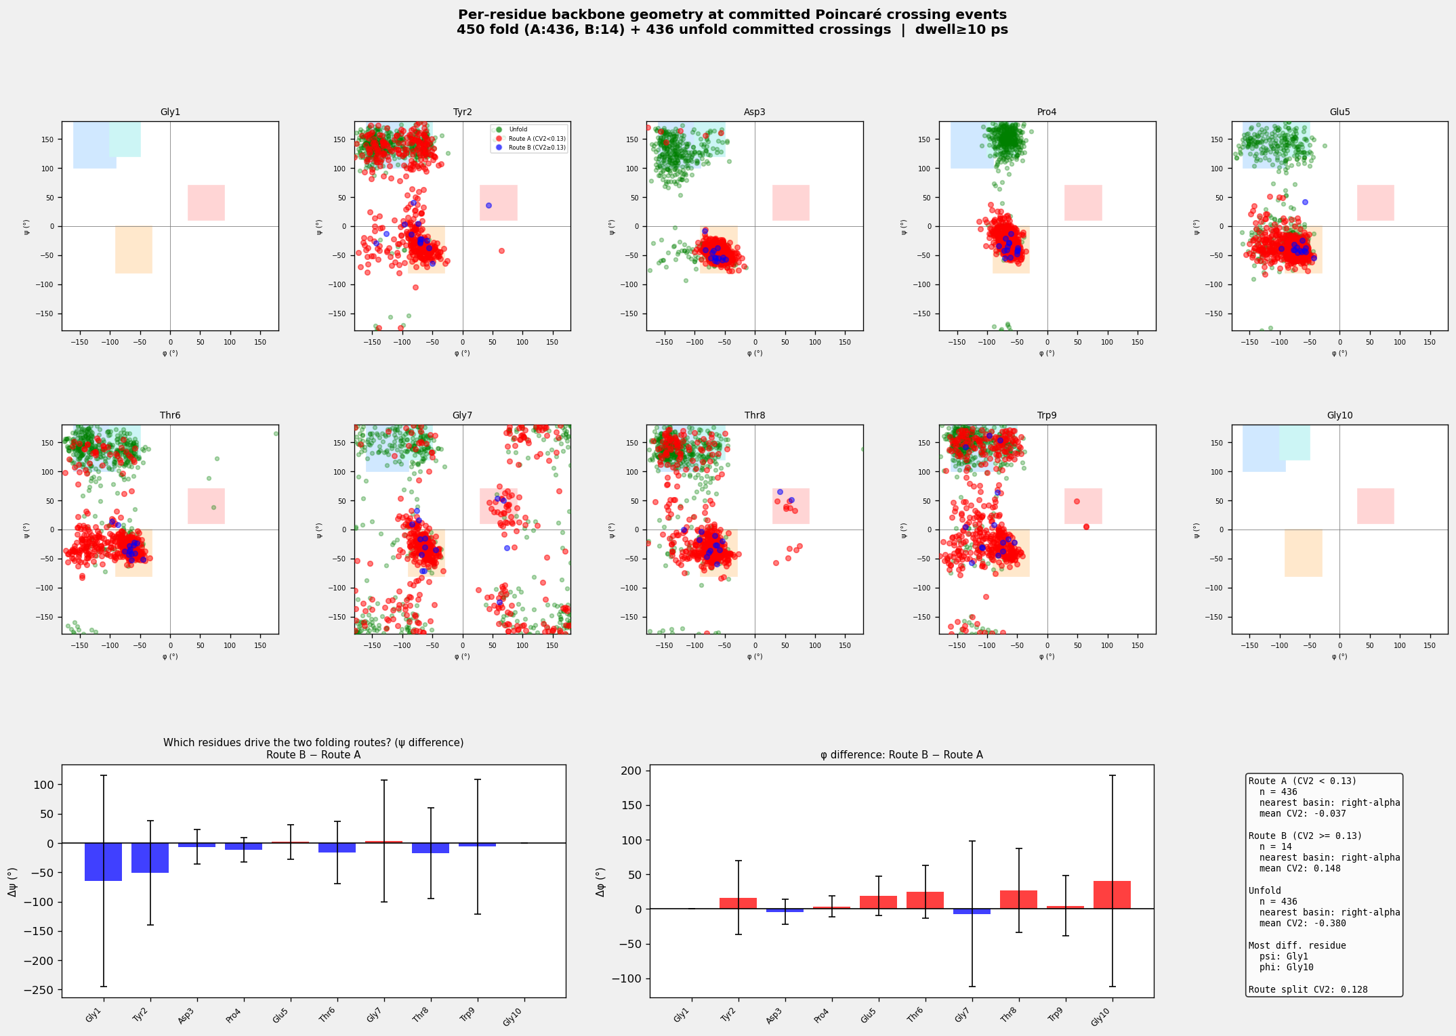
Figure 2. Per-residue Ramachandran plots at committed crossing frames. Top 10 panels: one per residue (Gly1–Gly10); red = Route A, blue = Route B, green = unfold. Background shading: β/extended (blue), PPII (cyan), right-α (orange), left-α (red). Bottom panels: mean ψ and φ differences (Route B − Route A) per residue with standard deviation error bars.

4. Methods and Caveats
- Simulation: GAREUS REUS+HMR-GaMD, 16 replicas, 66 ns, chignolin CLN025 (GYDPETGTWG), explicit TIP3P solvent, OpenMM 8.3+, CUDA.
- CVs: CV1 = nonlocal contact fraction (backbone-heavy, min seq sep 3, r₀=4.8 Å, normalised); CV2 = rama-map (weighted average φ/ψ similarity to 4 Ramachandran basin centres).
- Poincaré analysis: Σ_fold threshold CV1=0.140, Σ_unfold=0.010. Committor dwell filter 10 ps (50 frames at 0.2 ps/frame). Min segment between crossings: 5 frames.
- Torsion extraction: MDTraj 1.x; protein atoms selected via topology.select('protein'); φ/ψ computed via mdtraj.compute_phi/psi; XTC frames matched to crossing steps via traj_interval=50 steps/frame.
- REUS bias caveat: Crossing frequencies and recurrence times are biased by the umbrella potential. Map topology (clusters, diagonal memory) is qualitatively bias-robust; quantitative crossing rates require MBAR reweighting.
- Route B statistics: Only 14 events. Δψ/Δφ values are indicative. More simulation or lower dwell threshold needed for statistical significance.
- Crash artifacts: Two replica final XTC segments (replica_002, replica_006) were malformed (simulation crash at step 5,933,550). Those frames were skipped; earlier segments for those replicas were included normally.

5. Output Files
File | Description
poincare_map.png | Annotated return maps, CV1 distribution, CV2 marginals, recurrence times
poincare_map_summary.json | Threshold values, crossing counts, peak positions, route summaries
poincare_fold_crossings.csv | replica, step, cv2 for each committed fold crossing
poincare_unfold_crossings.csv | replica, step, cv2 for each committed unfold crossing
poincare_residue_torsions.png | Per-residue Ramachandran plots + Δφ/Δψ bar charts
poincare_residue_torsions.csv | event_type, replica, step, cv2, phi_0..phi_N, psi_0..psi_N
poincare_findings.docx | This report

