**The name of the application**: Weather Forecast App

**Application Description**: A smartphone application that offers users a five-day forecast as well as the local weather at the moment. The software locates the user using the device's location capabilities and obtains the pertinent weather information from an online API. Together with a symbol for the current weather, the app shows the current temperature, humidity, wind speed, and other pertinent data. The expected high and low temperatures, likelihood of precipitation, and other weather-related information may all be seen in a thorough five-day forecast, which is also available to users. Users of the app have an easy and practical approach to stay informed about the local weather conditions.

**A diagram showing how the activities are connected**

A star diagram showing the activity for the application

**Mockups of each activity Screen**

Main activity page mockup

Weather Conditions activity Page mockup

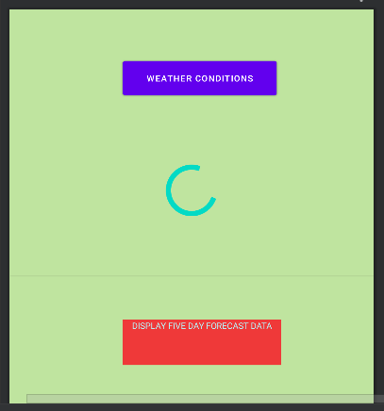

Five Day Forecast Mockup Page

**Details of Web Scraping**

For the Weather app, the app will be scraping weather data from an online API (Application Programming Interface) that provides weather data for a given location. The API will be accessed using HTTP requests from within the app, and the response will be in JSON format. The specific API used may vary depending on the needs of the app and the developer's preferences, but there are many options available such as OpenWeatherMap, Weather Underground, and AccuWeather. These APIs provide a wide range of weather-related data such as current temperature, humidity, wind speed, cloud cover, precipitation chances, and more.

The scraped data will be presented in the app through various UI components such as text views, image views, and icons, depending on the specific data being displayed. For example, the current temperature could be displayed using a text view, while the current weather conditions could be represented by an icon or image view.