**Topic**: Personalized Budget Manager

**Abstract**:

Managing finances effectively is crucial for individuals to reach their goals and maintain stability. Our project’s main objective is to develop a Personal Budget Manager Application that helps users track their expenses, set budgets and achieve their objectives. To ensure a user-friendly platform we will be utilizing technologies such, as Golang, Gin, Postgres, Apache Kafka, Sessions and GORM. With our application users can create accounts securely keep track of expenses categorize their spending habits set budget limits receive notifications and generate reports, for better financial management.

**Keywords: Personal finance management, Expense tracking, Budget planning, Financial goal setting, User authentication, Authorization system, Real-time notifications, Financial reporting, Goal tracking, Expense analysis.**

**1. Introduction**:

Managing personal finances effectively is crucial for individuals to attain financial security and achieve their financial objectives. In today's dynamic economic landscape, where individuals face various financial challenges and obligations, a robust budget management system is indispensable. The proposed Personal Budget Manager Application aims to address the need for comprehensive budget management tools accessible to users across different devices.

With the advent of digital technologies, managing personal finances has become more convenient and efficient. The Personal Budget Manager Application seeks to empower users to take control of their finances by providing features such as expense tracking, budget planning, goal setting, and comprehensive reporting capabilities. By leveraging advanced technologies and intuitive design principles, the application aims to streamline the budget management process and promote financial wellness among users.

The application targets individuals from diverse backgrounds who seek a user-friendly and accessible platform to manage their finances effectively. By providing tools for expense tracking, budget planning, and goal setting, the application aims to empower users to make informed financial decisions and achieve their long-term financial objectives.

The remainder of this report outlines the key features, functionalities, and technologies employed in the development of the Personal Budget Manager Application. Through a comprehensive analysis of user requirements and technological considerations, the report aims to provide insights into the design, implementation, and potential impact of the application on personal finance management.

**Purpose**:

The purpose of the Personal Budget Manager project is to develop a robust application tailored to assist users in managing their personal finances effectively. The project aims to provide a secure and user-friendly platform where individuals can track their expenses, set budget limits, define financial goals, and receive notifications to aid in better financial decision-making. By leveraging modern technologies such as Golang, Gin, Postgres, Apache Kafka, Sessions, and GORM, the project seeks to offer a comprehensive solution to address the diverse needs of users in managing their budgets.

Initial Idea to Achieve:

The initial idea of the project encompasses several key components:

* Implementation of User Authentication and Authorization: Securely managing user accounts and providing authentication mechanisms using email/password authentication.
* Development of Expense Tracking and Categorization: Allowing users to add, edit, and delete expenses while categorizing them for better organization and analysis.
* Incorporation of Budget Planning and Goal Setting: Enabling users to set budget limits for different expense categories and define financial goals such as saving for vacations or paying off debt.
* Integration of Notification System: Sending notifications or alerts to users when they approach or exceed budget limits or when custom expenditures approach a threshold value.
* Implementation of Exceeding Budget Management: Providing users with the option to reallocate excess expenditures from one budget category to another and automatically updating budget categories accordingly.
* Generation of End-of-Month Reports: Generating reports on daily and weekly expenditures, budget goals met, expenditure categorized by categories, and sorting categories based on expenditure for better financial analysis.

**Motivation**:

The motivation behind the Personal Budget Manager project arises from the recognition of the importance of effective budget management in individuals' financial well-being. With the increasing complexity of financial obligations and the need for better financial planning, there is a growing demand for accessible and intuitive budget management tools. The project seeks to address this need by providing users with a comprehensive platform to track expenses, set budgets, and achieve financial goals. By leveraging advanced technologies and implementing user-friendly interfaces, the project aims to empower users to take control of their finances and make informed decisions. Furthermore, the project draws motivation from the potential impact it can have on individuals' lives by promoting financial literacy and responsibility. By providing users with the tools and resources they need to manage their finances effectively, the project aims to contribute to their long-term financial stability and success.

**2.Related Works**:

Factors influencing personal finance management among Indian working professionals include income, saving, education, lifestyle, and residing status. The study [1] identifies income, saving, and education as the most significant factors. It highlights that while respondents generally have positive attitudes towards personal financial planning, their actual practice levels are low.

Budgeting practices among Indian professionals are shaped by the actions, strategies, and power dynamics within their specific field. The paper [2] underscores budgeting as a product of human interaction and practical knowledge. It elucidates how agents with varying viewpoints, trajectories, dispositions, and power relations influence the budgeting process, drawing upon Bourdieu’s theory of practice.

Apache Kafka is a leading open-source data streaming platform that has gained widespread adoption due to its high performance, scalability, and versatility [3]. Apache Kafka supports various use cases, such as event-driven architecture, log aggregation, data integration, and real-time analytics, in domains such as finance, retail, media, healthcare, and more. Apache Kafka also plays a critical role in microservices architecture, where it enables decoupled communication between services and provides real-time event-driven processing capabilities.

Go is designed to be simple, expressive, efficient, and concurrent, with features such as garbage collection, interfaces, goroutines, and channels [4]. Go has a large and active open-source community that contributes to its development and improvement, as well as a rich set of libraries and tools for various domains and applications. Go is widely used at Google and other companies for building web services, cloud infrastructure, distributed systems, and more. Go aims to simplify the problems that arise as software systems grow in complexity and scale, such as dependency management, code readability, testing, and debugging.

The spending and money management practices of college students in India are scrutinized, revealing trends of poor budgeting, inadequate saving, subpar investing, and frequent borrowing. The study [5] delves into the sources of income, expenditure patterns, and financial goals of college students, while suggesting strategies to bolster financial literacy and management among this demographic.

**3. Methodology**:

The methodology for developing the Personal Budget Manager project involves a structured approach to ensure the successful implementation of key functionalities and features. The methodology encompasses several stages aimed at designing, developing, and deploying a robust and user-friendly application for managing personal finances effectively.

1. Requirement Analysis:

Conduct a thorough analysis of user requirements and expectations regarding personal budget management.

Identify key features and functionalities essential for effective budget tracking, expense management, and financial goal setting.

2. Technology Selection:

Evaluate various technologies and frameworks suitable for building a web-based budget management application.

Choose appropriate technologies based on factors such as scalability, security, and ease of integration.

3. System Design:

Design the architecture and database schema for the Personal Budget Manager application.

Define data models for user profiles, transactions, expense categories, and budget plans.

Establish the user interface layout and navigation flow to ensure a seamless user experience.

4. Implementation:

Develop the backend infrastructure using Golang and Gin framework to handle user authentication, data persistence, and business logic.

Utilize Postgres as the relational database management system to store user data securely.

Implement features such as expense tracking, categorization, budget planning, and goal setting using appropriate algorithms and techniques.

Integrate Apache Kafka for real-time notifications and alerts regarding budget limits and expenditure thresholds.

5. User Interface Development:

Design and develop a responsive and intuitive user interface using HTML, CSS, and JavaScript.

Ensure cross-device compatibility and accessibility to enable users to access the application from desktops, tablets, and smartphones.

6. Testing and Quality Assurance:

Conduct comprehensive testing of all application components.

Identify and rectify any bugs, errors, or usability issues to ensure the application meets user expectations and requirements.

7. Deployment and Maintenance:

Deploy the Personal Budget Manager application to a reliable hosting environment, such as a cloud platform or dedicated server.

**Flowchart**:

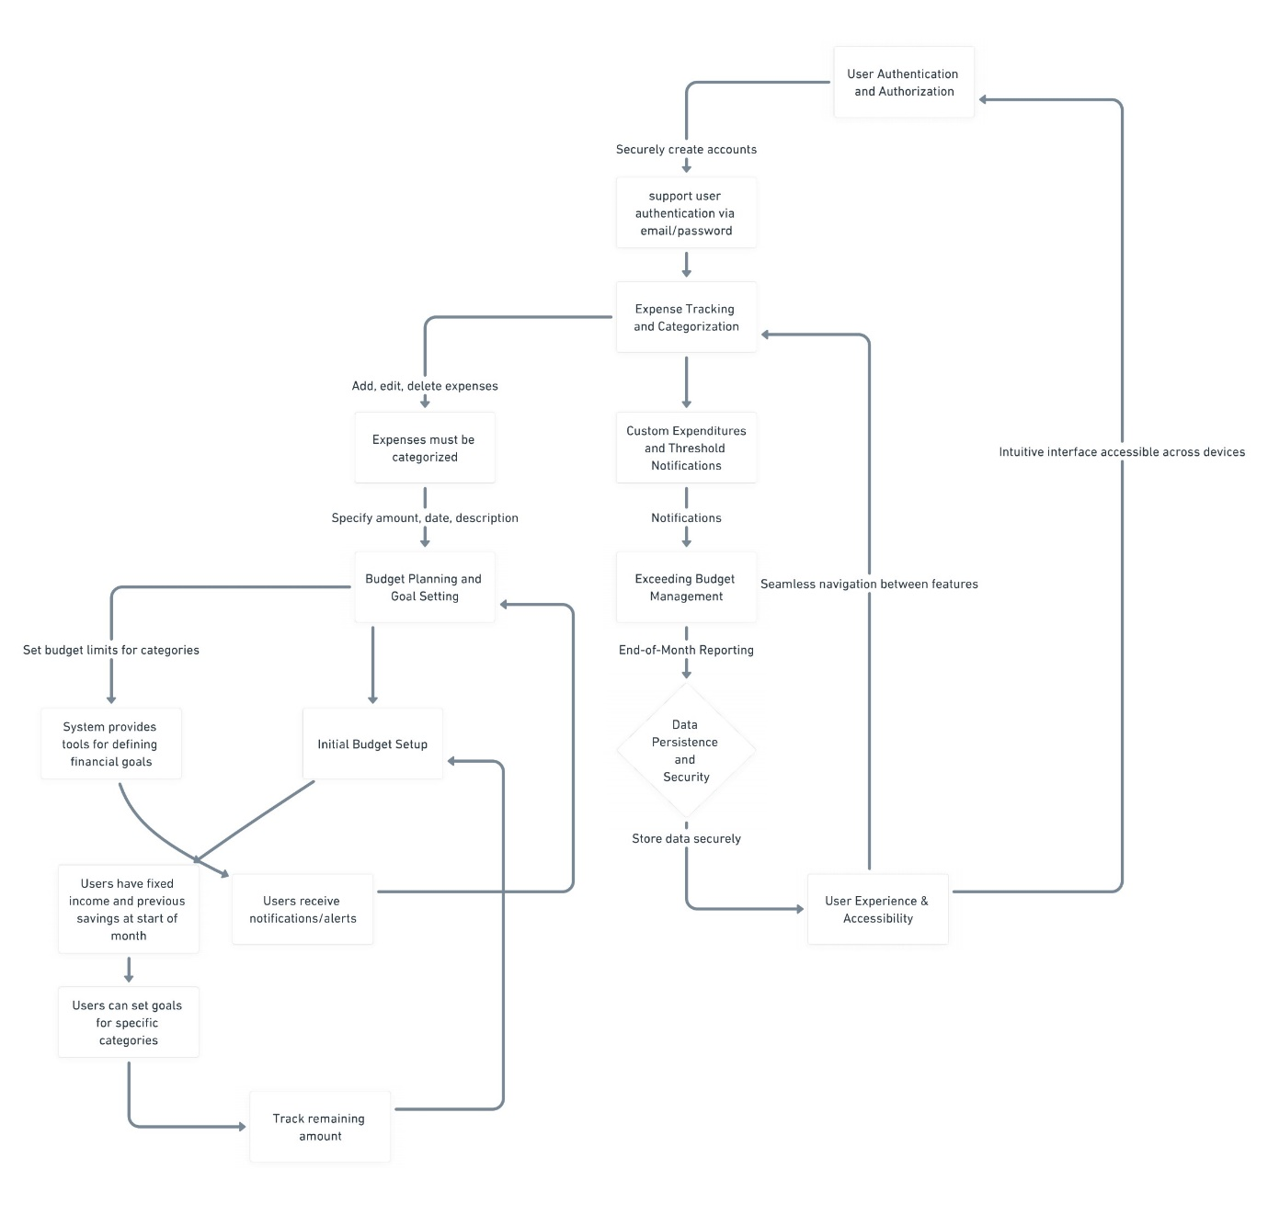

**4. Software Requirements**:

The software requirements for the Personal Budget Manager project are as follows:

4.1 Technology Stack:

* Programming Language: Golang
* Web Framework: Gin
* Frontend Framework: ReactJS
* Database Management System: Postgres
* Message Broker: Apache Kafka
* Session Management: Sessions
* Object-Relational Mapping (ORM): GORM
* API Testing and Documentation: Postman

4.2 Libraries and Dependencies:

Golang Packages:

* "github.com/gin-gonic/gin" for implementing web routes and handling HTTP requests.
* "github.com/jinzhu/gorm" for interacting with the database and managing object-relational mapping.
* "github.com/lib/pq" for connecting to and querying the PostgreSQL database.
* "github.com/segmentio/kafka-go" for integrating with Apache Kafka message broker.
* "github.com/gorilla/sessions" for managing user sessions and authentication tokens.
* Additional packages for data validation, encryption, and error handling as required.

4.3 External Dependencies:

* Postgres Database: Utilized for storing user profiles, transactions, and budget plans securely. Requires installation and configuration of PostgreSQL database server.
* Apache Kafka: Utilized for real-time communication and event-driven architecture. Requires installation and setup of Apache Kafka message broker.

4.4 Web Application Interface:

Frontend Components:

* ReactJS for building the user interface and implementing client-side interactions.
* HTML, CSS, and JavaScript for designing and styling the user interface components.

**Plan of action**:

* Week 1-2: Project Setup and Planning
  + Define project scope, objectives, and requirements based on provided criteria.
  + Set up development environment with Golang, Gin, PostgreSQL, Kafka, and create initial wireframes and database schema.
* Week 3-4: Backend Development
  + Implement user authentication and authorization system with secure account creation.
  + Develop CRUD operations for expenses and budget categories, integrating Kafka for real-time notifications.
* Week 5-6: Frontend Development with ReactJS
  + Design and implement user interface components using ReactJS for intuitive user experience.
  + Develop expense tracking interface allowing users to specify details and budget planning tools for financial goals.
* Week 7: Integration, Testing, and Deployment
  + Integrate frontend and backend components to ensure seamless communication.
* Week 8: Final Testing, Documentation, and Deployment
  + Generate end-of-month reports and finalize project documentation. Deploy application to production environment ensuring data persistence and security measures.

**References**

[1] Personal Finance Management Of Indian Working Professionals: An Empirical Study by Harpreet Singh, D. D. Chaturvedi, and Anuradha Jain (2018) in https://www.webology.org/data-cms/articles/20220325060733pmwebology%2015%20%281%29%20-%202%20pdf.pdf

[2] Budgeting as practice and knowing in action: experimenting with Bourdieu’s theory of practice: an empirical evidence from a public university by Chaturika Priyadarshani Seneviratne and Ashan Lester Martino (2021) in https://www.emerald.com/insight/content/doi/10.1108/AJAR-08-2020-0075/full/html

[3] Exploring the Power of Apache Kafka: A Comprehensive Study of Use Cases by Sameer Shukla (2023) in http://www.ijlemr.com/papers/volume8-issue03/8-IJLEMR-77768.pdf

[4] The Go Programming Language by Andrew Gerrand (2014) in https://ieeexplore.ieee.org/abstract/document/6898707

[5] Trends in Spending and Money Management Practices among College Students by S. S. S. Kumar and S. S. S. Kumar (2015) in https://ijcrt.org/papers/IJCRT2007222.pdf