6.ReactJS-HOL

**Objectives**

* **Understanding the need for styling React components**: To visually enhance the user interface and present information effectively.
* **Working with CSS Module and inline styles**: Employing two distinct methods for applying styles.
* **Style a React component**: The practical application of styling techniques.
* **Define styles using the CSS Module**: Creating modular, scoped CSS for components.
* **Apply styles to components using className and style properties**: Utilizing React's methods for class and inline styling.

**Code**

Trainer.js

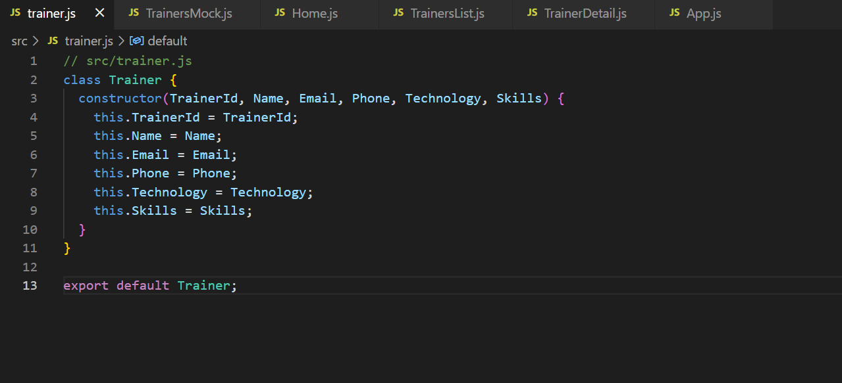

TrainersMock.js

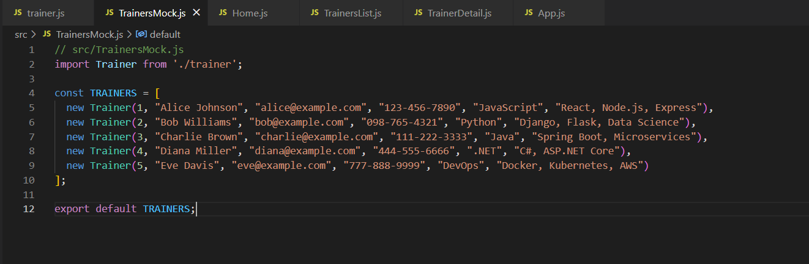

TrainersList.js

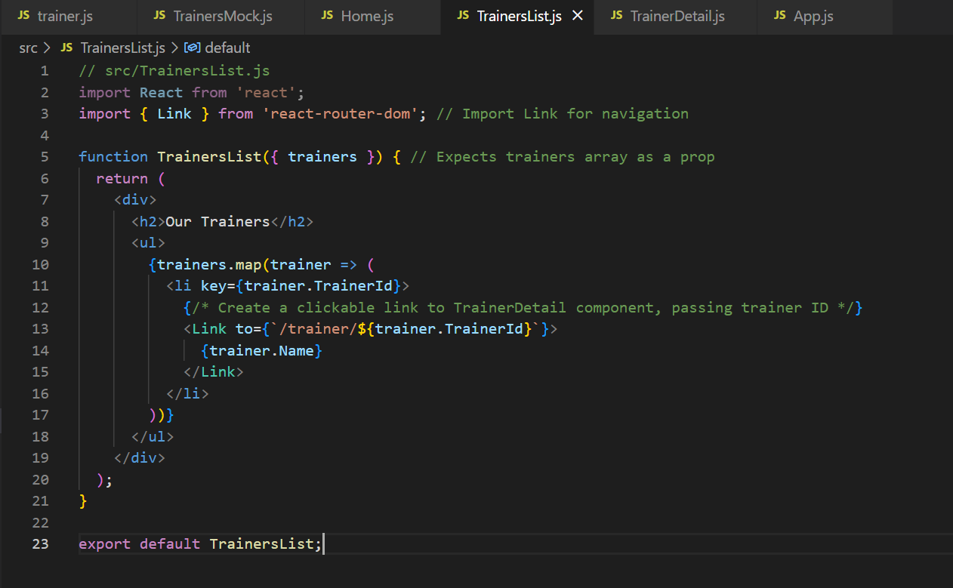

TrainerDetail.js

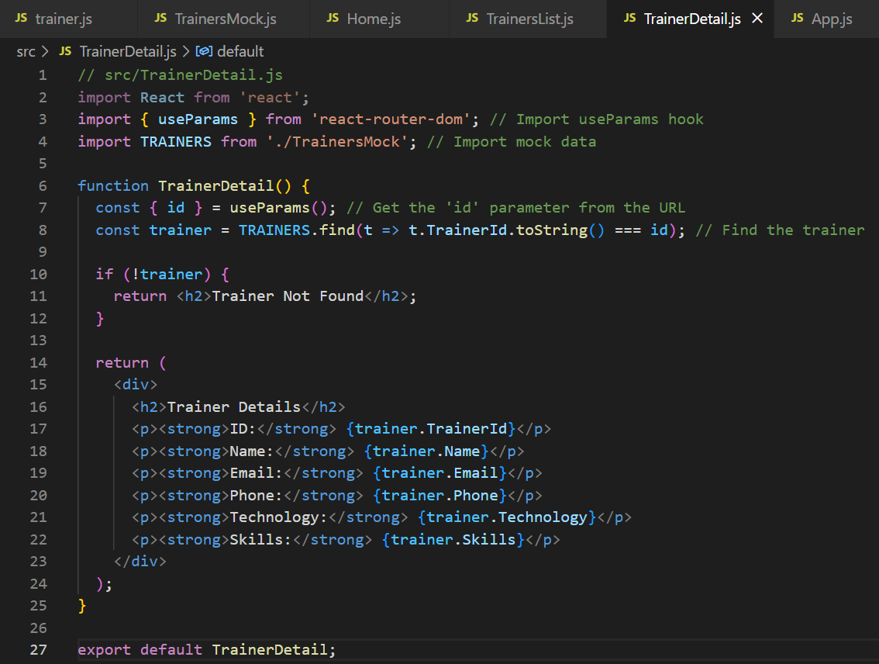

Home.js

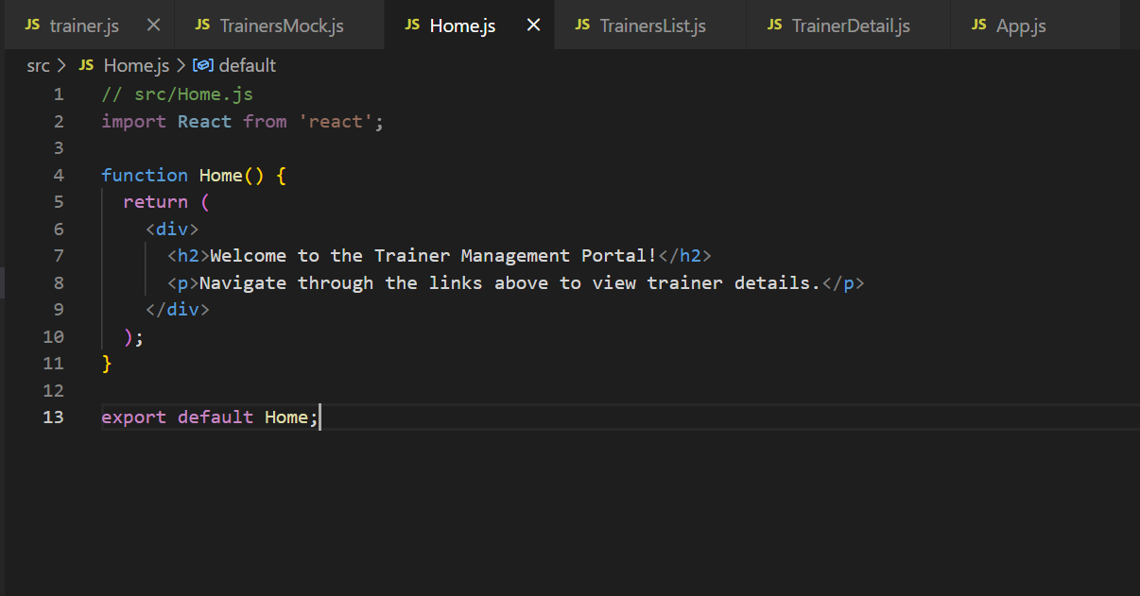

App.js

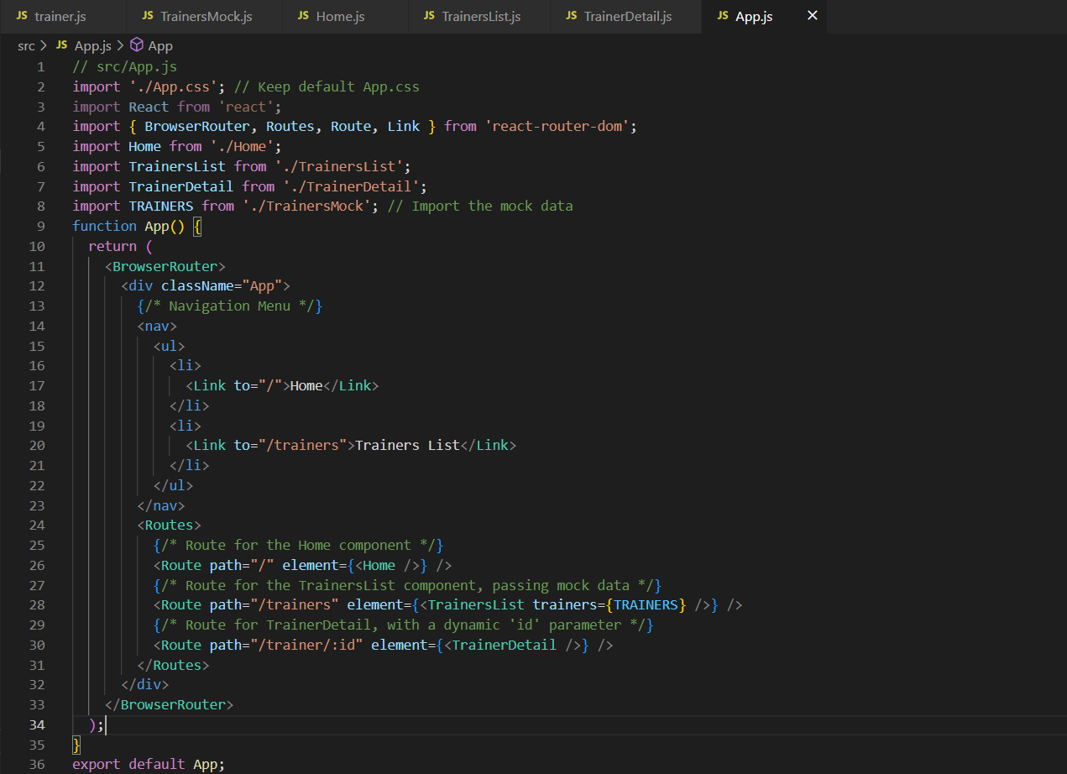

**Output:**

