7.ReactJS-HOL

**Objectives**

* **Define Props**: Understand that props (short for properties) are arguments passed into React components.
* **Explain Default Props**: Learn how to set default values for props if they are not explicitly provided.
* **Identify the differences between State and Props**: Differentiate between props (immutable, passed from parent) and state (mutable, managed within the component).
* **Explain ReactDOM.render()**: Understand its role in rendering React elements into the DOM (though in modern Create React App, this is typically handled in index.js).

ShoppingApp

**Code**

Cart.js

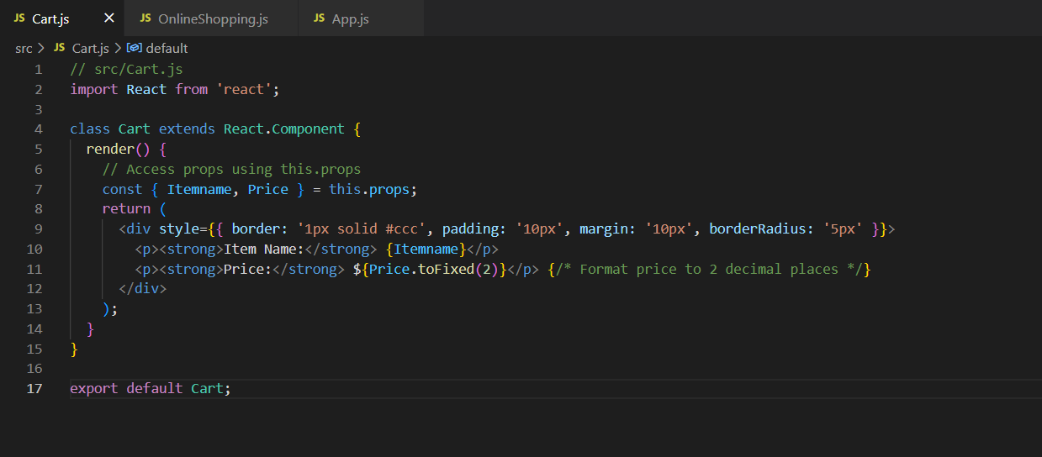

OnlineShopping.js 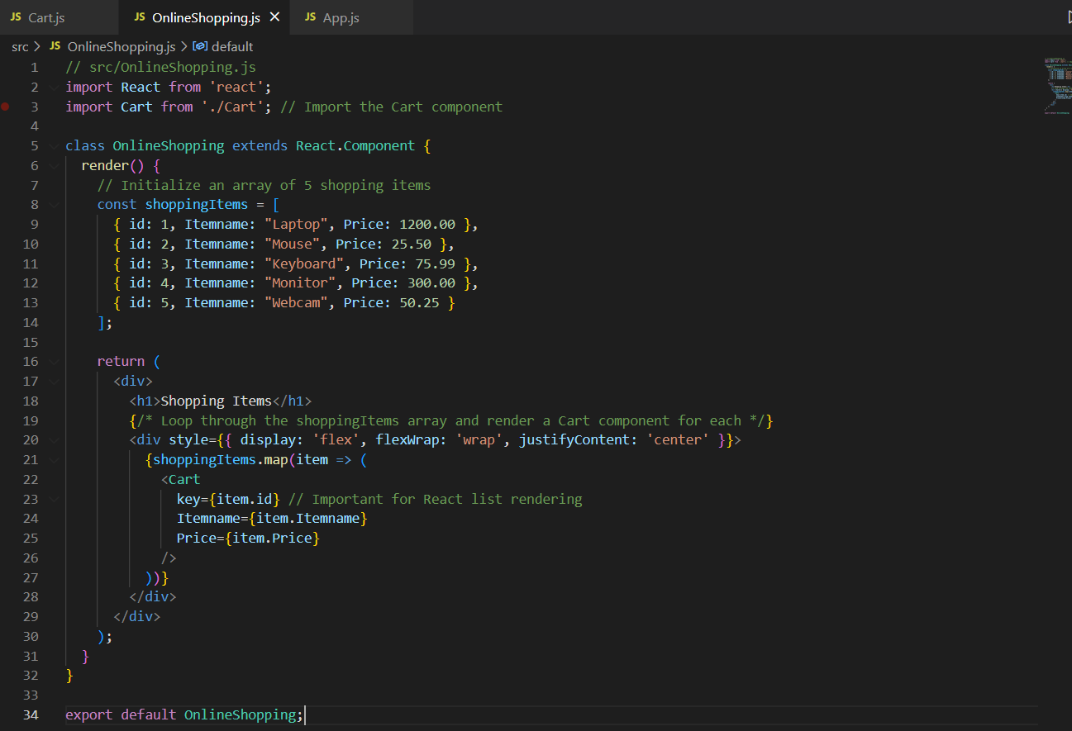

App.js

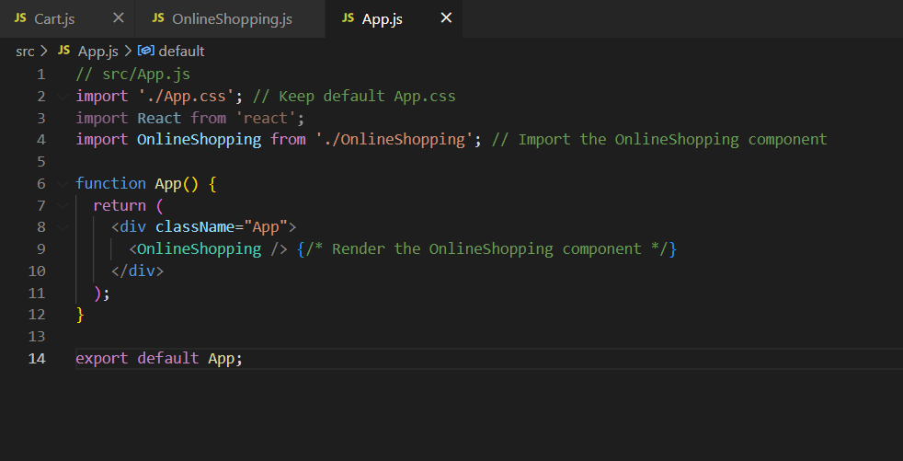

Output:

