10.ReactJS-HOL

**Objectives**

* **Explain the useEffect Hook**: useEffect is a Hook that lets you perform side effects in function components. It serves the same purpose as componentDidMount, componentDidUpdate, and componentWillUnmount in React class components.
* **Identify the use of useEffect Hook**: It's typically used for data fetching, subscriptions, manually changing the DOM, timers, and logging. It runs after every render of the component by default, but its behavior can be controlled using its dependency array.

**Hands-on Lab: Student Marks Application**

In this hands-on lab, you will learn how to:

* Implement useEffect to fetch student marks (mock data or from an API).
* Implement useEffect to trigger actions when specific data (e.g., marks) changes.

**Student Marks app**

**Code:**

StudentMarks.js

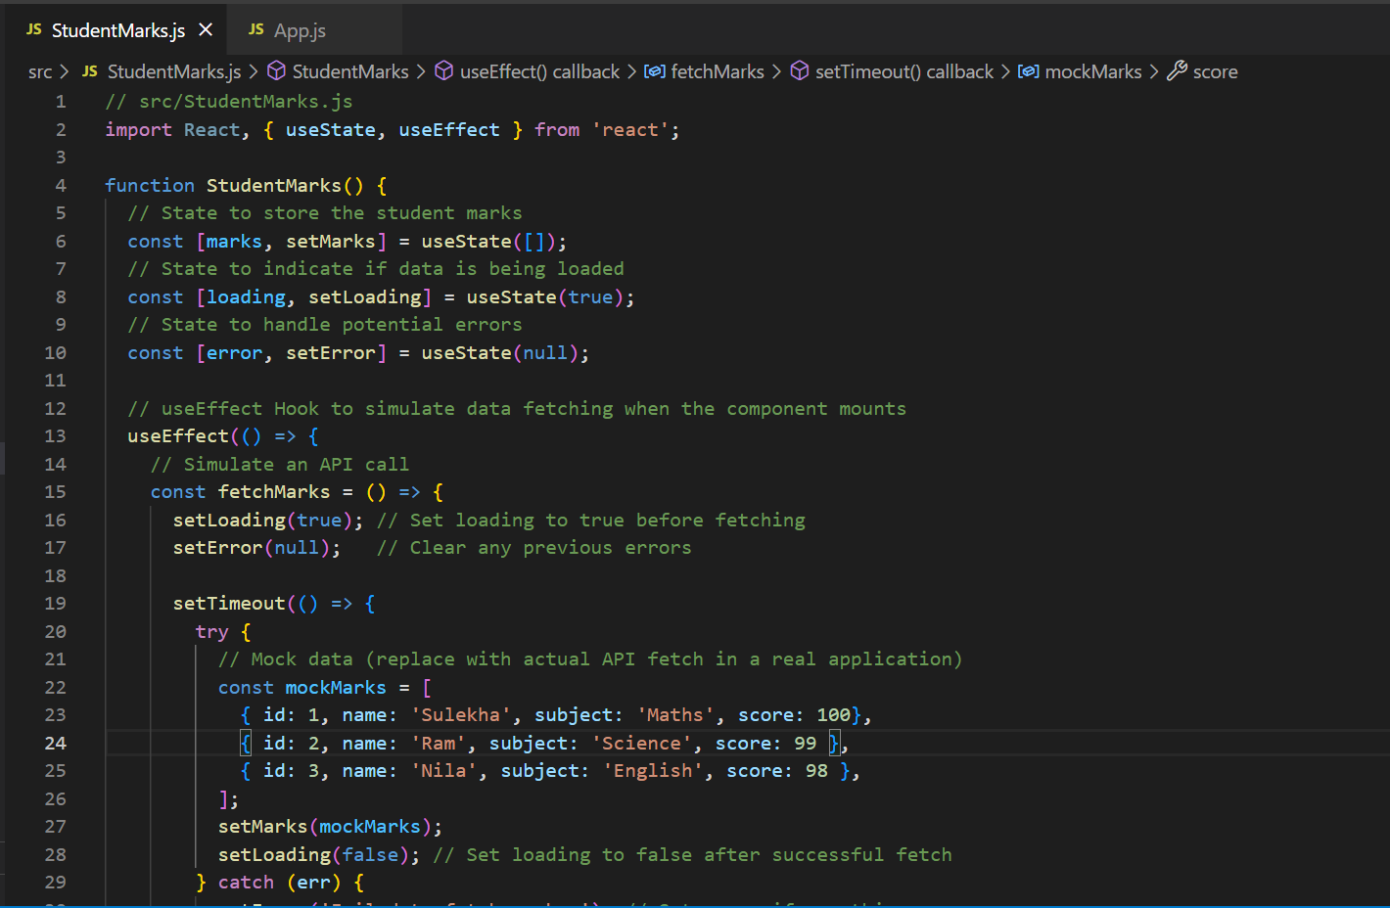

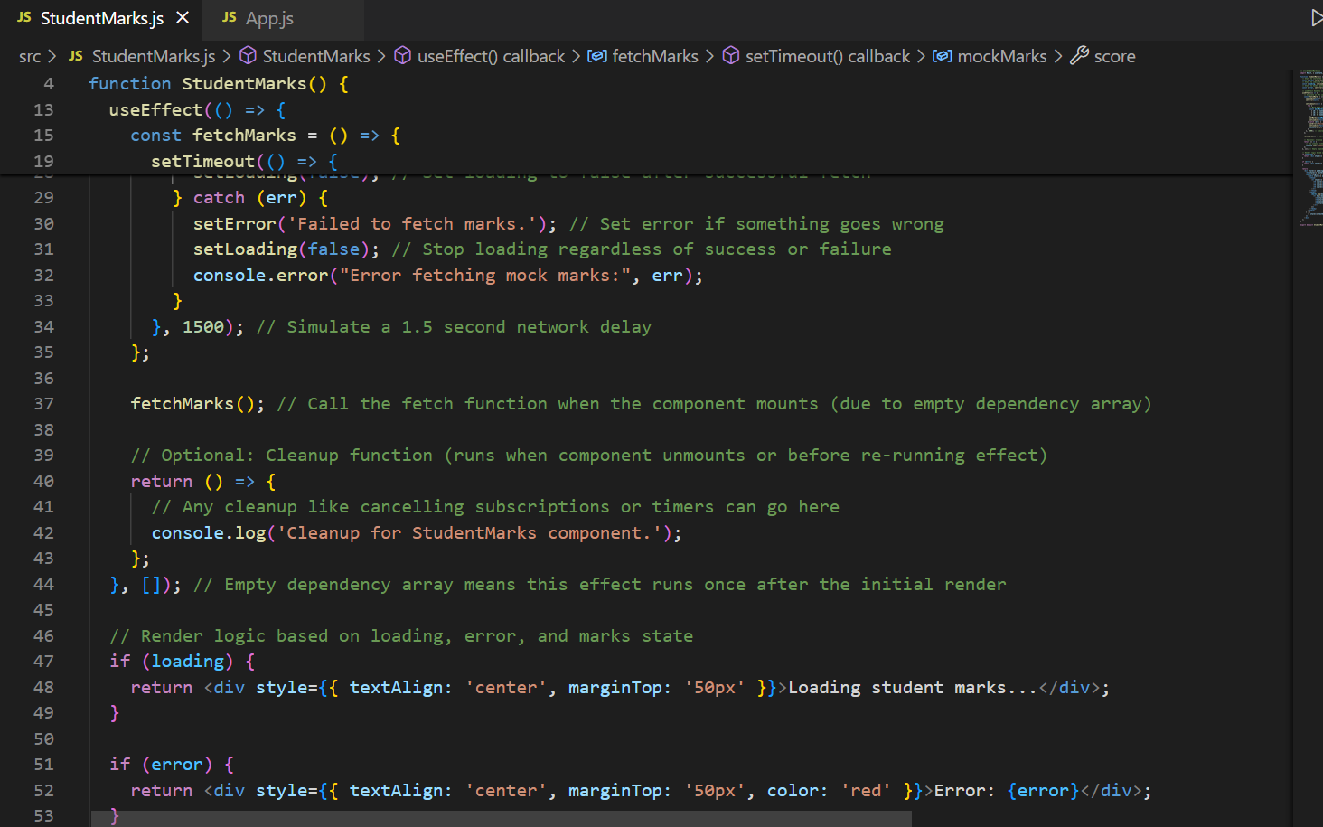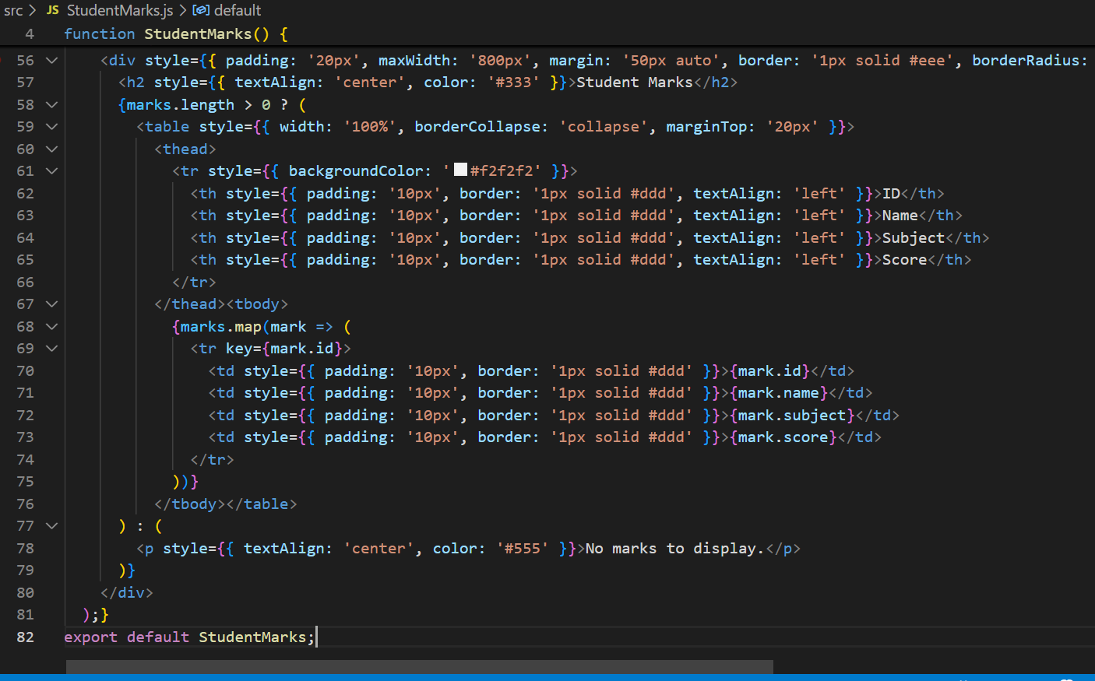

App.js

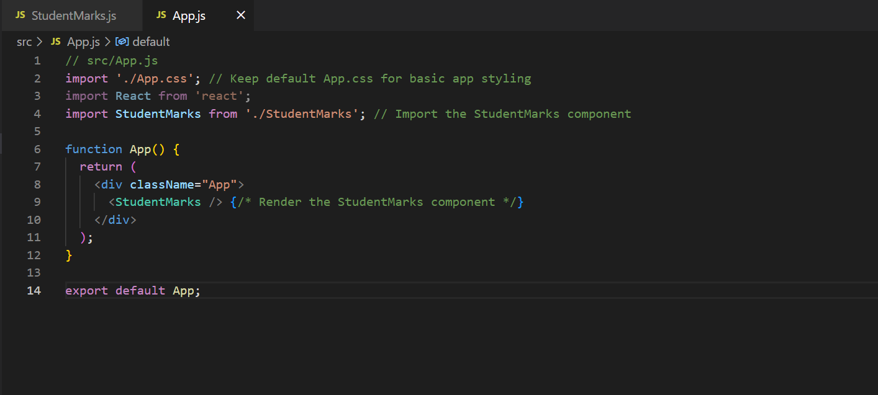

**Output:**

