11.ReactJS-HOL

**Objectives**

* **Explain the useState Hook: useState is a React Hook that lets you add state variables to function components. It returns a pair: the current state value and a function to update it. It's essential for managing data that changes over time within a component.**
* **Explain the useEffect Hook: useEffect is a React Hook that lets you perform side effects in function components. It's used for tasks like data fetching, subscriptions, or manually changing the DOM. Its behavior can be controlled by a dependency array, allowing it to run on mount, on updates to specific variables, or on unmount.**
* **Identify the use of useState and useEffect Hooks: Learn how to combine these hooks to create interactive features, such as filtering data based on user input.**

**Trainer Search App**

**Code:**

TrainersMock.js

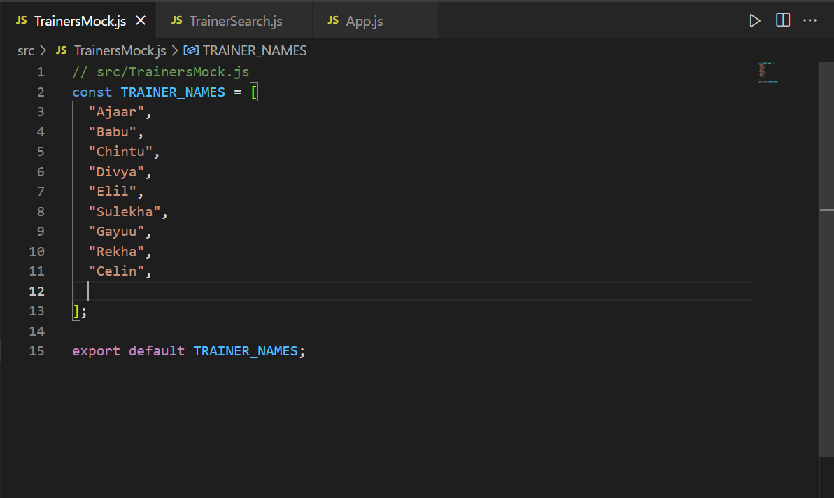

TrainerSearch.js

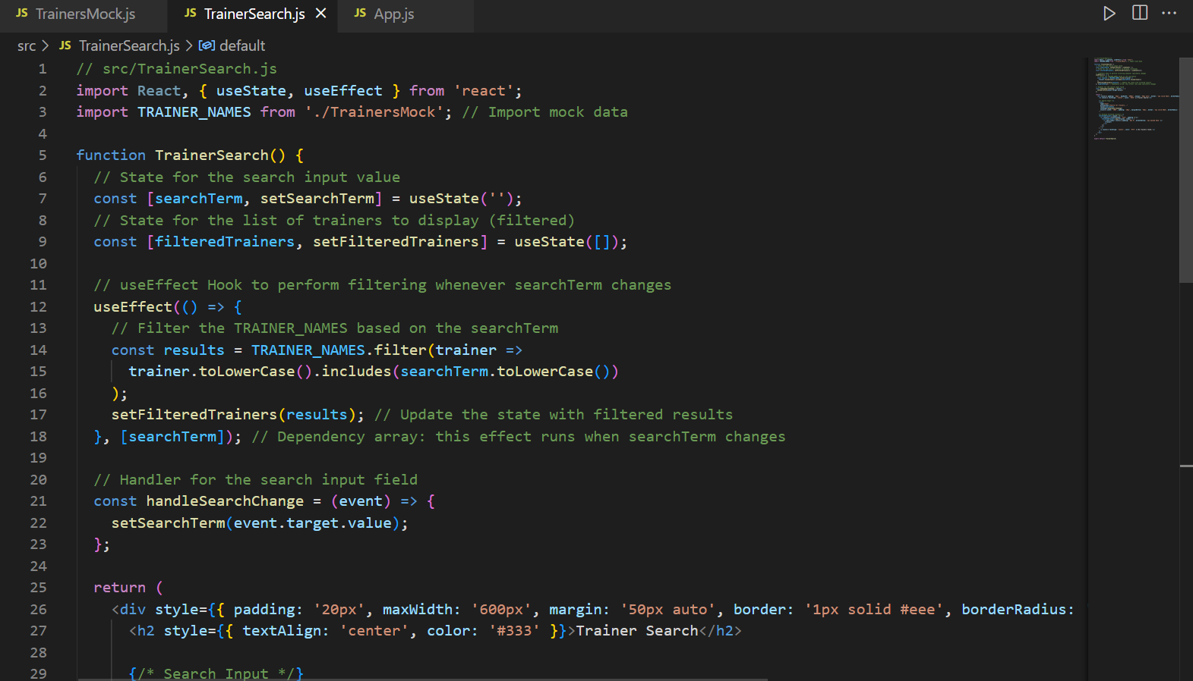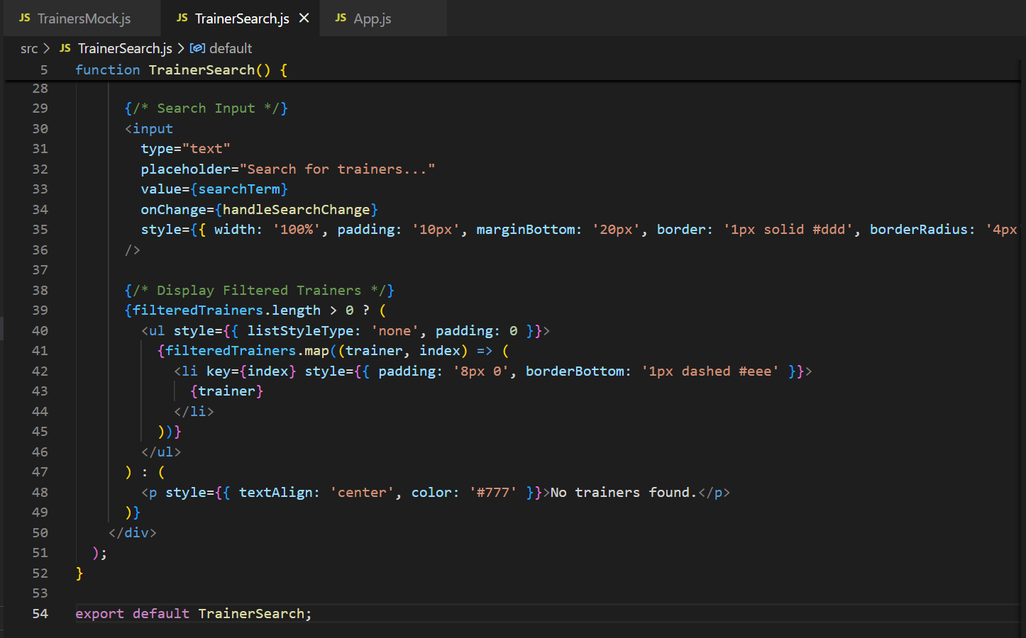

App.js

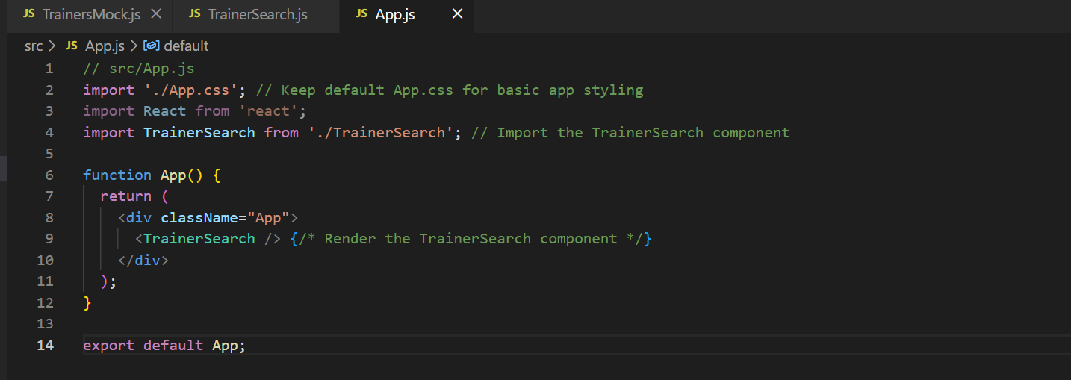

**Output:**

