13.ReactJS-HOL

**Objectives**

**Explain the need and Benefits of Context API**: React Context provides a way to pass data through the component tree without having to pass props down manually at every level. This is useful for "global" data like the current authenticated user, theme, or preferred language. It simplifies prop drilling in deeply nested components.

**Identify the Context Components**: Learn about createContext, Provider, and Consumer (or useContext Hook for function components).

**Create Context API in React Applications**: Learn the steps to define and utilize a Context.

Themes App

**Code:**

ThemeContext.js

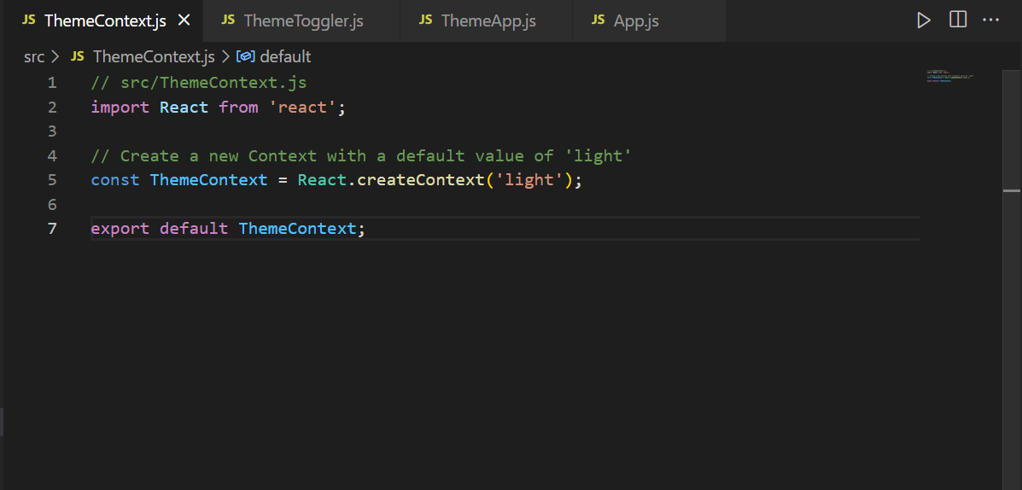

ThemeToggler.js

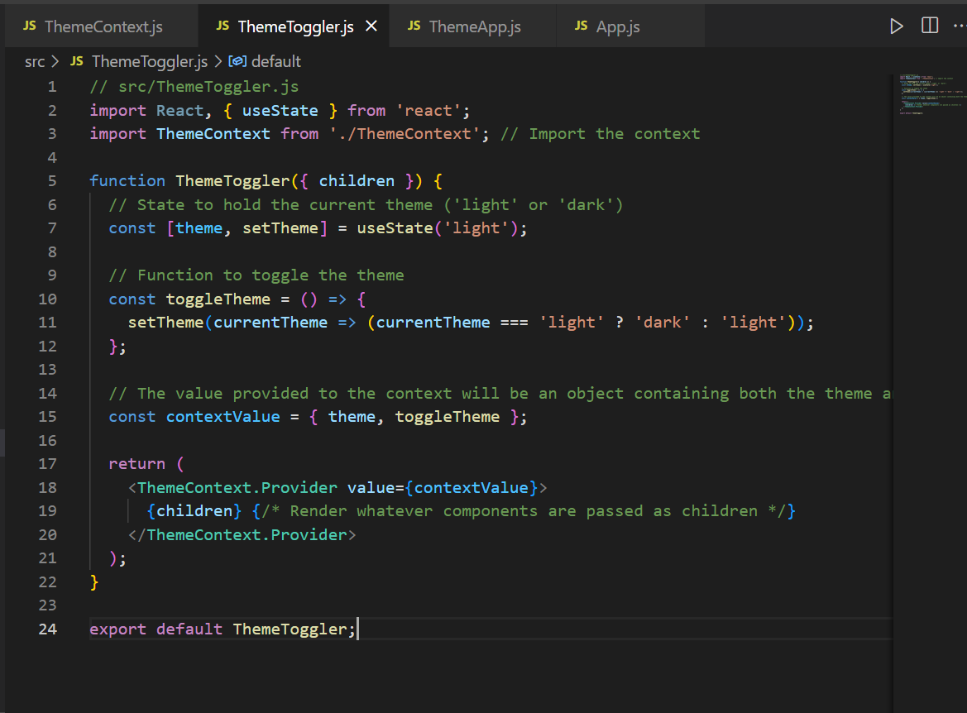

ThemeApp.js

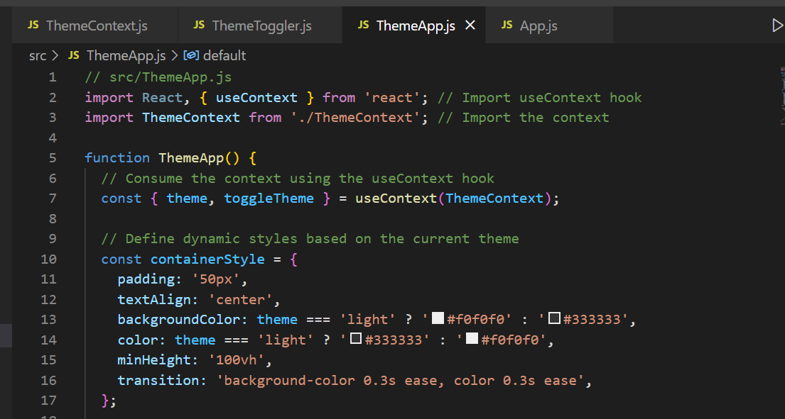

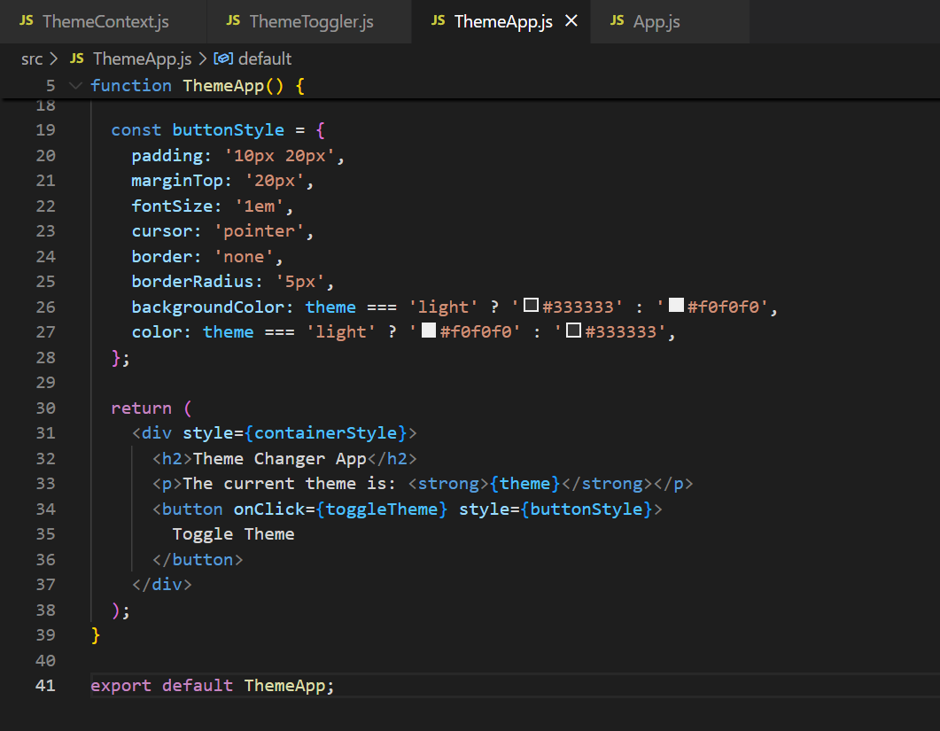

App.js

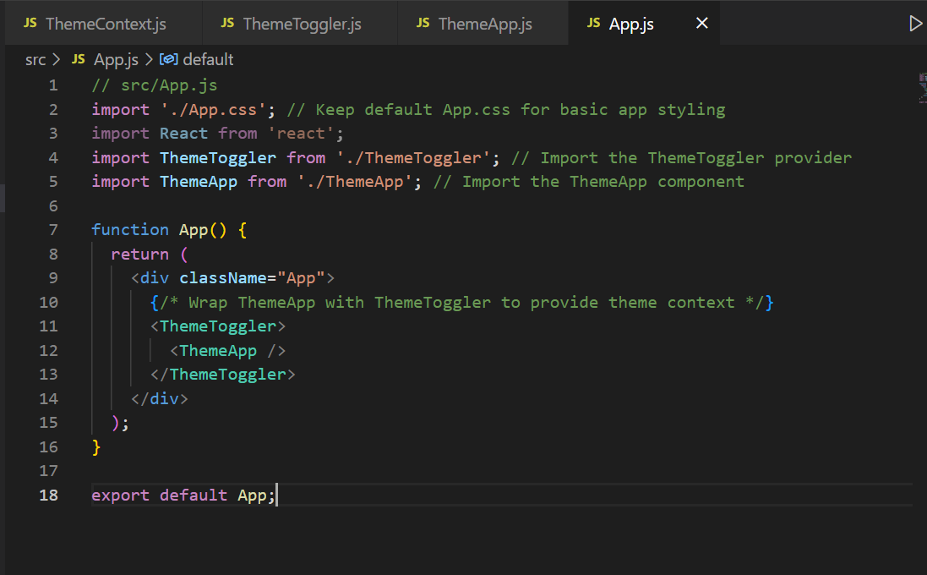

**Output:**

