9.ReactJS-HOL

**Objectives**

* **Explain the need of Hooks**: Hooks are functions that let you "hook into" React state and lifecycle features from function components. They allow you to write functional components with state and side effects, making it easier to reuse stateful logic without using class components.
* **Identify types of Hooks**: Key React Hooks include useState, useEffect, useContext, useReducer, useCallback, useMemo, useRef, etc.
* **Explain useState Hook**: useState is a Hook that lets you add React state to function components. It returns a pair: the current state value and a function that lets you update it.
* **Identify the use of useState Hook**: It's used to declare state variables in function components, enabling components to manage and react to changes in data.

Student Login Application

**Code:**

Login.js

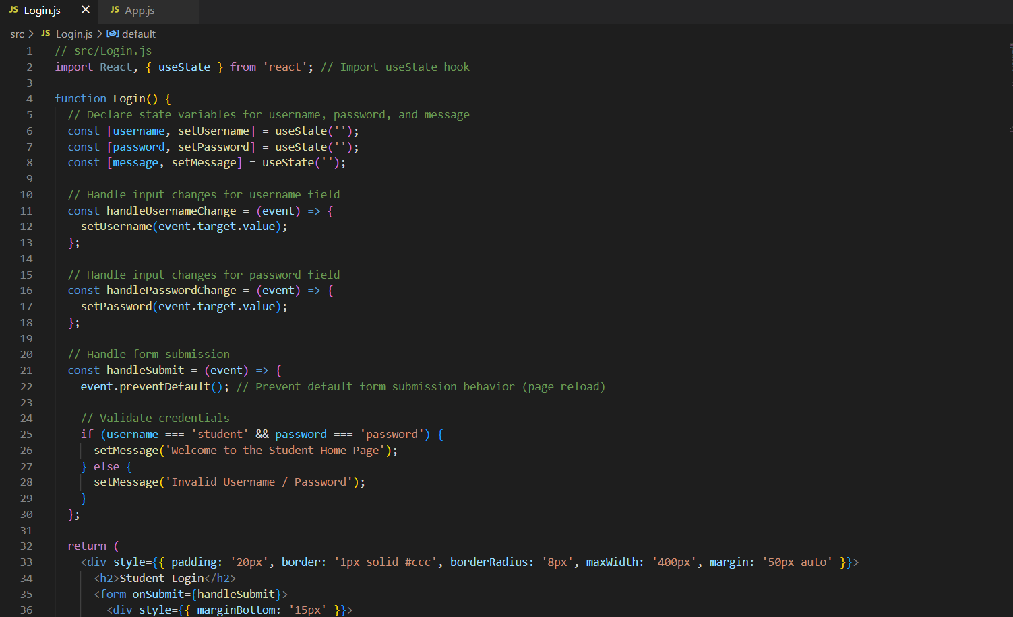

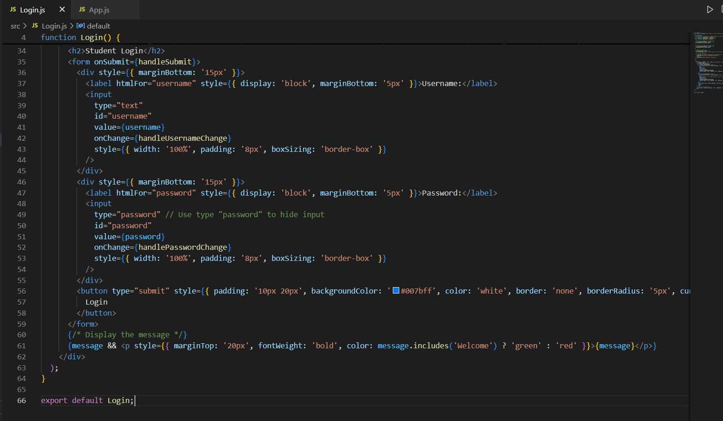

App.js

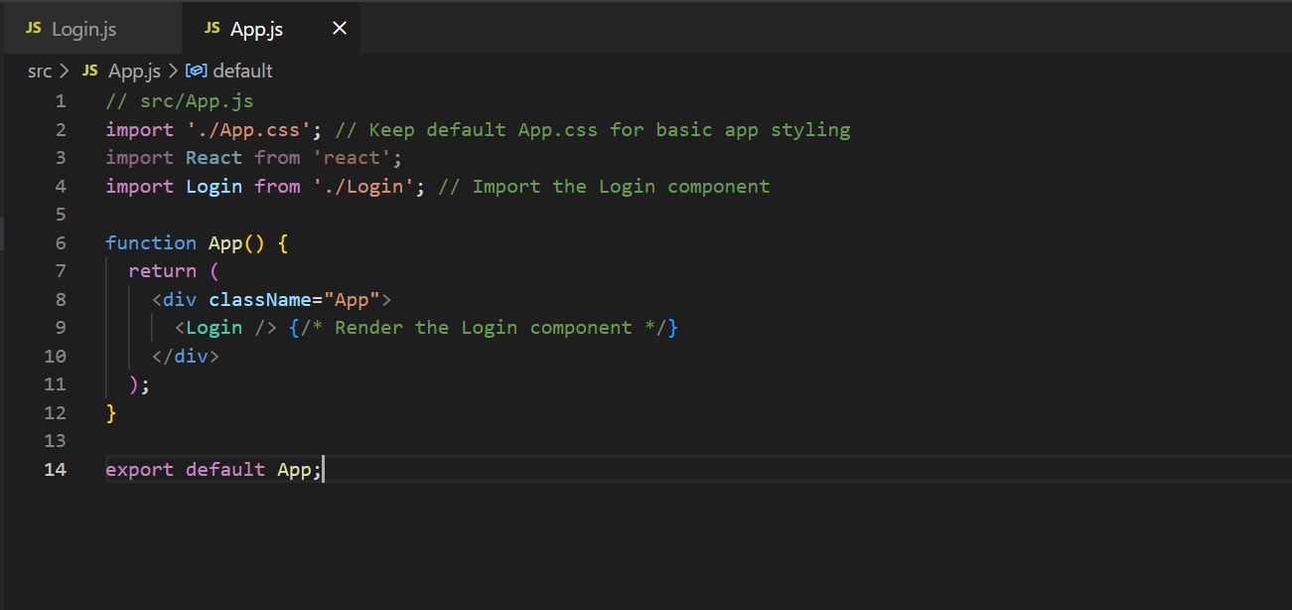

**Output:**

