1-usestaticarray

Screenshot of adding elements to one array

The code in this example is bad due to the loop set to 10 but the first array only has 4 elements leading to writing beyond array1 and causing more problems later on.

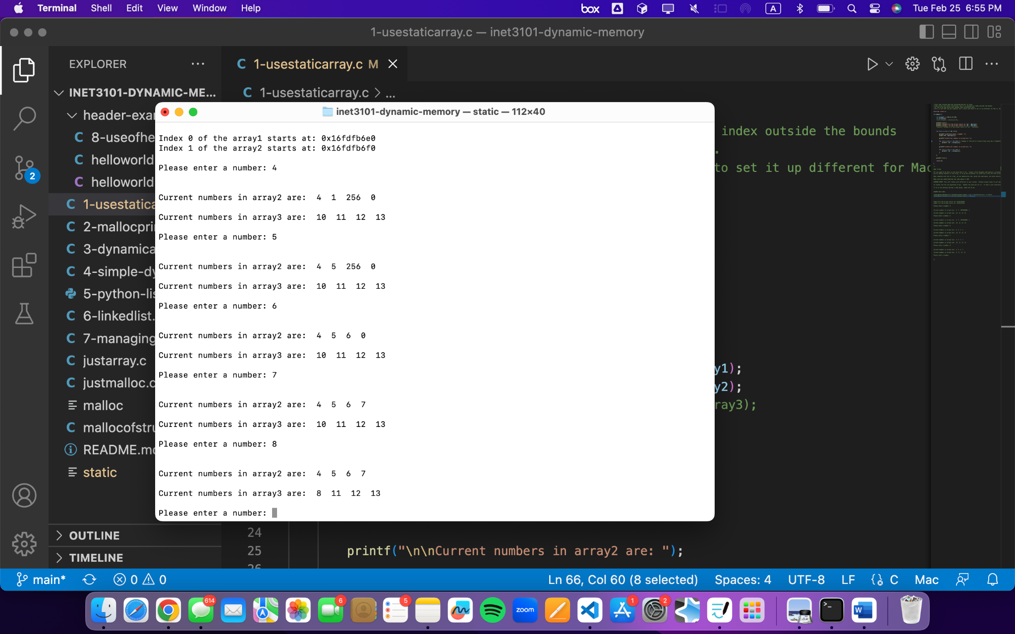

3-Dynamically-allocating

Instead of using a for loop like earlier, it’s much better to use a while loop since you can keep prompting the user and it’s not just a specific amount of inputs. This is much more efficient since it allows it to resize using the realloc() if it’s too much memory being used. This is much more flexible since it’s not limited and better when it comes to dynamically programming. No loss of the current data and it allows for extra space as needed.

4-simple-dynamic-example

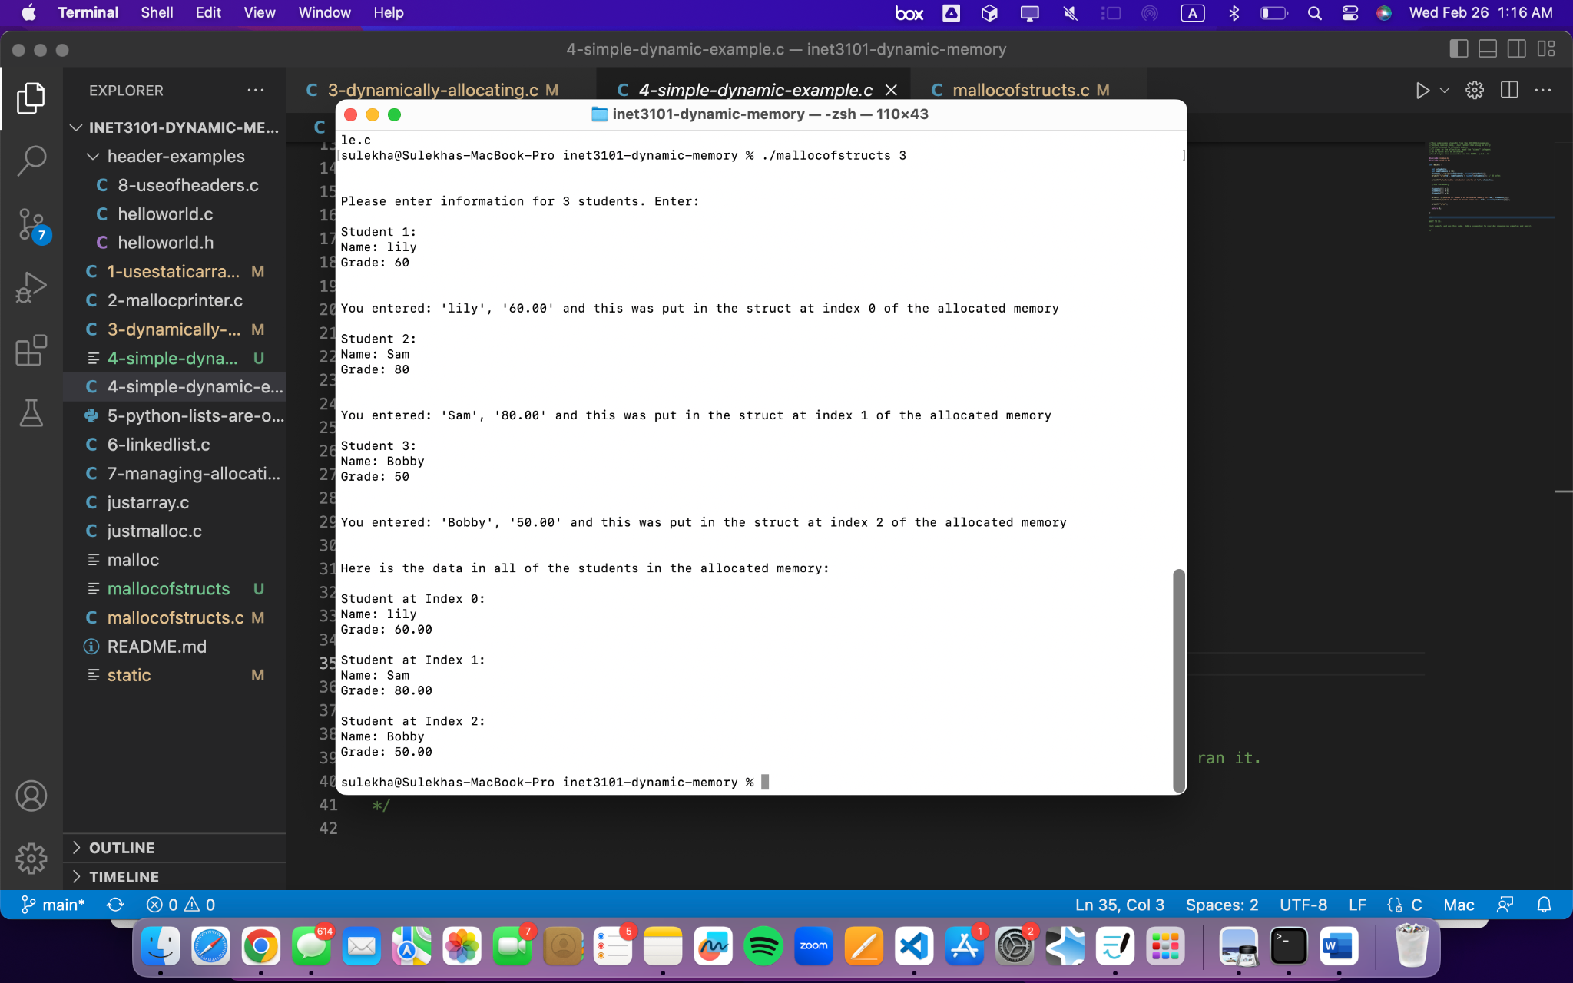

5-python-lists-are-objects-not-array

Define what an Object is in terms of the Object Oriented Programming paradigm.

An object is an instance of a class where it holds both attributes and methods/functions. Objects are basically created from classes, where classes are like the blueprint part of it. Based on the class, many objects can be created. A python list is actually an object because it doesn’t just simply hold numbers, etc but also has built-in functions that can be easily managed. These types of built-in functions can be the .append, .sort(), etc. Python lists embody what CoPilot is because it’s very simple and it's helpful as you don’t need to manually do everything when it comes to memory. Python lists just automatically adjust the size and manage memory and this is because the python list behind the scenes handles that memory management.

6-linkedlist

Write a short paragraph:

How does using a linked list solve some of the same problems we are trying to overcome when using dynamic memory?

Using a linked list solves some of those same problems in a much better way compared to dynamic memory. This is because linked lists allow adding new elements more easily and basically anywhere in memory without needing certain memory. On the other hand, dynamic memory allows adding new elements as well but can be way more complex than linked lists since it might require moving certain pieces of data around. Linked lists have less problems that deal with running out of space and making adding and deleting less complicated as well.

Mallocofstructs

