KEY FUNCTIONALITY
1.search for a book
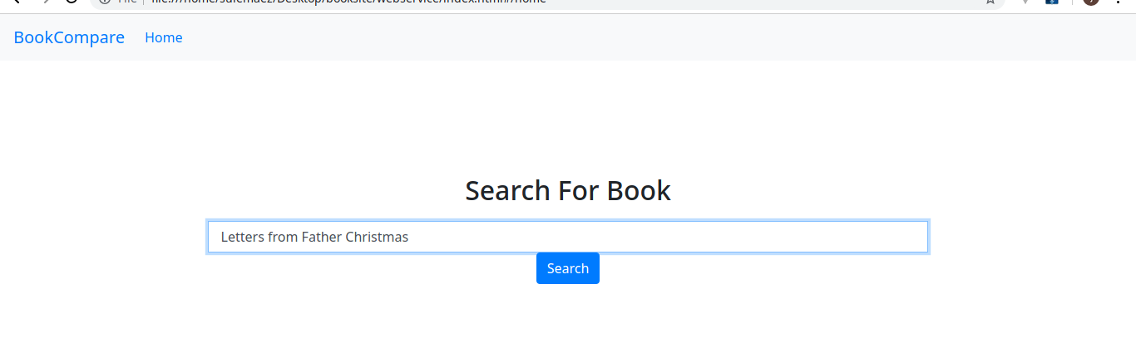
2.Get the results matched
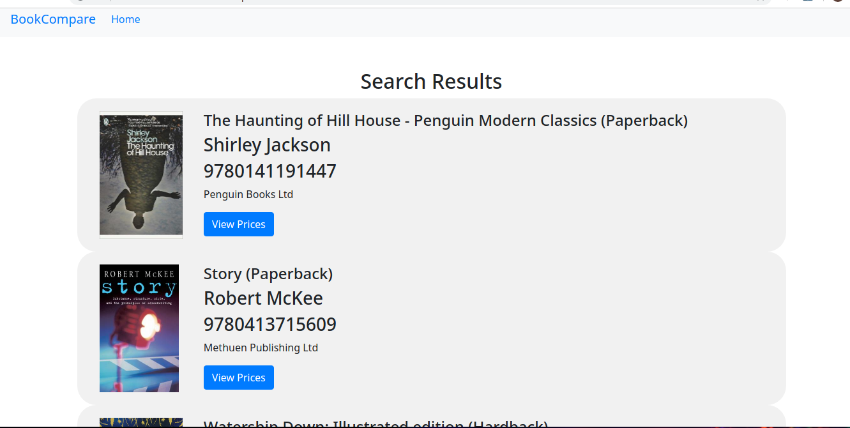

3.See the comparisions of a book

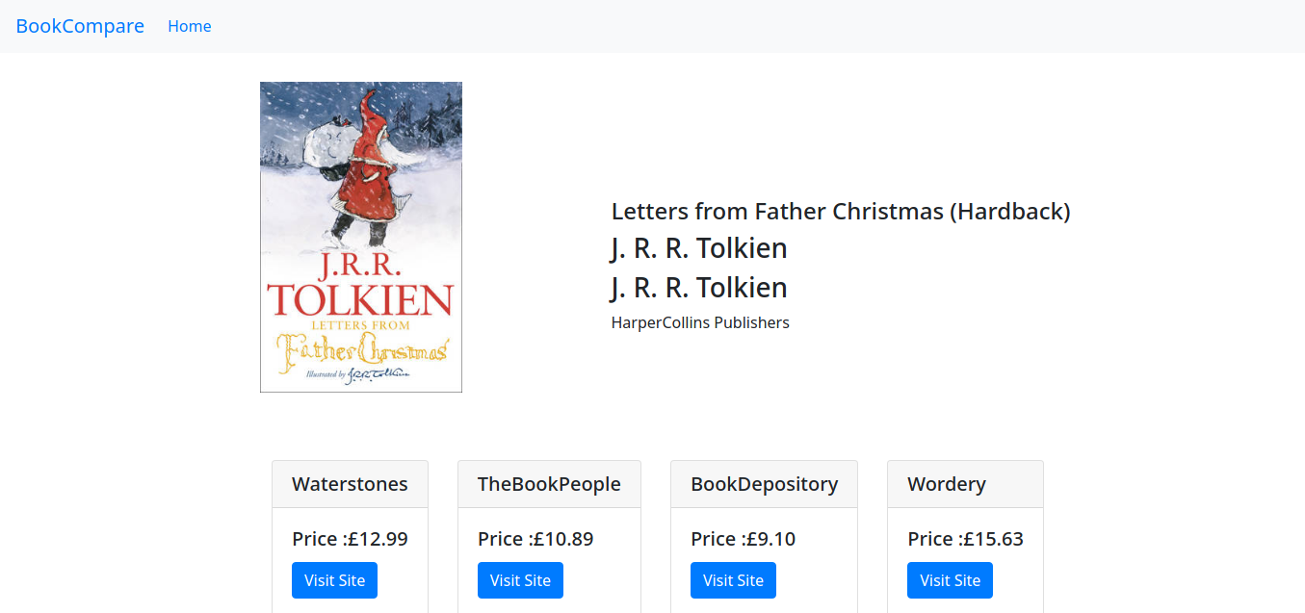
HOW IT WORKS
The data about the books is scrapped from five online bookstores.
1.Wordery
2.Blackwell
3 .The Book People
4.Book Depository
5.Waterstones

The webscrapper java spring application handles the scrapping and stores the information in the database.First a list of books is gotten from waterstones then information about the book is search from all the sites and then stored.The information stored is the Book details in a table called books,the different retailer of a book in a table called prices and the detilas of publishers in a table called publishers.
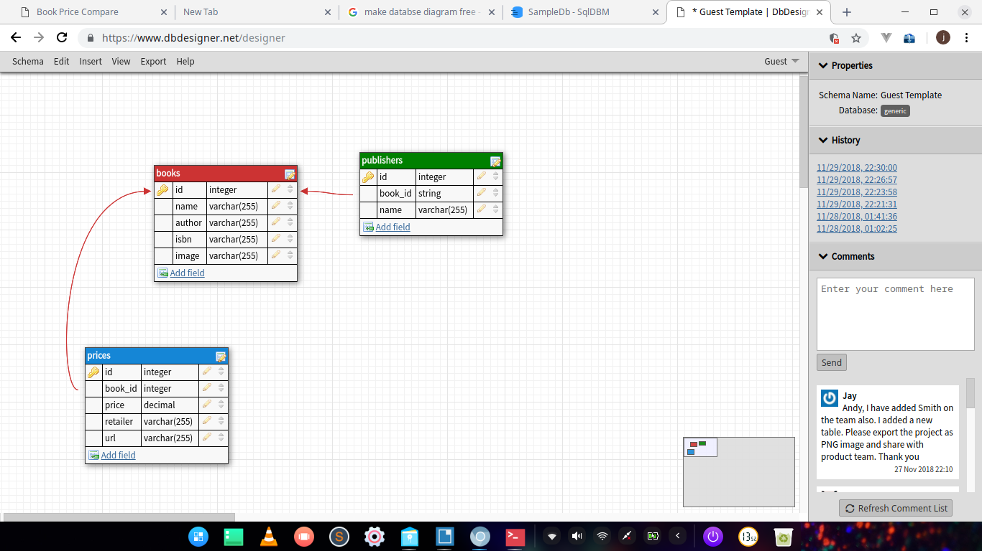
The rest api written in node.js connects to the database and offers two api points for getting the data.The first one is to search for any book that matches the seacrh keyword.It could be isbn, book name or author name.A get request is sent to /search?query=keyword. Then a json response containing all the books that match the criteria is sent back.
The second api point is used to fetch the different retailer prices for a certain book based on the book id.A get request is sent to /getdetails?bookId=id .A json response with the different retailers that have the book and their prices and details

The client frontend written in vue has three pages.The first page is the welcome and search page that accepts input that is the keyword and sends a get request to /search?query=keyword to get the books matching the search query.
When the results are sent back it opens the next page that parses the results and lists all the books that match the search criteria.Clicking on a specific book it routes the user to the next page after sending a get request to getdetails?bookId=id and the final page parses the json and displays the different retailers.There is a link for each retailer that sends you to the product page.

