

**Subject name**: Introduction to software engineering

**Submitted To**: Sir Shakir Rasheed Khatak

**Submitted By:   
Name:** Muhammad Suleman Faiz **Registration No:** FBAS/BSE/4349/ F/21-B

**ASSIGNMENT NO 1**

**Question 1:**

**Describe the waterfall model and list the stages of waterfall model for software development and list its three advantages and dis advantages?**

**Answer:**

The Waterfall Model was the first Process Model to be introduced. It is also referred to as a **linear-sequential life cycle model**. It is very simple to understand and use. In a waterfall model, each phase must be completed before the next phase can begin and there is no overlapping in the phases.

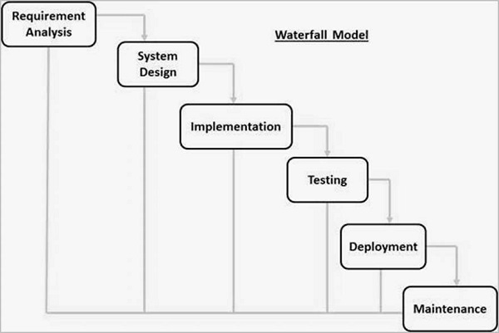

**Advantages:**

* Simple and easy to understand and use
* Easy to manage due to the rigidity of the model. Each phase has specific deliverables and a review process.
* Phases are processed and completed one at a time.

**Disadvantages:**

* No working software is produced until late during the life cycle.
* High amounts of risk and uncertainty.
* Not a good model for complex and object-oriented projects.

**List of the stages:**

1. Requirement Gathering and analysis
2. System Design
3. Implementation
4. Integration and Testing
5. Deployment of system
6. Maintenance

**Question 2:**

**List down the stages of SDLC and describe each stage in one phrase each?**

**Answer:**

1. **Requirement Gathering and analysis:**  All possible requirements of the system to be developed are captured in this phase and documented in a requirement specification document.
2. **System Design:** This system design helps in specifying hardware and system requirements and helps in defining the overall system architecture.
3. **Implementation:** With inputs from the system design, the system is first developed in small programs called units, which are integrated in the next phase.
4. **Integration and Testing**: All the units developed in the implementation phase are integrated into a system after testing of each unit.
5. **Deployment of system:** Once the functional and non-functional testing is done; the product is deployed in the customer environment or released into the market.
6. **Maintenance:** There are some issues which come up in the client environment. To fix those issues, patches are released. Also to enhance the product some better versions are released. Maintenance is done to deliver these changes in the customer environment.

**Question 3:**

**Write one user level and several system requirements?**

**Answer:**

**User requirement:**

Any library member should be able to search books by their title, author, and subject category as well by the publication date

**System requirement:**

There are two type of system requirements:

**Functional requirement:**

1. **Maintain stock*:*** : It must enter details with respect to new book, handouts, magazines and so on .The stock details are refreshed every single time another stock arrives or when a thing is taken out.
2. **Providing Identification number**: The framework gives one of a kind distinguishing proof number to everything independently. It ought to likewise give separate recognizable proof number to its individuals
3. **Manage Periodicals:** It means stocks that arrives on daily basis like newspapers, magazines. The system manages them efficiently.
4. **Reservation**:One of the most significant capacity of a Management framework is that it can assist individuals with reserving a specific thing which they need from anyplace by utilizing their enrollment number

**Non-Functional requirements:**

1. **Performance:**

The Server would be able to perform desired tasks in reasonable unit of time.

1. **Reliability:**

The Server would perform desired tasks as expected. The system does its work with more accuracy like user registration to the system, user validation and authorization, book search and issue operation, return status, and updating the database by synchronizing between database and application.

1. **Security:**

The system would provide access to only legitimate users. It will be secure on network and only authorized person can use it.

1. **Scalability:**

The proposed system would be scalable to support extended number of users.

**Question 4:**

**Draw use case diagram and domain model for university management system?**

**Answer:**

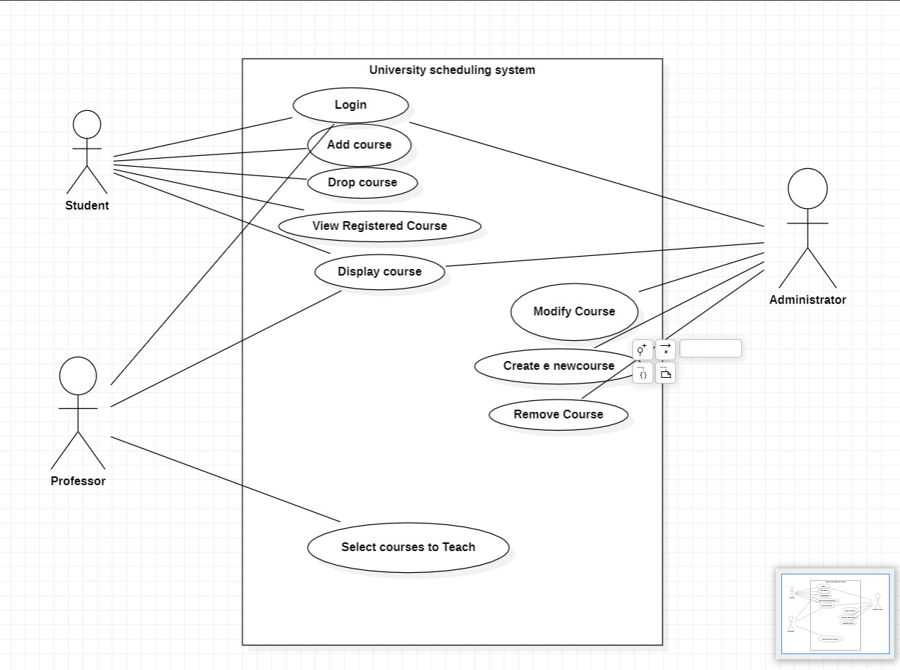

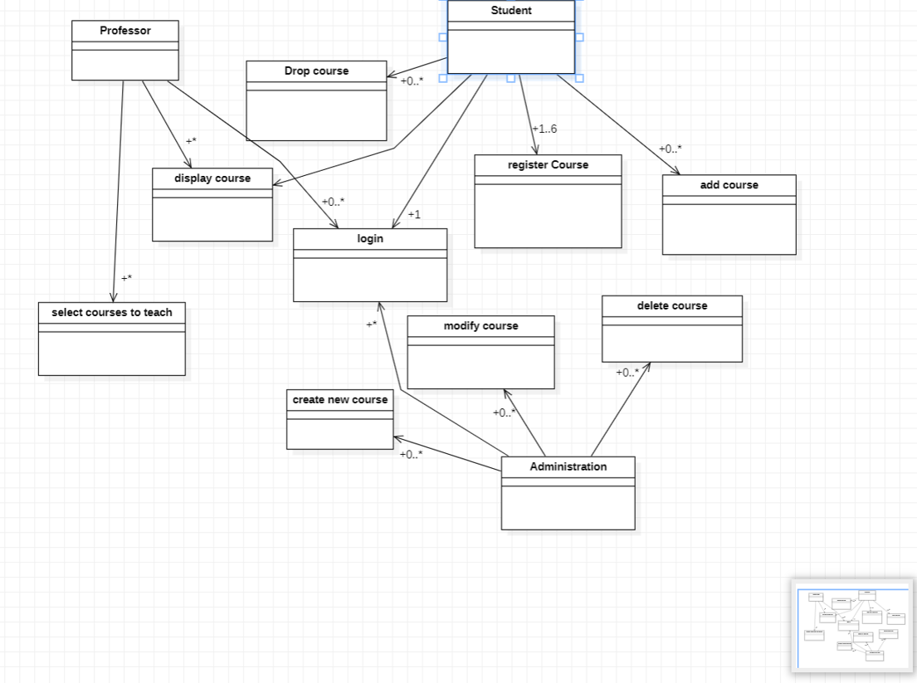**Domain model:**

**Question 5:**

**Write the non- functional requirement of the following projects?**

**Answer:**

**Bike racing game:**

1. Ease of use
2. Performance
3. Human aspects

**Online banking system:**

1. Usability
2. Availability
3. Confidentiality
4. Security