National University of Computer and Emerging Sciences



Name: Muhammad Suleman

Roll #: 22F-3350

Section: BCS-4B

Assignment # 01-Part02

# Question 01

*import* numpy *as* np

*import* matplotlib.pyplot *as* plt

*from* scipy.interpolate *import* CubicSpline

*# Load the data from the file*

data = np.loadtxt('bps.dat')

*# Extract the columns you want to use for interpolation and plotting*

x = data[:, 0] *# First column*

y = data[:, 1] *# Second column*

*# Create a cubic spline interpolation object*

cubic_spline = CubicSpline(x, y)

*# Generate points for interpolation*

x_interp = np.linspace(x[0], x[-1], 1000)

y_interp = cubic_spline(x_interp)

*# Plot the original data and interpolated curve*

plt.plot(x, y, 'o', label='Original Data')

plt.plot(x_interp, y_interp, label='Interpolated Curve')

plt.xlabel('X')

plt.ylabel('Y')

plt.title('Cubic Spline Interpolation')

plt.legend()

plt.grid(*True*)

plt.show()

## Output

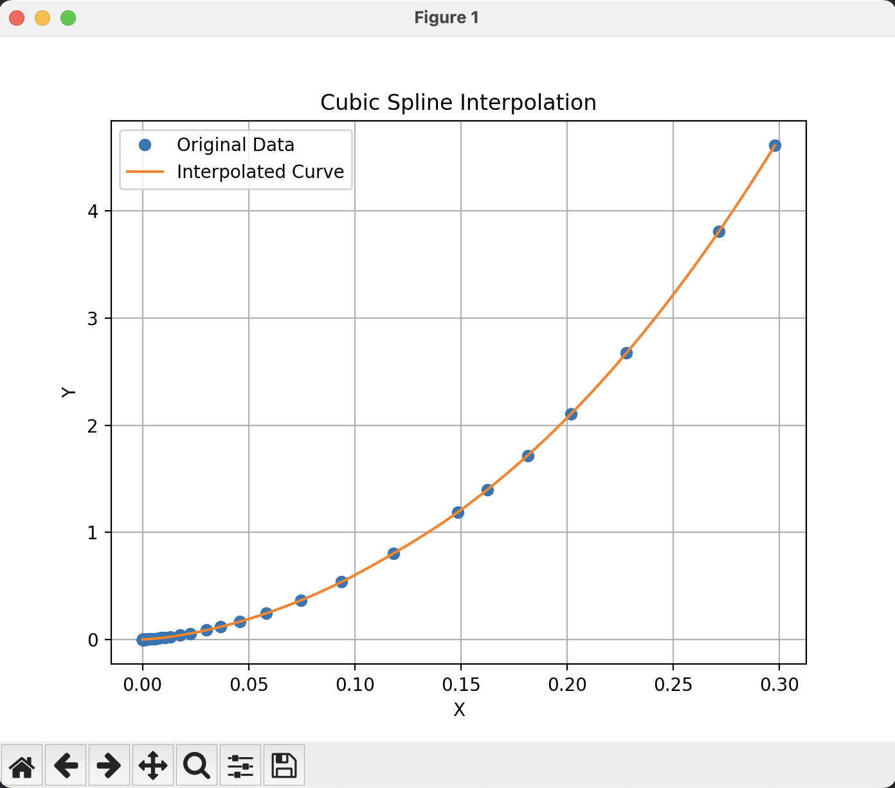

# Question 02

*import* sympy

*def* equations():

M, r, q = sympy.symbols('M r q', real=*True*, positive=*True*)

x, y, z = sympy.symbols('x y z', real=*True*)

eq1 = 1 / r + 2 * M * q ** 2 / r ** 3 - x ** 2 * r ** 2

eq2 = (1 / r + 2 * M * q ** 2 / r ** 3) * (y ** 2 / (x + z * r) ** 2)

eq3 = sympy.diff((1 / r + 2 * M * q ** 2 / r ** 3) * (y ** 2 / (x + z * r) ** 2), r)

*return* eq1, eq2, eq3

eq1, eq2, eq3 = equations()

*# Define x, y, z*

x, y, z = sympy.symbols('x y z', real=*True*)

sol = sympy.solve([eq1, eq2, eq3], [x, y, z])

*for* solution *in* sol:

print(sympy.simplify(solution))

*# Answer*

*# (-sqrt(2*M*q**2 + r**2)/r**(5/2), 0, z)*

*# (sqrt(2*M*q**2 + r**2)/r**(5/2), 0, z)*

## Output

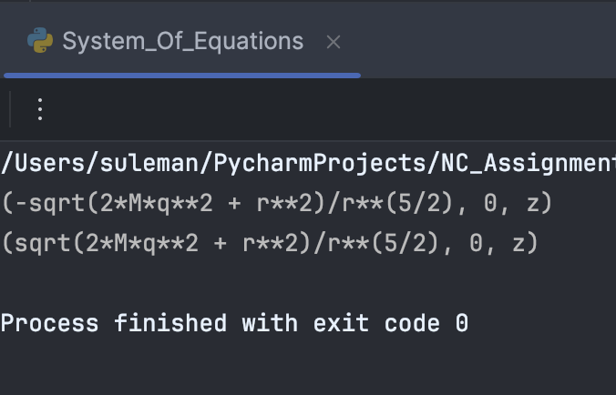

# Question 03

*import* numpy

*def* newton_backward_interpolation(x, y, x_new):

n = len(x)

*# Create a table to store the divided differences*

divided_differences = numpy.zeros((n, n))

*# Fill in the first column of the divided differences table*

divided_differences[:, 0] = y

*# Calculate the remaining divided differences*

*for* j *in* range(1, n):

*for* i *in* range(n - j):

divided_differences[i, j] = (divided_differences[i + 1, j - 1] - divided_differences[i, j - 1]) / (

x[i + j] - x[i])

*# Calculate the interpolated value*

y_new = divided_differences[0, 0]

*for* j *in* range(1, n):

term = divided_differences[0, j]

*for* k *in* range(j):

term *= (x_new - x[k])

y_new += term

*return* y_new

years = numpy.array([1941, 1951, 1961, 1971, 1981, 1991])

population = numpy.array([12, 15, 20, 27, 39, 51])

estimated_year1 = 1976

estimated_year2 = 1978

interpolated_population2 = newton_backward_interpolation(years, population, estimated_year2)

interpolated_population1 = newton_backward_interpolation(years, population, estimated_year1)

result = interpolated_population2 - interpolated_population1

print(f"Interpolated population at year {estimated_year1} is: {interpolated_population1:.4f}")

print(f"Interpolated population at year {estimated_year2} is: {interpolated_population2:.4f}")

print(f"Interpolated population from year {estimated_year1} to {estimated_year2} is: {result:.4f}")

## Output

