National University of Computer and Emerging Sciences



Lab # 01

# Question 01

1. echo hello world - Outputs the string "hello world" to the terminal.

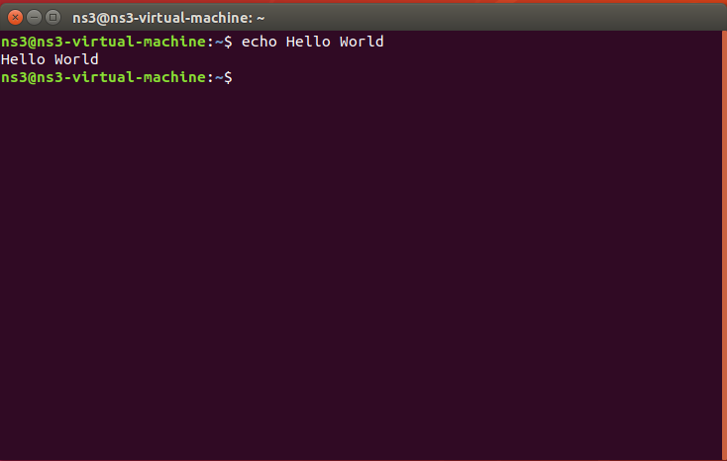

1. echo * - Displays the names of all files and directories in the current directory.

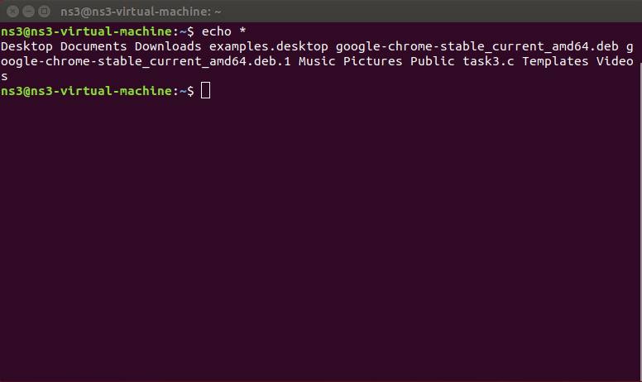

1. passwd - Changes the user's password.

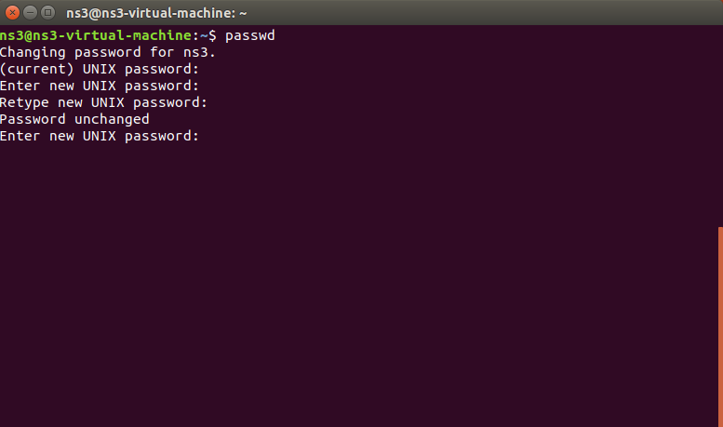

1. date - Displays the current date and time.

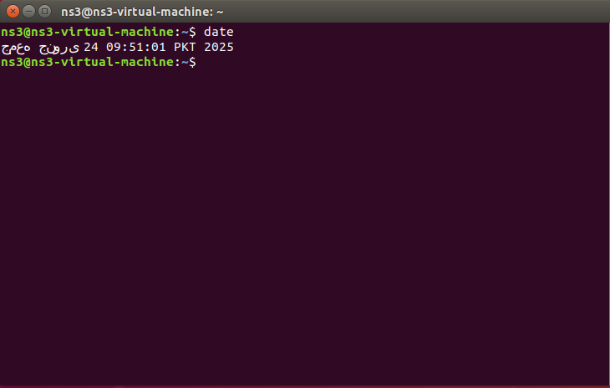

1. hostname - Shows the name of the current host system.

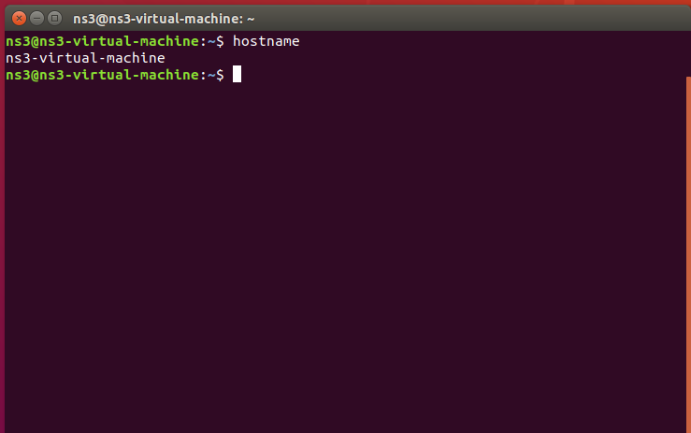

1. arch - Displays the architecture of the system (e.g., x86_64).

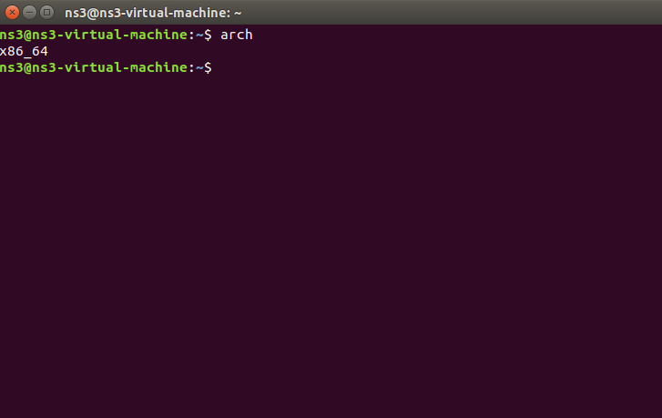

1. uname -a - Prints detailed information about the kernel and system.

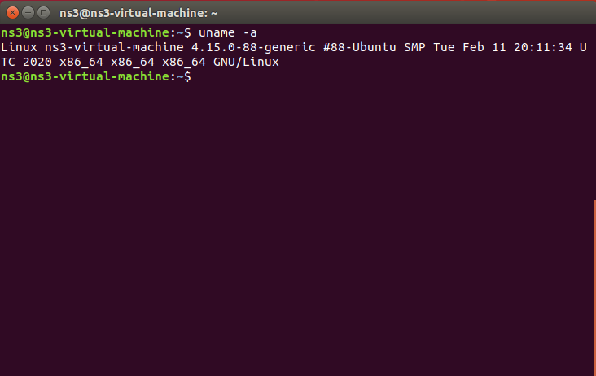

1. uptime - Shows how long the system has been running and its load averages.

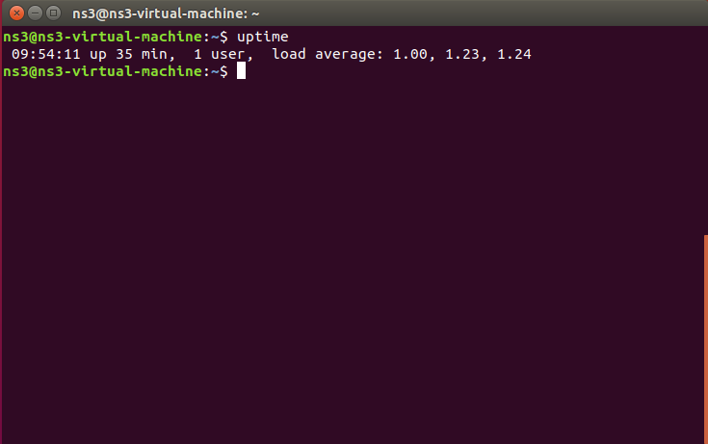

1. whoami - Displays the username of the current user and their terminal.

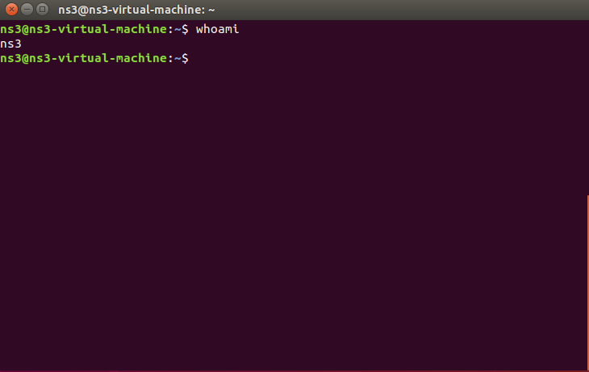

1. who - Lists all users currently logged into the system.

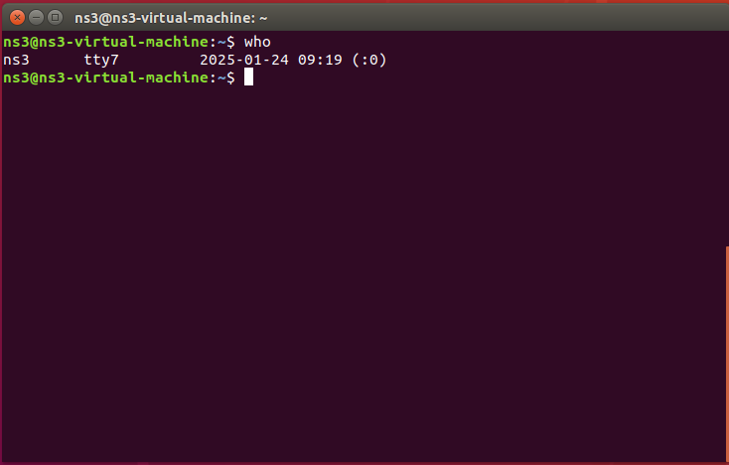

1. id - Displays the user ID (UID) and group ID (GID) of the current user.

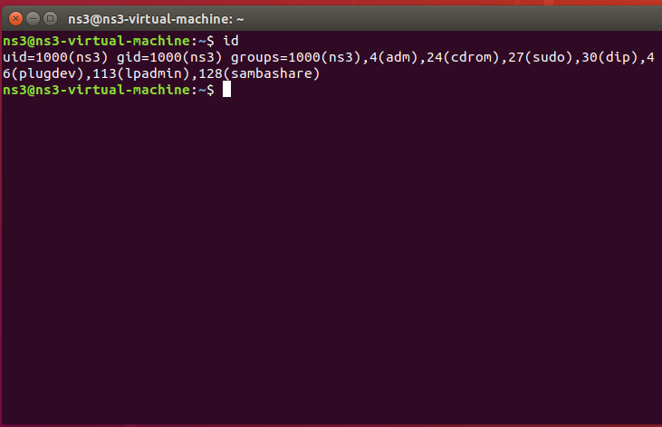

1. last - Shows a list of the most recent login sessions.

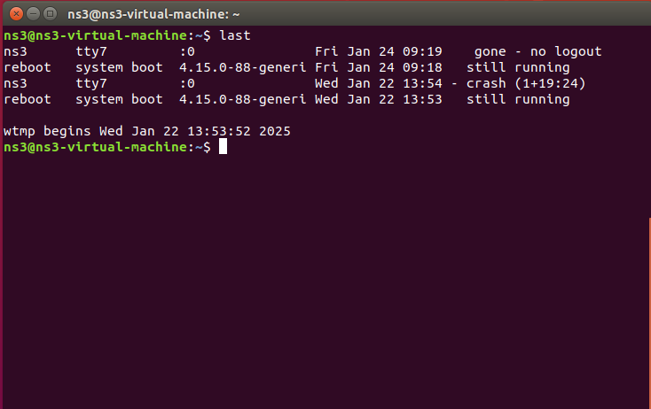

1. w - Displays who is logged on and what they are doing.

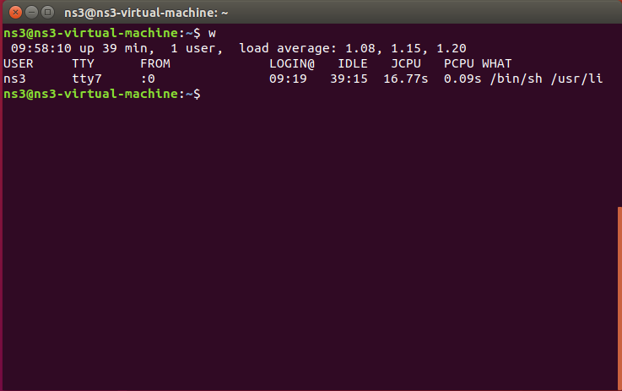

1. top - Provides a real-time view of system processes (press q to quit).

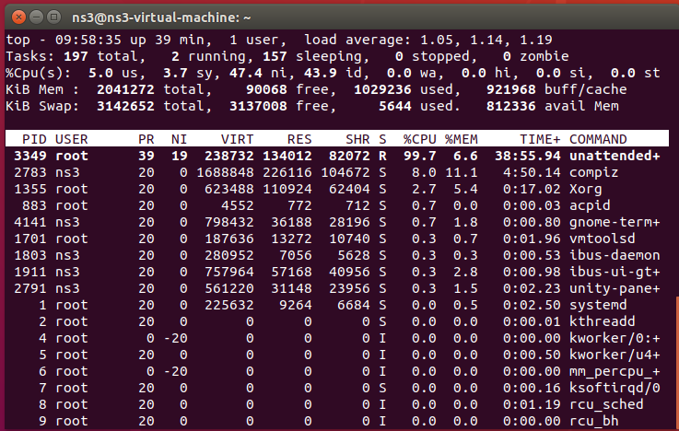

1. echo $SHELL - Outputs the current user's default shell.

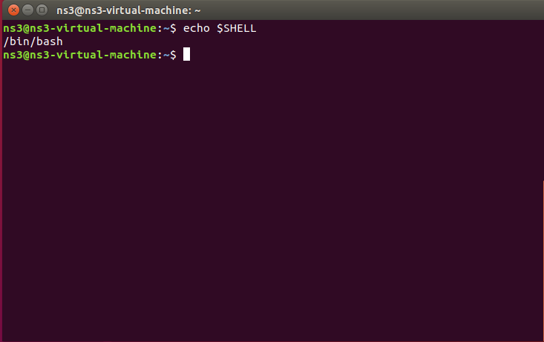

1. man ls - Displays the manual for the ls command (press q to quit).

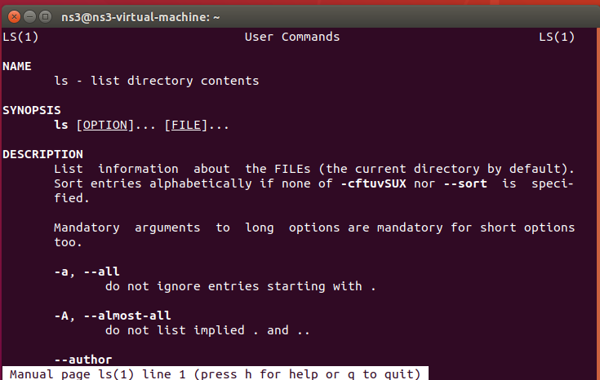

1. man who - Displays the manual for the who command (press q to quit).

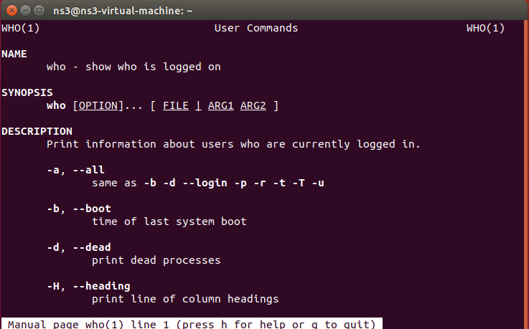

1. clear - Clears the terminal screen.

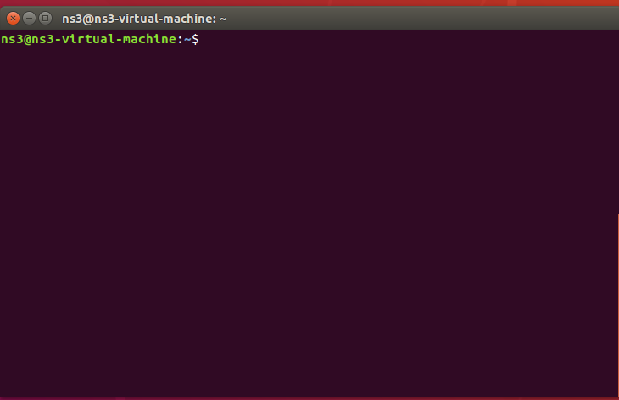

1. cal 2000 - Displays the calendar for the year 2000.

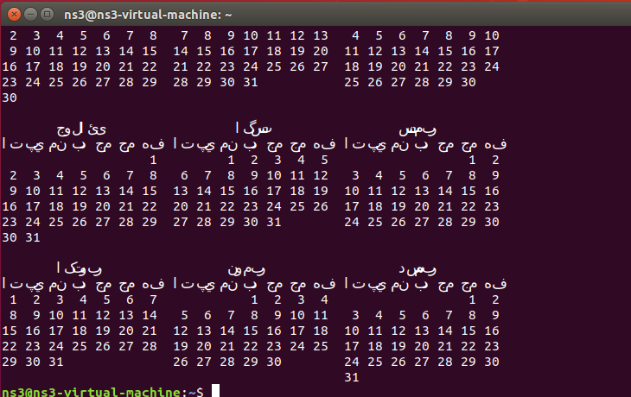

1. cal 9 1759 - Displays the calendar for September 1759.

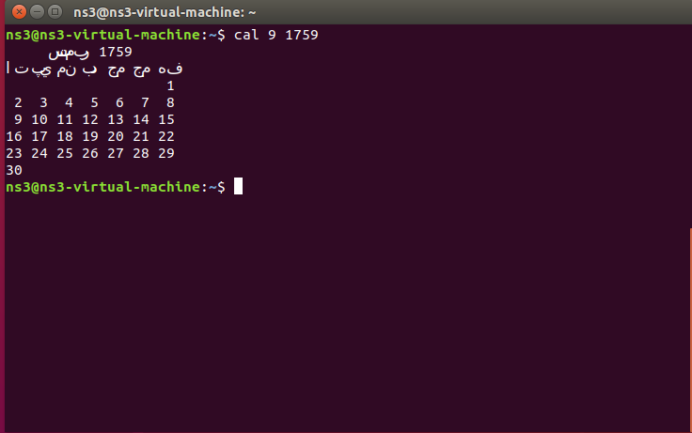

1. echo 5+4 | bc -l - Calculates the expression 5+4 using the bc calculator.

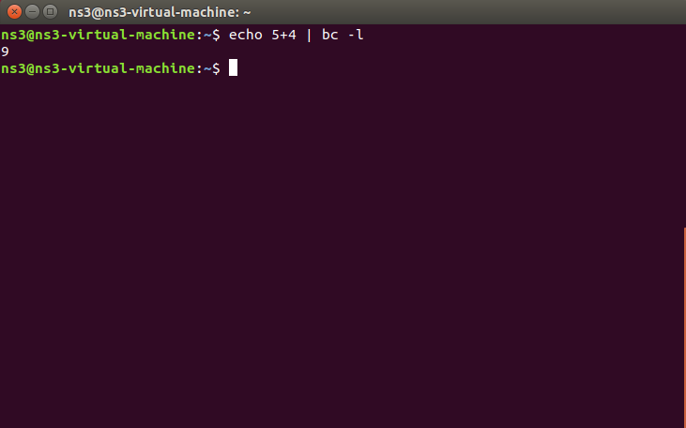

1. yes please - Continuously outputs "please" until interrupted (Ctrl-C to quit).

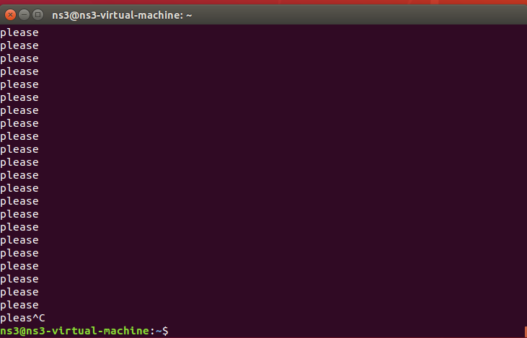

1. time sleep 5 - Measures the time taken to execute a sleep command for 5 seconds.

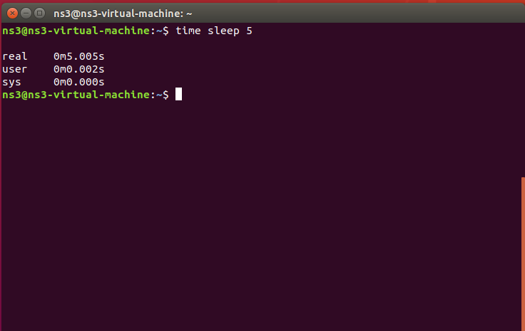

1. history - Shows the command history for the current session.

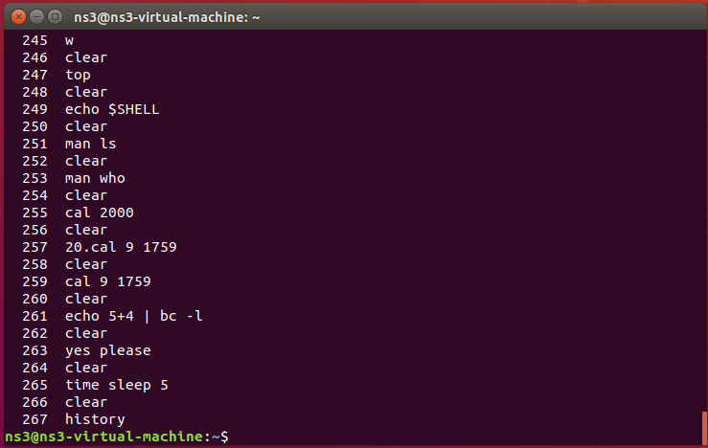

1. chown - Changes the ownership of files or directories.

BEFORE:

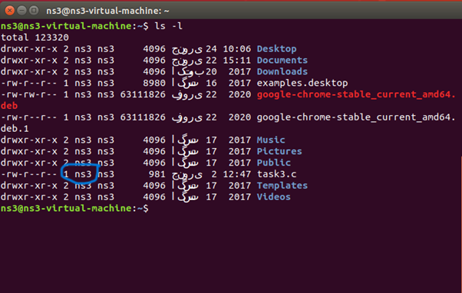

AFTER:

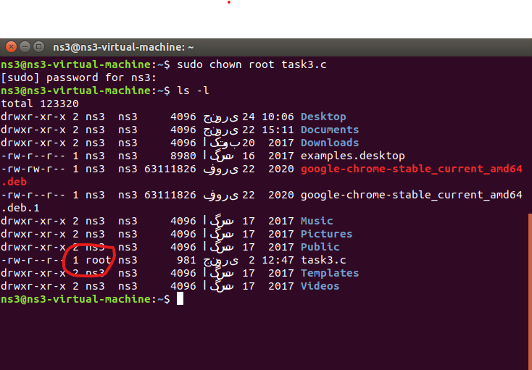

1. chmod - Changes the permissions of files or directories.

BEFORE:

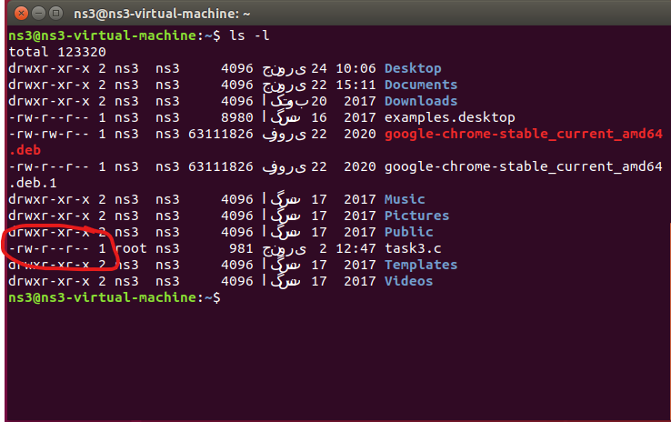

AFTER:

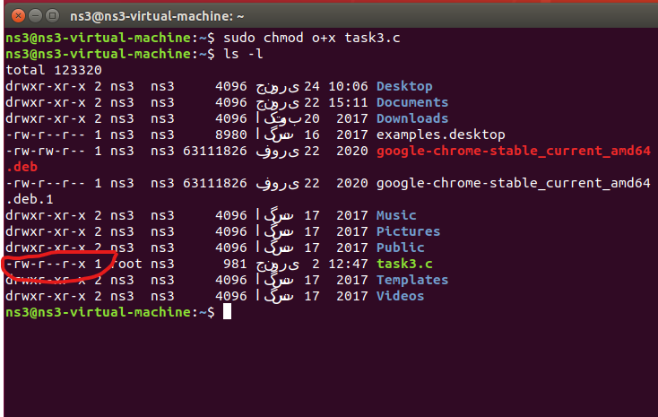

1. > - Redirects output to a file, overwriting it if it exists.

COMMAND:

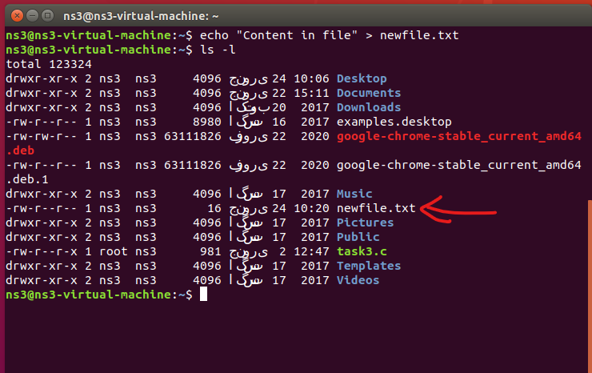

FILE-CONTENT:

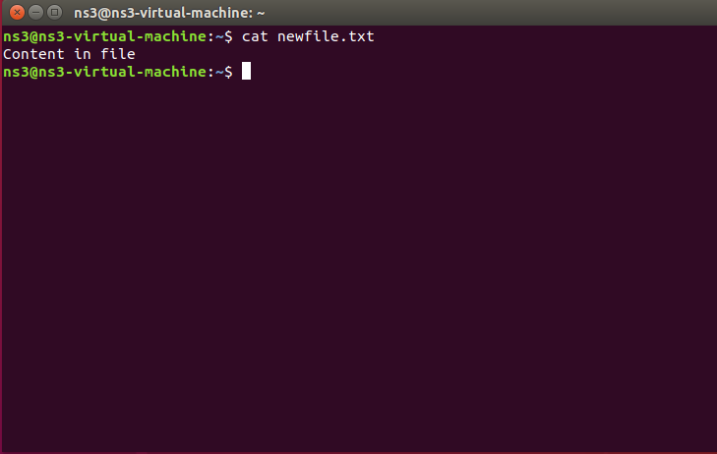

1. >> - Appends output to a file, creating it if it does not exist.

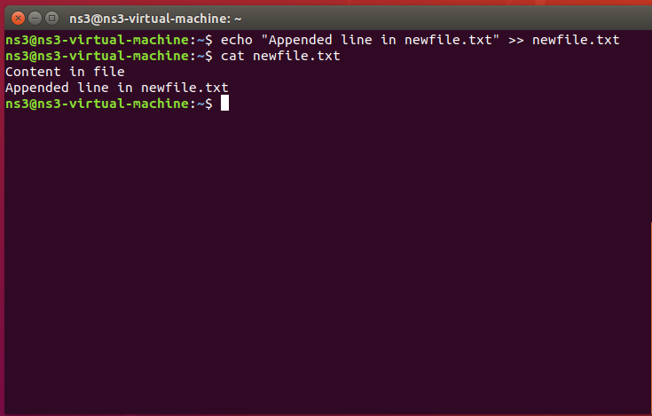

1. touch - Creates an empty file or updates the timestamp of an existing file.

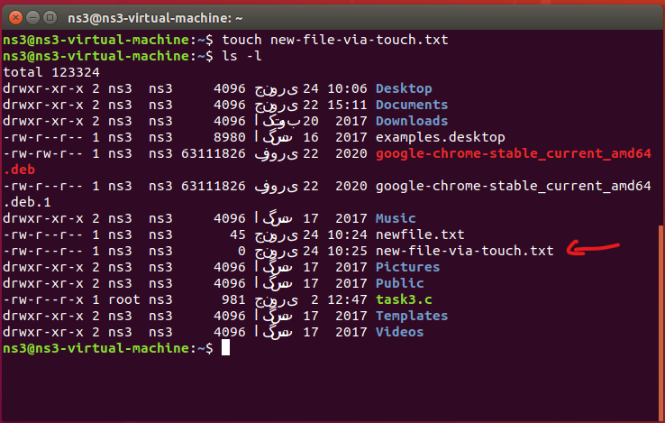

1. df - Displays disk space usage for file systems.

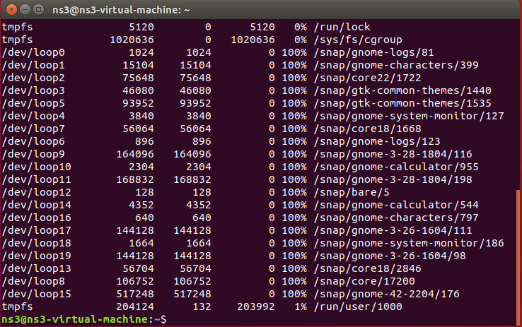

1. what if - (context-dependent; generally refers to a hypothetical scenario).

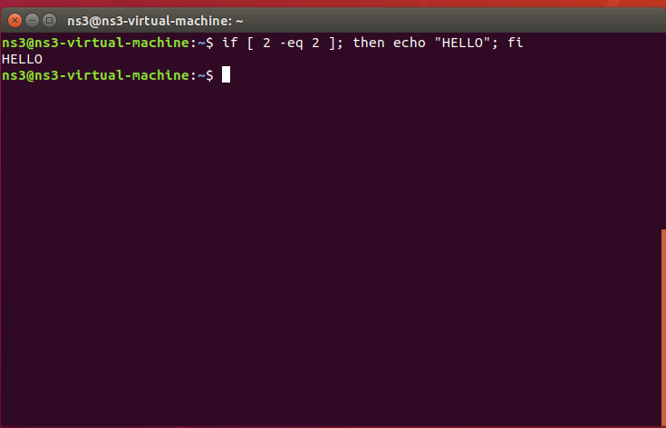

1. less - Views the content of a file one screen at a time.

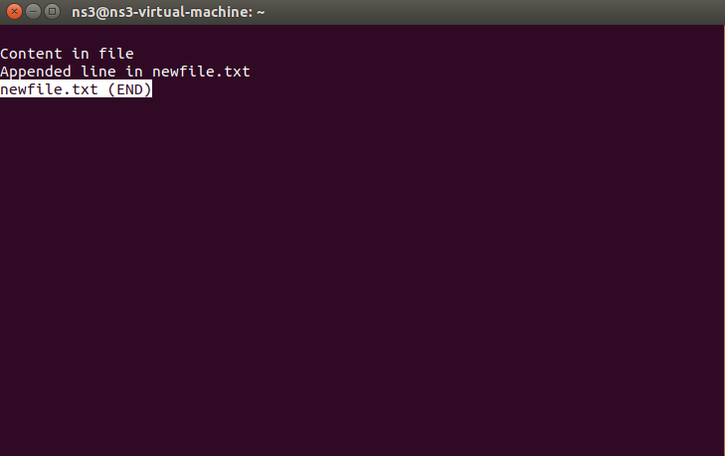

1. more - Similar to less, but with more limited navigation options.

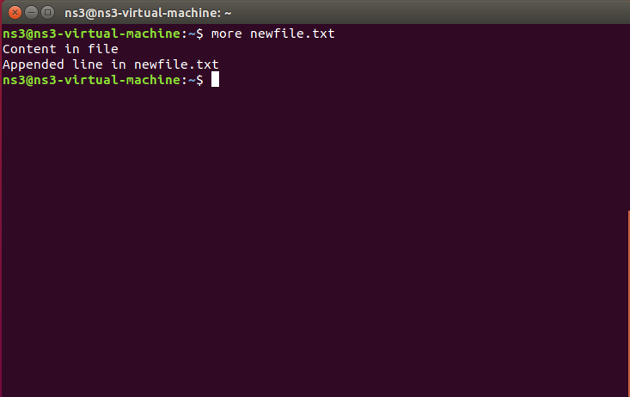

1. mv - Moves or renames files or directories.

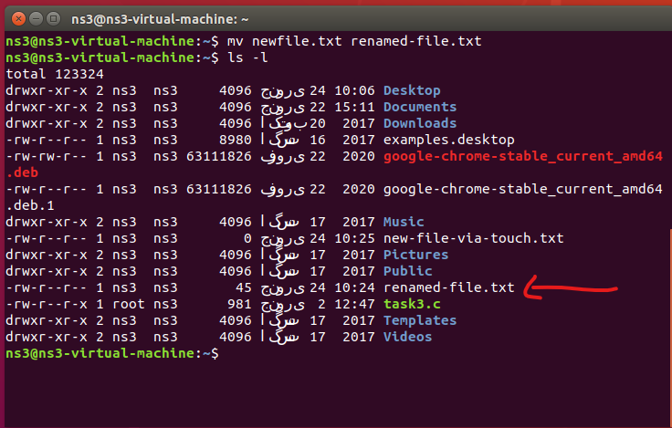

1. rm - Removes (deletes) files or directories.

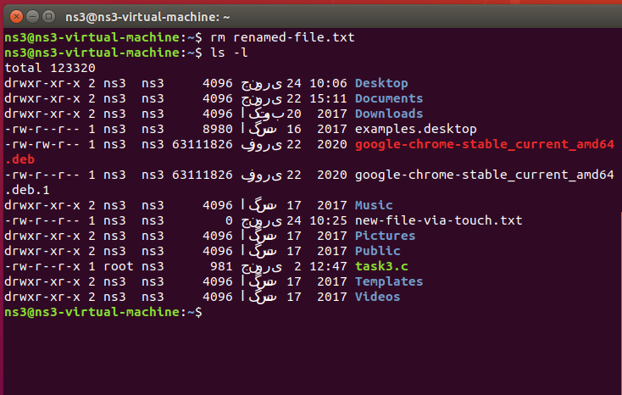

1. whatis - Provides a brief description of a command.

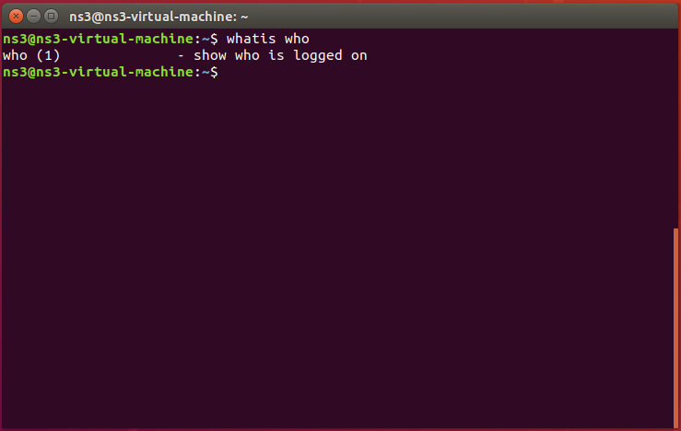

1. mkdir - Creates a new directory.

BEFORE:

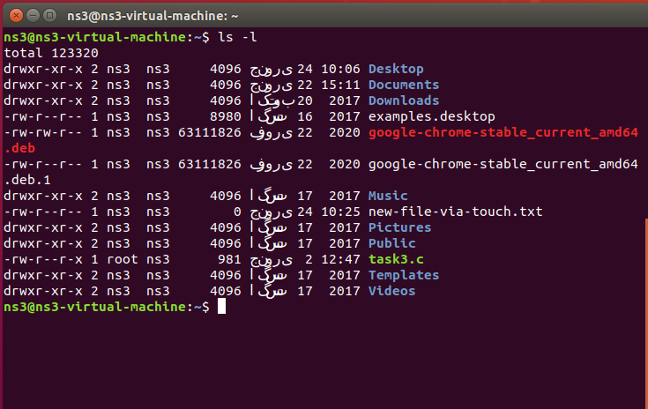

AFTER:

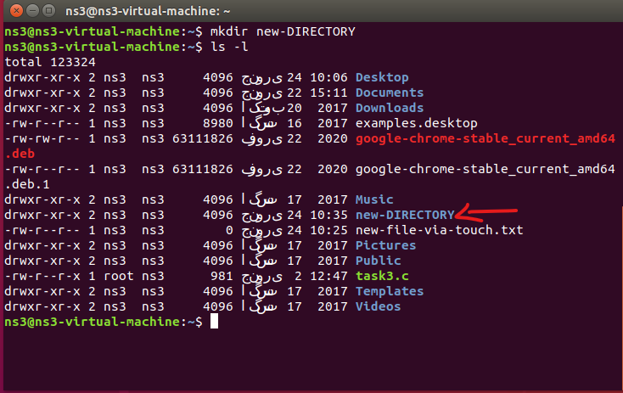

# Question 02

## cd, pwd, ls -al

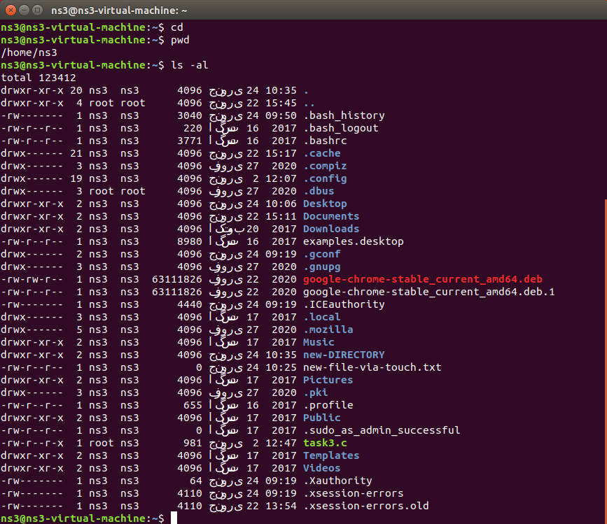

## cd ., pwd, cd .., pwd, ls -al, cd .., pwd, ls -al

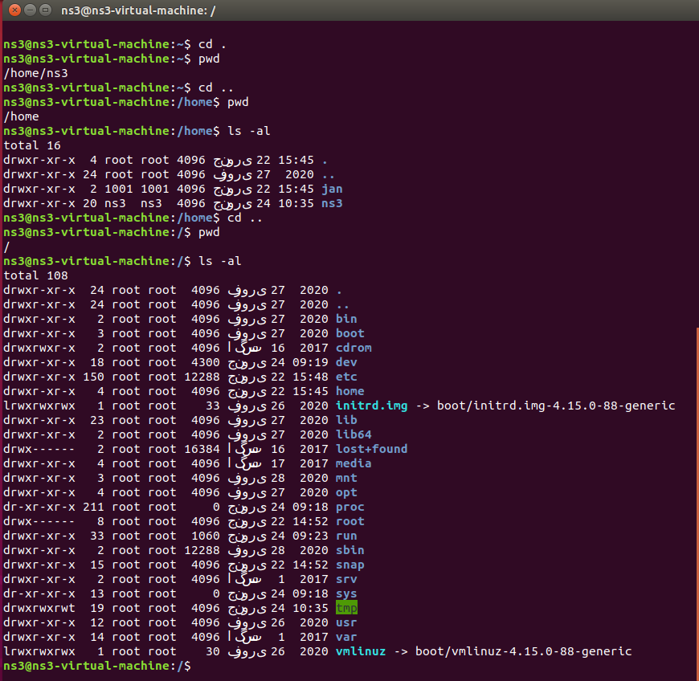

## cd .., pwd, cd /etc, ls -al | more

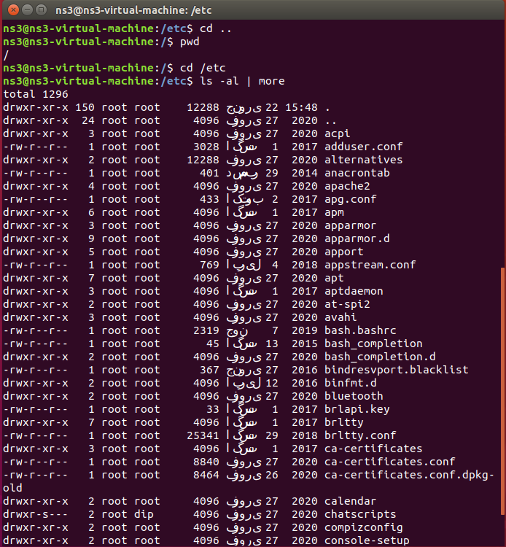

## cat passwd

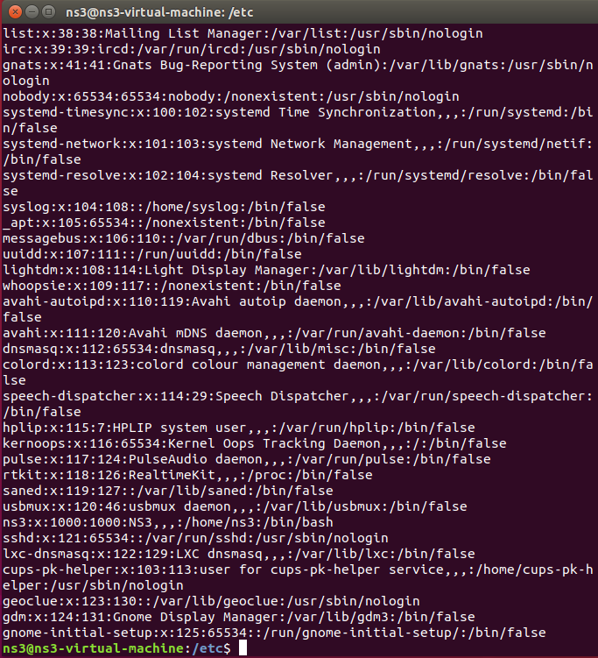

## cd –, pwd

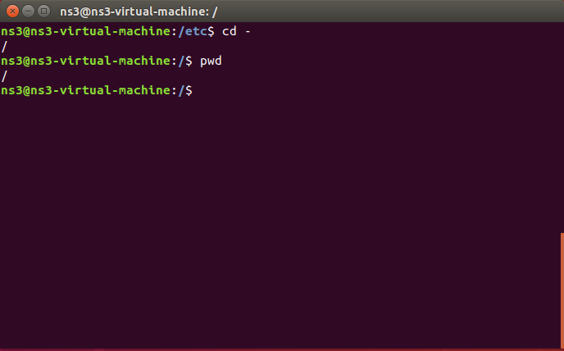

# Question 03

## Part 01

### /bin

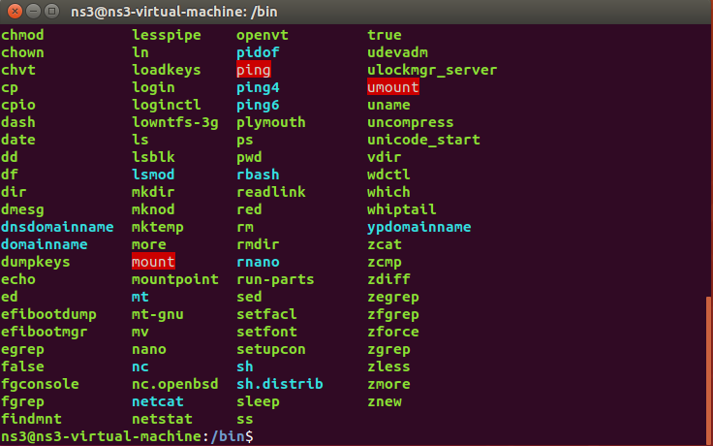

### /usr/bin

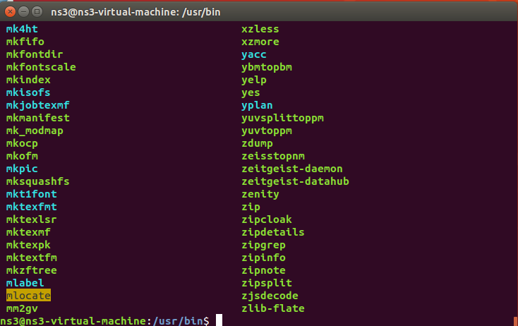

### /sbin

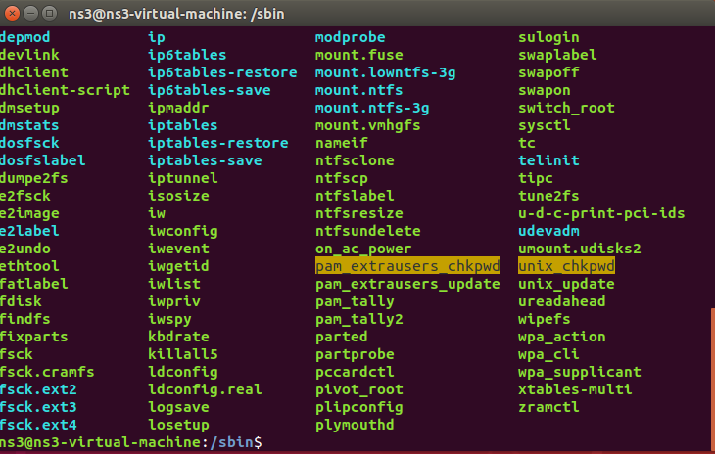

### /tmp

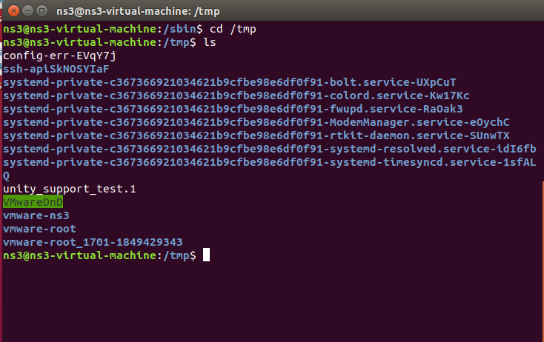

### /boot

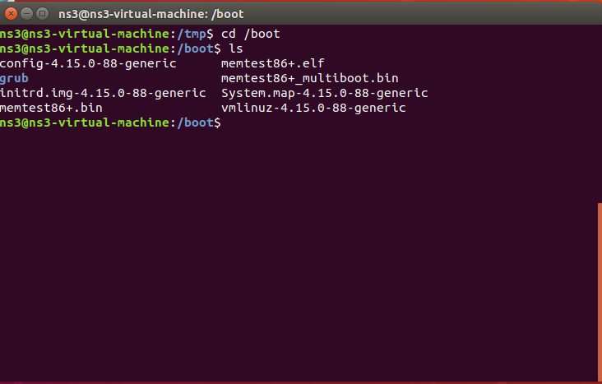

## Part 02

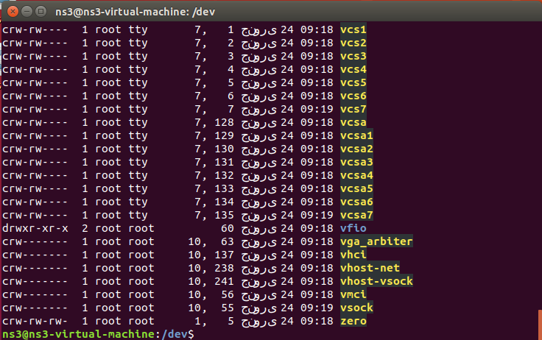

## Part 03

### Interrupts

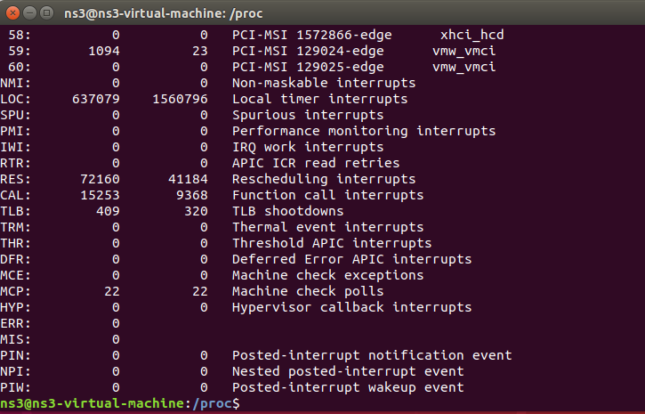

### Devices

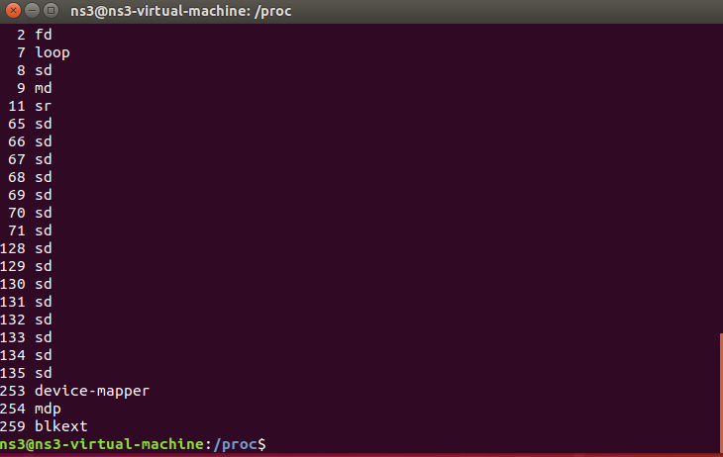

### Cpuinfo

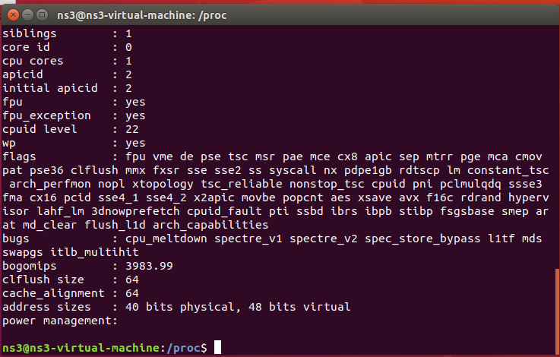

### Meminfo

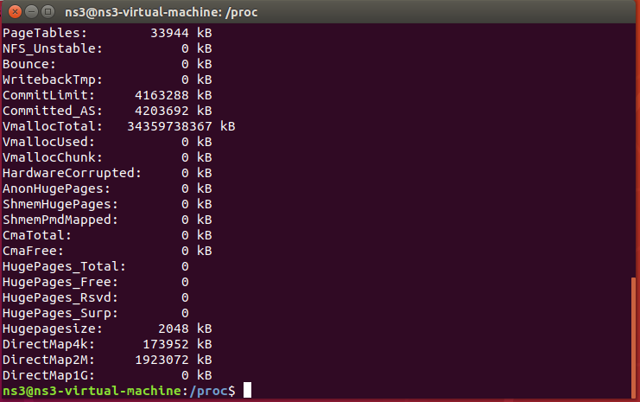

### Uptime

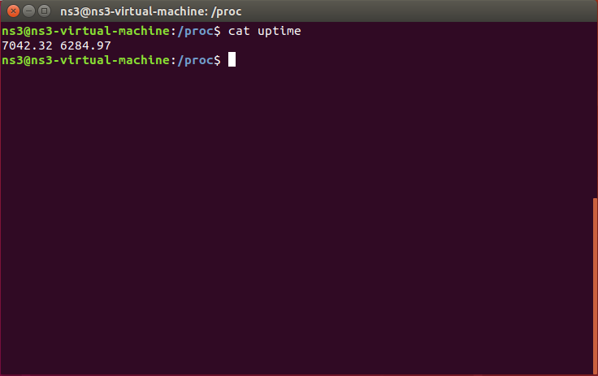

## Part 04

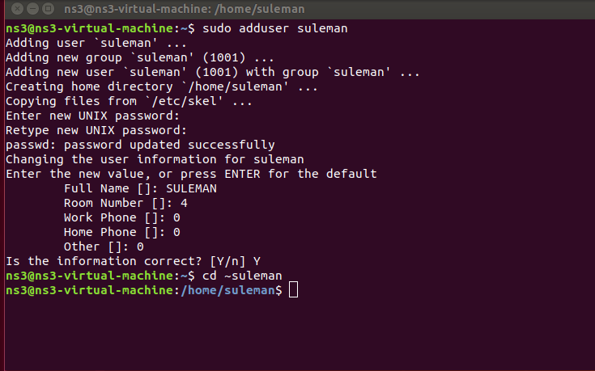

## Part 05

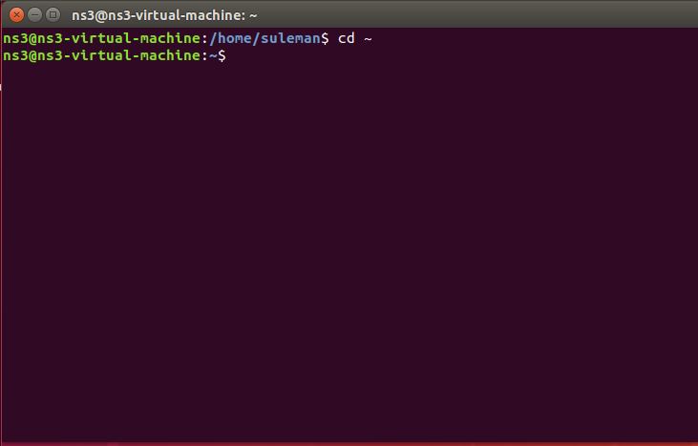

## Part 06

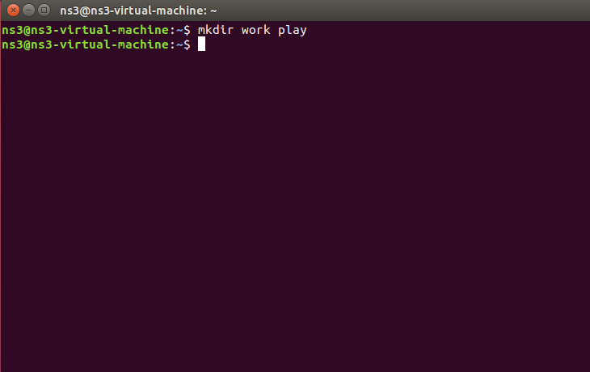

## Part 07

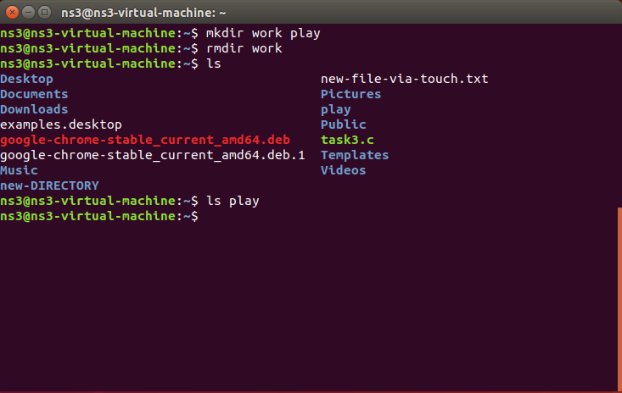

## Part 08

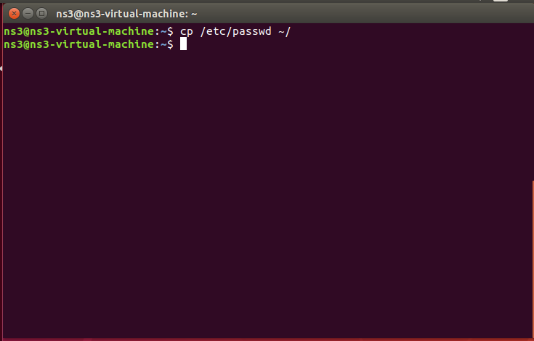

## Part 09

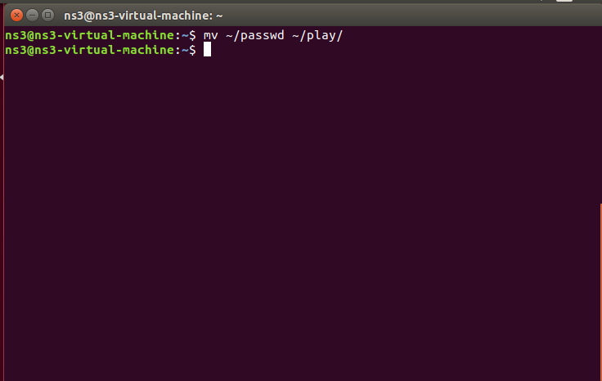

## Part 10

* **ls -l**: Lists files in long format, showing permissions, number of links, owner, group, size, and last modified time.
* **ls -L**: Follows symbolic links and lists the details of the files or directories they point to.

## Part 11

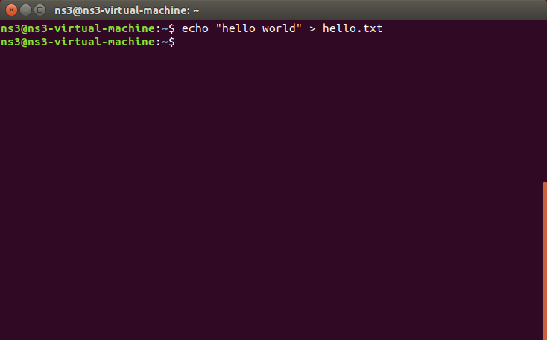

## Part 12

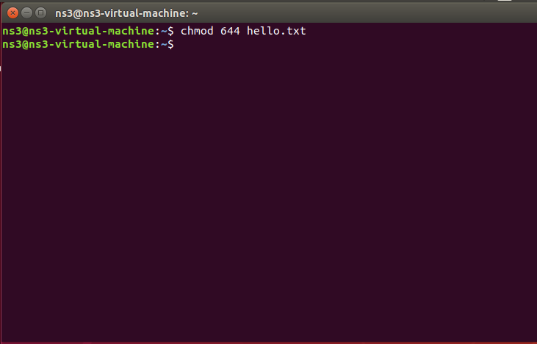

## Part 13

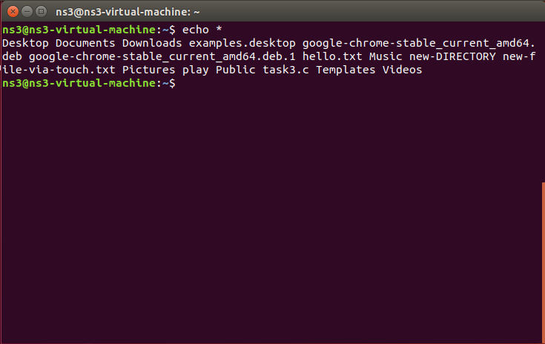

## Part 14

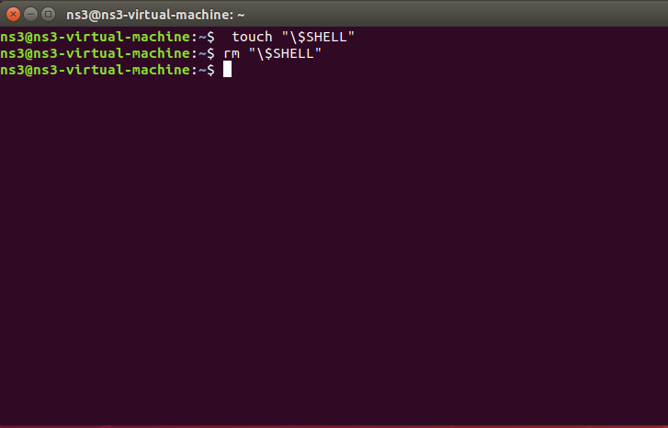

## Part 15

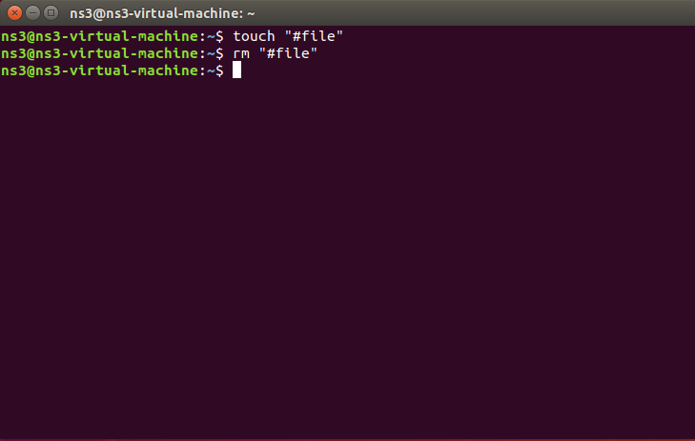

## Part 16

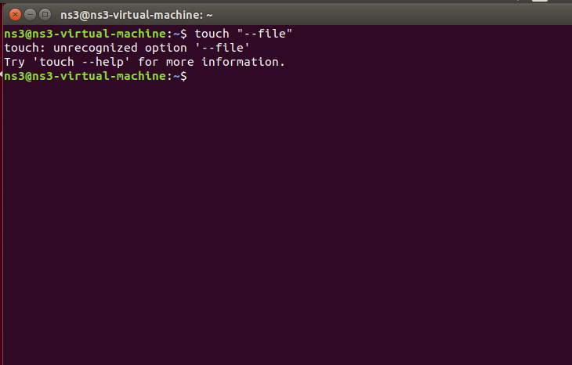

## Part 17

* **-d**: Lists directories themselves, not their contents.
* **-i**: Shows the inode number of each file.
* **-R**: Lists directories and their contents recursively.
* **-F**: Appends indicators to entries (e.g., / for directories, * for executables).