**Chapter 2 Vectors and Equilibrium**

**1. Which one is a vector:**  
a) Length  
b) Volume  
c) Velocity  
d) Work  
  
**2. An example of scalar quantity is**  
a) Displacement  
b) Speed  
c) Velocity  
d) Torque  
  
**3. Name the quantity which is vector:**  
a) Density  
b) Power  
c) Charge  
d) Moment of Force  
  
**4. Rectangular coordinate system is also called:**  
a) Polar coordinate system  
b) Cartesian coordinate system  
c) Cylindrical coordinate system  
d) Space coordinate system  
  
**5. The direction of a vector in space is specified by:**  
a) One angle  
b) Two angle  
c) Three angle  
d) No angle  
  
**6. If both components of a vector are negative, then resultant lies in:**  
a) 1st quadrant  
b) 2nd quadrant  
c) 3rd quadrant  
d) 4th quadrant  
  
**7. In which quadrant the two rectangular components of a vector have same sign?**  
a) 1st  
b) 2nd  
c) both 1st and 3rd  
d) 4th  
  
**8. If the x-component of a vector is positive and y-component is negative, then resultant vector lies in what quadrant:**  
a) 1st quadrant  
b) 2nd quadrant  
c) 3rd quadrant  
d) 4th quadrant  
  
**9. If vector A lies in the third quadrant, its direction will be:**  
a) 180 −  
b) 360 −  
c) 180 +  
d) none  
  
**10. A single vector having the same effect as all the original vectors taken together, is called**  
a) Resultant vector  
b) Equal vector  
c) Position vector  
d) Unit vector  
  
**11. When two vectors are anti-parallel, the angle between them is:**  
a) Zero  
b) 180°  
c) 90°  
d) 270°  
  
**12. The resultant of two forces 30 N and 40 N acting at an angle of 90° with each other is**  
a) 30 N  
b) 40 N  
c) 50 N  
d) 70 N  
  
**14. If 6N force act at right angle to 8N force, then the magnitude of resultant will be:**  
a) 6N  
b) 8N  
c) 10N  
d) 14N  
⃗ ⃗ ⃗ ⃗  
**15. If A + B = B + A, this shows that addition of vectors is**  
a) Associative  
b) Commutative  
c) Additive  
d) Additive inverse  
  
**16. A body is in dynamic equilibrium only when it is**  
a) At rest  
b) Moving with a variable velocity  
c) Moving with uniform acceleration  
d) Moving with uniform velocity  
  
[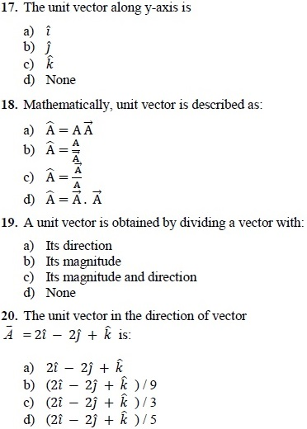](https://1.bp.blogspot.com/-DWZ0Kfo65FQ/XXtXeGBPKBI/AAAAAAAANUs/G_Hfv3BKaosj5dSgOwdzpxfs68eQckfHACNcBGAsYHQ/s1600/physics%2B1.jpg)  
  
**22. Vectors A is along y axis, its component along x axis is:**  
a) A  
b) A/2  
c) Zero  
d) 2A

**23. The angle between rectangular components of vector is:**  
a) 45°  
b) 60°  
c) 90°  
d) 180°  
  
**24. A force of 10N is acting along x-axis, its component along y-axis is**  
a) 10N  
b) 5N  
c) 8.66N  
d) Zero N

[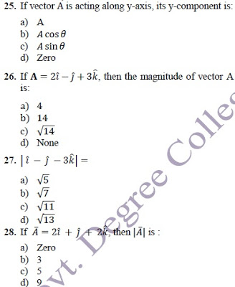](https://1.bp.blogspot.com/-ae-7Y0Fi7Fk/XXtYRILHjZI/AAAAAAAANU0/U31iq9enKy0wN5RgpHTFjM_tQI9zTUb-gCNcBGAsYHQ/s1600/physics%2B2.jpg)

**29. Dot product of two non-zero vectors is zero, when angle between them is:**  
a) 0  
b) 30  
c) 45  
d) 90  
  
**31. The scalar product of two vectors is maximum when they are:**  
a) Parallel  
b) Perpendicular  
c) Anti-parallel

[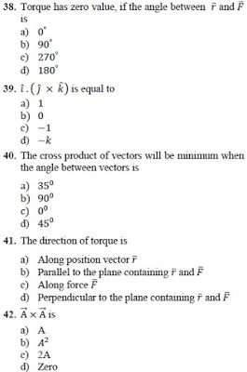](https://1.bp.blogspot.com/-PO1du_zFdUQ/XXtZFoTWvTI/AAAAAAAANVA/as03Ps6wRGAjoVur8l85NKc9V4krzA1nACNcBGAsYHQ/s1600/physics%2B3.jpg)

**43. If the position ̅and force are in same direction, then torque will be:**  
a) Maximum  
b) Minimum  
c) Same  
d) Negative

**44. The direction of torque can be found by:**  
a) Head to tail rule  
b) Right hand rule  
c) Left hand rule  
d) Fleming rule  
  
**45. At what angle, the two vectors of the same magnitude have to oriented, if they were to be combined to give a resultant equal to a vector of same magnitude?**  
a) 45°  
b) 90°  
c) 120°  
d) 180°  
  
**46. If the line of action of force passes through axis of rotation or the origin, then its torque is:**  
a) Maximum  
b) Unity  
c) Zero  
d) None of these  
  
**47. The magnitude of a vector can never be:**  
a) Positive  
b) Negative  
c) Positive and negative  
d) None of these

**48. The minimum number of unequal forces whose resultant will be zero:**  
a) 2  
b) 3  
c) 4  
d) 5  
  
**49. Torque is defined as.**  
a) Turning effect of force  
b) Cross product of force and position vector  
c) Product of force and moment arm  
d) All a, b and c are correct  
  
**50. SI unit of torque is:**  
a) Nm-1  
b) Nm  
c) Nm-2  
d) None  
  
**51. A body will be in complete equilibrium when it is satisfying:**  
a) 1st condition of equilibrium  
b) 2nd condition of equilibrium  
c) Both 1st and 2nd condition of equilibrium  
d) Impossible  
  
**53. If a body is at rest, then it will be in**  
a) Static equilibrium  
b) Dynamic equilibrium  
c) Translational equilibrium  
d) Unstable equilibrium  
  
**54. The magnitudes of rectangular component are equal if its angle with x-axis is:**  
a) 45°  
b) 90°  
c) 30°  
d) 0°  
  
**56. The resultant of two forces of equal magnitudes is also equal to the magnitude of the forces. The angle between the two forces is.**  
a) 30o  
b) 60 o  
c) 90 o  
d) 120 o  
  
**57. The magnitude of dot and cross product of two vectors are 6√3 and 6 respectively. The angle between them will be**  
a) 0°  
b) 30°  
c) 45°  
d) 60°

**58. The magnitude of cross-product and dot-product of two vectors are equal, the angle between them is**  
a) Zero  
b) 45°  
c) 90°  
d) 180°  
  
**59. Two vectors to be combined have magnitudes 60 N and 35 N. The correct answer for the magnitude of their resultant will be:**  
a) 15 N  
b) 20 N  
c) 70 N  
d) 100 N

**Answer key**

[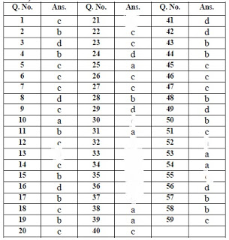](https://1.bp.blogspot.com/-4253Qi97SPk/XXtbGpX-t-I/AAAAAAAANVM/H4SNweD-9hkZnm4F_l2O6lzFDmV1xDBugCNcBGAsYHQ/s1600/physics%2B4.jpg)